
Notional Architecture
for a Geo-enabled Enterprise Portal Platform
for the AusIndustry Spatial Interoperability
Demonstration Project
Volume 2 – Technical Considerations:
Viewpoints, part 1
Version: 1.0
Date: August 17th 2004
Authors:
Dr. Robert Starling
and
Michael Wilson
(OGC- Australasia)
NOTICE

Permission to use, copy, and distribute this document in any medium for any purpose and without fee or royalty is hereby granted, provided that you include the OpenGIS Consortium copyright and the entire text of this NOTICE. We request that authorship attribution be provided in any software, documents, or other items or products that you create pursuant to the implementation of the contents of this document, or any portion thereof.

No right to create modifications or derivatives of OGC documents is granted pursuant to this license without permission of the OGC.

THIS DOCUMENT IS PROVIDED "AS IS," AND COPYRIGHT HOLDERS MAKE NO REPRESENTATIONS OR WARRANTIES, EXPRESS OR IMPLIED, INCLUDING, BUT NOT LIMITED TO, WARRANTIES OF MERCHANTABILITY, FITNESS FOR A PARTICULAR PURPOSE, NON-INFRINGEMENT, OR TITLE; THAT THE CONTENTS OF THE DOCUMENT ARE SUITABLE FOR ANY PURPOSE; NOR THAT THE IMPLEMENTATION OF SUCH CONTENTS WILL NOT INFRINGE ANY THIRD PARTY PATENTS, COPYRIGHTS, TRADEMARKS OR OTHER RIGHTS.

COPYRIGHT HOLDERS WILL NOT BE LIABLE FOR ANY DIRECT, INDIRECT, SPECIAL OR CONSEQUENTIAL DAMAGES ARISING OUT OF ANY USE OF THE DOCUMENT OR THE PERFORMANCE OR IMPLEMENTATION OF THE CONTENTS THEREOF.

OpenGIS® is a trademark or registered trademark of Open GIS Consortium, Inc. in the United States and in other countries.

SIDP Notional Architecture: Technical Considerations
SIDP Notional Architecture: Technical Considerations 2
Acknowledgements 1
V2-1 Overview 2
V2-2 Approach to developing the Notional Architecture 3
2.1. Approach 3
2.2. Overview Architecture 3
2.3. Architecture Component Overview 4
2.4. An Instance of Multi-Vendor Architecture Implementation: The OGC GOS-P Initiative 8
2.5. Web Services and Web Agents 9
2.6. Predicates of the Notional Architecture 10
V2-3 Viewpoints Concept 11
3.1. Enterprise Viewpoint 11
3.2. Information Viewpoint 12
3.3. Computational Viewpoint 15
3.4. Engineering Viewpoint 17
3.5. Technology Viewpoint 18
V2-4 Example Use Case scenarios 19
4.1. Creating scenarios 19
4.1.1. Mapping components to scenarios 19
4.1.2. Status of Components 19
4.1.3. Alignment to National and International Initiatives 19
4.1.4. Migratory model for custodianship 19
4.1.5. Method for Recognizing Custodianship 20
4.2. Use Case Scenarios 20
4.2.1. Requirements 20
4.2.2. The Scenario: Regional Reporting Process 21
4.2.3. The Regional Reporting Use Case 22
4.2.4. The Regional Reporting Data Processes 24
4.2.5. The Regional Reporting User Interaction 26
4.2.6. Capabilities Required 27
4.2.7. Components Required for the Regional Reporting Use Case 27
4.2.8. Priority Services 31
4.2.9. How this Aligns to the Component Levels of the Notional Architecture 32
4.2.10. Extensibility of the Use Case Method 32
4.2.11. Mapping Components to Scenarios 33
4.2.12. Status of Required Components 36
4.3. Use Case Service and Value Chains 38
4.4. Justification for Approach 39
V2-5 Enterprise Viewpoint 41
5.1. Strategic Enterprise Results Sought 41
5.2. Enterprise Method 42
5.3. Enterprise Standards 42
5.4. Business Processes 43
5.4.1. Executing Business Management Tasks 43
5.5. Best Practices 45
5.5.1. Adherence to OpenGIS standards 45
5.5.2. State of Implementation 45
V2-6 Information Viewpoint 50
6.1. Strategic Information Results Sought 50
6.2. Business Management Results Sought 50
6.3. Information Method 50
6.3.1. The World Wide Web 51
6.3.2. Web Services and Web Agents 51
6.3.3. The Publish-Find-Bind Model 51
6.4. Business management: Overview 51
6.4.1. Business Management: Agents 52
6.4.2. Business Management: Resources 53
6.4.3. Business Management: Tasks and Instruments 54
6.4.4. Overview: Tasks 55
6.4.5. Overview: Instruments 55
6.4.6. Authority 56
6.4.7. Policy 57
6.4.8. Role 57
6.5. Executing Business Management Tasks with Business Instruments 59
6.5.1. Managing Authorities and Roles 59
6.5.2. Managing Policies 61
6.5.3. Managing Resources 62
6.5.4. Manage Usage Accounting 63
6.5.5. Managing Web Agents 64
6.6. Characteristics of Agents, Tasks and Tools 64
6.6.1. Identity 65
6.6.2. Authenticity 65
6.6.3. Persistence 65
6.7. Roles and Authority to Use Instruments 65
6.8. Geospatial Information Model 66
The details of how to express a geospatial information model can be found in the OGC Reference Model (ORM – see discussion in 6.9) Rather then copy the contents of the ORM into this document, the reader is therefore refered to the OGC website for access to the Orm. 66
However, by way of illustration from the ORM: 67
6.9. Relevant OGC Specifications 67
6.9.1. Framework Data Standards 68
6.9.2. Service Specifications 68
6.9.3. Metadata Standards 68
6.9.4. Information Viewpoint - Expanded 69
6.9.5. Information Classes 69
6.9.6. Information Formats 70
6.9.7. OGC Emergency Services Symbology 72
V2-7 References 73
7.1. Bibliography 73
7.2. Acronyms 76
7.3. Glossary 79

Figure V2-1: ISO three-tier model 4
Figure V2-2: The SIDP Portal Platform Concept 5
Figure V2-4: Services and Information Flows 7
Figure V2-6: The OGC GOS-P Multi-vendor Interoperability Wiring Diagram 9
Figure V2-8: Web Services, Web Agents, Protocols and Messaging 10
Figure V2-9: Enterprise Viewpoint of the SIDP Virtual Portal 12
Figure V2-11: SIDP Information Viewpoint 14
Figure V2-12: SIDP Computational Viewpoint 16
Figure V2-13: Notional Architecture: SIDP organization 17
Figure V2-14: Regional Reporting – high-level use case portrayal 23
Figure V2-15: Regional Reporting – high-level data use portrayal 25
Figure V2-17: Regional Reporting – high-level user interaction portrayal 26
Figure V2-19: Regional Reporting - Indicative Service Components 29
Figure V2-21: Representative Service and Value Chaining Concept 39
Figure V2-15: Business tasks and service 43
Figure V2-17: SIDP Business Management Tasks 44
Figure V2-19: SIDP Business management Instruments 44
Figure V2-21: SIDP Business Management Overview 52
Figure V2-23: SIDP recognized Web Agent Types 53
Figure V2-25: SIDP platform resource types 54
Figure V2-27: Business Management Packages 55
Figure V2-29: Indicative Authority Types 56
Figure V2-31: Indicative Policy Types 57
Figure V2-33: Indicative Role Types 58
Figure V2-34: Business Management Instruments 59
Figure V2-35: Managing Authorities 60
Figure V2-36: SIDP Role Management 61
Figure V2-37: Managing Policies 62
Figure V2-38: Managing Resources 63
Figure V2-39: Managing Usage Accounting 63
Figure V2-40: Types of Web Agents 64
Figure V2-41: Characteristics of Agents, Tasks and Tools 65
Figure V2-41: User Web Agent Roles 66
Tables
Table V2-1: The Regional Reporting Process 21
Table V2-2: Notional Components required for the Use Case Scenario 33
Table V2-3: Existing Components versus Required Capabilities 36
Table V2-4: References to Best Practice Models 47

Acknowledgements
The SIDP appreciates the contribution of the Department of Land Information – Western Australia and the Queensland Spatial Information Infrastructure Council (QSIIC) for allowing as yet unpublished materials to be used as background and for ideas in those materials to be extended for the purposes of this study.
Other organisations such as the OpenGIS Consortium, Geo-Connections Canada, the City of Cologne (Germany) and the Geo-Intel Conference (2003) Platinum Sponsor Team have also provided unpublished materials in relation to the description and definition of some of the open standards based software components.
Processes undertaken for the use case scenario presented in the document were inspired (and funded) by the requirements for the SIDP. The SIDP will be developing three scenarios, as outlined in Volume 1. At this stage the scenarios are not detailed. Therefore the Regional Reporting Scenario is included as an exemplar of the process. The Regional Reporting Scenario is highly representative of the requirements of the SIDP, The strategy of collaborative and cumulative development between the participants is acknowledged and appreciated.
- Overview
The SIDP Architecture builds upon existing initiatives and infrastructure such as the Australian Spatial Data Directory (ASDD) and its existing nodes in Australian states and territories, the USGS Clearinghouse Network, and/or any other catalogues implemented in Australian Spatial Data Infrastructure (ASDI) and that have been documented according to internationally recognized metadata standards. SIDP will draw on and enhance existing clearinghouse capabilities, developed by different states, by providing direct access to a subset of the data in the catalogs - specifically, to those data services that use standardized access methods.
The SIDP methodology is based on open standards and specifications that are defined collaboratively by a variety of interested parties, are freely published, and are able to be implemented by any vendor or organization.
The following summarize the viewpoints used in considering possible future implementation strategies based on the notional architecture. The implementation architecture and actual service selection will be undertaken by the SIDP as the project evolves. It is suggested that the following steps be followed as the SIDP project proceeds.
- Apply ORM [26] Viewpoints
- Resolve each viewpoint in terms of strategic results required
- Describe method applied at each viewpoint
- Describe business tasks and instruments to apply
- Develop components
- Relate to one or more requirements
- Connect back to enterprise strategic outcomes.
- Approach to developing the Notional Architecture
The architecture is notional in that it makes no assumptions about implementation technology, specific implementations, institutions or system platforms other than their support and acceptance of open, non-proprietary standards. It provides an explanatory framework within which a distributed service managed by authoritative custodians can be implemented to support an expanding set of spatial services for the SIDP Project and as an exemplar to government, commercial re-sellers and citizens.
  - Approach
The approach used in this document will emphasize interoperability, which is to be achieved by utilizing the current IT industry thinking on component-based, services oriented architecture (SOA) drawing on data-driven data modeling processes.
SOA is based on deploying and enabling a transaction-based service request and delivery model, focusing on the creation of just-in-time products in response to external requests. It will embody a components-based architecture based on OpenGIS encoding protocols and interface specifications.
  - Overview Architecture
The recommended notional architecture builds on the work of the OGC membership on interoperable architectures and specifically on the OpenGIS Web Services Architecture [38].
The web services architecture uses an ISO/OSI three-tier model. Referring to Figure V2-1 below it can be seen that the model separates presentation from processes governed by business rules, and processes from the underlying methods for accessing persistent data repositories (whether relational databases, file systems, structured text files such as XML, etc).
Implementing this model in the form of distributed web services will require that communications between tiers, and amongst service components within tiers, can be mediated by using open standard Internet protocols transporting transactional messages structured in well-known manners.
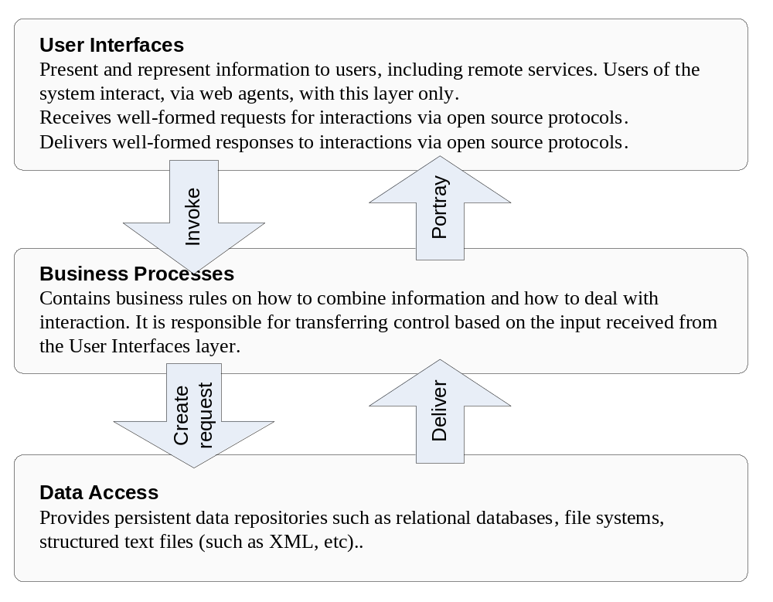
Figure V2-1: ISO three-tier model
Each of the three tiers in this model addresses a separate aspect of serving users’ business requirements – establishing interfaces for user access, implementing business rules as process services, and manipulating stored data. In the Notional Architecture communication between tiers, and amongst elements within tiers, is capable of being mediated via Internet protocols between web services.

The ISO three-tier model also corresponds to a pattern of an architecture definition widely recognized in the object-oriented analysis and development communities, that of the Model-View-Controller-Pattern, or the Boundary-Control-Entity-Schema. According to this approach, a notional architecture is constructed in three layers.
- The Boundary is responsible for representing information to the user and receiving interactions. Users of the system interact with this layer only.
- Control contains the rules on how to combine information and how to deal with interaction. It is responsible for transferring control based on the input received from the Boundary layer.
- The Entity layer holds the data and is responsible for its persistence.
Either of the ISO/OSI or OO viewpoints may be taken in considering the notional architecture, though the latter lends some advantage to later discussions of services, components and their interfaces.
  - Architecture Component Overview
The following Figure V2-2 presents a high-level service component view of the SIDP notional architecture. The salient points for SIDP are that:
- “Thin” clients are web browsers acting as agents for people accessing services through the World Wide Web. Behind the scenes, these peoples’ agents are using the open http protocol to exchange well-structured messages with a web platform configured to act as an interface to SIDP approved web services
- “Thick” clients are remote applications acting as their own web agents and able to invoke according to agreed message standards and protocols. Thick clients can be remote GIS desktop applications used directly by people. They can also be autonomous tasks such as statistical analysis and modeling engines.
- Portal service partners configure the web services to conduct business processes such as analysis, data manipulation, presentation of products according to designated symbology rules and layouts, and plausibly also to provide interactive help for users.
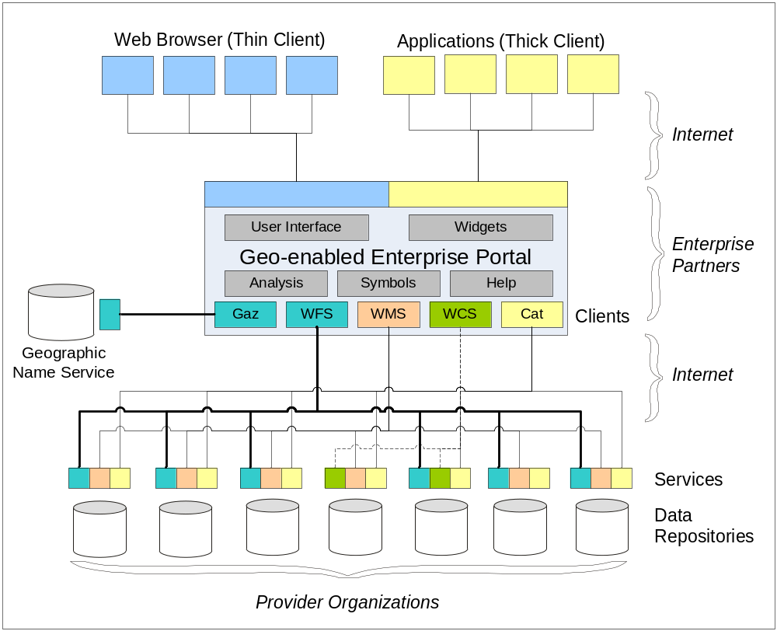
Figure V2-2: The SIDP Portal Platform Concept
The enterprise information portal mediates internet-based transactions between client agents (web browsers, remote applications) and a distributed community of service operators and content providers. The services include discovery (catalogues, registries and gazetteers), analysis, transformation and portrayal. OpenGIS and other open specifications define the interfaces amongst these services.

- Catalogue services support publication of service and data characteristics (metadata) and their discovery by appropriate agents. Catalogues also provide information about the language structures and interface capabilities supported by each service. All services to be accessed in the SIDP require catalogue references. The OGC now has the Catalog 2.0 candidate specification. The Catalog 2.0 is very close to formal adoption. The new version of the specification includes Z39.50, “coarse-grain CORBA,” and former WRS/Registry activities into a single specification document consistent with a new general model expressed in UML
- An OpenGIS gazetteer services support searches and other applications (such as portrayal) requiring the names of locations and features.
- The OpenGIS Web Feature Services (WFS) provides content neutral access to the abstract spatial data type “feature” and returns the result encoded in Geographic Markup Language (GML). The returned features are amenable to further analytical or representational processing, such as may be done with “thick” clients. WFS tend to deliver vector data content and attributes, but can also treat content such as gazetteer services as point data.
- The OpenGIS Web Coverage Services (WCS) similarly provides access to the abstract data type “coverage” (including raster data, but not constrained to rectangular reticules) to thick clients or for portrayal through WMS.
- The OpenGIS Web Mapping Services (WMS) provide pictorial portrayals of data as maps that are readily visualized and manipulated in “thin” clients but they are not amenable to further manipulation. WMS may stream and portray content from WFS.
Figure V2-3 following illustrates the services involved and the paths by which information flows between the services. The salient points to note for the SIDP are that:
- User interfaces (UIs in the diagram) and application programme interfaces (APIs) interact with the world wide web – or the internet in general – according to public standard protocols and interface specifications
- All interactions between users via their web agents, are transactional in nature
- Information flow occurs between numerous independent services managed by independent custodians
- All data assets are delivered via services
- Services and data descriptions are published into registries and catalogues available for search-driven discovery by web agents
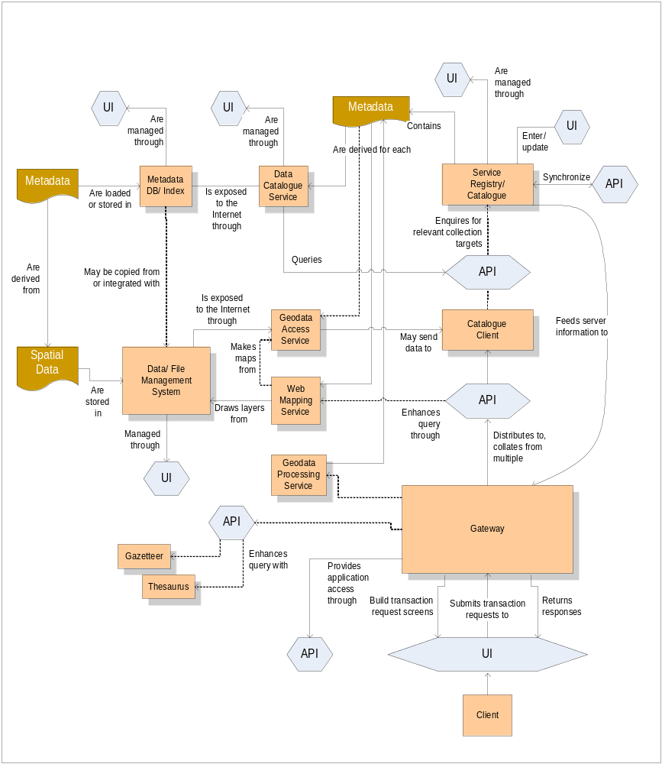
Figure V2-3: Services and Information Flows
Service components (rectangles, pink) are able to interchange informational messages via the open network standards used in the Internet. Various web service interfaces (hexagons, blue) provide the means by which service capability descriptions are requested, service instances are invoked, and resultant products are returned, amongst services (APIs) and users (user interfaces, UIs). Persistently stored data or various types (banner figures, brown) are accessed and manipulated by relevant services.
  - An Instance of Multi-Vendor Architecture Implementation: The OGC GOS-P Initiative
The OpenGIS Web Services Architecture [38] is evolving from concepts forwarded by OGC and the Federal Geographic Data Centre (FGDC) in the US, to implementations undergoing trials by the Canadian Department of Natural Resources and Mines, Ordnance Survey (UK), INSPIRE (EU), the Geo-Spatial One Stop Portal Initiative (US) and the City of Cologne (Germany).
Figure V2-4 shows how this inter-service information model has been applied in one particular multi-vendor interoperability initiative and demonstration. During 2003, the OGC with support from NASA, FGDC, other Federal Agencies, and numerous vendors, completed the Geospatial One Stop Portal (GOS-P) initiative and demonstration project of the US Government, now available on-line.
Many standards-based Commercial off the Shelf and Open Source products are now available that implement a variety of OpenGIS and ISO standards. The following figure, while perhaps dauntingly complex in appearance, nonetheless highlights the reality that real-world applications of the principles embodied in the SIDP Notional Architecture – institution neutrality, vendor neutrality and system platform neutrality - are practicable.
Salient points of Figure V2-4 include:
- Integration and use of numerous vendors’ products supporting specific service components of an enterprise platform;
- Implementation of the ISO three-tier model;
- Implementation of the Web Services Publish-Find-Bind model;
- Distributed services communicating via open Internet protocols;
- Interaction with pre-existing standards-based web services such as the NSDI clearinghouse via z39.50 connectors;
- Implementation of service and content resource discovery through gazetteers and registries (GNIS, NSDI);
- Implementation of platform user access control and management via a secure portal client generator;
- Implementation of portrayal services (WMS);
- Implementation of feature-based services (WFS), and their interaction with portrayal engines such as cascading map services (WMS);
- Specification of portrayal rules that are content independent through styled layer descriptors (SLD)
- The use of various client generators (CG) to create user interfaces for thin clients
- Interoperation with pre-existing proprietary services (e.g. ESRI IMS or GeoMedia WebMap) via standards-compliant connectors and wrappers
The following figure does not clearly portray how different services are operating in different system environments, although this is in fact the case. The wiring diagram depicts how the various OGC GOS participant technology solutions were integrated via the use of OGC standard interfaces into an operational demonstration portal. This diagram is not how the current GOS portal in the US is actually implemented.
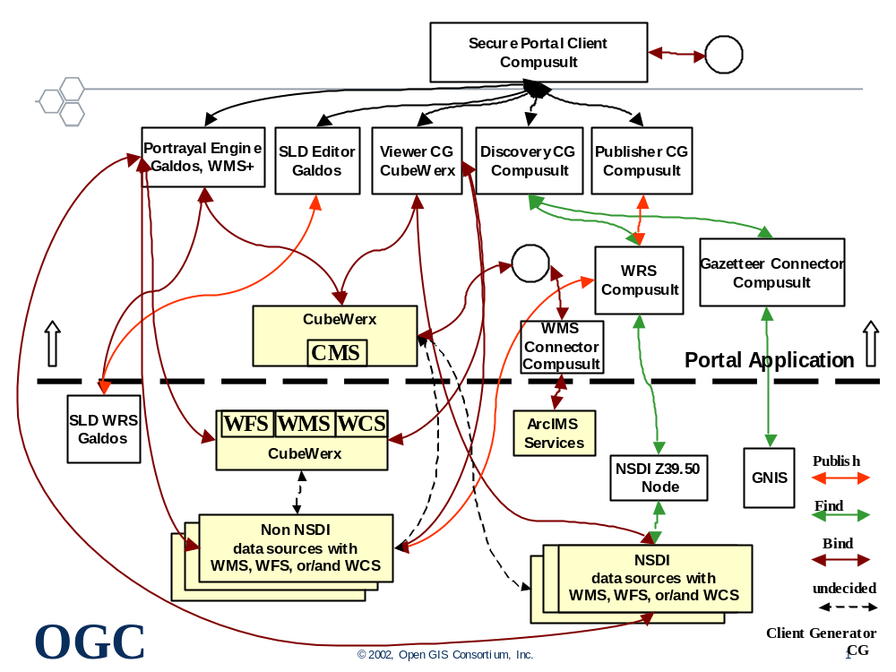
Figure V2-4: The OGC GOS-P Multi-vendor Interoperability Wiring Diagram
The OGC Geospatial One-stop Portal (GOS-P) initiative demonstrated implementation of a standards-based interoperability platform based on multiple vendors’ products. Pre-existing services interoperate with newly developed ones to support resource discovery, geo-processing and repository management.
  - Web Services and Web Agents
The World Wide Web (WWW, or simply Web) is an information space in which resources, the items of interest, are identified by global identifiers called Uniform Resource Identifiers (URIs).
A Web Service is application logic accessible across a network using standard Internet protocols. Web Services combine the best aspects of component-based development and the Web. Like components, Web Services represent functionality that can be easily reused without knowing how the service is implemented. Unlike current component technologies that are accessed via proprietary protocols, Web Services are accessed via ubiquitous Web protocols (e.g. http) using universally accepted data encoding formats (e.g.: XML).
Web agents are people or software that act on this information space. Software agents include browsers, servers, proxies, spiders, and multimedia players mediating interactions on behalf of a person, entity, or process.
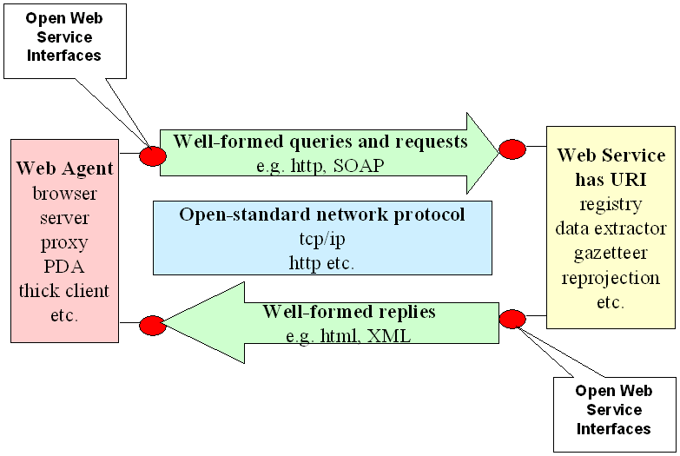
Figure V2-5: Web Services, Web Agents, Protocols and Messaging
Web services serve each other and web agents of various kinds, some of which represent peoples (e.g. browsers) and others that are autonomous processes (e.g. servers). Communication transactions employ standard Internet web protocols to transports request and response messages packaged in well-known forms.
  - Predicates of the Notional Architecture
The notional architecture is based on the notions that:
- There exist as Web Services a number of Resources
- Resources include:
- Data sets
- Services that access, manipulate, or portray data sets
- Processes that ‘chain’ services
- All resources are accessible only as services accessed by web agents
- Users can only use Web Agents to access these Resources to create useful Products.
- Providers of Resources may need to Account for, and possibly charge for, their use.
- Resources are offered in a distributed manner by a variety of Custodians.

- Viewpoints Concept
The SIDP Notional Architecture uses the ISO Reference Model of Open Distributed Processing [3] that is based on using five mutually consistent design viewpoints:
- The Enterprise Viewpoint describing business perspective, purpose, scope and policies;
- The Information Viewpoint concerning the semantics of information and information processing;
- The Computational Viewpoint concerning the interaction between computational components that transform information, their interfaces, operations and binding rules;
- The Engineering Viewpoint describing the hardware and software components and infrastructure used in a distributed system.
- The Technical Viewpoint considers the choice and suitability of physical implementation.
The possible SIDP services and processes for each of these viewpoints are discussed in detail in sections Volume 3 sections 3.3 to 3.6
  - Enterprise Viewpoint
The Enterprise Viewpoint seeks to portray how implementation of the notional architecture will achieve results relevant to the SIDP scenarios.
It also considers the high-level context within which informational elements, to be elaborated in the information viewpoint, are identified.
SIDP is to provide a platform for service to the spatial industry. Referring to Figure V2-6 (below), salient points are that:
- A variety of user communities, both within and beyond the project , are to have access to valuable products via the Internet, including the World Wide Web. User communities include government, civil, academic and commercial.
- Products are to be generated by collections of services representing defined business process, said services being created and managed by a variety of authoritative custodians. Access to services is to be governed according to user authentication, user authority and service usage policies.
- Services may also be accessible to other web platforms.
- Services draw upon data available in repositories maintained by various authoritative custodians and made accessible through data access services.
- Service providers may (and indeed should) draw on data hosted by custodians other than the service provider.
- Access to services and repositories extends beyond the SIDP and can include other Australian offerings and those from overseas.

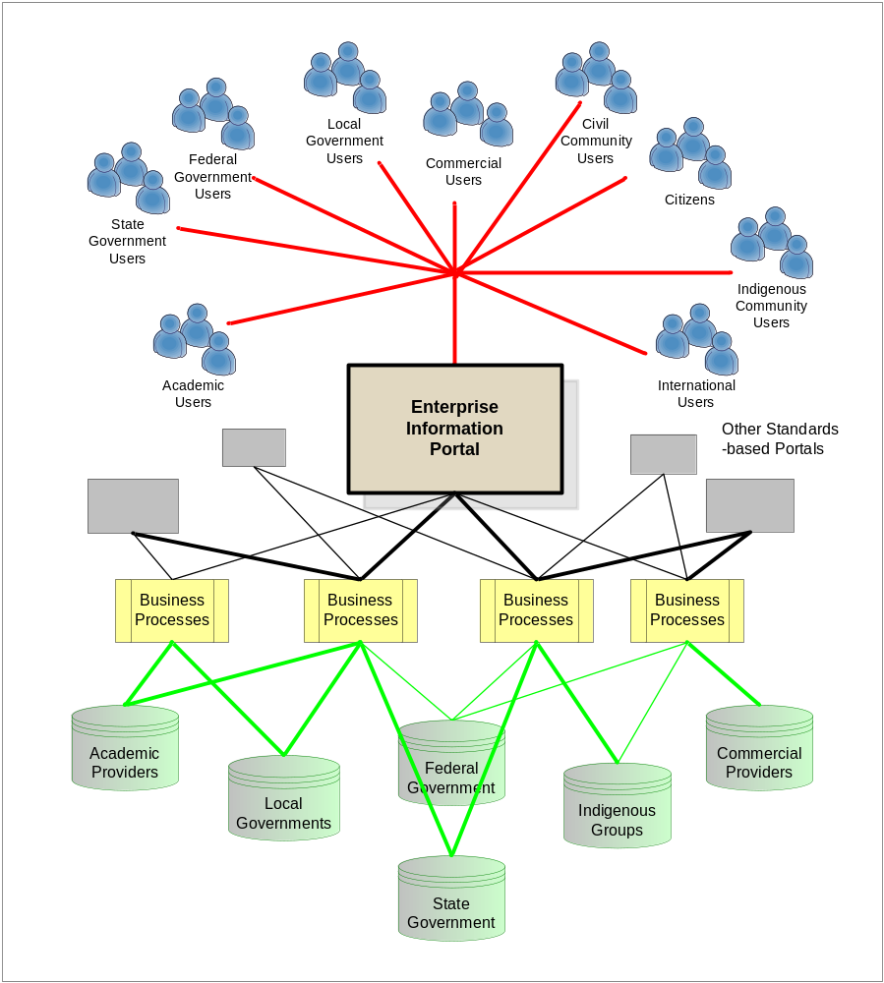
Figure V2-6: Enterprise Viewpoint of the SIDP Virtual Portal
Information seekers and users of various types use common standards-based Internet portals to gain access to an entire distributed community of authoritative content. Business processes manage and account for access to content and add value to it by generating user-specified products. Users may also be able to access services and products via other portals or directly.
  - Information Viewpoint

The information viewpoint is concerned with the semantics of information and information processing. The information viewpoint defines conceptual schemas for geospatial information and methods for defining application schemas. The conceptual, or base, schemas are formal descriptions of the model of any geospatial information. Application schemas are information models for a specific information community. Applications schemas are built from the conceptual schemas.

The information viewpoint represents the meaning of the information stored with and manipulated by the SIDP community, independently of the actual distribution within the community. It describes basic information building blocks and defines classes of information for the SIDP.
The Figure below shows the OGC approach to modeling geographic features. The OpenGIS Information Framework provides conceptual schemas to define abstract feature types and provides the process for domain experts to develop application schemas that are used to capture data about feature instances.
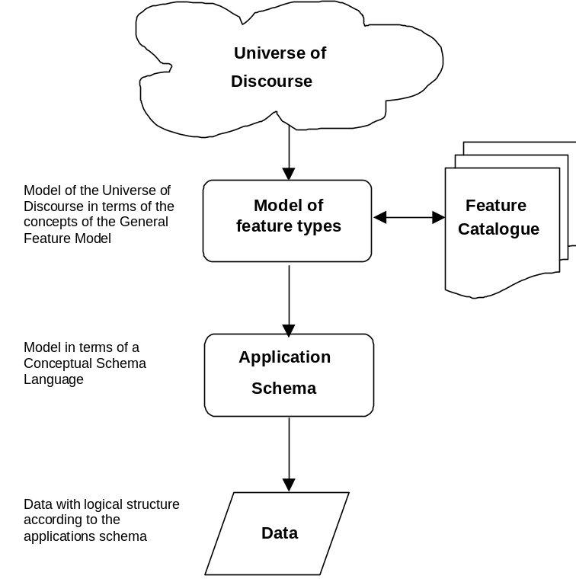

In addition to schemas, metadata is an integral component of the information model. Metadata describes the characteristics of content in a known and consistent manner. In the spatial world, the ISO 19115 Metadata standard is the foundation for the collection, storage and expression of metadata. Another related set of information that must be modeled is symbology.
Once the metadata, the required repositories, the symbology, and the schemas content are defined and agreed to, then these schemas, metadata and so forth need to be exposed so that they can be discovered (find) and “bound” to. Figure V2-11 provides an abstract model for implementation of the Information Model.
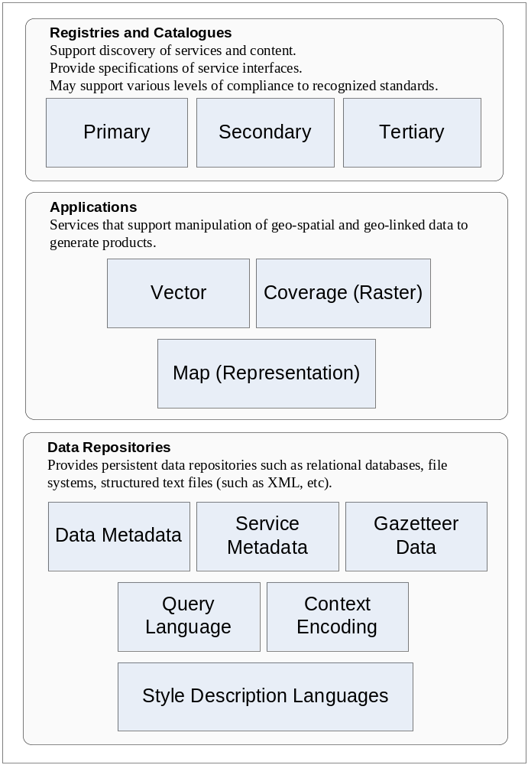
Figure V2-7: SIDP Information Viewpoint
The Information Viewpoint hinges around tasks of discovery, application and storage. Registries and catalogues storing metadata descriptions of resources (services and content) are central to the SIDP strategy. Application processes manipulate content to generate further content and products. Data repositories provide persistent storage for all types of information, including type definitions, symbology libraries as well as applications and discovery data.
Referring to the figure above, the salient points of the implementation of the information viewpoint concerning SIDP are:
- Registry and catalogue components to which custodians publish descriptions or metadata. Potential user agents are able to interrogate and potentially discover service and content, and bind to services according to descriptions of their interface characteristics.
- Application components able to manipulate data conforming to particular models such as vector, coverage (raster) and map (representational).
Repository components that provide persistent storage for a wide variety of data types that may include metadata describing data sets, metadata describing services, presentation metadata (styled layer descriptors and symbology), gazetteer data, query languages, and encodings for user service context (such as metadata describing policies and authorities).
  - Computational Viewpoint
The computational viewpoint portrays the functional decomposition of the SIDP into services interacting at well-defined interfaces. The services are grouped into meaningful packages reflecting the business tasks and instruments identified in the following Section and the information classes considered in the Enterprise Viewpoint.
These are referenced to the business management tasks and instruments previously identified from the information viewpoint.
Referring to the following figure, the salient points of the SIDP computational viewpoint are:
- Seven major types of computational components, instances of which are to be instantiated as web services.
- Registry and catalogue services to support publication and discovery
- Application services to provide the necessary interfaces for interaction with users’ web agents via the Internet
- Portrayal services to create the required representational products of data (maps, charts, raw vectors etc.) required by user agents
- Data access services to conduct transactional data retrieval from appropriate data sources
- Geo-processing services to manipulate geo-spatial data according to user agent requirements
- Authentication, authorization and accounting services to ensure that web agents meet policy requirements for establishing their bona fides, receive authority to exploit a service, and have their usage accounted for (possibly as the basis for chargeback).
The computational elements conform to the concepts of the ISO 3-tier model. In review, and referring to figure V2-8, the salient points concerning SIDP are that:
- The “3-tier” model loosely couples the outward-looking interfaces accessed by users from the operations that instantiate business processes, which are in turn loosely coupled with the core data repositories
- Interaction interfaces in the top level conform to the web services/ web agents method elaborated in Volume 4 Appendix A2 i.e. support query-response transactions in well-known format and conveyed by open standard network protocols.
- All interactions with users and remote services are mediated by web agents
- Business process also present web service interfaces
- Data access services should also be loosely coupled to business process as web services, although in practice they may be tightly coupled according to existing institutional policies.
Elaborating on the ISO 3-tier model, SIDP is envisaged as comprising a number of service components comprising seven service packages that instantiate the service requirements at each level.
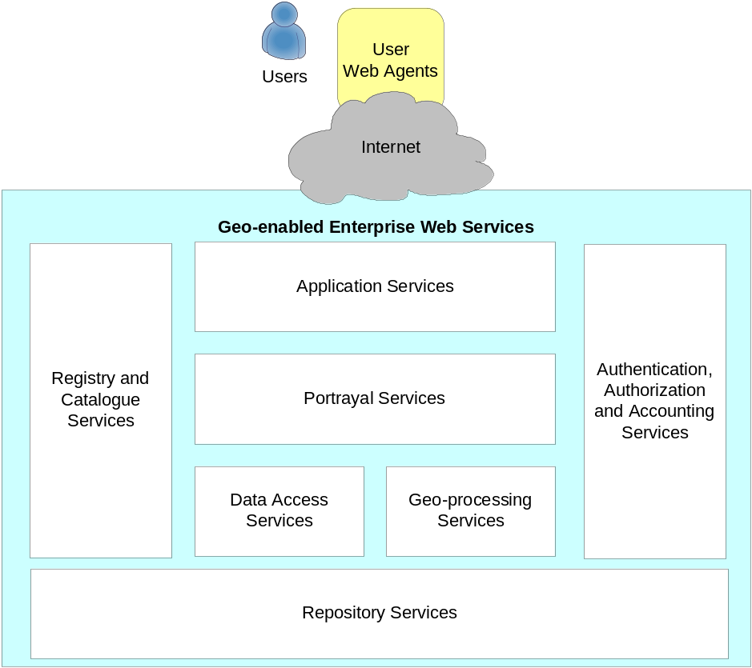
Figure V2-8: SIDP Computational Viewpoint
The SIDP Platform provides uniform and consistent managed access to distributed web services operated by authoritative custodians. These services comprise seven major categories address geo-data processing, presentation, access control, accounting and data management.
Referring to Figure V2-8 (above), the salient points concerning SIDP are that:
- The outward-looking user interface tier provides the actual user interfaces with which web agents interact (including clients generated for humans using web browsers to access SIDP), and portrayal services that prepare the outputs of the business process tier as final products for delivery
- The business process tier provides service components such as discovery of services and content (such as metadata catalogues), data manipulation services (such as extracting specified subsets), geo-processing (such as geocorrection), authentication of agents, their authorization and accounting for use, and a variety of ancillary services.
- The data repository tier accommodates the variety of services that store, manage and deliver data according transactional requests.
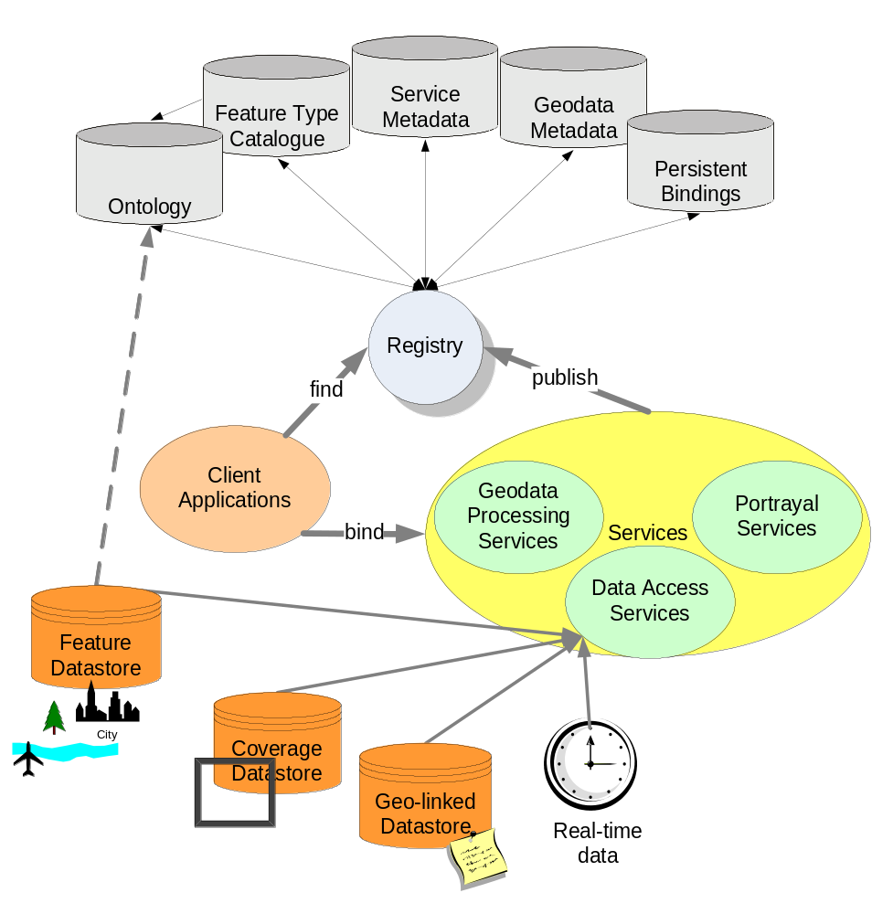
Figure V2-9: Notional Architecture: SIDP organization
Services provides access to valued data and services, which are described in registries that include definition of their capabilities, context and governance rules. Users’ clients bind to services via internet protocols implementing the governance rules. Data repositories of various kinds provide persistent storage for various types of geo-data. The community of providers shares a common vocabulary and ontology for describing features of common interest and the relationships amongst them.

  - Engineering Viewpoint
The engineering viewpoint focuses on the deployment aspects of a system, with explicit depiction of distribution rather than that merely implied in the computational viewpoint. It describes the major packages envisaged as providing the operational components of an implemented SIDP and the forms of their various interfaces.
These interfaces are referenced to the business management tasks and instruments previously identified from the information and computational viewpoint.
The Engineering Viewpoint requires the specific identification of packages, data and methods and as such is beyond the scope of the Notional Architecture, The Engineering Viewpoint will be addressed by the project in relation to the Implementation Architecture.
  - Technology Viewpoint
The technology viewpoint would focus on specification of technologies to be implemented to realize the notional SIDP architecture as an operational system.
A detailed technical engineering specification is beyond the scope of a notional architecture, and will require site-specific information to be gathered at a later date. However, a discussion of the engineering supporting SIDP could be elaborated in the design process in creation of the Implementation Architecture.

- Example Use Case scenarios
  - Creating scenarios
Determining user scenarios prepares the way for the first major iteration of the model. Use-case scenarios are described which indicate real world business requirements. Subsequent modeling by the Project Management Team will include identifying and specifying specific services for implementation. Modeling the Use Case Scenarios provides an example of how the application of the notional architecture and the modeling can be achieved to realise real business outcomes.
    - Mapping components to scenarios
Mapping components to the scenario(s) allows iteration against the model i.e. to ensure that all critical components are identified and linked to Service Categories and the Notional Architecture (i.e. have referential integrity). Such mapping also helps to recognize priority components , evaluate their alignment with existing initiatives and provide the basis of a strategy for moving forward.
    - Status of Components
Not all required SIDP component interfaces and/or encodings have been specified by a standards body. However, identifying requirements for a given interface to a component allows a watching brief to be kept on developments.
    - Alignment to National and International Initiatives
SIDP will become a model for an increasingly broad range of organisations moving towards increasing the data richness and processing capabilities of Spatial Data Infrastructures (SDIs), especially the Australian Spatial Data Infrastructure (ASDI).
Consistency with the ASDI not only ensures future interoperability between SIDP participants, but between the participants (individually or collectively) and Commonwealth government services, as well as SDI-compliant services being implemented. These include the WALIS Atlas, SLIP and LandGate in Western Australia and CANRI in New South Wales.
SDIs are based not only on collaboration within their jurisdictions but between jurisdictions evolving towards the Global Spatial Data Infrastructure (GSDI). The scalability, convergence and extent of such efforts are summarised in the Volume 4 Appendix A-9 “SIDP and Global SDI”.
    - Migratory model for custodianship
Where appropriate technology is not available, or available within a required time frame, then work could be encouraged, through in-kind contributions, to fill the gap with the resulting service being made available to others as a result of the use of standard interfaces.
This approach includes an expansion of the concept of custodianship to include groups or organisations electing to take responsibility for components and/or chained components that deliver a defined product as a service.
The approach also recognises that an organisation commissioning a service to address a specific business need may not be the logical custodian for any on-going service operation. Therefore, a mechanism is proposed for the migration of custodianship to ensure continuity and that cumulative benefits accrue.
    - Method for Recognizing Custodianship
Recognizing and accepting the notion of custodianship of services and processes allows a mechanism to be proposed for taking responsibility for different stages in the life cycle of a service or process.
For example, Industry Group A may define a scenario that requires business processes dependent on a component that is not currently available. Commissioning the development of the component fills a blank in the component status matrix and sees the project requirements met. However, others may undertake further use or enhancement of the service (Organisation B). SIDP may have determined, through consultation and/or in-line with the Project Plan, that the operational custodian of the service may be a different private company (Organisation C) or that another participant may be engaged to provide an on-going outsourced service.
The method would allow for re-use and for cumulative benefits to accrue. Services, initially available within the project may be exposed for wider use to appropriately authenticated and authorised users.
  - Use Case Scenarios
The SIDP will field three scenarios, to be refined by the project participants through workshops that will:
- Identify opportunities for shared, distributed web services;
- Identify the most-needed components of the notional architecture;
- Provide a gap analysis between existing and required capabilities;
- Consider the custodial arrangements by which services could evolve from design concept to prototype demonstrator to operational stability.
    - Requirements
The SIDP Workshops will define the scenarios for the project. This document presents a sample scenario to illustrate the practices and procedures and provides a template against which the specific SIDP scenarios can be documented and developed. The sample scenario:
- Provides a pragmatic example of applying the SIDP Notional Architecture to a business problem;
- Presents an example which could be used to communicate the opportunities, benefits and potential issues associated with adopting the Notional Architecture model;
- Identifies instances where existing infrastructure policies might be a barrier to adoption;
- Focuses on issues relating to information product licensing and pricing;
- Defines a prioritised list of the web services (and their components) which would be required to create the scenario as a demonstration project;
- Aids alignment of the list of components against existing projects and experience;
- Creates a list of targets which Participants could incorporate into future project plans to contribute re-usable web services to the SIDP community for testing;
- Enunciates a model for including non State government suppliers and customers of the data across government and private sectors, and across levels of government , and
- Meets the requirements of the target industry groups
Although the SIDP has developed some preliminary scenarios they are sufficiently defined to be used for analysis at this time. Therefore, the following outline considers a use case for creating regional reports that exemplifies the process.
    - The Scenario: Regional Reporting Process
The regional reporting process is initiated if a user requires a report on the economy of a geographic region, or region in the vicinity of an incident. . Assuming that a particular report template is to be undertaken for the first time the following process sequence is initiated.
Table V2-1: The Regional Reporting Process
- Define the geographic area.  Examples of different regional reporting areas include administrative and political; watersheds and drainage; emergency management including fire control; education administration regions; healthcare catchments.  An inherent problem is that these regional boundaries, defined independently for operational and historic reasons within or between departments and different levels of government, do not necessarily coincide or align. In fact, area or regional boundaries are dynamic and regularly change between statistical reporting periods. | 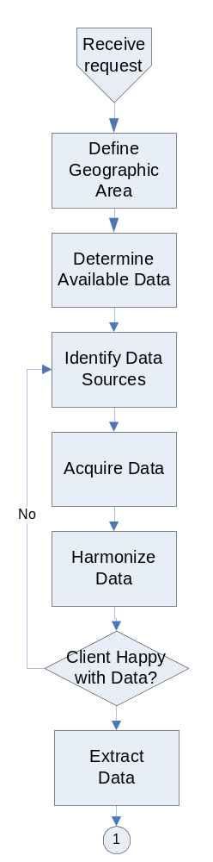
- Determine available data (data scanning)
What data are available for inclusion in the report? The sensitivity here depends on the level of geography is required i.e. a street intersection, a town, a Local Government Authority, a Statistical Division or what have you.
- Identify Data Sources
Data may be sourced from Commonwealth Departments), other State Government Agencies and Local Government Authorities, private data holders/suppliers and special interest group such as Professional Associations.
- Acquire the data.
Data not already accessible needs to be ordered, or access arrangements formalized, from the relevant agencies. This may require payment and/or data use monitoring
- Harmonize the data.
Data is received from agencies and converted into a suitable form. The datasets acquired may require post processing to extract information for the area of interest and allocation modeling to align different data sets to a common definition of a boundary for the “region”.
Feedback sought from the client regarding data sources.
- Extract Data. This is the process of actually displaying, downloading, or otherwise delivering the user required data in a content neutral manner, such as GML.

- Analyze and Interpret  These are undertaken as needed. For example, statistical analysis would be used to calculate a median farm size for the particular region. Another example would be to calculate the percentage increase in the combustible litter in the region; this could be compared to previous estimates to determine rates of change. Results of the analyses are stored for audit purposes and may also be used as input to further analyses. | 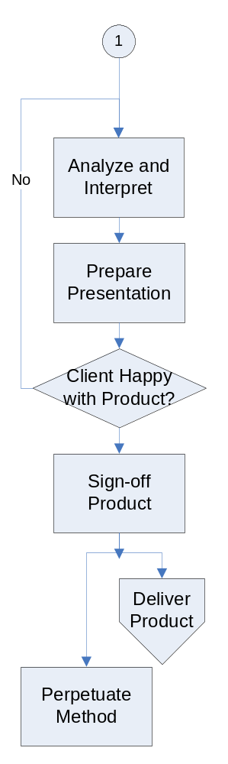
- Prepare Presentation.
The report is then written which includes graphs, tables, and maps. The result is a printable document.
- Validate and Assure Quality
The draft report is completed including the quality assurance of data in the report and the textual interpretation of the data.
Feedback is sought from the client regarding report layout and style.
- Product Sign-off.
Report is then submitted for approval.
- Product Delivery
Report is delivered to client.
- Method Perpetuation
The procedure used to generate the report is formalised so that the information product can be re-generated with current data and/or different data for the same or different areas with similar data inventories.
    - The Regional Reporting Use Case
Only high-level use case analysis is undertaken here.
Full, definitive elaboration of the Regional Reporting use case, in the accepted narrative forms for system analysis and design, are beyond the scope of this document because:
- The variety of potential requests sought by users is very broad, each instance of which requires its own definitive analysis;
- The variety of data sources available as input to reporting is likely to increase rather rapidly in the near future, with an increased sophistication in clients’ requirements;
- The types of analyses to be prepared for interpretation will also likely increase in sophistication as distributed custodial services become the accepted norm.
For current purposes, a high-level use case portrayal may be envisaged as per the following figure:
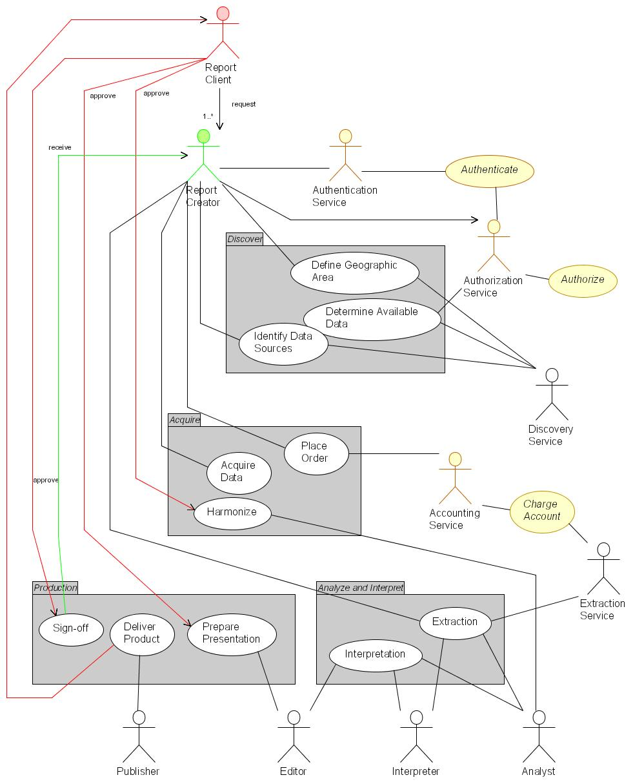
Figure V2-10: Regional Reporting – high-level use case portrayal
Production of regional reports involves numerous actors, both human and autonomous processes. The mix of these will evolve over time as ready-automated, high-demand actions become service components.
It should be apparent that considerably more actors are involved than those explicit in the above process description– actors required for authorization, authentication, accounting, discovery, analysis, editing and publishing, as well as for requesting and creating a particular report.
The sequence and timing for automation of any or all of these actors is a matter for consideration after the project scenarios are documented. It is feasible, for example, that any one of authentication, authorization or accounting services, while likely to fully automated in future, could be deferred to manual management while nonetheless delivering examples of regional reporting. Certain actions, such as data extraction, are good candidates for immediate automation and could be analyzed further immediately. Other, highly intellectual actions such as interpretation are likely to be carried out manually.
    - The Regional Reporting Data Processes
A review of the data access and process requirements of any specific Regional Reporting requirement must, of course, depend on the specific report required and the analyses and interpretation required to prepare it.
Nonetheless, we can envisage generic requirements, as represented in Figure V2-11 (below).
For current purposes, we overlook the data access and process requirements for user authentication, authorization and accounting. These facilities are recognized as necessary for the SIDP, and are assumed to be evolving from the on-going work of OASIS and related groups, in manners consistent with the standards and principles of OGC Web Services.
Referring to the figure:
- It is reasonable to believe that combinations of location name selection (such as locations or regions) and spatial specification (such as a ‘cookie cut’ drawn on a selection map to show a region of interest) will drive discovery of content and services.
- These selections will drive an identification of the services relevant to that region and provide the user with metadata description of those services and their accessible content, including their capabilities, attributes and bindings. Numerous registry services may be used to interrogate registry repositories for this.
- Named-based (i.e. Gazetteer services) return spatial coordinates to drive registry interrogation, whereas ‘cookie cuts’ provide these coordinates directly.
- Numerous registry and catalogue services supply the user with metadata descriptions of relevant content, for designation to the selected services.
- Data extraction service(s) cause a number of relevant repository services to deliver geodata, whether as GML, shapefiles, tables or other forms. Users may visualize some of these directly as required.
- Extracted data may also be delivered to the user’s agent(s) and made available for other portrayals and processes.

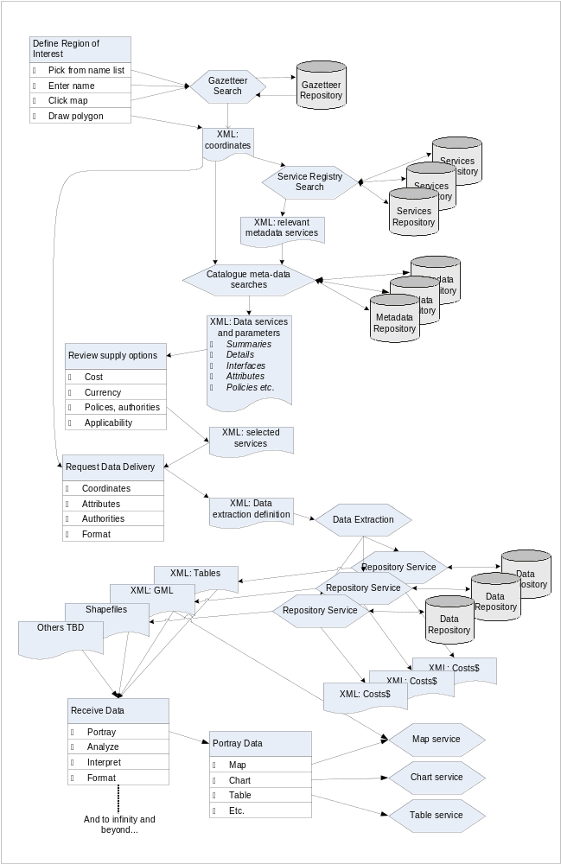
Figure V2-11: Regional Reporting – high-level data use portrayal
Production of regional reports involves numerous actors, both human and autonomous processes. The mix of these will evolve over time, as high-demand automatable actions become service components.
    - The Regional Reporting User Interaction
A review of the user interface and interaction requirements of a specific Regional Reporting requirement must, of course, depend on the specific report required and the analyses and interpretation required to prepare it.
Nonetheless, we can envisage generic requirements, as represented in Figure V2-12.
A variety of web service interactions are required, but only a minority of them interacts directly with user interfaces. All inter-service communication is mediated by XML-based message packets, such as the GML packaging of data returned by repository services from their respective data stores based on the XML-specified criteria.
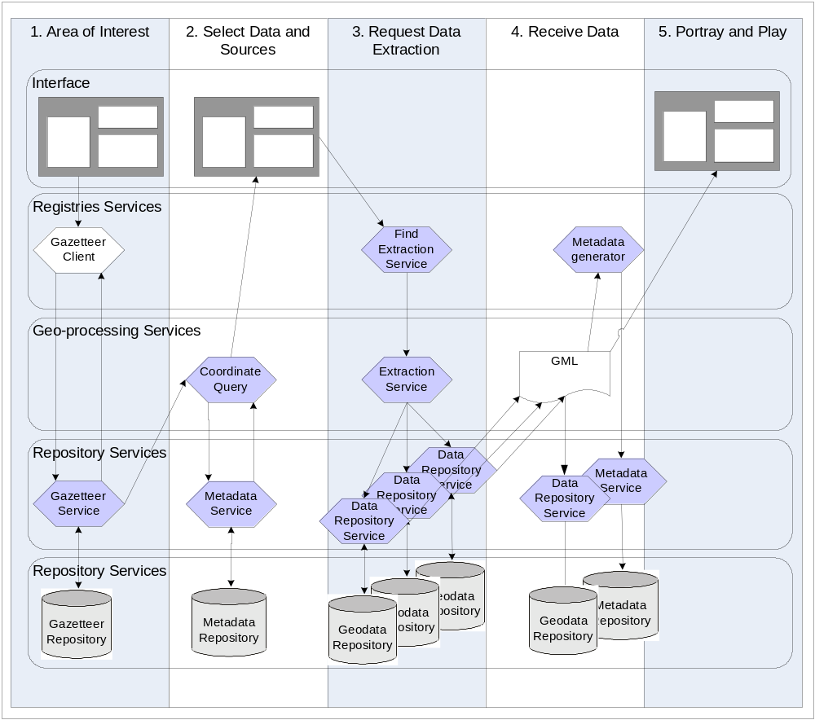
Figure V2-12: Regional Reporting – high-level user interaction portrayal
Users’ perception of interaction with the SIDP platform in the course of, say, generating a regional report belies a flurry of transactions taking place amongst various services performing discovery, data access geo-processing and portrayal, as well as managing the storage and description of newly generated data sets.

    - Capabilities Required
Authentication service to identify logon characteristics and to determine eligibility to see certain information products
Workflow definitions need to be established which describes the options for available information products and directs the process of data and process discovery, acquisition, processing and presentation
A directory of data accessible by each contributor and the terms and conditions for access and use (fit for purpose) of the data (meta data catalogue services)
A directory of the services that provide data processing, modeling and display options available from which computer on the network and its conditions of access and use (registry services).
Once located the data has to be accessed through data access services.
Data may need to be harmonised (re-projected, aligned for the scale of display dictated by the information product) and/or generalised (to fit on the screen or map window in a document).
Models may need to be executed such as fuel loading projections for the area or trend analysis of residential development or disease profiles – weather predictions in the event of long-term conditions such as drought or drastic short term such as a cyclone. (Modeling Services)
All the information has to be presented to the compiler as well as to the user (Portrayal Services including Style layer descriptors, symbology standardisation etc).
Messaging services will be required not just to communicate between the processes in the work flow but as notifications if certain data is not available, or errors occur in the chained processes, escalation rules might need to be included if response times (in service level agreement registry) are not met
Messages will also need to be sent and received from the customer about the state of the product and/or any issues that arise as a result of the presentation of the product (Customer Services).
    - Components Required for the Regional Reporting Use Case
A a full elaboration of the Regional Reporting use case was not undertaken because the representation here is indicative for the processes which will be undertaken by the SIDP project participants. Similarly, a rigorous definition of the service components that need to be implemented to support Regional Reporting would be refined by further analysis of specific scenario requirements.
However, the high-level use case suggests a minimum set of service components that would have to be available for Regional Reporting and as such to be feasible in the SIDP context. These suggested components are portrayed in the following figure.
Figure V2-13 below represents service components for regional reporting, of which the following points should be noted:
- The view is that of the reporting invoker;
- Numerous data repositories are assumed to exist already and are not portrayed explicitly. These include data set catalogues (metadata), authority and authentication metrics, accounting records and portrayal definitions such as style layer descriptors and symbology libraries;
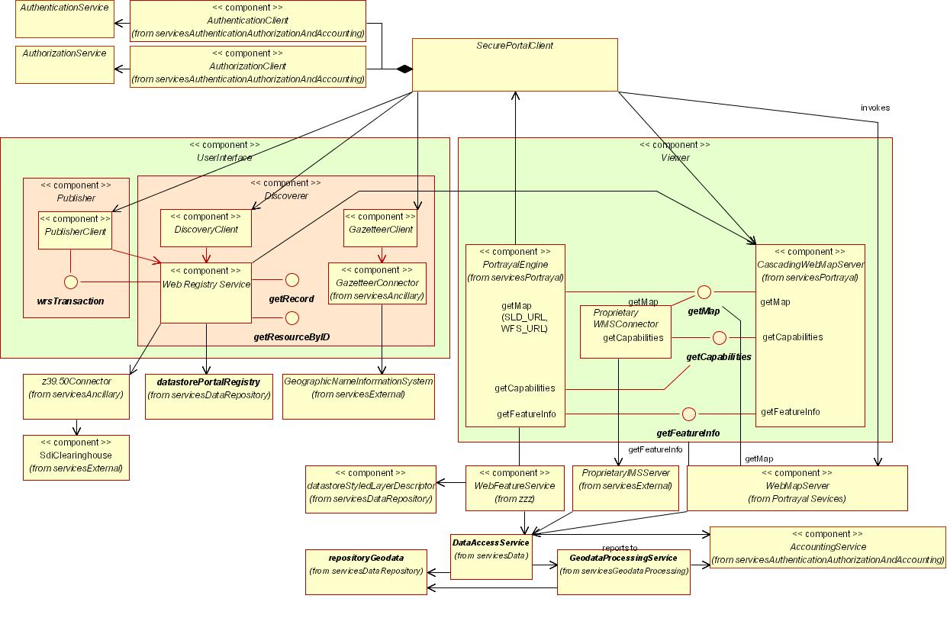
Figure V2-13: Regional Reporting - Indicative Service Components
A number of reusable components will need to be implemented to support an application such as regional reporting. Many of these are embodied in SCOTShelf (SCOTS) systems. More telling are the required repositories that will have to be assembled, operated and managed by SIDP collaborators.
- Many of the above data set repositories could also likely require references libraries of allowed types to assist and constrain authoring of the appropriate metadata;
- Many of the portrayal services are also available off-the-shelf as WMS and WFS implementations in the public domains and as SCOTS products;
- The interfaces portrayed are all defined according to OpenGIS specifications;
- Some external components, such as the clearinghouse connector, already exist and are available in both the public domain and the SCOTS world
As noted in earlier sections, the investment by the participants required to develop the first of each class of these components will yield payback in developing subsequent instances – the first library manager will stand as a model for each subsequent library manager, for example.
Finally: the apparent complexity visible in the following figure belies the fact that at least half of these components – data location, gazetteer discovery, portrayal services - will be required for any distributed services envisaged under the SIDP. Regional Reporting is likely to be as indicative driver of SIDP requirements as any other.
    - Priority Services
Based on best practices in other SDI implementations around the world, and the OGC Staff and OGC architecture consultants own experiences in SDI implementation, key service capabilities for the SIDP, which collectively are likely to be required for 80% of applications, and which can (with one exception) be implemented immediately are identified as:
- Registries supporting discovery of services and geodata content
- WFS Gazetteer services supporting users’ intuitive access to geodata, and providing the basis for Geocoding and Geoparsing.
- WFS and SLD-enabled cascading WMS Portrayal services for presenting representations of data to users, such as maps, charts, tables, animations, simulations.
- Repositories that store and serve geospatial features, coverages, schemas, registry information and management records.
- Data extractors for creating copies of designated data from repositories in standard formats such as GML, either for delivery to users or for forwarding to geoprocessing services
- Client generators for creating the web pages to be used by people at web browsers, in order to specify tasks to be carried out or to receive results.
- Basic geoprocessing capabilities such as coverage generalization, intersection, joining
- Authentication, authorization and accounting facilities to ensure that only appropriate activities occur for approved clients, and that are accounted for.
    - How this Aligns to the Component Levels of the Notional Architecture
Each of the components portrayed in Figure V2-13 is an element of the notional architecture elaborated more fully in the Computation Viewpoint detailed in Volume 3. The current elaboration encompasses about 90 components; the Regional Reporting analysis encompasses about 40, as tabulated below (see Table V2-2: Notional Components required for the Use Case Scenario) and in fact will number significantly more than this should a full implementation be required for elements like authentication, authorization, accounting, workflow management and other ‘non GIS’ elements.
    - Extensibility of the Use Case Method
The current model could be extended to provide information for school children (to which they could contribute). Economic development profiles detailing available industrially zoned land, labour profiles etc and, being an electronic web document could link an index of vulnerability for critical infrastructure to any particular site.
The extensibility of the model is indicative of the requirement that the notional architecture be:
- Scalable and flexible;
- Component based, the regional report is a component for setting the context for any number of other applications;
- Provide for user identification, authentication and authorisation security and role management; and
- Some of the profiles could attract fees and as such the scenario can be expanded to include on line ordering and payment processing. Fees could be scaled between profiles for different target customers with discounts for multiple purchases. Therefore the scenario can be extended beyond the scope of this project yet provide a common frame of reference.
Scalability is both up, and down, in the sense that a profile for a fire fighter at an office block could be included. Such a profile would use the same web services as the other scenarios but could have different extension to meet these specific requirements.

    - Mapping Components to Scenarios
The capabilities described above are now compared to a common suite of spatial information service components as identified by from various best practice implementations of spatial data infrastructures to identify those required. A priority is assigned to each of these.

Table V2-2: Notional Components required for the Use Case Scenario
Priority ratings are ✓ for ‘needed later on’, ✓✓ for ‘needed soon’
and ✓✓✓ for ‘needed immediately or sooner’;
no ✓ means ‘optional, not in the scope of the Use Case scenario’
Service |  | Component | Priority | Originator | Developer | Operator | Notes
Application Service Components |  | Data Extraction Client Generator | ✓
 |  | Discovery Client Generator | ✓✓✓
 |  | Gazetteer Client Generator | ✓✓✓
 |  | Map Viewer Client Generator | ✓✓✓
 |  | Publisher Client Generator | ✓✓
 |  | Symbol/Style Management Client Generator | ✓
 |  | Workflow Definition Client Generator | ?
Authentication, Authorization and Accounting Service Components
Data Repository Service Components | Datastore | Accounting Records Datastore | ✓✓
Data Repository Service Components | Datastore | Coverage Datastore
Data Repository Service Components | Datastore | Feature Datastore | ✓✓✓
Data Repository Service Components | Datastore | Gazetteer Datastore | ✓✓✓
Data Repository Service Components | Datastore | Geolinked Datastore | ✓✓✓
Data Repository Service Components | Library | Map Style Library | ✓✓
Data Repository Service Components | Library | Map Symbol Library | ✓✓
Data Repository Service Components | Library | Service Type Library | ✓✓
Data Repository Service Components | Registry | Component Registry | ✓✓✓
Data Repository Service Components | Registry | Geodata Resource Registry | ✓✓✓
Data Repository Service Components | Registry | Service Registry | ✓✓✓
Data Repository Service Components | Registry | Type/Schema Registry | ✓✓✓
Data Repository Service Components | Registry | User Registry | ✓✓✓
Data Service Components |  | Coordinate Transformation Service
 |  | Data Extraction Service
 |  | Format Conversion Service | ✓
 |  | Geolinked Data Access Service | ✓✓✓
 |  | Web Coverage Service
 |  | Web Feature Service | ✓✓✓
Geodata Processing Service Components |  | Coverage Analysis Service
 |  | Data Reallocation Service
 |  | Feature Association Service
 |  | Gazetteer Service
 |  | Geolinking Service | ✓✓✓
 |  | Geoparsing Service | ✓✓✓
 |  | Portrayal Service Component
 |  | Cascading SLD-enabled Web Map Service | ✓✓
 |  | Coverage Portrayal Service
 |  | Web Map Service | ✓✓✓
Registry and Catalogue Service Components |  | Components Registry Service | ✓✓✓
 |  | Event Registry Service
 |  | Geodata Resource Registry Service | ✓✓✓
 |  | Map Style Management Service | ✓
 |  | Map Styles Registry Service | ✓
 |  | Service Registry Service | ✓✓✓
 |  | Symbol Library Service
 |  | User Registry Service | ✓✓✓
Ancillary Components |  | Clearinghouse Connector | ✓✓
 |  | Discovery Service | ✓✓
 |  | Workflow Enactment Service | ✓✓

    - Status of Required Components
The components identified above are now reviewed to consider their status of implementation as existing services in Queensland, or as web services elsewhere in the world. Where no reference implementations exist, an indication is given of the state of development of their open specifications.
Components already implemented as web services receive the ✓ and show the custodian and specification.
Components likely to be implemented in the near future show an indicative date and the agency developing it.
Components not even on the horizon as web services get the 
Table V2-3: Existing Components versus Required Capabilities
Service |  | Component | Priority | Implementation
 |  | Component | Priority | Qld | Global
Application Service Components |  | Data Extraction Client Generator | ✓ |  | Geoconnections
 |  | Discovery Client Generator | ✓✓✓ | ✓ NR&M  OCS 1.1 | ✓ Many  OCS 1.1
 |  | Gazetteer Client Generator | ✓✓✓ | NR&M 2004 | Many  Soon
 |  | Map Viewer Client Generator | ✓✓✓ | ✓✓✓  EPA, NR&M | ✓✓✓  Many
 |  | Publisher Client Generator | ✓✓ |   Clearinghouse | ✓✓✓  Many
 |  | Symbol/Style Management Client Generator | ✓ |  | ?
 |  | Workflow Definition Client Generator | ✓✓✓ |  | Part of OGC Web Services 2.0. Using BPEL.
Authentication, Authorization and Accounting Service Components |  | Authorization Type Service | ✓✓✓ |   DIIE | OASIS 2004
 |  | Usage Policy Decision Points Service | ✓✓✓ |  | OASIS 2004
 |  | Usage Policy Service | ✓✓✓ |  | OASIS 2004
 |  | User Authentication Service | ✓✓✓ |  | OASIS 2004  GeoConnections (SAML)
 |  | User Authorization Service | ✓✓✓ |  | OASIS 2004
Repository Components | Datastore | Accounting Record Datastore | ✓✓✓ |   GLS | OASIS 2004
Repository Components | Datastore | Feature Datastore | ✓✓✓ | ✓  NR&M 2004 | ✓✓✓  Many
Repository Components | Datastore | Gazetteer Data store | ✓✓✓ | ✓  NR&M 2004 | ✓✓✓  Many
Repository Components | Datastore | Geolinked Data store | ✓✓✓ | ? | ✓✓✓  Many
Repository Components | Datastore | Management Records Data store | ✓ |  | ?
Repository Components | Datastore | Workflow Data store | ✓✓✓ |  | OASIS 2004
Repository Components | Library | Authority Type Library | ✓✓ |  | OASIS 2004
Repository Components | Library | Component Type Library | ✓✓ |  | OGC 2004
Repository Components | Library | Custodian Type Library | ✓✓ |  | OGC 2004
Repository Components | Library | Institution Type Library | ✓✓ |  | OGC 2004
Repository Components | Library | Map Style Library | ✓✓ |  | OGC 2004
Repository Components | Library | Map Symbol Library | ✓✓ |  | OGC 2004
Repository Components | Library | Service Type Library | ✓✓ |  | OGC 2004
Repository Components | Library | Type/Schema Library | ✓✓ |  | OGC 2004
Repository Components | Library | Utilization Policy Type Library | ✓✓✓ |  | OGC 2004
Repository Components | Registry | Component Registry | ✓✓✓ |  | OGC 2004
Repository Components | Registry | Custodian Registry | ✓✓✓ |  | OGC 2004
Repository Components | Registry | Geodata Resource Registry | ✓✓✓ |  | ✓✓✓  Many
Repository Components | Registry | Institutions Registry | ✓✓✓ |  | OGC 2004
Repository Components | Registry | Service Registry | ✓✓✓ |  | OGC 2004
Repository Components | Registry | Type/Schema Registry | ✓✓✓ |  | OGC 2004
Repository Components | Registry | User Registry | ✓✓✓ |   Clearinghouse | OASIS 2004
Data Service Components |  | Data Extraction Service | ✓✓✓ |   Clearinghouse  whole data sets only | ✓✓✓  Geobase (Canada)
 |  | Format Conversion Service | ✓ |  | ✓
 |  | Geolinked Data Access Service | ✓✓✓ |  | ✓✓✓  Many
 |  | Web Coverage Service |  |  | ✓✓✓  EROS
 |  | Web Feature Service | ✓✓✓ | NR&M 2004 | ✓✓✓  Many
Geodata Processing Service Component |  | Data Alignment Service | ✓✓ |  | ?
 |  | Feature Generalization Service | ✓ |  | ?
 |  | Geolinking Service | ✓✓✓ |  | ✓✓✓  Many
 |  | Geoparsing Service | ✓✓✓ |  | 
 |  | Modeling Service | ✓ |   DLGP? | ???  Many?
 |  | Cascading SLD-enabled Web Map Service | ✓✓ |  | ✓✓✓  Many
Registry and Catalogue Service Component |  | Components Registry Service | ✓✓✓ |  | OGC 2004  GeoConnections
 |  | Custodian Registry Service | ✓✓✓ |  | OGC 2004
 |  | Geodata Resource Registry Service | ✓✓✓ | ✓✓✓  ASDD | ✓✓✓  Many
 |  | Institutions Registry Service | ✓✓✓ |  | OGC 2004
 |  | Map Style Management Service | ✓ |  | OGC 2004
 |  | Map Styles Registry Service | ✓ |  | OGC 2004
 |  | Service Registry Service | ✓✓✓ |  | OGC 2004
 |  | Types/Schemas Registry Service | ✓✓✓ |  | OGC 2004
 |  | User Registry Service | ✓✓✓ |  | OASIS 2004
 |  | Workflow Definition Service | ✓✓✓ |  | OASIS 2004
Ancillary Component |  | Clearinghouse Connector | ✓✓ | ✓✓✓  ASDD | ✓✓✓  Many
 |  | Discovery Service | ✓✓ |  | 
 |  | Workflow Enactment Service | ✓✓ |  | 

  - Use Case Service and Value Chains
One or more elaborated Use Case scenarios would then be portrayed as service and value chains, using the identified components to form the basis for assigning costs to implementing and maintaining the services used to create products, and hence the cost of those products.
Individual services that are required to meet users’ specified product requirements are discovered through various registry services, and are invoked (possibly by an automated manager/agent) in an appropriate sequence and at an appropriate cost. Results at each stage are passed to subsequent processes as well-formatted packages, usually in an XML variant such as GML. All communication amongst services is mediated through open Internet protocols, in particular tcp/ip, http and HTML.
A generic portrayal is shown in Figure V2-14. The salient points to note are:
- Services are chained via standard web service interfaces and internet communications;
- Each service adds value to the delivered product;
- Each service reports a cost for use which contributes to the overall cost of production and may or may not be reflected in the cost borne by the user for requesting the product(s) according to service policy;
- The sequence of services may, soon, be determined dynamically based on discovery through their published or interrogated capabilities; and
- Sequences of services may already be provided as predefined packages (workflows) for user invocation; such packages may themselves be stored persistently (managed by a custodian) and published through registries.
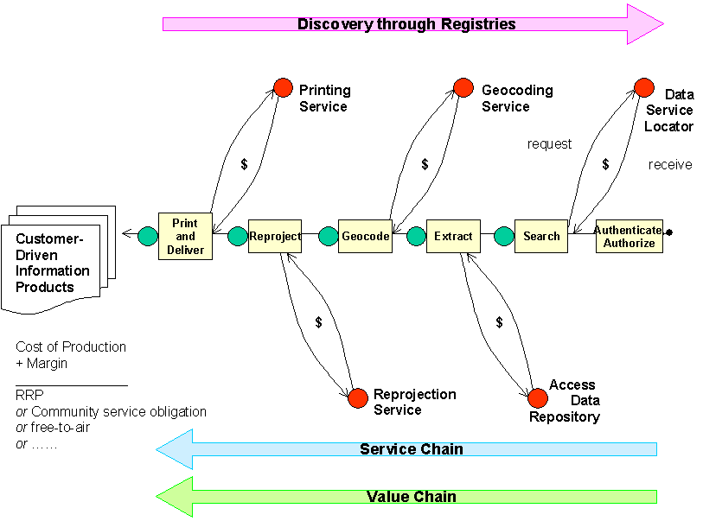
Figure V2-14: Representative Service and Value Chaining Concept
Services are cascaded, or chained, to meet user-specified requirements. Services support discovery, access control, accounting, processing and portrayal. Each service adds value to the product and bears an associated cost that contributes to the overall cost of production of the requested product(s). Such costs may or may not be passed onto product requesters, according to service policy.

  - Justification for Approach
The proposal does not start from scratch but builds existing systems already delivering products, services and business outcomes, and can be used or adapted to provide implementation of elements within the components-based architecture. This then will help deliver the outcomes.
This proposed approach therefore provides:
- A framework for the development of a web services master plan derived through an inclusive and consensus based process;
- Procedures for aligning business process requirements against components and services;
- A process for progressively filling service requirements as needed;
- A guiding framework within which users can describe their requirements through a mutually understood process;
- A method for modeling supply/value chain definitions to assess the impact of pricing of data and processing services on the cost-of-production of products rather than cost recovery of past decisions;
- Means for accumulating benefits through re-use of data and processing functionality and
- Examples of the way in which accessibility of custodial data, data of known provenance, with an accumulating history of use (fitness for purpose) would impact current practices and costs.
- Enterprise Viewpoint
The vision of SIDP is to demonstrate how Web Agents discover, view and obtain desired spatial information services for a particular part of the state or country, without needing to know the details of how the data are stored and maintained by independent organizations.
Other Portal Service can co-exist to provide additional functionality or more specialized views of the information because these providers support standardized protocols for accessing their services. Indeed, interfaces could run at multiple sites in order to provide redundancy, allow for fail-over and avoid bottlenecks at a single location.
Web Agents should be able to provide views of detailed standards-based documentation about the data service products and their provenances if desired.
The Enterprise Viewpoint seeks to portray how implementation of the notional architecture will achieve results relevant to the SIDP users’ business enterprises.
  - Strategic Enterprise Results Sought
The SIDP notional architecture seeks to be:
- Focused on user-driven product, process and service, not data;
- Institution neutral
- i.e. support a distributed, decentralized community of peer providers of services
- Technology neutral
- Content Neutral
- Support open, accessible standards
- Not prescribe any particular hardware, software or network products
- Vendor neutral
And upon implementation will:
- Demonstrate efficiencies in spatial information servicing;
- Align with the Australian national Spatial Data Infrastructure;
- Provide services that are secure, accountable, auditable
- Provide services to decision makers in communities, commercial bodies
- Not just GIS specialists
- Not just generate map products
- Provide answers to “yes/no” questions
- Provide answers to “How much?”, “How many?” and “When?” questions
- Be flexible and extensible
- Provide the potential to interoperate with other domains e.g. commercial, legal, health etc.
- Provide flexible technical entry points able to reach ‘up’ and ‘down’ along the continuum of technical capability and expertise.
Implementation towards the SIDP notional architecture would be achieved by:
Using an approach based on deployment of independent light-weight components rather than single, monolithic systems
- Progressive, incremental inclusion
- Use of standards-based off-the-shelf components
- Commercial products,
- Open source applications
- Freeware
- We hold that there are existing systems that have value. This does not preclude different future systems with different values. Where existing value is of relevance to SIDP it to be preserved and enhanced and not diminished.
- Existing services represent required business practices and opportunities for the creation of adapters which will extend the utility of the services
- Therefore considered ‘black box’, not to be tampered with
- Therefore add wrappers, middleware for open interfaces
These implementations will then support web services accessible by that are:
- Bi-directional and interactive
- Transactional and message-based
- Current batch downloads still constitute a transactional deliver
- Allow for small data volumes, high recurrence as well as high data volumes
- Service integrators, not just data exchangers
  - Enterprise Method
Use the methodology elaborated in the OGC Open Reference Model
- ISO 10746, Information technology -- Open Distributed Processing
Use OGC specifications
- Web Map Service,
- Web Feature Service,
- Catalog Service, for the Web
- Web Coverage Service
Please note that the current OGC OWS 2.0 Interoperability Initiative is defining SOAP wrappers for the WFS and WCS interfaces as well as WSDL bindings for WMS, WFS, and WCS. Use of SOAP and WSDL will make it much easier to integrate these OGC standards into Enterprise web services implementations.
Use other, complementary existing standards
- OASIS, W3C, IETF and ISO.
Section “Error: Reference source not found” provides instances where these standards and specifications are being implemented to meet enterprise requirements.
  - Enterprise Standards
Definition of the notional architecture is underpinned by three broad classes of standards, defined by policy and by functionality rather than by the nature of the real-world quantities represented by the information.
Relevant standards derive from the OpenGIS Consortium, ISO, W3C, the Motion Picture Expert Group, IETF and others
These are:
- Information Classes pertaining to geographic information
- Geospatial Information Formats
- Management and Control Data types
These are elaborated below.
  - Business Processes
Business processes are considered from two perspectives: business tasks and the instruments used to carry them out.
This section considers only the logical requirements of the enterprise viewpoint and does not yet identify the components required to meet them – that happens in Computational Viewpoint section.
    - Executing Business Management Tasks
Determining how to manage SIDP scenario definition and implementation according to the notional architecture will require considering how to achieve:
- Executing business management tasks, however they are defined;
- Identifying the business instruments needed to carry them out, and
- Determining the characteristics of agents, tasks and tools that govern their application.
Business tasks are realized as services that embody business rules. Services are, themselves, resources within SIDP Platform environment and require management.
Referring to Figure V2-15 it can be seen that a given task may call upon one or more services (these services of course, in the SIDP context) being available in the distributed web environment. A single service may be invoked in the course of many different business tasks (for example, discovery services are a common element in the majority of business tasks).
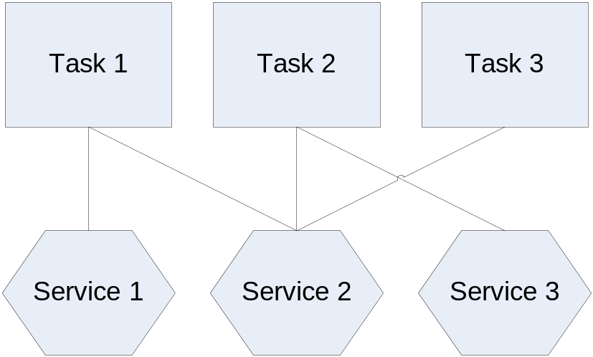
Figure V2-15: Business tasks and service
Business tasks are carried out using services. A single task may use one or more services. A given service may be used to carry out many tasks.
The high-level tasks envisaged for SIDP are represented in Figure V2-16 below.
The information viewpoint of the SIDP notional architecture will consider the types of information that will need to be characterized and the instruments needed.
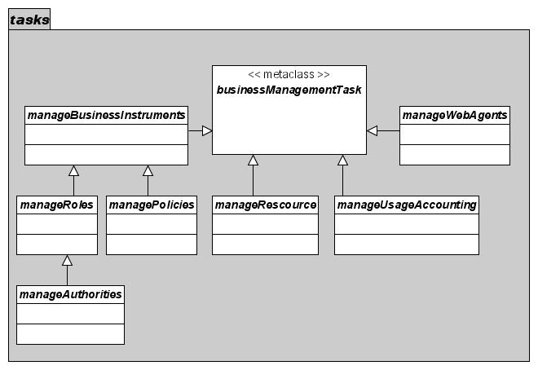
Figure V2-16: SIDP Business Management Tasks
Business management tasks require operational services before they can be performed. Tasks apply to managing resources (services and content), to managing the business instruments (authorities, roles and policies) needed to manage resources, to managing of agents and the managing of service usage accounting.
Business tasks are governed through application of business instruments, shown in Figure V2-17. The instruments required for SIDP are policies governing resource usage and authorities governing agents’ actions; agents act in assigned roles as collections of authorities.
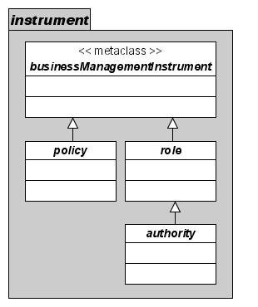
Figure V2-17: SIDP Business management Instruments
Business management instruments enable governing of platform resources (contents and services) and agents. Agents act in roles i.e. defined packages of authorities. Resources are used according to defined policies.
  - Best Practices
The remit of this activity covers the technical and institutional capabilities that can be envisaged as the “context” for the SIDP. It is recognized that only a fraction of the issues raised in these documents will be addressed. However, the value of the demonstrators is that they will illustrate the fundamental tenets of the model and the standards and specifications detailed. This will allow others to expand on the ideas and options for implementation to stimulate the spatial industry and its market in Australia.
Inevitably, the cross-governmental and cross-sectoral nature of the SIDP vision impinges on other agencies and social sectors, and raises matters of policy, coordination and procedure that lie beyond the terms of reference.
However, we can note that a number of existing spatial data infrastructures are already operating at international, regional, national and sub-national levels. They share the common characteristics with the envisaged SIDP such as:
- Open standards web service implementation
- Content collected once, used many times
- Distributed, custodial management of services and content
- Transaction-based interactive relationships between user agents and services.
- Collaborative web-based GIS and online lodgment e.g. LandXML
- Data extraction and delivery e.g. GML
- Modeling services invocation
- Authority-based access by Web Agents to policy-constrained services.
In short, each embodies at least some of the capabilities sought for SIDP. As such they provide valuable practical references demonstrating the state of practice of OpenGIS web services, and the promise of SIDP.
    - Adherence to OpenGIS standards
Numerous spatial infrastructure initiatives have been afoot since the OGC’s initiation in 1994. These have often been based upon pre-existing standards at the communications (e.g. z39.50 [12]), content (e.g. FGDC CSDGM) and institutional (e.g. GILS) levels.
These and subsequent activities have sought to foster:
- Interoperation with partner sites acting as custodial hosts without replication of data and metadata;
- Use of the web as a standard dissemination tool, either directly through http-based services or through adaptors to pre-existing protocols and standards;
- Incremental implementation based on national and international collaboration, such as the progressive rollout and registration of FGDC-compliant metadata sites accessed in the US NDSI.
    - State of Implementation
Note that many of these services are constrained by the current state of specification and/or implementation of OpenGIS services – for example, registry services as modeled in the recently approved OGC Catalogue Standard 2.0; federated registries; and web feature service streaming GML 3.0 to standard browsers or other applications. However, the expectation is uniformly that these constraints will lift with time.
The emerging use of GML for content delivery by major providers such as Ordnance Survey UK, the US Census, and the Canadian Geobase is heartening since it will drive commercial providers towards incorporating appropriate interfaces in future product releases.
GML-based content transfer between SIDP scenario processes and services should proceed. Rendering to portrayal services at the Interface Services layer can be accommodated via styled layer descriptors and the WFS features of many existing map servers. COTS and Open Source products for facilitating data format conversions through common GML intermediate forms exist in the market.
Meanwhile, using GML as the transfer standard will standardize developers programming requirements and, in short order, yield a suite of standard interface packages to be used with arbitrary processes. Most of these transfers will occur below the level of User Interface applications. Rendering data from GML to acceptable forms such as shapefiles can occur as a component of the Data Services package. A further review of best practices available in Volume 4 - Appendices.

Table V2-4: References to Best Practice Models
 | Sponsor and Capability | URL | Implements
- Compusult Ltd (Canada) | Commercial developer  WFS Gazetteer prototype  Stateless catalogue prototype | http://ogc.compusult.nf.ca/OGC/gaz_get_search.html  http://ogc.compusult.nf.ca/OWS/demo/index.html | WFS Gazetteer
- Data Discovery Facility SDDF (South Africa) | National Spatial Information Framework – distributed custodial metadata search and discovery | http://www.nsif.org.za/ncgi | OCS
- Geobase (Canada) | Canadian Spatial Data Infrastructure  spatial data download (map, coverage) | http://www.geobase.ca/ | OCS,  GML delivery, WMS
- GeoConnections Discovery Portal (Canada) | Canadian Spatial Data Infrastructure  distributed metadata discovery, map services, gazetteer service | http://geodiscover.cgdi.gov.ca/gdp/index.jsp | OCS, WMS
- Geodaten-online (Germany) | North Rhine/ Westphalia Pilot Project (OGCE)  e-business pricing models | http://www.geodaten-online.de/ | EbXML,  OASIS PKI,  OCS
- Geonetwork  (UN) | Food and Agriculture Organization FAO  distributed metadata discovery, map services | http://www.fao.org/geonetwork/srv/en/main.search | OCS, WMS
- Geospatial One-Stop Portal GOS-P (USA) | US Government  distributed metadata discovery, map services | http://www.geo-one-stop.gov/ http://www.geodata.gov/ | OCS, WMS
- Gestor de Dades Territorials Distribuides (Cataloña, Spain) | IDEC  distributed metadata discovery, map services | http://www.geoportal-idec.net/geoportal/IDECServlet?idioma=eng | OCS, WMS, WFS
- Geo-Informatic GeoPortal Startup Service (Netherlands) | North Rhine/ Westphalia Pilot Project (OGCE)  e-business pricing models | http://www.ncgi.nl/ncgi | EbXML,  OASIS PKI,  OCS (pending)
- Gigateway Service  (UK) | Association for Geographic Information AGI  distributed metadata discovery, map services | http://www.gigateway.org/default.html | Federated OCS
- IndustryLands  (Australia) | Homer Systems, Inc.  online lodgment, collaborative GIS via Web, OSS database-driven GIS | http://iplan.australis.net.au/landview.php | WMS,  WFS (pending),  PostGRESQL open-source database
- Interactive Highway Safety Design Model (USA) | Federal Highway Administration (FHWA) – 2-lane highway modeling based on XML definition | http://216.161.62.248/ihsdm_public/index.html | LandXML
- LandOnline e-Survey  (New Zealand) | Land Information New Zealand's electronic database of land title and survey information  online lodgment of survey data | http://www.landonline.govt.nz/info/esurvey_answers.htm | LandXML
- Natural Resources Data Directory NRDD (Australia) | Community Access to Natural Resource Information CANRI (NSW, Australia)  distributed metadata discovery, web mapping, web feature services | http://www.canri.nsw.gov.au/nrdd | OCS,  WMS,  WFS (pending)
- Ordnance Survey  (UK) | Spatial data download (map, coverage) | http://www.ordnancesurvey.co.uk/oswebsite/ | OCS,  GML delivery
- Terraserver.com  (USA) | Commercial subscription service  image serving WMS, dynamic reprojections, gazetteer service | http://terraserver-usa.com/webservices.aspx | OCS,  WMS,  WFS Gazetteer
- UNEPnet (UN) | UN Environment Programme  distributed metadata discovery, web mapping | http://www.unepnet.org/ | OCS,  WMS
- USGS FGDC Clearinghouse  (USA) | US Government  distributed metadata discovery | http://fgdclearhs.er.usgs.gov/ | OCS,  WMS
- US Census Web/TIGER  (USA) | US Government  online lodgments trial | http://aries.geo.census.gov/WebTIGER/tigergml.html | WFS lodgment, GML delivery
- US National Map | US Government National Map access as part of Homeland Security | http://nmviewogc.cr.usgs.gov/viewer.htm | OGC WMS

- Information Viewpoint
The information viewpoint is used to specify the meaning of the information stored with and manipulated by the SIDP community, independently of the actual distribution within the community. It describes basic information building blocks and defines classes of information for the platform. It then enumerates various encodings, formats, and languages of relevance.
A subset of the information viewpoint includes the model and schemas for modeling spatial data being access and manipulated.
  - Strategic Information Results Sought
Implementing SIDP according to consideration of the information viewpoint should influence business by:
- Clarifying the nature of (and removing ambiguity concerning) information entities, implemented according to the notional architecture, required to be accommodated are;
- Providing a current and future framework for extending the products and application services provided through SIDP, especially when integrating services provided by custodians not traditionally associated with the GIS community;
- Reduce the requirement for licensing proprietary products, such as GIS systems, as the sole and default means for acquiring access to products and services;
- Extend the reach and accessibility of private sector and government services by opening low cost opportunities for providing services to arbitrary Web Agents with no other tools than a free web browser and an Internet connection.
The SIDP notional architecture proposes that these results are to be achieved by the following means:
- Utilizing the existing and future capabilities of the global internet
- Employing the “Publish-Find-Bind” method
- Employing the “Web Services and Agents” method.
These are elaborated in the following sections.
  - Business Management Results Sought
Considering SIDP from an information viewpoint should identify means for achieving business management results such as:
- Identifying means for achieving methods for managing resources, managing usage of the system, and accounting for its usage;
- Indicate where standard interfaces would need to be applied to existing systems, currently not conforming the notional architecture, in order to achieve these means.
  - Information Method
In considering methods for identifying the information requirements for SIDP, and their decomposition from the computational viewpoint, the following methods will apply:
- Predicate information services on the world-wide web;
- Base analysis on the Publish-Find-Bind method;
- Base analysis on the notion of Web Services and Web Agents.
    - The World Wide Web
The world-wide web is implemented using free, open-source specifications and protocols, and provides a ubiquitous means of interconnectivity not realized by other network specifications.
The WWW is defined by implementation specifications such as http, HTML, tcp/ip and XML.
The terms of references for SIDP notional architecture specify the WWW as the network method to apply.
    - Web Services and Web Agents
Web Agents and Web Services are the software elements that are able to actually able to conduct a dialogue over the Internet in order to deliver a service to a user.
It must be noted that the notion of ‘services’ in the context of the SIDP notional architecture is not merely that of any arbitrary facility that happens to have a presence on the web. It is a quite precise concept that is governed by the types of messages that a service is able to send and receive, the language structures used in those messages, and the network protocols used to convey them.
A more thorough discussion of web agents and services is provided in Volume 4 Appendix A-2.
For the SIDP notional architecture, all interactions that contribute to providing value to users are the results of the actions of services to which the user’s agent has bound.
All resources are required to be services in the context of the SIDP notional architecture.
    - The Publish-Find-Bind Model
Geo-information services operating in conjunction with SIDP will employ the “Publish, Find and Bind” model of web services interaction as used in OGC, OASIS, W3C, and grid computing communities.
The Publish-Bind-Find model is discussed in Volume 4 Appendix A-3.
The Publish-Find-Bind model is concerned largely with those aspects of service provision that impinge on interactions through Internet interfaces. In reality there are considerably more considerations involved between identifying an unmet user need and actually delivering a service that adds useful value for that user. The considerations are considered at some length in Volume 4 Appendix A-4.
  - Business management: Overview
Business management in the context of the SIDP platform devolves to executing management tasks to deploy management instruments in order to govern the resources and the agents that use them.
As represented in Figure V2-18 below, SIDP management tasks manipulate information governing of resources, user accounts, web agents and the management of business instruments (policies, authorities and roles) themselves.
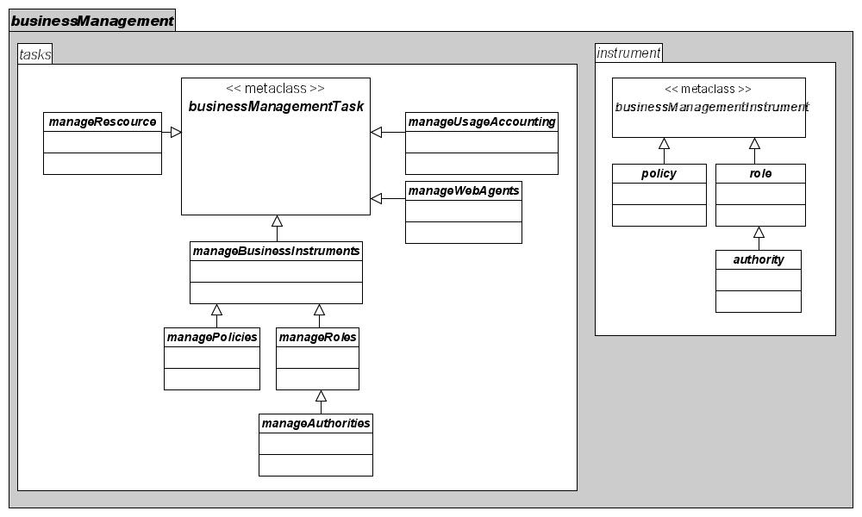
Figure V2-18: SIDP Business Management Overview
Business managers carry out tasks using instruments (policies, authorities and roles) to govern resources and agents.
The following sections elaborate on the information viewpoint perspectives on agents, resources and instruments.
    - Business Management: Agents
The SIDP portal platform must enable web agents to act upon resources.
Web agents, as depicted in Figure V2-19 below, can be recognized as many different types. Some, such as ‘thin clients’ (web browsers) directly represent human users. Others are local or remote autonomous processes. All transact communications over the Internet by exchanging query and response messages conforming to well-known formats.
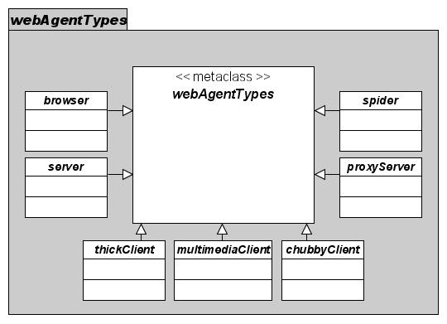
Figure V2-19: SIDP recognized Web Agent Types
Web agents are software processes that invoke service resources. Some, such as ‘thin client’ browsers, provide direct human interaction. Others are local or remote autonomous processes. Different types of agents have different capabilities are exchange differently formatted messages.
The nature of the agent dictates the type of message structure(s) that may validly be exchanged with services. For example, ‘thin client’ browsers require client generators to prepare the HTML describing the user interface and embodying the needed control functions (buttons, checklists etc.) by which people can indicate their requirements. On the other hand, a multimedia client may receive and process messages containing data formats that browsers are not equipped to deal with, while search ‘spider’ clients will receive messages encapsulating metadata describing the existence and location of resources.
    - Business Management: Resources
Resources comprise services and content to be used by authorized agents, shown in Figure V2-20. Services are software processes that act upon content. Content includes geo-data, metadata, symbologies, portrayal style definitions, accounting information, and definitions of user accounts, authorities and policies.
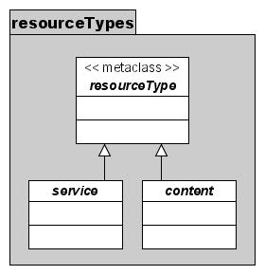
Figure V2-20: SIDP platform resource types
Resources comprise both services and content.
    - Business Management: Tasks and Instruments
The notional architecture must provide a framework within which services can be implemented to achieve business goals.
For the purposes of this analysis this is considered to indicate the information requirements for carrying out business tasks using toolkit of business instruments or tools.
Business Tasks are represented schematically in Figure V2-21 following.
All business tasks require repositories providing persistent standards-based storage of records describing agents, resources, user accounts and business instruments. These repositories comprise both registries (for discovery services) as well as datastores for dynamic records such as for user account management.
Some tasks are identified in the following sections in a generic sense. No attempt is made to suggest how, in detail, the tools should be implemented or how they would be assembled to provide task-oriented applications. On the other hand, tools or instruments are required to conform to the Web Services/ Web Agents concepts implemented according to the Publish-Find-Bind model.

Figure V2-21: Business Management Packages
Business management tasks require operational services before they can be performed. Tasks apply to both the management of resources (services and content) and to the management of the instruments (authorities, roles and policies) needed to manage resources.
    - Overview: Tasks
The SIDP platform must, in the ultimate analysis, enable Web Agents to access the Web Service resources needed to create useful products.
Business tasks are required for managing the business instruments as well as the business resources.
Required business management tasks are considered to be:
- Managing the authorities by which agents gain access to services;
- Managing the policies that govern access to resource;
- Managing the resources accessible via web services, including the policies that govern their invocation;
- Managing the roles that govern the authorities of collections of agents;
- Managing Usage Accounting;
- Managing web agents, including their authorities;
- Authenticating users and their agents, and
- Accounting of use of services by users and their agents.
    - Overview: Instruments
Business management instruments are needed to perform the tasks of managing Web Agents and resources, and to account for the use of resources by Web Agents.
The primary tools identified are:
- Role, the operational context of an agent;
- Authority, governing the legitimacy of an agent enacting a certain role to invoke a service, and
- Policy, by which a service is legitimately invoked by an authenticated agent carrying out a recognized role.
    - Authority
Authorities are defined and assigned to individual Web Agents (browsers, server, proxies, servers and other clients).
Authorities provide the rules of context by which each agent may seek to invoke services. Agents’ authorities must align with the policies governing use of the sought resource(s).
Plausible authorities are represented in Figure V2-22 below.
Authorities are assigned to agents according to their identity and collections of authorities enable agents to act in defined roles.
Authorities must themselves me managed, hence agents acting in management roles require meta-authorities governing how management agents may create, modify and destroy the authorities to be assigned to other resources.
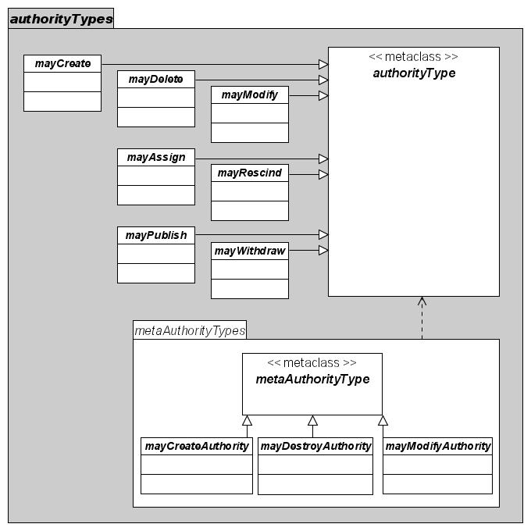
Figure V2-22: Indicative Authority Types
Authority types govern both the management of resources and the management of authorities to manage resources (meta-authorities). The figure indicates examples of authorities but is not definitive.
    - Policy
Policies are defined and assigned to individual Resources (data sets, processes and services).
Policies govern the contexts under which authorized or authenticated Web Agents may invoke them.
A resource’s usage policy must be consistent with a requesting agent’s authorities in order for the resource to be used.
Plausible policy types are portrayed in the Figure V2-23 below. These are merely indicative, not definitive, given that the universe of possible policies is so extensive. However, the figure illustrates how policies may variously depend upon:
- The identity of the requesting agent (for example, perhaps school children or people in developing countries have free access while other users are charged);
- The volume of data processed or accessed (for example, perhaps the first megabyte is free and subsequent megabytes charged for);
- Thresholds being exceeded, perhaps the number of accesses in a given period of time, or the number of different data sets being accessed;
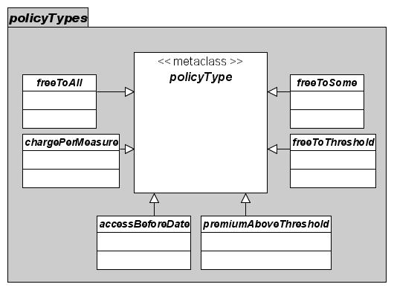
Figure V2-23: Indicative Policy Types
Policy types govern agents’ access to resources, assuming that the agents’ bear sufficient authorities. The figure indicates examples of authorities but is not definitive.
- Windows of validity of the resource, such as emergency response data representing volatile situations where stale data could cost lives.
No doubt the reader will have already anticipated other obvious and necessary policies, however, we reckon these are representative, for starters.
    - Role
Web Agents act, according to their identity, in Roles that aggregate of authorities that are frequently co-assigned to equivalent actors.
A Role encompasses the Authorities with which a Web Agent may act. Roles apply to remote automated processes as well as people interacting through a generated client.
All Web Agents are assigned a role.
Unidentified (hence unauthenticated) Web Agents have the default role “guest” assigned to them.
Plausible roles may include:
- Accounter manages the reporting of service utilization, including billing.
- Authorizer may assign a role to a user, an authority to a role, a policy to a resource, or may modify, withdraw or delete these authorities
- Creator may establish a new user, role, authority, policy or resource. Publisher is a subset of Creator
- Maintainer may modify resource content such as data sets in repositories, and the definitions and formats of portrayal services, but may not create or destroy these.
- Publisher establishes the Policy governing a Resource and authors the directory and registry entries regarding its use.
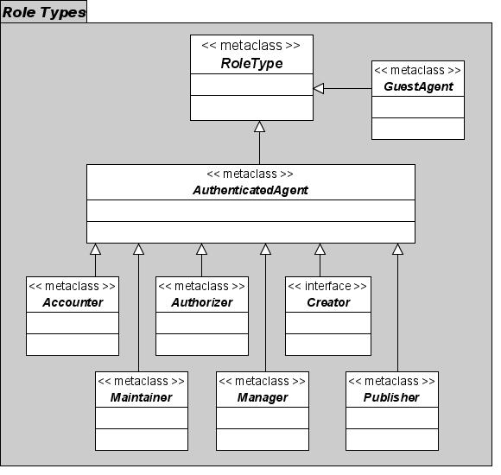
Figure V2-24: Indicative Role Types
Roles are implemented as standard packages of agents’ authorities. The figure indicates examples of role types but is not definitive. The specific authorities encapsulated by each role await designation.
  - Executing Business Management Tasks with Business Instruments
Business instruments enable resources and agents to be managed. The instruments are authorities for governing agents, policies for governing resources, and roles as collections of authorities. The instruments are elaborated in the following sections.
Figure V2-25: Business Management Instruments
Instruments enable governance of agents and resources. Authorities govern agents’ actions. Policies govern resource use. Roles are collections of authorities.
The discussion below refers to the figure above:
    - Managing Authorities and Roles
Authorities govern agents’ actions. According to agents’ identity they are assigned to roles which encapsulate groups of like-needed authorities.
Authorities are defined and assigned to individual Web Agents enabling them become ServiceUsers i.e. to use services and processes to create products, and, if identified and authenticated to carry out Resource Management and Web Agent Management tasks.
Authorities also encompass meta-authorities i.e. the authority by which Web Agents may be used to manage the authorities of other Web Agents
The ServiceUser role of “guest” has the most limited authority.
Plausible authorities may include:
- mayCreate a new Policy, Authority, Role, Authorized User, service, process or repository; ; this includes defining the cost of use for Authorised web agents.
- mayDelete a Policy, Authority, Role, Authorized User, Service, process or repository
- mayModify a Policy regarding a Service, an Authority regarding a Role, or a Role regarding a User, or the metadata regarding a Resource; this includes defining the cost of use for Authorised web agents.
- mayAssign an Authority to a Role or a Policy to a Service
- mayRescind an assigned Authority to a Role or a Policy to a Service
- mayPublish the metadata for a Resource
- mayWithdraw the metadata for a Resource.
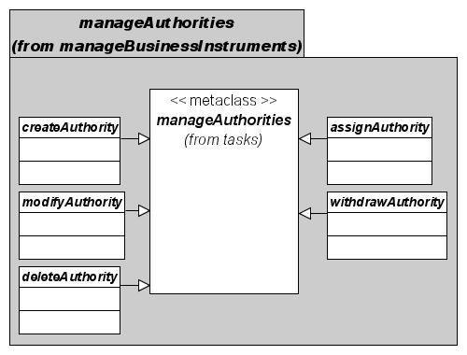
Figure V2-26: Managing Authorities
Authorities govern agent actions. Authorized management agents create, modify and delete authorities, and assign them to agents.
SIDP is to employ role-based agent management. Roles are collections of authorities assigned to agents based on their identity. Authorized management agents manage roles.
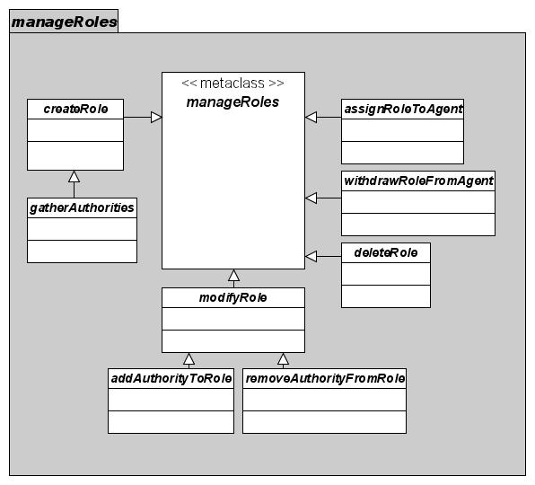
Figure V2-27: SIDP Role Management
Roles are collections of authorities governing agent actions. Roles are assigned to agents based on their identity. Authorized management agents create roles, modify them by gathering and removing authorities, and assign roles them to agents.
    - Managing Policies
Managing policies means providing for their creation and modification, and assignment to resources so allowing their appropriate use.
Policies need to:
- Be created, modified, maintained;
- Be assigned or retracted, and
- Be assigned to particular resources
All SIDP accessible services are governed by policies determining their interaction with authorized or authenticated web agents.
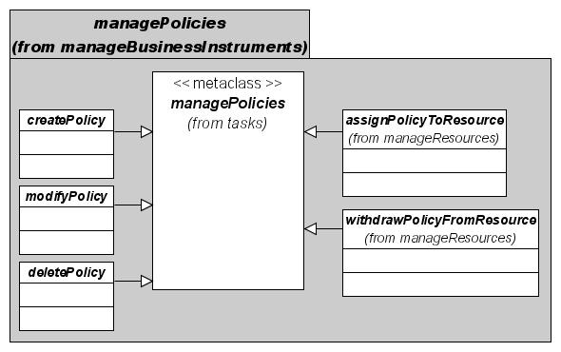
Figure V2-28: Managing Policies
Policies govern resource use. Authorized management agents create, modify and delete policies, and assign them to resources.
    - Managing Resources
Resources are data, services and components that are published and underlie the creation of all useful products. Resources are presented to the Internet as web services.
Managing resources encompasses the need for controlling the availability and appropriate use of resources.
Managing resources requires that they be able to be:
- Created,
- Published,
- Described,
- Maintained,
- Modified,
- Retracted, and
- Have their governing policies assigned and maintained.
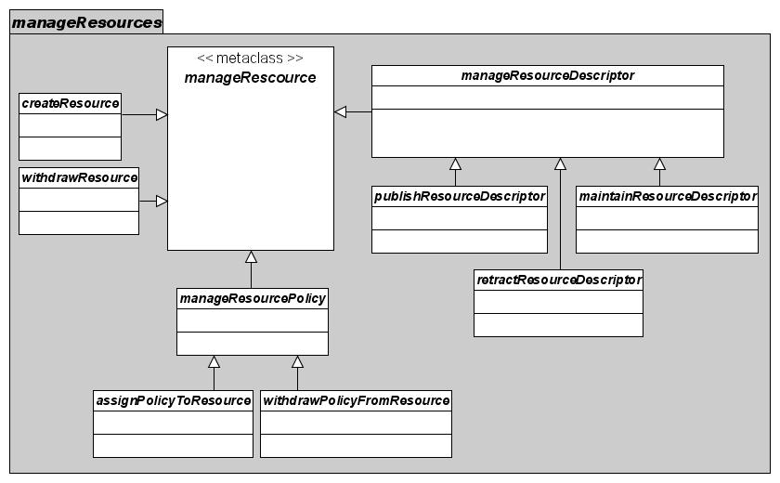
Figure V2-29: Managing Resources
The authorities for managing resources, including their publication are indicated. This is a reasonably complete set but not definitive.
    - Manage Usage Accounting
Usage accounting provides the infrastructure by which to track the extent of use of their resources by web agents. Service providers could determine their popularity, utility and directions for future development. Usage accounting may also underlie billing systems where required.
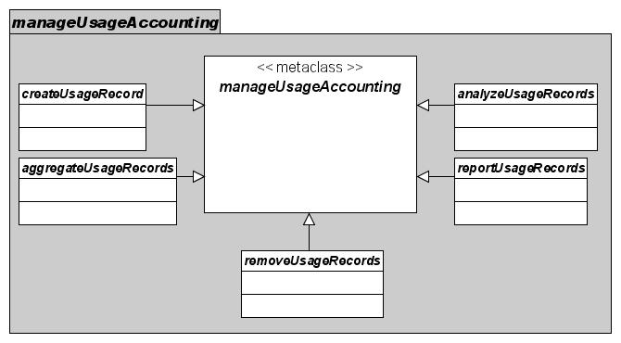
Figure V2-30: Managing Usage Accounting
Usage accounting forms the basis for utilization tracking, capacity planning, cost recovery and intrusion detection. Authorized management agents manage usage accounts. Authorities for managing usage records are indicated. This is a reasonably complete set but not definitive.
Usage accounting requires that usage records be:
- Created,
- Aggregated,
- Analyzed,
- Reported, and
- Removed.
    - Managing Web Agents
Managing web agents means providing for recognizing Web Agents and allowing their appropriate use of resources.
Web Agents need to:
- Have an Identity created, maintained or retracted
- Be assigned Roles to enact, or have them withdrawn, and
- Have their governing authorities created, assigned, modified, and rescinded.
All SIDP services are presented for interaction with web agents; this includes resource management and usage accounting.
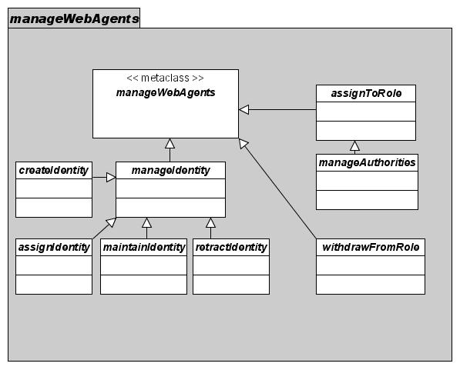
Figure V2-31: Types of Web Agents
Web agents exercise authorities to use resources according to their policies. Web agents require identity so as to be authenticated before exercising authority. They need also to be assigned roles encapsulating their authorities. The tasks for managing identities and authorities are indicated. This is a reasonably complete set but not definitive.
  - Characteristics of Agents, Tasks and Tools
Actualizing concepts such as agents, tasks and tools will require that they embody characteristics that are not transient but, rather, persist in a manner that enables them to be repeatedly and consistently applied across systems, space and time.
Designs for implementation of tasks and tools will need to account for and manage the following characteristics:
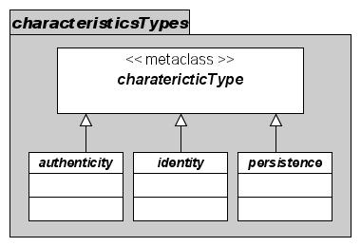
Figure V2-32: Characteristics of Agents, Tasks and Tools
Web agents and resources bear characteristics prior to be able to use or be used. The necessary characteristics are indicated.
    - Identity
Identity ensures the repeatable, unambiguous recognition of an individual User, Service or Process, and establishes the basis upon which Authenticity can be established.
Identity is persistent.
Anonymous Web Agents enacting the role of “guest” do not have identity.
    - Authenticity
Authenticity pertains to Web Agents who are recognized as identified i.e. their bona fides have been established and they are entitled to conduct themselves in one or more Roles.
Anonymous Web Agents enacting the role of “guest” do not have authenticity.
Authenticity is not persistent.
    - Persistence
Persistence is the characteristic of continued existence between service sessions. Persistent entities include:
- Data sets and repositories accessible for use by processes and services
- Process and service software delivering products
- Catalogues and registries supporting discovery
- User accounts and Context records of usage sessions
- Accounting records supporting usage accounting
Transient (non-persistent) entities include temporary output products such as html streams from client generators.
  - Roles and Authority to Use Instruments
User Agents, acting in a certain Role, is granted certain Authority to use certain Resources consistent with the Policy governing each resource.
Plausible User types might include:
- Accounter user has an Identity and a recognized Role granting Authority to view, process and publish usage accounting statistics, including disbursement of invoices to Authorized Web Agents for fee-based services used. Note that even free-to-air services may have an Accountant for resource usage and capacity planning reporting
- Creator user has an Identity and a recognized Role granting Authority to establish and remove new resources, policies, authorities and roles.
- Guest has no Identity, a Role of ‘guest’ and only the minimal Authority necessary to invoke services with policy ‘freeToAll.
- Manager user has an Identity and a recognized Role granting Authority to establish, modify, assign and rescind policies regarding resources.
- Maintainer user has an Identity and a recognized Role granting Authority to modify (though not create or destroy) content of resources and their metadata.
- Publisher user has an Identity and a recognized Role granting Authority to define, modify or rescind Policy regarding resources.
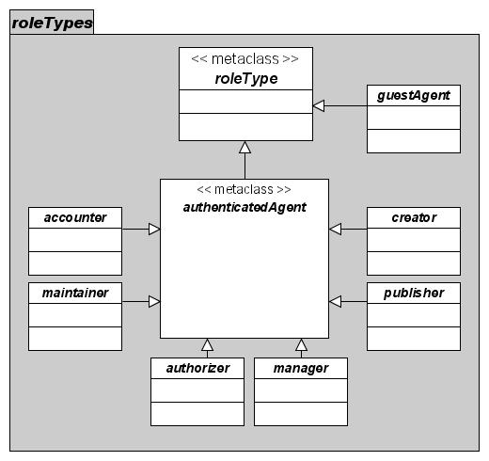
Figure V2-33: User Web Agent Roles
A web agent, once authenticated, exercises authority according to a designated role persistent for a given set of interactions. An unauthenticated agent exercises a limited set of authorities as a guest. The necessary role types are indicated.
  - Geospatial Information Model

The details of how to express a geospatial information model can be found in the OGC Reference Model (ORM – see discussion in 6.9) Rather then copy the contents of the ORM into this document, the reader is therefore refered to the OGC website for access to the Orm.

However, by way of illustration from the ORM:
The starting point for modeling of geographic information is the geographic feature. A feature is an abstraction of a real world phenomenon. A geographic feature is a feature associated with a location relative to the Earth. A digital representation of the real world can be thought of as a set of features.
Geographic features occur at two levels: feature instances and feature types (See Error: Reference source not found). At the instance level, a geographic feature is represented as a discrete phenomenon that is associated with its geographic and temporal coordinates. These individual feature instances are grouped into classes with common characteristics — feature types. Geographic information is subjectively perceived and its content depends upon the needs of particular applications. The needs of particular applications determine the way instances are grouped into types within a particular classification scheme.
  - Relevant OGC Specifications
The SIDP Information Viewpoint as described to this point is based on a superset of the output of OGC activities to date and includes concepts described in the draft OpenGIS Reference Model.
The OpenGIS Reference Model (ORM) provides an architecture framework for the ongoing work of the OGC. Further, the ORM provides a framework for the OGC Technical Baseline. The OGC Technical Baseline consists of the currently approved OpenGIS® Specifications as well as for a number of candidate specifications that are currently in progress.
The ORM has the following purposes:
- Provides a foundation for coordination and understanding (both internal and external to OGC) of ongoing OGC activities and the Technical Baseline;
- Update/Replacement of parts of the 1998 OpenGIS Guide;
- Describes the OGC requirements baseline for geospatial interoperability;
- Describes the OGC architecture framework through a series of non-overlapping viewpoints: including existing and future elements;
- Regularize the development of domain-specific interoperability architectures by providing examples.
The ORM is a living document that will be revised on a regular basis to continually and accurately reflect the ongoing work of the Consortium.

Thus, the OpenGIS Reference Model establishes the baseline of common interfaces, exchange protocols, and services that have been developed or adopted by the OGC community and describes a framework that can be profiled for use in application domains like SIDP.
OpenGIS Implementation Specifications provide guidance to application developers on how to build their products to comply with this framework.
OpenGIS Services are implementations of services that conform to OpenGIS Implementation Specifications.
OpenGIS Applications are compliant applications that can "plug into" the network of OpenGIS Services. SIDP is an example of an OpenGIS Applications.
SIDP-enabled geo-information services will employ the “Publish, Find and Bind” model of service interaction (see Volume 4 Appendix A3) as used in OGC, OASIS, W3C, and grid computing communities.
SIDP Standards pertain to Framework Data, Services and Metadata. These are summarized schematically in the following sections.
    - Framework Data Standards
Seven plausible geospatial data themes may be considered to be of fundamental importance to many applications i.e. "Framework Data”:
- Elevation (topography),
- Orthoimagery,
- Hydrography (including a standard coastline),
- Transportation,
- Government Units (administrative boundaries),
- Cadastral (property boundaries), and
- Geodetic Control.
Data sources to be classified as Framework Data shall, at minimum, are able to exchange data in a manner that complies with these emerging standards. SIDP shall be able to access both Framework Data sources and other, non-Framework data.
    - Service Specifications
Access to data and maps will be provided according to open consensus standards and specifications. For example:
- OGC Web Map Service [35]
- OGC Web Feature Service [34], and
- OGC Web Coverage Service [33]
These define methods for requesting data via the web in the geographic area of interest. Some organizations will offer only a Map service, while others will also offer Feature or Coverage services. Ongoing OGC developments envisage Web Terrain Services [39].
    - Metadata Standards
Metadata shall be published that provides detailed information about data and services. In particular, data will be documented according to:
- ISO 19115 Geographic Information – Metadata [8]
- ISO 19139 Metadata Implementation Standard [10]
- ANZLIC metadata standard (ANZLIC MDS) [1] and/or
- FGDC Content Standard for Digital Geospatial Metadata (CSDGM) [2].
Access to the metadata is through services such as the OpenGIS Catalog Service [22]. There will likely be other portals that access these metadata, and multiple services that maintain their own metadata registries. At present, communication amongst metadata repositories is mediated by the z39.50/ ISO 23950 protocol [12]. Ongoing OGC developments envisage OpenGIS Catalog Services and OpenGIS Web Registry Services [37].
    - Information Viewpoint - Expanded
Three broad classes, defined by policy and by functionality rather than by the nature of the real-world quantities represented by the information. These are:
- Information Classes pertaining to geographic information
- Geospatial Information Formats
- Management and Control Data types
    - Information Classes
      - Primary Information
Must comply with the three basic requirements described above at the end of the Enterprise Viewpoint:
- The information complies with Framework Data standards (or, possibly, the information belongs to some other defined relevant class of information).
- The information is accessible using the Service Specifications supported.
- The information has been documented according to the supported Metadata Standard.
Information is classified as "Framework Data" based on the providers’ implementation of policies, specifications and standards. In addition, specific types of non-Framework information of direct relevance may be defined.
Web Agents shall enable access to Primary Information without explicitly being required to perform a search.
      - Secondary Information
Must comply with two of the three basic requirements described above at the end of the Enterprise Viewpoint:
- The information is accessible using the Service Specifications supported.
- The information has been documented according to the supported Metadata Standard.
Secondary Information is that which (1) is available using OGC Web Service(s), and (2) has been documented with published metadata that includes reference(s) to one or more of OGC Web Services (i.e., WMS, WFS and WCS).
The facility is technically capable of discovering and then directly accessing the service, even though information has not been classified as Primary. Example: a WMS providing maps of soil types.
Web Agents will typically need to perform an explicit search in order to discover Secondary Information. The facility may provide some form of indication in the user interface that distinguishes Primary from Secondary Information.
      - Tertiary Information
Tertiary Information must comply with one of the three basic requirements described above at the end of the Enterprise Viewpoint:
The information has been documented according to the supported Metadata Standard.
Comprises metadata that has been created and published, but that is available only offline or through proprietary online services.
SIDP can discover Tertiary Information by searching metadata, but then can merely refer Web Agents to it (by displaying the metadata record) rather than performing a request on behalf of the user.
Example: a dataset that is available only by telephoning an individual and requesting a CD-ROM.
    - Information Formats
The Geo-spatial objects considered to be of relevance in the SIDP context include, for consideration:
- Geographic features,
- Geographic coverages,
- Geographic measurements,
- Spatial reference systems,
- Geographic transformations,
- Geographic projects,
- Geographic events,
- Map styles and symbologies, and
- Other representation systems.
The SIDP information viewpoint leaves, for later further elaboration, the descriptions as to where these entities currently repose and under which custodial authority.
      - Vector Data
Vector data is the class of data that represents point, line and polygon geospatial features. These data contains detailed geometry and attribute information about individual geospatial features. In the case of SIDP, the principal vector data will be those Framework Data themes that represent features (Hydrography, Transportation, Government Units, Cadastral, and Geodetic Control). Currently requirements are for 2D data, however, 3D data is also supported by the relevant specification.
The relevant specification is: GML Geography Markup Language [25]
Schemas for LandXML and LandGML are under consideration by OGC.
      - Coverage Data
Coverage data comprise gridded data, imagery, swath data, and continuous functions (e.g. digital terrain models). These data contain values for every point in a geospatial data grid.
The principal coverage data will be the Elevation and Orthoimagery Framework Data themes.
Relevant specifications include:
- GeoTIFF - Georeferenced Tagged-Image File Format
- HDF - Hierarchical Data Format
- SDTS - Spatial Data Transfer Standard
      - Maps
Maps are defined as visual portrayals of feature or coverage data--a map is a picture that can be readily viewed by a user. For purposes of SIDP, maps are considered a separate data class from imagery or coverage data and are typically the output from a WMS.
Relevant specifications for SIDP are:
- PNG - Portable Network Graphics
- GIF- Graphics Interchange Format
- JPEG- Joint Photographic Expert Group format (including JPEG2000)
      - Management and Control Data
- Data Metadata
Data Metadata is metadata that describes data holdings. The relevant specifications are:
- ANZLIC metadata profile
- CSDGM - FGDC Content Standard for Digital Geospatial Metadata
- ISO 19115 [8]
Note: the specification ANZLIC is expected to define a profile for "ISO 19115 Geographic Information - Metadata" in the near future.
- Service Metadata
Service Metadata is metadata that describes services. Relevant specifications for SIDP Metadata include (but are not limited to):
- WMS - OGC Web Map Service - Capabilities XML [35]
- WFS - OGC Web Feature Service - Capabilities XML [34]
- WCS - OGC Web Coverage Service - Capabilities XML [33]
- Gazetteer Data
Gazetteer data describe the location coordinates (and possibly extent) of named places and features. SIDP may use the existing gazetteer data for point location coordinated. Relevant specifications are:
WFS – OGC OpenGIS Web Feature Server (WFS) Implementation Specification, version 1.0 [35]
- Query Languages
Most of the services used in SIDP will present query interfaces for which client and server have a common understanding of what constitutes a valid query. Standardized query languages provide the common vocabulary and grammar needed to enable this interoperability.
Relevant specifications for SIDP Query Languages are:
- OGC Catalog Service [22]
- OGC Web Map Service - GetFeatureInfo operation [35]
- OGC Filter Encoding Specification [23]
- OGC WFS Gazetteer Service [34]
- Styling Description Languages
Some Web Map Service implementations provide Web Agents with the ability to customize the symbolization of the data they are requesting. In order to work across all such WMS implementations, there must be a standard way of expressing the desired symbolization.
Standardized styling description languages address this expression requirement.
Relevant specifications for the SIDP styling description languages are:
- SLD - OGC Styled Layer Descriptor [31]
    - OGC Emergency Services Symbology
The Emergency Mapping Symbology Interoperability Program Initiative was an OGC testbed initiative focusing on maturing the Style Management Service (SMS) and the Styled Layer Descriptor (SLD) with application to Emergency Mapping Symbology. The project tested enabling the use of multiple symbol sets with one set of feature data. The symbology used was come from the following:
- Emergency Response Map Symbology (ERMS) – a map symbology set being defined by the FGDC’s Homeland Security Work Group. See: http://www.fgdc.gov/publications/homeland.html
- Geospatial Symbols (GeoSym) for Digital Displays. The map symbology set defined by DOD to portray Vector Product Format (VPF)data. Reference TBD.
SMS is a service that was first described and demonstrated in the Open Web Services Phase 1.2 (OWS-1.2) test bed initiative. While SMS can be thought of as a type of service, it is in actuality a logical composition of design-patterns, service interfaces and encodings. As such, SMS defines architecture for enabling scalable and interoperable management of symbols and styles in support of cartographic portrayal processes.
- References
  - Bibliography
[1] | ANZLIC Metadata Guidelines (v2 – February 2001). Available at http://www.anzlic.org.au/download.html?oid=2358011755
[2] | FGDC-STD-001-1988, Content Standard for Digital Geospatial Metadata (version 2), US Federal Geographic Data Committee, http://www.fgdc.org/metadata/contstan.html
[3] | ISO 10746, Information technology -- Open Distributed Processing -- Reference model, see http://www.iso.ch/iso/en/ittf/PubliclyAvailableStandards/c020696e.zip for overview
[4] | ISO/PDTR 19103, Geographic Information – Conceptual Schema Language, see http://www.isotc211.org/pow.htm for a brief description.
[5] | ISO/CD 19107.3, Geographic Information - Spatial Schema, see http://www.isotc211.org/pow.htm for a brief description.
[6] | ISO 19108, Geographic Information - Temporal Schema, see http://www.isotc211.org/pow.htm for a brief description.
[7] | ISO/DIS 19109, Geographic Information – Rules for Application Schema, see http://www.isotc211.org/pow.htm for a brief description.
[8] | ISO/CD 19115 (ISO TC 211 N 1024, 2001-01-30) Geographic Information – Metadata, see http://www.isotc211.org/pow.htm for a brief description.
[9] | ISO 19118, Geographic Information – Encoding, see http://www.isotc211.org/pow.htm for a brief description.
[10] | ISO 19135, Geographic information -- Metadata -- Implementation specification; see http://www.iso.ch/iso/en/stdsdevelopment/techprog/workprog/TechnicalProgrammeProjectDetailPage.TechnicalProgrammeProjectDetail?csnumber=32557
[11] | ISO/CD 19119 (ISO TC 211 N 1044, 2001-01-29) Geographic Information – Services, see http://www.isotc211.org/pow.htm for a brief description.
[12] | ISO 23950 Information Retrieval (Z39.50): Application Service Definition and Protocol Specification, see http://lcweb.loc.gov/z3950/agency/document.html
[13] | OASIS ebXML see http://www.ebxml.org/
[14] | OASIS ebXML Registry Information Model v2.0 available at http://www.oasis-open.org/committees/regrep/documents/2.0/specs/ebrim.pdf
[15] | OASIS Public Key Infrastructure development, see http://www.pkiforum.org
[16] | OASIS SAML v1.0 specification set available at http://www.oasis-open.org/committees/download.php/2290/oasis-sstc-saml-1.0.zip
[17] | OASIS Universal Discovery Description and Integration see http://www.uddi.org/
[18] | OGC AS 1, The OpenGIS Abstract Specification Topic 5: OpenGIS Feature Geometry (ISO 19107 Spatial Schema), available at: http://www.opengis.org/techno/abstract.htm
[19] | OGC AS 2, The OpenGIS Abstract Specification Topic 2: Spatial Reference Systems, available at: http://www.opengis.org/techno/abstract.htm
[20] | OGC AS 5, The OpenGIS Abstract Specification Topic 5: OpenGIS Feature, available at: http://www.opengis.org/techno/abstract.htm
[21] | OGC AS 12, The OpenGIS Abstract Specification Topic 12: OpenGIS Service Architecture, available at: http://www.opengis.org/techno/abstract.htm
[22] | OpenGIS Catalog Services Implementation Specification, version 1.1.1, available at: http://www.opengis.org/techno/implementation.htm
[23] | OpenGIS Filter Encoding Implementation Specification, version 1.0, available at: http://www.opengis.org/techno/implementation.htm
[24] | OpenGIS Coordinate Transformation Services Implementation Specification, version 1.0, available at: http://www.opengis.org/techno/implementation.htm
[25] | OpenGIS Geography Markup Language (GML) Implementation Specification, version 3.0, available at: http://www.opengis.org/techno/implementation.htm
[26] | OpenGIS Reference Model (ORM), available at http://www.opengis.org/docs/03-040.pdf
[27] | OpenGIS Service Information Model (SIM) Discussion Paper, OGC document 03-026. Available at: http://www.opengis.org/info/discussion.htm
[28] | OpenGIS Simple Feature Specification for COM, version 1.1, available at: http://www.opengis.org/techno/implementation.htm
[29] | OpenGIS Simple Feature Specification for CORBA, version 1.0, available at: http://www.opengis.org/techno/implementation.htm
[30] | OpenGIS Simple Feature Specification for SQL, version 1.0, available at: http://www.opengis.org/techno/implementation.htm
[31] | OpenGIS Styled Layer Descriptor (SLD) Implementation Specification, version 1.0, available at: http://www.opengis.org/docs/02-070.pdf
[32] | OpenGIS Style Management Services Discussion Paper, OGC document 03-031. Available at: http://www.opengis.org/info/discussion.htm
[33] | OpenGIS Web Coverage Server (WCS) Implementation Specification, version 1.0 available at: http://www.opengis.org/docs/03-065r6.pdf
[34] | OpenGIS Web Feature Server (WFS) Implementation Specification, version 1.0, available at: http://www.opengis.org/docs/02-058.pdf
[35] | OpenGIS Web Mapping Server (WMS) Implementation Specification, version 1.1.1, available at: http://www.opengis.org/docs/01-068r2.pdf
[36] | OpenGIS Web Pricing and Ordering Service (WPOS) Discussion Paper version 0.2 Discussion Paper, available at: http://www.opengis.org/docs/02-039r1.pdf
[37] | OpenGIS Web Registry Service (WRS) Discussion Paper, version 0.0.2 at: http://www.opengis.org/docs/01-024r1.pdf
[38] | OpenGIS Web Services Architecture (OWS) Discussion Paper, available at: http://www.opengis.org/docs/03-025.pdf
[39] | OpenGIS Web Terrain Service (WTS) Request for Comment version 0.5 available at http://www.opengis.org/docs/03-081r2.pdf
[40] | OpenLDAP Foundation, see http://www.openldap.org/
[41] | World Wide Web Consortium Extensible Markup Language (XML) 1.0 available at http://www.w3.org/XML/Core/#Publications
[42] | World Wide Web Consortium Simple Object Access Protocol (SOAP) 1.1 available at http://www.w3.org/TR/SOAP/
[43] | World Wide Web Consortium Web Services Description Language (WSDL) 1.1 available at http://www.w3.org/TR/2001/NOTE-wsdl-20010315

  - Acronyms
ACXML | Access Control Extensible Markup Language (OASIS): see http://www.oasis-open.org/committees/tc_home.php?wg_abbrev=xacml
AGI | Association for Geographic Information (UK): see http://www.gigateway.org/
AGLS | Australian Government Locator System
ALGA | Australian Local Government Association: see http://www.alga.com.au/
ANZLIC | Australian New Zealand Land Information Council: see http://www.anzlic.org.au/
ASDD | Australian Spatial Data Directory: see http://asdd.ga.gov.au/asdd/
ASDI | Australian Spatial Data Infrastructure
ASIBA | Australian Spatial Industry Business Association: see http://www.asiba.com.au/
AUSLIG | Australian Survey and Land Information Group
BPR | Business Process Review (Queensland State Government)
CANRI | Community Access to Natural Resource Information (NSW) see http://www.canri.nsw.gov.au/
CMS | Cascading Map Server (OGC WMS)
COI | Community of Interest
COTS | Commercial off-the-shelf (software)
CQL | Common Catalogue Query Language (Library of Congress, USA): See http://www.loc.gov/z3950/agency/zing/cql/
CRC | Cooperative Research Centre (Australia): see https://www.crc.gov.au/
CSDGM | Content Standard for Digital Geospatial Metadata (FGDC, USA)
DACS | Distributed Access Control System: see http://dacs.dss.bc.ca/arch-spec.html
DES | Department of Emergency Services (Qld)
DIIE | Department of Innovation and the Information Economy (Qld): see http://www.iie.qld.gov.au/
DLGP | Department of Local Government and Planning (Qld): see http://www.dlgp.qld.gov.au/
DLI | Department of Land Information (Western Australia)
EbRIM | ebXML registry information model (OASIS): see http://www.ebxml.org/specs/ebRIM.pdf
EbXML | E-business Extensible Markup Language (OASIS): see http://www.ebxml.org/
EC | European Commission
e-GIF | E-Government Interoperability Framework
EPA | Environment Protection Agency (Qld)
EROS | Earth Resources Observation Systems (USA)
EU | European Union
FGDC | Federal Geographic Data Committee (USA): see http://www.fgdc.gov/
GA | Geosciences Australia (Australia Government): see http://www.ga.gov.au
GIA | Government Information Architecture (DIIE, Qld)
GIF | Graphic Interchange Format (Unisys)
GILS | Government Information Locator System (USA): see http://www.access.gpo.gov/su_docs/gils/
GINIE | Geographic Information in Europe (EC): see http://www.ec-gis.org/ginie/
GIS | Geographic Information System
GML | Geography Markup Language (OGC): see http://www.opengis.org/docs/02-023r4.pdf
GNIS | Geographic Name Information Service
GOS-P | Geo-spatial One-Stop Portal (US Government): see http://www.geo-one-stop.gov/
GSDI | Global Spatial Data Infrastructure
GSL | Government Services Locator
HDF | Hierarchical Data Format: see http://hdf.ncsa.uiuc.edu/
HTML | Hypertext Markup Language (W3C): see http://www.w3.org/MarkUp/
http | Hypertext Transport Protocol (W3C): see http://www.w3.org/Protocols/
IETF | Internet Engineering Task Force: see http://www.ietf.org/
IPA | Integrated Planning and Assessment (Qld)
SIDP | SIDP
ISCGM | International Standing Committee for Global Map http://www.iscgm.org/
ISO | International Organization for Standardization http://www.iso.org/
JPEG | Joint Photographic Expert Group format (including JPEG2000)
LandXML | An XML schema for land planning: see http://www.landxml.org/
LDAP | Lightweight Directory Access Protocol [40]: see http://www.openldap.org/
MIME | Multipurpose Internet Mail Extension (W3C)
NCSA | National Center for Supercomputing Applications
NIST | National Institute of Standards and Technology (USA): see http://www.nist.gov/
NR&M | Department of Natural Resources and Mines: see http://www.nrm.qld.gov.au/
NSDI | National Spatial Data Infrastructure initiatives
OASIS | Organization for the Advancement of Structured Information Standards: see http://www.oasis-open.org/who/
OCS | OpenGIS Catalog Services (OGC) [22]
OECD | Organization for Economic Cooperation and Development
OESR | Office of Economics and Statistical Research (Qld)
OGC | Open GIS Consortium (USA)
OgcRIM | OGC registry information model
OSI | Open Source Initiative
OSS | Open-source software
OWS | Open Web Service (OGC) [38]
PDA | Personal Digital Assistant
PKI | Public Key Infrastructure (NIST): see http://csrc.nist.gov/pki/
PNG | Portable Network Graphics (OGC) see http://www.w3.org/Graphics/PNG/
QIO | SIDP Information Office
QoS | Quality of Service
QPW | Department of Public Works (Qld): see http://www.publicworks.qld.gov.au/
QSIIC | Queensland Spatial Information Infrastructure Committee
SIDP | Queensland Spatial Information Infrastructure Strategy: see http://www.SIDP.qld.gov.au/
ROSI | Roster of Strategic Information (OESR, Qld)
SAML | Security Assertion Markup Language (OASIS) [16]
SCOTS | Standards-based Commercial Off The Shelf (software)
SDI | Spatial Data Infrastructure
SDTS | Spatial Data Transfer Standard (USGS): see http://mcmcweb.er.usgs.gov/sdts/
SFS | Simple Features Specification (OGC): see http://www.opengis.org/techno/specs/99-049.pdf
SII | Services Integration Infrastructure (Qld)
SLD | Styled Layer Descriptors (OGC): see http://ogc.cast.uark.edu/tnm/web/sld.html
SLIP | Shared Land Information Platform (DLI and WALIS, WA)
SOAP | Simple Object Access Protocol (W3C) [42]
SSQ | Smart Services Queensland
tcp/ip | Transport Control Protocol/ Internet Protocol (IETF)
TIFF | Tagged Image File Format: see http://home.earthlink.net/~ritter/tiff
UDDI | Universal Discovery Description and Integration (OASIS) [17]: see http://www.uddi.org/
UNEP | United Nations Environment Programme (Kenya): see http://www.unep.org/
UNGIWG | UN Geographic Information Working Group (USA): see http://www.ungiwg.org/
URI | Uniform Resource Indicator (W3C)
URL | Uniform Resource Locator (W3C)
USGS | US Geological Service (USA)
W3C | World-Wide Web Consortium: see http://www.w3.org
WALIS | Western Australian Land Information System: see http://www.walis.wa.gov.au/
WAP | Web Access Protocol
WCS | Web Coverage Service (OGC) [33]
WFS | Web Feature Service (OGC) [34]
WMS | Web Mapping Service (OGC) [35]
WPOS | OpenGIS Web Pricing and Ordering Service (OGC) [36]
WSDL | Web Services Description Language (W3C) [43] : see http://www.w3.org/TR/wsdl
XML | Extensible Markup Language (W3C) [41] : see http://www.w3.org/XML/

  - Glossary
Application | A program that performs a specific function directly for a user. Applications can make use of SDI.
Architecture | The organizational structure and operating environment of the SDI, including the relationships between its parts, and the principles and guidelines governing their design and evolution over time.
Binding | Specific syntax and parameter values used by a Client to invoke a specific Server Operation
Capabilities schema | XML schema that prescribes and constrains the syntax and vocabulary for the expression of service capabilities in XML.
Capabilities XML | Specific instance of service-level metadata describing a Service instance.
Catalogue | A registry that, in the SDI context, is usually used to describe spatial data sets.
Client | A software Component or an Application that accesses a Service.  Clients may be categorized in three ways:  Thin clients where the client supports only human-interface code, such as a web browser, an X-terminal, a text-only interface, a minimal PDA or WAP handset, and must support non-proprietary standards. Typically, lack long-tem memory such as disk drives. Application code and data access both run remotely, and so are entirely dependant on external network connection.  Thick clients where the client supports all the human interface and application code, may support some or all data access code, and may support long-term data memory. Human interface code may be entirely customized and not conform to non-proprietary standards. May not even support human interfaces i.e. may be entirely automated emote processes. May operate at times without network connection.  Chubby clients have capabilities somewhere on the spectrum between thick and thin clients i.e. may support some application and data code, and may store limited amounts of data. Will usually but not necessarily support human interfaces. May operate well for limited time without network connection.  A client may be any Web Agent or Web Service.
Component | Software that packages the Client or Server implementation of a Service and can provide the realization of a set of Interfaces. A component consists of software code (source, binary or executable) or other equivalents such as scripts or command files.
Conceptual Architecture | An overview of the Service, data, technology and institutional environment of SDI. It describes, in general terms, both what the SDI will include, and how it will operate.
Core Service | A Service that is critical to the ongoing operations of the SDI. The Error: Reference source not found service is an example of a core service. It is used to keep track of where SDI services can be found, so if this service were unavailable, client applications would not be able to locate the services required in order to complete a task.
Coverage | A continuous representation of a portion of the earth's surface. A coverage may be a collection of features (like a vector dataset) or it may be a raster or gridded surface representing one or more attributes.
Coverage Data | Gridded data, imagery, swath data, and continuous functions. Contains values for every point in a geospatial data. Relevant specifications for SIDP coverage data formats may include:  - SDTS - Spatial Data Transfer Standard  - GeoTIFF - Georeferenced Tagged-Image File Format  - HDF – Hierarchical Data Format
Custodian | The authoritative manager of an SDI resource, whether data set, Service or Component, who is responsible for declaration of the policies regarding utilization and accounting for the resource.
Datastore | Any type of persistent storage for SIDP components and data. Content may be static or dynamic.  May include database systems, file systems, structured text storage, XML repositories etc.
Event | An occurrence of interest to users or developers of the SDI. Events can be things such as the adjustment of a feature in a Framework Data layer, a flood, or the release of a new specification for an SDI Service.
Framework Data | The set of Geospatial Data that provides the reference framework for all other SDI compliant Geodata. See the SDI Framework Data Definition (http://www.geoconnections.org/opportunities/rfp/framework/rfp_sd_definition_E.pdf).  Seven geospatial data themes may be considered to be of fundamental importance to many applications. Known as "Framework Data," these themes are: Elevation, Orthoimagery, Hydrography, Transportation, Government Units (administrative boundaries), Cadastral (property boundaries), and Geodetic Control.  Framework Data shall, at minimum, are able to exchange data in a manner that complies with these emerging standards. SIDP shall be able to access both Framework Data sources and other, non-Framework data.
Gazetteer | A dictionary of geographical names. May encompass locations, cultural and landscape features, and may embody various naming conventions including official name, names in common usage, traditional and community-based names. Attributes of gazetteer entries may include geographic coordinates, extent and topology.  May be implemented through Error: Reference source not found for SDI applications such as user interfaces as well as support for Geocoding, Geoparsing and Geolinking services.
Geocoding | Associating geographic coordinate data with geographic names such as locations and addresses.
Geodata | Georeferenced spatial data such as a road network or a satellite image. Geodata explicitly describes the spatial extent of a set of features or describes a measurable surface. It includes both Geospatial Data and Geolinked Data.
Geodata Resource Registry | Peer registries that contain metadata about Geodata resources. These registries identify the agencies that are responsible each attribute dataset, and descriptions of that attribute data. They also contain information on how to access the data.
Geolinking | Associating non-spatial data with geographic coordinates via a reliable unambiguous attribute.
Geolinked Data | Geodata that are referenced to an identified set of geographic features without including the spatial description of those features. Geolinked data is normally attribute data in tabular data (such as population counts) that refers to a known framework (such as municipalities), where their unSIDPue identifier (such as the municipality name) refers to the elements (the municipalities). Geolinked data refers to all attribute data that is not directly attached and bundled with the geographic coordinates to which it applies.
Geoparsing | Analyzing textual content such as publications, database entries and text files for occurrences of geographic names, usually in preparation for their Geocoding.
Geospatial Data | Geodata with explicit geographic positioning information included, such as a road network from a GIS, or a georeferenced satellite image. Geospatial data may include attribute data that describes the features found in the dataset.
GeoTIFF | Georeferenced Tagged-Image File Format, an effort by over 160 different remote sensing, GIS, cartographic, and surveying related companies and organizations to establish a TIFF-based interchange format for georeferenced raster imagery. See http://remotesensing.org/geotiff/spec/geotiffhome.html
SIDP | The AusIndustry Interoperability Demonstration Project
Interface | The named set of related Operations that structure how a client interacts with a Server. The state and functionality of the underlying Component is hidden, and is only made externally accessible through its interface (i.e. the interface is the only "public" or "visible" part of the component). The same interface may be provided by several components and used by many components or Application.
LandXML | Facilitates the exchange of data created during the Land Planning, Civil Engineering and Land Survey process. LandXML is an XML application that utilizes XML Schema to define relationships and custom data types. Much like GML, LandXML is a fairly robust application of XML as a data format, targeted specifically towards land planning, engineering and survey applications.
Library | A type of Registry intended for recording references to entity types (as distinct from recording instances) i.e. a look-up. Content is generally static once instantiated
Map | A pictorial representation or portrayal of geographic data
Master System | A Primary System that is mirrored to other identical Systems, so as to ensure that any important information or Services can be accessed in an identical fashion from multiple Sites.
Metadata Standard | Data will be documented according the FGDC Content Standard for Digital Geospatial Metadata (CSDGM) and/or the ISO 19115 [8]
Notional Architecture | An idealized design framework based on vendor-neutral, open standards.
Ontology | The working model of entities and interactions in some particular domain of knowledge or practices, such as electronic commerce or "the activity of planning." A set of concepts - such as things, events, and relations - that are specified in some way (such as specific natural language) in order to create an agreed-upon vocabulary for exchanging information  In artificial intelligence, ontology is, according to Tom Gruber, "the specification of conceptualizations, used to help programs and humans share knowledge.” One or more taxonomies can be developed for the ontology and taxonomies can be used as part of the ontology model.
Operation | An interaction between a Client and a Server, resulting in a transfer of information or an action. An operation can be either an interrogation (i.e. request-response) or an announcement (i.e. notification).
Portal Service | A Site that provides "one-stop" access to the Provider Services.  An online access point to a collection of geospatial data -- more precisely, to a collection of services that provide data or relevant functionality.  A Portal neither stores nor maintains the data and its associated services; rather, these are distributed in many computers nationwide and maintained by the agency or organization that is responsible for its data and services.  Portals shall be based on open standards and specifications that are defined collaboratively by a various interested parties, are freely published, and are able to be implemented by any vendor or organization.
Primary System | A System that provides a Core Service and thus is critical to the operations of the SDI. Although a primary system may not be mirrored to other Sites, or even the most popular implementation of a particular Service, they are publicly identified and funded to ensure that Core Services are implemented on at least one system.
Process | A system offering a single Interface for the execution of a single task creating one or more products.  Processes may be grouped to provide a Service.
Provider Services | Include Map, data, Gazetteer, Catalogue and any other services hosted and maintained at remote sites independently of SIDP and are accessed by the it.  Portal Services is to provide "one-stop" access to the Provider Services.  Provider services may also me accessed directly by Web Agents and by other Web Services.
Reference Architecture | A technical blueprint that identifies and defines the Services that comprise the SDI, and specifies the Interfaces to those services.
Registry | A listing of the specific, individual Services, Components, datasets, or other things that comprise the SDI or are relevant to its users. Instance registries are used to identify, locate, and describe individual instances.  Many registries refer to associated Type Libraries that record the allowed types within registry classes e.g. types of services, types of user authorities.
Request | Invocation of a Service Operation by a Client.
Resource | Data, services and components that are published and underlie the creation of all useful products. Resources are presented to the Internet as Web Services.
Response | Result of an Operation returned to from a Server to a Client.
Schema | A schema is an expression of the Type using a particular data modeling language. Put another way types can be seen as a classification taxonomy for a set of schema definitions. The OGC application data modeling language is GML and each schema fragment corresponding to a given type is defined in GML.
Server | - A software Component that delivers a Service.  - A physical implementation of such a component that provides the realization of its operations.
Service | A collection of Operations, accessible through one or more Interfaces that allows a user to evoke a behavior of value to that user. A Server delivers each service.  A service may encapsulate may Processes.  A "service instance" is another name for a server (b).
Service Capabilities | Service-level metadata describing the Type, Operations, content, and Bindings available at a Service instance.  Organization, classification, and presentation of those entities may also be conveyed by the capabilities information.
Service Registry | Contains metadata about individual Services, including the type of service, and information about how to access the service.  A Service Registry Service provides a mechanism to:  - Register the characteristics of certain types of services (in a Service Type Registry) and register the existence of specific services (in a Service Registry);  - Search Service Registries; and  - Retrieve detailed information (metadata) that describes a service, in order to evaluate its suitability to meet a need.  A Service Type Registry contains information about specific types of services, including the name of the service type, and its definition.
Site | A location (e.g. URL) at which a System is accessed.
Spatial Reference System (SRS or CRS) | A projected or geographic coordinate reference system
Styled Layer Descriptor | Metadata describing presentation of geographical Types for portrayal in Web Map Servers and Error: Reference source not founds.  Addresses the need for geospatial consumers (either humans or machines) to control the visual portrayal of data. It can be used to portray the output of Web Map Servers, Web Feature Servers and Web Coverage Servers.  Uses consistent XML-based methods persisting in an SLD library.
System | Servers and data organized to accomplish one or more Services.  A system may be accessible at more than one Site.  Components of a individually service may be accessible by Web Agents and Web Services.
Taxonomy | The science of classification according to a pre-determined system, with the resulting catalog used to provide a conceptual framework for discussion, analysis, or information retrieval.  In theory, the development of a good taxonomy takes into account the importance of separating elements of a group (taxon) into subgroups (taxa) that are mutually exclusive, unambiguous, and taken together, include all possibilities.  In practice, a good taxonomy should be simple, easy to remember, and easy to use.
Type | A kind or class of geographic or geographic service entity.  Types are meaningful elements in a particular universe of discourse.
Web Agent | People or software that act on the web information space.  Software agents include browsers, servers, proxies, spiders, and multimedia players mediating interactions on behalf of a person, entity, or process.
Web Coverage Server [33] | Supports electronic interchange of geospatial data as "coverages" – that is, digital geospatial information representing space-varying phenomena.  A WCS provides access to potentially detailed and rich sets of geospatial information, in forms that are useful for client-side rendering, multi-valued coverages, and input into scientific models and other clients. The WCS may be compared to the OGC Web Map Server (WMS) and the OGC Web Feature Service (WFS); like them it allows clients to choose portions of a server's information holdings based on spatial constraints and other criteria.  Unlike WMS (OGC document 01-068r3), which filters and portrays spatial data to return static maps (rendered as pictures by the server), the Web Coverage Service provides available data together with their detailed descriptions; allows complex queries against these data; and returns data with its original semantics (instead of pictures) which can be interpreted, extrapolated, etc. -- and not just portrayed.  Unlike WFS (OGC Document 02-058), which returns discrete geospatial features, the Web Coverage Service returns representations of space-varying phenomena that relate a spatio-temporal domain to a (possibly multidimensional) range of properties.  The Web Coverage Service provides three operations: GetCapabilities, GetCoverage, and DescribeCoverage.
Web Feature Server [34] | Serves vector data (points, lines and polygons) to the web for use by applications on remote websites.  Provides interfaces for describing data manipulation operations on geographic features using http as the distributed computing platform.  Data manipulation operations include the ability to:  - Create a new feature instance  - Delete a feature instance  - Update a feature instance  - Get or Query features based on spatial and non-spatial constraints.  A Web Feature Service request consists of a description of query or data transformation operations that are to be applied to one or more features. The request is generated on the Client and is posted to a web feature server via http. The web feature server then reads and (in a sense) executes the request.  The OGC Web Map Service (WMS) allows a client to overlay map images for display served from multiple Web Map Services on the Internet. In a similar fashion, the OGC Web Feature Service allows a client to retrieve geospatial data encoded in Geography Markup Language (GML) from multiple Web Feature Services.  The requirements for a Web Feature Service are:  - The interfaces must be defined in XML.  - GML must be used to express features within the interface.  - At a minimum a WFS must be able to present features using GML.  - The predicate or filter language will be defined in XML and be derived from CQL as defined in the OpenGIS Catalogue Interface Implementation Specification.  - The datastore used to store geographic features should be opaque to client applications and their only view of the data should be through the WFS interface.  - The use of a subset of XPath expressions for referencing properties.
Web Map Server [35] | Produces maps of georeferenced data. A "map" is a visual representation of geodata; a map is not the data itself. These map views are rendered in a 2D pictorial format such as PNG, GIF or JPEG.  The specification defines three WMS operations:  - GetCapabilities returns service-level metadata, which is a description of the service's information content and acceptable request parameters;  - GetMap returns a map image whose geospatial and dimensional parameters are well defined;  - GetFeatureInfo (optional) returns information about particular features shown on a map.  The specification also defines syntax for WWW URLs that invoke each of these operations. Also, an Extensible Markup Language (XML) encoding is defined for service-level metadata.  When requesting a map, a client may specify the information to be shown on the map (one or more "Layers"), possibly the "Styles" of those Layers, what portion of the Earth is to be mapped (a "Bounding Box"), the projected or geographic coordinate reference system to be used (the "Spatial Reference System," or SRS), the desired output format, the output size (Width and Height), and background transparency and color.  When two or more maps are produced with the same Bounding Box, Spatial Reference System, and output size, the results can be accurately layered to produce a composite map. The use of image formats that support transparent backgrounds allows the lower Layers to be visible. Furthermore, individual map Layers can be requested from different Servers. The WMS specification thus enables the creation of a network of distributed Map Servers from which Clients can build customized maps.  A particular WMS provider in a distributed WMS network need only be the steward of its own data collection. This stands in contrast to vertically integrated web mapping sites that gather in one place all of the data to be made accessible by their own private interface.
Web Service | Application logic accessible across a network using standard Internet protocols.  Web Services combine the best aspects of component-based development and the Web. Like components, Web Services represent functionality that can be easily reused without knowing how the service is implemented. Unlike current component technologies that are accessed via proprietary protocols, Web Services are accessed via ubSIDPuitous Web protocols (e.g. http) using universally accepted data formats (e.g. XML).
Web Terrain Server [39] | Produces views of georeferenced data. We define a "view" as a visual representation of geodata; a view is not the data itself. These views are generally rendered in a 2D pictorial format such as PNG, GIF or JPEG.  The specification standardizes the way in which clients request views and the way that servers describe their data holdings. Two required operations are defined:  - GetCapabilities: Obtain service-level metadata, which is a machine-readable (and human-readable) description of the ' information content and acceptable request parameters.  - GetView: Obtain a 3D scene whose geospatial and dimensional parameters are indirectly defined.  Normative definitions of the GetCapabilities operation, as well as the GetMap operation from which GetView is derived, may be found in the Web Map Service Implementation Specification v. 1.1.1.  The GetView operation defines parameters for an HTTP GET request, and an XML call for an http POST request. It is intended that GetView may support a limited form of the Styled Layer Descriptor specification to support named styles and user layers. This will allow Web Terrain Services to extract data from Web Feature Services, drape them on the terrain, and style them appropriately.  The GetView operation of a WTS is normally run after a GetCapabilities response has indicated what queries are allowed and what data are available. The GetView operation returns an image in the specified format. Its syntax and semantics are similar to and generalized from the WMS.

See http://www.geo-one-stop.gov/
One type (amongst many) of URI is the Uniform Resource Locator (URL such as http://whatever.wherever.com) with which web users are familiar.
Standards and specifications underlying AAA remain as works in progress at the time of writing but are undergoing rapid development and evolution and can be anticipated to reach maturity in time to be incorporated in IDP in future. IDP implementation may proceed without these for now provided that appropriate placeholders remain in application designs and that a technology watch is maintained on the work of OASIS and related groups.
OGC members are currently driving the development of a Level 0 Profile of GML. This Profile is a set of rules and best practices for implementing a GML profile that accommodates the majority of spatial content models while insuring, as best as possible, interoperability between different vendor implementations of OpenGIS standards.
This extends to apparently counterintuitive realms including low-level tasks such as taking delivery of data for local processing – somewhere, a service such an ftp server or web server, managed and maintained by an individual or institution, must be hosting the data and must be delivering it, whether through the internet, writing it out to CD-ROM or whatever.

