
Notional Architecture for
a Geo-enabled Enterprise Portal Platform for the AusIndustry Spatial Interoperability Demonstration Project
Volume 1 – Summary
Version: 1.0
Date: August 17th 2004
Authors:
Dr. Robert Starling,
Michael Wilson
(OGC- Australasia)
and
Dr Renate Mason
Table of Contents
1. Purpose 1
2. Summary 2
3. Background 5
4. Assumptions 7
4.1. Role of Technology 8
4.2. Vendor Neutrality: the Role of Open Standards and Specifications 8
4.3. Distributed Implementation and Institutional Neutrality 9
4.4. Custodial Management and Federation 10
4.5. Shared Services 10
4.6. Incremental components-based access 10
5. Overview of the Notional Architecture 12
5.1. Architecture Requirements 12
5.2. Architecture Concepts 15
5.3. Architecture Component Overview 16
6. Conclusion 20
7. References 21
7.1. Acronyms 21
7.2. Glossary 23

Table of Figures – Volume 1
Figure V1-1: Provenance of the OGC-A Notional Architecture for SIDP 6
Figure V1 2: Enterprise Viewpoint for the SIDP 7
Figure V1-3: ISO three-tier model for the SIDP 13
Figure V1-4: Notional Architecture: SIDP Capabilities 14
Figure V1-5: Notional Architecture: SIDP Web-based Component Exampless 15
Figure V1-6: Notional Architecture: SIDP organization 16
Figure V1-7: The SIDP Portal Platform Concept 17
Figure V1-8: Services and Information Flows 19

Table of Tables – Volume 1
Table V1-1: SIDP Notional Architecture Viewpoints 4

. NOTICE
Permission to use, copy, and distribute this document in any medium for any purpose and without fee or royalty is hereby granted, provided that you include the OpenGIS Consortium copyright and the entire text of this NOTICE. We request that authorship attribution be provided in any software, documents, or other items or products that you create pursuant to the implementation of the contents of this document, or any portion thereof.

No right to create modifications or derivatives of OGC documents is granted pursuant to this license without permission of the OGC.

THIS DOCUMENT IS PROVIDED "AS IS," AND COPYRIGHT HOLDERS MAKE NO REPRESENTATIONS OR WARRANTIES, EXPRESS OR IMPLIED, INCLUDING, BUT NOT LIMITED TO, WARRANTIES OF MERCHANTABILITY, FITNESS FOR A PARTICULAR PURPOSE, NON-INFRINGEMENT, OR TITLE; THAT THE CONTENTS OF THE DOCUMENT ARE SUITABLE FOR ANY PURPOSE; NOR THAT THE IMPLEMENTATION OF SUCH CONTENTS WILL NOT INFRINGE ANY THIRD PARTY PATENTS, COPYRIGHTS, TRADEMARKS OR OTHER RIGHTS.

COPYRIGHT HOLDERS WILL NOT BE LIABLE FOR ANY DIRECT, INDIRECT, SPECIAL OR CONSEQUENTIAL DAMAGES ARISING OUT OF ANY USE OF THE DOCUMENT OR THE PERFORMANCE OR IMPLEMENTATION OF THE CONTENTS THEREOF.

OpenGIS® is a trademark or registered trademark of Open GIS Consortium, Inc. in the United States and in other countries.

- Purpose
This document defines an open, standards based notional architecture for the Interoperability Demonstration Platform Project (SIDP) that is vendor neutral. The notional architecture provides a frame of reference for the description and definition of scenarios encapsulating user requirements and the data access, processing and display services available to meet the requirements of the SIDP .
The architecture is notional in that it makes no assumptions either about physical implementation or about vendors and institutions other than their acceptance and support of open, non-proprietary standards. It provides an explanatory framework within which distributed services, managed by authoritative custodians, can be implemented to support an expanding set of spatial services for the SIDP.
The Notional Architecture is broad based and sets a context within which a number of selected services will be identified and exercised by the SIDP. The SIDP will not be exploring all possible components of a complete geospatial portal or enterprise implementation. More likely, only a limited number of components will be rigorously tested. However, the potential for future connectivity can be demonstrated and project participants will be able to evaluate the extensibility and flexibility of the approach.

- Summary
The SIDP will use existing international standards and technology to provide a platform for technology diffusion, technology transfer and skills development and increasing market awareness of the potential and benefits to be gained from the use of geospatial data and services in business. This will be accomplished by demonstrating the value of innovative spatial data system interoperability to the Australian industry, government and end-users. The demonstration will:
- Establish access on demand to spatial information from diverse information sources.
- Show how to enhance management of real-world critical situations in defence, security and emergency services.
- Improve Australian access to innovative worldwide research and technologies.
- Disseminate the knowledge acquired during the execution of the SIDP by facilitating and delivering seminars and training workshops to encourage capacity building, through the uptake of research and technologies by Australian organisations, especially Small and Medium Enterprises (SMEs) in the spatial industry.
- Provide awareness training to the marketplace – especially senior policy and decision makers in the private and public sectors - so that there is a committed market place for local SME capabilities, a market ready to demonstrate commitment to open standards through their procurement policies and guidelines.
This document establishes the SIDP “Notional Architecture” that provides the foundation and proof-of-concept of a spatial information solution for tracking, monitoring, identifying and responding to business opportunities and service delivery challenges for sustainable communication with, and planning and protection for, our communities.
The SIDP will design and deliver a reference implementation that can be used on an on-going basis, as a test bed for further scenario implementation and conformance testing. Participation and access to the demonstration will be available to the Australian spatial information industry. Both the demonstration and lessons learned (best practices) will support Australian skills development and transfer and to support bids for national and international projects.
The SIDP Notional Architecture must accommodate:
- Transactions between users and services being conducted by web agents, mediated through the Internet;
- Users and agents will have rules dictating their authority to access specific content and services. Authentication rules will be established according to services’ access policies, and there will be an accounting of the amount and type of services that are used;
- Applications providing transactional interfaces to users’ agents, whether via ‘thin’ (browsers) or ‘thick’ (remote processes such as desktop GIS) clients, to specify required actions and to receive results;
- Descriptions of services and content (metadata) being available for interrogation so as to allow dynamic discovery and in the case of services, provide detailed interface specifications that allow agents to adhere to the described service;
- Means for accessing data stored in repositories;
- Performing a variety of geographic processes including reprojection, sub-sampling, analysis, comparison and amalgamation; and
- Operational data repositories which collectively provide storage, modification and access to spatial data, geo-linked data, metadata descriptions, policy and authority specifications, and user accounts.
The definition and description of the SIDP Notional Architecture is based on the ISO Reference Model of Open Distributed Processing and the OGC Open Reference Model and addresses the first three of the five possible viewpoints. The Engineering and Technical Viewpoints are not considered in this document because each requires detailing specific hardware, software and communications technologies and identifying their roles in implementation. However, the SIDP Project will detail the Engineering and Technical viewpoints at a later date and establish the basis for the Implementation Architecture.

Viewpoints | Brief Description
Enterprise | Describes business perspective, purpose, scope and policies.
Information | Is concerned with the semantics of information and information processing.
Computational | Interacts between computational components linked by communication networks, their interfaces, their operations and binding rules.
Engineering | Describes the hardware and software components and infrastructure used in a distributed system.
Technical | Considers the choice and suitability of physical implementation.
Table V1-1: SIDP Notional Architecture Viewpoints

Discussion and detailed background information of the SIDP project’s Notional Architecture development are considered in more detail in volumes 2 and 3. When also considering progressing the Australian Spatial Data Infrastructure (ASDI) and making access to spatial/textual data easier and more efficient, Notional Architecture is required that accommodates the following:
- Production system integrity;
- Machine readable metadata in on-line catalogues of selected data and services;
- Digital rights management;
- Ensure security;
- Protect privacy;
- Conditions for data access and supply;
- Performance characteristics of geo-processing functions;
- Pricing and charging models, and
- Data semantics.
- Background
The Open GIS Consortium, Inc – Australia (OGC – A) and ASIBA have been engaged by the AusIndustry Innovation Access Program and Industry to realise a series of example scenarios that demonstrate how interoperable spatial data and processing services can aid in improving management and communications with the industry and communities of interest in public/civil emergencies and critical incident management such as bushfires.
The project highlights the benefits accruing when geospatial data and services conform to internationally recognized standards enabling cross-sector and cross-jurisdictional sharing and accessing of datasets that cover large areas necessary for emergency management and the associated geo-processing services that are the enablers. This SIDP document provides the foundation for a spatial/textual infrastructure, based on the Australian Spatial Data Infrastructure (ASDI) and upon which future requirements can be addressed. This infrastructure is an idealised model that also provides the basis to identify the web-based services to realise the SIDP.
The Australian Spatial Industry Business Association (ASIBA) is the lead organization responsible for managing the SIDP project on behalf of AusIndustry and Industry partners. In this role, ASIBA is responsible for contractual commitments, project outcomes, general administrative and management functions. An SIDP Steering Committee, guides strategic direction and oversees the implementation of the SIDP. The Steering Committee also links the SIDP, industry and governments and communicate the views of external stakeholders to the SIDP management, lead by the SIDP Project Director. While ASIBA and the Project Steering committee may access relevant specialist support in successfully implementing the SIDP, ASIBA remains responsible for all delegations under the deed of grant.
The Notional Architecture defined in these documents has evolved through a number of stages (see Figure V1-1 below).
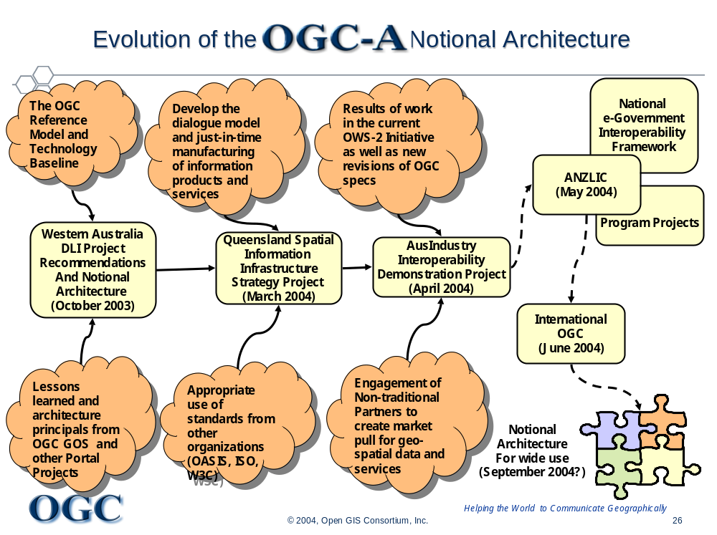
Figure V1-1: Provenance of the OGC-A Notional Architecture for SIDP

- Assumptions
The vision for the SIDP is to advance the state of spatial information sharing and standards based portals towards a situation portrayed in the following Figure V1 2 below where:
- Information products of improved quality are provided to customers that are easier to access within an environment where there is a scheduled reduction in the complexity of the processes (awareness, training and costs).
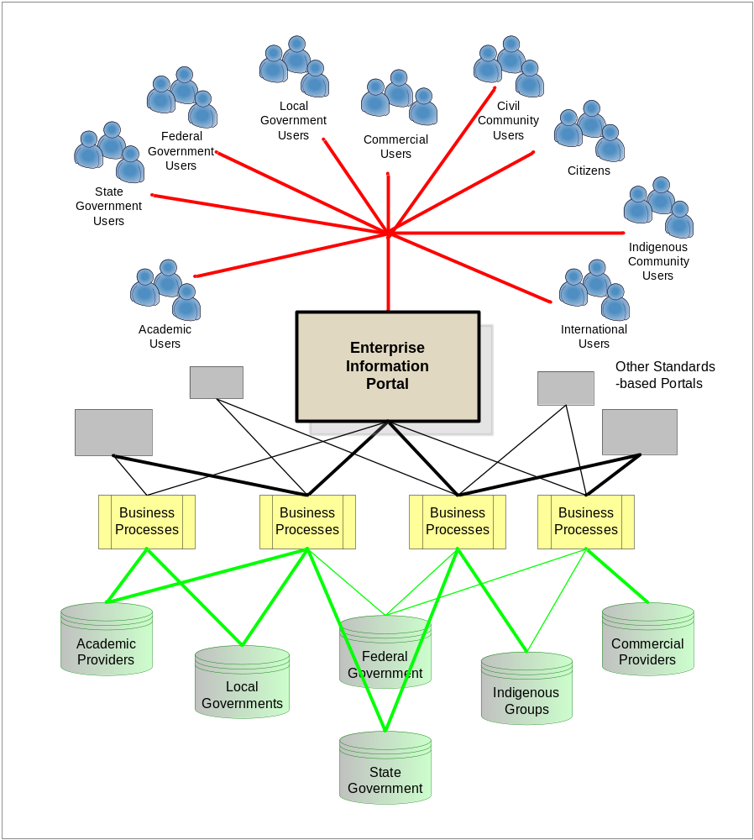
Figure V1 2: Enterprise Viewpoint for the SIDP
Information seekers and users of various types use common standards-based Internet portals to gain access to an entire distributed community of authoritative content. Business processes manage and account for access to content and add value by generating user-specified products. Users may also be able to access services and products directly or via other portals .

- Use the capabilities and opportunities provided by the Internet to complement existing delivery methods, such as call centres and counters, and to improve quality, timeliness and accessibility to services and products;
- Services and products are provided without the user having to know where within the Government, or private sector, the services and data originate;
- Services and products are provided to all users able to use simple Internet services. Users uncomfortable with or not connected to the Internet continue to use existing shop-counter services;
- Single authoritative sources of data are maintained and are made available using the Internet for processing through services of known quality to deliver current information in an auditable and cost effective manner.
  - Role of Technology
Technology such as the Internet provides the means for achieving the SIDP vision; it is not the ‘raison d’être’.
Previous efforts undertaken by the spatial industry in analysing spatially related information products and services have tended to focus on the technologies available and/or used occasionally losing sight of users and their requirements. This has placed many and varied hurdles between services and those to be served, such as:
- Users require knowledge of and access to particular technologies,
- Users must have familiarity with specialised technologies such as geographic information systems, and
- Users must have familiarity with diverse methods used inconsistently in different Government departments and between private sector suppliers.
  - Vendor Neutrality: the Role of Open Standards and Specifications
Standards and specifications are necessary for achieving the SIDP vision. However they are not the ‘raisons d’être’.
The information industry, including Government services, can learn from the experiences gained in manufacturing industries that have used technology to speed the time to market for physical products.
Manufacturing spatial/map products “just-in-time” is possible because of specifications and standards. Standards allow manufacturers to specify that a product, of known performance, will have specific plugs and sockets and when put in place will do a particular task. A product integrator (say, a vehicle assembler) can search for all products meeting a specified need (described according to the same standard), irrespective of manufacturer, then select a supplier to meet their business needs.
The equivalent in the technology of information is that a particular computer-based service set has certain specified performance characteristics wherein the process will receive input in certain specified forms, and deliver a specified result. The service may further rely on using specific data that are themselves described in certain specified ways, and can be selected on their fitness-for-purpose and cost. A “yellow pages” service allows users and programmers to discover services and data that can be combined to deliver the required product.
Such an approach is referred to as “just-in-time” information product manufacturing. Open specifications and standards underpin this ability. Protocols are now in place for using the Internet for the interchange of such things as personal medical information, bank details, lodging tax forms and filing mining claims. The often-stated concerns about security, confidentiality, integrity, and non-repudiation are being addressed by specialist groups in industry and are not considered to be barriers to adoption although they need to be acknowledged such issues are unlikely to be addressed in detail by the SIDP.
  - Distributed Implementation and Institutional Neutrality
In the past the only possible way to integrate information services was by either co-locating them, or by connecting them via expensive customized networks. Obviously this concentrated power in the hands of those who owned the systems and managed information.
The ubiquity of the Internet fundamentally undermines this historical state. The Internet and the Web provide an environment that enables institutional neutrality when considering content and/or service integration.
The Internet allows all custodians of products, services and data to function as equals. Centralization is no longer the default; it remains an option to be chosen on the basis of business requirements, special capabilities (for example, operational reliability; security management; economies of scale, specialized infrastructure) or where previous investments need to be amortized.
Note that the SIDP has no mandate to address the internal business requirements of individual participants, or how they meet them. It does have everything to do with the way in which information flows between the public, private companies, agencies and levels of government to facilitate service delivery.
  - Custodial Management and Federation
Custodians are responsible for managing the products that users receive, the services that generate them and the data that are employed. The ASDI is underpinned by integrated spatially related information services that are federated.
The term “federated” is used throughout this project in the sense as used by the Queensland Government Information Architecture (1999) i.e. agencies are independent and have their own accountability. They operate according to the principal of “mutual best interest” (indeed a public imperative) by collaborating to provide efficient, accountable, auditable delivery of authoritative information products, services and data to Executive Government, within government, to businesses, and the public. This definition appears to meet the requirements of the SIDP equally.
  - Shared Services
The Internet provides a scalable, vendor-neutral, institution-neutral means for achieving the goal of shared services. These shared services are user-focused and support specified business requirements. They support the concepts of supply chains and value chains. Shared services may also be built upon existing services. It has been demonstrated many times that existing systems can be augmented with open-specification interfaces (“wrappers”) that extend their accessibility to the Internet without compromise to security or integrity. Thus, their investment value is retained or even enhanced.
Each shared service may be small or large, sophisticated or elegantly simple. Some services might be implemented in just a few lines of code, created and developed by a single programmer and not even have data associated with them but instead only rely on the needed data being sent to them from other services elsewhere in the Internet. Others may be full-scale production systems accessing sophisticated databases, supported by a staff of dozens and for which new service applications need to be structured and quality-assured.
For the purposes of the SIDP, relevant “services” need to meet very specific criteria concerning their interfaces to the Internet, the protocols they use to communicate with other services, and the structures of the messages passing between services. (See Volume 4, Appendix A-2 “Web Services, Agents and Protocols”).
  - Incremental components-based access
Shared services can be accessed incrementally and independently. Incremental access – doing things in small steps – provides frequent opportunity to assess the effectiveness of new services in meeting SIDP needs. This will be an on-going process as participants’ expectations of product and service sophistication grows with the evolution of the project.
The SIDP is to demonstrate the effectiveness and potential of shared services and their incremental uptake and to build the confidence of the industry to consider such an approach. As a result each participant will be able to determine whether their business requirements are better met by retaining existing practices, implementing their own new service or using services operated elsewhere in Australia or in the world. Or, they may take the latter approach while assessing user requirements and, if justified, then invest in developing their own new service.
The SIDP will also be extending efforts undertaken by National Coordinating Bodies such as the Australian and New Zealand Land Information Council (ANZLIC) and State coordinating bodies such as the Western Australia Land Information System (WALIS) and Queensland Spatial Information Infrastructure Council (QSIIC). Each provides a crucial forum in which departments and agencies, local government and the private sector exchange information about their planned service developments and perhaps developing services cooperatively and sharing the cost. Alternatively, they may agree that one member develops one service and the other develops some other to avoid duplication and provide mutual benefits.
It is envisaged that the SIDP will use a similarly collaborative approach and create draft guidelines/summaries of their experience as a contribution to the spatial industry’s appreciation of the opportunities and pitfalls of the approach.
- Overview of the Notional Architecture
(Note: This section is substantially as in Volume 2, but is presented here for those interested in the overview and not the technical details provided in the subsequent Volume)
  - Architecture Requirements
The requirement of the SIDP is that the project be based on open non-proprietary standards. Therefore, the notional architecture for the SIDP applies the principles and standards recommended as best practices in the OpenGIS Web Services Architecture and other internationally recognized and adopted standards.
The web services architecture uses an ISO/OSI three-tier model. Referring to the following Figure V1-3, it can be seen that the model separates presentation from processes governed by business rules, and processes from the underlying methods for accessing persistent data repositories (whether relational databases, file systems, structured text files such as XML, etc).
Implementing this model in the form of distributed web services will require that communications between tiers, and amongst service components within tiers, can be mediated by open standard Internet protocols transporting transactional messages structured in well-known manners.
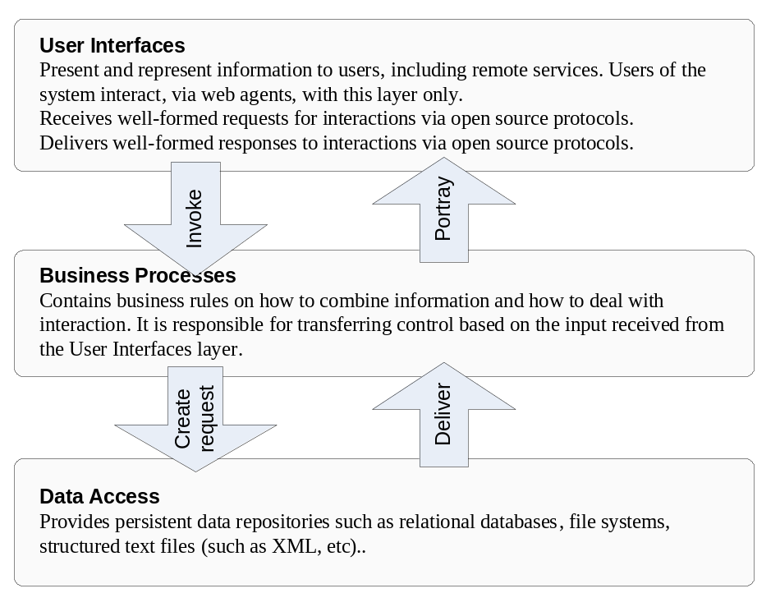
Figure V1-3: ISO three-tier model for the SIDP
Each of the three tiers in this model addresses a separate aspect of serving users’ business requirements – establishing interfaces for user access, implementing business rules as process services, and manipulating stored data. In the Notional Architecture communication between tiers, and amongst elements within tiers, is capable of being mediated via Internet protocols between web services.

The ISO three-tier model also corresponds to a pattern of an architecture definition widely recognized in the object-oriented analysis and development communities, that of the Model-View-Controller-Pattern, or the Boundary-Control-Entity-Schema. According to this, architecture comprises in three layers.
- The Boundary is responsible for representing information to the user and receiving interactions. Users of the system interact with this layer only.
- Control contains the rules on how to combine information and how to deal with interaction. It is responsible for transferring control based on the input received from the Boundary layer.
- The Entity layer holds the data and is responsible for its persistence.
Either of the ISO/OSI or OO viewpoints may be taken in considering the notional architecture, though the latter lends some advantage to later discussions of services, components and their interfaces.
The notional architecture therefore features:
- Standards and capabilities of the Internet and the World-Wide Web;
- Adaptable, modular web service components accessed incrementally and managed by many authoritative custodians;
- Dialogues conducted between services over the web discovering services and conducting transactions amongst them;
- Neutrality towards software and system vendors;
- Neutrality towards platforms, and
- Neutrality towards particular institutions.
A characterization of the notional architecture and high level service categories is presented in Figure V1-4 below.
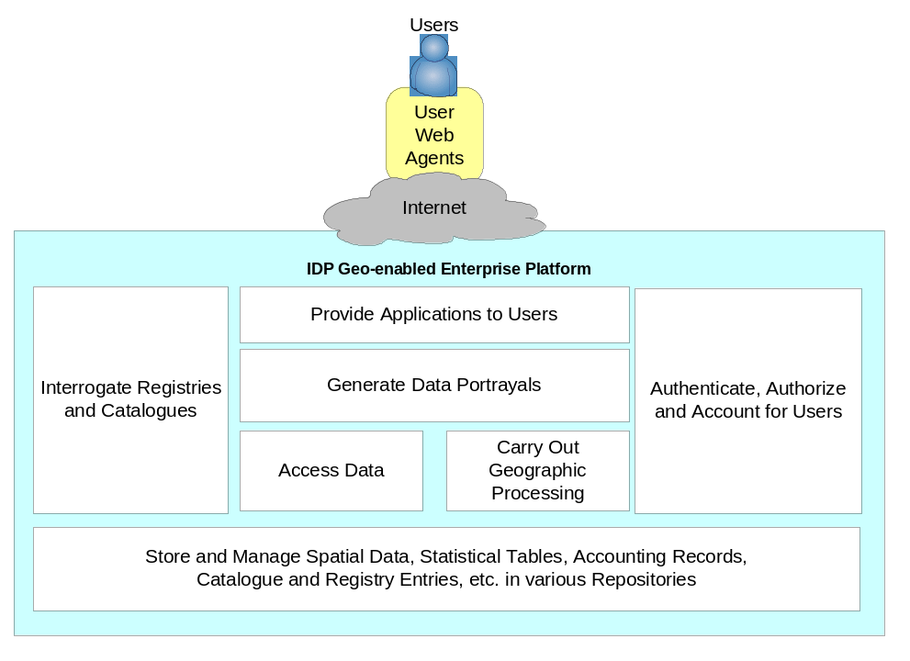
Figure V1-4: Notional Architecture: SIDP Capabilities
The SIDP Platform provides uniform and consistent managed access to distributed web services operated by authoritative custodians. These services comprise seven major categories that address geo-data processing, presentation, access control, accounting and data management.
Referring to the previous figure, the notional architecture identifies seven broad groups of capabilities; within each group various services are implemented as specific content and service components. Each component operates as a web service communicating on a transactional basis with other components, user agents and remote applications via the Internet.
Component services ‘plug into’ the Internet from many different locations and communicate amongst themselves, and with people using web browsers and similar tools. This is represented in Figure V1-5 below. Components can be dynamically assembled and combined to perform a variety of “just in time” processing. Discovery services for data and processing services provide the means for identifying capabilities and their governing rules. The internet provides the backbone by which components communicate. Standard internet messaging protocols and mark-up languages define the rules by which messages are created and interpreted.
Instances of envisaged Components are elaborated in considerable detail in Volume 3. While not intended to be definitively comprehensive these are nonetheless presented as indicative of the types of the components required by the SIDP platform.
Components are to be bought or built once and used many times. Examples of components are catalogue services, gazetteers, data delivery servers, data repositories will be key elements for many different uses in the SIDP.

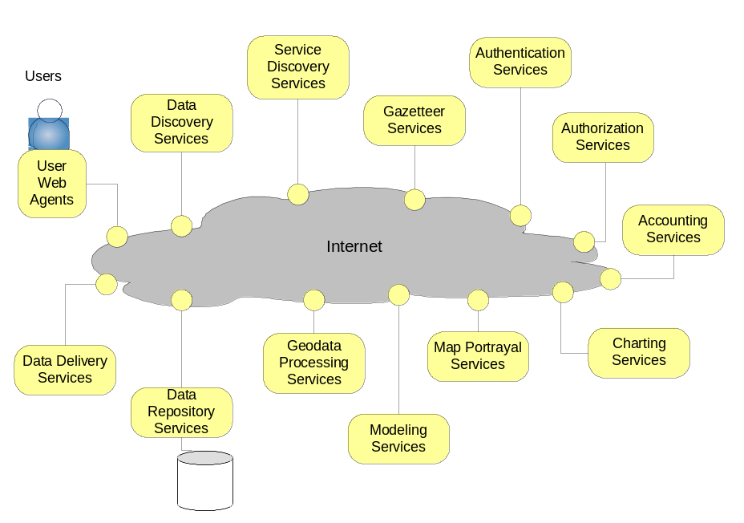
Figure V1-5: Notional Architecture: SIDP Web-based Component Examples
The SIDP Platform comprises numerous individual components that ‘plug into’ a common Internet backbone. Each component presents appropriate open-standard interfaces to the Internet. Service and content discovery via registry services provides for dynamic identification and selection in response to users’ requirements.

  - Architecture Concepts
Salient points of the notional SIDP platform architecture are represented in :
- A community of web services managed by independent custodians and access through standard mechanisms such as the Internet;
- The community is defined operationally by those who share a common agreed vocabulary naming the types of features of interest, and rules defining the relationships amongst these features i.e. communities share an ontology;
- Services provide access to data and data processes, and are published by custodians to registries for discovery and reference describing their capabilities, context and governing rules;
- Separation of services between those accessible by users, those that embody business rules, and those that directly access data stored in repositories; and
- Users, subject to various levels of authentication and authorization, using web agents to access these services through the Internet, and their usage accounted for. (The deleted sentence is not an architectural issue)
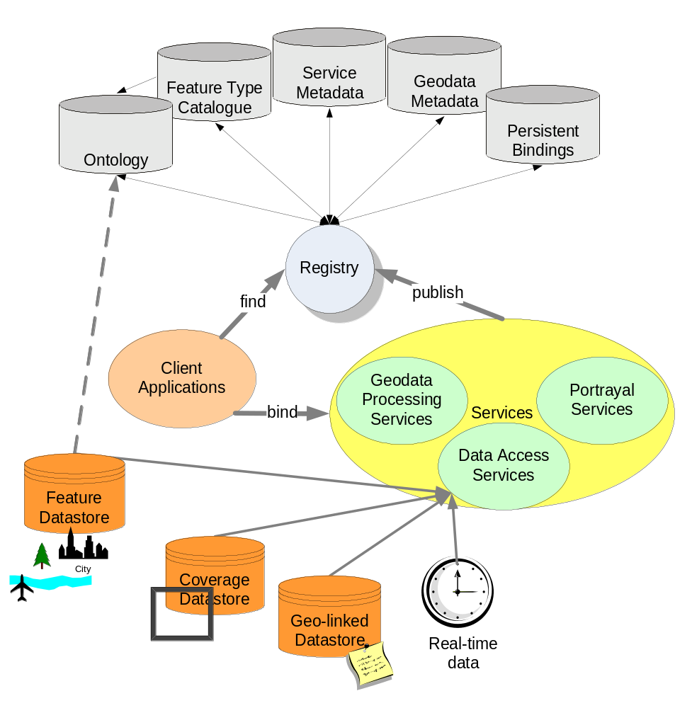
Figure V1-6: Notional Architecture: SIDP organization
Services provides access to valued data and services, which are described in registries that include definition of their capabilities, context and governance rules. Users’ clients bind to services via internet protocols implementing the governance rules. Data repositories of various kinds provide persistent storage for various types of geo-data. The community of providers shares a common vocabulary and ontology for describing features of common interest and the relationships amongst them.
  - Architecture Component Overview
Figure V1-7 presents a high-level service component view of the SIDP notional architecture. The salient points for SIDP are that:
- “Thin” clients are web browsers acting as agents for people accessing services through the World Wide Web. Behind the scenes, these peoples’ agents are using the open http protocol to exchange well-structured messages with a web platform configured to act as an interface to SIDP approved web services
- “Thick” clients are remote applications acting as their own web agents and able to invoke according to agreed message standards and protocols. Thick clients can be remote GIS desktop applications used directly by people. They can also be autonomous tasks such as statistical analysis and modeling engines.
- Portal service partners configure the web services to conduct business processes such as analysis, data manipulation, presentation of products according to designated symbologies and layouts, and plausibly also to provide interactive help for users.
- Catalogue services support publication of service and data characteristics (metadata) and their discovery by appropriate agents. Catalogues also provide information about the language structures and interface capabilities supported by each service. All services to be accessed in the SIDP require catalogue references.
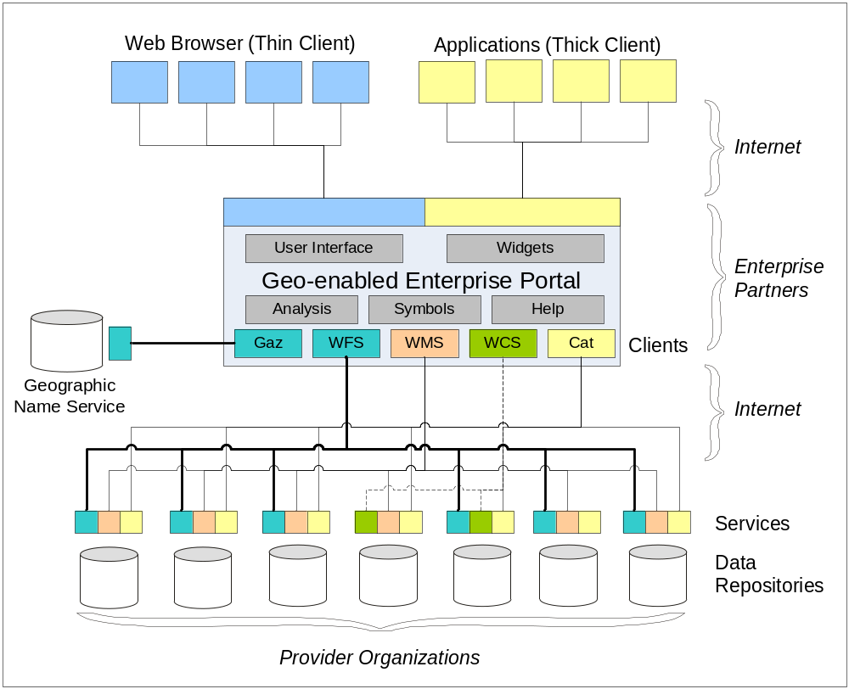
Figure V1-7: The SIDP Portal Platform Concept
The enterprise information portal mediates internet-based transactions between client agents (web browsers, remote applications) and a distributed community of service operators and content providers. The services include discovery (catalogues, registries and gazetteers), analysis, transformation and portrayal. OpenGIS and other open specifications define the interfaces amongst these services.

- The gazetteer services support searches and other applications (such as portrayal) requiring the names of locations and features.
- The web feature services (WFS) abstract data as topographic features encoded in geographic mark-up language (GML) that are amenable to further analytical or representational processing, such as may be done with “thick” clients. WFS tend to deliver vector data content and attributes, but can also treat content such as gazetteer services as point data.
- The web coverage services (WCS) similarly abstract coverage data (including raster data, but not constrained to rectangular reticules) to thick clients or for portrayal through WMS.
- The web mapping services (WMS) provide pictorial portrayals of data as maps which are readily visualized and manipulated in “thin” clients but they are not amenable to further manipulation. WMS may stream and portray content from WFS.
Figure V1-8 following illustrates the services involved and the paths by which information flows between the services. The salient points to note for the SIDP are that:
- User interfaces (UIs in the diagram) and application programme interfaces (APIs) interact with the world wide web – or the internet in general – according to public standard protocols and interface specifications
- All interactions between users via their web agents, are transactional in nature
- Information flow occurs between numerous independent services managed by independent custodians
- All data assets are delivered via services
- Services and data descriptions are published into registries and catalogues available for search-driven discovery by web agents
The types of business rules to be accommodated within the framework architecture are considered in Volume 2. A detailed technical discussion (computational viewpoint) of the architecture is presented in Volume 3.
The following two volumes provide increasing levels of detail as the Notional Architecture is defined from the Enterprise level to the Computational level. Volume 4 includes a series of Appendices discussing selected issues in greater detail and can be readily added to as specific topics are investigated in greater detail, or prove to need further qualification to clarify aspects of the architecture.
It is anticipated that additional volumes will complement the document as the Implementation Architecture fleshes out the Engineering and Technical Viewpoints.

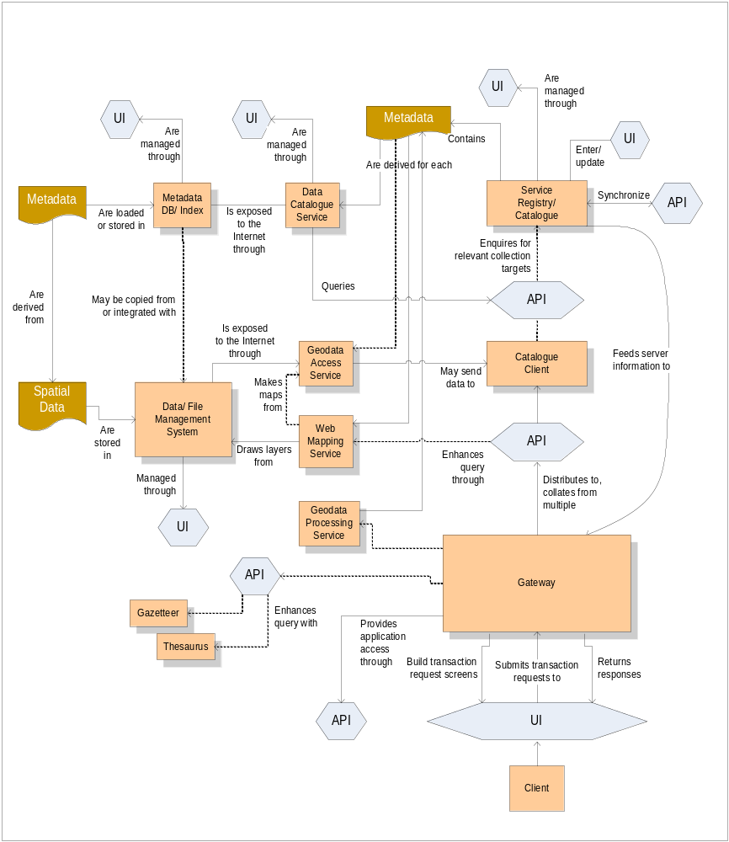
Figure V1-8: Services and Information Flows
Service components (rectangles, pink) are able to interchange informational messages via the open network standards used in the Internet. Various web service interfaces (hexagons, blue) provide the means by which service capability descriptions are requested, service instances are invoked, and resultant products are returned, amongst services (APIs) and users (user interfaces, UIs). Persistently stored data or various types (banner figures, brown) are accessed and manipulated by relevant services.

- Conclusion
The Notional Architecture is presented as a dynamic model. The standards and specifications referred to are evolving. There is a wide range of projects being undertaken around the world that are testing the varied aspects of interoperability. There is also an increasing interest in alignment between business processes, workflows and information product manufacturing and delivery, especially within the context of the e-Government Interoperability Frameworks. The SIDP will be keeping a watching brief on developments in the public arena.
There is also a wide range of initiatives underway within the private sector technology developers and suppliers, academia and systems integrators as well as in the Open Source community. New Open Source tools and services are becoming available at an accelerated rate.
OGC and OGC-A will, as part of their support for the SIDP, be providing updates to these documents and relaying any and all relevant information to the Project Manager and Steering Committee members, as appropriate.
The SIDP is a collaborative project. OGC-A will continue to actively seek other members of OGC, nationally and internationally, who will be able to contribute experience and in-sight into the issues facing the project as it progresses. These contacts will assist in meeting some of the goals for AusIndustry which include technology transfer to Australian businesses to take advantage of expertise and experience in open standards from overseas, to build capacity here in Australia and increase the international competitiveness of Australian companies.
- References
  - Acronyms
AAA | Authentication, authorization and accounting
ACXML | Access Control Extensible Mark-up Language (OASIS): see http://www.oasis-open.org/committees/tc_home.php?wg_abbrev=xacml
AGI | Association for Geographic Information (UK): see http://www.gigateway.org/
AGLS | Australian Government Locator System
ALGA | Australian Local Government Association: see http://www.alga.com.au/
ANZLIC | Australian New Zealand Land Information Council: see http://www.anzlic.org.au/
ASAP | Aligning Services and Priorities (Government of Qld)
ASDD | Australian Spatial Data Directory: see http://asdd.ga.gov.au/asdd/
ASDI | Australian Spatial Data Infrastructure
ASIBA | Australian Spatial Industry Business Association: see http://www.asiba.com.au/
AUSLIG | Australian Survey and Land Information Group
BPR | Business Process Review (Queensland State Government)
CANRI | Community Access to Natural Resource Information (NSW) see http://www.canri.nsw.gov.au/
CMS | Cascading Map Server (OGC WMS)
CQL | Common Catalogue Query Language (Library of Congress, USA): See http://www.loc.gov/z3950/agency/zing/cql/
CRC | Cooperative Research Centre (Australia): see https://www.crc.gov.au/
CSDGM | Content Standard for Digital Geospatial Metadata (USA FGDC)
DACS | Distributed Access Control System (OGC): see http://dacs.dss.bc.ca/arch-spec.html
DES | Department of Emergency Services (Qld)
DIIE | Department of Innovation and the Information Economy (Qld): see http://www.iie.qld.gov.au/
DLGP | Department of Local Government and Planning (Qld): see http://www.dlgp.qld.gov.au/
EbRIM | ebXML registry information model (OASIS) see http://www.ebxml.org/specs/ebRIM.pdf
EbXML | E-business Extensible Mark-up Language (OASIS): see http://www.ebxml.org/
EC | European Commission
e-GIF | E-Government Interoperability Framework
ENRII | Environment for Natural Resource Information Integration (Qld)
EPA | Environment Protection Agency (Qld)
EROS | Earth Resources Observation Systems
EU | European Union
FGDC | Federal Geographic Data Committee (USA): see http://www.fgdc.gov/
GIA | Government Information Architecture (DIIE, Qld): see http://www.iie.qld.gov.au/comminfo/gia/
GILS | Government Information Locator System (USA) see http://www.access.gpo.gov/su_docs/gils/
GINIE | Geographic Information in Europe (EC): see http://www.ec-gis.org/ginie/
GIS | Geographic Information System
GML | Geography Mark-up Language (OGC): see http://www.opengis.org/docs/02-023r4.pdf
GNIS | Geographic Name Information Service
GOS-P | Geo-spatial One-Stop Portal (US Government): see http://www.geo-one-stop.gov/
GSDI | Global Spatial Data Infrastructure
GSL | Government Services Locator
HDF | Hierarchical Data Format: see http://hdf.ncsa.uiuc.edu/
HTML | Hypertext Mark-up Language (W3C): see http://www.w3.org/MarkUp/
http | Hypertext Transport Protocol (W3C): see http://www.w3.org/Protocols/
IETF | Internet Engineering Task Force: see http://www.ietf.org/
IPA | Integrated Planning and Assessment (Qld)
IQ | Information Queensland
ISCGM | International Standing Committee for Global Map http://www.iscgm.org/
ISO | International Organization for Standardization http://www.iso.org/
LandXML | An XML schema for land planning: see http://www.landxml.org/
LDAP | Lightweight Directory Access Protocol: see http://www.openldap.org/
MIME | Multipurpose Internet Mail Extension (IETF)
NAP | National Action Plan
NCSA | National Center for Supercomputing Applications
NIST | National Institute of Standards and Technology (USA): see http://www.nist.gov/
NR&M | Department of Natural Resources and Mines: see http://www.nrm.qld.gov.au/
NSDI | National Spatial Data Infrastructure initiatives
OASIS | Organization for the Advancement of Structured Information Standards: see http://www.oasis-open.org/who/
OCS | OpenGIS Catalog Services (OGC)
OECD | Organization for Economic Cooperation and Development
OESR | Office of Economics and Statistical Research (Qld)
OGC | Open GIS Consortium (USA): see http://www.opengis.org
OgcRIM | OGC registry information model
OSI | Open Source Initiative
OSS | Open-source software
OWS | Open Web Service (OGC)
PDA | Personal Digital Assistant
PKI | Public Key Infrastructure (NIST): see http://csrc.nist.gov/pki/
PNG | Portable Network Graphics (W3C) see http://www.w3.org/Graphics/PNG/
QIO | QSIIS Information Office
QPW | Department of Public Works (Qld): see http://www.publicworks.qld.gov.au/
QSIIC | Queensland Spatial Information Infrastructure Committee
QSIIS | Queensland Spatial Information Infrastructure Strategy: see http://www.qsiis.qld.gov.au/
RIS | Regional Information Service (Qld)
ROSI | Roster of Strategic Information (OESR, Qld)
SAML | Security Assertion Mark-up Language (OASIS)
SCOTS | Standards-based Commercial Off The Shelf software
SDI | Spatial Data Infrastructure
SDTS | Spatial Data Transfer Standard (USGS): see http://mcmcweb.er.usgs.gov/sdts/
SFS | Simple Features Specification (OGC): see http://www.opengis.org/techno/specs/99-049.pdf
SII | Services Integration Infrastructure (Qld)
SLD | Styled Layer Descriptors (OGC): see http://ogc.cast.uark.edu/tnm/web/sld.html
SMIS | SmartMap Information System (Qld.)
SOAP | Simple Object Access Protocol (W3C): see http://www.w3.org/TR/2000/NOTE-SOAP-20000508/
SSQ | Smart Services Queensland
TCP/IP | Transport Control Protocol/ Internet Protocol (IETF)
UDDI | Universal Discovery Description and Integration (OASIS): see http://www.uddi.org/
UNEP | United Nations Environment Programme (Kenya): see http://www.unep.org/
UNGIWG | UN Geographic Information Working Group (USA): see http://www.ungiwg.org/
URI | Uniform Resource Indicator (W3C)
URL | Uniform Resource Locator (W3C)
USGS | US Geological Service (USA): see http://www.usgs.gov
W3C | World-Wide Web Consortium: see http://www.w3.org
WALIS | Western Australian Land Information System: see http://www.walis.wa.gov.au/
WCS | Web Coverage Service (OGC)
WFS | Web Feature Service (OGC)
WMS | Web Mapping Service (OGC)
WOG-GIS | Whole-of-Government GIS (Qld)
WPOS | OpenGIS Web Pricing & Ordering Service (OGC)
WSDL | Web Services Description Language (W3C): see http://www.w3.org/TR/wsdl
XML | Extensible Mark-up Language (W3C): see http://www.w3.org/XML/

  - Glossary
Application | A program that performs a specific function directly for a user. Applications can make use of SDI.
Architecture | The organizational structure and operating environment of the SDI, including the relationships between its parts, and the principles and guidelines governing their design and evolution over time.
Binding | Specific syntax and parameter values used by a client to invoke a specific server operation
Capabilities schema | XML schema that prescribes and constrains the syntax and vocabulary for the expression of service capabilities in XML.
Capabilities XML | Specific instance of service-level metadata describing a service instance.
Client | A software component or an application that accesses a service.  Clients may be categorized in three ways:  Thin clients where the client supports only human-interface code, such as a web browser, and X-terminal, a text-only interface or a minimal PDA or WiFi handset, and must support non-proprietary standards. Typically, lack long-tem memory such as disk drives. Application code and data access both run remotely, and so are entirely dependant on external network connection.  Thick clients where the client supports all the human interface and application code, may support some or all data access code, and may support long-term data memory. Human interface code may be entirely customized and not conform to non-proprietary standards. May not even support human interfaces i.e. may be entirely automated emote processes. May operate at times without network connection.  Chubby clients have capabilities somewhere on the spectrum between thick and thin clients i.e. may support some application and data code, and may store limited amounts of data. Will usually but not necessarily support human interfaces. May operate well for limited time without network connection.
Component | Software that packages the client or server implementation of a service and can provide the realization of a set of interfaces. A component consists of software code (source, binary or executable) or other equivalents such as scripts or command files.
Conceptual Architecture | An overview of the services, data, technology and institutional environment of SDI. It describes, in general terms, both what the SDI will include, and how it will operate.
Core Service | A service that is critical to the ongoing operations of the SDI. The Service Registry Service is an example of a core service. It is used to keep track of where SDI services can be found, so if this service were unavailable, client applications would not be able to locate the services required in order to complete a task.
Coverage | A continuous representation of a portion of the earth's surface. A coverage may be a collection of features (like a vector dataset) or it may be a raster or gridded surface representing one or more attributes.
Coverage Data | Gridded data, imagery, swath data, and continuous functions. Contains values for every point in a geospatial data. Relevant specifications for Information Queensland coverage data formats may include:  - SDTS - Spatial Data Transfer Standard  - GeoTIFF - Georeferenced Tagged-Image File Format  - HDF – Hierarchical Data Format
Custodian | The authoritative manager of an SDI resource, whether data set, service or component, who is responsible for declaration of the policies regarding utilization and accounting for the resource.
Datastore | Any type of persistent storage for Information Queensland components and data. Content may be static or dynamic.  May include database systems, file systems, structured text storage, XML repositories etc.
Event | An occurrence of interest to users or developers of the SDI. Events can be things such as the adjustment of a feature in a framework data layer, a flood in the Red River basin, or the release of a new specification for a SDI service.
Framework Data | The set of geospatial data that provides the reference framework for all other SDI compliant geodata. See the SDI Framework Data Definition.  Seven geospatial data themes may be considered to be of fundamental importance to many applications. Known as "Framework Data," these themes are: Elevation, Orthoimagery, Hydrography, Transportation, Government Units (administrative boundaries), Cadastral (property boundaries), and Geodetic Control.  Framework Data shall, at minimum, are able to exchange data in a manner that complies with these emerging standards. Information Queensland shall be able to access both Framework Data sources and other, non-Framework data.
Geodata | Georeferenced spatial data such as a road network or a satellite image. Geodata explicitly describes the spatial extent of a set of features or describes a measurable surface. It includes both geospatial data and geolinked data.
Geodata Resource Registry | Peer registries that contain metadata about geodata resources. These registries identify the agencies that are responsible each attribute dataset, and descriptions of that attribute data. They also contain information on how to access the data.
Geolinked Data | Geodata that are referenced to an identified set of geographic features without including the spatial description of those features. Geolinked data are normally attribute data in tabular data (such as population counts) that refer to a known framework (such as municipalities), where their unique identifier (such as the municipality name) refers to the elements (the municipalities). The term “geolinked data” refers to all attribute data that is not directly attached and bundled with the geographic coordinates to which it applies.
Geospatial Data | Geodata with explicit geographic positioning information included, such as a road network from a GIS, or a georeferenced satellite image. Geospatial data may include attribute data that describes the features found in the dataset.
GeoTIFF | Georeferenced Tagged-Image File Format
Information Queensland | The concept of an all-of-government, distributed system of services providing added-value spatial information products to users in all sectors of society in Queensland and beyond
Interface | The named set of related operations that structures how a client interacts with a server. The state and functionality of the underlying component is hidden, and is only made externally accessible through its interface (i.e. the interface is the only "public" or "visible" part of the component). The same interface may be provided by several components and used by many components or applications.
LandXML | Facilitates the exchange of data created during the Land Planning, Civil Engineering and Land Survey process. LandXML is an XML application that utilizes XML Schema to define relationships and custom data types. Much like GML, LandXML is a fairly robust application of XML as a data format, targeted specifically towards land planning, engineering and survey applications.
Library | A type of registry intended for recording references to entity types (as distinct from recording instances) i.e. a look-up. Content is generally static once instantiated
Map | A pictorial representation or portrayal of geographic data
Master System | A primary system that is mirrored to other identical systems, so as to ensure that any important information or services can be accessed in an identical fashion from multiple sites.
Metadata Standard | Data will be documented according the FGDC Content Standard for Digital Geospatial Metadata (CSDGM) and/or the ISO 19115
Notional Architecture | A design framework based on vendor-neutral, open standards.
Operation | An interaction between a client and a server, resulting in a transfer of information or an action. An operation can be either an interrogation (i.e. request-response) or an announcement (i.e. notification).
Portal Services | Provide "one-stop" access to the Provider Services.  An online access point to a collection of geospatial data -- more precisely, to a collection of services that provide data or relevant functionality.  A Portal does not store or maintain the data and its associated services; rather, these are distributed in many computers nationwide and maintained by the agency or organization that is responsible for its data and services.  Portals shall be based on open standards and specifications that are defined collaboratively by a various interested parties, are freely published, and are able to be implemented by any vendor or organization.
Primary System | A system that provides a core service and thus is critical to the operations of the SDI. Although a primary system may not be mirrored to other sites, or even the most popular implementation of a particular service, they are publicly identified and funded to ensure that core services are implemented on at least one system.
Process | A system offering a single interface for the execution of a single task creating one or more products.  Processes may be grouped to provide a service.
Provider Services | Include map, data, gazetteer, catalogue and any other services hosted and maintained at remote sites independently of Information Queensland and are accessed by the it. The role of the Portal Services is to provide "one-stop" access to the Provider Services.
Reference Architecture | A technical blueprint that identifies and defines the services that comprise the SDI, and specifies the interfaces to those services.
Registry | A listing of the specific, individual services, components, datasets, or other things that comprise the SDI or are relevant to its users. Instance registries are used to identify, locate, and describe individual instances.  Many registries refer to associated Type Libraries that record the allowed types within registry classes e.g. types of services, types of user authorities.
Request | Invocation of a server operation by a client
Response | Result of an operation returned from a server to a client
Schema | A schema is an expression of the type using a particular data modeling language. Types provide the basis for classification taxonomies for sets of schema definitions. In the OGC the application data-modeling language is GML and each schema fragment corresponding to a given type is defined in GML.
Server | (a) A software component that delivers a service.  (b) A physical implementation of such a component, that provides the realization of its operations.
Service | A collection of operations, accessible through one or more interfaces, that allows a user to evoke a behaviour of value to that user. A server is delivers each service.  A service may encapsulate may processes.  A "service instance" is another name for a server (b).
Service capabilities | Service-level metadata describing the types, operations, content, and bindings available at a service instance. Organization, classification, and presentation of those entities may also be conveyed by the capabilities information.
Service Registry | Contains metadata about individual services, including the type of service, and information about how to access the service.  A Service Registry Service provides a mechanism to:  - Register the characteristics of certain types of services (in a Service Type Registry) and register the existence of specific services (in a Service Registry);  - Search Service Registries; and  - Retrieve detailed information (metadata) that describes a service, in order to evaluate its suitability to meet a need.  A Service Type Registry contains information about specific types of services, including the name of the service type, and its definition.  A Service Type Registry is being maintained manually, at http://www.geoconnections.org/architecture/systems/ServiceTypeRegistry
Site | A location (e.g. URL) at which a system is accessed.
Spatial reference system (SRS or CRS) | A projected or geographic coordinate reference system
Styled Layer Descriptor | Metadata describing presentation of geographical types for portrayal in WMS and WFS  Addresses the need for geospatial consumers (either humans or machines) to control the visual portrayal of data. It can be used to portray the output of Web Map Servers, Web Feature Servers and Web Coverage Servers.  Uses consistent XML-based methods persisting in an SDL library.
System | Servers and data organized to accomplish one or more Services. A system may be accessible at more than one site.
Type | A type refers to a kind or class of geographic entity. Types are meaningful elements in a particular universe of discourse.
Web Agent | People or software that act on the web information space. Software agents include browsers, servers, proxies, spiders, and multimedia players mediating interactions on behalf of a person, entity, or process.
Web Service | Application logic accessible across a network using standard Internet protocols. Web Services combine the best aspects of component-based development and the Web. Like components, Web Services represent functionality that can be easily reused without knowing how the service is implemented. Unlike current component technologies that are accessed via proprietary protocols, Web Services are accessed via ubiquitous Web protocols (e.g. http) using universally accepted data formats (e.g. XML).

By open, we mean royalty and license free, non-discriminatory, vendor and data neutral, and developed by a well defined industry consensus process.
OpenGIS Web Services Architecture (OWS) Discussion Paper, available at: http://www.opengis.org/docs/03-025.pdf
In this document, a portal is a website that acts as gateway providing a single access point to multiple resources. It is a web environment that allows an organization or a community of information users and providers to aggregate and share content. It is an organized collection of links to other sites. A portal may be secure and it may be personalized. A geospatial portal is a human interface to a collection of online geospatial information resources, including data sets and services.

