
Notional Architecture
for a Geo-enabled Enterprise Portal Platform
for the AusIndustry Spatial Interoperability
Demonstration Project
Volume 5 – Model to assist in the preparation of Scenarios
Version: 1.0
Date: August 17th 2004
Authors:
Dr. Robert Starling
and
Michael Wilson
(OGC- Australasia)
NOTICE

Permission to use, copy, and distribute this document in any medium for any purpose and without fee or royalty is hereby granted, provided that you include the OpenGIS Consortium copyright and the entire text of this NOTICE. We request that authorship attribution be provided in any software, documents, or other items or products that you create pursuant to the implementation of the contents of this document, or any portion thereof.

No right to create modifications or derivatives of OGC documents is granted pursuant to this license without permission of the OGC.

THIS DOCUMENT IS PROVIDED "AS IS," AND COPYRIGHT HOLDERS MAKE NO REPRESENTATIONS OR WARRANTIES, EXPRESS OR IMPLIED, INCLUDING, BUT NOT LIMITED TO, WARRANTIES OF MERCHANTABILITY, FITNESS FOR A PARTICULAR PURPOSE, NON-INFRINGEMENT, OR TITLE; THAT THE CONTENTS OF THE DOCUMENT ARE SUITABLE FOR ANY PURPOSE; NOR THAT THE IMPLEMENTATION OF SUCH CONTENTS WILL NOT INFRINGE ANY THIRD PARTY PATENTS, COPYRIGHTS, TRADEMARKS OR OTHER RIGHTS.

COPYRIGHT HOLDERS WILL NOT BE LIABLE FOR ANY DIRECT, INDIRECT, SPECIAL OR CONSEQUENTIAL DAMAGES ARISING OUT OF ANY USE OF THE DOCUMENT OR THE PERFORMANCE OR IMPLEMENTATION OF THE CONTENTS THEREOF.

OpenGIS® is a trademark or registered trademark of Open GIS Consortium, Inc. in the United States and in other countries.

SIDP Notional Architecture: Scenarios
Acknowledgements 1
V5-1 Overview 2
1.1. Background 2
1.2. Approach 2
V5-2 Example Use Case scenarios 4
2.1. Creating scenarios 4
2.1.1. Mapping components to scenarios 4
2.1.2. Status of Components 5
2.1.3. Alignment to National and International Initiatives 5
2.1.4. Migratory model for custodianship 5
2.1.5. Method for Recognizing Custodianship 6
2.2. Use Case Scenarios 6
2.2.1. Requirements 6
2.2.2. The Scenario: Regional Reporting Process 7
2.2.3. The Regional Reporting Use Case 8
2.2.4. The Regional Reporting Data Processes 10
2.2.5. The Regional Reporting User Interaction 12
2.2.6. Capabilities Required 13
2.2.7. Components Required for the Regional Reporting Use Case 13
2.2.8. Priority Services 15
2.2.9. How this Aligns to the Component Levels of the Notional Architecture 16
2.2.10. Extensibility of the Use Case Method 16
2.2.11. Mapping Components to Scenarios 17
2.2.12. Status of Required Components 20
2.3. Use Case Service and Value Chains 22
2.4. Justification for Approach 24
2.5. Acronyms 25
2.6. Glossary 27

Table of Figures
Figure V5-1: Summary of SIDP Processes by Phase 4
Figure V5-2: Regional Reporting – high-level use case portrayal 9
Figure V5-3: Regional Reporting – high-level data use portrayal 11
Figure V5-4: Regional Reporting – high-level user interaction portrayal 12
Figure V5-5: Regional Reporting - Indicative Service Components 14
Figure V5-6: Representative Service and Value Chaining Concept 23
Figure V5-7: Allocation of potential barriers to links and actions in the Supply/Value Chain 24
Tables

Table V5-1: The Regional Reporting Process 7
Table V5-2: Notional Components required for the Use Case Scenario 17
Table V5-3: Existing Components versus Required Capabilities 20

Acknowledgements
The SIDP appreciates the contribution of the Department of Land Information – Western Australia and the Queensland Spatial Information Infrastructure Council (QSIIC) for allowing as yet unpublished materials to be used as background and for ideas in those materials to be extended for the purposes of this study.
Other organisations such as the OpenGIS Consortium, Geo-Connections Canada, the City of Cologne (Germany) and the Geo-Intel Conference (2003) Platinum Sponsor Team have also provided unpublished materials in relation to the description and definition of some of the open standards based software components.
Processes undertaken for the use case scenario presented in the document were inspired (and funded) by the requirements for the SIDP and QSIIC. The SIDP will be developing three scenarios, as outlined in Volume 1. At this stage the scenarios are not detailed. Therefore the Regional Reporting Scenario is included as an exemplar of the process. The Regional Reporting Scenario is highly representative of the requirements of the SIDP. The strategy of collaborative and cumulative development between the participants is acknowledged and appreciated.

- Overview
  - Background
Use-case scenarios are used to describe real world business requirements in on-technical terms. Subsequent modeling by the SIDP Project Management Team will include identifying and specifying specific data and services to be accessed implementation. Defining the Use Case Scenarios provides an example of how the application of the notional architecture and the modeling can be achieved to realise real business outcomes.
The approach outlined in this document is driven by the principles of collaboration and mutual best interest. The public investment in the spatial information infrastructure is often locked away in stovepipe technologies and practices. These proprietary environments are probably fine for the production and maintenance of the data content but do not necessarily provide the most sustainable, economic and flexible approach for the publication of data and the provision of access to publicly funded processing services. There is also a danger that the secondary information product and service industries may be impeded, by parochial proprietary standards and procedures, without the benefit of open internationally recognized standards for vendor neutral interoperability. Such open international standards are the essence of the Global, National and Local Spatial Data Infrastructures.
The SIDP is a publicly funded (AusIndustry) initiative to demonstrate the requirement (demand) for an open interoperable Spatial Data Infrastructure and the readiness of the spatial industry at large (suppliers) to deliver such benefits to the public and private sectors in Australia.
The point of convergence of economic and technical outcomes is exemplified through the definition of scenarios. The target user communities provide the requirements to deliver their economic (including social and political) outcomes and the technologists display their ability to deliver sustainable and extensible outcomes using international best practice.
  - Approach
As noted in the Acknowledgements, the SIDP is undertaking a consultative and collaborative approach to the definition of scenarios.
The approach being undertaken by the SIDP, as summarised in Figure V5-1, requires the definition of the context of the project through a notional architecture, employing internationally recognised vendor neutral open standards, and a defined number of scenarios to deliver, within this context, the business outcomes for the target constituents (users). A further consideration is that the efforts of the project adopt international and Australian best practice, compliment other synergistic initiatives, progress the local market for geospatial information and services and assist industry participants in being aware of, and adopting, the lessons learned from the project.
In order to provide sustainable outcomes the notional architecture includes a proposed approach for inclusion in the documentation for the scenarios to assist in aligning the project to deliver.
In summary, the notional architecture defines a broad set of interoperable components using the ISO Reference Model for Open Distributed Processing and the first three of the five possible viewpoints (Enterprise, Information and Computational). This process results in a list of candidate services and components.
The scenarios presented in this document encapsulate user requirements. The requirements are then reduced to workflows and those data and processing services required to deliver the required outcomes. Data and processing requirements from each scenario are tabulated. Data requirements are prioritised and rationalised to exploit commonalities and the budget. The refined list is then cross-referenced to the custodial and/or point of truth data sources.
Processing services are treated in a similar manner i.e. tabulated and rationalised. Sources of the services are identified.
Workflows are created, with one form of representation being the supply chain (Figure V5.6), to deliver the information products required and indicating key institutional/business considerations mapped to the links and nodes (Figure V5-7).
It is recommended that the Universal Modeling Language (UML) be used in the SIDP, as appropriate, to represent the scenarios and specifications.
By adopting a tabular approach to the representation of the summary information for data and services a readily understood form of communication is provided between project participants and interested parties. The tables also provide a straightforward representation for update, the communication of “status” and an auditable trail of what information is available where and when.
It is recommended that the project and its participants be responsible for the maintenance these status tables for the duration of the project and arrange for the handover of this responsibility to a suitable entity at the conclusion of the project.
QSIIC has undertaken a similar scenario description effort (Jan-April 2004) in part, to that described in this document. The following approach uses the QSIIC scenario, which addresses the requirement for Regional Reporting, as highly indicative of the issues being addressed by the SIDP.
Regional Reporting is a process by which a comprehensive suite of background information and computed trends are presented to document the status of a region. A region is a discrete geographic concept that can vary in scale from defining the extent of a local incident, for example, burglary of an apartment, to that of, in this case, the State of Queensland. Regional reports are of different types and provide defined information in a prescribed format (information products). The workflows are well known and are invoked for any defined region.
A number of templates are described, as a starting point. It is recognised that as the project progresses refinements and further inclusions will be made, as such this document is a working document and will be updated.

- Example Use Case scenarios
  - Creating scenarios
Determining user scenarios prepares the way for the first major iteration of the notional architecture model. Use-case scenarios are described to indicate real world business requirements. Subsequent modeling by the Project Management Team will include identifying and specifying specific services for implementation. Modeling the Use Case Scenarios provides an example of how the application of the notional architecture and the modeling are positioned to realise real business outcomes.
    - Mapping components to scenarios
Mapping components to the scenario(s) allows iteration against the model i.e. to ensure that all critical components are identified and linked to Service Categories and the Notional Architecture (i.e. have referential integrity). Such mapping also helps to recognize priority components , evaluate their alignment with existing initiatives and provide the basis of a strategy for moving forward. The approach, as presented by OGC-A to the SIDP meeting 29th January 2004, is summarized in Figure V5-1.
Figure V5-1: Summary of SIDP Processes by Phase
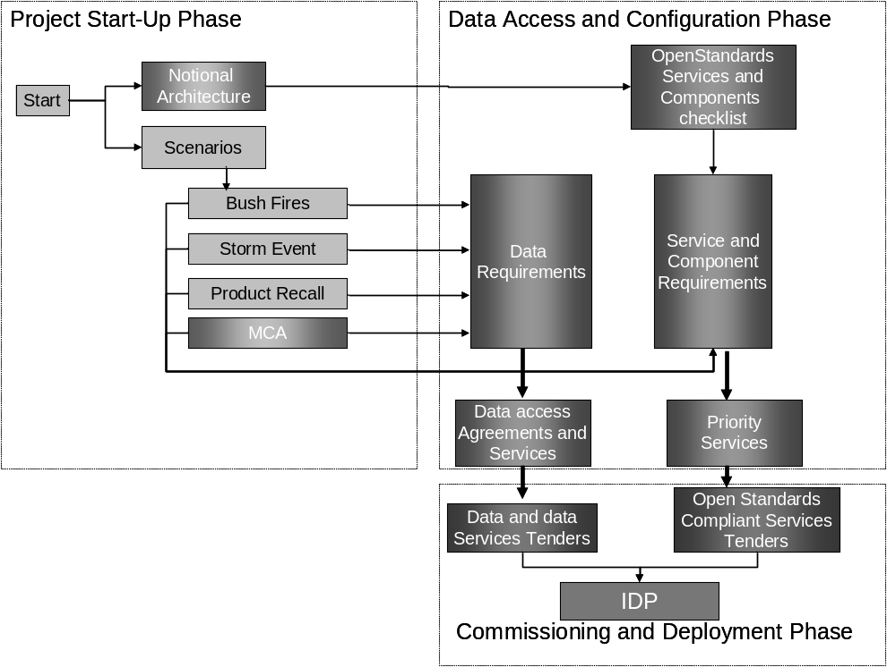
SIDP approach consists of three main phases involving definition, configuration and commissioning and deployment. The figure presents the flow between the Phases and points of interaction between the major deliverables.
    - Status of Components
      - Data Components
Definition of the scenarios for the SIDP will include identify the data requirements. The data items are to be listed and items common to each of the scenarios identified. The process will enable priorities to be assigned to the data items and models of the scenarios be iterated to accommodate a rationalization of the data items required. The prioritized lists will identify required data items and their custodial and/or point of truth sources. The sources will then be the targets to provide metadata into the registry services, access methods and business rules to allow the information products to be generated and delivered. Where data components cannot be provided in the manner specified then expediencies might be required but isolated for removal once the best practices are in place.

The following forms are indicative of the basic information that could be used to list the data requirements for each scenario. Rationalisation could include instances where generalization might provide information suitable for more than one scenario.

Data Theme | Data Item | Con-currrency | Scale/  Resolution | Scenario 1 | Scenario 2 | Scenario 3 | Rationalis-ation | Priority

After rationalizing and prioritising the data items identification of the custodial/point of truth and/or private authoritative sources and the readiness of the organisations to participate will assist in determining the levels of effort and cooperation required to progress.

Data Theme | Data Item | Priority | Source(s) | Discover-able | Access-ible

      - Web Service Components
Not all required SIDP component interfaces and/or encodings have been specified by a standards body. However, identifying requirements for a given interface to a component allows a watching brief to be kept on developments; as the project development progresses to define the Engineering and Technical Viewpoints reference can be made to these placeholders in the Notional Architecture - for details see Tables V5-2 and V5-3.
    - Alignment to National and International Initiatives
SIDP will become a model for an increasingly broad range of organisations moving towards increasing the data richness and processing capabilities of Spatial Data Infrastructures (SDIs), especially the Australian Spatial Data Infrastructure (ASDI).
Consistency with the ASDI not only ensures future interoperability between SIDP participants, but between the participants (individually or collectively) and Commonwealth government services, as well as SDI-compliant services being implemented. These include the WALIS Atlas, SLIP and LandGate in Western Australia and CANRI in New South Wales.
SDIs are based not only on collaboration within their jurisdictions but between jurisdictions evolving towards the Global Spatial Data Infrastructure (GSDI). The scalability, convergence and extent of such efforts are summarised in the Volume 4 Appendix A-9 “SIDP and Global SDI”.
    - Migratory model for custodianship
Where appropriate technology is not available, or available within a required time frame, then work could be encouraged, through in-kind contributions, to fill the gap with the resulting service being made available to others as a result of the use of standard interfaces.
This approach includes an expansion of the concept of custodianship to include groups or organisations electing to take responsibility for components and/or chained components that deliver a defined product as a service.
The approach also recognises that an organisation commissioning a service to address a specific business need may not be the logical custodian for any on-going service operation. Therefore, a mechanism is proposed for the migration of custodianship to ensure continuity and that cumulative benefits accrue.
    - Method for Recognizing Custodianship
Recognizing and accepting the notion of custodianship of services and processes allows a mechanism to be proposed for taking responsibility for different stages in the life cycle of a service or process.
For example, Industry Group A may define a scenario that requires business processes dependent on a component that is not currently available. Commissioning the development of the component fills a blank in the component status matrix and sees the project requirements met. However, others may undertake further use or enhancement of the service (Organisation B). SIDP may have determined, through consultation and/or in-line with the Project Plan, that the operational custodian of the service may be a different private company (Organisation C) or that another participant may be engaged to provide an on-going outsourced service.
The method would allow for re-use and for cumulative benefits to accrue. Services, initially available within the project may be exposed for wider use to appropriately authenticated and authorised users.
  - Use Case Scenarios
The SIDP will field three scenarios, to be refined by the project participants through workshops that will:
- Identify opportunities for shared, distributed web services;
- Identify the most-needed components of the notional architecture;
- Provide a gap analysis between existing and required capabilities;
- Consider the custodial arrangements by which services could evolve from design concept to prototype demonstrator to operational stability.
    - Requirements
The SIDP Workshops will define the scenarios for the project. This document presents a sample scenario to illustrate the practices and procedures and provides a template against which the specific SIDP scenarios can be documented and developed. The sample scenario:
- Provides a pragmatic example of applying the SIDP Notional Architecture to a business problem;
- Presents an example which could be used to communicate the opportunities, benefits and potential issues associated with adopting the Notional Architecture model;
- Identifies instances where existing infrastructure policies might be a barrier to adoption;
- Focuses on issues relating to information product licensing and pricing;
- Defines a prioritised list of functional components that would be required to create the scenario as a demonstration project;
- Aids alignment of the list of components against existing projects and experience;
- Creates a list of targets which Participants could incorporate into future project plans to contribute re-usable web services to the SIDP community for testing;
- Enunciates a model for including non State government suppliers and customers of the data across government and private sectors, and across levels of government, and
- Meets the requirements of the target industry groups
Although the SIDP has developed some preliminary scenarios they are sufficiently defined to be used for analysis at this time. Therefore, the following outline considers a use case for creating regional reports that exemplifies the process.
    - The Scenario: Regional Reporting Process
The regional reporting process is initiated if a user requires a report on the economy of a geographic region, or region in the vicinity of an incident. Assuming that a particular report template is to be undertaken for the first time the following process sequence is initiated.
Table V5-1: The Regional Reporting Process
- Define the geographic area.  Examples of different regional reporting areas include administrative and political; watersheds and drainage; emergency management including fire control; education administration regions; healthcare catchments.  An inherent problem is that these regional boundaries, defined independently for operational and historic reasons within or between departments and different levels of government, do not necessarily coincide or align. In fact, area or regional boundaries are dynamic and regularly change between statistical reporting periods. | 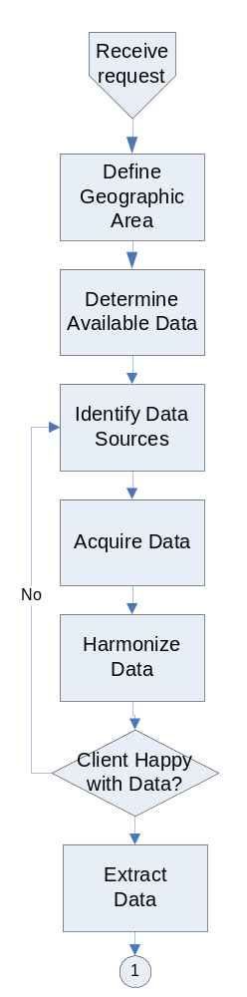
- Determine available data (data scanning)
What data are available for inclusion in the report? The sensitivity here depends on the level of geography is required i.e. a street intersection, a town, a Local Government Authority, a Statistical Division or what have you.
- Identify Data Sources
Data may be sourced from Commonwealth Departments), other State Government Agencies and Local Government Authorities, private data holders/suppliers and special interest group such as Professional Associations.
- Acquire the data.
Data not already accessible needs to be ordered, or access arrangements formalized, from the relevant agencies. This may require payment and/or data use monitoring
- Harmonize the data.
Data is received from agencies and converted into a suitable form. The datasets acquired may require post processing to extract information for the area of interest and allocation modeling to align different data sets to a common definition of a boundary for the “region”.
Feedback sought from the client regarding data sources.
- Extract Data. This is the process of actually displaying, downloading, or otherwise delivering the user required data in a content neutral manner, such as GML.

- Analyze and Interpret  These are undertaken as needed. For example, statistical analysis would be used to calculate a median farm size for the particular region. Another example would be to calculate the percentage increase in the combustible litter in the region; this could be compared to previous estimates to determine rates of change. Results of the analyses are stored for audit purposes and may also be used as input to further analyses. | 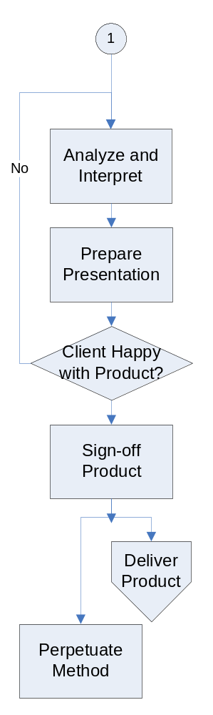
- Prepare Presentation.
The report is then written which includes graphs, tables, and maps. The result is a printable document.
- Validate and Assure Quality
The draft report is completed including the quality assurance of data in the report and the textual interpretation of the data.
Feedback is sought from the client regarding report layout and style.
- Product Sign-off.
Report is then submitted for approval.
- Product Delivery
Report is delivered to client.
- Method Perpetuation
The procedure used to generate the report is formalised so that the information product can be re-generated with current data and/or different data for the same or different areas with similar data inventories.
    - The Regional Reporting Use Case
Only a high-level use case analysis is undertaken here.
Full, definitive elaboration of the Regional Reporting use case, in the accepted narrative forms for system analysis and design, are beyond the scope of this document because:
- Feedback is required from all the participants. Definition of user cases is best done in collaboration with the stakeholders.
- The variety of potential requests sought by users is very broad, each instance of which requires its own definitive analysis;
- The variety of data sources available as input to reporting is likely to increase rather rapidly in the near future, with an increased sophistication in clients’ requirements;
- The types of analyses to be prepared for interpretation will also likely increase in sophistication as distributed custodial services become the accepted norm.
For current purposes, a high-level use case portrayal may be envisaged as per the following figure:
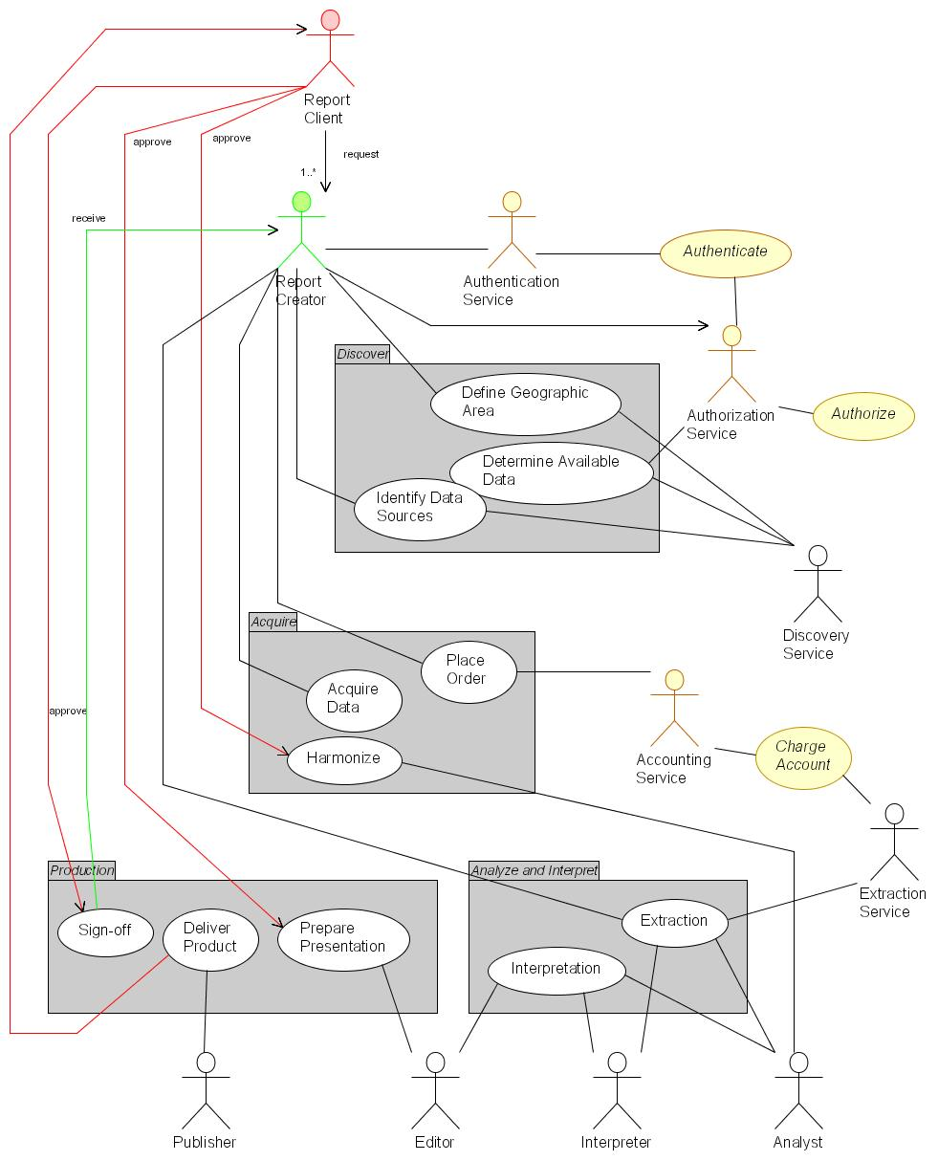
Figure V5-21: Regional Reporting – high-level use case portrayal
Production of regional reports involves numerous actors, both human and autonomous processes. The mix of these will evolve over time as ready-automated, high-demand actions become service components.
It should be apparent that considerably more actors are involved than those explicit in the above process description– actors required for authorization, authentication, accounting, discovery, analysis, editing and publishing, as well as for requesting and creating a particular report.
The sequence and timing for automation of any or all of these actors is a matter for consideration after the project scenarios are documented. It is feasible, for example, that any one of authentication, authorization or accounting services, while likely to fully automated in future, could be deferred to manual management while nonetheless delivering examples of regional reporting. Certain actions, such as data extraction, are good candidates for immediate automation and could be analyzed further immediately. Other, highly intellectual actions such as interpretation are likely to be carried out manually.
    - The Regional Reporting Data Processes
A review of the data access and process requirements of any specific Regional Reporting requirement must, of course, depend on the specific report required and the analyses and interpretation required to prepare it.
Nonetheless, we can envisage generic requirements, as represented in Figure V5-3 (below).
For current purposes, we overlook the data access and process requirements for user authentication, authorization and accounting. These facilities are recognized as necessary for the SIDP, and are assumed to be evolving from the on-going work of OASIS and related groups, in manners consistent with the standards and principles of OGC Web Services.
Referring to the figure V5.3:
- It is reasonable to believe that combinations of location name selection (such as locations or regions) and spatial specification (such as a ‘cookie cut’ drawn on a selection map to show a region of interest) will drive discovery of content and services.
- These selections will drive an identification of the services relevant to that region and provide the user with metadata description of those services and their accessible content, including their capabilities, attributes and bindings. Numerous registry services may be used to interrogate registry repositories for this.
- Named-based (i.e. Gazetteer services) return spatial coordinates to drive registry interrogation, whereas ‘cookie cuts’ provide these coordinates directly.
- Numerous registry and catalogue services supply the user with metadata descriptions of relevant content, for designation to the selected services.
- Data extraction service(s) cause a number of relevant repository services to deliver geodata, whether as GML, shapefiles, tables or other forms. Users may visualize some of these directly as required.
- Extracted data may also be delivered to the user’s agent(s) and made available for other portrayals and processes.

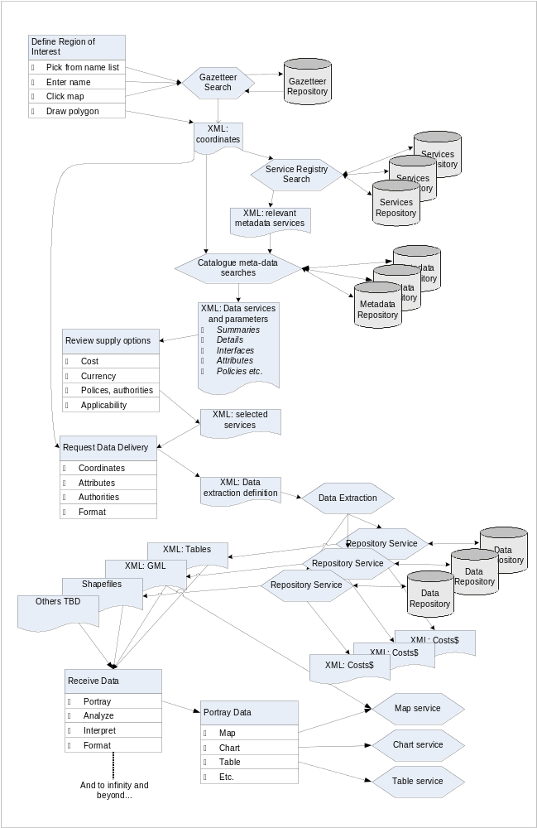
Figure V5-3: Regional Reporting – high-level data use portrayal
Production of regional reports involves numerous actors, both human and autonomous processes. The mix of these will evolve over time, as high-demand automatable actions become service components.
    - The Regional Reporting User Interaction
A review of the user interface and interaction requirements of a specific Regional Reporting requirement must, of course, depend on the specific report required and the analyses and interpretation required to prepare it.
Nonetheless, we can envisage generic requirements, as represented in Figure V5-.
A variety of web service interactions are required, but only a minority of them interacts directly with user interfaces. All inter-service communication is mediated by XML-based message payloads, such as the GML.
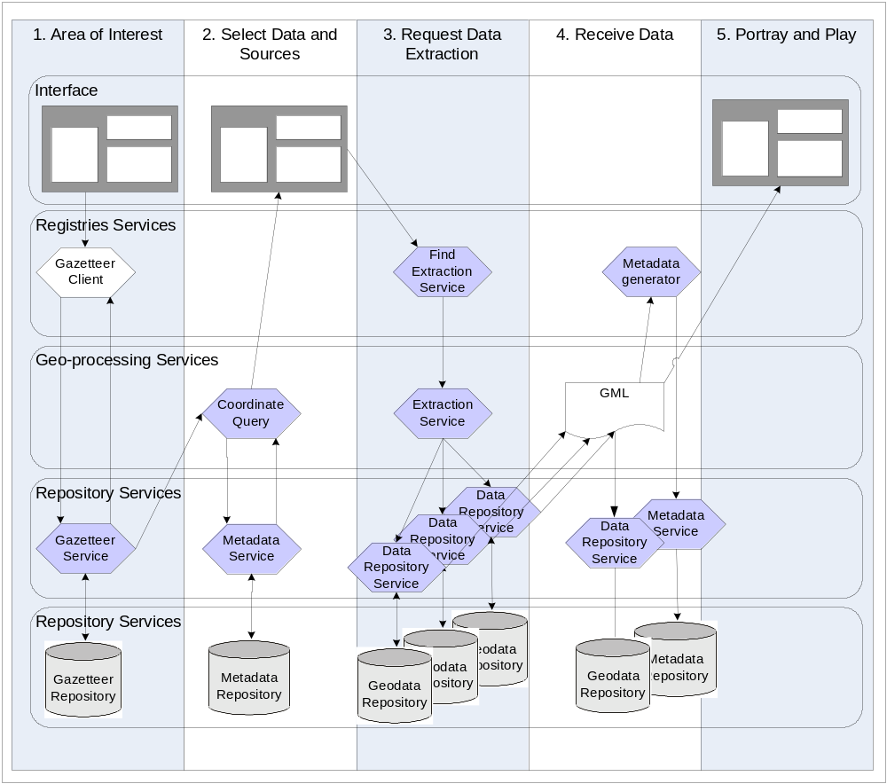
Figure V5-4: Regional Reporting – high-level user interaction portrayal
Users’ perception of interaction with the SIDP platform in the course of, say, generating a regional report belies a flurry of transactions taking place amongst various services performing discovery, data access geo-processing and portrayal, as well as managing the storage and description of newly generated data sets.

    - Capabilities Required
Authentication service to identify logon characteristics and to determine eligibility to see certain information products
Workflow definitions need to be established which describes the options for available information products and directs the process of data and process discovery, acquisition, processing and presentation
A directory of data accessible by each contributor and the terms and conditions for access and use (fit for purpose) of the data (meta data catalogue services)
A directory of the services that provide data processing, modeling and display options available from which computer on the network and its conditions of access and use (registry services).
Once located the data has to be accessed through data access services.
Data may need to be harmonised (re-projected, aligned for the scale of display dictated by the information product) and/or generalised (to fit on the screen or map window in a document).
Models may need to be executed such as fuel loading projections for the area or trend analysis of residential development or disease profiles – weather predictions in the event of long-term conditions such as drought or drastic short term such as a cyclone. (Modeling Services)
All the information has to be presented to the compiler as well as to the user (Portrayal Services including Style layer descriptors, symbology standardisation etc).
Messaging services will be required not just to communicate between the processes in the work flow but as notifications if certain data is not available, or errors occur in the chained processes, escalation rules might need to be included if response times (in service level agreement registry) are not met
Messages will also need to be sent and received from the customer about the state of the product and/or any issues that arise as a result of the presentation of the product (Customer Services).
    - Components Required for the Regional Reporting Use Case
A a full elaboration of the Regional Reporting use case was not undertaken because the representation here is indicative for the processes which will be undertaken by the SIDP project participants. Similarly, a rigorous definition of the service components that need to be implemented to support Regional Reporting would be refined by further analysis of specific scenario requirements.
However, the high-level use case suggests a minimum set of service components that would have to be available for Regional Reporting and as such to be feasible in the SIDP context. These suggested components are portrayed in the following figure.
Figure V5- below represents service components for regional reporting, of which the following points should be noted:
- The view is that of the reporting invoker;
- Numerous data repositories are assumed to exist already and are not portrayed explicitly. These include data set catalogues (metadata), authority and authentication metrics, accounting records and portrayal definitions such as style layer descriptors and symbology libraries;
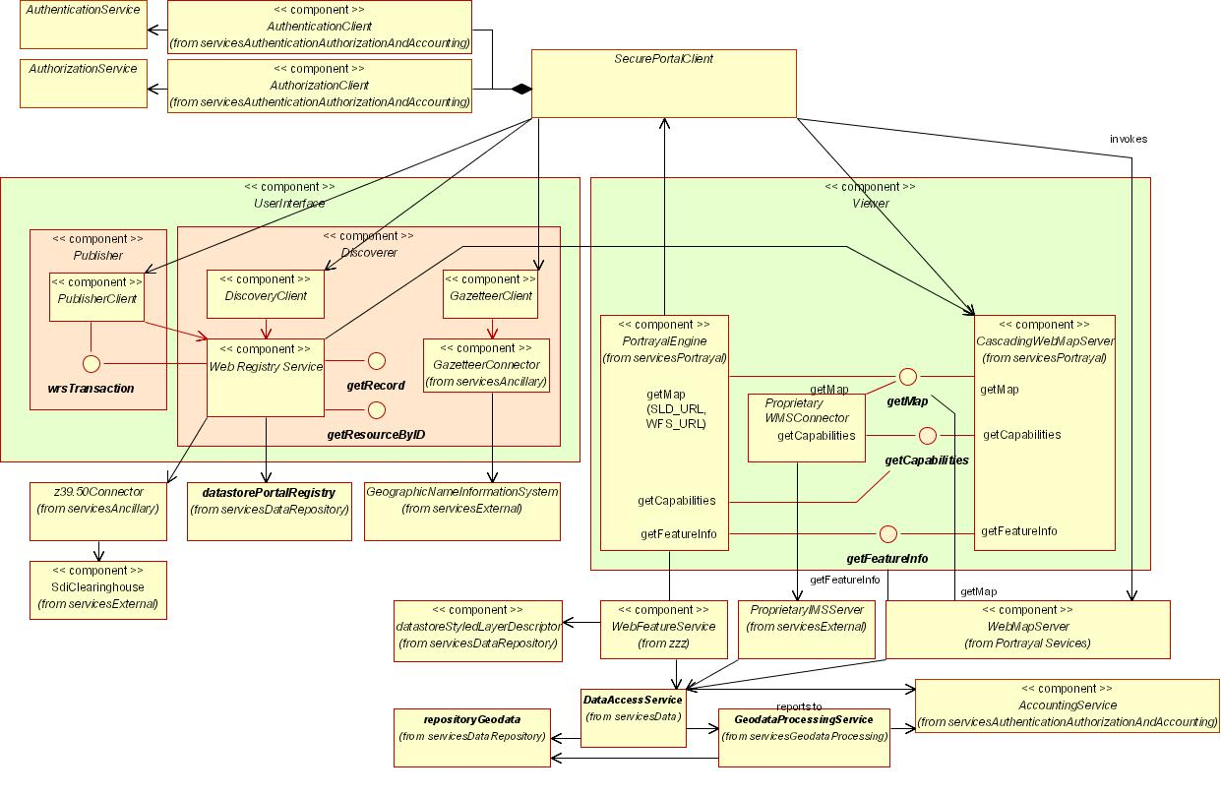
Figure V5-5: Regional Reporting - Indicative Service Components
A number of reusable components will need to be implemented to support an application such as regional reporting. Many of these are embodied in SCOTShelf (SCOTS) systems. More telling are the required repositories that will have to be assembled, operated and managed by SIDP collaborators.
- Many of the above data set repositories could also likely require references libraries of allowed types to assist and constrain authoring of the appropriate metadata;
- Many of the portrayal services are also available off-the-shelf as WMS and WFS implementations in the public domains and as SCOTS products;
- The interfaces portrayed are all defined according to OpenGIS specifications;
- Some external components, such as the clearinghouse connector, already exist and are available in both the public domain and the SCOTS world
As noted in earlier sections, the investment by the participants required to develop the first of each class of these components will yield payback in developing subsequent instances – the first library manager will stand as a model for each subsequent library manager, for example.
Finally: the apparent complexity visible in the following figure belies the fact that at least half of these components – data location, gazetteer discovery, portrayal services - will be required for any distributed services envisaged under the SIDP. Regional Reporting is likely to be as indicative driver of SIDP requirements as any other.
    - Priority Services
Based on best practices in other SDI implementations around the world, and the OGC Staff and OGC architecture consultants own experiences in SDI implementation, key service capabilities for the SIDP, which collectively are likely to be required for 80% of applications, and which can (with one exception) be implemented immediately are identified as:
- Registries supporting discovery of services and geodata content
- WFS Gazetteer services supporting users’ intuitive access to geodata, and providing the basis for Geocoding and Geoparsing.
- WFS and SLD-enabled cascading WMS Portrayal services for presenting representations of data to users, such as maps, charts, tables, animations, simulations.
- Repositories that store and serve geospatial features, coverages, schemas, registry information and management records.
- Data extractors for creating copies of designated data from repositories in standard formats such as GML, either for delivery to users or for forwarding to geoprocessing services
- Client generators for creating the web pages to be used by people at web browsers, in order to specify tasks to be carried out or to receive results.
- Basic geoprocessing capabilities such as coverage generalization, intersection, joining
- Authentication, authorization and accounting facilities to ensure that only appropriate activities occur for approved clients, and that are accounted for.
    - How this Aligns to the Component Levels of the Notional Architecture
Each of the components portrayed in Figure V5-2 is an element of the notional architecture elaborated more fully in the Computation Viewpoint detailed in Volume 3. The current elaboration encompasses about 90 components; the Regional Reporting analysis encompasses about 40, as tabulated below (see Table V5-2: Notional Components required for the Use Case Scenario) and in fact will number significantly more than this should a full implementation be required for elements like authentication, authorization, accounting, workflow management and other ‘non GIS’ elements.
    - Extensibility of the Use Case Method
The current model could be extended to provide information for school children (to which they could contribute). Economic development profiles detailing available industrially zoned land, labour profiles etc and, being an electronic web document could link an index of vulnerability for critical infrastructure to any particular site.
The extensibility of the model is indicative of the requirement that the notional architecture be:
- Scalable and flexible;
- Component based, the regional report is a component for setting the context for any number of other applications;
- Provide for user identification, authentication and authorisation security and role management; and
- Some of the profiles could attract fees and as such the scenario can be expanded to include on line ordering and payment processing. Fees could be scaled between profiles for different target customers with discounts for multiple purchases. Therefore the scenario can be extended beyond the scope of this project yet provide a common frame of reference.
Scalability is both up, and down, in the sense that a profile for a fire fighter at an office block could be included. Such a profile would use the same web services as the other scenarios but could have different extension to meet these specific requirements.

    - Mapping Components to Scenarios
The capabilities described above are now compared to a common suite of spatial information service components as identified by from various best practice implementations of spatial data infrastructures to identify those required. A priority is assigned to each of these.

Table V5-2: Notional Components required for the Use Case Scenario
Priority ratings are ✓ for ‘needed later on’, ✓✓ for ‘needed soon’
and ✓✓✓ for ‘needed immediately or sooner’;
no ✓ means ‘optional, not in the scope of the Use Case scenario’
Service |  | Component | Priority | Originator | Developer | Operator | Notes
Application Service Components |  | Data Extraction Client Generator | ✓
 |  | Discovery Client Generator | ✓✓✓
 |  | Gazetteer Client Generator | ✓✓✓
 |  | Map Viewer Client Generator | ✓✓✓
 |  | Publisher Client Generator | ✓✓
 |  | Symbol/Style Management Client Generator | ✓
 |  | Workflow Definition Client Generator | ?
Authentication, Authorization and Accounting Service Components
Data Repository Service Components | Datastore | Accounting Records Datastore | ✓✓
Data Repository Service Components | Datastore | Coverage Datastore
Data Repository Service Components | Datastore | Feature Datastore | ✓✓✓
Data Repository Service Components | Datastore | Gazetteer Datastore | ✓✓✓
Data Repository Service Components | Datastore | Geolinked Datastore | ✓✓✓
Data Repository Service Components | Library | Map Style Library | ✓✓
Data Repository Service Components | Library | Map Symbol Library | ✓✓
Data Repository Service Components | Library | Service Type Library | ✓✓
Data Repository Service Components | Registry | Component Registry | ✓✓✓
Data Repository Service Components | Registry | Geodata Resource Registry | ✓✓✓
Data Repository Service Components | Registry | Service Registry | ✓✓✓
Data Repository Service Components | Registry | Type/Schema Registry | ✓✓✓
Data Repository Service Components | Registry | User Registry | ✓✓✓
Data Service Components |  | Coordinate Transformation Service
 |  | Data Extraction Service
 |  | Format Conversion Service | ✓
 |  | Geolinked Data Access Service | ✓✓✓
 |  | Web Coverage Service
 |  | Web Feature Service | ✓✓✓
Geodata Processing Service Components |  | Coverage Analysis Service
 |  | Data Reallocation Service
 |  | Feature Association Service
 |  | Gazetteer Service
 |  | Geolinking Service | ✓✓✓
 |  | Geoparsing Service | ✓✓✓
 |  | Portrayal Service Component
 |  | Cascading SLD-enabled Web Map Service | ✓✓
 |  | Coverage Portrayal Service
 |  | Web Map Service | ✓✓✓
Registry and Catalogue Service Components |  | Components Registry Service | ✓✓✓
 |  | Event Registry Service
 |  | Geodata Resource Registry Service | ✓✓✓
 |  | Map Style Management Service | ✓
 |  | Map Styles Registry Service | ✓
 |  | Service Registry Service | ✓✓✓
 |  | Symbol Library Service
 |  | User Registry Service | ✓✓✓
Ancillary Components |  | Clearinghouse Connector | ✓✓
 |  | Discovery Service | ✓✓
 |  | Workflow Enactment Service | ✓✓

    - Status of Required Components
The components identified above are now reviewed to consider their status of implementation as existing services in relation to the SIDP, or as web services elsewhere in the world. Where no reference implementations exist, an indication is given of the state of development of their open specifications.
Components already implemented as web services receive the “✓” and show the custodian and specification.
Components likely to be implemented in the near future show an indicative date and the agency developing it.
Components not even on the horizon as web services get the 
Table V5-3: Existing Components versus Required Capabilities
Service |  | Component | Priority | Implementation
 |  | Component | Priority | Qld | Global
Application Service Components |  | Data Extraction Client Generator | ✓ |  | Geoconnections
 |  | Discovery Client Generator | ✓✓✓ | ✓ NR&M  OCS 1.1 | ✓ Many  OCS 1.1
 |  | Gazetteer Client Generator | ✓✓✓ | NR&M 2004 | Many  Soon
 |  | Map Viewer Client Generator | ✓✓✓ | ✓✓✓  EPA, NR&M | ✓✓✓  Many
 |  | Publisher Client Generator | ✓✓ |   Clearinghouse | ✓✓✓  Many
 |  | Symbol/Style Management Client Generator | ✓ |  | ?
 |  | Workflow Definition Client Generator | ✓✓✓ |  | Part of OGC Web Services 2.0. Using BPEL.
Authentication, Authorization and Accounting Service Components |  | Authorization Type Service | ✓✓✓ |   DIIE | OASIS 2004
 |  | Usage Policy Decision Points Service | ✓✓✓ |  | OASIS 2004
 |  | Usage Policy Service | ✓✓✓ |  | OASIS 2004
 |  | User Authentication Service | ✓✓✓ |  | OASIS 2004  GeoConnections (SAML)
 |  | User Authorization Service | ✓✓✓ |  | OASIS 2004
Repository Components | Datastore | Accounting Record Datastore | ✓✓✓ |   GLS | OASIS 2004
Repository Components | Datastore | Feature Datastore | ✓✓✓ | ✓  NR&M 2004 | ✓✓✓  Many
Repository Components | Datastore | Gazetteer Data store | ✓✓✓ | ✓  NR&M 2004 | ✓✓✓  Many
Repository Components | Datastore | Geolinked Data store | ✓✓✓ | ? | ✓✓✓  Many
Repository Components | Datastore | Management Records Data store | ✓ |  | ?
Repository Components | Datastore | Workflow Data store | ✓✓✓ |  | OASIS 2004
Repository Components | Library | Authority Type Library | ✓✓ |  | OASIS 2004
Repository Components | Library | Component Type Library | ✓✓ |  | OGC 2004
Repository Components | Library | Custodian Type Library | ✓✓ |  | OGC 2004
Repository Components | Library | Institution Type Library | ✓✓ |  | OGC 2004
Repository Components | Library | Map Style Library | ✓✓ |  | OGC 2004
Repository Components | Library | Map Symbol Library | ✓✓ |  | OGC 2004
Repository Components | Library | Service Type Library | ✓✓ |  | OGC 2004
Repository Components | Library | Type/Schema Library | ✓✓ |  | OGC 2004
Repository Components | Library | Utilization Policy Type Library | ✓✓✓ |  | OGC 2004
Repository Components | Registry | Component Registry | ✓✓✓ |  | OGC 2004
Repository Components | Registry | Custodian Registry | ✓✓✓ |  | OGC 2004
Repository Components | Registry | Geodata Resource Registry | ✓✓✓ |  | ✓✓✓  Many
Repository Components | Registry | Institutions Registry | ✓✓✓ |  | OGC 2004
Repository Components | Registry | Service Registry | ✓✓✓ |  | OGC 2004
Repository Components | Registry | Type/Schema Registry | ✓✓✓ |  | OGC 2004
Repository Components | Registry | User Registry | ✓✓✓ |   Clearinghouse | OASIS 2004
Data Service Components |  | Data Extraction Service | ✓✓✓ |   Clearinghouse  whole data sets only | ✓✓✓  Geobase (Canada)
 |  | Format Conversion Service | ✓ |  | ✓
 |  | Geolinked Data Access Service | ✓✓✓ |  | ✓✓✓  Many
 |  | Web Coverage Service |  |  | ✓✓✓  EROS
 |  | Web Feature Service | ✓✓✓ | NR&M 2004 | ✓✓✓  Many
Geodata Processing Service Component |  | Data Alignment Service | ✓✓ |  | ?
 |  | Feature Generalization Service | ✓ |  | ?
 |  | Geolinking Service | ✓✓✓ |  | ✓✓✓  Many
 |  | Geoparsing Service | ✓✓✓ |  | 
 |  | Modeling Service | ✓ |   DLGP? | ???  Many?
 |  | Cascading SLD-enabled Web Map Service | ✓✓ |  | ✓✓✓  Many
Registry and Catalogue Service Component |  | Components Registry Service | ✓✓✓ |  | OGC 2004  GeoConnections
 |  | Custodian Registry Service | ✓✓✓ |  | OGC 2004
 |  | Geodata Resource Registry Service | ✓✓✓ | ✓✓✓  ASDD | ✓✓✓  Many
 |  | Institutions Registry Service | ✓✓✓ |  | OGC 2004
 |  | Map Style Management Service | ✓ |  | OGC 2004
 |  | Map Styles Registry Service | ✓ |  | OGC 2004
 |  | Service Registry Service | ✓✓✓ |  | OGC 2004
 |  | Types/Schemas Registry Service | ✓✓✓ |  | OGC 2004
 |  | User Registry Service | ✓✓✓ |  | OASIS 2004
 |  | Workflow Definition Service | ✓✓✓ |  | OASIS 2004
Ancillary Component |  | Clearinghouse Connector | ✓✓ | ✓✓✓  ASDD | ✓✓✓  Many
 |  | Discovery Service | ✓✓ |  | 
 |  | Workflow Enactment Service | ✓✓ |  | 

  - Use Case Service and Value Chains
One or more elaborated Use Case scenarios would then be portrayed as service and value chains, using the identified components to form the basis for assigning costs to implementing and maintaining the services used to create products, and hence the cost of those products.
Individual services that are required to meet users’ specified product requirements are discovered through various registry services, and are invoked (possibly by an automated manager/agent) in an appropriate sequence and at an appropriate cost. Results at each stage are passed to subsequent processes as well-formatted packages, usually in an XML variant such as GML. All communication amongst services is mediated through open Internet protocols, in particular tcp/ip, http and HTML.
A generic portrayal is shown in Figure V5-6. The salient points to note are:
- Services are chained via standard web service interfaces and internet communications;
- Each service adds value to the delivered product;
- Each service reports a cost for use which contributes to the overall cost of production and may or may not be reflected in the cost borne by the user for requesting the product(s) according to service policy;
- The sequence of services may, soon, be determined dynamically based on discovery through their published or interrogated capabilities; and
- Sequences of services may already be provided as predefined packages (workflows) for user invocation; such packages may themselves be stored persistently (managed by a custodian) and published through registries.
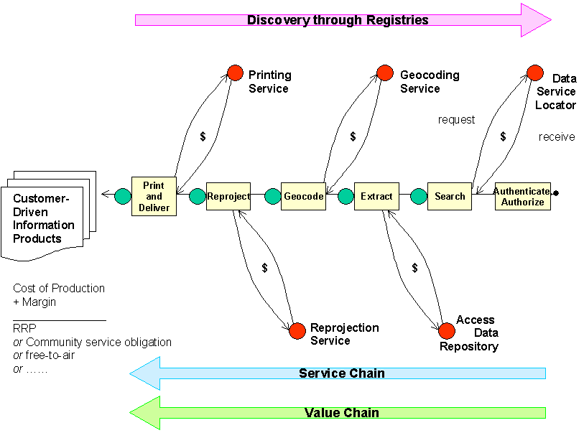
Figure V5-6: Representative Service and Value Chaining Concept
Services are cascaded, or chained, to meet user-specified requirements. Services support discovery, access control, accounting, processing and portrayal. Each service adds value to the product and bears an associated cost that contributes to the overall cost of production of the requested product(s). Such costs may or may not be passed onto product requesters, according to service policy.

A persistent point of discussion relates to administrative issues involving such topics as copyright, pricing, terms and conditions of use, data security and concurrency. The supply/value chain model outlined above also provides a framework against which such topics can be mapped (Figure V5-7). The purpose of the mapping is to illustrate what the impact on the information product will be if any of the topics become barriers to the creation of the information product. The barrier might be the terms and conditions of use, pricing and/or a multiple of other topics. If each topic is taken in isolation it is likely that existing impasses will remain. It is proposed that if the topics are visualized in terms of their potential impact on the delivery of specific products and services then this might be a method of resolving any nexus. Compartmentalization of the issues/topics allows the definition of business rules within the workflows and permits the information products/services to be created. The business rules are formalized and available for change as the processes and policies are fine-tuned.

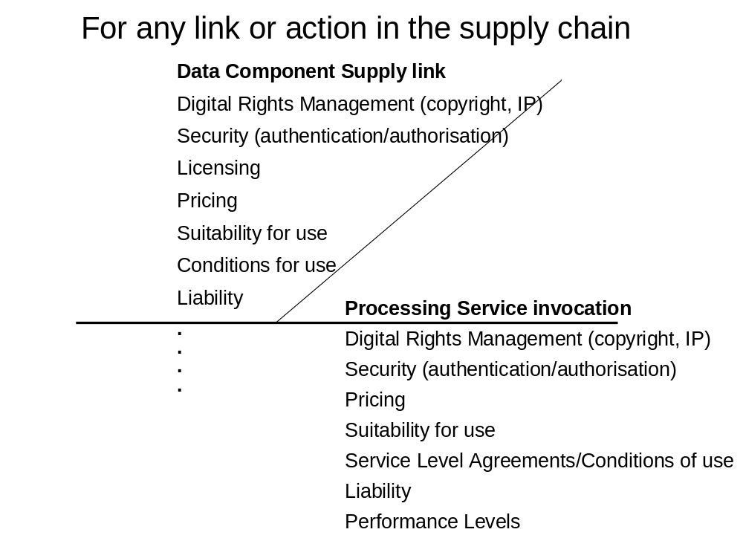5-

Figure V5-7: Allocation of potential barriers to links and actions in the Supply/Value Chain
Example topics, potential barriers for links to be made in the supply chain workflow are allocated to the links for resolution with the respective supplier(s)/custodian(s),definition of business rules and rules for update.
  - Justification for Approach
The proposed model does not start from scratch but builds existing systems already delivering products, services and business outcomes, and can be used or adapted to provide implementation of elements within the components-based architecture. This then will help deliver the outcomes.
This proposed approach therefore provides:
- A framework for the development of a web services master plan derived through an inclusive and consensus based process;
- Procedures for aligning business process requirements against components and services;
- A process for progressively filling service requirements as needed;
- A guiding framework within which users can describe their requirements through a mutually understood process;
- A method for modeling supply/value chain definitions to assess the impact of pricing of data and processing services on the cost-of-production of products rather than cost recovery of past decisions;
- Means for accumulating benefits through re-use of data and processing functionality and
- Examples of the way in which accessibility of custodial data, data of known provenance, with an accumulating history of use (fitness for purpose) would impact current practices and costs.

Appendix: Acronyms
ACXML | Access Control Extensible Markup Language (OASIS): see http://www.oasis-open.org/committees/tc_home.php?wg_abbrev=xacml
AGI | Association for Geographic Information (UK): see http://www.gigateway.org/
AGLS | Australian Government Locator System
ALGA | Australian Local Government Association: see http://www.alga.com.au/
ANZLIC | Australian New Zealand Land Information Council: see http://www.anzlic.org.au/
ASDD | Australian Spatial Data Directory: see http://asdd.ga.gov.au/asdd/
ASDI | Australian Spatial Data Infrastructure
ASIBA | Australian Spatial Industry Business Association: see http://www.asiba.com.au/
AUSLIG | Australian Survey and Land Information Group
BPR | Business Process Review (Queensland State Government)
CANRI | Community Access to Natural Resource Information (NSW) see http://www.canri.nsw.gov.au/
CMS | Cascading Map Server (OGC WMS)
COI | Community of Interest
COTS | Commercial off-the-shelf (software)
CQL | Common Catalogue Query Language (Library of Congress, USA): See http://www.loc.gov/z3950/agency/zing/cql/
CRC | Cooperative Research Centre (Australia): see https://www.crc.gov.au/
CSDGM | Content Standard for Digital Geospatial Metadata (FGDC, USA)
DACS | Distributed Access Control System: see http://dacs.dss.bc.ca/arch-spec.html
DES | Department of Emergency Services (Qld)
DIIE | Department of Innovation and the Information Economy (Qld): see http://www.iie.qld.gov.au/
DLGP | Department of Local Government and Planning (Qld): see http://www.dlgp.qld.gov.au/
DLI | Department of Land Information (Western Australia)
EbRIM | ebXML registry information model (OASIS): see http://www.ebxml.org/specs/ebRIM.pdf
EbXML | E-business Extensible Markup Language (OASIS): see http://www.ebxml.org/
EC | European Commission
e-GIF | E-Government Interoperability Framework
EPA | Environment Protection Agency (Qld)
EROS | Earth Resources Observation Systems (USA)
EU | European Union
FGDC | Federal Geographic Data Committee (USA): see http://www.fgdc.gov/
GA | Geosciences Australia (Australia Government): see http://www.ga.gov.au
GIA | Government Information Architecture (DIIE, Qld)
GIF | Graphic Interchange Format (Unisys)
GILS | Government Information Locator System (USA): see http://www.access.gpo.gov/su_docs/gils/
GINIE | Geographic Information in Europe (EC): see http://www.ec-gis.org/ginie/
GIS | Geographic Information System
GML | Geography Markup Language (OGC): see http://www.opengis.org/docs/02-023r4.pdf
GNIS | Geographic Name Information Service
GOS-P | Geo-spatial One-Stop Portal (US Government): see http://www.geo-one-stop.gov/
GSDI | Global Spatial Data Infrastructure
GSL | Government Services Locator
HDF | Hierarchical Data Format: see http://hdf.ncsa.uiuc.edu/
HTML | Hypertext Markup Language (W3C): see http://www.w3.org/MarkUp/
http | Hypertext Transport Protocol (W3C): see http://www.w3.org/Protocols/
IETF | Internet Engineering Task Force: see http://www.ietf.org/
IPA | Integrated Planning and Assessment (Qld)
SIDP | SIDP
ISCGM | International Standing Committee for Global Map http://www.iscgm.org/
ISO | International Organization for Standardization http://www.iso.org/
JPEG | Joint Photographic Expert Group format (including JPEG2000)
LandXML | An XML schema for land planning: see http://www.landxml.org/
LDAP | Lightweight Directory Access Protocol Error: Reference source not found: see http://www.openldap.org/
MIME | Multipurpose Internet Mail Extension (W3C)
NCSA | National Center for Supercomputing Applications
NIST | National Institute of Standards and Technology (USA): see http://www.nist.gov/
NR&M | Department of Natural Resources and Mines: see http://www.nrm.qld.gov.au/
NSDI | National Spatial Data Infrastructure initiatives
OASIS | Organization for the Advancement of Structured Information Standards: see http://www.oasis-open.org/who/
OCS | OpenGIS Catalog Services (OGC) Error: Reference source not found
OECD | Organization for Economic Cooperation and Development
OESR | Office of Economics and Statistical Research (Qld)
OGC | Open GIS Consortium (USA)
OgcRIM | OGC registry information model
OSI | Open Source Initiative
OSS | Open-source software
OWS | Open Web Service (OGC) Error: Reference source not found
PDA | Personal Digital Assistant
PKI | Public Key Infrastructure (NIST): see http://csrc.nist.gov/pki/
PNG | Portable Network Graphics (OGC) see http://www.w3.org/Graphics/PNG/
QIO | SIDP Information Office
QoS | Quality of Service
QPW | Department of Public Works (Qld): see http://www.publicworks.qld.gov.au/
QSIIC | Queensland Spatial Information Infrastructure Committee
SIDP | Queensland Spatial Information Infrastructure Strategy: see http://www.SIDP.qld.gov.au/
ROSI | Roster of Strategic Information (OESR, Qld)
SAML | Security Assertion Markup Language (OASIS) Error: Reference source not found
SCOTS | Standards-based Commercial Off The Shelf (software)
SDI | Spatial Data Infrastructure
SDTS | Spatial Data Transfer Standard (USGS): see http://mcmcweb.er.usgs.gov/sdts/
SFS | Simple Features Specification (OGC): see http://www.opengis.org/techno/specs/99-049.pdf
SII | Services Integration Infrastructure (Qld)
SLD | Styled Layer Descriptors (OGC): see http://ogc.cast.uark.edu/tnm/web/sld.html
SLIP | Shared Land Information Platform (DLI and WALIS, WA)
SOAP | Simple Object Access Protocol (W3C) Error: Reference source not found
SSQ | Smart Services Queensland
tcp/ip | Transport Control Protocol/ Internet Protocol (IETF)
TIFF | Tagged Image File Format: see http://home.earthlink.net/~ritter/tiff
UDDI | Universal Discovery Description and Integration (OASIS) Error: Reference source not found: see http://www.uddi.org/
UNEP | United Nations Environment Programme (Kenya): see http://www.unep.org/
UNGIWG | UN Geographic Information Working Group (USA): see http://www.ungiwg.org/
URI | Uniform Resource Indicator (W3C)
URL | Uniform Resource Locator (W3C)
USGS | US Geological Service (USA)
W3C | World-Wide Web Consortium: see http://www.w3.org
WALIS | Western Australian Land Information System: see http://www.walis.wa.gov.au/
WAP | Web Access Protocol
WCS | Web Coverage Service (OGC) Error: Reference source not found
WFS | Web Feature Service (OGC) Error: Reference source not found
WMS | Web Mapping Service (OGC) Error: Reference source not found
WPOS | OpenGIS Web Pricing and Ordering Service (OGC) Error: Reference source not found
WSDL | Web Services Description Language (W3C) Error: Reference source not found : see http://www.w3.org/TR/wsdl
XML | Extensible Markup Language (W3C) Error: Reference source not found : see http://www.w3.org/XML/
  - Glossary
Application | A program that performs a specific function directly for a user. Applications can make use of SDI.
Architecture | The organizational structure and operating environment of the SDI, including the relationships between its parts, and the principles and guidelines governing their design and evolution over time.
Binding | Specific syntax and parameter values used by a Client to invoke a specific Server Operation
Capabilities schema | XML schema that prescribes and constrains the syntax and vocabulary for the expression of service capabilities in XML.
Capabilities XML | Specific instance of service-level metadata describing a Service instance.
Catalogue | A registry that, in the SDI context, is usually used to describe spatial data sets.
Client | A software Component or an Application that accesses a Service.  Clients may be categorized in three ways:  Thin clients where the client supports only human-interface code, such as a web browser, an X-terminal, a text-only interface, a minimal PDA or WAP handset, and must support non-proprietary standards. Typically, lack long-tem memory such as disk drives. Application code and data access both run remotely, and so are entirely dependant on external network connection.  Thick clients where the client supports all the human interface and application code, may support some or all data access code, and may support long-term data memory. Human interface code may be entirely customized and not conform to non-proprietary standards. May not even support human interfaces i.e. may be entirely automated emote processes. May operate at times without network connection.  Chubby clients have capabilities somewhere on the spectrum between thick and thin clients i.e. may support some application and data code, and may store limited amounts of data. Will usually but not necessarily support human interfaces. May operate well for limited time without network connection.  A client may be any Web Agent or Web Service.
Component | Software that packages the Client or Server implementation of a Service and can provide the realization of a set of Interfaces. A component consists of software code (source, binary or executable) or other equivalents such as scripts or command files.
Conceptual Architecture | An overview of the Service, data, technology and institutional environment of SDI. It describes, in general terms, both what the SDI will include, and how it will operate.
Core Service | A Service that is critical to the ongoing operations of the SDI. The Error: Reference source not found service is an example of a core service. It is used to keep track of where SDI services can be found, so if this service were unavailable, client applications would not be able to locate the services required in order to complete a task.
Coverage | A continuous representation of a portion of the earth's surface. A coverage may be a collection of features (like a vector dataset) or it may be a raster or gridded surface representing one or more attributes.
Coverage Data | Gridded data, imagery, swath data, and continuous functions. Contains values for every point in a geospatial data. Relevant specifications for SIDP coverage data formats may include:  - SDTS - Spatial Data Transfer Standard  - GeoTIFF - Georeferenced Tagged-Image File Format  - HDF – Hierarchical Data Format
Custodian | The authoritative manager of an SDI resource, whether data set, Service or Component, who is responsible for declaration of the policies regarding utilization and accounting for the resource.
Datastore | Any type of persistent storage for SIDP components and data. Content may be static or dynamic.  May include database systems, file systems, structured text storage, XML repositories etc.
Event | An occurrence of interest to users or developers of the SDI. Events can be things such as the adjustment of a feature in a Framework Data layer, a flood, or the release of a new specification for an SDI Service.
Framework Data | The set of Geospatial Data that provides the reference framework for all other SDI compliant Geodata. See the SDI Framework Data Definition (http://www.geoconnections.org/opportunities/rfp/framework/rfp_sd_definition_E.pdf).  Seven geospatial data themes may be considered to be of fundamental importance to many applications. Known as "Framework Data," these themes are: Elevation, Orthoimagery, Hydrography, Transportation, Government Units (administrative boundaries), Cadastral (property boundaries), and Geodetic Control.  Framework Data shall, at minimum, are able to exchange data in a manner that complies with these emerging standards. SIDP shall be able to access both Framework Data sources and other, non-Framework data.
Gazetteer | A dictionary of geographical names. May encompass locations, cultural and landscape features, and may embody various naming conventions including official name, names in common usage, traditional and community-based names. Attributes of gazetteer entries may include geographic coordinates, extent and topology.  May be implemented through Error: Reference source not found for SDI applications such as user interfaces as well as support for Geocoding, Geoparsing and Geolinking services.
Geocoding | Associating geographic coordinate data with geographic names such as locations and addresses.
Geodata | Georeferenced spatial data such as a road network or a satellite image. Geodata explicitly describes the spatial extent of a set of features or describes a measurable surface. It includes both Geospatial Data and Geolinked Data.
Geodata Resource Registry | Peer registries that contain metadata about Geodata resources. These registries identify the agencies that are responsible each attribute dataset, and descriptions of that attribute data. They also contain information on how to access the data.
Geolinking | Associating non-spatial data with geographic coordinates via a reliable unambiguous attribute.
Geolinked Data | Geodata that are referenced to an identified set of geographic features without including the spatial description of those features. Geolinked data is normally attribute data in tabular data (such as population counts) that refers to a known framework (such as municipalities), where their unSIDPue identifier (such as the municipality name) refers to the elements (the municipalities). Geolinked data refers to all attribute data that is not directly attached and bundled with the geographic coordinates to which it applies.
Geoparsing | Analyzing textual content such as publications, database entries and text files for occurrences of geographic names, usually in preparation for their Geocoding.
Geospatial Data | Geodata with explicit geographic positioning information included, such as a road network from a GIS, or a georeferenced satellite image. Geospatial data may include attribute data that describes the features found in the dataset.
GeoTIFF | Georeferenced Tagged-Image File Format, an effort by over 160 different remote sensing, GIS, cartographic, and surveying related companies and organizations to establish a TIFF-based interchange format for georeferenced raster imagery. See http://remotesensing.org/geotiff/spec/geotiffhome.html
SIDP | The AusIndustry Interoperability Demonstration Project
Interface | The named set of related Operations that structure how a client interacts with a Server. The state and functionality of the underlying Component is hidden, and is only made externally accessible through its interface (i.e. the interface is the only "public" or "visible" part of the component). The same interface may be provided by several components and used by many components or Application.
LandXML | Facilitates the exchange of data created during the Land Planning, Civil Engineering and Land Survey process. LandXML is an XML application that utilizes XML Schema to define relationships and custom data types. Much like GML, LandXML is a fairly robust application of XML as a data format, targeted specifically towards land planning, engineering and survey applications.
Library | A type of Registry intended for recording references to entity types (as distinct from recording instances) i.e. a look-up. Content is generally static once instantiated
Map | A pictorial representation or portrayal of geographic data
Master System | A Primary System that is mirrored to other identical Systems, so as to ensure that any important information or Services can be accessed in an identical fashion from multiple Sites.
Metadata Standard | Data will be documented according the FGDC Content Standard for Digital Geospatial Metadata (CSDGM) and/or the ISO 19115 Error: Reference source not found
Notional Architecture | An idealized design framework based on vendor-neutral, open standards.
Ontology | The working model of entities and interactions in some particular domain of knowledge or practices, such as electronic commerce or "the activity of planning." A set of concepts - such as things, events, and relations - that are specified in some way (such as specific natural language) in order to create an agreed-upon vocabulary for exchanging information  In artificial intelligence, ontology is, according to Tom Gruber, "the specification of conceptualizations, used to help programs and humans share knowledge.” One or more taxonomies can be developed for the ontology and taxonomies can be used as part of the ontology model.
Operation | An interaction between a Client and a Server, resulting in a transfer of information or an action. An operation can be either an interrogation (i.e. request-response) or an announcement (i.e. notification).
Portal Service | A Site that provides "one-stop" access to the Provider Services.  An online access point to a collection of geospatial data -- more precisely, to a collection of services that provide data or relevant functionality.  A Portal neither stores nor maintains the data and its associated services; rather, these are distributed in many computers nationwide and maintained by the agency or organization that is responsible for its data and services.  Portals shall be based on open standards and specifications that are defined collaboratively by a various interested parties, are freely published, and are able to be implemented by any vendor or organization.
Primary System | A System that provides a Core Service and thus is critical to the operations of the SDI. Although a primary system may not be mirrored to other Sites, or even the most popular implementation of a particular Service, they are publicly identified and funded to ensure that Core Services are implemented on at least one system.
Process | A system offering a single Interface for the execution of a single task creating one or more products.  Processes may be grouped to provide a Service.
Provider Services | Include Map, data, Gazetteer, Catalogue and any other services hosted and maintained at remote sites independently of SIDP and are accessed by the it.  Portal Services is to provide "one-stop" access to the Provider Services.  Provider services may also me accessed directly by Web Agents and by other Web Services.
Reference Architecture | A technical blueprint that identifies and defines the Services that comprise the SDI, and specifies the Interfaces to those services.
Registry | A listing of the specific, individual Services, Components, datasets, or other things that comprise the SDI or are relevant to its users. Instance registries are used to identify, locate, and describe individual instances.  Many registries refer to associated Type Libraries that record the allowed types within registry classes e.g. types of services, types of user authorities.
Request | Invocation of a Service Operation by a Client.
Resource | Data, services and components that are published and underlie the creation of all useful products. Resources are presented to the Internet as Web Services.
Response | Result of an Operation returned to from a Server to a Client.
Schema | A schema is an expression of the Type using a particular data modeling language. Put another way types can be seen as a classification taxonomy for a set of schema definitions. The OGC application data modeling language is GML and each schema fragment corresponding to a given type is defined in GML.
Server | - A software Component that delivers a Service.  - A physical implementation of such a component that provides the realization of its operations.
Service | A collection of Operations, accessible through one or more Interfaces that allows a user to evoke a behavior of value to that user. A Server delivers each service.  A service may encapsulate may Processes.  A "service instance" is another name for a server (b).
Service Capabilities | Service-level metadata describing the Type, Operations, content, and Bindings available at a Service instance.  Organization, classification, and presentation of those entities may also be conveyed by the capabilities information.
Service Registry | Contains metadata about individual Services, including the type of service, and information about how to access the service.  A Service Registry Service provides a mechanism to:  - Register the characteristics of certain types of services (in a Service Type Registry) and register the existence of specific services (in a Service Registry);  - Search Service Registries; and  - Retrieve detailed information (metadata) that describes a service, in order to evaluate its suitability to meet a need.  A Service Type Registry contains information about specific types of services, including the name of the service type, and its definition.
Site | A location (e.g. URL) at which a System is accessed.
Spatial Reference System (SRS or CRS) | A projected or geographic coordinate reference system
Styled Layer Descriptor | Metadata describing presentation of geographical Types for portrayal in Web Map Servers and Error: Reference source not founds.  Addresses the need for geospatial consumers (either humans or machines) to control the visual portrayal of data. It can be used to portray the output of Web Map Servers, Web Feature Servers and Web Coverage Servers.  Uses consistent XML-based methods persisting in an SLD library.
System | Servers and data organized to accomplish one or more Services.  A system may be accessible at more than one Site.  Components of a individually service may be accessible by Web Agents and Web Services.
Taxonomy | The science of classification according to a pre-determined system, with the resulting catalog used to provide a conceptual framework for discussion, analysis, or information retrieval.  In theory, the development of a good taxonomy takes into account the importance of separating elements of a group (taxon) into subgroups (taxa) that are mutually exclusive, unambiguous, and taken together, include all possibilities.  In practice, a good taxonomy should be simple, easy to remember, and easy to use.
Type | A kind or class of geographic or geographic service entity.  Types are meaningful elements in a particular universe of discourse.
Web Agent | People or software that act on the web information space.  Software agents include browsers, servers, proxies, spiders, and multimedia players mediating interactions on behalf of a person, entity, or process.
Web Coverage Server Error: Reference source not found | Supports electronic interchange of geospatial data as "coverages" – that is, digital geospatial information representing space-varying phenomena.  A WCS provides access to potentially detailed and rich sets of geospatial information, in forms that are useful for client-side rendering, multi-valued coverages, and input into scientific models and other clients. The WCS may be compared to the OGC Web Map Server (WMS) and the OGC Web Feature Service (WFS); like them it allows clients to choose portions of a server's information holdings based on spatial constraints and other criteria.  Unlike WMS (OGC document 01-068r3), which filters and portrays spatial data to return static maps (rendered as pictures by the server), the Web Coverage Service provides available data together with their detailed descriptions; allows complex queries against these data; and returns data with its original semantics (instead of pictures) which can be interpreted, extrapolated, etc. -- and not just portrayed.  Unlike WFS (OGC Document 02-058), which returns discrete geospatial features, the Web Coverage Service returns representations of space-varying phenomena that relate a spatio-temporal domain to a (possibly multidimensional) range of properties.  The Web Coverage Service provides three operations: GetCapabilities, GetCoverage, and DescribeCoverage.
Web Feature Server Error: Reference source not found | Serves vector data (points, lines and polygons) to the web for use by applications on remote websites.  Provides interfaces for describing data manipulation operations on geographic features using http as the distributed computing platform.  Data manipulation operations include the ability to:  - Create a new feature instance  - Delete a feature instance  - Update a feature instance  - Get or Query features based on spatial and non-spatial constraints.  A Web Feature Service request consists of a description of query or data transformation operations that are to be applied to one or more features. The request is generated on the Client and is posted to a web feature server via http. The web feature server then reads and (in a sense) executes the request.  The OGC Web Map Service (WMS) allows a client to overlay map images for display served from multiple Web Map Services on the Internet. In a similar fashion, the OGC Web Feature Service allows a client to retrieve geospatial data encoded in Geography Markup Language (GML) from multiple Web Feature Services.  The requirements for a Web Feature Service are:  - The interfaces must be defined in XML.  - GML must be used to express features within the interface.  - At a minimum a WFS must be able to present features using GML.  - The predicate or filter language will be defined in XML and be derived from CQL as defined in the OpenGIS Catalogue Interface Implementation Specification.  - The datastore used to store geographic features should be opaque to client applications and their only view of the data should be through the WFS interface.  - The use of a subset of XPath expressions for referencing properties.
Web Map Server Error: Reference source not found | Produces maps of georeferenced data. A "map" is a visual representation of geodata; a map is not the data itself. These map views are rendered in a 2D pictorial format such as PNG, GIF or JPEG.  The specification defines three WMS operations:  - GetCapabilities returns service-level metadata, which is a description of the service's information content and acceptable request parameters;  - GetMap returns a map image whose geospatial and dimensional parameters are well defined;  - GetFeatureInfo (optional) returns information about particular features shown on a map.  The specification also defines syntax for WWW URLs that invoke each of these operations. Also, an Extensible Markup Language (XML) encoding is defined for service-level metadata.  When requesting a map, a client may specify the information to be shown on the map (one or more "Layers"), possibly the "Styles" of those Layers, what portion of the Earth is to be mapped (a "Bounding Box"), the projected or geographic coordinate reference system to be used (the "Spatial Reference System," or SRS), the desired output format, the output size (Width and Height), and background transparency and color.  When two or more maps are produced with the same Bounding Box, Spatial Reference System, and output size, the results can be accurately layered to produce a composite map. The use of image formats that support transparent backgrounds allows the lower Layers to be visible. Furthermore, individual map Layers can be requested from different Servers. The WMS specification thus enables the creation of a network of distributed Map Servers from which Clients can build customized maps.  A particular WMS provider in a distributed WMS network need only be the steward of its own data collection. This stands in contrast to vertically integrated web mapping sites that gather in one place all of the data to be made accessible by their own private interface.
Web Service | Application logic accessible across a network using standard Internet protocols.  Web Services combine the best aspects of component-based development and the Web. Like components, Web Services represent functionality that can be easily reused without knowing how the service is implemented. Unlike current component technologies that are accessed via proprietary protocols, Web Services are accessed via ubSIDPuitous Web protocols (e.g. http) using universally accepted data formats (e.g. XML).
Web Terrain Server Error: Reference source not found | Produces views of georeferenced data. We define a "view" as a visual representation of geodata; a view is not the data itself. These views are generally rendered in a 2D pictorial format such as PNG, GIF or JPEG.  The specification standardizes the way in which clients request views and the way that servers describe their data holdings. Two required operations are defined:  - GetCapabilities: Obtain service-level metadata, which is a machine-readable (and human-readable) description of the ' information content and acceptable request parameters.  - GetView: Obtain a 3D scene whose geospatial and dimensional parameters are indirectly defined.  Normative definitions of the GetCapabilities operation, as well as the GetMap operation from which GetView is derived, may be found in the Web Map Service Implementation Specification v. 1.1.1.  The GetView operation defines parameters for an HTTP GET request, and an XML call for an http POST request. It is intended that GetView may support a limited form of the Styled Layer Descriptor specification to support named styles and user layers. This will allow Web Terrain Services to extract data from Web Feature Services, drape them on the terrain, and style them appropriately.  The GetView operation of a WTS is normally run after a GetCapabilities response has indicated what queries are allowed and what data are available. The GetView operation returns an image in the specified format. Its syntax and semantics are similar to and generalized from the WMS.

Standards and specifications underlying AAA remain as works in progress at the time of writing but are undergoing rapid development and evolution and can be anticipated to reach maturity in time to be incorporated in IDP in future. IDP implementation may proceed without these for now provided that appropriate placeholders remain in application designs and that a technology watch is maintained on the work of OASIS and related groups.

