
Notional Architecture
for a Geo-enabled Enterprise Portal Platform
for the AusIndustry Spatial Interoperability
Demonstration Project
Volume 4 – Appendices
Version: 1.0
Date: August 17th 2004
Authors:
Dr. Robert Starling
and
Michael Wilson
(OGC- Australasia)

SIDP Notional Architecture:
Appendices

A-1 Web Services, Agents and Protocols 1
A-2 The Publish-Bind-Find Model 2
A-3 Seven-Step Model for Service Invocation 4
A-4 Resources as Services: Binding Models 6
A-5 Discovery Background 8
5.1. Knowledge Context 8
5.2. Query Specificity 9
A-6 Discovery Services 15
6.1. Discovery Services – Specific and Profile Queries 15
6.2. Discovery Services – General Query 16
6.3. Discovery Methodologies 18
A-7 Best Practices - expanded 20
A-8 SIDP and the Global SDI 25
8.1. Context: Spatial Data Infrastructures 26
8.2. The SDI Services Model for the SIDP 26
8.3. The SDI Component Model 27
8.4. SDI Standards, Protocols and Specifications 28
A-9 Recurrent comments: 30
A-10 Gazetteers, Geocoding, Geoparsing and Geolinking 32
10.1. Gazetteer 32
10.2. Geocoding 32
10.3. Geoparsing 32
10.4. Geolinking 32
A-11 Services Registry Sample Content 33
Table of Figures – Volume 4
Figure A2-1: Web Services, Web Agents, Protocols and Messaging 1
Figure A3-2: The Publish-Bind-Find model 2
Figure A5-3 - Specific (Focused) and General / Complex Queries 10
Figure A6-4 - Functional View of Metadata-Based Discovery 15
Figure A6-5: The Challenge of Knowledge Discovery 16
Figure A9-6: Relative and Hierarchical Roles of SDI Nodes 25
Figure A8-7: OpenGIS Standards and their Distinct Roles 29

. NOTICE
Permission to use, copy, and distribute this document in any medium for any purpose and without fee or royalty is hereby granted, provided that you include the OpenGIS Consortium copyright and the entire text of this NOTICE. We request that authorship attribution be provided in any software, documents, or other items or products that you create pursuant to the implementation of the contents of this document, or any portion thereof.

No right to create modifications or derivatives of OGC documents is granted pursuant to this license without permission of the OGC.

THIS DOCUMENT IS PROVIDED "AS IS," AND COPYRIGHT HOLDERS MAKE NO REPRESENTATIONS OR WARRANTIES, EXPRESS OR IMPLIED, INCLUDING, BUT NOT LIMITED TO, WARRANTIES OF MERCHANTABILITY, FITNESS FOR A PARTICULAR PURPOSE, NON-INFRINGEMENT, OR TITLE; THAT THE CONTENTS OF THE DOCUMENT ARE SUITABLE FOR ANY PURPOSE; NOR THAT THE IMPLEMENTATION OF SUCH CONTENTS WILL NOT INFRINGE ANY THIRD PARTY PATENTS, COPYRIGHTS, TRADEMARKS OR OTHER RIGHTS.

COPYRIGHT HOLDERS WILL NOT BE LIABLE FOR ANY DIRECT, INDIRECT, SPECIAL OR CONSEQUENTIAL DAMAGES ARISING OUT OF ANY USE OF THE DOCUMENT OR THE PERFORMANCE OR IMPLEMENTATION OF THE CONTENTS THEREOF.

OpenGIS® is a trademark or registered trademark of Open GIS Consortium, Inc. in the United States and in other countries.

- Web Services, Agents and Protocols
Network services such as the Internet know nothing about people. They only know about other entities connected to the network that speak the right ‘language’ and accept the right ‘answers’. This dialogue occurs between web agents and web services, and is mediated using network protocols in the information space of the World Wide Web.
The notional architecture for the SIDP is based upon the Web Services and Agent method. It is important to distinguish the “web services” discussed here from the more generalized “any old service that presents an interface to the web”. In the case of the SIDP, web services possess quite specific characteristics:
- Web Agents are people or software that act on the web information space. Software agents include browsers, servers, proxies, spiders, and multimedia players mediating interactions on behalf of a person, entity, or process.
- Web Services are application logic accessible across a network using standard Internet protocols. Web Services combine the best aspects of component-based development and the Web. Like components, Web Services represent functionality that can be easily reused without knowing how the service is implemented. Unlike current component technologies that are accessed via proprietary protocols, Web Services are accessed via ubiquitous Web protocols (e.g. http) using universally accepted data formats (e.g. XML).
Information requirements identified in this viewpoint for further assessment from the Computational Viewpoint are based on this method.
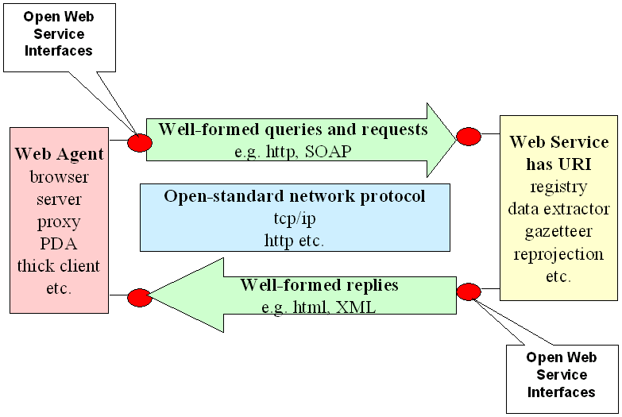
Figure A2-1: Web Services, Web Agents, Protocols and Messaging
Web services communicate amongst themselves, and with client web agents, by presenting open web service interfaces that use open-standards network protocols to transmit and receive transactional messages formatted according to well-known rules.

- The Publish-Bind-Find Model
The discussion following refers to Figure A3-2 below.
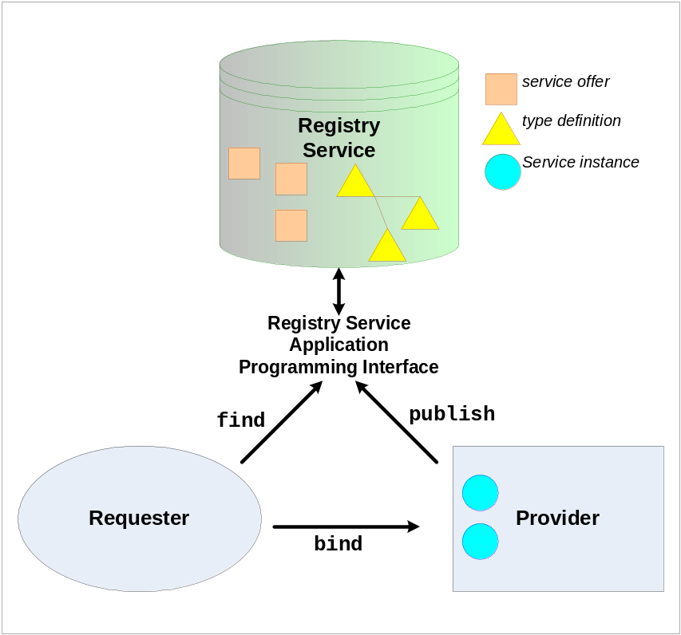
Figure A3-2: The Publish-Bind-Find model
Each service provider publishes a record describing their service – including its type, capabilities and interfaces – to a service registry. A requester seeking services interrogates the registry to find relevant service(s) and then binds directly to the identified service using the interface description provided.
- A service or content provider (or custodian), who is ready to bring their asset to public attention, creates metadata describing their offering according to an appropriate and accepted metadata content standard. The metadata includes information about how to access the asset;
- The metadata is published to a registry service that provides an appropriate programme interface that supports search queries and returns responses in an appropriate well-formed message according to an agreed protocol;
- A requester uses an appropriate agent to launch a well-formed query to the registry programme interface and receives a well-formed reply, both according to an agreed protocol.
- A requester, upon identifying a useful metadata description, including information regarding its location, extracts the description of the location of the asset and invokes an appropriate agent that binds to it, using another agreed protocol.
From that point, the requester agent and the provider’s service engage in a transactional exchange, the nature of which will be according to the agreed protocol.
The Publish-Bind-Find Model only addresses some particular aspects of the invocation process that closest to the web service world, i.e. most pertinent to the developers of web interoperability specification and protocols.
For example, P-F-B gives no consideration to the need for discriminating between applicable and irrelevant services, nor assessment of the usefulness achieved by having bound to a certain service.
More realistically one needs to consider the whole lifetime of service development from the recognition of user need through to final utility. These considerations are elaborated in A-3 Seven-Step Model for Service Invocation.

- Seven-Step Model for Service Invocation
To understand where discovery fits into the enterprise, an understanding of how resources are accessed is in order. The seven-step model for service invocation captures the typical process.
Table A3-1: The Seven Steps of Service Invocation
Step | Action | Possible Instantiations
1. Model | Develop information models (data and metadata models, process models, capability models) software/service models | UML, Enterprise/Business process modeling tools, and other not-yet standardized implementations.
2. Instantiate | Develop descriptive information, known as discovery metadata, for the models for each asset | EbRIM, Dublin Core, WSDL, XML Schema
3. Publish | Provide discovery metadata to the Discovery service | Push to the discovery service,  Pull by discovery service
4. Discover (Find) | Build a discovery service request, a “query”, and obtain the instances that satisfy the query – multiple instantiation methods possible | SQL, Natural Language, XML Query
5. Evaluate | Evaluate query answer effectiveness, select resource to access
6. Bind | Establish a connection between the selected resource and the query originator | Directly or through a service broker
7. Use | Use data/service directly, or transform through data mediation service(s)
- Model – While discovery can occur without an a priori information model (e.g., a Google search on the Internet), discovery services in an Enterprise are likely to be much more effective if performed using established and accessible information models for information and services published or made accessible via the SIDP portal..
Ideally, every resource on the SIDP Portal will have some concept of what it provides and how it provides it. In addition, enterprise wide shared concepts for how resources are described and accessed will improve the chances that information seekers and service requestors will discover what they are looking for. The creation and maintenance of information models for these shared concepts and embodying them in the SIDP Portal as an integral part of discovery services is critical for useful discovery.
Such information model-driven services will complement the more ad hoc search services such as Google that are typically associated with searches on the Internet.
- Instantiate – Once models have been created, it is necessary to develop representations of these models that are accessible/executable by discovery services.
These representations of information models are commonly referred to as metadata. At a minimum, metadata should be available to describe all service interfaces, the information context for all services, and the information model for managing that metadata. As with the models, creation and maintenance of this metadata is critical for successful discovery.
While some information resources may be published on the network without an explicit service interface (e.g., a web page, although one could argue that an http request to a URL is a service interface), eventually most resources of interest to SIDP PORTAL users will be accessible to a published service interface.
- Publish – It pays to advertise. Creating a model and metadata does not make a resource discoverable. Users or service requestors (who may also be service providers) go to discovery services to find resources. For them to find a particular resource, however, the discovery service must be informed that the resource exists and how to represent it in one or more information model-based directories or service registries.
Publication is the process of registering a resource with discovery services. There are a number of ways in which publication can take place including:
- Push – the resource explicitly loads its metadata into discovery services on an unsolicited basis, presumably through a service interface that supports such a push or “posting”;
- Pull – the resource registers a URL with discovery services which then harvest the metadata through a “capabilities” interface at the resource on some scheduled basis or on some trigger event; and
- Agent based – software agents, such as web crawlers, gather the metadata as they traverse the enterprise. This requires that the resource provide the metadata in a location and format that the agents can access. Once the metadata is accessed, the agent loads the metadata into the discovery services. This is a kind of “pull” by third parties (agents) typically representing specific interest groups or domain information brokers interested in specific types of information or services.
- Discover – Users and service requestors who are in need of a resource will go to a discovery service to find it. This step encompasses the process of matching up user needs with published resources and returning that information to the user or software entity. A user of a service can be an end user (typically from a web portal interface), an application executing on behalf of a user (e.g., a PC client application or “servlet” on a server), or an application service provider executing on behalf of some organizational/mission entity (e.g., a “track manager” or data aggregator/integrator).
- Evaluate – Discovery services are not perfect. Once a result has been provided to the requestor, it is necessary to evaluate that result to determine if it is sufficient or if additional discovery is required. It is not unusual for the initial result to describe more resources than desired. Multiple discover/evaluate cycles can be expected with more refined queries in each cycle, especially if the requestor is an end user (person)
- Bind – Once a suitable resource has been found, it is necessary to establish a relationship with that resource. At a minimum this requires selecting client software that is compatible with accessing/displaying the resource or invoking the resource service interface, and providing it with the information necessary to establish a connection with the resource.
- Use – The final step. At this point a suitable resource has been identified and an association established with that resource. All that remains is to exercise that resource’s service interface to perform that task that it was needed for in the first place.
- Resources as Services: Binding Models
Discovery services can be used to locate any type of enterprise resource within the SIDP Portal.
Ultimately, no matter what the resource, it will be accessed through a network protocol. Use of the resource will be enabled by software on the user’s system communicating with software on the resources’ system. This software-to-software interaction is a service invocation. Therefore, at the most basic level, all discoveries are service discoveries, although some services are very primitive/basic, such as accessing a web page at a specific URL. Resource discovery is the application of constraints to the selection of appropriate services, such as entering search criteria into a search engine or specifying service categories and performance parameters into a service registry request.
The concept that all resources are services has particular implications to the Evaluate and Bind steps in the Seven Steps to Service Invocation (see Seven-Step Model for Service Invocation in A-3 above). It is not sufficient for evaluation to assess the suitability of a resource just by its characteristics. The evaluation process must also assess whether or not there is suitable software on the users system to access the hosted service. Only if such software is available can the discovery process move forward.
Likewise, the bind operation must have access to sufficient information to invoke the hosted service. If this information is not provided as part or the resource metadata, or if the client does not have access to that service, then the resource cannot be accessed.
The need for client-side software that knows how to request the services needed to access a resource has additional implications for discovery and the enterprise framework. There are several ways to link the discovery and binding processes. Run-time binding is the case where a user already has the necessary software on their machine to access the hosting service. Currently the Web is largely a run-time binding environment with web browsers capable of accessing most resources through web servers.
More complex protocols have evolved recently. The Simple Object Access Protocol (SOAP), a lightweight protocol for exchanging structured information in a decentralized, distributed environment, facilitates information exchange between programs. With the recent IT move to service-based architectures and the development of more complex web protocols such as SOAP, the web browser will support user access to web pages and web-based application programs, and protocols such SOAP will normally be used between programs.
For example, a complete supply chain management program built upon web services, which utilize SOAP, is accessible from a browser, but the program obtains the data it presents to the browser user via SOAP from other programs, potentially executing on systems managed by diverse organizations that are part of the supply chain.
The need to support additional services leads to several additional binding models, including:
- Build-time binding: Under a build-time model, the user is the software/service developer and discovers the services required to implement the desired functionality/capability. The developer then makes the necessary modifications to the client to use the discovered and selected services. This implies that users (i.e., developers) have the tools and authority to modify their applications and that a significant delay between service discovery and invocation is acceptable.
That is not usually the case for end users of a geospatially enabled portal environment, although one could envision certain “superuser” tools (applications) that would permit such build time service binding by authorized end users. For example, setting up a Joint Task Force to support a particular operation might involve creating business processes and associated work flow rules, user workspaces and data repositories related to the operation, and service definitions for posting and accessing data in those workspaces. One could argue that this is a “configuration-time” binding capability, as opposed to build-time or run-time, but with the advent of interpretive execution systems, the distinction may be somewhat arbitrary.
- Run-time multi-step: The necessary software is loaded on the requestor’s machine (possibly requiring new levels of license management), and activated to bind with the resource as if it had always been there. This approach can have numerous challenges in a whole-of-government environment including potential violation of the vendors’ mobile code policies, and violation of many departmental Configuration Management policies for client systems.
- Proxy-brokerage: A broker could “proxy” for the software, locate it on another machine, and direct the output back to the client machine. This approach addresses the shortfalls of the first two models. It does raise the question that if the client has sufficient capabilities to invoke the interfaces on the proxy, then why not just implement those interfaces on the service in the first place?
- Service taxonomy: This final approach is to establish a taxonomy of well-known service types and the associated interface definitions. Client software can be written to these standard interfaces with the assurance that they will be able to perform run-time binding to services implementing those interfaces. With careful governance, client software implementing a relatively small number of interfaces would be able to invoke most of the envisioned services available from the SIDP Portal.
This is a hybrid of build-time and run-time binding in which the binding is to a type of service at build time and the specifics of the service request are generated at run time. This seems to be the most probable approach for most SIDP Portal uses of discovery services. If the service interface specifications to service types include explicit versioning, context parameters, and sub-typing capabilities, services will be able to evolve and support multiple versions/sub-types of a given service on the network simultaneously. This will allow service requestors to continue working with older versions of a service type until all service requestors using SIDP Portal have been transitioned as necessary to use newer versions of the service (at build time).
- Discovery Background
In previous volumes, there has been considerable discussion of Registries and Catalogues. Registries and Catalogues are required functional areas that operationally enable the find-bid-publish model. They are especially critical for the Find, or Discovery, process. The following discussion provides a broader context for the potential role of Discovery in web services. However, this discussion should not lead to the conclusion that all the possible levels of discovery and knowledge expression will be implemented as part of the SIDP. Only a small subset will actually be implemented and demonstrated. These will be in the areas of service discovery and content (metadata) discovery.
There are various types of discovery that may potentially be supported by SIDP Portal services. They differ in the type of resource to be discovered, the specificity of the query, and the knowledge context in which discovery takes place. An examination of the ramifications of these parameters is detailed in this section.
  - Knowledge Context
The discovery process deals with finding what we know. This specifically addresses a subset of “knowability” as expressed by the US Defense Secretary Donald Rumsfeld. Secretary Rumsfeld told a news briefing: “Reports that say something hasn’t happened are always interesting to me, because as we know, there are known knowns; there are things we know we know." He went on to say, “We also know there are known unknowns; that is to say we know there are some things we do not know. But there are also unknown unknowns – the ones we don’t know we don’t know.” Table A6-2 illustrates Secretary Rumsfeld’s observation as a four quadrant graph.
In the case of “known knowns,” we are often performing a specific or focused discovery process initiated through a specific query. We have a strong expectation that a certain kind of information is already isolated and easily found, which allows generation of a specific answer. In many enterprise architectures, this type of discovery process is implemented using approaches very close to keyed retrieval.
Table A6-2 An Ontology of Knowability
“Knowability,” per Defense Secretary Rumsfeld
Knowledge | We Know  Our Knowledge  (“known knowability”) | We Don’t Know  Our Knowledge  (“unknown knowability”)
Known | “known knowns” (*)  Location discovery  Starting with a known element, “locating” the specific information associated with that element | “unknown knowns” (Implicitly defined)  Knowledge discovery:  Starting with a known initial element of an event, find more information about that event.
Unknown | “known unknowns” (**)  Knowledge discovery:  Finding additional information related to what we know | “unknown unknowns” (***)  Knowledge discovery:  Finding new information, usually through correlations between known elements or facts
In the case of “unknown knowns” and “known unknowns,” we are often performing a general or broad discovery process, whereby we use a general query to retrieve information about a subject by extracting it from large corpora, and consolidating and analyzing that information into (hopefully) knowledge. This is where the “knowledge” so extracted will likely pass through several forms of representation. Different metrics are required to evaluate efficacy with each different representation and processing mechanism. As the capabilities supporting broad discovery mature within the greater enterprise architecture, we expect that the amount of “known knowns” to increase because things become less unknown.
The discovery of “unknown unknowns” is beyond the scope of a discovery service. “Unknown unknowns” can only be addressed through information collection activities. As new, previously unknown information is ingested into a system, that information transitions into one or more of the discoverable categories.
  - Query Specificity
Discovery Services operating within the SIDP Portal will provide users and their agents with the means to access needed and relevant information and capabilities. Whether driven as a singular or persistent process, all discovery acts begin with a single instigation: the Query. (See Figure A5-3.)
There are two basic kinds of queries: specific and general. Typically, specific queries correspond to focused discovery with specific retrieval and general queries correspond to broad discovery with general and/or specific retrieval.
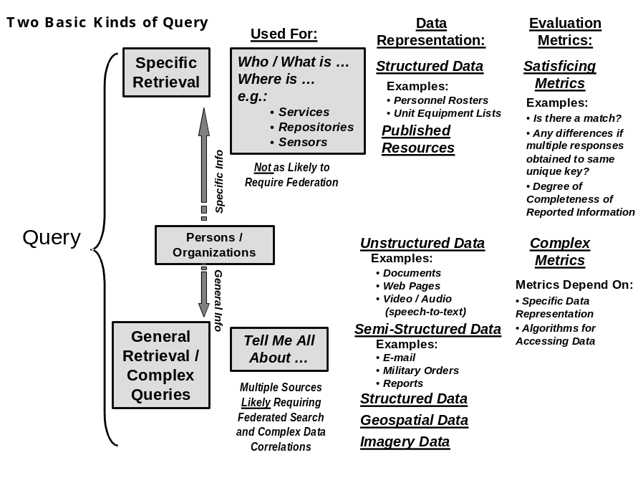
Figure A5-3 - Specific (Focused) and General / Complex Queries
    - Specific Query
Users and their agents typically use a specific query when they require and expect a specific answer. The discovery process supporting a specific query is typically very focused, and may be categorized as focused discovery. An example of such a query is: Find the boundaries for a given parcel or lot of property. Focused discovery can typically be accomplished by accessing the correct, and often singular, data repository. Further, the targets of focused discovery are typically stored as structured data. Thus, it is relatively straightforward to not only access the answer, but to perform a metric on the answer(s). For example, completeness metrics (e.g., is the lot’s cadastre available and complete?) will apply. Consistency metrics will also apply. (E.g., if multiple answers are obtained, how consistent are the answers with each other?)
Focused discovery also extends to specific queries aimed not to target so much a singular piece of information, but rather to find all instances of elements that meet certain criteria. (E.g., find all airborne sensor images currently available over a certain area.) These specific queries again will be subject to focused discovery with rather straightforward evaluation metrics for measuring completeness.
Enterprise Architecture support for specific queries and corresponding focused discovery is typically unique to a community of interest (COI), such as primary production within a state-government. It typically requires that users and their agents have significant knowledge of their enterprise’s subject mater, data availability, and system operation before they are capable of formulating the specific queries that facilitate focused discovery. This can lead to an increasing amount of interoperability issues that may surface with COI growth and multi-COI interoperability as a federation. One COI’s specific query with focused discovery often becomes a general query with broad discovery when given to a different COI. Mediation plays a critical role in addressing this issue. By bridging the syntactic and semantic differences between COIs, mediation services will promote cross-COI discovery and a migration from general to focused discovery as confidence in the services grows.
    - Profile Query
In addition to finding specific information about an entity, users can also perform “profile queries.” This can be of two forms: First, the system will yield back a “profile” about a given individual, and second, the system can provide individuals that match a specific profile.
Typically, profiles operate on structured data associated with a given person. In the case of finding a specific individual’s profile, the response should yield their rank (if in service), job title / posting and operational specialty, and clearance identification. A more specifically tuned profile seeker can report additional information.
In the case of finding individuals that match a given profile, users have the opportunity to rapidly find Subject Matter Experts (SMEs) and other people-resources. For example, a user might request a profile for an expert in policy frameworks governing estuarine pollutions who is available to consult on Friday. This involves searching a structured information repository with a simple match-logic protocol.
Adding even limited advanced query capabilities to the profiling search mechanism (e.g., concept extraction, defined in Section 4.2.1) will allow users to create and/or access useful profiles even if they use query variants that are slightly different from what would yield precise returns under match logic.
    - General Query
In contrast, general queries are more open ended (e.g., “tell me all about X” or “what are the Minister’s views on Y”). Users and their agents typically use a general query when they don’t specifically know if the information exists, don’t specifically know how to obtain the information, and/or don’t specifically know what information they need. The discovery process supporting a general query is typically very broad, and may be categorized as broad discovery. Broad discovery will require additional processes and evaluation metrics beyond those required by focused discovery. Most importantly, it is the general query that will require:

- An architecture including multiple kinds of both broad and focused discovery processes and capabilities;
- Greater orchestration of multiple processes and capabilities that can meet the established capability requirements;
- Processes and capabilities to compose the potentially disparate and/or conflicting results sets into a response; and
- More complex evaluation processes and capabilities, with a different evaluation metric likely to be required at each processing level.
Enterprise Architecture support for general queries and corresponding broad discovery typically strive to be as COI independent and globally accessible as possible.
Users and their agents often use broad discovery when they do not have the sufficient level of COI specific enterprise knowledge or access; which may or may not be intentional. In addition, they may uses broad discovery when the more focused, COI dependent capabilities are not meeting their current needs. In this case, the COI independence and global accessibility provided by general query support is leveraged in an attempt to overcome unintended barriers to processes, data and/or capabilities within the COI.
When operating across COIs, users and their agents must typically start by using the available broad discovery capabilities. One reason is because they often don’t have the levels of knowledge or access required across multiple COIs for a significant amount of COI unique knowledge and capability to be immediately usable and/or understandable. Typically, a user or their agent will use broad discovery to support a learning process the goal of which is to realize more specific results; and a faster process for obtaining similar results. In short, users and their agents (often advanced and/or talented) primarily leverage broad discovery support to achieve results approaching those similar to focused discovery. In most enterprises, the consistent use of general queries should be addressed and (typically) reduced by maturing the enterprise architecture throughout its life cycle.
With general discovery, the imperative goal remains to allow nearly any authorized user and their agent the ability to begin knowing and understand any COI’s data, processes, and capabilities. However, general discovery may typically be most appropriately used by a fairly small number of users and their agents. This smaller group helps determine the more specific capabilities requirements for specific enterprise architecture improvements that can be addressed within the enterprise architectures lifecycle maturity process (this process may be totally manual, totally automated, and/or any combination in-between). It’s these users who are most responsible for realizing the greatest amount of value the multi-COI Enterprise Architecture is capable of providing throughout the entire enterprise lifecycle.
    - Discovered Resource Types
The types of resources that can be discovered in an enterprise are nearly infinite. Typical discoverable resources include:
- People – individuals and information relating to an individual:
      - “Specific queries” on a person will yield “known” information;
      - “Profile queries” will yield either a profile of a given person or respond with persons who match a given profile; and
      - “General queries” about a person will yield a wide range of information associated with that person.
- Organizations – organizations and information relating to an organization:
      - “Specific queries” on an organization will yield “known” information;
      - “Profile queries” will yield either a profile of a given organization or respond with organizations who match a given profile; and
      - “General queries” about a organization will yield a wide range of information associated with that organization.
- Services – software entities that can be invoked over the enterprise network;
- Symbols – Different operational environment use different symbology to represent information. It is desirable to allow users on the enterprise to access any data and view it using the symbology that they are accustomed to. This suggests that standardized symbol for the different operational environments could be defined and provides as an enterprise resource for discovery and access.
- Repositories – Different data collections will house different kinds of information. High-level metadata associated with the collection as a whole will allow a user or the user’s agent to determine whether or not a given repository should be used as a possible data source. This high-level metadata will also help users and their agents to determine necessary services for accessing the data. For example, a repository containing structured data will be accessed with different services than a repository containing free text. Repository descriptor meta-tags will also identify the security credentials required for access to the repository.
The kinds of data that can be held in various repositories will be of different types. These can include:
- Structured information – information that is represented in a well defined, knowable structure (e.g. databases);
- Unstructured information – information that has little or no structure (e.g. free text, voice traffic that can be converted to free text, speech or text accompanying video, etc.) This information will typically either be indexed as it is entered into a repository, or indexing can be applied to it, resulting in a set of content-based meta-tags associated with each element of the corpus. The indices will facilitate concept-based searching;
- Semi-structured information – information that has some or a flexible structure (e.g. XML and HTML.) This would include some information sources that carry descriptive meta-tags with them; e.g., metadata associated by a human or machine with an image. In addition, email traffic, radio traffic, and certain documents (e.g., reports) contain some degree of structure within known and associated data fields, or within the content (e.g., spoken identifiers in radio traffic);
- Information feeds – not all information is static. Sensor, video, and audio data, for example, are often provided as real-time information. Accessing this type of resource requires the establishment of a persistent relationship with the resource so that information can be delivered as it occurs. Some live data feeds also provide associated text; and
- Stored video and image data. Some of this can have associated audio tracks, or other associated sensor data (e.g., GPS data associated with a reconnaissance video sent back from an UAV). Some video and image data will have useful metadata associated with it, done manually or automatically, or as a result of a process (e.g., “change detection”) applied to the feed.
In addition, there are several different high-level forms of information that can be discovered. These include:
- Schemas – schemas describe the structure of information. In any enterprise of any size there will be many information models. The ability to discover and access schemas describing those models is a critical requirement for an interoperable enterprise;
- Ontologies – where schemas capture the structure of information, ontologies capture the meaning (semantics) of information. As an enterprise grows it becomes necessary to be able to translate information both in terms of its’ schema as well as its’ meaning. This requires the discovery and access of representations of meaning; and
- Taxonomies – identify the specific way in which a given ontology is expressed within an organizational structure. E.g., all military service branches use aircraft, but their organizational structure for defining the aircraft and their use can vary from one service to another. A given entity (a person, an aircraft, etc.) can “inherit” properties from more than one “taxonomy.” For example, a person can inherit “time in grade” from one taxonomic classification and an expertise rating from another taxonomy.
These different resource types all carry implications for discovery. All require their own unique metadata. Some have implications as to how they can be accessed. They differ greatly in volatility, from long-lived schemas to time-sensitive information feeds. The challenge for discovery services is to accommodate these differences while maintaining as much commonality as possible.
- Discovery Services
Discovery capabilities can exits as discrete services or as an integral part of a service. For example, an information management service would provide discovery capabilities so that customers can locate information within that service that they need. Discussion of discovery in that context is not within the scope of this project. The discovery services being discussed here are not affiliated with any particular information set or service. For the SIDP, the focus will be on service and metadata discovery through simple query. More advanced query concepts, such as concept and syntactic query, will not be implemented as part of SIDP.
  - Discovery Services – Specific and Profile Queries
In order to discuss discovery services, it helps to have a generic functional model for a discovery service. The model shown in Figure A6-4 will be used to describe the case where the resources have posted metadata about themselves. This will include both metadata describing content as well as describing a service. This model describes four components to a specific query discovery service:
- Metadata Processing – the ingestion of metadata describing a resource and any processing done to add value to that metadata.
- Query Processing – the receipt of a query from a customer and any processing done to add value to that query.
- Metadata Storage – the metadata collection describing all resources known to this discovery service.
- Match Logic – the processing logic that identifies the resources that meet the query criteria based on the content of the Metadata Storage.
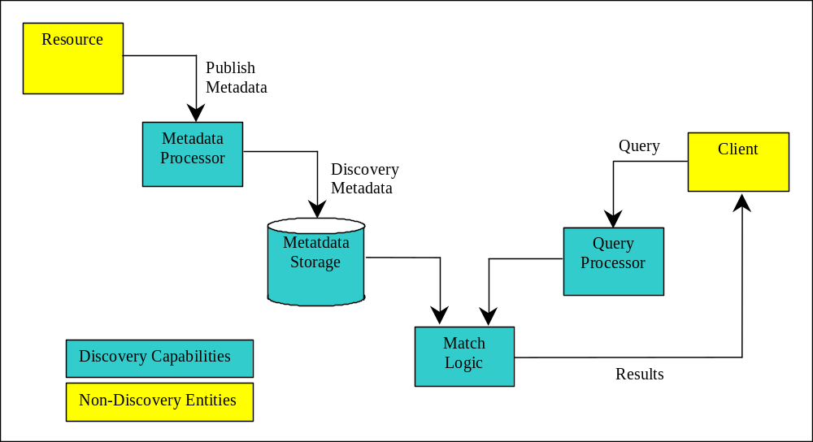
Figure A6-4 - Functional View of Metadata-Based Discovery
    - Match Logic-Based Discovery
Match logic is usually a simple keyword match between query parameters and metadata elements. These systems are limited to handling simple queries. They can only identify “known-knowns.” The basic Google query is an example of a match logic-based query. Most queries against structured databases perform match logic.
    - Metadata Based Discovery
Metadata-based discovery is the most basic and most common discovery service. These systems perform little or no processing on the published metadata or on the query. Metadata-based discovery is, however, capable of discovering any resource type.
Maturity:
Most of the discovery capabilities available today are Metadata based services. Examples include:
- LDAP
- UDDI
- ebXML (ebRIM)
- Z39.50
Limitations:
To be effective, the service provider and service consumer must have a common understanding of both the service invocation protocols and the metadata model of the discovery service. Over a large enterprise, this common understanding is difficult to achieve.
The fidelity of the discovery process is governed by the richness of the discovery metadata. More robust metadata enables greater fidelity in discovery. However, robust metadata imposes additional (and often unimplemented) requirements on resource providers.
  - Discovery Services – General Query
In order to implement Discovery within a Net-Centric Enterprise Service such as the SIDP Portal, we distinguish between the functional capability provided by a discovery service and the actual discovery methodology. Specifically, capabilities will encompass all aspects of Discovery as it pertains to identifying necessary processing steps and levels, referencing to the full available Enterprise Architecture, and selecting functional components from that architecture as needed.
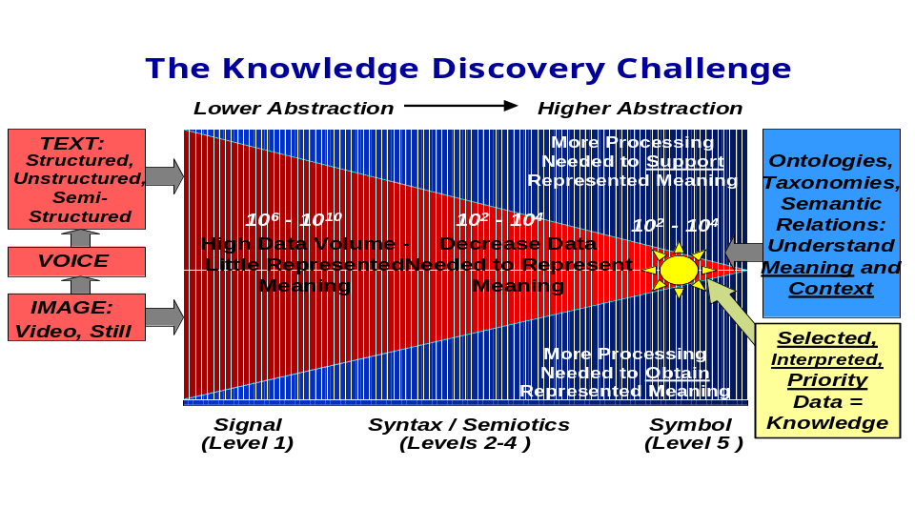
Figure A6-5: The Challenge of Knowledge Discovery
The knowledge discovery challenge for general discovery is to scale down the very large-size corpora elements that are passed to the more computationally intensive but significant capabilities. This is the requirement that will most drive the selection, federation, and orchestration of different Knowledge Discovery services. Certain services that offer high value come at a very high computational price. In order to successfully handle large corpora, there must be a means of extracting elements that have a high likelihood of containing valuable information. These are the elements that should be passed to the more computationally complex capabilities for further processing.
One way in which this can be done is to define different kinds of general discovery tasks, based on the kinds of data that are being processed and the algorithms that perform the processes. This yields a mathematical basis for describing different “levels” of general knowledge discovery.
    - Concept Extraction
Concept Extraction is typically the first step in general knowledge discovery. It extends the metadata model by identifying and incorporating concepts and concept-based descriptive meta-tags that are not explicitly in the published metadata. This capability is usually applied at the metadata processing stage, thereby providing a richer set of metadata against which to evaluate a query.
Maturity:
Some work has been done in this area particularly in the area of geographic locations. Geocoding software is capable of extracting location related information, such as place names and addresses, and establishing the geographic location (lat, long) associated with that information.
Limitations:
Concept extraction is limited to specific sets of concepts and the limited number of algorithms available to perform concept extraction.
    - Concept Correlation
Concept Correlation builds on Concept Extraction by establishing associations between related concepts. For example, a user requesting information on XML may also be interested in Web Services, parsers, and HTML.
Maturity:
Much work has been done in this area particularly in the area on-line retail, as well as existing COTS systems performing correlation after concept extraction has been done. Normally, this capability needs to be automated. Both humans and automata can examine the results of concept extraction query pushed towards concept correlation. Research and development in this area will be required.
Limitations:
Correlation tends to be a manual process. Automated processes are computationally expensive (order of N²); this is why concept extraction is typically used as a front-end process. In addition, concept association links can first wander extensively and second be too hard to extract as specific association sets when the corpora containing the concepts becomes too large and diverse. This is another reason why the inputs to a concept correlation tool should be the results of previous “extractions.”
    - Syntactic Discovery
Syntactic Discovery introduces natural language to the query processing. Query processing identifies the “relationships” (verbs) linking “concepts” (nouns) in a query. This yields an “intelligence primitive” that is assessed against the discovery service holdings. In some cases the publish metadata may undergo similar processing allowing for better syntactic matching between query and resource.
Maturity:
Some work has been done on natural language discovery Ask Jeeves is an early and primitive example; more recent COTS systems have been developed. This is also an area in which capabilities are being rapidly developed and released.
Limitations:
Automated processes are computationally intensive (order of >N²).
    - Context-Based Discovery
Context Based discovery recognizes that the meaning of a term depends on the context in which it is used. By analyzing both the publish metadata and the query within their operational context, additional conceptual information can be extracted to support the discovery process.
At this level, it is possible to extract “information primitives.” This can also include people, places, and things that are recognized as such. It can also identify geo-specific places, such as Paris, France (and distinguish the “Paris in France” from any other Paris), and provide coordinates to a geo-specific location. This requires use of certain COTS tools that are designed specifically to provide latitude / longitude correlations given a properly “named” place.
Maturity:
There are many methods for Context Based discovery but it is not clear that any are ready for operational deployment.
There exist COTS tools that will perform geo-specific coordinates given appropriate place names as inputs. Metacarta is one such example. There are other COTS tools that can extract known places with some reasonable degree of maturity.
Limitations:
This is computationally intensive. May require the discovery of user and resource operational context through information security services.
    - Semantic Discovery
Semantic Discovery enhances the matching of requests to resources by using the “meaning” of publish and query information as well as structure and concepts. This capability is enabled through the creation of ontologies and taxonomies to capture communities of common vocabulary. Using these resources, semantic discovery processes can evaluate information within its original and target semantic context to enhance matching.
Maturity:
Emerging. This capability leverages work done in the semantic web and related research.
Limitations:
This is very computationally intensive. Requires a long-term investment in representing the organizational and/or knowledge infrastructure of the enterprise through ontologies and taxonomies.
  - Discovery Methodologies
Discovery requires multiple kinds of tools, interacting with each other. The concept is that operations will not be limited, even within a given representation level, to a single tool. Rather, federated search and discovery can take advantage of whatever tools are available. This approach enables self-healing, in that if one tool is not available for a task, other tools can be selected to perform the same or similar function. We note that the majority of tools that can be considered are already owned and operated inside certain and specific elements of the Australian Spatial community.
    - Single service
The simplest approach to a discovery service is to provide it as a single, monolithic service with a stateless interface. Refining a query means enhancing the query itself. Each refined query is issued against the entire metadata set. Discovery services using Web protocols often use this model.
      - Single service with feedback
A more common approach is to provide a stateful interface to the service. This allows the user to issue queries against the result set of the previous query, enabling rapid refinement of the result set with minimal processing by the discovery service. Relational databases implement this model.
    - Federation
To be useful, a discovery service must contain an accurate representation of the available resources. As an enterprise gets larger, maintaining the currency of a single central discovery service becomes an unmanageable task. Most large enterprises address this issue by deploying multiple discovery services within local communities of interest. This leads to the problem of how to discover resources held by a discovery service outside the local community.
Federation is the process of one discovery service forwarding a query on to other discovery services and joining the results into a single response. As a result, a large collection of discovery services can be accessed through a query directed to just one.
Federation has been supported by relational databases for some time.
    - Orchestrated Discovery
Orchestration services allow different discovery capabilities to be brought together into a workflow such that the individual capabilities can be invoked individually or as a single integrated service.
Orchestrated services are available today.
      - Orchestrated with Controlled Feedback
Orchestrated Discovery provides a process chain with a static flow of information and control. By adding control logic, the orchestration service can create feedback loops within the process flow and control when and how those loops are executed based on intermediate results. This allows the discovery process flow to adapt somewhat to improve the performance and accuracy of the discovery process.
      - Orchestrated with Reasoning-Based Feedback
Orchestrated Discovery provides a process chain with a static flow of information and control. By adding intelligent control logic, the orchestration service can create an optimal process flow by enabling feedback loops when and where they will provide the most value. This approach will provide the most value from a collection of discovery capabilities deployed for general query processing.
- Best Practices - expanded
- Collaborative Development of Geospatial Databases.
Geospatial data and GIS technologies have proven to be very valuable for users in varying levels of government and the private sector. However, use of the information has not fully reached its potential in government business processes. A constraint in wider use of GIS has been the high cost of building and maintaining Geospatial databases. Despite the high costs of Geospatial data, there is redundant geospatial database construction at different levels of government and in the private sector. Collaboration has sometimes allowed user organizations in multiple sectors to avoid this redundant geospatial database development.
- Development of Geospatial Data Standards.
An additional constraint on broader cooperative use of geospatial data has been limited progress in the development of geospatial data content standards. For Geospatial One Stop, content standards have been or are being developed for the seven framework data types. Geospatial data content standards are best practices that enable increased data sharing and collaboration within the geospatial data and GIS communities.
While significant standards progress has been made and interoperability has improved, many standards issues remain. The OpenGIS Consortium has coordinated development of interoperable and simple features standards for access and communication of geospatial data. These standards efforts at the Federal level need to be aggressively accelerated and implemented to ensure success.
- Development of Geospatial Data Portals to Provide Public Access to Geospatial Data.
Geospatial data portals have improved significantly in recent years but are still in relatively early stages of development due mainly to lack of standards, the functionality limits of Internet GIS tools and performance limitations.
Perhaps the most broad reaching and mature standards based NSDI portal is the Canadian Geospatial Data Infrastructure initiative. http://cgdi.gc.ca/CGDI.cfm The CGDI is a multi-jurisdictional, multi-participant effort. The effort is coordinated by GeoConnections Canada. GeoConnections is a national partnership initiative working to build the Canadian Geospatial Data Infrastructure (CGDI), which will make Canada's geospatial databases, tools and services readily accessible on-line. GeoConnections and the CGDI partners are fully committed to using standards based service architectures and web services as the foundation of the ongoing deployment. There are currently 132 Federal, Provincial, Academic, and Private sector partners.
The GeoConnections Discovery Portal can be found at (http://geodiscover.cgdi.ca/gdp/search?action=searchForm&entryType=webService). This portal is an excellent example of the implementation of many of the concepts documented in this report.
Other examples are ESRI’s GeographyNetwork geospatial data portal (http://www.geographynetwork.com), the Department of Agriculture's (USDA) Resource Data Gateway, Microsoft’s TerraServer ( http://www.terraserver.com), the terrafly server (http://www.terrafly.com) and the GIS Data Depot (http://www.gisdatadepot.com) are best practice examples of portal development to increase use of geospatial data.
The Internet functionality and performance limits are, however, technical issues that can be effectively addressed through continued standards development and improvements in software and technology.
- Development of National Geospatial Data Initiatives.
While beyond the scope of the SIDP Project, many of the Australian Spatial Industry issues relate to development of a more coordinated and coherent geospatial data policy at a national level. Development of a national geospatial data policy with standardized, national coverage data at varying levels of detail is a best practice. The United Kingdom Ordnance Survey (http://www.ordnancesurvey.com), which has traditionally provided a comprehensive series of national maps, now provides a variety of types of geospatial data on a national basis. The data that is provided is detailed enough to meet the needs of local governments and utilities as well as the national government.
The Ordnance Survey geospatial data is copyrighted and rights to use geospatial data are sold to user organizations. National geospatial data coverage guarantees that users will have access to data regardless of its location. It also ensures that geospatial data can be used on a comparative basis to evaluate alternative locations. For example, demographic data can be used to analyze the potential markets for store locations across the country.
Challenge 1: Involve state and local governments and the private sector in an effective National data content standards development and collaboration process while maintaining traceability to business requirements.
Best Practice: Identify and Assess Geospatial Data Requirements and Develop Data Content Model and Access Standards
It is critically important that business requirements for Geospatial data access through any Australian NSDI portal be assessed in a detailed manner for each user community on an individual Geospatial data type basis. This involves determination of the following types of information by organization for each data type:
- Spatial resolution requirements;
- Date or timeliness requirement;
- Cost limitations;
- Performance requirements to access and use data;
- Volume and timing of transactions that access data;
- Size of typical area of interest for a transaction; and
- Comprehensive geographic area of interest.
These requirements will vary by type of user and by organization. A detailed analysis is necessary both to assess the real potential for data collaboration as well as technical requirements for data, enterprise architecture and portal functionality.
As new sources of remotely sensed data are becoming available from innovative types of imaging sensors, proactive standards definition could also address changing sources of image data that need to be geocoded or fused in compatible ways with other types of image data.
Geospatial data content standards should address both relational and object relational data. Object relational data are increasingly used for geospatial repositories and have important advantages relative to more traditional relational data structures.
Geospatial data content standards are best practices that enable increased data sharing and collaboration within the geospatial data and GIS communities. To support broad based data collaboration, multiple user organizations at Federal, State and local governments and in the private sector need to be effectively involved in efforts to develop, define and approve geospatial data standards. Best practice geospatial data standards development examples include the Ordnance Survey OSMasterMap standards and the OpenGIS Consortium simple features standard.
Best Practice: Encourage and Support Multisector Geospatial Data Collaboration
The Federal Government has encouraged expanded cooperative use of Geospatial data through the Australian Spatial Data Infrastructure (ASDI). Cooperative funding of geospatial data construction between different levels of government and/or government and industry is a best practice. Cooperative funding of digital orthophotos by could be a specific example of this best practice through SLIC-P.
Challenge 2: Facilitate improved geospatial data access and collaboration via the SIDP Project and other mechanisms.
Best Practice: Develop Geospatial Data Portals and Improve Access to Data
Federal agencies, private sector companies, state and local governments, and universities have developed geospatially enabled data discovery and access portals over the last five years. These portals offer data that is accessible on-line as well as metadata for data that can be ordered for delivery at a later date. In some cases, geospatial data access fees are assessed while in other cases the data are available free. User interfaces vary from simple and friendly map based displays of the availability of data to more difficult tabular listings of geospatial metadata. All geospatial data portals, however, offer the user improved access to data that is expensive and time consuming to produce from traditional map and records sources.
Best Practice: Develop Effective Geospatial Portal User Interface and Functionality
An Australian NSDI (ASDI)will serve various customers including other Federal agencies, State and local governments, private companies and citizens. Any NSDI must provide user-friendly access to various types of data in various locations. Best practices to find and access geospatial data include metadata standards and map displays of data availability as well as tabular listings. The user should also be able to constrain data searches by area of interest, type, date and scale. Some existing portals provide limited ability to constrain geospatial data searches and deliver an overwhelming amount of data for the user to review to find the data that really meets their needs. The user should also be provided with the ability to order and receive data through a variety of means including on-line access, ftp downloads, and CDs.
Challenge 3: Develop policies regarding appropriate private sector use of the of any Australian NSDI portal.
Best Practice: Provide Value Added Geospatial Data and Services
Some private sector firms will want to provide customer access to geospatial data that they publish through the portal. In many cases fees may be charged for access to published geospatial data. Firms also may want to publish links to value added services that use applications software and geospatial data, which may also be value added, to perform analytic tasks for customers.
Examples of existing value added geospatial services and data include geo-demographic market research services (e.g., Claritas) and routing and directions services which use digital street network data (e.g., MapQuest, Geographic Data Technology, Inc., Tele Atlas, etc.). These value added geospatial data sources and services all started with Bureau of Census data with investments as high as hundreds of millions of dollars to add value to this data and to develop applications to use the data. The examples show, however, that value added national geospatial data and services are a best practice that provides services to clients and increased revenue to government.
Challenge 4: Develop interoperable web GIS interfaces and services (e.g., mapping, analysis, etc) for the portal.
Best Practice: Develop Interoperability Standards and Architecture
The nature of spatial systems is that they are widely distributed both within as well as amongst many public and private organizations. In order for an geospatial portal to be successful, it must therefore provide a means to link widely distributed systems in a single network. The distribution of these systems is not just spatial but also logical and physical.
Therefore, the SIDP architecture is based on IT standards to support interoperability of both distributed users as well as producers/contributors of spatial content. Interoperability must be supported in two forms, first, intersystem communication and secondly, intersystem exchange of content. Intersystem communication will require the use of a new standard for distributed systems: web services.
The second area of interoperability is intersystem exchange of content. Web services support communication but not specifically how and what information is exchanged. Industry standards for content models and data exchange formats are needed to complete the interoperability capabilities of the SIDP Portal. Within the US and international communities, the Australian Spatial Data Infrastructure (ASDI) and Global Spatial Data Infrastructure (GSDI) activities have made significant advances in addressing the requirement for logical data model standards for key framework spatial layers, as well as, metadata standards for describing these framework layers. These activities have allowed a large range of users of geospatial data to provide input to the design and configuration of these content standards.
Challenge 5: Anticipate and design to support operational user demands for geospatial data access through the portal.
Best Practice: Conduct Demand Analysis and Enterprise Performance Modeling
It is important that the operational business needs for geospatial data within Federal agencies be analyzed to assess the frequency of transactions that will access data through any Australian NSDI portal. For example, requirements for digital orthophoto should be assessed so that the frequency of access, typical area of interest, seasonality of demand, need to view or download data, resolution and currency of the required image, etc. are all understood. This information is needed so that the portal and, more importantly, the geospatial data archives and bandwidth are all appropriately sized so that users will experience acceptable performance.
Best Practice: Use Component Architectural Frameworks
Component Architect Frameworks reduce the overall effort for integration as well as reducing overall system life cycle costs (LCC). Architectural Frameworks have evolved and matured in the commercial sector over the past three years. (http://www.ichnet.org/). Moreover, most adhere to standards that limit specific technology lock in and more importantly, provide the ability to abstract Business Process Management (http://www.bpmi.org) from the technology. This is very significant and will usually allow the business user to establish and change processes (because business will change), without a ripple effect into the technology. The result is that IT infrastructure will enable process change and not hinder it.
Best Practice: Provide for Business Continuity Geospatial Data Storage and Management
To take advantage of Moore’s law for data storage, a best practice is to choose Redundant Arrays of Independent Disk Drives (RAID) systems that offer the greatest flexibility to incorporate future technology (disk drive sizes, network connection type, and change in architecture) as the technology changes. Future changes and upgrades should minimize disruption as much as possible without needing to change the entire storage system every couple of years to meet new business demands.
Also, low-end GIS storage systems that may work fine at the prototype, workgroup, and departmental level, often do not scale to meet enterprise needs for performance, reliability, and spike demand.
Best Practice: Provide Interoperable Geospatial Portal with Web Mapping Services
The SIDP project will need to support interoperable standards and interfaces to provide effective access to data stored on various data archives. Provision of web mapping services via the portal could also allow users to compose simple maps while accessing data from multiple archives. This ability to compose maps using data at various locations is a best practice that is provided by some GIS software tools Web mapping services may also allow users to perform other simple processing and analysis tasks like generating buffers around a feature (e.g., 20 meter buffer around a road, etc.). Free, simple geospatial data viewing and analysis tools, an additional best practice supported by some GIS vendors, might also be made available via the portal to encourage more widespread use of the data by more casual users.
- SIDP and the Global SDI
The foundation of SIDP notional architecture is an SDI (spatial data infrastructure) that links providers and users of spatial and spatially related data and services.
The SDI aims to operate in as flexible and ubiquitous a manner as transport and communication networks link service providers and users. Implementations of SDI’s are predicated on the concept of Web Services.
The SIDP Portal will provide the Australian community with demonstration capabilities consistent with those of the more than fifty nations that are developing national spatial data infrastructures (NSDIs) to improve their ability to find, access and more effectively use geospatial information and technology in their governmental and business activities. These national activities are supported by regional collaborative efforts in Asia and the Pacific, Europe, the Americas and Africa as well as an emerging Global Spatial Data Infrastructure (GSDI) effort.
The SIDP Portal is to expose data stores to the SDI via OpenGIS compliant service interfaces. The data themselves are available for representation by services supporting their discovery, viewing, analysis, examination, presentation, processing or transfer in non-proprietary open standard formats.
-
The services used to access the data stores are, in many cases, existing legacy systems which will have been adapted with appropriate wrappers or middleware to translate between their internal proprietary formats and interfaces and the external open standard mechanisms required for interoperability within and between SDIs.
National and Regional Nodes
Sub-National Nodes in structured network
Ad hoc service exchanges
Structured service exchanges
Figure A9-6: Relative and Hierarchical Roles of SDI Nodes
The SIDP Portal will enable Australian geospatial community data services, when equipped with appropriate interoperability interfaces, to exchange services and data with other SDI participants at State, Commonwealth and international levels. International connectivity options include image repositories maintained by US NASA and EROS Data Center, the Asian-Pacific regional SDI, the United Nations SDI-based interoperability framework, services operated by the World Bank and OECD, and numerous non-governmental institutions such as the World Conservational Monitoring Centre and the World Resources Institute.
  - Context: Spatial Data Infrastructures
Institutional relationships within the GSDI tend to be hierarchical i.e. sub-national groups are represented by national bodies at regional and global fora. However, the implementation of the GSDI is not explicitly hierarchical. For example, international bodies such as the United Nations may be operating SDI-compliant services that fit no designated hierarchy.
Figure A8-7 OpenGIS Standards and their Distinct Roles presents an idealized view of the possible interrelationships amongst SDI nodes operating at national, sub-national or international levels. Relationships may be horizontal amongst peers, vertical though international - national -sub-national links, or oblique e.g. directly from a sub-national node in one country to the national node of some other country.
The SIDP portal will employ internationally recognized technical standards that are employed for SDIs. These standards are transparent to notions of hierarchy in the manner as the Internet World Wide Web. SDI standards foster interoperation amongst nodes as peers, whether as well-defined, permanent operation arrangements or as transitory ad hoc instances.
The SIDP portal, like any national spatial data infrastructure, may include a node providing nation-wide access to sub-national (state, provincial, local, sectoral, community, commercial) nodes. However it is institutional requirements that determine the types of acceptable interoperability amongst nodes within a nation, sub-national nodes in different nations, or sub-national nodes of one country with national nodes of a different country. Departmental or sectoral nodes within a state or provincial SDI may interact with nodes in other states, provinces, regions, countries or communities according to local procedures, guidelines and requirements.
  - The SDI Services Model for the SIDP
The SIDP Portal will demonstrate to the geo-spatial information community to move comprehensively beyond the ‘map delivery’ services generally already in place. Predefined and rigid product lines that rely on back-end GIS analysis will be complemented with web-enabled mapping services. Such services facilitate that migration of competence from GIS specialists to on-line users who are offered increased flexibility for ad hoc product creation and generation, especially when their requirements can only be met through combinations of information from multiple sources.
Demonstrated services will remove the necessity for information users to receive copies of data. More importantly, it may remove the need for them to have the GIS hardware, software and expertise to convert these data into their required information products. SDI services may optionally include data delivery as a service at the discretion of the data custodian.
Geo-information services operating in conjunction with the SIDP Portal will employ the “Publish, Find and Bind” model. (See A-2 The Publish-Bind-Find Model)
Separating the service processes from the presentation and human-interaction interfaces (provided through web browsers and other clients) means that service custodians are strengthening the long-term protection of their geo-data infrastructure investments.
For example, business decisions dictating new requirements to exploit emerging technical capabilities such as mobile computing and location based services will not require wholesale re-engineering of existing services. Instead, the publish-find-bind model enables system adaptation to be made as required to meet the capabilities of new clients, while the mission-critical backend business processes and services continue undisturbed.
The SIDP Portal will implement each aspect of the “publish-find-bind” model. OpenGIS compliant catalogue and registry services support systematic standards-based publication of service, data and feature descriptors. Service policies (appropriate use, utilization monitoring and invoicing, etc.) are also made known at these interfaces.
Each organization participating in the SIDP will retain the choice whether to implement its own catalogues and repositories; conversely, there may be compelling cases for consolidating their needs with similar requirements in other organizations and so jointly providing a centralized catalogue service. The option is open for the centralized catalogue to be supported by a commercial provider. Similar considerations pertain to issues such as client authorization and management. OGC standards compliance ensures that each decision can be made on a case-by-case basis to best meet institutional requirements.
The SDIP Portal will support some level of distributed search and discovery across multiple catalogues and registries. Again, standard protocols (SOAP, LDAP, ISO 23950 CSGDM) exist already and are in wide implementation. These methods are already widely employed, including in the Australian Spatial Data Directory and DNRMeta. Extending these capabilities through Information Streamlining interoperation will open opportunities for agencies that wish to do so, to exercise increased custodial authority over their metadata and catalogue entries.
Clients’ ability to bind to SIDP-enabled services ultimately depends on internet-available protocols combined with various implementations of policies described in the registries and implemented through OGC-compliant interfaces (at least for data and presentation geo-services). Developments taking place in complementary arenas such as “grid” computing will in the near future introduce a number of specific considerations for implementing the binding (and chaining and streaming) of services. For instance, geo-data extracted from one source could be streamed to a reprojection service before being integrated with numerical model operating on a third server.
  - The SDI Component Model
An SIDP Portal developed on SDI concepts will embody a component-based architecture that will ensure that each element of the infrastructure can be created, managed, refined, upgraded and resourced separately. An open, standards-based design allows separation of the ‘why’ of each required functionality from the ‘how’. It also allows SIDP collaborators to engineer their systems independently to meet local business requirements while remaining assured of later ability to interoperate with other collaborators’ similarly-engineered systems i.e. assure convergence. This can be achieved without requiring the imposition of additional, higher levels of coordinating bureaucracy because of the precepts embedded in the choice of OGC methods and open standards.
  - SDI Standards, Protocols and Specifications
Agreed the use of common standards and architectures, developed or endorsed by international, national and voluntary standards organizations, enables the typical SDI. The fact that this is a shared, common approach across many SDI activities provides opportunities for learning from others’ experience and testing the validity of approaches.
The standards underlying SDI are in many cases precisely those already accepted and underlying the design and operation of the Internet, the World Wide Web and associated facilities. The standards, specifications and protocols underlying the SDI’s apply at many conceptual levels analogous to the OSI network ‘stack’ (see Figure A8-7) i.e. from low-level communications protocols through data formats and semantics through to service definition, description and discovery to service orchestration for workflows.
The coordination efforts of the GSDI Association (formerly the Global Spatial Data Infrastructure Steering Committee) are leading the GSDI to clear form and substance.
Standardized Geospatial Metadata (FGDC CSGDM, ISO 19115) and OGC Catalog Services are defined,
A network of Spatial Data Clearinghouses is operating on common standards based protocols (z39.50/ ISO 23950 CSGDM). Over 270 servers are operational, including more than 20 operated by Australia state and federal authorities such as the ASDD, and the Canadian spatial data infrastructure GeoConnections service.
Figure A8-7 below portrays the inter-relationship amongst these standards and the status of their relative implementations and uptake in commercial and open-source software.
The current OGC Catalog Service Implementation Specification (version 2.0) specifies interfaces with existing z39.50 (ISO 23950) FGDC clearinghouse-type metadata catalogues. This stateless protocol does not support the full “publish-find-bind” model although standards-based work-arounds have been demonstrated. Version 2 of the OGC specification defines binding models and will be available for implementation as part of the SIDP.
- Clear – and in many cases formalized - liaison relationships between spatial data standards bodies and their counterpart organizations in fields such as international standards definition (ISO), internet (IETF), web (W3C) specification, and e-commerce, and business (OASIS); and
- An emerging agreement on a set of core application schema to be available globally as a basis for SDI linkage, for common use in spatial data applications, and for further attribution and densification for larger scale use. Information Queensland will implement the necessary standard interface with these.

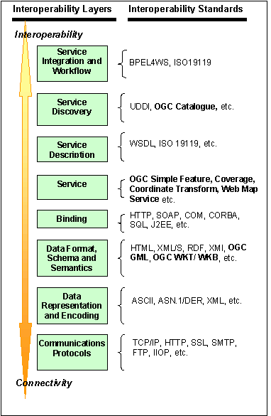
Figure A8-7: OpenGIS Standards and their Distinct Roles

- Recurrent comments:
The following comments and observations are from the Queensland Spatial Community.
“GIS, per se, is an overhead on our business that we do not need, but we do need access to geo-spatial data. Being able to access current authoritative data sets on an as-needed basis is preferable to downloading whole datasets and locally processing and maintaining them.”
“We don’t need the whole data set of the whole state the whole of the time. Our needs are ad hoc access to local or regional data, but the only way we can be ensured of that is to copy the whole-State data time and again, then work to bring it line with our other data.”
“Short term expediencies often turn into long term millstones, especially in managing externally supplied and maintained data sets; an alternative strategy is to pull the plug, lose the added value and move on to the next project.”
“The private sector has not been proactive in taking up initiatives outlined by government. Where government is to be main beneficiary then an option is for the government to prove viability and then outsource.”
“The lack of clear and practical channels of supply for data creates problems for all.”
“Support for Emergency Services’ data and processing requirements highlights the need for rapid access to current accurate data from highly fragmented data sources across multiple jurisdictions on demand and within a short time.”
Comments such as these prompt the following observations regarding the use of GI in Queensland:
- Domain expertise is distributed across numerous specialized agencies and departments.
- Data management expertise resides in a few, key agencies whose staff members are not necessarily aware of the practical applications of their data by other domain experts.
- Domain specialists and remote GI specialists seeking data have little option but to accept large volumes of data in batches - rather than in the ‘chunks’ they actually require – which are expensive to maintain and synchronize.
- The interactive capability of the internet is not effectively exploited; it is largely a surrogate for data deliveries that used to be made on tape or disk.
- There is little or no incentive for agencies and departments to discover and benefit from each other’s application and data development...
Alternative approaches therefore suggest themselves:
- Distributing authority and custodianship of data and services (processes) to the agencies.
- Using the interactive capability of the internet for user-driven ‘just in time’ delivery of selected data on demand.
- Enhancing this with access by domain experts to commonly required applications that render base data as analysed information products rather than raw data.
- Fostering a culture of peer-based publication of applications and data by authoritative and recognized custodians.
Consider replacing the development of application monoliths, each demanding considerable expense and on-going commitment in specialist technologies, with ‘bite sized’ low-cost short-term developments meeting mandated business requirements.
- Gazetteers, Geocoding, Geoparsing and Geolinking
A key element of integrated servicing across jurisdictions is the ability to use place names as common ‘glue’ providing current context. The notional architecture proposes the components ‘gazetteer’, ‘geocoder, ‘geoparser’ and ‘geolinker’ to support these needs. This section describes each in a little more detail.
  - Gazetteer
A gazetteer is a list of names of places and features, with geographic references such as latitude and longitude. The features may be natural (rivers, mountains etc.) or social (towns, administrative areas, schools, hospitals etc.). Gazetteers can be official (i.e. based on the work of place name authority for the jurisdiction) and arbitrary such as might originate with indigenous communities, industries such as mining or forestry, common local usage etc.
A gazetteer service can be implemented as a WMS to support searches:
- “Where is Longreach?” i.e. a place name query () receives coordinate data in reply;
- “What features or locations are in this box?” i.e. where an extent query such as bounding box receives a reply of lat/lon coordinate pairs plus names;
- “What features locations are with some distance of this other location or feature?”, again receiving a reply of lat/lon coordinate pairs plus names.
A gazetteer can provide a crucial underpinning for geocoding, geoparsing and geolinking services.
A gazetteer can also support a wide range of navigation services in an integrated environment, such as ordering systems for aerial photography, searching for government services, or identifying Government reports related to a certain region.
  - Geocoding
Geocoding is the resolution of place or features and descriptions as geographic coordinates. A gazetteer WFS can be a major element of a geocoding service, but the concept can be extended to deeper levels such as street-level addressing, lot-on-plan numbers, mining lease numbers etc.
  - Geoparsing
Geoparsing services digest textual documents, identify plausible location and feature names, geocode these and return the name/ coordinate data to the requester. A gazetteer service can provide and authoritative location name list against which parsing may take place.
  - Geolinking
Many organizations do not consider that they deal with geographic data, yet commonly deal with data tables that have systematic labels for referencing.
- Services Registry Sample Content
The following table indicates the minimum metadata fields that are required in any Service Registry in the Canadian Geospatial Data Infrastructure (http://www.geoconnections.org). One record is created for each SDI-compliant service.
Table A-3: Sample Service Registry Minimum Metadata Fields
Field Name | Description
About | The URI of the service instance being described
Publisher | The name of the institution that owns the service
Title | The name of the service
Description | A brief description of the service in plain text, as much as a whole paragraph in length.
Service | The type of service, chosen from a list of well-known types defined by a SDI Service Type Service. For a non-standard service, the content should be identified as "OTHER".
Specification | The URI of the Specification (in HTML) that describes the content and behavior unique to this specific implementation of the service. This is a human-readable description. It may be the same URI as defined below in Documentation.  (optional)
Documentation | The URI of the Documentation (in RDF) that describes the specific implementation of the service.  (optional)
Capabilities | The URI that returns the GetCapabilities document for the service (for many services, this is similar to the “about” URI above, with “?GetCapabilities” appended).  (optional)
WSDL | The URI of the WSDL description of the service  (optional)
Constraints | Access control restrictions to the service
Language | Language of this service description, where  "en" is for English,  "fr" is for French  Other languages / combinations are possible using ISO-3166-2 codes
Contact | A technical contact (which should include name, email, phone number or a link to a URI for this information)
Status | Operational status of this service in a free text format (7x24, production, testing, etc)
Date | Publication date of this service description

In SOAP version 2.0 document they are dropping the full name and just referring to the protocol as SOAP
Rumsfeld, D. An ontology of knowability, Department of Defense news briefing, Feb. 12, 2002, http://slate.msn.com/id/2081042
These EROS imagery archives are both WMS enabled. Also, NASA is implementing a WCS for their Global Mosaic Archive.
Web Services Components are software elements embodying application logic that are accessible across a network using standard Internet protocols, using ubiquitous Web protocols (e.g. HTTP)and universally accepted data formats (ex: XML).Services Components can be designed to be easily reused.
See http://edcsns15.cr.usgs.gov/serverstatus/
See http://www.geoconnections.org/CGDI.cfm/fuseaction/data.welcome/gcs.cfm
For example, the UN Geographic Information Working Group implemented in June 2002 a service using existing FGDC metadata structures to implement binding to multiple distributed services discovered through standard metadata searches.

