
Notional Architecture
for a Geo-enabled Enterprise Portal Platform
for the AusIndustry Spatial Interoperability
Demonstration Project
Volume 3 – Technical Considerations:
Viewpoints, part 2
Version: 1.0
Date: August 17th 2004
Authors:
Dr. Robert Starling
and
Michael Wilson
(OGC- Australasia)

. NOTICE
Permission to use, copy, and distribute this document in any medium for any purpose and without fee or royalty is hereby granted, provided that you include the OpenGIS Consortium copyright and the entire text of this NOTICE. We request that authorship attribution be provided in any software, documents, or other items or products that you create pursuant to the implementation of the contents of this document, or any portion thereof.

No right to create modifications or derivatives of OGC documents is granted pursuant to this license without permission of the OGC.

THIS DOCUMENT IS PROVIDED "AS IS," AND COPYRIGHT HOLDERS MAKE NO REPRESENTATIONS OR WARRANTIES, EXPRESS OR IMPLIED, INCLUDING, BUT NOT LIMITED TO, WARRANTIES OF MERCHANTABILITY, FITNESS FOR A PARTICULAR PURPOSE, NON-INFRINGEMENT, OR TITLE; THAT THE CONTENTS OF THE DOCUMENT ARE SUITABLE FOR ANY PURPOSE; NOR THAT THE IMPLEMENTATION OF SUCH CONTENTS WILL NOT INFRINGE ANY THIRD PARTY PATENTS, COPYRIGHTS, TRADEMARKS OR OTHER RIGHTS.

COPYRIGHT HOLDERS WILL NOT BE LIABLE FOR ANY DIRECT, INDIRECT, SPECIAL OR CONSEQUENTIAL DAMAGES ARISING OUT OF ANY USE OF THE DOCUMENT OR THE PERFORMANCE OR IMPLEMENTATION OF THE CONTENTS THEREOF.

OpenGIS® is a trademark or registered trademark of Open GIS Consortium, Inc. in the United States and in other countries.

SIDP Notional Architecture:
Technical Considerations, Part 2
V3-1 Introduction 1
V3-2 Computational method 5
2.1. Components 5
2.1.1. Application Services 6
2.1.2. Authentication, Authorization and Accounting Services 6
2.1.3. Data Repository Services 7
2.1.4. Data Services 8
2.1.5. Geodata Processing Services 8
2.1.6. Portrayal Services 9
2.1.7. Registry and Catalogue Services 9
2.1.8. Ancillary Services (also known as “Work Flow and Task Management in ISO 19119) 9
2.1.9. External Services 10
2.2. Component Characteristics 10
V3-3 Application Services Components 14
3.1. Applications Services Characteristics 16
3.2. Applications Process Model 17
3.3. Authority and Role Manager Client Generator 19
3.4. Component Manager Client Generator 21
3.5. Custodian Manager Client Generator 23
3.6. Data Extraction Client Generator 25
3.7. Data Manipulation Client Generator 27
3.8. Discovery Client Generator 29
3.9. Event Manager Client Generator 31
3.10. Event Subscription Manager Client Generator 32
3.11. Gazetteer Client Generator 33
3.12. Geodata Acquisition Client Generator 34
3.13. Geodata Manager Client Generator 35
3.14. Institution Manager Client Generator 37
3.15. Map Style Manager Client Generator 39
3.16. Map Symbol Manager Client Generator 41
3.17. Map Viewer Client Generator 43
3.18. Publisher Client Generator 44
3.19. Service Manager Client Generator 45
3.20. Type/Schema Manager Client Generator 47
3.21. Usage Accounting Manager Client Generator 49
3.22. User Account Manager Client Generator 50
3.23. Utilization Policy Manager Client Generator 51
3.24. Workflow (Choreography) Manager Client Generator 53
3.25. Workload Manager Client Generator 55
V3-4 Authentication, Authorization and Accounting Services Components 56
4.1. AAA Services Characteristics 57
4.2. AAA Process Model 58
4.3. Authentication Management Service 60
4.4. Authority Management Service 60
4.5. Authorization Management Service 60
4.6. Usage Accounting Service 60
4.7. User Accounting Service 61
4.8. User Authentication Service 61
4.9. User Authorization Service 61
4.10. User Registration Management Service 62
4.11. Utilization Policy Decision Points Service 62
4.12. Utilization Policy Management Service 62
V3-5 Data Repository Services Components 63
5.1. Data Repository Services Characteristics 64
5.2. Data Repository Process Model 65
5.3. Datastore Services 67
5.3.1. Accounting Records Datastore 68
5.3.2. Coverage Datastore 68
5.3.3. Feature Datastore 68
5.3.4. Gazetteer Datastore 69
5.3.5. Geodata Resource Datastore 69
5.3.6. Geographic Measurements Datastore 69
5.3.7. Geolinked Data Datastore 69
5.3.8. Management Records Datastore 70
5.3.9. Workflow (Choreography) Datastore 70
5.3.10. Workload Datastore 70
5.4. Library Services 71
5.4.1. Authentication Type Library 72
5.4.2. Authority Type Library 72
5.4.3. Component Type Library 72
5.4.4. Custodian Type Library 72
5.4.5. Event Type Library 73
5.4.6. Geodata Resource Type Library 73
5.4.7. Institution Type Library 73
5.4.8. Map Style Library 73
5.4.9. Map Symbol Library 74
5.4.10. Portal Type Library 74
5.4.11. Service Type Library 74
5.4.12. Coordinate Reference System Dictionary 74
5.4.13. Type/Schema Library 75
5.4.14. User Type Library 75
5.4.15. Utilization Policy Type Library 75
5.5. Registry Services 76
5.5.1. Component Registry 77
5.5.2. Custodian Registry 77
5.5.3. Event Registry 77
5.5.4. Event Subscription Registry 78
5.5.5. Geodata Resource Registry 78
5.5.6. Institutions Registry 78
5.5.7. Local Registry 79
5.5.8. Map Style Registry 79
5.5.9. Map Symbol Registry 79
5.5.10. Portal Registry 79
5.5.11. Service Registry 80
5.5.12. Type/Schema Registry 80
5.5.13. User Registry 80
5.5.14. Utilization Policy Registry 81
5.5.15. Utilization Policy Type Library 81
V3-6 Data Services Components 82
6.1. Data Services Characteristics 83
6.2. Coordinate Transformation Service 83
6.3. Data Extraction Service 83
6.4. Filter Encoding Service 84
6.5. Format Conversion Service 84
6.6. Geolinked Data Access Service 84
6.7. Web Coverage Service 84
6.8. Web Feature Service 85
V3-7 Geodata Processing Service Components 86
7.1. Geodata Processing Services Characteristics 87
7.2. Coverage Analysis Service 87
7.3. Coverage Difference Service 87
7.4. Coverage Generalization Service 88
7.5. Data Alignment Service 88
7.6. Data Reallocation Service 88
7.7. Feature Association Service 88
7.8. Feature Generalization Service 89
7.9. Framework Tiling Service 89
7.10. Gazetteer Service 89
7.11. Geolinking Service 91
7.12. Geoparsing Service 93
7.13. Image Geocorrection Service 93
7.14. Modeling Service 93
7.15. Overlaying Service 94
7.16. Reprojection Service (Also known as Coordinate Reference Transformation Service) 94
7.17. Routing Service 94
7.18. Schema Translation Service 95
7.19. Semantic Translation Service 95
V3-8 Portrayal Services Components 96
8.1. Portrayal Services Characteristics 96
8.2. Cascading SLD-enabled Web Map Service 97
8.3. Coverage Portrayal Service 97
8.4. Web Map Service 97
8.5. Web Terrain Service 98
V3-9 Registry and Catalogue Service Components 99
9.1. Registry and Catalogue Services Characteristics 99
9.2. Components Registry 103
9.3. Components Type Library Registry 104
9.4. Custodian Registry 104
9.5. Custodian Type Library 104
9.6. Event Registry 104
9.7. Event Subscription Registry 105
9.8. Event Type Library Registry 105
9.9. Geodata Resource Registry 105
9.10. Geodata Resource Type Library Registry 106
9.11. Institutions Registry 106
9.12. Institutions Type Library 107
9.13. Local Registry 107
9.14. Map Styles Library Registry 107
9.15. Map Styles Management Registry 107
9.16. Map Styles Registry 108
9.17. Map Symbol Library Registry 108
9.18. Portal Registry 108
9.19. Portal Type Library Registry 110
9.20. Service Registry 110
9.21. Service Type Library Registry 110
9.22. Types/Schemas Registry 110
9.23. Types/Schemas Library Registry 111
9.24. User Registry 111
9.25. Workflow (Choreography) Registry 112
9.26. Workload Registry 112
V3-10 External Service Components 113
10.1. Proprietary IMS Service 113
10.2. Clearinghouse Service 113
10.3. Web Service 113
V3-11 Ancillary Service Components 114
11.1. Clearinghouse Connector 114
11.2. Context-Based Discovery Service 114
11.3. Discovery Service 114
11.4. Infrastructure Accessibility Service 115
11.5. Workflow (Choreography) Enactment Service 115
V3-12 Future options: Federating Registries 116
V3-13 References 117
13.1. Bibliography 117
13.2. Acronyms 120
13.3. Glossary 123
Table of Figures
Figure V3-1: Computational Viewpoint 2
Figure V3-2: ISO 3-tier model 3
Figure V3-3: Seven Major Packages in the 3-tier Model 4
Figure V3-4: SIDP platform Packages and Communication relations model 5
Figure V3-5: Application Services Components 15
Figure V3-6: Application Services Process Model 18
Figure V3-7: Authority and Role Manager Client Generator Deployment 19
Figure V3-8: Component Manager Client Generator Deployment 21
Figure V3-9: Custodian Manager Client Generator Deployment 23
Figure V3-10: Data Extraction Client Generator Deployment 25
Figure V3-11: Data Manipulation Client Generator Deployment 27
Figure V3-12: Discovery Client Generator Deployment 29
Figure V3-13: Event Manager Client Generator Deployment 31
Figure V3-14: Event Subscription Manager Client Generator Deployment 32
Figure V3-15: Gazetteer Client Generator Deployment 33
Figure V3-16: Geodata Acquisition Client Generator Deployment 34
Figure V3-17: Geodata Manager Client Generator Deployment 35
Figure V3-18: Institution Manager Client Generator Deployment 37
Figure V3-19: Map Style Manager Client Generator Deployment 39
Figure V3-20: Map Symbol Manager Client Generator Deployment 41
Figure V3-21: Map Viewer Client Generator Deployment 43
Figure V3-22: Publisher Client Generator Deployment 44
Figure V3-23: Service Manager Client Generator Deployment 45
Figure V3-24: Type/Schema Manager Client Generator Deployment 47
Figure V3-25: Usage Accounting Manager Client Generator Deployment 49
Figure V3-26: User Account Manager Client Generator Deployment 50
Figure V3-27: Utilization Policy Manager Client Generator Deployment 51
Figure V3-28: Workflow (Choreography) Manager Client Generator Deployment 53
Figure V3-29: Workload Manager Client Generator Deployment 55
Figure V3-30: Authentication, Authorization and Accounting Services Components 56
Figure V3-31: Authentication, Authorization and Accounting (AAA) Generalized Process Model 59
Figure V3-33: Data Repository Service Segments 63
Figure V3-34: Data Repository Generalized Process Model 66
Figure V3-36: Datastore Repository Component Examples 67
Figure V3-37: Library Repository Component Examples 71
Figure V3-38: Registry Repository Component Examples 76
Figure V3-39: Data Service Components 82
Figure V3-40: Geodata Processing Service Components 86
Figure 41: Geolinking Service process Model 92
Figure V3-42: Portrayal Service Components 96
Figure V3-43: Registry and Catalogue Service Components 99
Figure V3-44: Core elements of the registry information model 101
Figure V3-46: Describing schemas in the registry 102
Figure V3-47: Component Registry Service Deployment 103
Figure V3-50: Federating Registries 116

- Introduction
The computational viewpoint portrays the functional decomposition of the SIDP platform into services interacting at well-defined interfaces. The services are grouped into meaningful packages reflecting the business tasks and instruments identified in the following Section 3.3 and the information classes considered elsewhere in the information Viewpoint.
These are referenced to the business management tasks and instruments previously identified from the information viewpoint.
Referring to the following figure V-3.1, the salient points of the SIDP platform computational viewpoint are:
- Seven major types of computational components, instances of which are to be instantiated as web services;
- Registry and catalogue services to support publication and discovery;
- Application services to provide the necessary interfaces for interaction with users’ web agents via the Internet;
- Portrayal services to create the required representational products of data (maps, charts, raw vectors etc.) required by user agents;
- Data access services to conduct transactional data retrieval from appropriate data sources;
- Geo-processing services to manipulate geo-spatial data according to user agent requirements; and
- Authentication, authorization and accounting services to ensure that web agents meet policy requirements for establishing their bona fides, receive authority to exploit a service, and have their usage accounted for (possibly as the basis for chargeback).
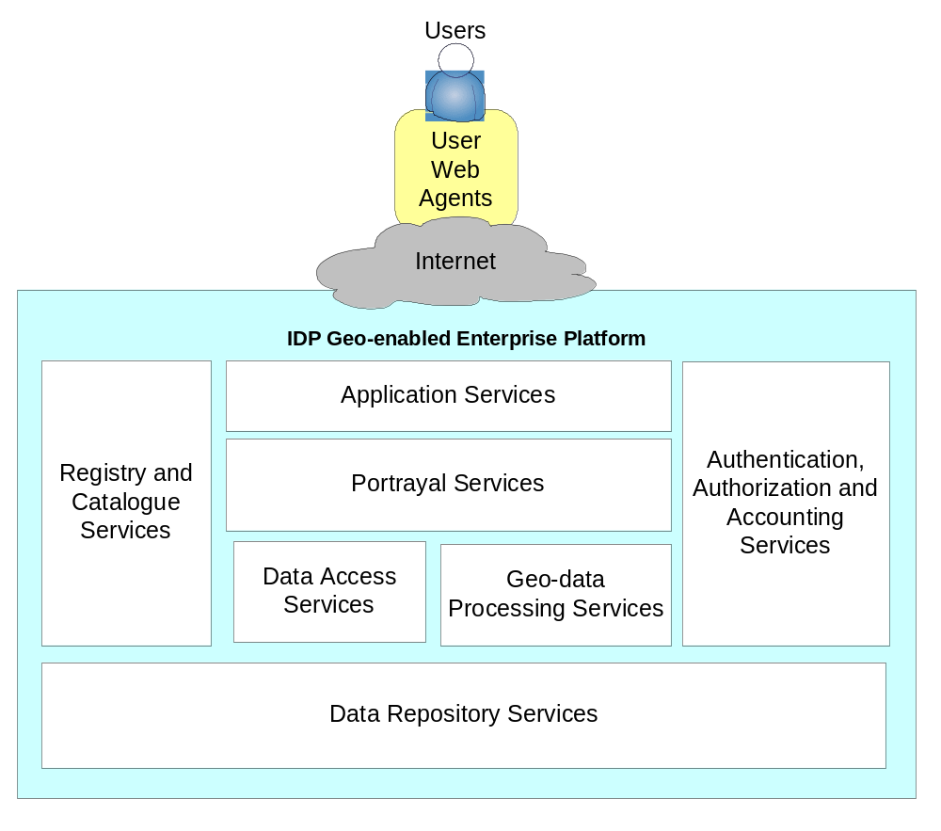
Figure V3-1: Computational Viewpoint
The SIDP platform provides uniform and consistent managed access to distributed web services capable of transforming information. These services comprise seven major categories address geo-data processing, presentation, access control, accounting and data management. Each is operated by an authoritative custodian who describes it in a registry.
The computational elements conform to the concepts of the ISO 3-tier model. In review, and referring to the following figure, the salient points concerning the SIDP platform are that:
- The “3-tier” model loosely couples the outward-looking interfaces accessed by users from the operations that instantiate business processes, which are in turn loosely coupled with the core data repositories
- Interaction interfaces in the top level conform to the web services/ web agents method elaborated in Appendix A2 i.e. support query-response transactions in well-known format and conveyed by open standard network protocols.
- All interactions with users and remote services are mediated by web agents
- Business process also present web service interfaces
- Data access services should also be loosely coupled to business process as web services, although in practice they may be tightly coupled according to existing institutional policies.
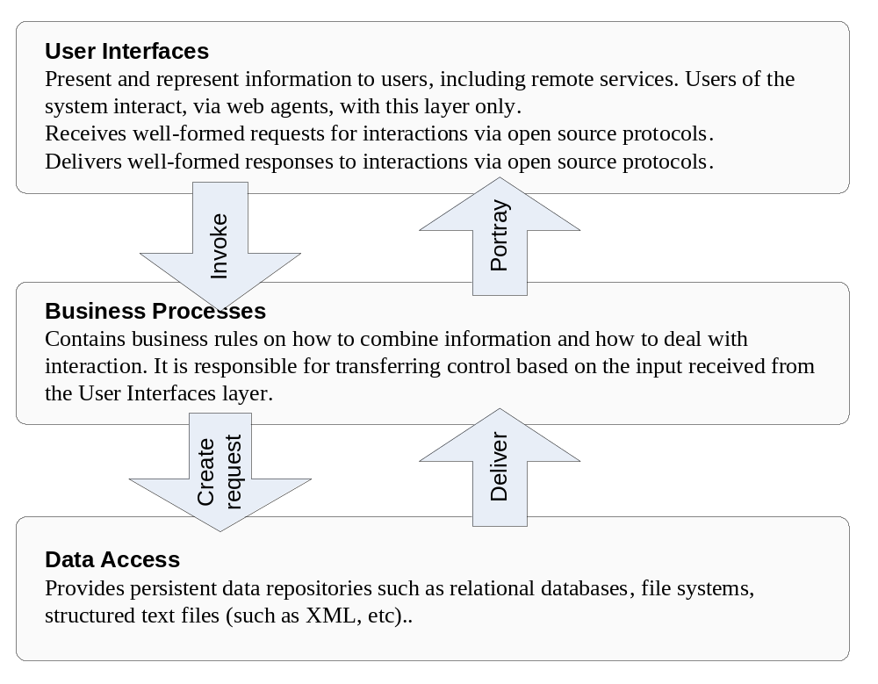
Figure V3-2: ISO 3-tier model
Each of the three tiers in this model addresses a separate aspect of serving users’ business requirements – establishing interfaces for user access, implementing business rules as process services, and manipulating stored data. In the Notional Architecture communication between tiers, and amongst elements within tiers, is capable of being mediated via Internet protocols between web services.
Elaborating on the ISO 3-tier model, the Portal is envisaged as comprising a number of service components that instantiate the service requirements at each level.
Referring to the Figure V3-3 below, the salient points concerning SIDP platform are that:
- The outward-looking user interface tier provides the actual user interfaces with which web agents interact (including clients generated for humans using web browsers to access the SIDP platform), and portrayal services that prepare the outputs of the business process tier as final products for delivery
- The business process tier provides service components such as discovery of services and content (such as metadata catalogues), data manipulation services (such as extracting specified subsets), geo-processing (such as geocorrection), authentication of agents, their authorization and accounting for use, and a variety of ancillary services.
- The data repository tier accommodates the variety of services that store, manage and deliver data according transactional requests. These are not directluy accessible to users’ agents and all interaction is mediated by business processes.
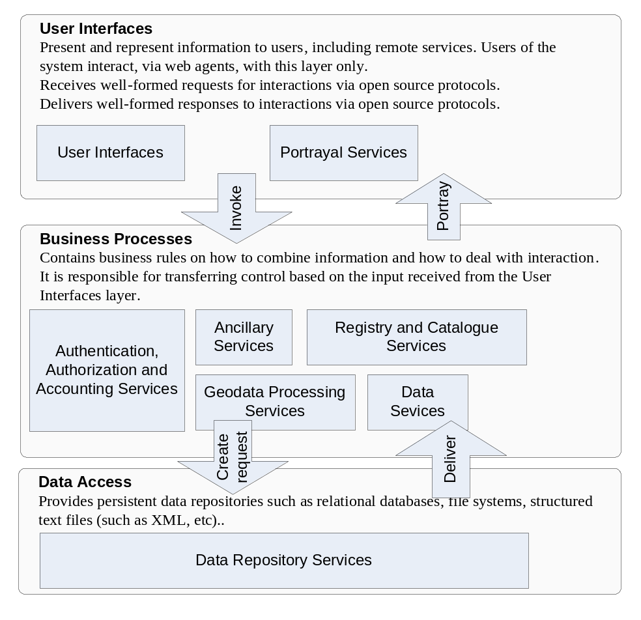
Figure V3-3: Seven Major Packages in the 3-tier Model
Seven major service packages are identified for implementing the SIDP Notional Architecture. User interfaces and Portrayal Services at the first tier address user agents’ requirements for establishing authenticity, receiving authorization to use resources, and specifying requirenets. Business processes at the second tier provide the only means by which user agents may access data, retrieve them or and transform them, and have their usage accounted for. Data respositories in the third tier are not directly accessible to user agents.

- Computational method
This section portrays the functional decomposition of the SIDP platform into services interacting at well-defined interfaces. The services are grouped into meaningful packages reflecting the business tasks and instruments identified in the previous section, and the information classes considered in Volume 2.
The Notional Architecture proposes that implementation of the SIDP platform will devolve to seven main packages that, in turn, comprise many specific components. The relationship amongst these packages is represented in Figure V3-4 below
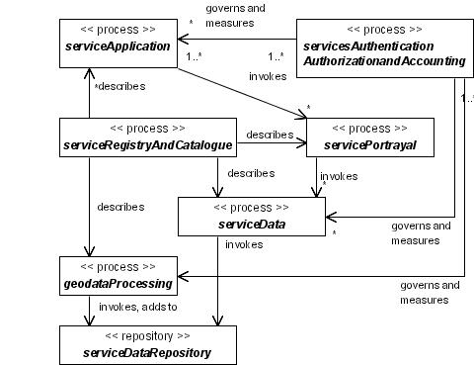
Figure V3-4: SIDP platform Packages and Communication relations model
Seven major computational packages govern the transformation of information in the SIDP. Authentication, Authorization and Accounting (AAA) services govern the accessibility of resources and the means of their accounting. Application services provide user interfaces for thin web clients. Registry and Catalogue services describe resources and their governance policies. Data respoitories are only accessed via geodata processes and data access services, which govern and measure their use.
These packages do not necessarily correspond one-to-one to the tasks or instruments described in Computational Viewpoint since these derive instead from the Enterprise Viewpoint. However, all such tasks and instruments must be accounted for among the services, their processes and components.
Each package comprises a number of specific components selected on the balance between cost-effectiveness, demand, control and distributed autonomy sought by the enterprise community.
  - Components
The choice of components and their priority for implementation will depend on the maturity of various specifications and standards, the balance between service priorities, cost-effective coordination and the distributed autonomy sought by the community. The seven principle packages and their components are described below. Their components are elaborated in below.
Table V3-1: Service Components Breakdown
- Application Services  Provide server-side Client Generators for accessing business and data access services. For Thin clients using standard web browsers this requires generating html client-side generators.  These do not modify data repository content directly, only via the appropriate management and data repository services.  See Application Services Components, Section V3-3 | Authority and Role Manager Client Generator  Component Manager Client Generator  Custodian Manager Client Generator  Data Extraction Client Generator  Data Manipulation Client Generator  Discovery Client Generator  Event Manager Client Generator  Event Subscription Manager Client Generator  Gazetteer Client Generator  Geodata Acquisition Client Generator  Geodata Manager Client Generator  Institution Manager Client Generator  Map Style Manager Client Generator  Map Symbol Manager Client Generator  Map Viewer Client Generator  Publisher Client Generator  Service Manager Client Generator  Type/Schema Manager Client Generator  Usage Accounting Manager Client Generator  User Account Manager Client Generator  Utilization Policy Manager Client Generator  Workflow (Choreography) Manager Client Generator  Workload Manager Client Generator
- Authentication, Authorization and Accounting Services  Provide for management of, and accounting for, SDI resources.  These do not modify datastore repository content  See Authentication, Authorization and Accounting Services Components, Section V3-4 | Authentication Management Service  Authority Management Service  Authorization Management Service  Usage Accounting Service  User Accounting Service  User Authentication Service  User Authorization Service  User Registration Management Service  Utilization Policy Decision Points Service  Utilization Policy Management Service

- Data Repository Services  Provide the persistent storage of geographic objects, temporal events, associated geolinkable aspatial data, user audit and management records, registry and catalogue metadata, and articulated service and data use policies.  Comprise Datastore services, Library services and Registry services.  These may modify data repository content.  See Data Repository Services Components, Section V3-5 | Datastore Services  Accounting Records Datastore  Coverage Datastore  Feature Datastore  Gazetteer Datastore  Geodata Resource Datastore  Geographic Measurements Datastore  Geolinked Data Datastore  Management Records Datastore  Workflow (Choreography) Datastore  Workload Datastore  Library Services  Authentication Type Library  Authority Type Library  Component Type Library  Custodian Type Library  Event Type Library  Geodata Resource Type Library  Institution Type Library  Map Style Library  Map Symbol Library  Portal Type Library  Service Type Library  Coordinate Reference System Dictionary  Type/Schema Library  User Type Library  Utilization Policy Type Library

- Data Services  The means by which Web Agents (including automated processes) acquire copies of data in either original or processed form.  This encompasses simple existing facilities for downloading copies of entire data elements such as GML files, shapefiles, raster images or database records, as well more sophisticated services delivering data that may have been customized to Web Agents’ requirements through Geodata Processing Services (see below) such as extraction, abstraction, combination, reformatting, reprojection, merging and so on.  Additionally, transactions (creation, replace, update, delete) to existing data stores can be accommondated through the use of transactional interfaces, such as the OGC Web Feature Service. This capability is very useful, for example, when collecting new information in the field via a mobile device and the user wishes to then send the new transactions to the server.  See Data Services Components, Section V3-6 | Coordinate Transformation Service  Data Extraction Service  Filter Encoding Service  Format Conversion Service  Geolinked Data Access Service  Web Coverage Service  Web Feature Service
- Geodata Processing Services  Provide the service building blocks that operate on geospatial data and provide services that add value to applications.  Geodata Processing Services conduct transformations of data originating from Data Repositories or other Geodata Processing Services and may deliver their outputs to Portrayal Services, Data Services or other processing Services.  These do not modify data repository content directly but may deliver modified versions of the data to the web agent.  See Geodata Processing Service Components, Section V3-7 | Coverage Analysis Service  Coverage Difference Service  Coverage Generalization Service  Data Alignment Service  Data Reallocation Service  Feature Association Service  Feature Generalization Service  Framework Tiling Service  Gazetteer Service  Geolinking Service  Geoparsing Service  Image Geocorrection Service  Modeling Service  Overlaying Service  Reprojection Service  Routing Service  Schema Translation Service  Semantic Translation Service

- Portrayal Services  Prepare visualizations and representations of data originating from Data Repositories and Geodata Processing Services.  Web Agents receive images representing the data, not the actual data values. These images may be maps, statistical charts, coropleth depictions, VRML animations or narrative packages such as summaries delivered in PDF format. A common existing Portrayal Service required for the SIDP platform is the Web Mapping Service.  These do not modify data repository content.  See Portrayal Services Components, Section V3-8 | Cascading SLD-enabled Web Map Service  Coverage Portrayal Service  Web Map Service  Web Terrain Service
- Registry and Catalogue Services  Provide a common mechanism to search, access information about resources available on a network. Resources are network addressable instances of typed data or services.  Also provide tools enabling authorized Web Agents to classify, register, describe and maintain resource metadata according to their assigned authority type.  These may modify data repository content  See Registry and Catalogue Service Components, Section V3-9 | Components Registry  Components Type Library Registry  Custodian Registry  Custodian Type Library  Event Registry  Event Subscription Registry  Event Type Library Registry  Geodata Resource Registry  Geodata Resource Type Library Registry  Institutions Registry  Institutions Type Library  Local Registry  Map Styles Registry  Map Styles Library Registry  Map Symbol Registry Service  Map Symbol Library Registry  Service Registry  Types/Schemas Library Registry  Types/Schemas Registry  Workflow (Choreography) Registry  Workload Registry
- Ancillary Services (also known as “Work Flow and Task Management in ISO 19119)  Provide service elements used in a variety of contexts including geodata processing, application services, and portrayal services.  Do not modify data repository content  See Ancillary Service Components, Section V3-11 | Clearinghouse Connector  Context-Based Discovery Service  Discovery Service  Infrastructure Accessibility Service  Workflow (Choreography) Enactment Service

- External Services  Components that exist and operate externally to the platform environment.  Do not modify data repository content  See External Service Components, Section V3-10 | Clearinghouse Service  Proprietary IMS Service  Web Service

  - Component Characteristics
The characteristics of major the SIDP platform packages are summarized in the Table V3-2 on the next page. These segments are elaborated further in section V3-3.4 following.
Table V3-3 below portrays a crosswalk of Enterprise and Computation Viewpoints highlights the tasks and tools relevant to each of the seven major service packages. It provides details of the current specification developed by by OGC and other groups related to these service packages. In summary:
- Specifications for portrayal services such as web map services are mature and widely implemented in commercial and open-source software;
- Data repository services, per se, do not require implementation of OGC interface specifications and are not directly accessible as web services.
- Some data services, such as extraction of representations of data from repositories in the form of application profiles of the OpenGIS® Geographic Markup Language (GML) and the transformation between representations, are mature and widely implemented in commercial and open-source software against a wide variety of commercial and open-source database backend systems;
- Delivery of vector representations of data using technologies such as the OpenGIS Web Feature Service interface specification to appropriate Web Agents through web feature services is mature and widely implemented in commercial and open-source software;
- Data discovery is well and widely implemented according to the Open Catalogue Service specification, which is implemented in FGDC CSDGM-CSDGM compliant catalogue services such as the ASDD. This specification underwent further development in 2003 and early 2004 and will soon be approved as adopted OGC technology (expected August 2004).;
- Service discovery through well-formed registries has been specified but remains to be fully described;
- The specifications governing Application Services, which generate the clients delivered to web browsers, are well developed by the W3C and underlie all existing web browsers. However, the specific form of these applications will depend on business requirements and so are beyond the bounds of standards organizations.
- Geodata Processing are the most complex arena. This is the least well specified work area in the standards community. Some, such as gazetteer, routing, geocoding and geoparsing, are currently either adopted OGC standards or are in progress. Routing, geocoding and reverse geocoding are part of the OGC Location Services Core Specification package.. Further, in the current OWS-2 Interoperability Initiative, there is considerable work being done on service chaining, imagery classification, and modelling. However, whatever form these services take, the use of GML as the transport format is assured and members of the group may elect to drive specific developments.
- Authentication, Authorization and Accounting specifically address business process requirements and hence are highly customized. However, the OASIS group continues to address and provide standards, such as SAML, for a wide range of common business requirements through web services, including security and confidentiality, user authentication and authorization, resource use accounting and charge-back.

Table V3-2: The SIDP platform Packages and Functions
Package | Function | Demands | Utilizes
Application Services Components | Generate client applications for services such as discovery, publishing, gazetteer and data extraction for “thin” external clients i.e. web browsers | A data extraction service or data portrayal service for portrayal delivery to Web Agents | Data Repository Services (spatial metadata, services, components, custodians, institutions, policies etc.  Geodata Processing Services (various)  Data Services (various)
Authentication, Authorization and Accounting Services Components | Provide services for managing SDI components and services through policies, authorities, authentication | Data Repository Services (read only) | Data Services  Geodata Processing Services
Data Repository Services Components | Provide persistent storage for geodata, control data, format data etc. | A data extraction service or data portrayal service for product delivery to Web Agents | Geodata processing Services  Data Services
Data Services Components | Provide methods for clients to acquire copies of data in either original or processed form. | Data Repository Services | Data Services
Geodata Processing Service Components | Provide the service building blocks that operate on geospatial data and provide services that add value to applications. | Data Repository Services | Geodata Processing Services
Portrayal Services Components | Provide the service building blocks that operate on geospatial data and provide services that add value to applications. | Data Repository Services or Geodata Processing Services | Geodata Processing Services
Registry and Catalogue Service Components | Provide a common mechanism to publish, search, access information about resources available on a network. Resources are network addressable instances of typed data or services. | Data Repository Services
Table V3-3: Crosswalk: Enterprise and Computational Viewpoints

 | Contributes to Business Management Task | Uses Business Management Instruments
Applications Services | Resource Management  User Management | Authority, Authenticity, Identity, Policy, Role
Authentication, Authorization and Accounting Services | Usage Accounting | Authority, Authenticity, Identity, Role
Data Repository Services | Resource Management | Authority, Authenticity, Identity, Role
Data Services | Resource Management  Usage Accounting | Authority, Authenticity, Identity, Policy, Role
Geodata Processing Services | Resource Management  Usage Accounting | Authority, Authenticity, Identity, Policy, Role
Portrayal Services | Resource Management | Authority, Identity, Policy, Role
Registry and Catalogue Services | Resource Management  User Management | Authority, Authenticity, Identity, Policy, Role

- Application Services Components
Application Services Components process requests from Thin clients, maintain or transfer state between requests, and return responses to the requesting Thin Client. More specifically, when accessed as a World Wide Web application a Client Generator runs on an HTTP server and generates HTML pages to be displayed in the User's web browser (the thin client).
In the SIDP platform, Client Generators are termed "server-side" components because they run on computers hosting the SIDP platform services, not on the end-user's machine or on the data service provider's machine.
Several Application Service types are identified in the following diagram. In the SIDP platform, Application Services are realized as, or requested from, web pages transferred across a network from application servers and supported by server-side capabilities to generate various clients and process requests. Thus, each item in the list below is called a "Client Generator" (CG) of some type.
Application services may be considered in two classes:
- Managers, which enable the contents of repositories to be created, modified, deleted or discovered, and
- Accessors, which allow only for discovery and access to repository content but do not allow it to be modified.
The Application Services provide the user interface of the SIDP platform. Web Agents may reuse Application Services to access the SIDP platform Registry, Portrayal, and Geodata Processing packages and distributed Map and Data Services, depending upon the requirements and designed implementation of the application.
In the SIDP platform, server-side Application Service Components shall provide a human user interface to the underlying service components defined in the following sections. Each of those underlying services shall have an application interface that is documented in the SIDP platform Architecture Specification (or by reference to another specification). Those application interfaces shall be invoked by the Application Service components and may be used by "thick clients" to bypass the human interface and directly access the convenience functions provided by the SIDP platform. (For example, a desktop software application could use the Gazetteer Connector to access the GNIS, or invoke the Schema Translation Service.) The SIDP platform Service Custodians shall be able to impose independent access restrictions on each service component.
Provider Services are accessible from Application Services operating on user terminals (e.g. desktop, laptop, etc.) or servers that have network connectivity.

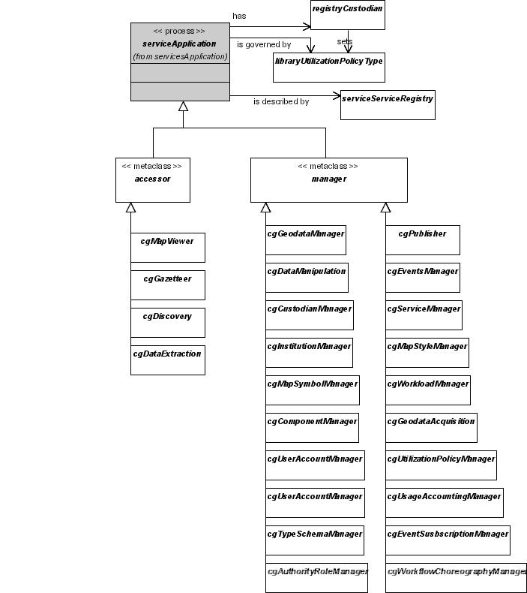
Figure V3-5: Application Services Components
Application Services generate interfaces for thin clients (browsers). In general there will be a separate client generator for each application service. The client generator in turn invokes the appropriate management service on behalf of the thin client, including authentication, authorization and usage accounting. Each application service is described in a Service Registry entry, and has a custodian who sets utilization policy
Envisaged application services include:
Application Services Components
Accessors | Managers
Data Extraction Client Generator  Discovery Client Generator  Event Manager Client Generator  Gazetteer Client Generator | Authority and Role Manager Client Generator  Component Manager Client Generator  Custodian Manager Client Generator  Data Manipulation Client Generator  Discovery Client Generator  Event Subscription Manager Client Generator  Geodata Acquisition Client Generator  Geodata Manager Client Generator  Institution Manager Client Generator  Map Style Manager Client Generator  Map Symbol Manager Client Generator  Map Viewer Client Generator  Publisher Client Generator  Service Manager Client Generator  Type/Schema Manager Client Generator  Usage Accounting Manager Client Generator  User Account Manager Client Generator  Utilization Policy Manager Client Generator  Workflow (Choreography) Manager Client Generator  Workload Manager Client Generator
  - Applications Services Characteristics
The following characterize the roles and responsibilities of Applications Services in the SIDP platform:
- Provided for human and remote system clients
- All interactions are mediated through the Internet using generic protocols (tcp/ip. http)
- All interactions are mediated by messages in well-structured vendor-neutral formats (XML)
- Human interface interaction (web browsers and other clients) are ultimately realized in the same messaging structures used for remote system messaging
- Human interfaces may be portrayed via thin, thick or ‘chubby’ clients i.e. web browsers, sophisticated desktop applications or web browsers enhanced with additional capabilities provided by substantial chunks of Java add-ins.
- Interfaces will also be portrayed in device platforms such as mobile computing platforms, PDAs, WAP-enabled handsets and similar clients.
Given the large number of potential client genertors required for different application services, and the degree of similarity in form, function and presentation of many of these, a given site may choose implement these as variants within a CG service, perhaps driven by systematized templates to ease CG development and ensure implementation standards. However, each application service (and its CG) must present as a separate, invocable and bindable service logically separate from all other application services.
  - Applications Process Model
Application client generators serve thin clients (browsers).
Each generated client interfaces with a client service, which may be a management service able to modify the content of repositories, or an accessor service, such as a discovery service or a map viewer, which can access but not modify repository content.

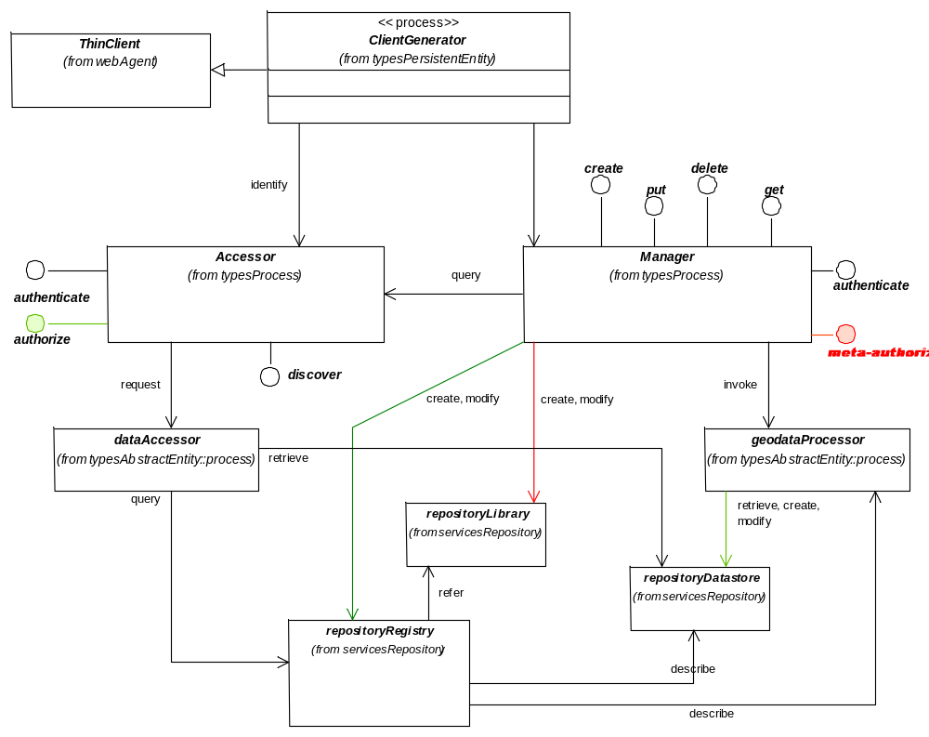 | Figure V3-6: Application Services Process Model  Client generators create interfaces for thin clients to content management services and to utility services such as discovery and map viewers.  User agents granted meta-authority (symbolized in red bold) are authorized to manage types of resources and tools i.e. to define policies types, authority types, resource types and and so on. These entries are managed in libraryr repositories.  User agents granted normal authorities may be able to manage datastore repository and registry repository entries (symbolized in green), or may simply be able to access these without management authority.

- Authority and Role Manager Client Generator |  | 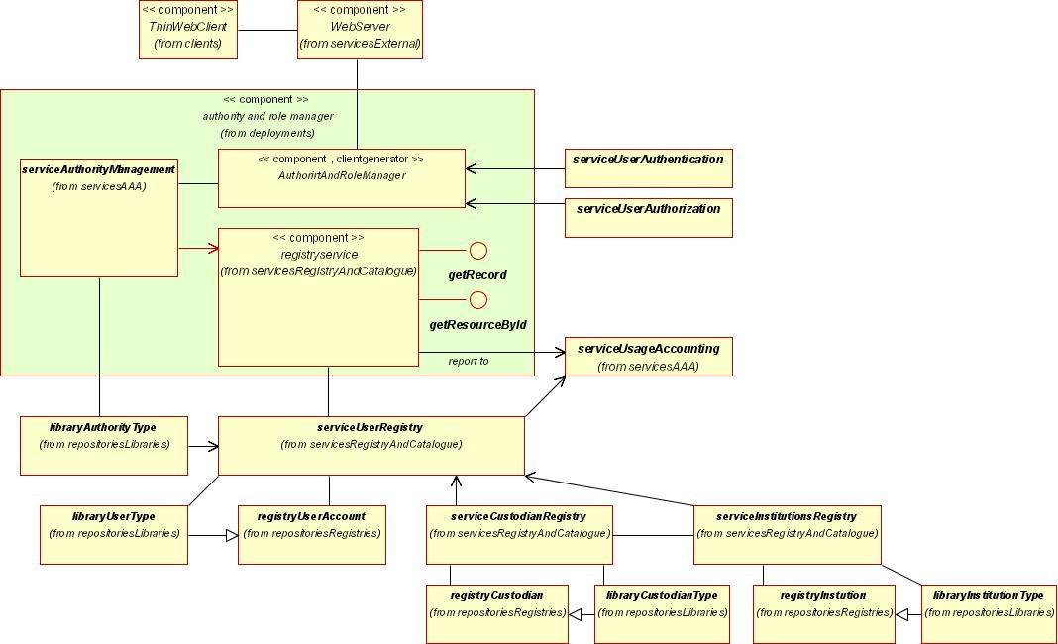  Figure V3-7: Authority and Role Manager Client Generator Deployment
Application Services Components
Invoked by | Thin web client (browser)
Invokes | Authority Management Service  User Authentication Service  User Authorization Service
May modify | Authority Type Library
Refers to | Authority Type Library  User Registry  Institutions Registry  User Type Library
A server-side component that generates thin clients enabling browser users to manage authorities.
Authorities govern web agents’ ability to use resources (content and services). Groups of authorities may be assigned simultaneously as roles.
Authorities and roles are assigned to agents when their User Account is created.

- Create a description of an authority type;
- Modify an existing description of a authority type;
- Delete/ rescind/ deprecate a description of an authority type;
- Define a role as an aggregation of individual authorities;
- Modify the definition of an existing role;
- Delete/ rescind/ deprecate a description of a role;
The client generator provides an authorised thin client web agent with the interface facilities so that it may:
- Assign a user an authority or role;
- Modify a user’s existing role or authorities, or
- Delete/ rescind/ deprecate a user’s role or authority;
Authority definitions are stored in an authority library and are created, accessed, modified or deleted by an Authority Management Service.

- Component Manager Client Generator |  | 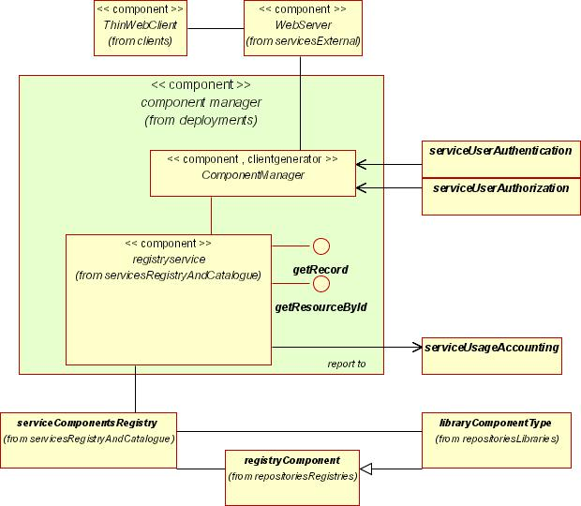  Figure V3-8: Component Manager Client Generator Deployment
Application Services Components
Invoked by | Thin web client (browser)
Invokes | Components Registry  User Authentication Service  User Authorization Service
May modify | Component Registry  Component Type Library
Refers to | Component Type Library
A server-side component that generates thin clients enabling browser users to manage components.
Components are software code or other equivalents, such as scripts or command files that provide the realization of a set of interfaces for SDI compliant services.
The client generator provides a meta-authorised thin client web agent with the interface facilities so that it may:
- Create a definition of a component type;
- Modify an existing definition of a component type;
- Delete/ rescind/ deprecate a definition of a component type.

- Create a description of a component;
- Modify an existing description of a component; or
- Delete/ rescind/ deprecate a description of a component.
Component definitions are stored in a component registry and are created, accessed, modified or deleted by a Registry Service. Component types are referred to from a Component Type Library.

- Custodian Manager Client Generator |  | 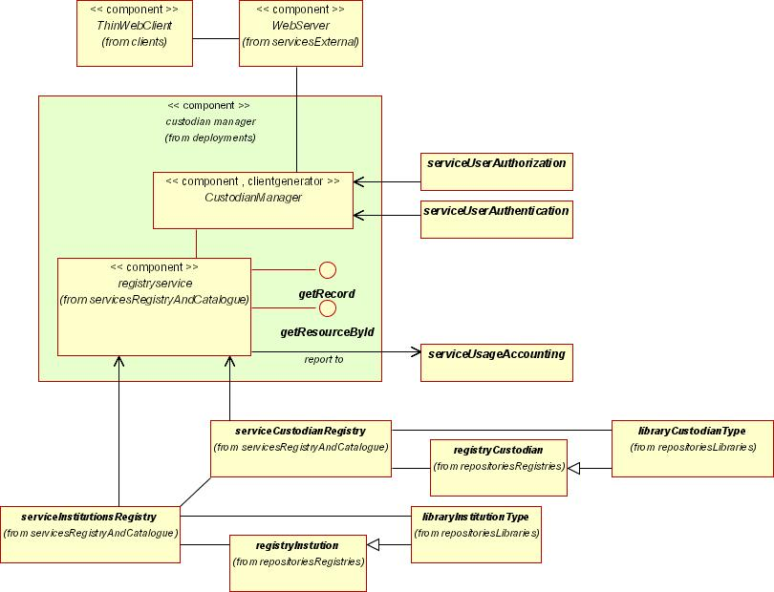  Figure V3-9: Custodian Manager Client Generator Deployment
Application Services Components
Invoked by | Thin web client (browser)
Invokes | Custodian Registry
May modify | Custodian Registry  Custodian Type Library
Refers to | Custodian Type Library  Institutions Registry
A server-side component that generates thin clients enabling browser users to manage custodians.
Custodians are people or institutions bearing operational authority for managing and providing geodata resources or services.
All services described in the Service Registry should have a custodian, which may be an institution or a person affiliated with an institution.
The client generator provides a meta-authorised thin client web agent with the interface facilities so that it may:
- Create a definition of a custodian type;
- Modify an existing definition of a custodian type, or

- Delete/ rescind/ deprecate a custodian type definition.
The client generator provides an authorised thin client web agent with the interface facilities so that it may:
- Create a description of a custodian;
- Modify an existing description of a custodian, or
- Delete/ rescind/ deprecate a custodian.

- Data Extraction Client Generator |  | 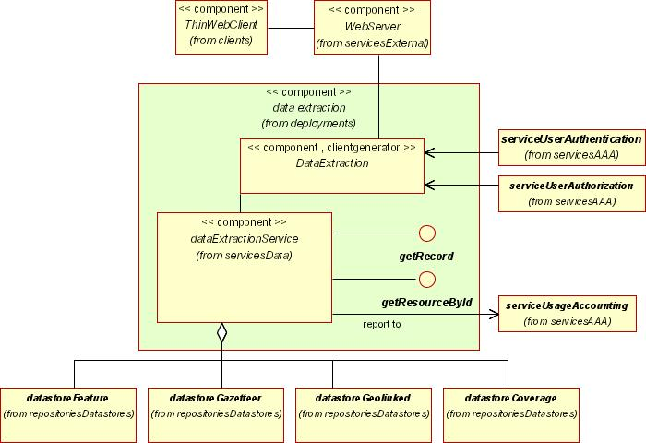  Figure V3-10: Data Extraction Client Generator Deployment
Application Services Components
Invoked by | Thin web client (browser)
Invokes | Data Extraction Service  User Authentication Service  User Authorization Service
May modify | Component Registry
Refers to | Component Type Library
A server-side component that generates thin clients that allow browser users to order and take delivery of unmodified data either held persistently in repositories or generated non-persistently (transiently) by geo-data processing services.

The client generator provides an authorised thin client web agent with the interface facilities so that it may:
- Extract features or coverage data from WCS and WFS instances, or
- Extract arbitrary data types from competent services Delete/ rescind/ deprecate a custodian.
Service utilization policy may require that Usage of data extraction services be accounted for.

- Data Manipulation Client Generator |  | 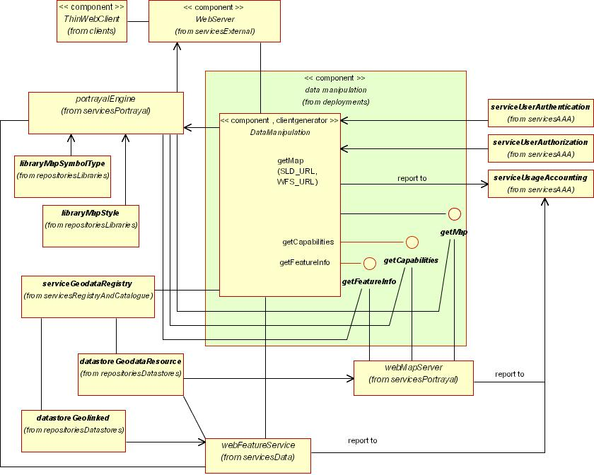  Figure V3-11: Data Manipulation Client Generator Deployment
Application Services Components
Invoked by | Thin web client (browser)
Invokes | Components Registry  User Authentication Service  User Authorization Service
May modify | Component Registry
Refers to | Component Type Library
A server-side component that enables thin Data Manipulation clients.
Provides Web Agents the ability to access, modify, add, and delete geospatial content stored at remote WFS, and possibly WMS or WCS, instances.
The client generator provides an authorised thin client web agent with the interface facilities so that it may:
- Extract features or coverage data from WFS (and possibly WCS and WMS) instances;
- Modify extracted feature data using Geodata Processing Services;

- Return modified data to the data repository (and modified meta data to appropriate registries), or
- Delete feature data from the data repository (and add appropriate indications to metadata registries).
Representations of manipulated data may be presented to the thin client according to selected or appropriate styled layer descriptors and symbology libraries.
Service utilization policy may require that Usage of data extraction services be accounted for.

- Discovery Client Generator |  | 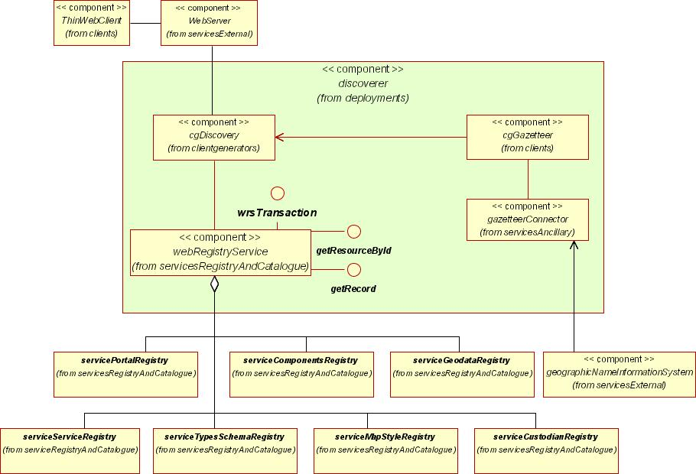  Figure V3-12: Discovery Client Generator Deployment
Application Services Components
Invoked by | Thin web client (browser)
Invokes | Uses the Discovery Service  User Authentication Service  User Authorization Service
May modify | Component Registry
Refers to | Component Type Library
A server-side component that enables thin Discovery Clients.
Provides Web Agents the ability to locate needed data and services according to user-defined criteria.
The client generator provides an authorised thin client web agent with the interface facilities so that it may:

- Define the features or coverage geodata sought from WFS, WCS, WMS instances;
- Define the geo-linkable data sought from arbitrary data source instances;
- Define the custodian, institutions or services sought;
- To define any of the above in combinations of thematic, geographic and temporal attributes.

- Event Manager Client Generator |  | 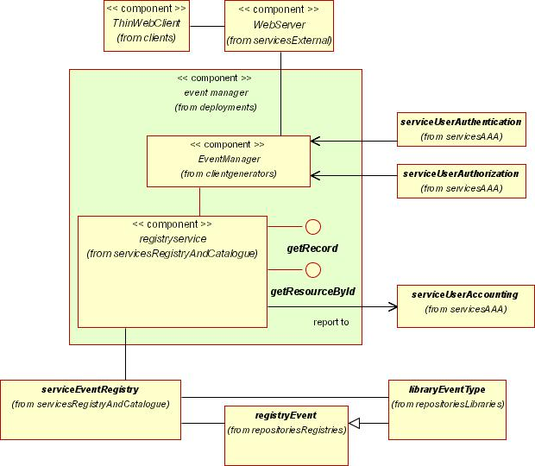  Figure V3-13: Event Manager Client Generator Deployment
Application Services Components
Invoked by | Thin web client (browser)
Invokes | Event Registry
May modify | Event Registry
Refers to | Event Type Library
A server-side component that enables thin Event Manager Clients.
Events are occurrences of interest to users and systems. For example:
- the creation or removal of a data set
- the availability of a new symbol library
- affiliation of a new custodian with an institutions
The client generator provides a meta-authorised thin client web agent with the interface facilities so that it may:
- Create, modify and delete event type definitions.
The client generator provides an authorised thin client web agent with the interface facilities so that it may:
- Create, modify and delete event descriptions.
Agents can subscribe to be alerted about events using the Event Subscription Registry.

- Event Subscription Manager Client Generator |  | 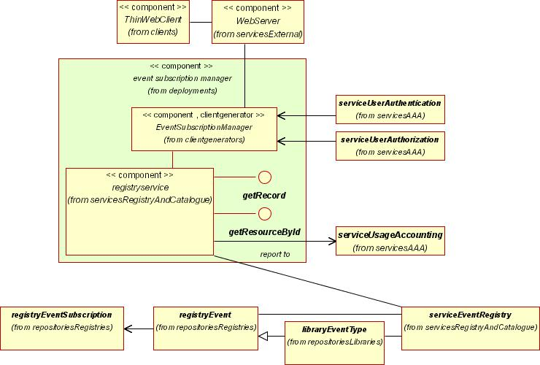  Figure V3-14: Event Subscription Manager Client Generator Deployment
Application Services Components
Invoked by | Thin web client (browser)
Invokes | Event Subscription Registry
May modify | Event Subscription Registry
Refers to | Event Type Library
A server-side component that enables thin Event Subscription Manager Clients.
Events are occurrences of interest to users and systems. For example:
- the creation or removal of a data set
- the availability of a new symbol library
- affiliation of a new custodian with an institutions
The client generator provides an authorised thin client web agent with the interface facilities so that it may:
- Create, modify and delete an event subscription.
Agents can describe events using the Event Registry.

- Gazetteer Client Generator |  | 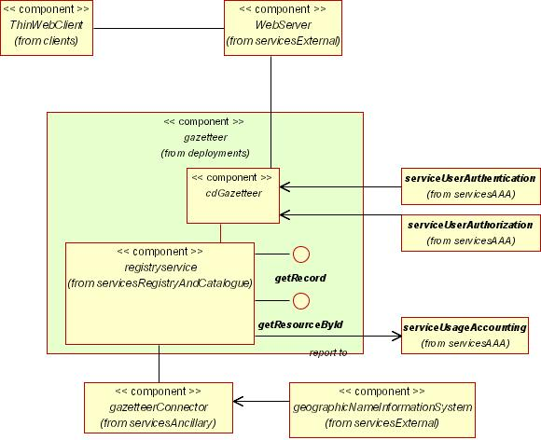  Figure V3-15: Gazetteer Client Generator Deployment
Application Services Components
Invoked by | Thin web client (browser)
Invokes | Gazetteer Service  User Authentication Service  User Authorization Service
May modify
Refers to | Gazetteer Datastore
A server-side component that enables thin Gazetteer clients.
Gazetteers are collections of names, locations and other attributes of features.
Provides Web Agents the ability to navigate through spatially organized features with well-known feature names.
Allows Web Agents to formulate queries to retrieve named features. In the SIDP platform, the Gazetteer Client will use an agreed Geographic Names Information System such as NIMA as a primary database of feature names.

- Geodata Acquisition Client Generator |  | 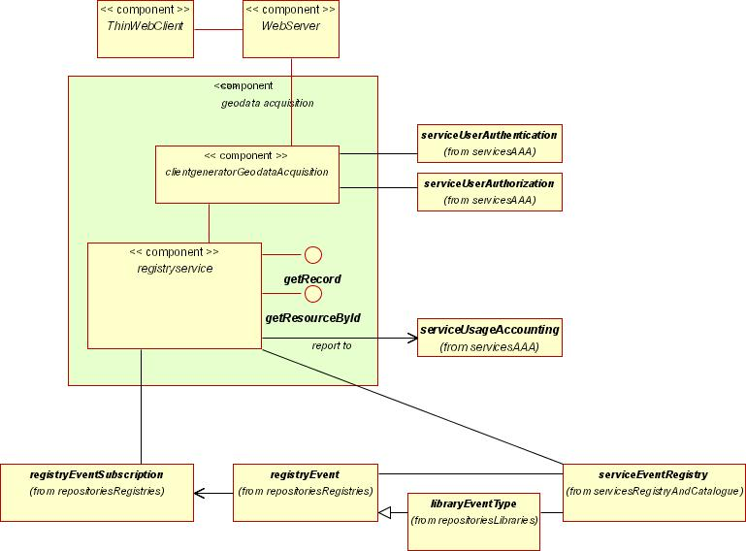  Figure V3-16: Geodata Acquisition Client Generator Deployment
Application Services Components
Invoked by | Thin web client (browser)
Invokes | User Authentication Service  User Authorization Service
May modify | Event Subscription Registry  Event Registry
Refers to | Event Type Library
A server-side component that enables thin Geodata Acquisition clients.
A Geodata Acquisition Service provides a set of interfaces by which authorizewd agents may request Geodata acquisition activities such as aerial, ground surveys or satellite images. Users specify the geographic extent of the area of interest, as well as the type of survey or sensor required, and the proposed timeframe of the data acquisition project.
These functions essentially combine interfaces for event management (“this aeriel image is acquired”) with event subscription (“tell me when an image is acquired over this area”).
Service utilization policy may require Usage of the geodata acquisition service be accounted for.

- Geodata Manager Client Generator |  | 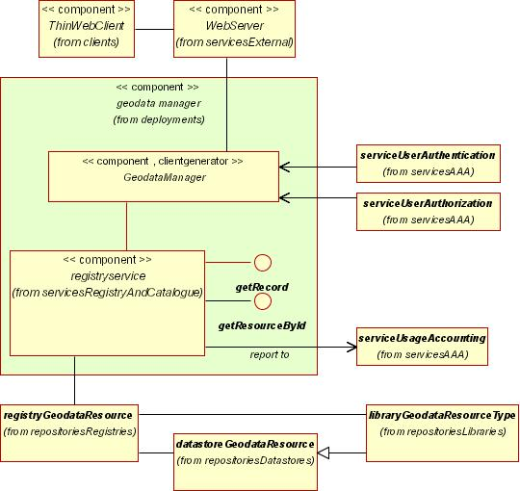  Figure V3-17: Geodata Manager Client Generator Deployment
Application Services Components
Invoked by | Thin web client (browser)
Invokes | Geodata Resource Registry  User Authentication Service  User Authorization Service
May modify | Geodata Resource Registry  Geodata Resource Type Library
Refers to | Geodata Resource Type Library
A server-side component that enables thin Geodata Management clients.
The client generator provides a meta-authorised thin client web agent with the interface facilities so that it may:
- Create a definition of a geodata resource type;
- Modify an existing definition of a geodata resource type;
- Delete/ rescind/ deprecate a definition of a geodata resource type.
The client generator provides an authorised thin client web agent with the interface facilities so that it may:
- Create a description of a geodata resource;
- Modify an existing description of a geodata resource; or

- Delete/ rescind/ deprecate a description of a geodata resource.
Geodata management includes facilities for:
- Creating, editing and removing geodata resource descriptions (i.e. metadata entries) discoverable through catalogue search-and-retrieval services such as the Discovery Service.
- Adding and removing data sets from Datastores.
The client generator provides an authorised thin client web agent with the interface facilities so that it may:
- Define the features or coverage geodata sought from WFS, WCS, WMS instances;
- Define the geo-linkable data sought from arbitrary data source instances;
- Define the custodian, institutions or services sought;
- To define any of the above in combinations of thematic, geographic and temporal attributes.
Service utilization policy may require Usage of the geodata manager service be accounted for.

- Institution Manager Client Generator |  | 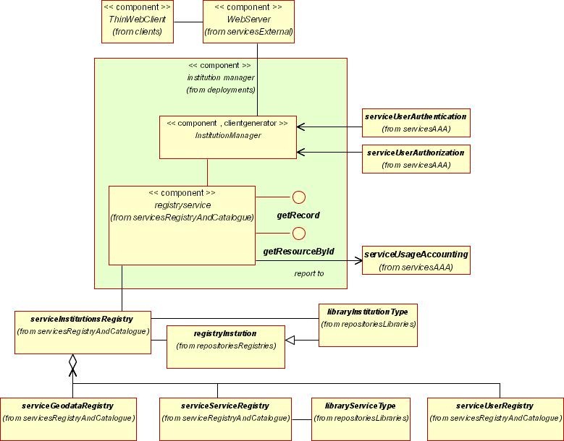  Figure V3-18: Institution Manager Client Generator Deployment
Application Services Components
Invoked by | Thin web client (browser)
Invokes | Institutions Registry  User Authentication Service  User Authorization Service
May modify | Institutions Registry
Refers to | Institution Type Library
A server-side component that enables thin Institutions Management clients.
Institutions are of interest as the custodians of data, metadata, services or because such custodians are affiliated with them.
The client generator provides a meta-authorised thin client web agent with the interface facilities so that it may:
- Create a definition of an institution type;
- Modify an existing definition of an institution type;
- Delete/ rescind/ deprecate a definition of an institution type.

The client generator provides an authorised thin client web agent with the interface facilities so that it may:
- Create a description of an institution;
- Modify an existing description of an institution; or
- Delete/ rescind/ deprecate a description of an institution.
Institution management includes facilities for creating, editing and removing institutions descriptions i.e. metadata entries discoverable through catalogue search-and-retrieval services such as the Discovery Service
Service utilization policy may require Usage of the institution manager service be accounted for.

- Map Style Manager Client Generator |  | 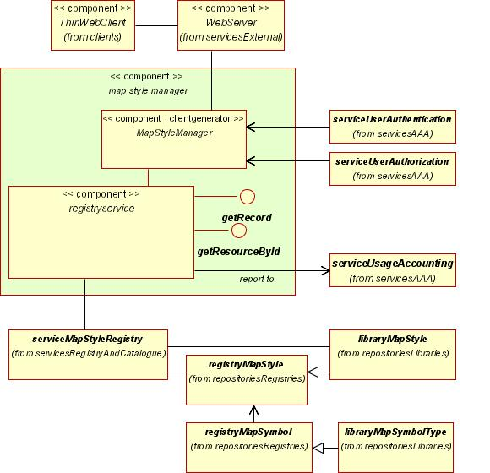  Figure V3-19: Map Style Manager Client Generator Deployment
Application Services Components
Invoked by | Thin web client (browser)
Invokes | Map Styles Library Registry  User Authentication Service  User Authorization Service
May modify | Map Style Registry
Refers to | Map Style Library
A server-side component that enables thin Map Style Management clients.
Map styles control the presentation of features when they are portrayed. Styled Layer Descriptors describe map styles are used by Web Feature Services and Cascading SLD-enabled Web Map Services.
The client generator provides a meta-authorised thin client web agent with the interface facilities so that it may:
- Create a definition of a map style type;
- Modify an existing definition of a map style type;
- Delete/ rescind/ deprecate a definition of a map style type.

The client generator provides an authorised thin client web agent with the interface facilities so that it may:
- Create a description of a may style;
- Modify an existing description of an map style; or
- Delete/ rescind/ deprecate a description of an map style.
SLDs (map style descriptions) are metadata entries discoverable through catalogue search-and-retrieval services such as the Discovery Service.
Service utilization policy may require Usage of the map style manager service be accounted for.

- Map Symbol Manager Client Generator |  | Figure V3-20: Map Symbol Manager Client Generator Deployment
Application Services Components
Invoked by | Thin web client (browser)
Invokes | Map Symbol Registry Service  User Authentication Service  User Authorization Service
May modify | Map Symbol Registry
Refers to | Map Symbol Library
A server-side component that enables thin Map Symbol Management clients.
Map symbol libraries provide refresences to common map symbology sets providing standard representations for different feature types according to institutional methodology
The client generator provides a meta-authorised thin client web agent with the interface facilities so that it may:
- Create a definition of a map symbol type;
- Modify an existing definition of a map symbol type;
- Delete/ rescind/ deprecate a definition of a map symbol type.
The client generator provides an authorised thin client web agent with the interface facilities so that it may:

- Create a definition of a map symbol collection;
- Modify an existing definition of a map symbol collection;
- Delete/ rescind/ deprecate a definition of a map symbol collection.
Map symbol descriptions i.e. metadata entries discoverable through catalogue search-and-retrieval services such as the Discovery Service.
Service utilization policy may require Usage of the map symbol manager service be accounted for.

- Map Viewer Client Generator |  | 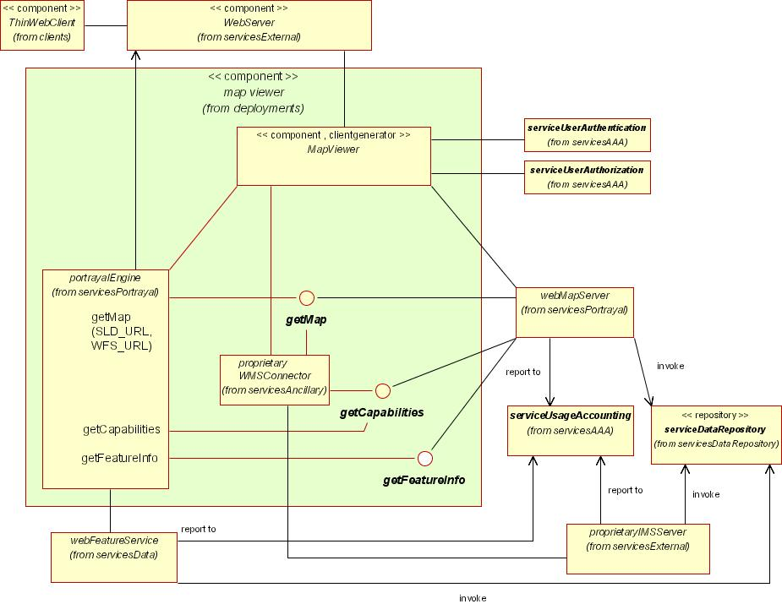  Figure V3-21: Map Viewer Client Generator Deployment
Application Services Components
Invoked by | Thin web client (browser)
Invokes | Web Map Service  User Authentication Service  User Authorization Service
May modify
Refers to
A server-side component that enables thin Viewer clients.
The client generator provides an authorised thin client web agent with the interface facilities so that it may:
- indicate the particular map composition to be displayed;
- Modify the characteristics of the portrayal by selecting scale, feature types and symbol libraries to apply.
Provides a visualization user interface to display and navigate content retrieved from WMS, WFS, WCS and other services. Map compositions may reporesent content originating from a number of distributed sources.
Service utilization policy will generally not require accounting for, but rather the usage of the underlying data access and processing services.

- Publisher Client Generator |  | 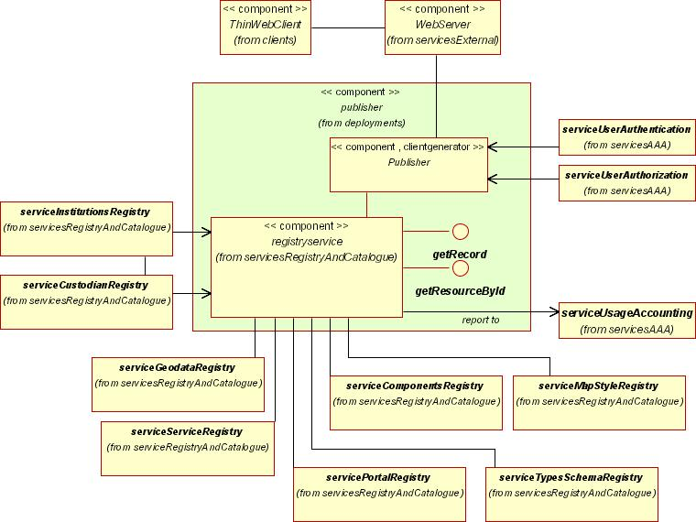  Figure V3-22: Publisher Client Generator Deployment
Application Services Components
Invoked by | Thin web client (browser)
Invokes | Geodata Resource Registry  Service Registry  User Authentication Service  User Authorization Service
May modify | Geodata Resource Registry
Refers to | Geodata Resource Type Library  Service Type Library
A server-side component that enables thin Publisher clients.
The client generator provides an authorised thin client web agent with the interface facilities so that it may:
- Create a description of a resource (service or content;
- Modify an existing description of a resource;
- Delete/ rescind/ deprecate a description of a resource.
In the SIDP platform, the Publisher Client Generator will allow authorized Web Agents to register Primary information sources, pre-defined symbolization rules, and possibly other information.
The Role of publisher need not be synonymous with creator or manager but is responsible for availability and quality of service.

- Service Manager Client Generator |  | 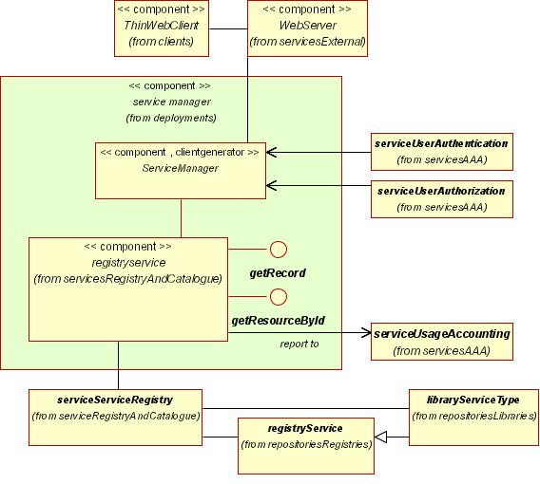  Figure V3-23: Service Manager Client Generator Deployment
Application Services Components
Invoked by | Thin web client (browser)
Invokes | Uses the Service Registry  User Authentication Service  User Authorization Service
May modify | Service Registry
Refers to | Service Type Library
A server-side component that enables thin Service Management clients.
Services are collections of Operations, accessible through one or more Interfaces that allows a user to evoke a behavior of value to that user. A Server delivers each service.
The client generator provides a meta-authorised thin client web agent with the interface facilities so that it may:
- Create a description of a service type;
- Modify an existing description of a service type;
- Delete/ rescind/ deprecate a description of a service type.

The client generator provides an authorised thin client web agent with the interface facilities so that it may:
- Create a description of a service, including custodian, utilization policies, and accounting rules, as well as interface specifications and service parameters;
- Modify an existing description of a service;
- Delete/ rescind/ deprecate a description of a service.
Provides means for Web Agents to define, create, manage and browse service definitions.
Service metadata is held in a Service Registry, from where it may be recovered either:
- Through resource Discovery Service, or
- By direct invocation of a known service for which a remote autonomous agent requires interface and aparameter definitions prior to binding.
Service utilization policy may require Usage of the service manager service be accounted for.

- Type/Schema Manager Client Generator |  | 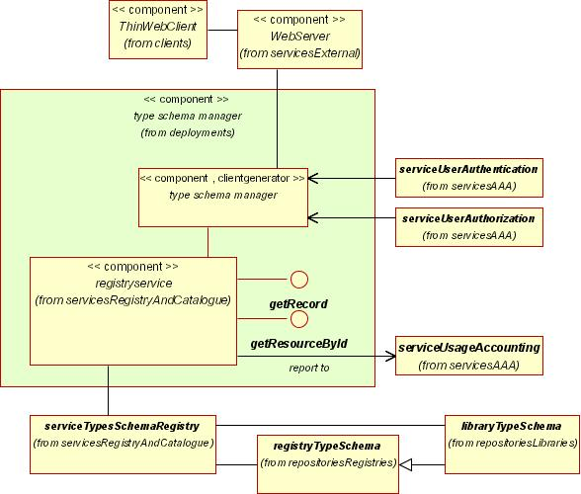  Figure V3-24: Type/Schema Manager Client Generator Deployment
Application Services Components
Invoked by | Thin web client (browser)
Invokes | Types/Schemas Registry  User Authentication Service  User Authorization Service
May modify | Type/Schema Registry
Refers to | Type/Schema Library
A server-side component that enables thin Symbol/Style Management clients.
Provides means for Web Agents to define, create, manage and browse the geographic Types and type schemata available and apply a predefined schemata definition for a particular feature type(s).
The client generator provides a meta-authorised thin client web agent with the interface facilities so that it may:
- Create a description of a type and/or its associated schemata;
- Modify an existing description of a type or schema;

- Delete/ rescind/ deprecate a description of type or schema.
The client generator provides an authorised thin client web agent with the interface facilities so that it may:
- Create a description of a service, including custodian, utilization policies, and accounting rules, as well as interface specifications and service parameters;
- Modify an existing description of a service;
- Delete/ rescind/ deprecate a description of a service.
Service utilization policy may require Usage of the type/schema manager service be accounted for.

- Usage Accounting Manager Client Generator |  | 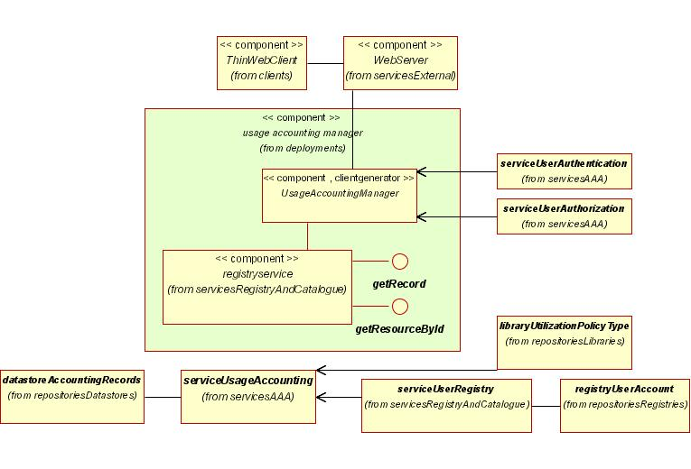  Figure V3-25: Usage Accounting Manager Client Generator Deployment
Application Services Components
Invoked by | Thin web client (browser)
Invokes | Usage Accounting Service  User Authentication Service  User Authorization Service
May modify | Accounting Records Datastore
Refers to
A server-side component that enables thin User Accounting Management clients.
Provides means for Web Agents to define, create, manage, report and browse accounting records created when agents’ use of SDI resources. This may include regular, automated cyclic reporting to be distributed through the Event Subscription Registry.
Service utilization policy may require Usage of the usage accounting manager service be accounted for.

- User Account Manager Client Generator |  | 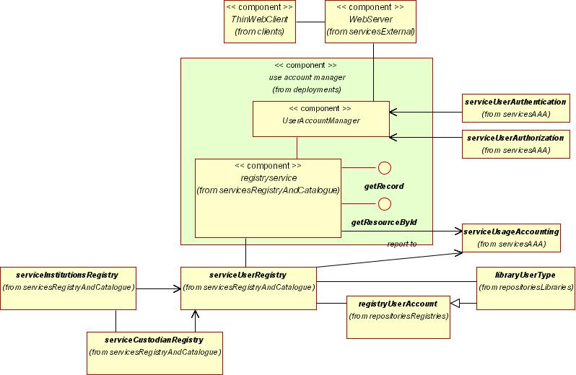  Figure V3-26: User Account Manager Client Generator Deployment
Application Services Components
Invoked by | Thin web client (browser)
Invokes | User Registry  User Authentication Service  User Authorization Service
May modify | User Registry
Refers to
A server-side component that enables thin User Account Management clients.
Provides means for Web Agents to define, create, manage and browse user accounts including assignment of roles, authorities, authentication rules, accounting rules and authorizations. User may also be associated with institutions, and designated as custodians of relevant resources.
Service utilization policy may require Usage of the utilization policy manager service be accounted for.

- Utilization Policy Manager Client Generator |  | 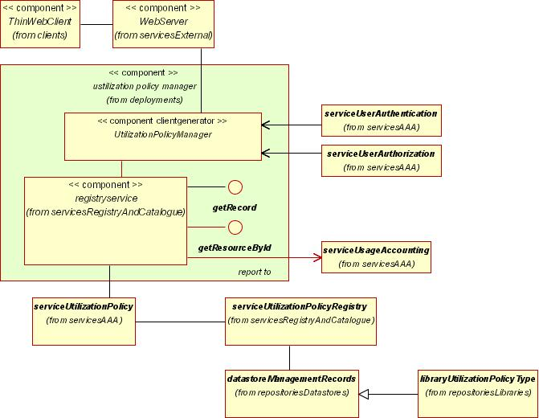  Figure V3-27: Utilization Policy Manager Client Generator Deployment
Application Services Components
Invoked by | Thin web client (browser)
Invokes | User Authentication Service  User Authorization Service  Utilization Policy Management Service
May modify | Workflow (Choreography) Datastore
Refers to
A server-side component that enables thin Utilization Policy Management clients.
Utilization Policy defines the conditions under which resources (services and content) may be used by web agents. Web agents may require certain Authority before being able to adhere to the utilization policy.
The Utilization Policy Decision Points Service determines whether and agent’s authority is sufficient to invoke the utilization policy.

The client generator provides a meta-authorised thin client web agent with the interface facilities so that it may:
- Create a description of a utilization policy type;
- Modify an existing description of a utilization policy type;
- Delete/ rescind/ deprecate a description of utilization policy type.
The client generator provides an authorised thin client web agent with the interface facilities so that it may:
- Create a description of a utilization policy;
- Modify an existing description of a utilization policy;
- Delete/ rescind/ deprecate a description of a utilization policy.
Service utilization policy may require Usage of the utilization policy manager service be accounted for.

- Workflow (Choreography) Manager Client Generator |  | 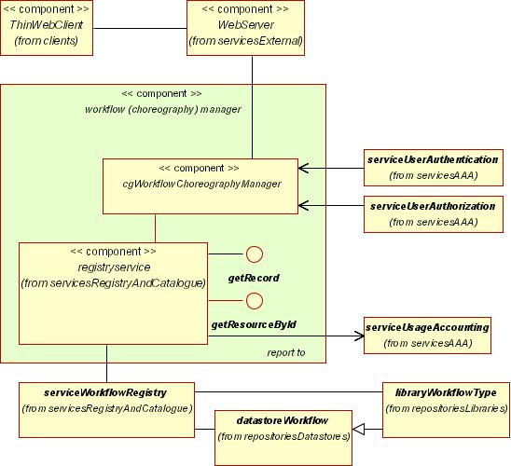  Figure V3-28: Workflow (Choreography) Manager Client Generator Deployment
Application Services Components
Invoked by | Thin web client (browser)
Invokes | User Authentication Service  User Authorization Service  Workflow (Choreography) Registry
May modify | Workflow (Choreography) Datastore
Refers to
Web Services Choreography concerns the observable interactions of services with their users. Any user of a Web Service, automated or otherwise, is a client of that service. These users may, in turn, be other Web Services, applications or human beings. A specific set of interactions maybe related over time to some form of collaboration grouping that is initiated at some source and runs through a set of Web Services and their client.
Provides means for Web Agents to define a sequence of services (a workflow, or chain) that perform a required action.

For example, a user may wish to send the output from a Feature Generalization Service to a WMS in order to visualize the data.
The client generator provides a meta-authorised thin client web agent with the interface facilities so that it may:
- Create a description of a workflow type;
- Modify an existing description of a workflow type;
- Delete/ rescind/ deprecate a description of workflow type.
The client generator provides an authorised thin client web agent with the interface facilities so that it may:
- Create a description of a workflow;
- Modify an existing description of a workflow;
- Delete/ rescind/ deprecate a description of a workflow.
Service utilization policy may require Usage of the workflow manager service be accounted for.

- Workload Manager Client Generator |  | 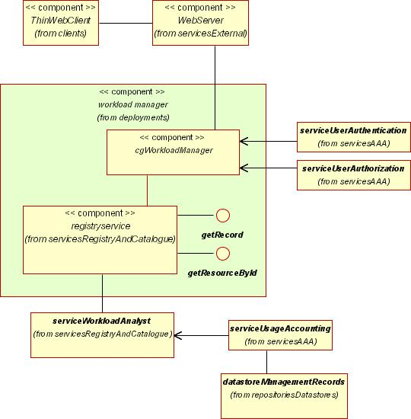  Figure V3-29: Workload Manager Client Generator Deployment
Application Services Components
Invoked by | Thin web client (browser)
Invokes | User Authentication Service  User Authorization Service  Workload Registry
May modify | Workflow (Choreography) Datastore
Refers to
A server-side application supporting Thin Workload Manager Clients
Workload describes how geodata resources are being used. The Workload Manager provides tools for helping to diagnose problems and recommend fixes to database administrators.

- Authentication, Authorization and Accounting Services Components
The Authentication, Authorization and Accounting (AAA) Services Components provide means by which user agents approaching the SIDP platform are able to authenticate their bona fides, receive authorization as appropriate for access to requested services, and have their usage accounted for.
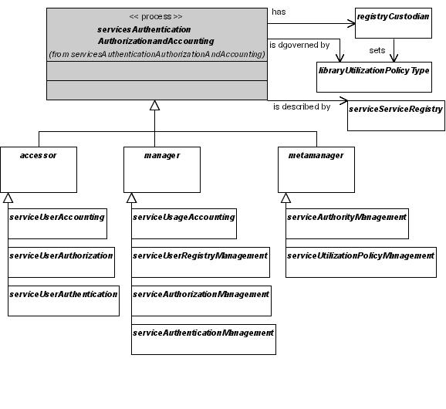
Figure V3-30: Authentication, Authorization and Accounting Services Components
Authentication, Authorization and Accounting (AAA) services manage resource definition and utilization according to utilization policies articulated by custodians. Each AAA service is described in a Service Registry entry, and has a custodian who sets utilization policy. This applies particularly to the ability to manage type library entries, including business tool authority types and policy types, for which meta-authorities are required since these in turn govern the application of other authorities.

Envisaged application services include:
Authentication, Authorization and Accounting Services Components
Accessors | Managers | Meta-Managers
User Authentication Service  User Authorization Service  User Accounting Service  Utilization Policy Decision Points Service | Authentication Management Service  Authorization Management Service  Usage Accounting Service  User Registration Management Service | Authority Management Service  Utilization Policy Management Service
  - AAA Services Characteristics
The following characterize the roles and responsibilities of Authentication, Authorization and Accounting Services in the SIDP platform:
- Clients may be required to be authorized to used a service;
- Authorization and certification are mediated using appropriately well-formed XML;
- Clients may need to be invoiced for using services;
Usage statistics will form one base for utilization monitoring, reporting, QoS assurance and transaction auditing, according to policy promulgated by Service Custodians, plus support cost recovery, QoS assessment, audit trails and capacity planning.
AAA services may be considered in three classes:
- Meta-managers, which enable utilization policies and agent authorities to be created, modified and deprecated i.e. which may modify entries in the Policies Type Library or the Authorities Type Library;
- Managers, which enable to create user agent accounts, assign roles (collections of authorities) to them, to assign individual authorities, or to apply utilization policies to resources i.e. may modify the contents of User Registry or the Utilization Policy Registry; and
- Accessors, which allow only for discovery and access to repository content but do not allow it to be modified.
AAA services may apply as meta-managers;
- Defining the nature of management tools (authorities and policies);
AAA management services provide authorized manager web agents with mechanisms for:
- Assigning the authenticities required of, and authorities assigned to, other web agents, including their Roles;
- Assigning the policies governing resource (service and content) utilization;
- Creating and managing agents user accounts.
AAA accessor service provide web agents with mechanisms for:
- Testing the validity of their assigned authorities against policy requirements, and
- Testing their authenticity; and
- Reporting user accounting.

The following characterize the roles and responsibilities of Authentication, Authorization and Accounting Services Services in the SIDP platform:
- Provided for human and remote system clients;
- All interactions are mediated through the Internet using generic protocols (tcp/ip. http)
- All interactions are mediated by messages in well-structured vendor-neutral formats (XML)
- Human interface interaction (web browsers and other clients) are ultimately realized in the same messaging structures used for remote system messaging
- Human interfaces may be portrayed via thin, thick or ‘chubby’ clients i.e. web browsers, sophisticated desktop applications or web browsers enhanced with additional capabilities provided by substantial chunks of Java add-ins.
- Interfaces will also be portrayed in device platforms such as mobile computing platforms, PDAs, WAP-enabled handsets and similar clients.
  - AAA Process Model
Referring to Figure V3-31: Authentication, Authorization and Accounting (AAA) Generalized Process Model (above):
Authentication, Authorization and Accounting (AAA) services manage and account for resource utilization through defining and applying management tools, and creating and reporting usage records.
AAA services may be invoked by thin clients (browsers), via an appropriate client interface, by thick clients, or by remote processes.
AAA management services authenticate agents prior to authorizing them or assigning roles. AAA accessor services may or may not authenticate or authorize web agents.
Management tool definitions are stored in appropriate type libraries and applied to agents and resources through references in their registry entries.

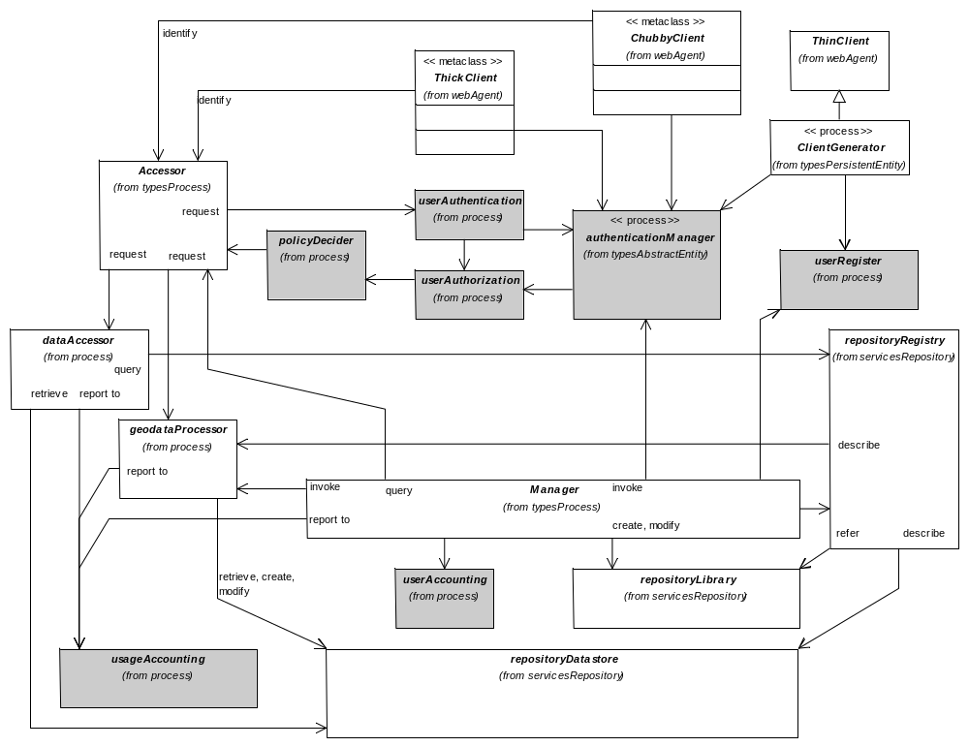 | Figure V3-31: Authentication, Authorization and Accounting (AAA) Generalized Process Model  AAA services ensure controlled use of resources and accounting for their usage. They are used by all types of client (thin, chubby and thick) either as accessors (i.e. referring to authorities and policies, or to decision regarding their application), as meta-managers able to modify authorities and policies, or as managers able to apply authorities to agents and policies to resources.

- Authentication Management Service |  | Authentication, Authorization and Accounting Services Components
Invoked by | User Authentication Service | May modify | User Registry
Invokes |  | Refers to | Authentication Type Library
Provides tools for creating, modifying and rescinding the types of authentication rules by which Web Agents’ bona fides are established and their rights to use the SIDP platform services and data are assigned.

- Authority Management Service |  | Authentication, Authorization and Accounting Services Components
Invoked by | User Registry  User Authentication Service | May modify | Authority Type Library
Invokes |  | Refers to
Provides tools for creating, modifying and rescinding the types of authorities (including accounting rules) governing Web Agents’ rights to use the SIDP platform services and data.
Authorization types are bundled into commonly applied groups described as Roles.

- Authorization Management Service |  | Authentication, Authorization and Accounting Services Components
Invoked by | User Authentication Service | May modify
Invokes |  | Refers to | Authority Type Library
Provides tools for creating, modifying and rescinding the types of authorities (including accounting rules) governing Web Agents’ rights to use the SIDP platform services and data.

- Usage Accounting Service |  | Authentication, Authorization and Accounting Services Components
Invoked by | Any other service for which usage must be accounted | May modify | Accounting Records Datastore
Invokes |  | Refers to | Utilization Policy Registry
Provides tools for
- Defining, modifying and removing accounting rules to be applied by various Usage Policies
- Monitoring utilization of system services
- Reporting individual and aggregate Accounting information
Generates accounting records.

- User Accounting Service |  | Authentication, Authorization and Accounting Services Components
Invoked by | Usage Accounting Services | May modify
Invokes |  | Refers to | Accounting Records Datastore
Provides tools for reporting on and managing Web Agents’ accounts for usage of the SIDP platform services and data.

- User Authentication Service |  | Authentication, Authorization and Accounting Services Components
Invoked by | Any portal or interface service for which agents’ bona fides are to be established | May modify
Invokes |  | Refers to | User Type Library
Verifies presented user credentials against User Accounts prior to the user’s authority being established.

- User Authorization Service |  | Authentication, Authorization and Accounting Services Components
Invoked by | Any service for which an agent’s authority must be verified against resource usage policy | May modify
Invokes |  | Refers to | User Registry  Policy decision points  Geodata Resource Registry  Geolinked Data Datastore  Service Registry  Authority Type Library
Verifies presented user credentials against User Accounts prior to the user’s authority being established.
Provides tools for assigning users’ Web Agents’ authorities against the usage policy for services and data being requested.

- User Registration Management Service |  | Authentication, Authorization and Accounting Services Components
Invoked by | User Account Manager Client Generator  Any service for which an agent’s authenticity must be verified against resource usage policy | May modify | User Registry
Invokes |  | Refers to | Authority Type Library
Provides tools for assign Web Agents’ assigned authorities against the usage policy for services and data being requested.

- Utilization Policy Decision Points Service |  | Authentication, Authorization and Accounting Services Components
Invoked by | Any other service for which usage must be accounted | May modify
Invokes |  | Refers to | Utilization Policy Type Library
Provides tools for testing each agent request for utilization of an SDI resource against Utilization Policy Type as recorded in the Utilization Policy Type Library.

- Utilization Policy Management Service |  | Authentication, Authorization and Accounting Services Components
Invoked by | Utilization Policy Manager Client Generator  Any service for which an agent’s authenticity must be verified against resource usage policy | May modify | Utilization Policy Registry  Utilization Policy Type Library
Invokes |  | Refers to | Utilization Policy Type Library
Provides tools for defining, modifying and deleting policies governing Web Agents’ access to the SIDP platform services and data, including accounting rules.

- Data Repository Services Components
Data repositories are software components providing various types of persistent storage for substantive content, management and control information, reference libraries and metadata describing resources for their discovery and use.
They comprise substantive Geodata sources and Geolinked Data, as well as storing the information required by the Gazetteer Service and the Authentication, Authorization and Accounting Services. These segments comprise Datastore services, Library services and Registry services, as depicted in the following figure.
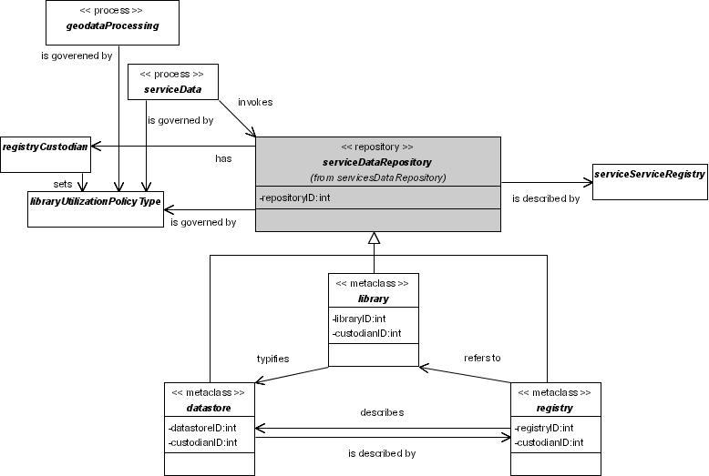
Figure V3-32: Data Repository Service Segments
Data Repository services provide persistent data storage and for access and management of contents. Datastores store dynamic content; libraries store reference information; registries store metadata. Data Repsoitory services can only be invoked by intermediary Data Services or Geodata processing Services that are capable of enacting utilization policy, not by arbitrary remote agents. Each Data Repository Service has a custodian who set utilization policy, although said policies will be enacted at the Data Service or the Geodata Processing Service level. Each data repository service is described in a Service Registry entry; the contents of datastores are described atomically in their associated registries.
Each of these segments may be decomposed into numerous components, the precise variety of which will depend on priorities and requirements.
Envisaged Data Repository Services include:
Data Repository Services Components
Datastore Services
Accounting Records Datastore  Coverage Datastore  Feature Datastore  Gazetteer Datastore  Geodata Resource Datastore | Geographic Measurements Datastore  Geolinked Data Datastore  Management Records Datastore  Workflow (Choreography) Datastore  Workload Datastore

Data Repository Services Components
Library Services
Authentication Type Library  Authority Type Library  Component Type Library  Custodian Type Library  Event Type Library  Geodata Resource Type Library  Institution Type Library  Map Style Library | Map Symbol Library  Portal Type Library  Service Type Library  Coordinate Reference System Dictionary  Type/Schema Library  User Type Library  Utilization Policy Type Library

  - Data Repository Services Characteristics
For the SIDP platform’s purposes Data Repositories are assumed to:
- Reside at many dispersed sites each managed a collaborator, commercial partner, community publisher or any SDI-enabled facility residing anywhere on earth;
- Each be the responsibility of a data custodian possessing the technical means, mandate and motivation to competently maintain data content and their associated metadata, and to ensure their reliable availability;
- Each be subject to articulated utilization policies governing the appropriate access, use and cost-recovery for use of data;
- Require, in some cases, on-line transaction-based content update via the SIDP platform interface;
- All interactions are mediated through the Internet using generic protocols (tcp/ip. http);
- All interactions are mediated by messages in well-structured vendor-neutral formats (XML);
- No human interface interaction (web browsers and other clients) are directly realized against repository services, but rather through intermediary access-controlled elements such as Data Services Components or Geodata Processing Service Components using the same messaging structures used for remote system messaging;
- Intermediary components may also ensure usage accounting; and
- Interfaces will also be portrayed in device platforms such as mobile computing platforms, PDAs, WAP-enabled handsets and similar clients.
Given the large number of repositories (datastores, registries and associated libraries) required for different application services, and the degree of similarity of structures and interfaces amongst many of these, a given site may chose to implement these as variants within a repository service e.g. a single generalized DBMS or a generalized XML-based repository. However, each repository service must present as a separate, evocable and bindable service logically separate from all other repository services.
  - Data Repository Process Model
In general, the architecture describing processes around data repositories will be as follows - exceptions will be noted as appropriate.
A datastore will persistently maintain copies of data. A transient datastore will do so for a single process session.
In practice, only one datastore may be required to be implemented, provided that it supports views of different logical datastore entities.
For example, the features encoded in a feature datastore may be operationally separable into, say, mapping features and gazetteer features i.e. require logically distinguishable and operationally separate interfaces, but nonetheless be manifest in the same system repository.
A registry persistently store metadata describing the entities held in the datastore. Again, many logically distinguishable registries (e.g. data sets, custodians, services) may be realized in a single generalized registry repository.
A library will persistently store the recurrent, standard elements needed to create a registry record describing an element of a datastore. Again, many logically distinguishable libraries (e.g. map style types, custodian types, service types) may be realized in a single generalized library repository.
In fact, datastores, registries and libraries could all be realized in the same generalized repository system, and rendered as appropriate logical views for particular applications in particular contexts.
A repository management service will mediate transactions that create, modify or remove elements from a datastore, whether datastore, registry or library.
A datastore service will mediate transactions for authorized web agents that create, locate, modify and delete records from a datastore whether it is geo-data datastores (such as Coverage Datastore or Feature Datastore) or an Accounting Records Datastore. A datastore access service mediates all transactions against the persistent storage system for operational data on behalf of web agents. A datastore manager client generator provides a human interface for browser users.
A registry service will mediate transactions for an authorized web client that create, locate, modify and delete metadata records from a registry. A registry access service mediates all transactions against the persistent storage system for descriptive metadata on behalf of web agents. A registry manager client generator provides a human interface for browser users.
A library service will mediate transactions for an authorized web client that create, locate, modify and delete records from a library. A library access service mediates all transactions against the persistent storage system for reference definitions on behalf of web agents. A library manager client generator provides a human interface for browser users.
Figure V3-33 (below) portrays a generalized repository process model. The salient features are:
- Data repositories are manipulated via access services;
- Management services control access to and operation of data services, providing for authentication and authorization of web agents (users), the control mechanisms for creating, modifying and destroying repository content, and handles for searching metadata;

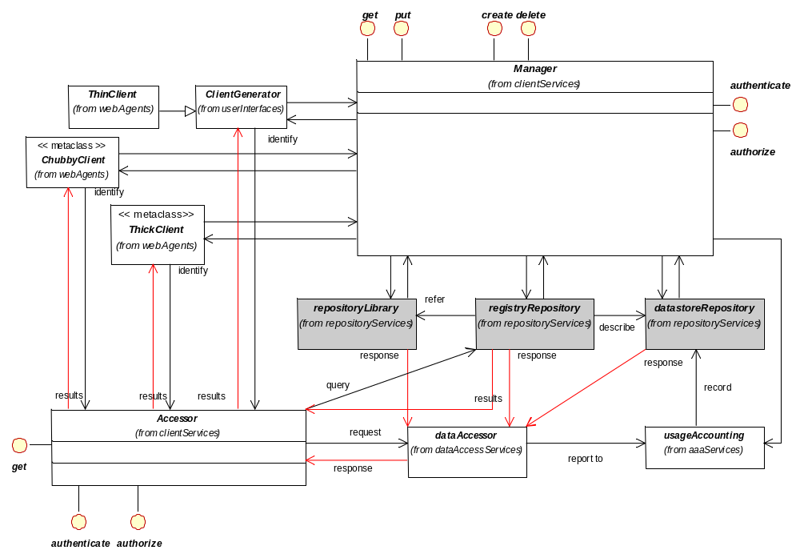 | Figure V3-33: Data Repository Generalized Process Model  Data repositories provide persistent storage for operational data, metadata and reference information. They are manipulated via access services. Management services provide means for controlling data services; they provide for authentication and authorization of web agents (users), the control mechanisms for creating, modifying and destroying repository content, and handles for searching metadata. These interfaces may be offered to thick clients directly, or to thin clients (browsers) via an appropriate client generator (CG).

- Interfaces may be offered to thick clients and chubby clients directly, or
- Interfaces may be offered to thin clients (browsers) via an appropriate client generator.
  - Datastore Services
A datastore is a software component providing persistent storage for the operational state of resources, whether services or content. Datastores may maintain geodata, metadata or management and control records.
Of the other types of repositories, registries persistently store metadata aiding discovery and description of resources largely according to library type descriptors. Their information tends to of a less operational and substantive nature and therefore less dynamic than that stores in datastores.
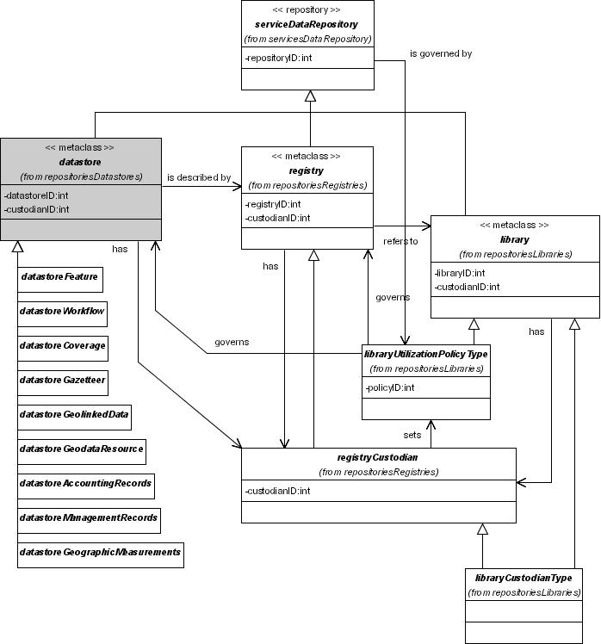
Figure V3-34: Datastore Repository Component Examples
Datastores are a class of repository managing dynamic operational data. All datastores have custodians and are governed by utilization policies.
Envisaged Datastore Services include:

Data Repository Services Components
Datastore Services
Accounting Records Datastore  Coverage Datastore  Feature Datastore  Gazetteer Datastore  Geodata Resource Datastore | Geographic Measurements Datastore  Geolinked Data Datastore  Management Records Datastore  Workflow (Choreography) Datastore  Workload Datastore

- Accounting Records Datastore |  | Data Repository Services Components:  Datastore Services
Invoked by | Usage Accounting Service  User Registry | May modify
Invokes |  | Refers to
Record the utilization of data access and service processes per user according to the requirements of the custodians’ utilization policies.
The Accounting Record Datastore can be a SQL relational database, flat files, an XML based datastore, etc.

- Coverage Datastore |  | Data Repository Services Components:  Datastore Services
Invoked by | Web Coverage Service | May modify
Invokes |  | Refers to
Stores continuous representations of a portion of the earth's surface. Each coverage may be a collection of features (like a vector dataset) or it may be a raster or gridded surface representing one or more attributes.

- Feature Datastore |  | Data Repository Services Components:  Datastore Services
Invoked by | Web Feature Service including Gazetteer Service | May modify
Invokes |  | Refers to
A software component for persistently storing and managing the spatial and non-spatial properties of geographic features.
The Feature Datastore can be an SQL relational database, flat files, an ARCINFO database, an XML based datastore, etc.

- Gazetteer Datastore |  | Data Repository Services Components:  Datastore Services
Invoked by | Discovery Service  Gazetteer Service | May modify
Invokes |  | Refers to
A Web Feature Server software component for providing persistent storage for Gazetteer features. A gazetteer is an online "dictionary" of geospatial words or terms, with or without applicable feature geometries. The Gazetteer Service is used to transform a set of place names into a set of stored geometry. The geometry is specific with respect to the coordinate reference system.
The Gazetteer Datastore can be an SQL relational database, flat files, an XML based datastore, etc.

- Geodata Resource Datastore |  | Data Repository Services Components:  Datastore Services
Invoked by | Data Extraction Service  Web Coverage Service  Web Feature Service  Web Map Service | May modify
Invokes |  | Refers to
Commonly also known as a “geo-database” or “data set archive”.
A software component for providing persistent storage of descriptions of SDI resources.

- Geographic Measurements Datastore |  | Data Repository Services Components:  Datastore Services
Invoked by | Data Alignment Service | May modify
Invokes |  | Refers to
A software component for providing persistent storage of measurement data such as surveys, hydrographic and oceanographic measurements
The Geographic Measurement Datastore can be an SQL relational database, flat files, an XML based datastore, etc.

- Geolinked Data Datastore |  | Data Repository Services Components:  Datastore Services
Invoked by | Geolinked Data Access Service | May modify
Invokes |  | Refers to
A software component for providing persistent storage for data (often, but not necessarily, tabular) available for Geolinking via common attributes to spatial data sets.
May be an SQL relational database, flat files, an XML based datastore, etc.

- Management Records Datastore |  | Data Repository Services Components:  Datastore Services
Invoked by | User Accounting Service  Usage Accounting Service | May modify
Invokes |  | Refers to
A software component for providing persistent storage of Management Records.
The Management Records Datastore can be a SQL relational database, flat files, an XML based datastore, etc.

- Workflow (Choreography) Datastore |  | Data Repository Services Components:  Datastore Services
Invoked by | Workflow (Choreography) Registry | May modify
Invokes | Workflow (Choreography) Enactment Service | Refers to
A software component for providing persistent storage of information describing definitions of service chains.
The Workflow (Choreography) Datastore can be a SQL relational database, flat files, an XML based datastore, etc.

- Workload Datastore |  | Data Repository Services Components:  Datastore Services
Invoked by | Workflow Archive Service | May modify
Invokes |  | Refers to
A software component for providing persistent storage of information describing how the geodata resources are being used.

  - Library Services
A library is a software component providing persistent storage for type definitions and schemas referred to by services and content, especially registry entries.
Of the other types of repositories, registries persistently store metadata aiding discovery and description of resources. Datastores persistently store information on the state of resources whether services or content.
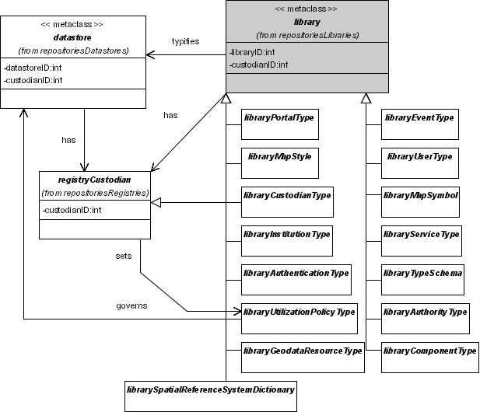
Figure V3-35: Library Repository Component Examples
Libraries are a class of repository storing reference type information applying to resources and tools. Each library has a custodian and is governed by the utilization policy of the resource or tool which refers to it.
Envisaged Library Services include:

Data Repository Services Components
Library Services
Authentication Type Library  Authority Type Library  Component Type Library  Custodian Type Library  Event Type Library  Geodata Resource Type Library  Institution Type Library  Map Style Library | Map Symbol Library  Portal Type Library  Service Type Library  Coordinate Reference System Dictionary  Type/Schema Library  User Type Library  Utilization Policy Type Library

- Authentication Type Library |  | Data Repository Services Components:  Library Services
Invoked by | Authentication Management Service  User Authentication Service | May modify
Invokes |  | Refers to
An Authentication Type Library records the types of authentication methods that may be applied to Web Agents seeking verification prior to user access to data and services.

- Authority Type Library |  | Data Repository Services Components:  Library Services
Invoked by | Authorization Management Service  User Accounting Service  User Authorization Service | May modify
Invokes |  | Refers to
An Authority Type Library records the types of authorities that may be assigned to Web Agents (and recorded in the Utilization Policy Type Library) for verification against utilization policies prior to user access to data and services.

- Component Type Library |  | Data Repository Services Components:  Library Services
Invoked by | Component Manager Client Generator  Components Registry  Components Type Library Registry  Discovery Service | May modify
Invokes |  | Refers to
A Component Type Library records details of type of software that packages the Client or Server implementation of a Service and can provide the realization of a set of Interfaces.
Used for component definition and discovery

- Custodian Type Library |  | Data Repository Services Components:  Library Services
Invoked by | Custodian Registry  Discovery Service  Geodata Resource Registry  Service Registry | May modify
Invokes | Custodian Type Library | Refers to
A Custudian Type Library is a software component for persistently storing information about specific types of custodians that may be referred to in the SDI such as legal status, geographic mandate, type of service etc.
Used for custodian description and discovery.

- Event Type Library |  | Data Repository Services Components:  Library Services
Invoked by | Discovery Service  Event Registry  Event Subscription Registry  Event Type Library Registry | May modify
Invokes |  | Refers to
An Event Type Library is a software component for persistently storing information about specific types of Events, including the name of the event type, and its definition. Records details of type of occurrences that may be instantiated in the SDI, such as data updates, emergency events, publication of SDI standards or procedures etc.
Used for event definition and discovery.

- Geodata Resource Type Library |  | Data Repository Services Components:  Library Services
Invoked by | Discovery Service  Geodata Resource Registry  Geodata Resource Type Library Registry | May modify
Invokes |  | Refers to
A Geospatial Data Resource Type Library is a software component for persistently storing information about specific types of Geodata resources, including the name of the geodata resource type, and its definition.
Used for geodata description and discovery.

- Institution Type Library |  | Data Repository Services Components:  Library Services
Invoked by | Discovery Service  Institutions Registry  Institutions Type Library | May modify
Invokes |  | Refers to
An Institution Type Library is a software component for persistently storing information about specific types of institutions that may be referred to in the SDI such as legal status, geographic mandate, tax status etc.
Used for institution description and discovery.

- Map Style Library |  | Data Repository Services Components:  Library Services
Invoked by | Discovery Service  Map Styles Library Registry  Map Styles Registry | May modify
Invokes |  | Refers to
A Map Style Library is a software component for providing persistent storage of Map Style definitions, also known as Styled Layer Descriptors. These are typically XML schemas that define portrayal rules.
Used for map style description and discovery.

- Map Symbol Library |  | Data Repository Services Components:  Library Services
Invoked by | Discovery Service  Map Symbol Registry Service | May modify
Invokes |  | Refers to
A Map Symbol Library is a software component for providing persistent storage of definitions of map symbols.
Used for map symbol description and discovery.

- Portal Type Library |  | Data Repository Services Components:  Library Services
Invoked by | Discovery Service  Portal Registry  Portal Type Library Registry | May modify
Invokes |  | Refers to
A Portal Type Library is a software component for providing persistent storage of definitions of portal definitions.
Used by the and for portal discovery

- Service Type Library |  | Data Repository Services Components:  Library Services
Invoked by | Discovery Service  Service Registry  Service Type Library Registry | May modify
Invokes |  | Refers to
A Service Type Library is a software component for persistently storing the characteristics of certain types of services.
Used for service description and discovery.

- Coordinate Reference System Dictionary |  | Data Repository Services Components:  Library Services
Invoked by | Coordinate Transformation Service  Image Geocorrection Service | May modify
Invokes |  | Refers to
A Coordiante Reference System Registry is a software component for persistently storing characteristics of coordinate reference systems, both for metadata creation purposes.

- Type/Schema Library |  | Data Repository Services Components:  Library Services
Invoked by | Discovery Service  Types/Schemas Registry  Types/Schemas Library Registry | May modify
Invokes |  | Refers to
A Type/Schema Library is a software component for persistently storing reference Types, schema fragments and schemata.
Used for discovery and description of Types and schemata

- User Type Library |  | Data Repository Services Components:  Library Services
Invoked by | Discovery Service  User Registry  U | May modify
Invokes |  | Refers to
A User Type Library is a software component for persistently storing the characteristics of certain types of users or, more specifically, their agents, particularly the types of roles they may enact.

- Utilization Policy Type Library |  | Data Repository Services Components:  Library Services
Invoked by | Discovery Service  User Authorization Service  Utilization Policy Decision Points Service  Geodata Resource Registry | May modify
Invokes |  | Refers to
A Utilization Policy Type Library is a software component for providing persistent storage of records describing the policy categories governing access to Resources i.e. Services and data.
User authorities are verified against policies prior accessing to data and services.

  - Registry Services
A registry is a software component for persistently storing metadata aiding discovery and description of resources.
Of the other types of repositories, libraries providing type definitions and schemas for describing resources, while datastores persistently store information on the state of resources whether services or content.
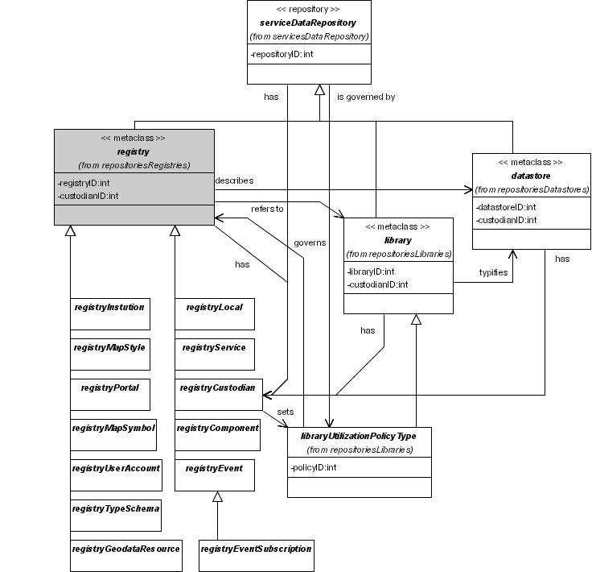
Figure V3-36: Registry Repository Component Examples
Registries are a class of repository persistently storing metadata for discovery of services and tool resources. Their contents are largely constrained by type entries in appropriate tlibraries. Each registry has a custodian and is governed by a ustilization policy.
Types of Registry Services envisaged includes:

Data Repository Services Components:
Registry Services
Component Registry  Custodian Registry  Event Registry  Event Subscription Registry  Geodata Resource Registry  Institutions Registry  Local Registry | Map Style Registry  Map Symbol Registry  Portal Registry  Service Registry  Type/Schema Registry  User Registry

- Component Registry |  | Data Repository Services Components:  Registry Services
Invoked by | Discovery Service  Components Registry Service | May modify
Invokes |  | Refers to | Component Type Library
A software component for providing persistent storage of details of the software that packages the Client or Server implementation of a Service and can provide the realization of a set of Interfaces.
A component consists of software code (source, binary or executable) or other equivalents such as scripts or command files. Components are accessed via standard interfaces.
Used for component description and discovery.

- Custodian Registry |  | Data Repository Services Components:  Registry Services
Invoked by | Discovery Service  Custodian Registry | May modify
Invokes | Custodian Type Library | Refers to | Custodian Type Library
A software component for providing persistent storage of information about custodians of each Service, Component or data resource. Contain information about specific custodians such as physical location, contact details, relevant resources, custodian history etc.
Used for custodian description and discovery

- Event Registry |  | Data Repository Services Components:  Registry Services
Invoked by | Discovery Service  Event Registry  Event Subscription Registry | May modify
Invokes | Event Type Library Registry | Refers to | Event Type Library
A software component for providing persistent storage of details of an occurrence of interest to Web Agents or developers of the SDI.
Contains metadata about individual Events, including the date of the event, the type of event, and the datasets, systems, geographic areas, or other objects affected, as well as the contact information for the event.
Events can be things such as the adjustment of a feature in a Framework Data layer, a flood in the Swan River basin, or the release of a new specification for a SDI Service.
Used for event description and discovery.

- Event Subscription Registry |  | Data Repository Services Components:  Registry Services
Invoked by | Event Subscription Registry | May modify
Invokes | Event Registry  Event Type Library Registry | Refers to | Event Registry  Event Type Library
A software component for providing persistent storage of information about subscribers to specific events, including:
- The type of Event being subscribed to;
- The geographic area of interest;
- The contact information for the subscriber; and
- A client specified action that the client may wish to invoke.
Used for event subscription.

- Geodata Resource Registry |  | Data Repository Services Components:  Registry Services
Invoked by | Discovery Service  Geodata Resource Registry | May modify
Invokes | Event Registry  Event Type Library Registry | Refers to | Event Registry  Event Type Library
Also commonly known as the meta-database or data set catalogue.
A software component for providing persistent storage of metadata about coverages (including images), features, other spatial data sets, and data sets suitable for Geolinking.
The Geodata Resource Registry can be a SQL relational database, flat files, an XML based datastore, etc.
Used for geodata description and discovery

- Institutions Registry |  | Data Repository Services Components:  Registry Services
Invoked by | Discovery Service  Institutions Registry  User Registry | May modify
Invokes | Event Registry  Event Type Library Registry | Refers to | Institution Type Library
A software component for providing persistent storage recording details of the institutions that participate as Web Agents of or providers to the SDI.
Institutions of interest in the SDI are those with which are affiliated custodians, components, services, or geodata resources.
Used for description and discovery of institutions, custodians, geodata resources, services and components.

- Local Registry |  | Data Repository Services Components:  Registry Services
Invoked by | Local Registry | May modify
Invokes | Event Registry  Event Type Library Registry | Refers to
A software component for providing persistent storage recording details of resources local to a portal i.e. do not require discovery.

- Map Style Registry |  | Data Repository Services Components:  Registry Services
Invoked by | Map Styles Registry  Web Map Services  Web Coverage Services  Local Registry | May modify
Invokes | Map Styles Library Registry | Refers to | Map Style Library
A software component for providing persistent storage of map style definitions to be referenced through SLDs.
Used for map style description and discovery.

- Map Symbol Registry |  | Data Repository Services Components:  Registry Services
Invoked by | Local Registry  Map Symbol Registry Service  Web Map Services  Web Coverage Services | May modify
Invokes |  | Refers to | Map Symbol Library
A software component for providing persistent storage of map symbol definitions to be referenced through SLDs.
Used for map symbol definition and discovery.

- Portal Registry |  | Data Repository Services Components:  Registry Services
Invoked by | Discovery Service  Local Registry  Portal Registry | May modify
Invokes | Portal Type Library Registry | Refers to | Portal Type Library  Service Type Library
A software component for providing persistent storage of references to portals via which provider services may be accessed using standard web service interfaces.
Used for portal description and discovery.

- Service Registry |  | Data Repository Services Components:  Registry Services
Invoked by | Discovery Service  Local Registry  Service Registry | May modify
Invokes | Service Type Library Registry | Refers to | Service Type Library
A software component for providing persistent storage of information describing specific instances of Services available with the SIDP platform via standard, well-described interfaces.
It includes detailed information (metadata) that describes a service available for retrieval in order to evaluate its suitability to meet a need.
Used for service description and discovery.

- Type/Schema Registry |  | Data Repository Services Components:  Registry Services
Invoked by | Discovery Service  Local Registry  Types/Schemas Registry | May modify
Invokes | Types/Schemas Library Registry | Refers to | Type/Schema Library
A software component for providing persistent storage of map types and schemas. It supports operations for the management of Types, schema fragments, and schemas.
The OGC has defined a general Service Model based on the EbXML Registry Model [13]. This Registry Model supports the registration and classification of more or less arbitrary objects. To date it has been applied to Service Offers defined in large measure by WSDL documents, but it is the intention of the OGC to extend this to the registration and classification of many kinds of objects including in particular types and schemas.
The OGC Service Model (a.k.a. Registry Model) supports the notion of a classification taxonomy that can be registered through the Registry Interface. The classification taxonomy is a type hierarchy in the sense of a classification of meaningful geographic entities.
Used for discovery of Types and schemata.

- User Registry |  | Data Repository Services Components:  Registry Services
Invoked by | Service Discovery  Local Registry  Types/Schemas Registry | May modify
Invokes | Authentication Management Service  Authorization Management Service  U | Refers to | Authority Type Library  Institutions Registry  User Type Library
A software component for providing persistent storage of information describing specific instances of Web Agents and clients known to the SIDP platform via standard Interfaces. It includes detailed information (metadata) that describes the user’s authorities (if any), accounting details, event subscriptions etc.
Used for user account description and discovery.

- Utilization Policy Registry |  | Data Repository Services Components:  Registry Services
Invoked by | Geodata Resource Registry  Utilization Policy Service | May modify
Invokes |  | Refers to | Utilization Policy Type Library
A software component for providing persistent storage of information describing specific policies governing Web Agents access to Services and resources.
Used for utilization policy description and discovery

- Utilization Policy Type Library |  | Data Repository Services Components:  Registry Services
Invoked by | Utilization Policy Service | May modify
Invokes |  | Refers to | Utilization Policy Type Library
A software component for providing persistent storage of information describing specific policies governing Web Agents access to Services and resources.
Used for utilization policy description and discovery

- Data Services Components
Data services deliver data to web agents (as distinct from delivering data portrayals to web agents). The data to be delivered may originate from any combination of persistent datastore repositories and non-persistent results generated by geodata processing services.
Data services may entail:
- Online transaction-oriented delivery such as provided by a Web Feature Service or a Web Coverage Service;
- Batch-oriented on-line file delivery (for example, conversion of stored data to an ESRI shapefile for on-line delivery via ftp); and
- Off-line delivery on physical media (ditto, but perhaps mailed on CD-ROM or DVD).
Data Services do not change data values, although they may be reformatted, subset by selective filtering, geo-linked to provide coordinate references, or presented in transformed coordinate systems.
The typical users of Data Services possess technical expertise in geographic information systems, cartography, statistical analysis or database manipulation. They subject the data to further processing in ‘thick’ or ‘chubby’ clients systems such as desktop GIS, database and statistical systems.
Example data services are represented in the following figure.
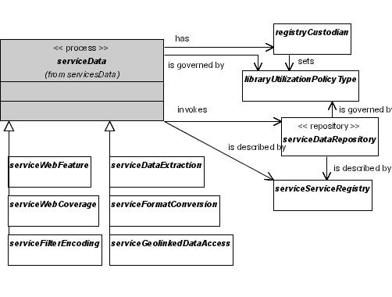
Figure V3-37: Data Service Components
Data Service Components extract and abstract data for delivery to ‘thick’ and ‘chubby’ clients. They do not modify data values, nor do they portray the data. Each data service is described in a Service Registry, and has a custodian who sets utilization policy. Data Services invoke Data Repository services according to their (separate) utilization policies.
  - Data Services Characteristics
The Web Feature Service is a required Data Service for the SIDP platform as it is central to portrayal service functions and also underlies potential high-value services based on gazetteer capabilities, including geo-coding, geo-linking and geo-parsing.
For the SIDP platform’s purposes Data Services are assumed to:
- Reside at many dispersed sites each managed a collaborator, commercial partner, community publisher or any SDI-enabled facility residing anywhere on earth;
- Each deliver content in accepted standard content formats and transfer formats. The SIDP platform envisages using the GML as its transport format.
- Each be the responsibility of a Service Custodian possessing the technical means, mandate and motivation to competently maintain services and their associated metadata, and to ensure their reliable availability;
- Each be subject to articulated policies governing the appropriate access, use and cost-recovery for use of the service;
- Not necessarily be co-resident with any of the Data Repositories underlying the service.
- Extract and abstract the content from Data Repositories for delivery to ‘chubby’ and ‘thick’ clients that are capable of using GML-mediated.

Data Services Components
Coordinate Transformation Service
Data Extraction Service
Filter Encoding Service
Format Conversion Service
Geolinked Data Access Service
Web Coverage Service
Web Feature Service

- Coordinate Transformation Service |  | Data Services Components
Invoked by | Geo-processing services | May modify | Transient datastore
Invokes | Coordiante Transformation Service | Refers to | Feature Datastore
Allows Web Agents and applications to convert a position given in one coordinate reference system into the corresponding position in another coordinate reference system.

- Data Extraction Service |  | Data Services Components
Invoked by | Geo-processing services | May modify | Transient datastore
Invokes | Coverage Datastore Access Service  Feature Datastore Access Service  Geolinked Data Datastore Access Service | Refers to | Coverage Datastore  Feature Datastore  Geolinked Data Datastore
Allow authorized clients to extract subsets of data for delivery to local storage. Delivery may be online or on physical media according to custodian policy.

- Filter Encoding Service |  | Data Service Component
Invoked by | Web Feature Service  Any other services able to express predicates in XML | May modify | Transient datastore
Invokes | Coverage Datastore Access Service  Feature Datastore Access Service  Geolinked Data Datastore Access Service | Refers to | Coverage Datastore  Feature Datastore  Geolinked Data Datastore
Provides a standard XML-based means of restricting the records that are returned from a query. Filter encoding can handle both spatial and non-spatial aspects of a query. This specification was designed to work with the Web Feature Service, but can be used by a broad range of services that require the ability to express predicates in XML.

- Format Conversion Service |  | Data Services Components
Invoked by | Geo-processing services  Web Coverage Service  Web Feature Service | May modify | Transient datastore
Invokes | Coverage Datastore Access Service  Feature Datastore Access Service  Geolinked Data Datastore Access Service | Refers to | Coverage Datastore  Feature Datastore  Geolinked Data Datastore
Transforms the format supported by Web Coverage Service and Web Feature Service instances into a format supported by the client.
Returns geospatial data in a different exchange format, given a dataset and a translation request. For example, a format conversion service could translate a road network from GML to ESRI Shapefile.

- Geolinked Data Access Service |  | Data Services Components
Invoked by | Geo-processing services  Web Coverage Service  Web Feature Service | May modify | Transient datastore
Invokes | Geolinked Data Datastore Access Service | Refers to | Geolinked Data Datastore
Allows a client to retrieve a set of Geolinked Data. Organizations that wish to distribute attribute data without the accompanying geolinked data can do so via this service.
Geolinked data returned from a request to this service can be merged with a set of Geospatial Data using a Geolinking service.

- Web Coverage Service |  | Data Services Components
Invoked by | Geo-processing services | May modify | Transient datastore
Invokes | Coverage Datastore Access Service | Refers to | Coverage Datastore
Allows access to geospatial Coverages that represent values or properties of geographic locations, rather than simple images. While the WMS returns an "image" which is an array of pixel values ready for portrayal, the Web Coverage Service returns a collection of values of interest, such as temperature, ownership, average rainfall, and so on. The WCS provides for analysis involving the use of multiple coverages to answer specific questions. These values must be further processed if they are to be portrayed.
This access to intact, unprocessed geospatial information is needed for client side processing, multi-valued coverages, and input into scientific models and other clients beyond simple viewers.
See also: Web Map Service and Web Feature Service.

- Web Feature Service |  | Data Services Components
Invoked by | Geo-processing services | May modify | Transient datastore
Invokes | Feature Datastore Access Service | Refers to | Feature Datastore
A Web Feature Services allows a client or web agent to define a query and access one or more distributed feature (usually vector) repositories. The results of a query are returned in some payload encoding, typically GML. The OGC WFS interfaces also allows a client to perform data transaction operations on a set of geographic features. WFSata manipulation operations include the ability to:
- Get or Query features based on spatial and non-spatial constraints.
- Create a new feature
- Delete a feature
- Update a feature
See also: Web Map Service and Web Coverage Service.

- Geodata Processing Service Components
Geodata Processing modifies data values prior to delivery to web agents through Data Services, or portrayal to clients through Portrayal Services.
Geodata processing services may source data either from persistent datastores or from the non-persistent (transient) results generated by other geodata processes.
Geodata Processing services may be required for providing service any type of end Web Agents. The transformations provided may be geometric (e.g. reprojection), topological (e.g. merging coverages), arithmetic (e.g. statistical modeling), format related or extractive.
The precise requirements for geo-processing services remain to be elaborated and require careful consideration. Many of these services require conceptually and computationally complex applications. Each represents a potential for significant intellectual investment in development, operation and maintenance.
Representative examples of commonly required geo-processing services are presented in the following figure.
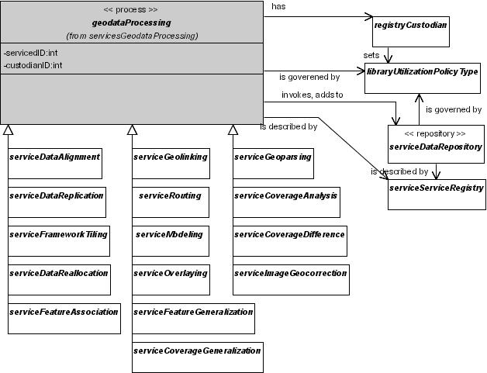
Figure V3-38: Geodata Processing Service Components
Geodata processing services transform data values originating from either persistent storage or from non-persistent (transient) products of other geodata processes. Results are delivered via Data Services or Portrayal Services. Each geodata processing service is described in a Service Registry entry, and has a custodian who sets utilization policy. Geodata processes may invoke Data Repsoitory Services according to the (separate) utilization policies governing their use.
Envisaged Geodata Processing services include:

Geodata Processing Service Components
Coverage Analysis Service  Coverage Difference Service  Coverage Generalization Service  Data Alignment Service  Data Reallocation Service  Feature Association Service  Feature Generalization Service  Framework Tiling Service  Gazetteer Service | Geolinking Service  Geoparsing Service  Image Geocorrection Service  Modeling Service  Overlaying Service  Reprojection Service  Routing Service  Schema Translation Service  Semantic Translation Service
  - Geodata Processing Services Characteristics
For the SIDP platform’s purposes Geodata Processing Services are assumed to:
- Reside at many dispersed sites each managed a collaborator, commercial partner, community publisher or any SDI-enabled facility residing anywhere on earth;
- Each deliver content in accepted standard content formats and transfer formats. The SIDP platform envisages using the GML or compressed GML as its transport format.
- Each be the responsibility of a Service Custodian possessing the technical means, mandate and motivation to competently maintain services and their associated metadata, and to ensure their reliable availability;
- Each be subject to articulated policies governing the appropriate access, use and cost-recovery for use of the service;
- Not necessarily be co-resident with any of the Data Repositories exploited by the service.
- Extract and abstract the content from Data Repositories for delivery to ‘chubby’ and ‘thick’ clients that are capable of using GML-mediated.

- Coverage Analysis Service |  | Geodata Processing Service Components
Invoked by | Geo-processing services  Web Coverage Service | May modify | Transient datastore
Invokes | Coverage Datastore Access Service | Refers to | Coverage Datastore
One or more geoprocessing services that operate on and/or manipulate coverage data. An example would be an image classification service that is applied to an imagery coverage. The OGC membership is currently defining an imagery classification interface specification (Web Imagery Classification Service – WICS). Coverage analysis also requires the ability to “chain” services together into workflows.

- Coverage Difference Service |  | Geodata Processing Service Components
Invoked by | Geo-processing services  Web Coverage Service | May modify | Transient datastore
Invokes | Feature Datastore Access Service  Coverage Datastore Access Service | Refers to | Feature Datastore  Coverage Datastore
Identifies the differences between two different sets of Geospatial Data.
In the case of vector data, this service would produce a third set of vector data that contains the vectors found in only one of the two sets of geospatial data, and a list of the differences between the polygon attribute tables. In the case of raster data, this service would produce a surface that represents the differences between the raster values.

- Coverage Generalization Service |  | Geodata Processing Service Components
Invoked by | Geo-processing services  Web Coverage Service | May modify | Transient datastore
Invokes | Coverage Datastore | Refers to
Allows a client to generalize a set of Geospatial Data from the data content perspective.
Potential types of generalization would include data aggregation and classification. This service allows the client to specify the dataset of interest, and the type and degree of generalization.
See also: Feature Generalization Service.

- Data Alignment Service |  | Geodata Processing Service Components
Invoked by | Geo-processing services  Web Coverage Service | May modify | Transient datastore
Invokes | Coverage Datastore  Feature Datastore | Refers to
Provides the capability to align a geodata set to Ground Control Points (GCP).
Ground control points are typically stored in the alignment layer of the SDI Framework Data set.

- Data Reallocation Service |  | Geodata Processing Service Components
Invoked by | Geo-processing services  Web Coverage Service | May modify | Transient datastore
Invokes | Coverage Datastore  Feature Datastore | Refers to
Allows a user to convert attributes associated with one set of geospatial data to another set of geospatial data.
For example, a user may want to convert population figures available by Census Subdivisions into another framework like watersheds.

- Feature Association Service |  | Geodata Processing Service Components
Invoked by | Geo-processing services  Web Coverage Service | May modify | Transient datastore
Invokes | Feature Datastore | Refers to
Allows a client to create and maintain associations (relationships) between geospatial data items.
For example, the location of a shire boundary is co-incident with the underlying state boundary, the Feature Association Service can be used to identify this relationship and thus facilitate the creation and maintenance of multiple GIS layers.

- Feature Generalization Service |  | Geodata Processing Service Components
Invoked by | Geo-processing services  Web Coverage Service | May modify | Transient datastore
Invokes | Feature Datastore | Refers to
Allows a client to generalize a set of geospatial data from the graphical representation perspective.
Potential types of generalization would include vector points, or the linework comprising lines or polygons. This service allows the client to specify the dataset of interest, the type of feature to be generalized, and the degree of generalization.
See also: Coverage Generalization Service

- Framework Tiling Service |  | Geodata Processing Service Components
Invoked by | Geo-processing services  Web Coverage Service | May modify | Transient datastore
Invokes | Feature Datastore | Refers to | Geodata Resource Registry
The Framework Tiling Service provides a mechanism to piece together geographically contiguous portions of a Framework Data layer. Given two or more contiguous pieces of a Framework Data layer, this service will produce a single amalgamated dataset that matches the Framework Data specifications.

- Gazetteer Service |  | Geodata Processing Service Components
Invoked by | Discovery Service  Geo-processing services  Web Coverage Service | May modify | Transient datastore
Invokes | Feature Datastore, specifically Gazetteer Datastore | Refers to
A gazetteer is an online "dictionary" of geospatial words or terms, with or without applicable feature geometries. The Gazetteer Service is used to transform a set of place names into a set of stored geometry. The geometry is specific with respect to the coordinate reference system. Typically, the geometry is returned to a client as GML.
For example, a Gazetteer system may be able to transform the name of a city into a polygon or a single point that represents that city. A Gazetteer system may include the capability to do geocoding, which means it would be able to convert a street address to a geographic location.
The Gazetteer Service specification is a specialization of the Web Feature Service specification. The GAZ provides for multi-lingual environments.
See also: Geolinking Service, Geoparsing Service

- Geolinking Service |  | Geodata Processing Service Components
Invoked by | Geo-processing services  Web Feature Service  Web Coverage Service | May modify | Transient datastore
Invokes | Geolinked Data Datastore | Refers to
A Geolinking Service operates on geolinked data. Geolinked data is geographically related data in which the geometry is not directly stored with the attribute data, but instead a geographic identifier is used. The geographic identifier refers to a geometric feature in a separate geospatial data set. An example of geolinked data is a table of populations of Canadian cities. The table does not contain the geographic location of each city, but instead uses the city name. The city name can be used to join the population data to a separate geospatial data set that contains the geographic location of each city, in order to map the information or perform some sort of geospatial analysis. A geolinking service is an Internet-enabled “relate” (a.k.a. link/join/merge) function on two tables that share a common key field. The development of services based on this specification presupposes the existence of corporate databases that contain geographically referenced information, but where the corporate environment does not contain a direct link to a GIS.
Therefore, a Geolinking Service takes the attributes found in a set of Geolinked Data and merges them with a related set of Geospatial Data to produce a combined set of geospatial data which contains those attributes. The merging of these datasets is based on the use of a linkage field that is found in both sets of data. This service can be implemented to publish this information via an existing Web Map Server.
A Geolinked Data Access Service normally provides the geolinked data. The related set of geospatial data may reside locally, or provided by a Web Feature Service.
Communicates with an external Gazetteer to retrieve geometry and other attributes associated with geographic names. This component provides a "wrapper" for a gazetteer instance that does not support the OGC Gazetteer Service interface: it accepts OGC-compliant queries, issues requests to the non-compliant gazetteer, and converts the responses to make them OGC-compliant. The SIDP platform will require a Geographic Names Information System such as NGA to be designated as the external gazetteer.
See also: Gazetteer Service, Geoparsing Service.
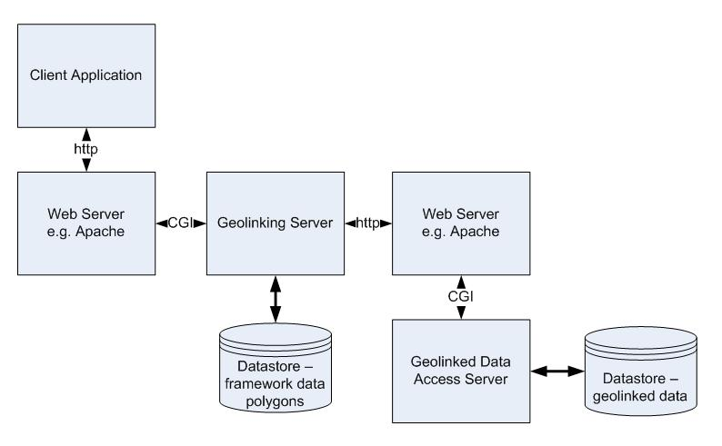
Figure 39: Geolinking Service process Model
Geo-linkaable data i.e. non-spatial data that share a common reference attribute with a spatially-referenced framework data set – may be extracted, abstracted, summarized, combined and/or portrayed in spatial contexts via the geo-linking service.

  - Geoparsing Service
Invoked by | Geo-processing services  Web Feature Service  Web Coverage Service | May modify | Transient datastore
Invokes |  | Refers to | Gazetteer Datastore
Processes textual documents to identify key words and phrases that have a spatial context.
A Geoparsing Service works with two bodies of information:
- A reserved vocabulary (usually of place names) and
- A text source (e.g., a newspaper, or voice track.)
The Geoparser returns all occurrences of the use (in the text source) of any word in the reserved vocabulary. Each occasion establishes a geolink between the source and the location associated with the reserved word. For example, your home might be Geolinked with your water bill through their common address. This information is used to provide geolink identifiers for use in a geolinking service.
See also: Gazetteer Service, Geolinking Service

- Image Geocorrection Service |  | Geodata Processing Service Components
Invoked by | Geo-processing services  Web Feature Service  Web Coverage Service | May modify | Transient datastore  Coverage Datastore
Invokes | Feature Datastore | Refers to
Allows an arbitrary image to be aligned to Geolinked Data and thereafter treated as a Coverage.

- Modeling Service |  | Geodata Processing Service Components
Invoked by | Geo-processing services  Web Feature Service  Web Coverage Service | May modify | Transient datastore  Coverage Datastore
Invokes | Coverage Datastore  Feature Datastore  Geolinked Data Datastore | Refers to
There is considerable work pertinent to modelling and simulation being done as part of the OGC Web Service 2.0 initiative. This work includes experiments with the OASIS Business Process Engineering Language (BPEL) for service chaining and workflow control. It also includes development of a prototype client for imagery modelling and classification andimagery chaining for decision support. This work will result in a number of OGC Discussion papers that will provide the baseline for how to define modelling and simulation services for decision support. Target date is September 2004.

- Overlaying Service |  | Geodata Processing Service Components
Invoked by | Geo-processing services  Web Feature Service  Web Coverage Service | May modify | Transient datastore  Coverage Datastore
Invokes | Coverage Datastore  Feature Datastore  Geolinked Data Datastore | Refers to
The Overlay Service takes two provided map layers as input, performs data processing at both geometry and attribute level, and generates a new map layer that combines the geometry and attribute sets of the original layers. Both input and output are in GML.

- Reprojection Service (Also known as Coordinate Reference Transformation Service) |  | Geodata Processing Service Components
Invoked by | Geo-processing services  Web Feature Service  Web Coverage Service | May modify | Transient datastore  Coverage Datastore
Invokes | Coverage Datastore  Feature Datastore  Geolinked Data Datastore | Refers to | Coordinate Reference System Dictionary
Supports conversion of coverage and feature data between different Spatial Reference Systems. There are several possible mechanisms for providing a CRS transformation. One possibility is to use an OGC enabled service using the candidate interface specification titled “Web Coordinate Transformation Service Interface Specification”. There is currently considerable work being done on this specification with the intent to have it available as an OGC adopted standard by early 2005.

- Routing Service |  | Geodata Processing Service Components
Invoked by | Geo-processing services  Web Feature Service  Web Coverage Service | May modify | Transient datastore  Coverage Datastore
Invokes | Coverage Datastore  Feature Datastore  Geolinked Data Datastore | Refers to | Coordinate Reference System Dictionary
The Routing Service finds the optimum path connecting given a set of locations and routes, which connect those locations. For example, a routing service can respond to a query similar to "What is the quickest route from Brisbane to Longreach?” A routing service may be able to optimize for different criteria, like speed, distance, or cost.
This OGC OLS Interface for routing provides access to a service that determines a route for a subscriber. The subscriber must use a navigation application to set up the use of the service. They must indicate the start point (usually the position acquired through the Gateway Service, but this could be a planned trip from a specified location, say, from their home), and the endpoint (any location, like a place for which they only have the phone number or an address, or a place acquired through a search to a Directory Service). The subscriber may optionally specify waypoints, in some manner, the route preference (fastest, shortest, least traffic, most scenic, etc.), and the preferred mode of transport. The subscriber may optionally store a route for as long as needed, thus requiring the means to also fetch a stored route.

- Schema Translation Service |  | Geodata Processing Service Components
Invoked by | Geo-processing services  Web Feature Service | May modify | Transient datastore  Coverage Datastore
Invokes | Feature Datastore  Geolinked Data Datastore | Refers to | Type/Schema Library
Allows Web Feature Service to ingest features using one data schema and export that same data using the original or another well-known schema. This translation is performed such that the semantic integrity is maintained.

- Semantic Translation Service |  | Geodata Processing Service Components
Invoked by | Geo-processing services  Web Feature Service | May modify | Transient datastore  Coverage Datastore
Invokes | Feature Datastore  Geolinked Data Datastore | Refers to | Type/Schema Library
Executes thesaurus conversion.
Provides a mechanism to maintain a thesaurus of terms that indicates equivalent terms in different languages, disciplines, and data suppliers, particularly those terms that are geospatial in context.
Facilitates manual or automated translation of metadata, text, or feature type selections.
For the SIDP platform’s purposes Geodata Processing Services are assumed to:
- Reside at many dispersed sites each managed a collaborator, commercial partner, community publisher or any SDI-enabled facility residing anywhere on earth;
- Each deliver content in accepted standard content formats and transfer formats. The SIDP platform envisages using the GML as its transport format.
- Each be the responsibility of a Service Custodian possessing the technical means, mandate and motivation to competently maintain services and their associated metadata, and to ensure their reliable availability;
- Each be subject to articulated policies governing the appropriate access, use and cost-recovery for use of the service;
- Not necessarily be co-resident with any of the Data Repositories underlying the service.
Other types of processes for manipulating data delivered from various Geodata Processing Services for delivery via Data Services to ‘chubby’ and thick clients. The community will identify or designate custodians for each process.
- Portrayal Services Components
Portrayal services are typically required for providing service to ‘thin’ web clients, mobile computing platforms and the likes. The typical user of Portrayal Services need not possess technical expertise in geographic information systems, cartography, statistical analysis or database manipulation that the Data Service user possess.
Portrayal Services provide specialized capabilities supporting visualization of geospatial information. Portrayal Services are components that, given one or more inputs, produce rendered outputs (e.g., cartographically portrayed maps) or reuse the parameters of rendered outputs to coordinate multi-source display (e.g. create scale and view-dependent displays). The SIDP platform Portrayal Services are loosely coupled with other services such as Map and Data Services and transform, combine, or create portrayed outputs.
Three components are identified in the following figure.
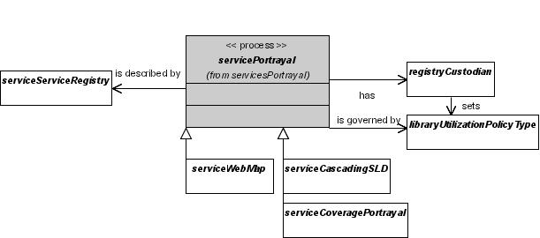
Figure V3-40: Portrayal Service Components
Portrayal services deliver representations of data to web agents, typically ‘thin’ clients such as browsers. Data values may originate directly from persistent values abstracted from datastores by Data Services or from non-persistent (transient) values generated by Geoprocessing Services. The style of representation is managed on the server. Clients do not receive copies of the underlying data values. Each portrayal services is described in a Services Registry, and has a custodian who sets utilization policy.
The envisaged Portrayal Services include:

Portrayal Services Components
Cascading SLD-enabled Web Map Service
Coverage Portrayal Service
Web Map Service
  - Portrayal Services Characteristics
For the SIDP platform’s purposes Portrayal Services are assumed to:
- Reside at many dispersed sites each managed a collaborator, commercial partner, community publisher or any SDI-enabled facility residing anywhere on earth;
- Each deliver portrayals in accepted standard graphical and/or text formats and transfer formats. The SIDP platform envisages using Well Known Text, JPEG, GIF and PNG.
- Each be the responsibility of a Service Custodian possessing the technical means, mandate and motivation to competently maintain services and their associated metadata, and to ensure their reliable availability;
- Each be subject to articulated policies governing the appropriate access, use and cost-recovery for use of the service;
- Not necessarily be co-resident with any of the Data Repositories underlying the service.
- Render geo-data in forms suitable for the Map Viewer Client, based on the contents of various data repositories both local and remote.

- Cascading SLD-enabled Web Map Service |  | Portrayal Services Components
Invoked by | Web Map Service | May modify
Invokes | Coverage Datastore  Feature Datastore  Geolinked Data Datastore | Refers to | Map Style Registry  Map Symbol Registry
Formulates and possibly executes valid operations to request service metadata, to request maps, or to perform other operations available from the Provider.
Communicates with Provider Web Map Server instances, both basic and Style Layer Descriptor-enabled.
The Cascading WMS component can transform map formats and map projections. It allows Web Agents to discover and select appropriate styles (either named or SLD-based) for each map layer and composes the SLDs so that map portrayal can be requested.

- Coverage Portrayal Service |  | Portrayal Services Components
Invoked by | Web Map Service | May modify
Invokes | Coverage Datastore  Geolinked Data Datastore | Refers to | Map Style Registry  Map Symbol Registry
Renders coverage data for display to the user.
Receives coverage data from a Web Coverage Server or Image Handling System, applies symbolization information in the form of Styled Layer Descriptors.

- Web Map Service |  | Portrayal Services Components
Invoked by | Web Map Service | May modify
Invokes | Coverage Datastore  Geolinked Data Datastore | Refers to | Map Style Registry  Map Symbol Registry
A Web Map Service can:
- Produce a map (as a picture, as a series of graphical elements, or as a packaged set of geographic feature data);
- Answer basic queries about the content of the map; and
- Tell a Client what maps it can produce and which of those can be queried further.
In contrast with a Web Feature Service, this service is not intended to provide access to the original unprocessed data.
A Web Map Service may act as a client by combining a number of images served by other WMS servers, and it may also accommodate an extension called a Styled Layer Descriptor.

- Web Terrain Service |  | Portrayal Services Components
Invoked by | Web Map Service | May modify | Web Map Service
Invokes | Coverage Datastore  Feature Datastore | Refers to | Map Style Registry  Map Symbol Registry
A WTS allows a client to request three-dimensional terrain scenes from a server capable of their generation. A "3D scene" is defined as a 2D projection of three-dimensional features into a viewing plane located at an arbitrary position and angle in 3D space, in such a way as to preserve the visual appearance of a third spatial dimension. A “terrain scene” is defined as a rendering of geometric representations of geographic entities upon a land surface in such a way as to simulate the view of a human observer.

A WTS can be used in concert with a WMS, WFS, and WCS enabled set of servers. Views are generally rendered in a pictorial format such as Portable Network Graphics (PNG), Graphics Interchange Format (GIF) or Joint Photographic Expert Group (JPEG) format. The WTS standardizes the way in which clients request views and the way that servers describe their data holdings.

- Registry and Catalogue Service Components
Registry and Catalogue Service provide for management of the contents delivered through a variety of registries and catalogue services.
Registries and catalogues are metadata repositories storing description of resources to enable their discovery and appropriate use.
In general, one or more registry or catalogue service components will be required for each of the registries and libraries described in the Registry and Catalogue Service Components.
Registry and Catalogue Services provide means for creating, modifying, publishing and withdrawing information describing services and content, some of which will be geo-spatial in nature while some other will relate to portrayal styles, roles, authorities and service usage policies, and administrative records concerning institutions and users.
Registries support search-and-discovery by providing reference pointers to largely static descriptions services, their interfaces and their components.
Catalogues support search-and-discovery by providing reference pointers to more volatile descriptions of geo-data set contents.
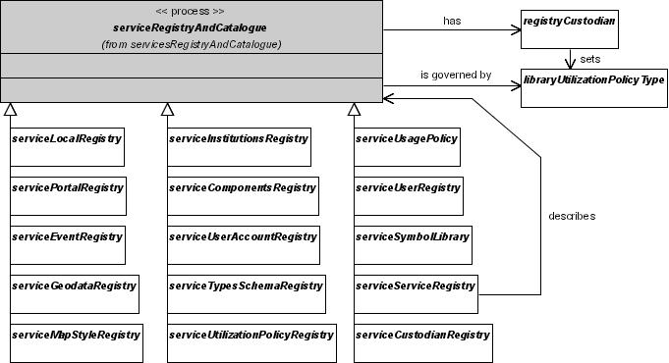
Figure V3-41: Registry and Catalogue Service Components
Registry and catalogue services manage the metadata describing resources, whether content or services, including registry and catalogue services themselves. Each registry and catalogue service has a custodian who sets utilization policy.
  - Registry and Catalogue Services Characteristics
There are potentially dozens of unique registry types (and schemas) accessible to a client or web agent via profiles of a single interface definition – the OGC Catalog Interface Specification. Examples are service registries, symbology registries, and metadata registries. This range of possible registry types can be stored in one or more distributed repositories. Separate service definitions and instances are not required for each registry type.
The following characterize the roles and responsibilities of the Catalogue and Registry Service in the SIDP platform:
- Each service custodian publishes their service to a registry detailing the nature of the service and the policies regarding it use.
- Registry entries are formulated using appropriate OpenGIS registry service forms.
- Each dataset custodian may use the Publisher Client to create and modify ISO 19115/ FGDC compliant data set metadata.
A proposed registry UML depiction is shown in “Figure V3-42: Core elements of the registry information model”.
The RegistryEntry lies at the heart of the model. Indeed, every registered resource is a registry entry. A Schema object (i.e. a GML Application Schema) is a registry entry that contains schema-related metadata. Each such application schema is associated with other registry objects in order to fully describe an available schema.
Below, “Figure V3-42” informally illustrates how the various entries in a registry are related.
Several of the registry objects in Figure V3-42 (above) are extrinsic objects that are ‘opaque’ to the registry (i.e. stored documents). For example, GML Application Schemas and XML Schema objects reference repository items that have a text/xml MIME type; the registry may not be capable of examining these resources to support finer-grained queries. But if the isOpaque attribute is set to “false” for such resources, the registry will support XPath queries against them.
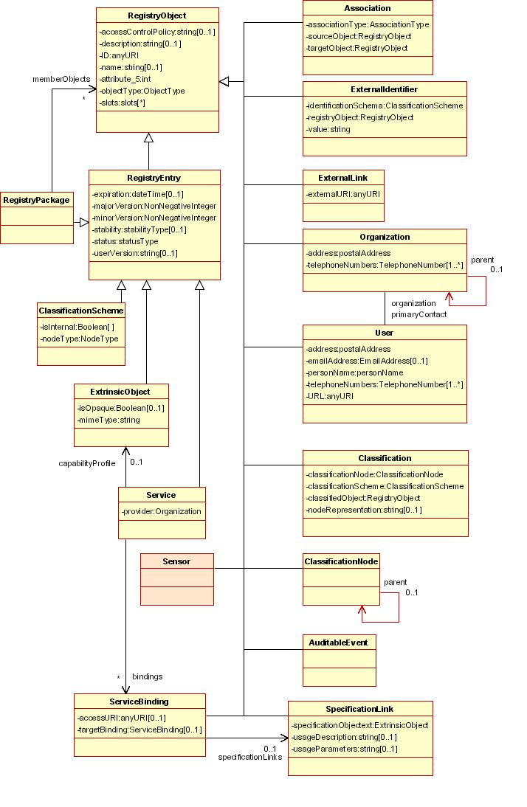
Figure V3-42: Core elements of the registry information model

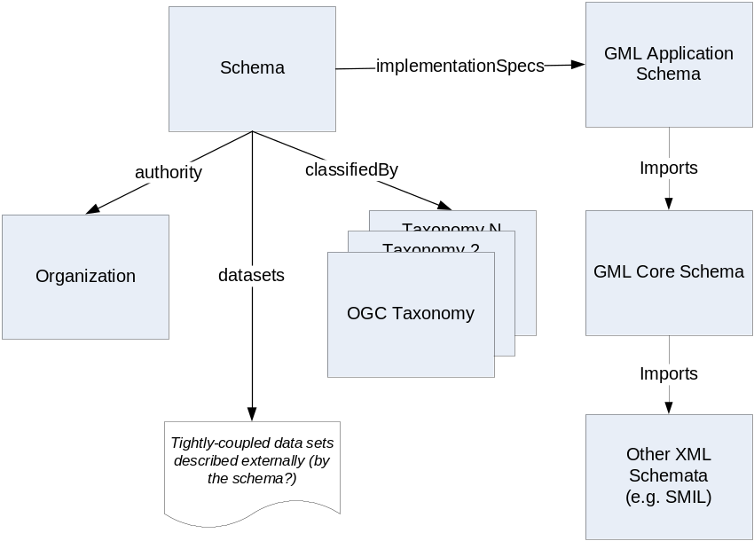
Figure V3-43: Describing schemas in the registry
Description of each shcema encompasses its issuing authority, taxonomy (or taxonomies) and GML-based specification for methods for implementation. Tightly-coupled datasets may manifest specific schemata at the cost of reduced flexibility of description or implementation compared to more generalized methods.
Envisaged service definitions available through a Registry and Catalogue services could include:

Possible registries available via the Catalog Service or Services
Components Registry  Components Type Library Registry  Custodian Registry  Custodian Type Library  Event Registry  Event Subscription Registry  Event Type Library Registry  Geodata Resource Registry  Geodata Resource Type Library Registry  Institutions Registry  Institutions Type Library | Local Registry  Map Styles Registry  Map Styles Library Registry  Map Symbol Registry Service  Map Symbol Library Registry  Service Registry  Types/Schemas Library Registry  Types/Schemas Registry  Workflow (Choreography) Registry  Workload Registry

- Components Registry |  | Registry and Catalogue Service Components
Invoked by | Chubby client  Component Manager Client Generator  Think client | May modify | Component Registry
Invokes | Components Type Library Registry | Refers to | Component Type Library
Provides means for Web Agents to define, create, manage and browse service component definitions including access policies, and accounting rules. Web agents may be either Thin clients or appropriate competent Chubby clients or Thick clients.
Components are software code or other equivalents, such as scripts or command files that provide the realization of a set of interfaces for SDI compliant services.
The components registry service enables authenticated and authorized web agents to:
- Register software components in a Component Registry, and modify or delete these registration entries.
- Search Component Registries that describe SDI compliant components; and
- Retrieve detailed information (metadata) that describes the component, in order to evaluate its suitability to meet a need.
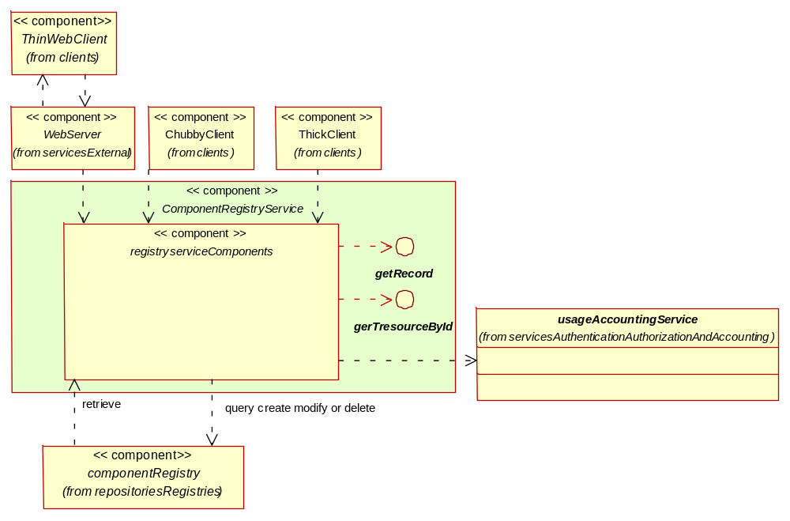
Figure V3-44: Component Registry Service Deployment
Authorized and authenticated agents may create, modify and delete component descriptions in the component registry. Use of registry services may be accounted for.

- Components Type Library Registry |  | Registry and Catalogue Service Components
Invoked by | Chubby client  Component Manager Client Generator  Components Registry  Think client | May modify | Component Type Library
Invokes | Component Type Library | Refers to
Provides means for Web Agents to define, create, manage and browse service component definitions including access policies, and accounting rules. Web agents may be either Thin clients or appropriate competent Chubby clients or Thick clients.
Components are software code or other equivalents, such as scripts or command files that provide the realization of a set of interfaces for SDI compliant services.

- Custodian Registry |  | Registry and Catalogue Service Components
Invoked by | Custodian Manager Client Generator  Chubby client  Institutions Registry  Think client  User Registry | May modify | Custodian Registry
Invokes | Custodian Type Library | Refers to | Custodian Type Library  Institutions Registry
Provides tools for defining, modifying and removing description of Custodians of services and data.

- Custodian Type Library |  | Registry and Catalogue Service Components
Invoked by | Custodian Registry  Chubby client  Think client | May modify | Custodian Type Library
Invokes |  | Refers to
Provides tools for defining, modifying and removing description of Custodians of services and data.

- Event Registry |  | Registry and Catalogue Service Components
Invoked by | Event Manager Client Generator  Chubby client  Think client | May modify | Event Registry
Invokes | Event Type Library Registry | Refers to | Event Type Library
Facilitates the development of Event notification systems that can notify a set of subscribers about the occurrence of a specific event.
When Web Agents subscribe to a specific set of events using this service, they are added to an Event Subscription Registry. The service can also maintain types of events (defined in the Event Type Library), and register the occurrence of specific events (in an Event Registry).
Event notification systems can be developed that will monitor the contents of an Event Registry, and notify clients that have subscribed to that particular type of event using contact information stored in an Event Subscription Registry.

- Event Subscription Registry |  | Registry and Catalogue Service Components
Invoked by | Chubby client  Event Subscription Manager Client Generator  Think client | May modify | Event Subscription Registry
Invokes | Event Type Library Registry | Refers to | Event Type Library
Provides Web Agents with the tools to register their interest in specific types of system events for notification.

- Event Type Library Registry |  | Registry and Catalogue Service Components
Invoked by | Chubby client  Event Registry  Event Subscription Manager Client Generator  Think client | May modify | Event Type Library
Invokes |  | Refers to
Facilitates the development of Event notification systems that can notify a set of subscribers about the occurrence of a specific event.
When Web Agents subscribe to a specific set of events using this service, they are added to an Event Subscription Registry. The service can also maintain types of events (defined in the Event Type Library), and register the occurrence of specific events (in an Event Registry).
Event notification systems can be developed that will monitor the contents of an Event Registry, and notify clients that have subscribed to that particular type of event using contact information stored in an Event Subscription Registry.

- Geodata Resource Registry |  | Registry and Catalogue Service Components
Invoked by | Chubby client  Discovery Service  Think client | May modify | Geodata Resource Registry
Invokes | Geodata Resource Type Library Registry | Refers to | Geodata Resource Type Library
Supports data discovery through peer registries that contain metadata about Geodata resources.
These registries identify the agencies that are responsible each attribute dataset, and descriptions of that attribute data. They also contain information on how to access the data.
The FGDC CSDGM provides a metadata standard employed by OGC OCS ver. 1.1.1 [22]. This will be superseded in ver. 2.0 later in 2004.
Geodata includes all types of geographic (or geospatial) data entities. Examples of geodata are:
- A collection of related geographic features, such as the road network;
- A satellite image; or
- A collection of geodata products, such as a collection of Landsat-5 images.
A Geodata Discovery Service provides a mechanism to:
- Search Geodata Resource Registry entries; and
- Retrieve detailed information (metadata) that describes a geodata resource, in order to evaluate its suitability to meet a need.
Currently, the Geodata Discovery Service is based on the FGDC "Z39.50 Application Profile for Geospatial Metadata" or "GEO". GEO is based on the ANSI/NISO Z39.50-1995 Information Retrieval (Z39.50): Application Service Definition and Protocol Specification [11]. The GEO profile includes not only the specifications for Z39.50 search service, but also the specifications for the metadata, as well as other aspects of a GEO-conformant server that apply to the Geodata Discovery Service.
A new stateless version of the Geodata Discovery Service is in development, and is intended to replace the existing Z39.50 based service.
A Geodata Resource Registration Service facilitates the registration of geodata in a Geodata Resource Registry. The registry includes information about:
- The type of data,
- Its geographic extent, and
- Information about how to retrieve the data.

- Geodata Resource Type Library Registry |  | Registry and Catalogue Service Components
Invoked by | Chubby client  Geodata Resource Registry  Think client | May modify | Geodata Resource Type Library
Invokes |  | Refers to
Provides mechanisms to register the existence of specific types of geodata resources in the Geodata Resource Type Library.

- Institutions Registry |  | Registry and Catalogue Service Components
Invoked by | Chubby client  Institution Manager Client Generator  Think client | May modify | Institutions Registry
Invokes | Institutions Type Library | Refers to | Institution Type Library
Provides mechanisms to Record details of specific instances of institutions in the Institutions Registry.

- Institutions Type Library |  | Registry and Catalogue Service Components
Invoked by | Chubby client  Institutions Registry  Think client | May modify | Institution Type Library
Invokes |  | Refers to
Provides mechanisms to register the existence of specific types on institutions in the Institution Type Library

- Local Registry |  | Registry and Catalogue Service Components
Invoked by | Local Registry Management Client Generator  Chubby client  Think client | May modify | Local Registry
Invokes |  | Refers to
A registry service maintained and operated locally by an SIDP platform service provider. It is accessible by the Publisher Client Generator. It maintains a list of Primary information sources and their service metadata. It may temporarily cache metadata regarding user-discovered Secondary and Tertiary information sources. It may store predefined SLD documents.

- Map Styles Library Registry |  | Registry and Catalogue Service Components
Invoked by | Map Styles Registry  Chubby client  Think client | May modify | Map Style Library
Invokes |  | Refers to
Supports management and discovery of available map styles and symbologies for use by Cascading SLD-enabled Web Map Service.

- Map Styles Management Registry |  | Registry and Catalogue Service Components
Invoked by | Map Styles Registry  Chubby client  Think client | May modify
Invokes |  | Refers to | Map Style Library  Map Style Registry
Accesses Web Map Server styled layer descriptor library.
Addresses the need for geospatial consumers (either humans or machines) to control the visual portrayal of data. It can be used to portray the output of Web Map Servers, Web Feature Services and Web Feature Servers.
A multi-component system that enables map and data retrieval, and includes the capability for creating, storing, and/or retrieving styles and symbols from multiple communities or user groups and combining all these elements of information into an appropriately symbolized map.
This service may consist of multiple components including a Map Style Registry, Map Style Library, Map Symbol Registry, and Map Symbol Library presented through a common, standard interface.

- Map Styles Registry |  | Registry and Catalogue Service Components
Invoked by | Map Style Management Client Generator  Chubby client  Think client | May modify | Map Style Library
Invokes |  | Refers to | Map Style Registry
Provides a mechanism to:
- Register the existence of specific types map styles in a Map Style Library;
- Search Service Type Library; and
- Retrieve detailed information (metadata) that describes a map style, in order to evaluate its suitability to meet a need.

- Map Symbol Library Registry |  | Registry and Catalogue Service Components
Invoked by | Map Symbol Registry Service  Chubby client  Think client | May modify | Map Symbol Library
Invokes |  | Refers to
Provides mechanisms for creating and managing map symbols for reference in SLDs.
Provides access to symbol definitions that are used in the graphical portrayal of geo-spatial information. A symbol (also called a "graphic" in OGC) is a meaningless (it is not associated a priori with any feature type) graphical drawing with an identity. Two symbols are distinct if they have distinct identities. Symbols with identical appearance but having different identities are regarded as different symbols.
The Symbol Library Service provides operations for the access to and management of collections of symbols.
Supports discovery of map symbols.

- Portal Registry |  | Registry and Catalogue Service Components
Invoked by | Portal Management Client Generator  Chubby client  Think client | May modify | Portal Registry
Invokes | Portal Type Library Registry | Refers to | Portal Type Library
Provides a mechanism create and manage description of Portal Service i.e. means of accessing provider services via standard web service interfaces.
Supports discovery of utilization policies.

- Portal Type Library Registry |  | Registry and Catalogue Service Components
Invoked by | Map Symbol Registry Service  Chubby client  Think client | May modify | Portal Type Library
Invokes |  | Refers to
Supports discovery of portals.

- Service Registry |  | Registry and Catalogue Service Components
Invoked by | Service Management Client Generator  Chubby client  Think client | May modify | Service Registry
Invokes | Service Type Library Registry | Refers to | Service Type Library
Provides a mechanism to:
- Register the existence of specific types of services (in a Service Type Library,) and register information about specific events (in a Service Registry);
- Search Service Registries; and
- Retrieve detailed information (metadata) that describes a Service, in order to evaluate its suitability to meet a need.
Supports description and discovery of services.

- Service Type Library Registry |  | Registry and Catalogue Service Components
Invoked by | Service Registry  Chubby client  Think client | May modify | Service Type Library
Invokes |  | Refers to
Provides for the efficient management of descriptions of broad types such as mapping, coverage, geo-processing and accounting. It provides operations for registering and querying service types.
Supports discovery of map symbols.

- Types/Schemas Registry |  | Registry and Catalogue Service Components
Invoked by | Type/Schema Manager Client Generator  Chubby client  Think client | May modify | Type/Schema Registry
Invokes | Types/Schemas Library Registry | Refers to | Type/Schema Library
Provides for the efficient management of type and schema information. It provides operations for registering and querying schemas/types.
A type refers to a kind or class of geographic entity. Types are meaningful elements in a particular universe of discourse.
A schema is an expression of the type using a particular data modeling language. Put another way types it can be seen as a classification taxonomy for a set of schema definitions. In the OGC the application data-modeling language is GML and each schema fragment corresponding to a given type is defined in GML.
The type/schema registry service supports operations for the management of types, schema fragments, and schemas.
Supports discovery of types and schemata.

- Types/Schemas Library Registry |  | Registry and Catalogue Service Components
Invoked by | Type/Schema Registry  Chubby client  Think client | May modify | Type/Schema Library
Invokes |  | Refers to
Provides for the efficient management of type and schema information. It provides operations for registering and querying schemas/types.
A type refers to a kind or class of geographic entity. Types are meaningful elements in a particular universe of discourse.
A schema is an expression of the type using a particular data modeling language. Put another way types it can be seen as a classification taxonomy for a set of schema definitions. In the OGC the application data-modeling language is GML and each schema fragment corresponding to a given type is defined in GML.
The type/schema registry service supports operations for the management of types, schema fragments, and schemas.
Supports discovery of types and schemata.

- User Registry |  | Registry and Catalogue Service Components
Invoked by | User Manager Client Generator  Chubby client  Thin client | May modify | User Registry
Invokes | U | Refers to | User Type Library
Provides tools for:
- Creating, modifying and deleting user accounts, including authentication criteria
- Assigning and rescinding Web Agents’ authorities for service access
- Reviewing Web Agents’ Accounting Records
Supports discovery of user accounts.

- Workflow (Choreography) Registry |  | Registry and Catalogue Service Components
Invoked by | Workflow manager Client Generator  Chubby client  Think client | May modify | Workflow (Choreography) Datastore
Invokes |  | Refers to
Provides tools for executing allowing a user to define a sequence of services (a workflow, or chain) that perform a required action.
For example, a user may wish to send the output from a Feature Generalization Service to a Web Map Service in order to visualize the data.
A Workflow Definition Service is likely to be a low priority. It is unlikely that it will be specified before 2005.
This service may not be needed, particularly for the vast majority of service chains that are enacted. Domain-specific applications could contain definitions of standard sequences of operations, and to facilitate the calling of these services. Service chaining may not become a service per se but a set of operations embedded inside a large number of domain related application services that will allow those applications to dynamically chain to other services based on service discovery operations.
It may be possible to choose a generic web technology solution for this service.

- Workload Registry |  | Registry and Catalogue Service Components
Invoked by | Workload Manager Client Generator  Chubby client  Think client | May modify | Workload Datastore
Invokes |  | Refers to
Provides tools for describing how the geodata resources are being used, diagnose problems and recommend fixes to database administrators.

- External Service Components
Not strictly part of the SIDP platform but are readily envisaged as existing, neighbouring services accessible as OWS or via appropriate connectors.
These components doe not need to be implemented within the SIDP platform and so are not portrayed as deployments.
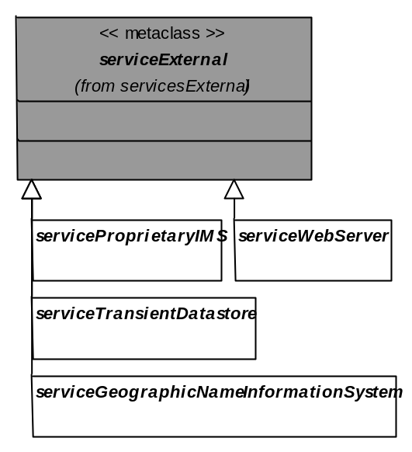
Figure V3-45: External service components
External services are assumed to exist and to be operational but do not lie within the management environment of the SIDP platform. External services do not have Service Registry entries managed within the SIDP platform, although they may be described – and, hence, rendered discoverable – in other standards-based Service Registries, perhaps including ones federated with the SIDP platform.
Table V3-4: External Components
External Component | Description
- Proprietary IMS Service | Any remote system supporting OGC WMS, WCS or WFS query via appropriate middleware
- Clearinghouse Service | A remote system serving FGDC compliant metadata via z39.50, and accessed by the SIDP platform using the Clearinghouse Connector. Examples include the ASDD clearinghouse and the US FGDC Clearinghouse.
- Web Service | The generic HTTP-enabled service mediating all thin-client interactions with the platform.
- Ancillary Service Components
Ancillary Service Components provide adjunct services for the SIDP platform core components.
These are ancillary in the sense that provide extension to geo-data, portrayal and administrative without forming part of the services themselves. For example, a workflow (choreography) enactment service would link (“chain”) various geo-processes so that the output of one (for example, geo-correction) would then be provided as the input to another (say, unsupervised classification).
These components do not need to be implemented within the SIDP platform and so are not portrayed as deployments. However, they do figure in deployments of other components.
Representative ancillary services are shown in the following figure.
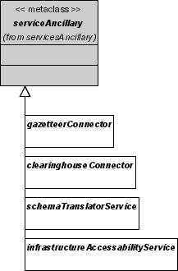
Figure 46: Ancillary Service Components Examples
  - Clearinghouse Connector
A software enabling searches of clearinghouses via the z39.50 protocol.
  - Context-Based Discovery Service
Automatically discovers services providing data of those same types in the new bounding box as the User navigates (changes the displayed bounding box) while viewing maps of one or more types of data; allows the user to select them and to de-select services no longer relevant to the user's new bounding box.
  - Discovery Service
A software component that supports searches of geodata catalogues. Will enable the FGDC-compliant Clearinghouse Networks such as the ASDD to be searched within the SIDP platform.
  - Infrastructure Accessibility Service
Monitors the availability of the critical datasets and popular Sites that support the SDI, and allows clients to identify the most appropriate (or available) site to access a dataset or Service. Where more than one site delivers the same service, clients accessing this service could evaluate the response of those sites and then choose to access the site with the fastest response time.
  - Workflow (Choreography) Enactment Service
Provides tools for executing a sequence of services (a chain) that perform a required action.
For example, a user may enact a workflow that sends the output from a Feature Generalization Service to a Web Map Service in order to visualize the data.
A Workflow Enactment Service is likely to be a low priority. It is unlikely that it will be specified before 2005.
This service may not be needed, particularly for the vast majority of service chains that are enacted. Domain-specific applications could contain definitions of standard sequences of operations, and to facilitate the calling of these services. Service chaining may not become a service per se but a set of operations embedded inside a large number of domain related application services that will allow those applications to dynamically chain to other services based on service discovery operations.
It may be possible to choose a generic web technology solution for this service.
- Future options: Federating Registries
The SIDP platform will for present have a single Services Registry (though plausibly multiple data catalogues) since the OGC WRS specification does not yet support registry federation. The Services Registry is the ‘heartbeat’ of the SIDP platform and must have high availability, reliability, integrity, security and performance.
OGC Catalogue specification describes federating catalogue services, where a ‘source’ catalogue consolidates responses from other ‘target’ catalogues. The catalogue implementation specification briefly addresses the topic of distributed searching in the context of a stateful catalogue service inspired by the z39.50 protocol [11]; various query parameters (e.g. queryScope) may be used to control distributed search behavior. This specification does not currently propose a mechanism for propagating queries among registry peers—such functionality remains a future work item for the Technical Committee of OGC in collaboration with W3C and OASIS. Such a mechanism would permit a registry to locate and query other registries, thereby enabling the specification of a search horizon through the use of a distributed search policy.
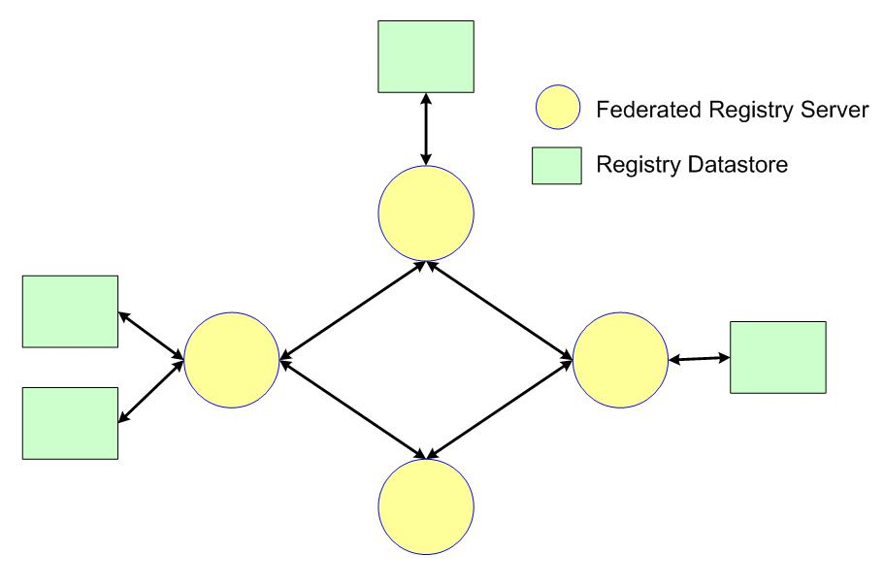
Figure V3-47: Federating Registries
Federated registriessupported multiple distributed registries that are able to to the client appea as a single intergated whole. A registry server may publicise multiple local regsitries. Conversely, A registry server need not necessarily suppoty any registries at all and merely proxie for remote registries.
The OWS Web Registry Service Interoperability Report describes a registry that may be completely isolated from other registries, or it could interwork with one or more affiliated registries. Interworking—or federation—refers to the communication and exchange of information between two or more autonomous systems. When a service registry is linked to another service registry, it makes the offer space of the affiliated registry implicitly available to its own clients without loss of individual autonomy. This is contemplated functionality that awaits implementation, yet should be borne in mind as for future functional flexibility and custodian autonomy as the SIDP platform is designed and implemented.
- References
  - Bibliography
[1] | ANZLIC Metadata Guidelines (v2 – February 2001). Available at http://www.anzlic.org.au/download.html?oid=2358011755
[2] | FGDC-STD-001-1988, Content Standard for Digital Geospatial Metadata (version 2), US Federal Geographic Data Committee, http://www.fgdc.org/metadata/contstan.html
[3] | ISO 10746, Information technology -- Open Distributed Processing -- Reference model, see http://www.iso.ch/iso/en/ittf/PubliclyAvailableStandards/c020696e.zip for overview
[4] | ISO/PDTR 19103, Geographic Information – Conceptual Schema Language, see http://www.isotc211.org/pow.htm for a brief description.
[5] | ISO/CD 19107.3, Geographic Information - Spatial Schema, see http://www.isotc211.org/pow.htm for a brief description.
[6] | ISO 19108, Geographic Information - Temporal Schema, see http://www.isotc211.org/pow.htm for a brief description.
[7] | ISO/DIS 19109, Geographic Information – Rules for Application Schema, see http://www.isotc211.org/pow.htm for a brief description.
[8] | ISO/CD 19115 (ISO TC 211 N 1024, 2001-01-30) Geographic Information – Metadata, see http://www.isotc211.org/pow.htm for a brief description.
[9] | ISO 19118, Geographic Information – Encoding, see http://www.isotc211.org/pow.htm for a brief description.
[10] | ISO/CD 19119 (ISO TC 211 N 1044, 2001-01-29) Geographic Information – Services, see http://www.isotc211.org/pow.htm for a brief description.
[11] | ISO 23950 Information Retrieval (Z39.50): Application Service Definition and Protocol Specification, see http://lcweb.loc.gov/z3950/agency/document.html
[12] | OASIS ebXML see http://www.ebxml.org/
[13] | OASIS ebXML Registry Information Model v2.0 available at http://www.oasis-open.org/committees/regrep/documents/2.0/specs/ebrim.pdf
[14] | OASIS Public Key Infrastructure development, see http://www.pkiforum.org
[15] | OASIS SAML v1.0 specification set available at http://www.oasis-open.org/committees/download.php/2290/oasis-sstc-saml-1.0.zip
[16] | OASIS Universal Discovery Description and Integration see http://www.uddi.org/
[17] | OGC AS 1, The OpenGIS Abstract Specification Topic 1: OpenGIS Feature Geometry (same as ISO 19107 Spatial Schema), available at:://www.opengis.org/docs/01-101.pdf
[18] | OGC AS 2, The OpenGIS Abstract Specification Topic 2: Spatial Reference Systems, available at: http://www.opengis.org/docs/03-073r1.zip
[20] | OGC AS 5, The OpenGIS Abstract Specification Topic 5: OpenGIS Feature, available at:://www.opengis.org/docs/99-105r2.pdf
[21] | OGC AS 12, The OpenGIS Abstract Specification Topic 12: OpenGIS Service Architecture,(same as ISO 19119: Services) available at: http://www.opengis.org/docs/02-112.pdf
[22] | OpenGIS Catalog Services Implementation Specification, version 1.1.1, available at: http://www.opengis.org/docs/02-087r3.pdf
[23] | OpenGIS Filter Encoding Implementation Specification, version 1.0, available at: http://www.opengis.org/docs/02-059.pdf
[24] | OpenGIS Coordinate Transformation Services Implementation Specification, version 1.0, available at: http://www.opengis.org/docs/01-009.pdf
[25] | OpenGIS Geography Markup Language (GML) Implementation Specification, version 3.0, available at: http://www.opengis.org/docs/02-023r4.pdf
[26] | OpenGIS Reference Model (ORM), available at http://www.opengis.org/docs/03-040.pdf
[27] | OpenGIS Service Information Model (SIM) Discussion Paper, OGC document 03-026. Available at: http://www.opengis.org/docs/03-026.pdf
[28] | OpenGIS Simple Feature Specification for COM, version 1.1, available at: http://www.opengis.org/docs/99-050.pdf
[29] | OpenGIS Simple Feature Specification for CORBA, version 1.0, available at: http://www.opengis.org/docs/99-054.pdf
[30] | OpenGIS Simple Feature Specification for SQL, version 1.0, available at: http://www.opengis.org/docs/99-049.pdf
[31] | OpenGIS Styled Layer Descriptor (SLD) Implementation Specification, version 1.0, available at: http://www.opengis.org/docs/02-070.pdf
[32] | OpenGIS Style Management Services Discussion Paper, OGC document 03-031. Available at: http://www.opengis.org/docs/03-031.pdf
[33] | OpenGIS Web Coverage Server (WCS) Implementation Specification, version 1.0 available at: http://www.opengis.org/docs/03-065r6.pdf
[34] | OpenGIS Web Feature Server (WFS) Implementation Specification, version 1.0, available at: http://www.opengis.org/docs/02-058.pdf
[35] | OpenGIS Web Mapping Server (WMS) Implementation Specification, version 1.1.1, available at: http://www.opengis.org/docs/01-068r2.pdf
[36] | OpenGIS Web Pricing and Ordering Service (WPOS) Discussion Paper version 0.2 Discussion Paper, available at: http://www.opengis.org/docs/02-039r1.pdf
[37] | OpenGIS Web Registry Service (WRS) Discussion Paper, version 0.0.2 at: http://www.opengis.org/docs/01-024r1.pdf
[38] | OpenGIS Web Services Architecture (OWS) Discussion Paper, available at: http://www.opengis.org/docs/03-025.pdf
[39] | OpenGIS Web Terrain Service (WTS) Request for Comment version 0.5 available at http://www.opengis.org/docs/03-081r2.pdf
[40] | OpenLDAP Foundation, see http://www.openldap.org/
[41] | World Wide Web Consortium Extensible Markup Language (XML) 1.0 available at http://www.w3.org/XML/Core/#Publications
[42] | World Wide Web Consortium Simple Object Access Protocol (SOAP) 1.1 available at http://www.w3.org/TR/SOAP/
[43] | World Wide Web Consortium Web Services Choreography Requirements (Working Draft 11 March 2004) available at http://www.w3.org/TR/2004/WD-ws-chor-reqs-20040311/
[44] | World Wide Web Consortium Web Services Description Language (WSDL) 1.1 available at http://www.w3.org/TR/2001/NOTE-wsdl-20010315

  - Acronyms
AAA | Authentication, Authorization and Accounting (services)
ACXML | Access Control Extensible Markup Language (OASIS): see http://www.oasis-open.org/committees/tc_home.php?wg_abbrev=xacml
AGI | Association for Geographic Information (UK): see http://www.gigateway.org/
AGLS | Australian Government Locator System
ALGA | Australian Local Government Association: see http://www.alga.com.au/
ANZLIC | Australian New Zealand Land Information Council: see http://www.anzlic.org.au/
ASDD | Australian Spatial Data Directory: see http://asdd.ga.gov.au/asdd/
ASDI | Australian Spatial Data Infrastructure
ASIBA | Australian Spatial Industry Business Association: see http://www.asiba.com.au/
AUSLIG | Australian Survey and Land Information Group
CANRI | Community Access to Natural Resource Information (NSW) see http://www.canri.nsw.gov.au/
CG | Client generator
CMS | Cascading Map Server (OGC WMS)
COI | Community of Interest
COTS | Commercial off-the-shelf (software)
CQL | Common Catalogue Query Language (Library of Congress, USA): See http://www.loc.gov/z3950/agency/zing/cql/
CRC | Cooperative Research Centre (Australia): see https://www.crc.gov.au/
CSDGM | Content Standard for Digital Geospatial Metadata (FGDC, USA)
DACS | Distributed Access Control System: see http://dacs.dss.bc.ca/arch-spec.html
DBMS | Database management system
DLI | Department of Land Information (Western Australia)
EbRIM | ebXML registry information model (OASIS): see http://www.ebxml.org/specs/ebRIM.pdf
EbXML | E-business Extensible Markup Language (OASIS): see http://www.ebxml.org/
EC | European Commission
e-GIF | E-Government Interoperability Framework
EROS | Earth Resources Observation Systems (USA)
EU | European Union
FGDC | Federal Geographic Data Committee (USA): see http://www.fgdc.gov/
GA | Geosciences Australia (Australia Government): see http://www.ga.gov.au
GIF | Graphic Interchange Format (Unisys)
GILS | Government Information Locator System (USA): see http://www.access.gpo.gov/su_docs/gils/
GINIE | Geographic Information in Europe (EC): see http://www.ec-gis.org/ginie/
GIS | Geographic Information System
GML | Geography Markup Language (OGC): see http://www.opengis.org/docs/02-023r4.pdf
GNIS | Geographic Name Information Service
GOS-P | Geo-spatial One-Stop Portal (US Government): see http://www.geo-one-stop.gov/
GSDI | Global Spatial Data Infrastructure
GSL | Government Services Locator
HDF | Hierarchical Data Format: see http://hdf.ncsa.uiuc.edu/
HTML | Hypertext Markup Language (W3C): see http://www.w3.org/MarkUp/
http | Hypertext Transport Protocol (W3C): see http://www.w3.org/Protocols/
IETF | Internet Engineering Task Force: see http://www.ietf.org/
ISCGM | International Standing Committee for Global Map http://www.iscgm.org/
ISO | International Organization for Standardization http://www.iso.org/
JPEG | Joint Photographic Expert Group format (including JPEG2000)
LandXML | An XML schema for land planning: see http://www.landxml.org/
LDAP | Lightweight Directory Access Protocol [40]: see http://www.openldap.org/
MIME | Multipurpose Internet Mail Extension (W3C)
NCSA | National Center for Supercomputing Applications
NIST | National Institute of Standards and Technology (USA): see http://www.nist.gov/
NSDI | National Spatial Data Infrastructure initiatives
OASIS | Organization for the Advancement of Structured Information Standards: see http://www.oasis-open.org/who/
OCS | OpenGIS Catalog Services (OGC) [22]
OECD | Organization for Economic Cooperation and Development
OGC | Open GIS Consortium (USA)
OgcRIM | OGC registry information model
OSI | Open Source Initiative
OSS | Open-source software
OWS | Open Web Service (OGC) [38]
PDA | Personal Digital Assistant
PKI | Public Key Infrastructure (NIST): see http://csrc.nist.gov/pki/
PNG | Portable Network Graphics (OGC) see http://www.w3.org/Graphics/PNG/
SAML | Security Assertion Markup Language (OASIS) [15]
SCOTS | Standards-based Commercial Off The Shelf (software)
SDI | Spatial Data Infrastructure
SDTS | Spatial Data Transfer Standard (USGS): see http://mcmcweb.er.usgs.gov/sdts/
SFS | Simple Features Specification (OGC): see http://www.opengis.org/techno/specs/99-049.pdf
SLD | Styled Layer Descriptors (OGC): see http://ogc.cast.uark.edu/tnm/web/sld.html
SLIP | Shared Land Information Platform (DLI and WALIS, WA)
SOAP | Simple Object Access Protocol (W3C) [42]
tcp/ip | Transport Control Protocol/ Internet Protocol (IETF) http://www.ibiblio.org/pub/docs/rfc/rfc793.txt
TIFF | Tagged Image File Format: see http://home.earthlink.net/~ritter/tiff
UDDI | Universal Discovery Description and Integration (OASIS) [16]: see http://www.uddi.org/
UNEP | United Nations Environment Programme (Kenya): see http://www.unep.org/
UNGIWG | UN Geographic Information Working Group (USA): see http://www.ungiwg.org/
URI | Uniform Resource Indicator (W3C)
URL | Uniform Resource Locator (W3C)
USGS | US Geological Service (USA)
W3C | World-Wide Web Consortium: see http://www.w3.org
WALIS | Western Australian Land Information System: see http://www.walis.wa.gov.au/
WAP | Web Access Protocol
WCS | Web Coverage Service (OGC) [33]
WFS | Web Feature Service (OGC) [34]
WMS | Web Mapping Service (OGC) [35]
WPOS | OpenGIS Web Pricing and Ordering Service (OGC) [36]
WSDL | Web Services Description Language (W3C) [44] : see http://www.w3.org/TR/wsdl
XML | Extensible Markup Language (W3C) [41] : see http://www.w3.org/XML/

  - Glossary
Application | A program that performs a specific function directly for a user. Applications can make use of SDI.
Architecture | The organizational structure and operating environment of the SDI, including the relationships between its parts, and the principles and guidelines governing their design and evolution over time.
Authority | A business tool for governing the valid actions which may be undertaken by web agents. Commonly grouped into complementary sets defining and agent’s Role.
Binding | Specific syntax and parameter values used by a Client to invoke a specific Server Operation
Capabilities schema | XML schema that prescribes and constrains the syntax and vocabulary for the expression of service capabilities in XML.
Capabilities XML | Specific instance of service-level metadata describing a Service instance.
Catalogue | A registry that, in the SDI context, is usually used to describe spatial data sets.
Choreography | Web Services Choreography concerns the observable interactions of services with their users. Any user of a Web Service, automated or otherwise, is a client of that service. These users may, in turn, be other Web Services, applications or human beings. A specific set of interactions maybe related over time to some form of collaboration grouping that is initiated at some source and runs through a set of Web Services and their client. A collaboration group among Web Services and their clients as a specific set of observable interactions to which further meaning maybe attached.
Client | A software Component or an Application that accesses a Service.  Clients may be categorized in three ways:  Thin clients where the client supports only human-interface code, such as a web browser, an X-terminal, a text-only interface, a minimal PDA or WAP handset, and must support non-proprietary standards. Typically, lack long-tem memory such as disk drives. Application code and data access both run remotely, and so are entirely dependant on external network connection.  Thick clients where the client supports all the human interface and application code, may support some or all data access code, and may support long-term data memory. Human interface code may be entirely customized and not conform to non-proprietary standards. May not even support human interfaces i.e. may be entirely automated remote processes. May operate at times without network connection.  Chubby clients have capabilities somewhere on the spectrum between thick and thin clients i.e. may support some application and data code, and may store limited amounts of data. Will usually but not necessarily support human interfaces. May operate well for limited time without network connection.  A client may be any Web Agent or Web Service.
Component | Software that packages the Client or Server implementation of a Service and can provide the realization of a set of Interfaces. A component consists of software code (source, binary or executable) or other equivalents such as scripts or command files.
Conceptual Architecture | An overview of the Service, data, technology and institutional environment of SDI. It describes, in general terms, both what the SDI will include, and how it will operate.
Core Service | A Service that is critical to the ongoing operations of the SDI. The Service Registry service is an example of a core service. It is used to keep track of where SDI services can be found, so if this service were unavailable, client applications would not be able to locate the services required in order to complete a task.
Coverage | A continuous representation of a portion of the earth's surface. A coverage may be a collection of features (like a vector dataset) or it may be a raster or gridded surface representing one or more attributes.
Coverage Data | Gridded data, imagery, swath data, and continuous functions. Contains values for every point in a geospatial data. Relevant specifications for the SIDP platform coverage data formats may include:  - SDTS - Spatial Data Transfer Standard  - GeoTIFF - Georeferenced Tagged-Image File Format  - HDF – Hierarchical Data Format
Custodian | The authoritative manager of an SDI resource, whether data set, Service or Component, who is responsible for declaration of the policies regarding utilization and accounting for the resource.
Datastore | Any type of persistent storage for the SIDP platform components and data. Content may be static or dynamic.  May include database systems, file systems, structured text storage, XML repositories etc.
Event | An occurrence of interest to users or developers of the SDI. Events can be things such as the adjustment of a feature in a Framework Data layer, a flood, or the release of a new specification for an SDI Service.
Framework Data | The set of Geospatial Data that provides the reference framework for all other SDI compliant Geodata. See the SDI Framework Data Definition (http://www.geoconnections.org/opportunities/rfp/framework/rfp_sd_definition_E.pdf).  Seven geospatial data themes may be considered to be of fundamental importance to many applications. Known as "Framework Data," these themes are: Elevation, Orthoimagery, Hydrography, Transportation, Government Units (administrative boundaries), Cadastral (property boundaries), and Geodetic Control.  Framework Data shall, at minimum, are able to exchange data in a manner that complies with these emerging standards. The SIDP platform shall be able to access both Framework Data sources and other, non-Framework data.
Gazetteer | A dictionary of geographical names. May encompass locations, cultural and landscape features, and may embody various naming conventions including official name, names in common usage, traditional and community-based names. Attributes of gazetteer entries may include geographic coordinates, extent and topology.  May be implemented through Web Feature Service for SDI applications such as user interfaces as well as support for Geocoding, Geoparsing and Geolinking services.
Geocoding | Associating geographic coordinate data with geographic names such as locations and addresses.
Geodata | Georeferenced spatial data such as a road network or a satellite image. Geodata explicitly describes the spatial extent of a set of features or describes a measurable surface. It includes both Geospatial Data and Geolinked Data.
Geodata Resource Registry | Peer registries that contain metadata about Geodata resources. These registries identify the agencies that are responsible each attribute dataset, and descriptions of that attribute data. They also contain information on how to access the data.
Geolinking | Associating non-spatial data with geographic coordinates via a reliable unambiguous attribute.
Geolinked Data | Geodata that are referenced to an identified set of geographic features without including the spatial description of those features. Geolinked data is normally attribute data in tabular data (such as population counts) that refers to a known framework (such as municipalities), where their unique identifier (such as the municipality name) refers to the elements (the municipalities). Geolinked data refers to all attribute data that is not directly attached and bundled with the geographic coordinates to which it applies.
Geoparsing | Analyzing textual content such as publications, database entries and text files for occurrences of geographic names, usually in preparation for their Geocoding.
Geospatial Data | Geodata with explicit geographic positioning information included, such as a road network from a GIS, or a geo-referenced satellite image. Geospatial data may include attribute data that describes the features found in the dataset.
GeoTIFF | Georeferenced Tagged-Image File Format, an effort by over 160 different remote sensing, GIS, cartographic, and surveying related companies and organizations to establish a TIFF-based interchange format for geo-referenced raster imagery. See http://remotesensing.org/geotiff/spec/geotiffhome.html
Interface | The named set of related Operations that structure how a client interacts with a Server. The state and functionality of the underlying Component is hidden, and is only made externally accessible through its interface (i.e. the interface is the only "public" or "visible" part of the component). The same interface may be provided by several components and used by many components or Application.
LandXML | Facilitates the exchange of data created during the Land Planning, Civil Engineering and Land Survey process. LandXML is an XML application that utilizes XML Schema to define relationships and custom data types. Much like GML, LandXML is a fairly robust application of XML as a data format, targeted specifically towards land planning, engineering and survey applications.
Library | A type of Registry intended for recording references to entity types (as distinct from recording instances) i.e. a look-up. Content is generally static once instantiated
Map | A pictorial representation or portrayal of geographic data
Master System | A Primary System that is mirrored to other identical Systems, so as to ensure that any important information or Services can be accessed in an identical fashion from multiple Sites.
Metadata Standard | Data will be documented according the FGDC Content Standard for Digital Geospatial Metadata (CSDGM) and/or the ISO 19115 [8]
Notional Architecture | An idealized design framework based on vendor-neutral, open standards.
Ontology | The working model of entities and interactions in some particular domain of knowledge or practices, such as electronic commerce or "the activity of planning." A set of concepts - such as things, events, and relations - that are specified in some way (such as specific natural language) in order to create an agreed-upon vocabulary for exchanging information  In artificial intelligence, ontology is, according to Tom Gruber, "the specification of conceptualizations, used to help programs and humans share knowledge.” One or more taxonomies can be developed for the ontology and taxonomies can be used as part of the ontology model.
Operation | An interaction between a Client and a Server, resulting in a transfer of information or an action. An operation can be either an interrogation (i.e. request-response) or an announcement (i.e. notification).
Portal Service | A Site that provides "one-stop" access to the Provider Services.  An online access point to a collection of geospatial data -- more precisely, to a collection of services that provide data or relevant functionality.  A Portal neither stores nor maintains the data and its associated services; rather, these are distributed in many computers nationwide and maintained by the agency or organization that is responsible for its data and services.  Portals shall be based on open standards and specifications that are defined collaboratively by a various interested parties, are freely published, and are able to be implemented by any vendor or organization.
Primary System | A System that provides a Core Service and thus is critical to the operations of the SDI. Although a primary system may not be mirrored to other Sites, or even the most popular implementation of a particular Service, they are publicly identified and funded to ensure that Core Services are implemented on at least one system.
Process | A system offering a single Interface for the execution of a single task creating one or more products.  Processes may be grouped to provide a Service.
Provider Services | Include Map, data, Gazetteer, Catalogue and any other services hosted and maintained at remote sites independently of the SIDP platform and are accessed by the it.  Portal Services is to provide "one-stop" access to the Provider Services.  Provider services may also me accessed directly by Web Agents and by other Web Services.
Reference Architecture | A technical blueprint that identifies and defines the Services that comprise the SDI, and specifies the Interfaces to those services.
Registry | A listing of the specific, individual Services, Components, datasets, or other things that comprise the SDI or are relevant to its users. Instance registries are used to identify, locate, and describe individual instances.  Many registries refer to associated Type Libraries that record the allowed types within registry classes e.g. types of services, types of user authorities.
Request | Invocation of a Service Operation by a Client.
Resource | Data, services and components that are published and underlie the creation of all useful products. Resources are presented to the Internet as Web Services.
Response | Result of an Operation returned to from a Server to a Client.
Role | A collection of complementary Authority assignments to a web agent functioning in a particular defined context such as ‘manager’ or ‘publisher’.
Schema | A schema is an expression of the Type using a particular data modeling language. Put another way types can be seen as a classification taxonomy for a set of schema definitions. The OGC application data modeling language is GML and each schema fragment corresponding to a given type is defined in GML.
Server | - A software Component that delivers a Service.  - A physical implementation of such a component that provides the realization of its operations.
Service | A collection of Operations, accessible through one or more Interfaces that allows a user to evoke a behavior of value to that user. A Server delivers each service.  A service may encapsulate many Processes.  A "service instance" is another name for a server (b).
Service Capabilities | Service-level metadata describing the Type, Operations, content, and Bindings available at a Service instance.  Organization, classification, and presentation of those entities may also be conveyed by the capabilities information.
Service Registry | Contains metadata about individual Services, including the type of service, and information about how to access the service.  A Service Registry Service provides a mechanism to:  - Register the characteristics of certain types of services (in a Service Type Registry) and register the existence of specific services (in a Service Registry);  - Search Service Registries; and  - Retrieve detailed information (metadata) that describes a service, in order to evaluate its suitability to meet a need.  A Service Type Registry contains information about specific types of services, including the name of the service type, and its definition.
Site | A location (e.g. URL) at which a System is accessed.
Spatial Reference System (SRS or CRS) | A projected or geographic coordinate reference system
Styled Layer Descriptor | Metadata describing presentation of geographical Types for portrayal in Web Map Servers and Web Feature Services.  Addresses the need for geospatial consumers (either humans or machines) to control the visual portrayal of data. It can be used to portray the output of Web Map Servers, Web Feature Servers and Web Coverage Servers.  Uses consistent XML-based methods persisting in an SLD library.
System | Servers and data organized to accomplish one or more Services.  A system may be accessible at more than one Site.  Components of a individually service may be accessible by Web Agents and Web Services.
Taxonomy | The science of classification according to a pre-determined system, with the resulting catalog used to provide a conceptual framework for discussion, analysis, or information retrieval.  In theory, the development of a good taxonomy takes into account the importance of separating elements of a group (taxon) into subgroups (taxa) that are mutually exclusive, unambiguous, and taken together, include all possibilities.  In practice, a good taxonomy should be simple, easy to remember, and easy to use.
Type | A kind or class of geographic or geographic service entity.  Types are meaningful elements in a particular universe of discourse.
Web Agent | People or software that act on the web information space.  Software agents include browsers, servers, proxies, spiders, and multimedia players mediating interactions on behalf of a person, entity, or process.
Web Coverage Server [33] | Supports electronic interchange of geospatial data as "coverages" – that is, digital geospatial information representing space-varying phenomena.  A WCS provides access to potentially detailed and rich sets of geospatial information, in forms that are useful for client-side rendering, multi-valued coverages, and input into scientific models and other clients. The WCS may be compared to the OGC Web Map Server (WMS) and the Web Feature Service (WFS); like them it allows clients to choose portions of a server's information holdings based on spatial constraints and other criteria.  Unlike WMS (OGC document 01-068r3), which filters and portrays spatial data to return static maps (rendered as pictures by the server), the Web Coverage Service provides available data together with their detailed descriptions; allows complex queries against these data; and returns data with its original semantics (instead of pictures) which can be interpreted, extrapolated, etc. -- and not just portrayed.  Unlike WFS (OGC Document 02-058), which returns discrete geospatial features, the Web Coverage Service returns representations of space-varying phenomena that relate a spatio-temporal domain to a (possibly multidimensional) range of properties.  The Web Coverage Service provides three operations: GetCapabilities, GetCoverage, and DescribeCoverage.
Web Feature Server [34] | Serves vector data (points, lines and polygons) to the web for use by applications on remote websites.  Provides interfaces for describing data manipulation operations on geographic features using HTTP as the distributed computing platform.  Data manipulation operations include the ability to:  - Create a new feature instance  - Delete a feature instance  - Update a feature instance  - Get or Query features based on spatial and non-spatial constraints.  A Web Feature Service request consists of a description of query or data transformation operations that are to be applied to one or more features. The request is generated on the Client and is posted to a web feature server via http. The web feature server then reads and (in a sense) executes the request.  The OGC Web Map Service allows a client to overlay map images for display served from multiple Web Map Services on the Internet. In a similar fashion, the OGC Web Feature Service allows a client to retrieve geospatial data encoded in Geography Markup Language (GML) from multiple Web Feature Services.  The requirements for a Web Feature Service are:  - The interfaces must be defined in XML.  - GML must be used to express features within the interface.  - At a minimum a WFS must be able to present features using GML.  - The predicate or filter language will be defined in XML and be derived from CQL as defined in the OpenGIS Catalogue Interface Implementation Specification.  - The datastore used to store geographic features should be opaque to client applications and their only view of the data should be through the WFS interface.  - The use of a subset of XPath expressions for referencing properties.
Web Map Server [35] | Produces maps of geo-referenced data.  A "map" is a visual representation of geodata; a map is not the data itself. The specification defines three WMS operations:  - GetCapabilities returns service-level metadata, which is a description of the service's information content and acceptable request parameters;  - GetMap returns a map image whose geospatial and dimensional parameters are well defined;  - GetFeatureInfo (optional) returns information about particular features shown on a map.  The specification also defines syntax for WWW URLs that invoke each of these operations. Also, an Extensible Markup Language (XML) encoding is defined for service-level metadata.  When requesting a map, a client may specify the information to be shown on the map (one or more "Layers"), possibly the "Styles" of those Layers, what portion of the Earth is to be mapped (a "Bounding Box"), the projected or geographic coordinate reference system to be used (the "Spatial Reference System," or SRS), the desired output format, the output size (Width and Height), and background transparency and color.  When two or more maps are produced with the same Bounding Box, Spatial Reference System, and output size, the results can be accurately layered to produce a composite map. The use of image formats that support transparent backgrounds allows the lower Layers to be visible. Furthermore, individual map Layers can be requested from different Servers. The WMS specification thus enables the creation of a network of distributed Map Servers from which Clients can build customized maps.  A particular WMS provider in a distributed WMS network need only be the steward of its own data collection. This stands in contrast to vertically integrated web mapping sites that gather in one place all of the data to be made accessible by their own private interface.
Web Service | Application logic accessible across a network using standard Internet protocols.  Web Services combine the best aspects of component-based development and the Web. Like components, Web Services represent functionality that can be easily reused without knowing how the service is implemented. Unlike current component technologies that are accessed via proprietary protocols, Web Services are accessed via ubiquitous Web protocols (e.g. http) using universally accepted data formats (e.g. XML).
Web Terrain Server | Produces views of geo-referenced data. We define a "view" as a visual representation of geodata; a view is not the data itself. These views are generally rendered in a 2D pictorial format such as Portable Network Graphics (PNG), Graphics Interchange Format (GIF) or Joint Photographic Expert Group (JPEG) format.  The specification standardizes the way in which clients request views and the way that servers describe their data holdings. Two required operations are defined:  - GetCapabilities: Obtain service-level metadata, which is a machine-readable (and human-readable) description of the WTS's information content and acceptable request parameters.  - GetView: Obtain a 3D scene whose geospatial and dimensional parameters are indirectly defined.  Normative definitions of the GetCapabilities operation, as well as the GetMap operation from which GetView is derived, may be found in the Web Map Service Implementation Specification v. 1.1.1.  The GetView operation defines parameters for an HTTP GET request, and an XML DTD for an HTTP POST request. It is intended that GetView may support a limited form of the Styled Layer Descriptor specification to support named styles and user layers. This will allow Web Terrain Services to extract data from Web Feature Services, drape them on the terrain, and style them appropriately.  The GetView operation of a WTS is normally run after a GetCapabilities response has indicated what queries are allowed and what data are available. The GetView operation returns an image in the specified format. Its syntax and semantics are similar to and generalized from the WMS.

