**CHEM 4305 Term Project:**

**Simulating Molecular Liquids**

## Part 1: Molecule Building and Charge Fitting

**1. Sign into WebMO.**

Go to [https://webmo.ace-net.ca](https://webmo.ace-net.ca/) and sign in using your ACEnet username and password.

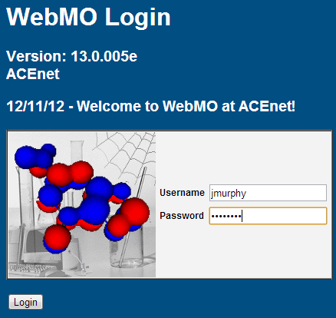

**2. Start a New Job**

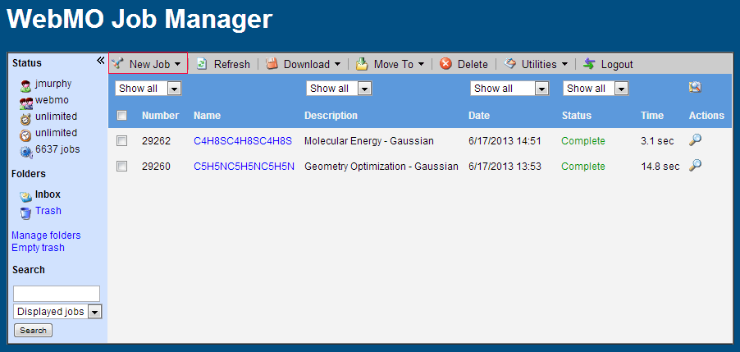

**3. Building a Molecule**

The molecule used in this example is thiophene. To begin, click on the periodic table and select the element you need. Sulfur is chosen in this example.

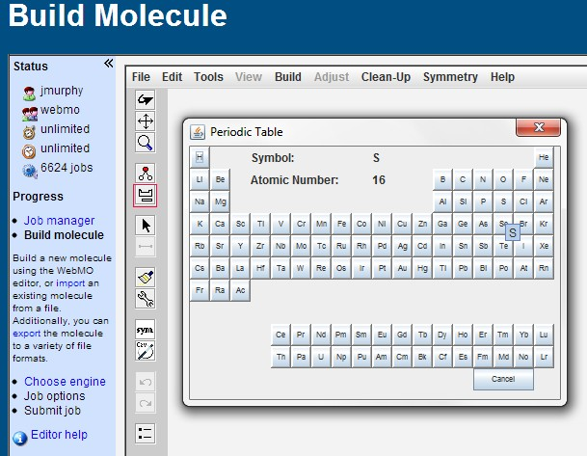

Click anywhere on the blank surface to add an atom. To add bonds, select the element required and click and drag.

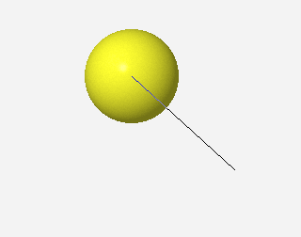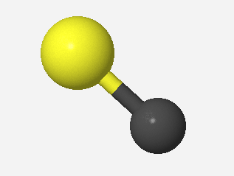

To make double bonds, draw a second bond between the atoms in the same way as you added the single bond.

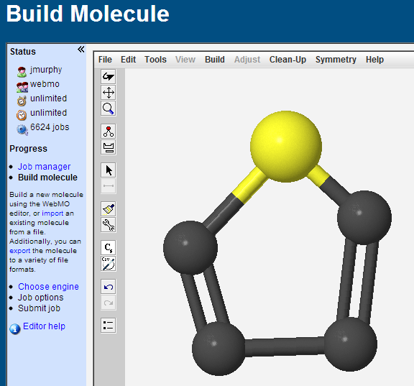

**4. Clean Up Your Structure**

Tidy up your bond angles and add hydrogen atoms by selecting the broom icon. Clicking the symmetry button adjusts the symmetry of your molecule so that it is in the highest point group available.

Save a screenshot of this page to submit for your term project.

To go to the next step, click the forward button at the bottom of the screen.

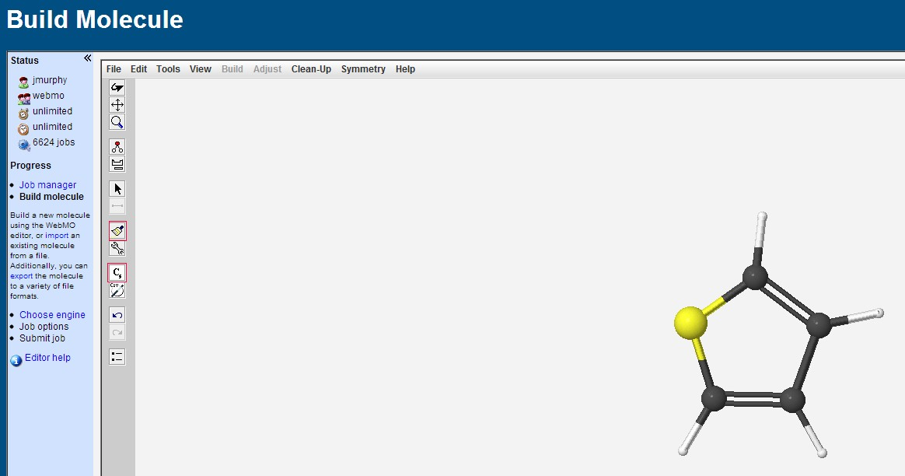

**5. Choose a Computational Engine**

Select the Gaussian computational engine and continue forward.

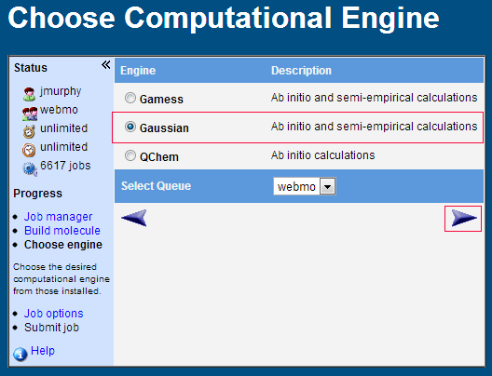

**6. Geometry Optimization**

Select ‘Geometry Optimization’ under the calculation drop-down menu. Set the run time to 12 hours. Set the theory to Hartree-Fock and be sure that the basis set matches the one shown below.

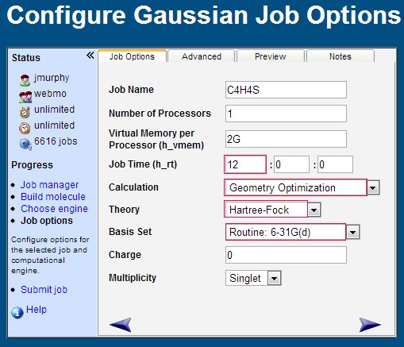

**7. Wait for the Job to Complete**

Your job will be placed in the ACEnet queue until a compute node is available. It will show “Queued” status until it is executed, when it will say “Running.” The job status will change to “Complete” when it is finished. Once your job is finished, click on the chemical formula corresponding to your molecule in the Job Manager screen.

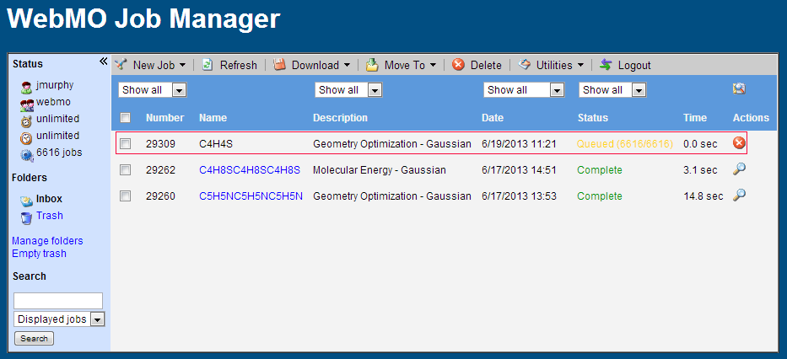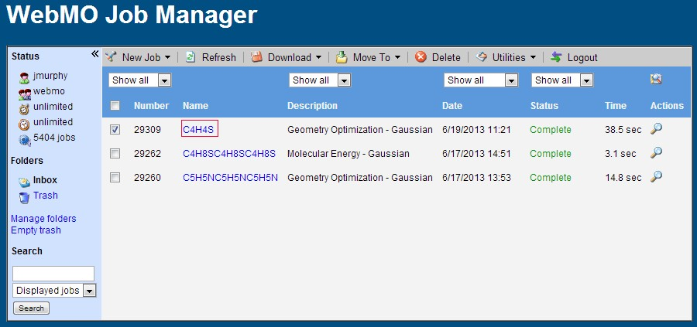

**8. Downloading your .log File**

Choose ‘all files’ on the left of the screen. Select the binary of output.log (you can rename it later) it will automatically download. This is the file that needs to be transferred to placentia using Filezilla or a SCP client like Filezilla.

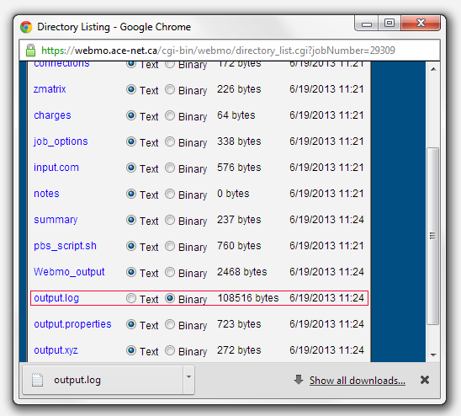

**9. Transfer the output.log file to placentia using Filezilla**

Open Filezilla, put in the host as placentia.ace-net.ca and enter your ACEnet username and password. The port is 22. Once you have connected, get organized. Make a folder on placentia to put your .log file into. To do this, right click and make a new folder on the placentia side. Mine is called ‘antechamber demo’. Then, locate your output.log file in your downloads. I have renamed mine ‘thiophene.log’, I suggest you rename yours appropriately. To transfer your file, chick on the file and drag it into the new folder on placentia that you have made.

**10. Open Putty and Log in to placentia.**

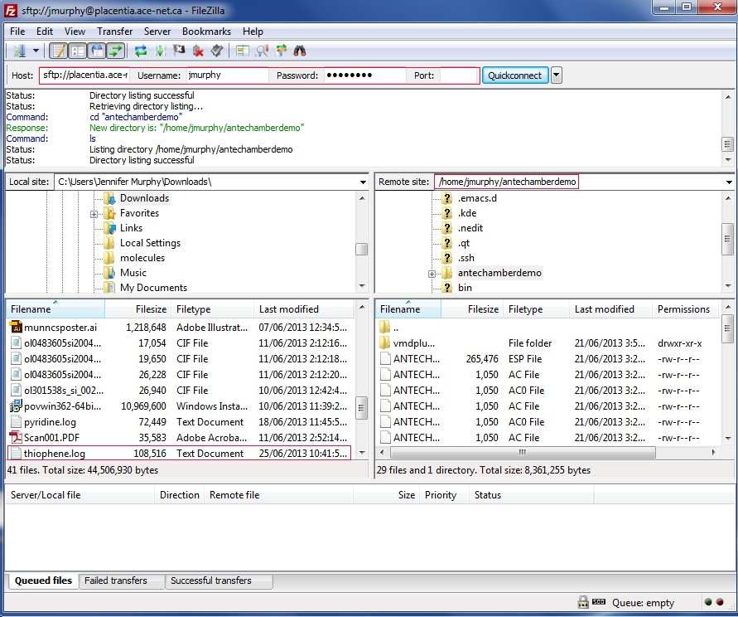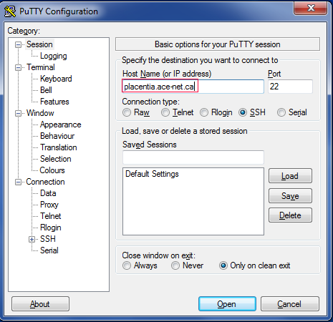

**11. Change into the directory you put the output.log file in**

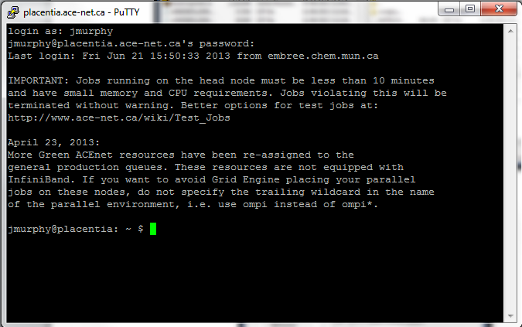

Run the command ‘**ls**’ to check to make sure the antechamberdemo directory is present, then change into the antechamberdemo directory.

|  |  |  |  |
| --- | --- | --- | --- |
| ~ $ **ls**   |  |  |  | | --- | --- | --- | | antechamberdemo  scratch | Bin  sulfur_molecules | output_sulfur_molecules |   ~ $ **cd antechamberdemo/**  antechamberdemo $ **ls**  pyridine.log thiophene.log |

**12. Run Babel**

Load the module for the openbabel program, then run the command **babel** to convert the Gaussian log file to a mol2 file. Use the command **less** to look at your mol2 file to confirm the conversion worked.

|  |
| --- |
| $ **module load gcc openbabel**  $ **babel -i g09 thiophene.log -o mol2 thiophene.mol2**  $ **less thiophene.mol2**  @<TRIPOS>MOLECULE  thiophene.log  9 9 0 0 0  SMALL  USER_CHARGES  ****  Gaussian 09 #N HF/6-31G(d) OPT Geom=Connectivity  @<TRIPOS>ATOM  1 C -1.2336 -0.0153 0.0000 C.ar 1 LIG1 -0.2774  2 C -0.7187 -1.2580 0.0000 C.ar 1 LIG1 -0.0932  3 C 0.7185 -1.2582 0.0000 C.ar 1 LIG1 -0.0997  4 C 1.2338 -0.0157 0.0000 C.ar 1 LIG1 -0.2726  5 S 0.0000 1.1906 0.0000 S.2 1 LIG1 0.0224  6 H 2.2668 0.2664 0.0000 H 1 LIG1 0.2255  7 H 1.3156 -2.1501 0.0000 H 1 LIG1 0.1347  8 H -1.3155 -2.1501 0.0000 H 1 LIG1 0.1335  9 H -2.2666 0.2668 0.0000 H 1 LIG1 0.2268 |

**\*Press q to exit less**

**13. Generate the Gaussian Input File Using Antechamber**

Load the modules for antechamber program. Use the command **antechamber** to convert the mol2 file to a Gaussian input file, thiophene.gjf. Look at the file thiophene.gjf using less to make sure the conversion worked.

|  |
| --- |
| $ **module load intel ambertools**  $ **export AMBERHOME=/usr/local/ambertools-13/**  $ **antechamber -fi mol2 -i thiophene.mol2 -fo gcrt -o thiophene.gjf**  $ **less thiophene.gjf** |

Your Gaussian input file should look like this:

|  |
| --- |
| --Link1--  %chk=molecule  #HF/6-31G* SCF=tight Test Pop=MK iop(6/33=2) iop(6/42=6) opt  remark line goes here  0 1  C 0.0000000000 0.7066000000 -1.2724000000  C 0.0000000000 1.2344000000 0.0014000000  S 0.0000000000 0.0000000000 1.1864000000  C 0.0000000000 -1.2344000000 0.0014000000  C 0.0000000000 -0.7066000000 -1.2724000000  H 0.0000000000 -1.3188000000 -2.1622000000  H 0.0000000000 -2.2708000000 0.2974000000  H 0.0000000000 2.2708000000 0.2974000000  H 0.0000000000 1.3188000000 -2.1622000000 |

**14. Submit the Gaussian Calculation to the Queue**

Running the Gaussian input file to calculate the electrostatic potential for charge fitting. This calculation will take longer, so it must be run through the queuing system. The program **nano** is an editor that will let you write a script to submit to the queuing system.

|  |
| --- |
| $ **nano script-1.sh** |

Paste these lines into the editor:

|  |
| --- |
| #!/bin/sh  #$ -l h_rt=01:00:00  #$ -cwd  module load gaussian  g09 < thiophene.gjf 1>thiophene.out 2>thiophegjf.err |

Save this script to disk by typing Ctrl-o and pressing Enter. Type Ctrl-x to exit back to the command line. Use the command **qsub** to submit this script to the queue. Check to see its status in the queue with the command **qstat**.

|  |
| --- |
| $ **qsub script-1.sh**  Your job 5693900 ("script-1.sh") has been submitted  $ **qstat**  job-ID prior name user state submit/start at queue slots ja-task-ID  -----------------------------------------------------------------------------------------------------------------  5693900 0.00000 script-3.s jmurphy qw 07/04/2013 15:01:58 1 |

You may have to wait up to a day for your job to be executed. The job will no longer be shown in the qstat output after it is complete. Once this has happened, you should be able to see a large output file (.out) in this directory list.

|  |
| --- |
| $ **ls –l**  -rw-r--r-- 1 jmurphy crowley 0 Jul 4 14:45 script-2.sh.o5693893  -rw-r--r-- 1 jmurphy crowley 1 Jul 4 14:56 script-2.sh.o5693899  -rw-r--r-- 1 jmurphy crowley 98 Jul 4 10:47 script-3.sh  -rw-r--r-- 1 jmurphy crowley 0 Jul 4 15:03 script-3.sh.e5693900  -rw-r--r-- 1 jmurphy crowley 0 Jul 4 15:03 script-3.sh.o5693900  -rw-r--r-- 1 jmurphy crowley 111 Jul 4 10:49 script-4.sh  -rw-r--r-- 1 jmurphy crowley 0 Jul 4 15:03 thiophegjf.err  -rw-r--r-- 1 jmurphy crowley 752 Jul 4 14:56 thiophene.gjf  -rw-r--r-- 1 jmurphy crowley 882193 Jul 4 10:06 thiophene.log  -rw-r--r-- 1 jmurphy crowley 1053 Jul 4 14:32 thiophene.mol2  **-rw-r--r-- 1 jmurphy crowley 774402 Jul 4 15:18 thiophene.out** |

**15. Use Antechamber to Generate Parameter and Topology Files**

Run antechamber again on the Gaussian output file.

|  |  |  |  |  |  |  |  |  |  |  |  |  |  |  |  |  |  |  |  |  |  |  |  |  |  |  |  |  |  |  |  |  |  |  |  |  |  |  |  |
| --- | --- | --- | --- | --- | --- | --- | --- | --- | --- | --- | --- | --- | --- | --- | --- | --- | --- | --- | --- | --- | --- | --- | --- | --- | --- | --- | --- | --- | --- | --- | --- | --- | --- | --- | --- | --- | --- | --- | --- |
| $ **module load intel ambertools**  $ **export AMBERHOME=/usr/local/ambertools-13/**  $ **antechamber -fi gout -i thiophene.out -fo charmm -o thiophene -c resp**  $ **ls**   |  |  |  | | --- | --- | --- | | ANTECHAMBER_AC.AC | babel.sh | script-4.sh.e5693909 | | ANTECHAMBER_AC.AC0 | Esout | script-4.sh.o5693909 | | ANTECHAMBER_BOND_TYPE.AC | molecule.chk | thiophegjf.err | | ANTECHAMBER_BOND_TYPE.AC0 | Qout | thiophene.gjf | | ANTECHAMBER.ESP | AC0 QOUT | thiophene.inp | | ANTECHAMBER_PREP.AC | script-1.sh | thiophene.log | | ANTECHAMBER_PREP.AC0 | script-1.sh.e5693885 | thiophene.mol2 | | ANTECHAMBER_RESP1.IN | script-1.sh.o5693885 | thiophene.out | | ANTECHAMBER_RESP1.OUT | script-2.sh | thiophene.prm | | ANTECHAMBER_RESP2.IN | script-2.sh.e5693899 | thiophene.rtf | | ANTECHAMBER_RESP2.OUT | script-2.sh.o5693899 |  | | ANTECHAMBER_RESP.AC | script-3.sh |  | | ATOMTYPE.INF | script-3.sh.e5693900 |  | |

**16. Modify the CHARMM Input File**

In order to create the .psf file, the CHARMM input file, thiophene.inp, must be edited using the ‘nano’ command. Add the following three lines to the end of the input file. To save the file: ctrl o, enter, crtl x.

|  |
| --- |
| $ **nano thiophene.inp** |

Add these lines to the bottom of the input file:

|  |
| --- |
| write psf card xplor name thiophene.psf  write coor card pdb name thiophene.pdb  stop |

**17. Execute CHARMM to Generate the PSF and PDB Files**

Use the command **wget** to download the program charmm to your ACEnet account. Decompress this file using **tar**, then execute charm using the input file you’ve generated. There will be a series of files generated.

|  |  |  |  |  |  |  |  |  |  |  |  |  |  |  |  |  |  |  |  |  |  |  |  |  |  |  |  |  |  |  |  |  |  |  |  |  |  |  |  |  |  |  |  |  |  |
| --- | --- | --- | --- | --- | --- | --- | --- | --- | --- | --- | --- | --- | --- | --- | --- | --- | --- | --- | --- | --- | --- | --- | --- | --- | --- | --- | --- | --- | --- | --- | --- | --- | --- | --- | --- | --- | --- | --- | --- | --- | --- | --- | --- | --- | --- |
| $ **wget** [**http://www.chem.mun.ca/homes/cnrhome/charmm.tgz**](http://www.chem.mun.ca/homes/cnrhome/charmm.tgz)  $ **tar xfz charmm.tgz**  $ ./**charmm < thiophene.inp > thiophene.charmmout**  $ **ls**   |  |  |  | | --- | --- | --- | | ANTECHAMBER_AC.AC | molecule.chk | script-5.sh.o5693912 | | ANTECHAMBER_AC.AC0 | qout | script-6.sh | | ANTECHAMBER_BOND_TYPE.AC | AC0 QOUT | script-6.sh.e5693920 | | ANTECHAMBER_BOND_TYPE.AC0 | script-1.sh | script-6.sh.o5693920 | | ANTECHAMBER.ESP | script-1.sh.e5693885 | thiophegjf.err | | ANTECHAMBER_PREP.AC | script-1.sh.o5693885 | thiophene.gjf | | ANTECHAMBER_PREP.AC0 | script-2.sh | thiophene.inp | | ANTECHAMBER_RESP1.IN | script-2.sh.e5693899 | thiophene.log | | ANTECHAMBER_RESP1.OUT | script-2.sh.o5693899 | thiophene.mol2 | | ANTECHAMBER_RESP2.IN | script-3.sh | thiophene.out | | ANTECHAMBER_RESP2.OUT | script-3.sh.e5693900 | thiophene.pdb | | ANTECHAMBER_RESP.AC | script-4.sh.e5693909 | thiophene.prm | | ATOMTYPE.INF | script-4.sh.o5693909 | thiophene.psf | | babel.sh | script-5.sh | thiophene.rtf | | Esout | script-5.sh.e5693912 | tmp.out | |

**Stage 1 Complete**

Download the psf and pdb files generated in the last step and submit them along with your WebMO screen shot.