**CHEM 4305 Term Project:**

**Simulating Molecular Liquids**

## Part 2: Building a Molecular Liquid and Equilibrating the System

**18. Get your .psf, .pdb and .rtf back onto the desktop using Filezilla.**

This is similar to Step 9. Open Filezilla and make a folder on your desktop to transfer the files to.

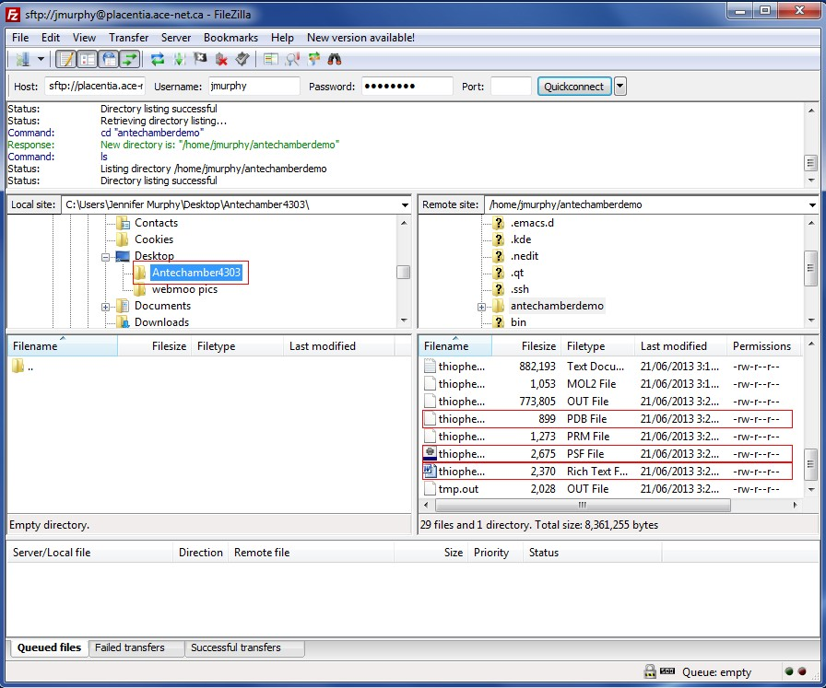

**19. Download the liquefy.tcl plugin**

Enter the URL: <http://www.chem.mun.ca/homes/cnrhome/liquefy.tcl> into your web browser. Save the file to your computer.

**19. Open VMD from the desktop**

Find the program “VMD” in your Program Files directory under “University of Illinois.” There should be three windows that come up, shown below.

**Program Window**

**Graphics Window**

**Command Window**

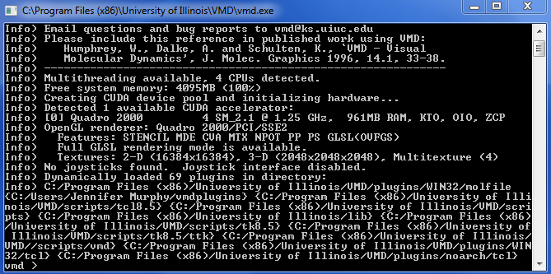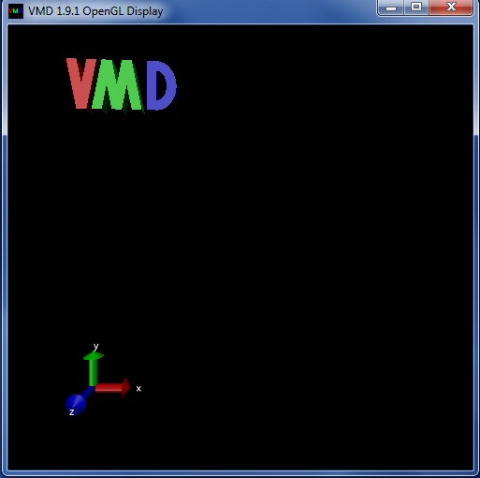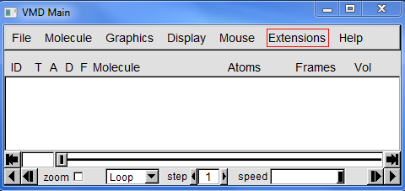

**20. Execute the Liquefy Script**

In the command window, type the following commands:

|  |
| --- |
| vmd > source Downloads/liquefy.tcl  vmd > Liquefy::liquefy_gui |

A new window will appear. You will use this extension to build a unit cell of your liquid.

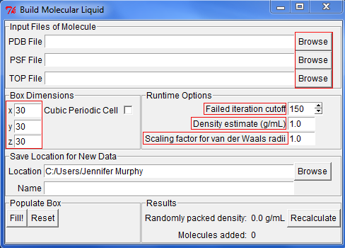

Browse to put in the .pdb, .psf and .rtf files that you have transferred over from placentia in the “Input Files of Molecule” section. For your project, change x, y, and z lengths under “Box Dimensions” to 40 Å  × 40 Å  × 40 Å. Enter the density of your liquid in the “Density estimate” box. Give your liquid an appropriate name and be sure you save it to the same folder as your other files. When you are sure everything is put in the plugin correctly, click ‘fill’ to construct the unit cell of randomly oriented molecules. Click the “Fill!” button to generate a unit cell for your simulation.

You may need to make several attempts to generate a unit cell with the correct density. You can increase the number of iterations up to a maximum of 1000 and the scaling for the van der Waals radii can be decreased to a minimum of 0.75 if your density is too low. It is OK if your density is too low – the box size will decrease during the simulation to achieve the optimal density.

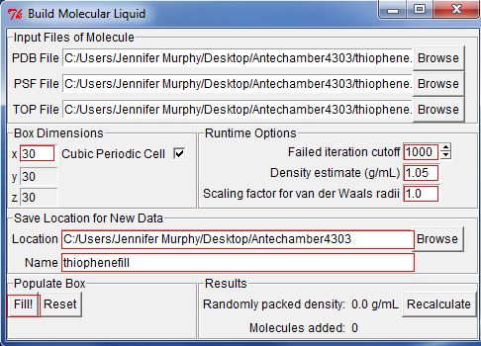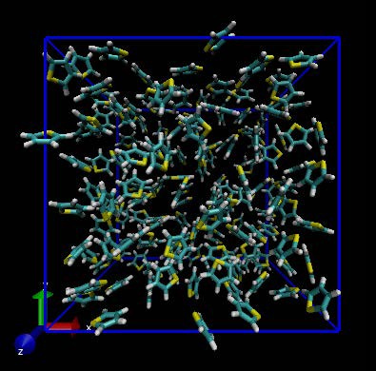

**21. Check your density value**

Your box should be filled with the molecule like the picture shown above. Look at the main VMD window to see what the density of the liquid is. It’s OK if your density differs somewhat from the experimental density; the equilibration simulation will correct this.

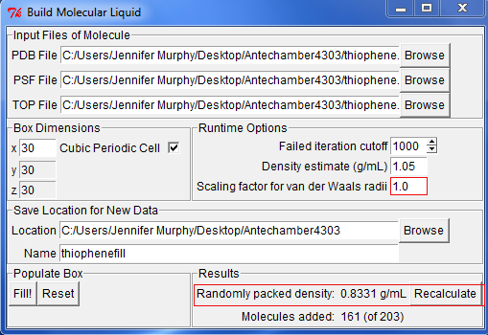

As you can see, the density is only 0.8331 g/mL. Now we can play around with the scaling factor for van der Waals radii to get the density approximation closer to the experimental value. Also, only 161 molecules out of a possible 203 based on the dimensions of the box were used, this should be higher. You can start by changing the scaling factor to 0.80 and filling the box again.

In this case, the density after altering the scaling factor works out to 1.0504 g/mL and all 203 molecules are used. This may not be true for your liquid and you may have to play around with the scaling factor before you get a density that is close to the experimental value.

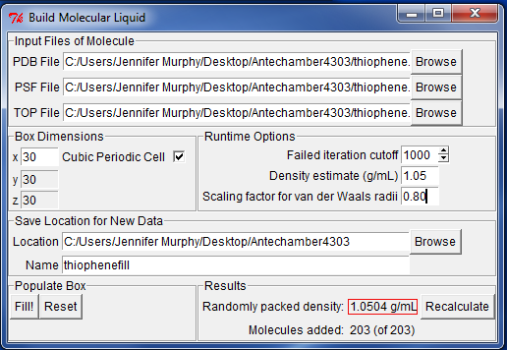

**22. Copy the sample NAMD configuration file to your directory on placentia**

Edit the NAMD file so that is matches your molecule.

|  |
| --- |
| $ **cp /home/crowley/chm4305/moleculefill.namd .**  $ **nano moleculefill.namd** |

Your input file will look like the following. You should edit the lines like “moleculefile.pdb” to reflect the names of the PSF and PDB files generated using Liquefy and the prm file generated using antechamber.

|  |
| --- |
| # input  coordinates moleculefill.pdb  extendedSystem moleculefill.xsc  structure moleculefill.psf  parameters molecule.prm  paratypecharmm on  # output  set output moleculefill  outputname $output  dcdfile ${output}.dcd  xstFile ${output}.xst  dcdfreq 10000  xstFreq 10000  binaryoutput no  binaryrestart no  outputEnergies 100  restartfreq 1000  fixedAtoms off  # Basic dynamics  exclude scaled1-4  1-4scaling 1  COMmotion no  dielectric 1.0  # Simulation space partitioning  switching on  switchdist 9  cutoff 10  pairlistdist 12  # Multiple timestepping  firsttimestep 0  timestep 1  stepspercycle 20  nonbondedFreq 2  fullElectFrequency 4  # Temperature control  set temperature 298  temperature $temperature; # initial temperature  # Langevin Dynamics  langevin on; # do langevin dynamics  langevinDamping 1; # damping coefficient (gamma) of 1/ps  langevinTemp $temperature; # bath temperature  langevinHydrogen no; # don't couple langevin bath to hydrogens  seed 12345  # Pressure control  langevinPiston on  langevinPistonTarget 1.01325; # in bar -> 1.01325 bar = 1 atm  langevinPistonPeriod 2000  langevinPistonDecay 100  langevinPistonTemp $temperature  useFlexibleCell no  useGroupPressure no  fixedAtomsForces off  # PBC  wrapAll on  PME yes  PMEGridSpacing 1.0  # Scripting  minimize 1000  reinitvels $temperature  run 1000000 |

**23. Submit the NAMD simulation to the queue on placentia**

|  |
| --- |
| $ **nano script-2.sh** |
| #!/bin/bash  #$ -l h_rt=24:00:00  #$ -cwd  module load namd  namd2 moleculefill.namd 1> moleculefill.out 2> moleculefill.err |
| $ **qsub script-2.sh** |

**24. Lights, camera, action!**

It is time to check out you movie! The trajectory of your MD simulation will be saved to a DCD file in this directory. To view the trajectory, use filezilla to transfer your .dcd file to your desktop. Open vmd and load your moleculefill.psf. Then, right click on the moleculefill.psf file so that the whole line turns green and a drop down menu comes down. Select ‘load data onto molecule’ and browse for the thiophenefill.dcd file, click ‘load’.

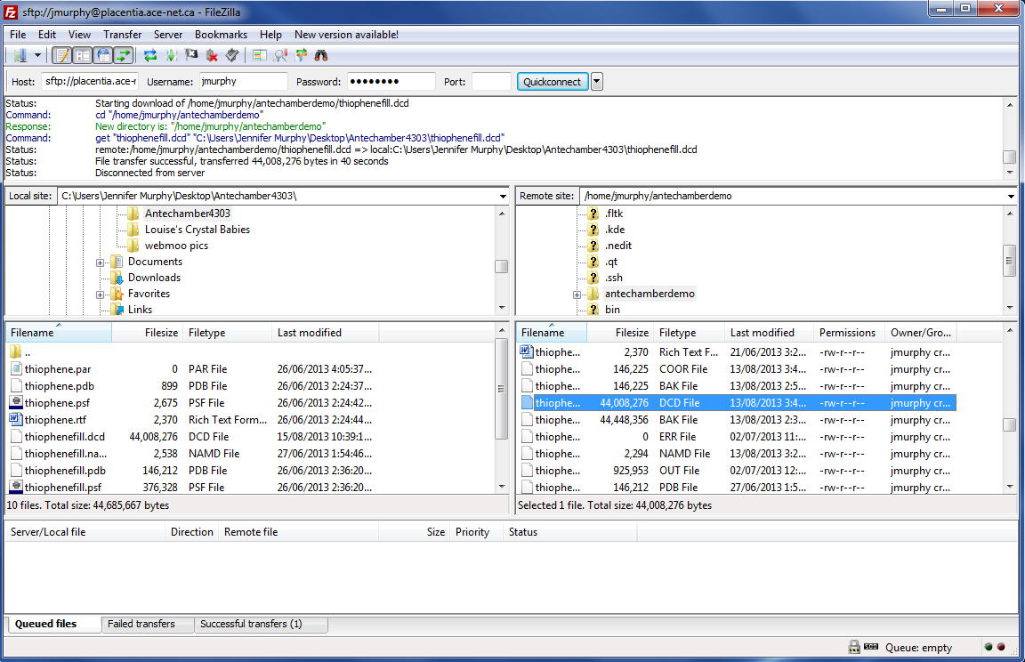

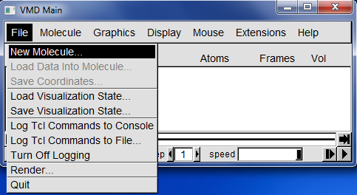

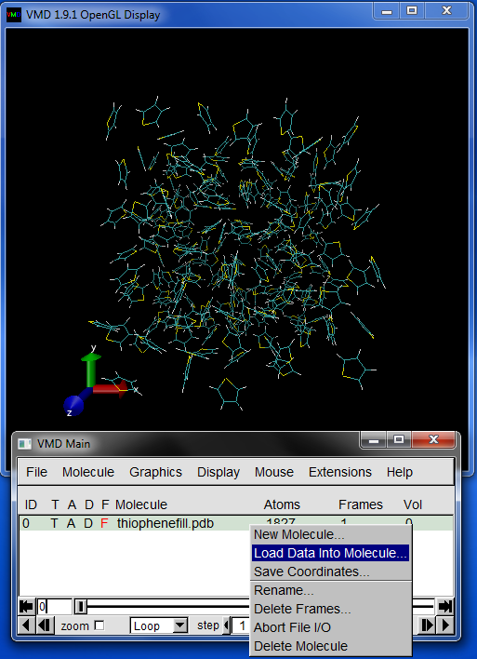

**25. Extracting energies/volumes and making graphs in gnuplot.**

Use the following commands to extract the potential and total energy from your .namd output file.

|  |
| --- |
| $ **grep "^ENERGY": moleculefill.out > energy_eq.txt** |

**You need to look at your .namd output files to see what columns the potential and total energy are in. The potential energy is in 14 and total energy is in 12. An example, from the end of an output file is shown below. The timestep is in column 2.**

|  |
| --- |
| ETITLE: TS BOND ANGLE DIHED IMPRP ELECT VDW  BOUNDARY MISC KINETIC TOTAL TEMP POTENTIAL TOTAL3 TEMP  AVG PRESSURE GPRESSURE VOLUME PRESSAVG GPRESSAVG  ENERGY: 100000 2418.5540 435.0343 304.9260 35.2647 -1108.3803 -330.4578  0.0000 0.0000 1580.1563 3335.0973 290.1554 1754.9410 3354.8077 291.0  053 1278.5353 751.4656 27477.3849 15.7136 3.1915 |

Write a script for your graphs, copy and paste the one below.

|  |
| --- |
| $ **nano liquidenergygraphs_eq** |
| # Gnuplot script file for plotting data in file "energy_eq.txt"  # This file is called liquidenergygraphs_eq  set terminal png  set output "liquidenergygraphs_eq.png"  set autoscale # scale axes automatically  unset log # remove any log-scaling  unset label # remove any previous labels  set xtic auto # set xtics automatically  set ytic auto # set ytics automatically  set title "Equilibriation energies for liquid thiophene"  set xlabel "Timestep"  set ylabel "Energy (kJ)"  set key auto  set xr [0.0:100000]  set yr [-60000:60000]  plot "energy_eq.txt" using 2:12 title 'Total' with linespoints , \  "energy_eq.txt" using 2:14 title 'Potential' with points |

We are using GNUPLOT to make our graphs. For more information about GNUPLOT, check out this website: <http://people.duke.edu/~hpgavin/gnuplot.html>

|  |
| --- |
| $ **module load gnuplot**  $ **gnuplot**  G N U P L O T  Version 4.6 patchlevel 0 last modified 2012-03-04  Build System: Linux x86_64  Copyright (C) 1986-1993, 1998, 2004, 2007-2012  Thomas Williams, Colin Kelley and many others  gnuplot home: http://www.gnuplot.info  faq, bugs, etc: type "help FAQ"  immediate help: type "help" (plot window: hit 'h')  gnuplot> **load 'liquidenergygraphs_eq’** |

To get your graph, you must transfer your liquidenergygraphs_eq.png file back to your PC using Filezilla.

You may need to adjust the scale of the plot to a value that’s appropriate for your data. You can adjust the scale by changing the “set yr [-60000:60000]” line in the gnuplot input file.

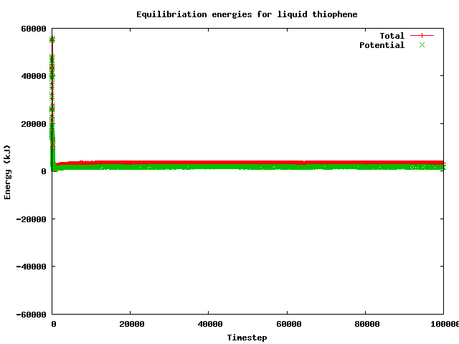

You should also plot of volume to make sure density of the simulation has reached equilibrium. Note: Volume is in column 19.

|  |
| --- |
| $ **nano liquidvol_eq** |
| # Gnuplot script file for plotting data in file "energy_eq.txt"  # This file is called thiophenevol_eq  set terminal png  set output "liquidvol_eq.png"  set autoscale # scale axes automatically  unset log # remove any log-scaling  unset label # remove any previous labels  set xtic auto # set xtics automatically  set ytic auto # set ytics automatically  set title "Equilibriation volume for liquid thiophene"  set xlabel "Timestep"  set ylabel "Volume)"  set key auto  set xr [0.0:100000]  set yr [0:35000]  plot "energy_eq.txt" using 2:19 title 'Volume' with linespoints |
| $ **gnuplot**  G N U P L O T  Version 4.6 patchlevel 0 last modified 2012-03-04  Build System: Linux x86_64  Copyright (C) 1986-1993, 1998, 2004, 2007-2012  Thomas Williams, Colin Kelley and many others  gnuplot home: http://www.gnuplot.info  faq, bugs, etc: type "help FAQ"  immediate help: type "help" (plot window: hit 'h')    gnuplot> **load 'liquidvol_eq'** |

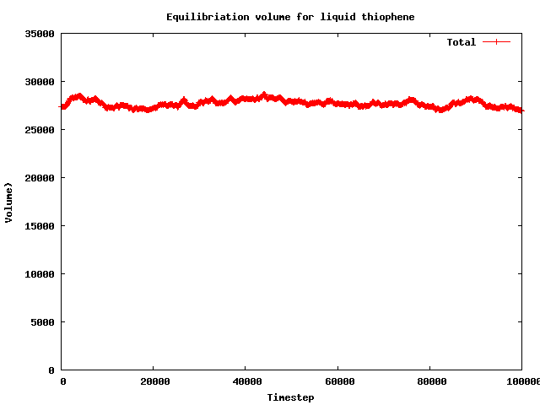

**Stage 2 Complete**

Download the initial PDB generated by Liquefy and the final coordinates from the NAMD simulation (moleculefill.coor), and the PNG files of the plots of the cell volume and potential energy to show convergence of this simulation.