iScape: A Collaborative Memory Palace for Digital Library Search Results

Katy Börner

SLIS, Indiana University, 10th Street & Jordan Avenue, Bloomington, IN 47405, USA
Email: katy@indiana.edu

ABSTRACT
Massive amounts of data are available in today’s Digital Libraries (DLs). The challenge is to find relevant information quickly and easily, and to use it effectively. A standard way to access DLs is via a text-based query issued by a single user. Typically, the query results in a potentially very long ordered list of matching documents, that makes it hard for users to find what they are looking for.
This paper presents iScape, a shared virtual desktop world dedicated to the collaborative exploration and management of information. Data mining and information visualization techniques are applied to extract and visualize semantic relationships in search results. A three-dimensional (3-D) online browser system is exploited to facilitate complex and sophisticated human-computer and human-human interaction.
Informal user studies have been conducted to compare the iScape world with a text-based, a 2-D visual Web interface, and a 3-D non-collaborative CAVE interface. We conclude with a discussion.

1. INTRODUCTION
Extensive amounts of human knowledge are available online, not only in the form of texts and images, but also as audio files, 3-D models, video files, etc. Given the complexity and the amount of digital data, it seems to be advantageous to exploit spatial metaphors in order to visualize and access information. At the same time, a growing number of projects are collaborative efforts that bring people with different skills and expertise together. Domain experts are often spread out in space and time zones, thus consultation and collaboration has to proceed remotely instead of face-to-face. Required for these interactions are user interfaces that can access multi-modal data, that are available on a standard PC at any time, and that support collaborative information access and information management efficiently and intuitively.
In this paper, we present research on iScape (Information Landscape), which is part of the LVis (Digital Library Visualizer) project (Börner et al., 2000). iScape is a world in Active Worlds (AW) Educational Universe, a special universe with an educational focus. It aims to support navigation through complex information spaces by mapping data stored in digital libraries onto an ‘information landscape’ which can then be explored by human users in a more natural manner. In particular, iScape displays retrieval results in a multi-modal, multi-user, navigable, virtual desktop virtual world in 3-D, which is interconnected with standard 2-D web pages. Documents are laid out according to their semantic relationships and can be navigated collaboratively. Full document texts, images or even videos can be displayed in the 2-D web interface on demand. Users can change the spatial arrangement of retrieved documents and annotate documents, thereby ultimately transforming the world into a ‘collaborative memory palace’.
The subsequent section presents an overview of research on the visualization of search results. The design and the current capabilities of iScape are explained in Section 3. First results of a usability study comparing the efficiency and accuracy of the iScape environment with a text-based, and a 2-D visual Web interface as well as a 3-D non-collaborative CAVE interface are reported in section 4. We conclude with a discussion of the work.

2. VISUALIZATION OF SEARCH RESULTS
The majority of today’s search engines confront their users with long lists of rank-ordered documents. The examination of those documents can be very time consuming and the document of real interest might be hidden deep inside the list.
Visualizations are used to help understand search results. For example, Spoerri’s (1993) InfoCrystal or TileBars (Hearst, 1995) visualize the document-query relevance.
Recently, several approaches have been developed that cluster and label search results to provide users with a general overview of the retrieval result and easier access to relevant information (Hearst, 1999). An example is the scatter/gather algorithm developed by Cutting et al. (1996). Clustering can be performed over the entire collection in advance, reducing the time spent at retrieval time. However, post-retrieval document clustering has been shown to produce superior results (Hearst, 1999, p. 272) because the clusters are tailored to the retrieved document set. Labels for clusters need to be concise and accurate so that users can browse efficiently.
Other research utilizes visualizations to support query formulation, the selection of an information source, or to keep track of the search progress (Hearst, 1999, p. 257). For example, Ahlberg & Shneiderman (1994) established a set of general visual information seeking principles comprising Dynamic Query Filters (query parameters are rapidly adjusted with sliders, buttons, maps, etc.), Starfield displays (two-dimensional scatterplots to structure result sets and zooming to reduce clutter), and Tight Coupling (interrelating query components to preserve display invariants and to support progressive refinement combined with an emphasis on using search output to foster search input).
Another line of research exploits spatial, real world metaphors to represent information. Examples include the Data Mountain by Czerwinski et al. (1999) or StarWalker by Chen & Carr (1999). The former enables users to manually organize a relatively small information space of personal bookmarks. The latter uses automatic data mining and artificial intelligence techniques to display citation networks of large documents sets in 3-D. StarWalker uses Blaxxun’s community platform (http://www.blaxxun.com/products/community_platform) to display documents by spheres that are connected by citation links. Clicking on a sphere displays the original full text version at ACM's website in the web browser frame. Multiple users can visit this space together and communicate via the built in chat facility. However, to our knowledge, users cannot change the semantic layout of documents or annotate them.
Librarea is a world in the main Active Worlds Universe in which real librarians can create functional, information-rich environments, meet with other librarians from around the world, create a work of art, etc. (http://librarians.about.com/careers/librarians/). However, Librarea does not apply data mining or information visualization techniques to ease the access and manipulation of information.
The LVis (Digital Library Visualizer) comes with two interfaces: a 2-D Java applet that can be used on a desktop computer (Börner, 2000) as well as a 3-D immersive environment (Börner et al., 2000) for the CAVE (Cruz-Neira et al., 1993). However, only a small number of documents can be visualized on a standard screen without overlap and the CAVE interface exploits 3-D but is a very limited resource. In addition, the CAVE requires users to use a special input device such as the joystick-like ‘wand’ which takes practice to learn.
To our knowledge, there exists no semantically organized visualization of search results that can be collaboratively explored, modified, and annotated in 3-D and that is accessible via a standard desktop computer.

3. THE iSCAPE WORLD
The iScape world is a multi-modal, multi-user, collaborative 3-D virtual environment that is interconnected with standard web pages. It was created using the 3-D Virtual Reality Chat & Design Tool by Active Worlds (AW) (http://www.activeworlds.com/). Figure 1 shows the AW interface. In contains four main windows: a list of worlds on the left, a 3-D graphics window in the middle showing the iScape world, a Web browser window on the left, and a chat window. At the top are a menu bar and a toolbar for avatar actions.

Upon entering iScape, users can explore different search results from the Dido Image Bank at the Department of the History of Art, Indiana University (http://www.dlib.indiana.edu/ collections/dido/). Dido stores about 9,500 digitized images from the Fine Arts Slide Library collection of over 320,000 images. Latent Semantic Analysis (Landauer et al., 1998) as well as clustering techniques were applied to extract salient semantic structures and citation patterns automatically. A Force Directed Placement algorithm (Battista et al., 1994) was used to spatially visualize co-citation patterns and semantic similarity networks of retrieved images for interactive exploration. The final spatial layout of images corresponds to their semantic similarity. Similar images are placed close to one another. Dissimilar images are further apart. Details are reported elsewhere (Börner et al., 2000; Börner, 2000).

Users of iScape are represented by avatars (see fig. 3, left). They can collaboratively navigate in 3-D, move their mouse pointer over an object to bring up its description (see Fig. 1), click on 3-D objects to display the corresponding web page in the right Web frame of the AW browser, or teleport to other places. The web browser maintains a history of visited places and web pages so that the user can return to previous locations.

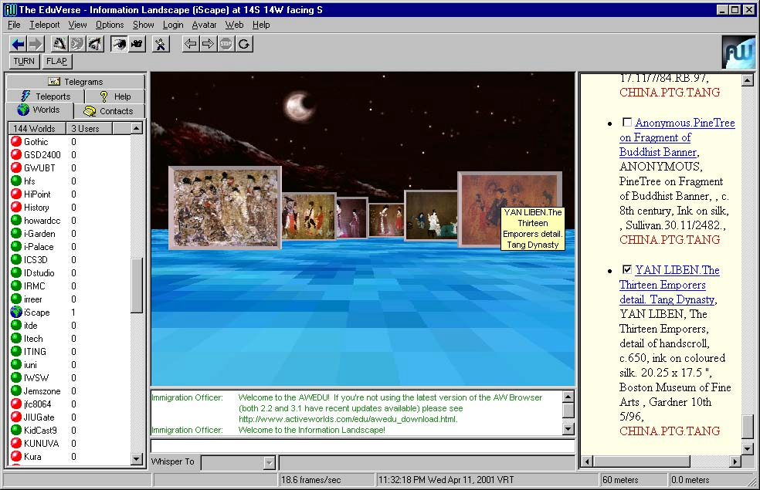

Figure 1: AW interface showing the iScape world

Besides exploring the space collaboratively, users can select and move images thus changing the semantic structure of documents to resemble and communicate their experiences and interests. In addition, they can annotate images.

4. INFORMAL USER STUDY
Cugini et al. (1999) report an extensive usability study in which they evaluated text-based, 2-D and 3-D visual interfaces to search results employing a document three-keyword axes display to visualize query relevance. In particular, they showed how visualizations might lead to either increased or decreased cognitive load.

So far, a set of informal user studies has been conducted to compare the efficiency and accuracy of the iScape environment with Dido’s original text-based interface (see fig. 2, left), the 2-D LVis Java applet Web interface (fig. 2 right), and the 3-D non-collaborative LVis CAVE interface (fig. 3, right). Note that all four interfaces depicted in fig. 2 and 3 display the same search result, namely chinese paintings from the 5th Dynasty period (keyword equals china.ptg.tang) retrieved from Dido.

Inspired by Cugini et al.’s (1999) study, we tried to make the visual appearance of the four interfaces as similar as possible, preserving as much of the functionality as possible. In particular, the background and floor of iScape’s AW interface and the LVis CAVE interface have been changed to the same yellow as the Dido text-based interface & the LVis 2-D Java applet. The exact same spatial layout of images was used for the 2-D and the 3-D interfaces. The proportion of images to the human user in the CAVE interface and images presented in AW to the users’ avatar are identical.

Each subject was confronted with two interfaces and had to solve a set of retrieval tasks such as:
- Find an image given part of its textual description.
- Find an image given its image.
- Find two images that are visually similar to an image, and
- Find all images by the same artist.
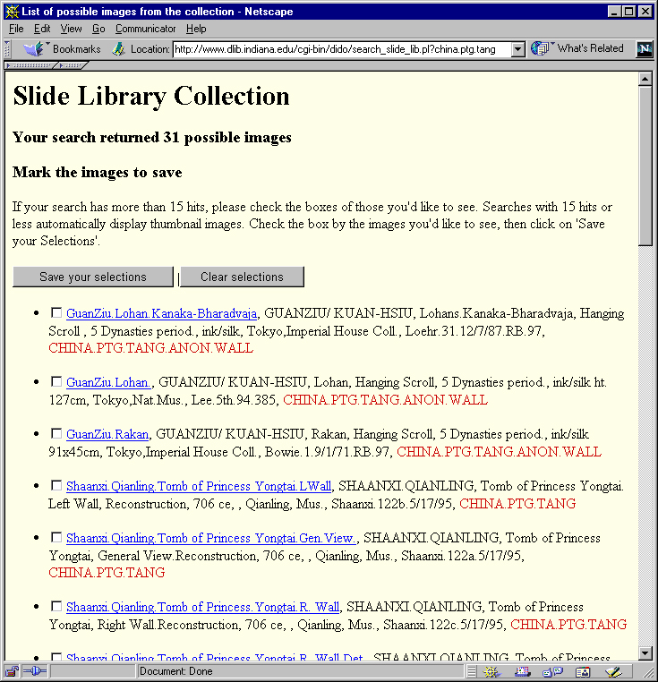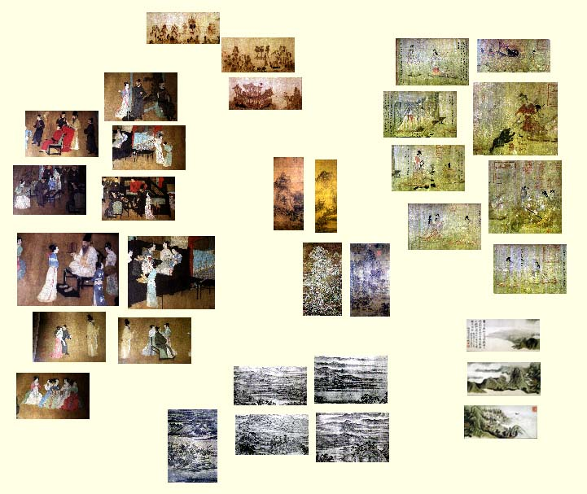

Figure 2: Dido text-based interface and the LVis 2-D Java applet

In general, retrieval using textual image descriptions was superior in response time and accuracy for task 1 and 4. As for task 2 and 3, the 2-D Java interface was superior over the 3-D interfaces if the number of images was small and images did not overlap.

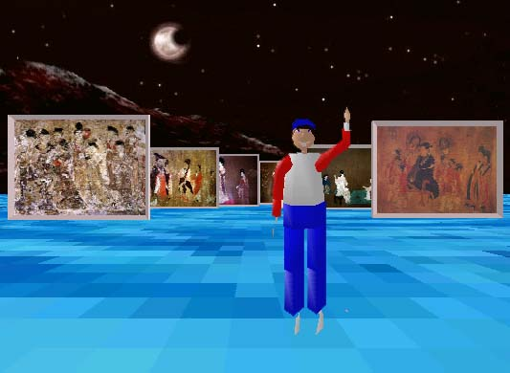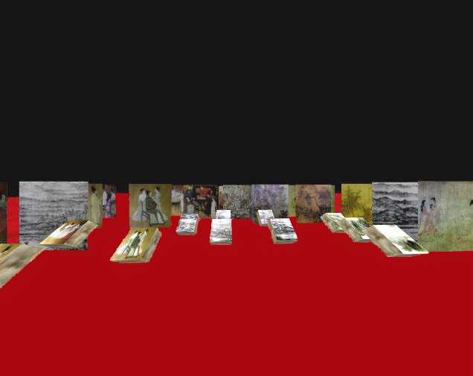

Figure 3: iScape AW interface and the LVis CAVE interface

For larger numbers of images, users exploited 3-D navigation to quickly get different vantage points on image sets. The bird’s eye view was used frequently. Response time and task accuracy have been better for the AW browser than for the CAVE interface which is very like due to the fact that users interact in AW via a standard mouse and keyboard while they are required to learn an unfamiliar interface in the CAVE. Like Cugini et al. (1999) we found that users are typically familiar with text-like operations such as scrolling and selecting, but they need time to learn how to use graphical interfaces. Also, it took some practice of 3-D navigation and object selection before they could exploit spatial metaphors in 3-D. The overall user satisfaction with the 2-D Java and the 3-D interfaces was higher than for the text-based interface. Detailed results of this usability study are forthcoming.

5. DISCUSSION
This paper introduced iScape, a virtual desktop world for the display of retrieval results. Users of iScape can collaboratively experience the semantic relationships between documents or access concrete images/documents. In addition, they can manipulate the semantic structure of documents to resemble and communicate their experiences and interests.
We believe that the computational power and high-end interface technology available today should be exploited to build DL interfaces that are easier to use and interact with and that assist users in the selection, navigation and exploitation of information.
Still, our knowledge about the strengths and limitations of 3-D, immersive (desktop) worlds is very limited. Detailed usability studies are necessary to provide guidance on the selection of appropriate interfaces and visualizations for specific user (groups), tasks, and domains.

6. ACKNOWLEDGEMENTS
This work would not have been possible without ActiveWorld’s generous free hosting of the iScape world, Mandee Tatum’s and Lucrezia Borgia’s continuous support, and the active research environment in EduVerse. We are grateful to Eileen Fry from Indiana University for her insightful comments on this research as well as ongoing discussions concerning the Dido Image Bank. Maggie Swan provided insightful comments on an earlier version of this paper. The SVDPACK by M. Berry was used for computing the singular value decomposition. The research is supported by a High Performance Network Applications grant of Indiana University, Bloomington.

REFERENCES
Ahlberg, C. & Shneiderman, B. (1994) Visual Information Seeking: Tight Coupling of Dynamic Query Filters with Starfield Displays, Proceedings of CHI'94 Conference on Human Factors in Computing Systems, ACM press, pp. 313-480.
Anders, P. (1998) Envisioning Cyberspace: Designing 3-D Electronic Spaces, McGraw-Hill Professional Publishing.
Battista, G., Eades, P., Tamassia, R. & Tollis, I.G. (1994) Algorithms for drawing graphs: An annotated bibliography. Computational Geometry: Theory and Applications, 4 (5), pp. 235-282.
Börner, K., Dillon, A. & Dolinsky, M. (2000) LVis - Digital Library Visualizer. Information Visualisation 2000, Symposium on Digital Libraries, London, England, 19 -21 July, pp. 77-81. (http://ella.slis.indiana.edu/~katy/IV-LVis/)
Börner, K. (2000) Extracting and visualizing semantic structures in retrieval results for browsing. ACM Digital Libraries, San Antonio, Texas, June 2-7, pp. 234-235. (http://ella.slis.indiana.edu/~katy/DL00/)
Chen, C. & Carr, L. (1999) Trialblazing the literature of hypertext: Author co-citation analysis (1989-1998). Proceedings of the 10th ACM Conference on Hypertext.
Cruz-Neira, C., Sandin, D. J. and DeFanti, T. A. (1993) Surround-screen projection-based virtual reality: The design and implementation of the CAVE, in J. T. Kajiya (ed.), Computer Graphics (Proceedings of SIGGRAPH 93), Vol. 27, Springer Verlag, pp. 135-142.
Cutting, D., Karger, D., Pedersen, J. & Tukey, John W. (1992) Scatter/Gather: A Cluster-based Approach to Browsing Large Document Collections, Proceedings of the 15th Annual International ACM/SIGIR Conference, Copenhagen.
Hearst, M. (1995) TileBars: Visualization of Term Distribution Information in Full Text Information Access, Proceedings of the ACM SIGCHI Conference on Human Factors in Computing Systems (CHI), pp. 59-66.
Hearst, M. (1999) User Interfaces and Visualization. In Modern Information Retrieval, Ricardo Baeza-Yates & Berthier Ribeiro-Neto, chapter 10, Addison-Wesley.
Landauer, T. K., Foltz, P. W., & Laham, D. (1998) Introduction to Latent Semantic Analysis. Discourse Processes, 25, 259-284.
Sebrechts, M. M., Cugini, J. V., Laskowski, S. J., Vasilakis J. & Miller, M. S. (1999) Visualization of search results: A comparative evaluation of text, 2-D, and 3-D interfaces. Proceedings on the 22nd Annual International ACM SIGIR Conference on Research and Development in Information Retrieval, pp. 3-10.
Spoerri, A. (1993). InfoCrystal: A Visual Tool for Information Retrieval. In Proc. Visualization'93, pages 150-157, San Jose, California (1993). IEEE Computer Society.
The Indiana University Department of the History of Art Dido Image Bank, http://www.dlib.indiana.edu/ collections/dido/

Memory palaces refer to highly evolved mnemonic structures. They were developed in classical Greek culture to manage and recite great quantities of information. Basically, a memory palace is a non-linear storage system or random access memory that is responsive to the user’s position in an imagined space. Peter Anders (1998) argues on p. 34, that ‘The memory palace could resurface as a model for future collective memory allowing users to navigate stored information in an intuitive spatial manner’ and that ‘… cyberspace will evolve to be an important extension of our mental processes’ allowing us to ‘… create interactive mnemonic structures to be shared and passed from one generation to the next.’

