Collaborative Visual Interfaces to Digital Libraries

Katy Börner
SLIS, Indiana University
10th Street & Jordan Avenue
Bloomington, IN 47405, USA
+1 (812) 855-3256
katy@indiana.edu

Ying Feng
CS, Indiana University
501 S. Woodlawn Avenue
Bloomington, IN 47405, USA
+1 (812 ) 856-5230
yingfeng@cs.indiana.edu

Tamara McMahon
Indiana Univ. Health Center
600 N. Jordan Avenue
Bloomington, IN 47405, USA
+1 (812) 855-7222
tmmcmaho@indiana.edu

ABSTRACT
This paper argues for the design of collaborative visual interfaces to digital libraries that support social navigation. As an illustrative example we present work in progress on the design of a three-dimensional document space for a scholarly community – namely faculty, staff, and students at the School of Library and Information Science, Indiana University.
Categories & Subject Descriptors
H.3.7 Digital Libraries, H.5.1 Artificial, augmented, and virtual realities, H.5.3 Group and Organization Interfaces

General Terms
Design, Human Factors

Keywords
Information visualization, digital libraries, collaboration, social navigation, three-dimensional interfaces

MOTIVATION & BACKGOUND
Real world (public) libraries are very social places – crowded with people looking for a specific book, browsing audio-visual material under a certain topic, attending author readings, hanging out with their kids. There are multiple cues that aid social navigation. Among them are crowded parking around the library, a higher density of people during events in certain areas of the library, usage signs on books, tapes, toys (e.g., dog ears, annotations), and last but not least reference librarians providing assistance.
Digital libraries (DLs), in comparison, are very lonely places. Your best friend may query, e.g., the ACM library, with the identical search term and sift through the potentially large set of retrieved documents at the very same time. However, there is no way you will ever find out this happened. There is no means to annotate articles so that others can capitalize from your expertise; no indication how many people have read an article (besides page access counters or citation counts); nobody to ask for help.
Dourish & Chalmers [1] identified three major paradigms for information navigation: spatial navigation – mimicking our experiences in the physical world; semantic navigation – driven by

semantic relationships or underlying logic; and social navigation – taking advantage of the behavior of like-minded people.
A growing number of systems exploit human spatial cognition and powerful human vision by organizing documents semantically in a two-dimensional (2-D) or three-dimensional (3-D) space [2]. Still, the majority of today’s DL interfaces is designed for single users.
Very few interfaces to DLs facilitate and support all three navigation paradigms or are collaborative allowing multiple users to explore a data set together. StarWalker was explicitly designed to support social navigation of ACM publications [3]. The Knowledge Garden [4] is a collaborative 3-D information visualization tool that people can utilize to meet and share information. Visitors of these semantically organized 3-D spaces are represented by avatars, are aware of one another, and can communicate.
We suggest going beyond existing efforts by creating collaborative visual interfaces to DLs that users can shape by contributing new documents, annotate them or influence the layout and presentation of documents. The design of collaborative interfaces is facilitated by commercially available 3-D Online Browser Systems such as Blaxxun's online community client-server architecture, Active Worlds technology, or the new Adobe Atmosphere browser, to name just a few. Each of these 3-D browser systems facilitates the creation of multi-modal, multi-user, navigable, and collaborative virtual worlds in 3-D that are interconnected with standard web pages and that are accessible from standard computer platforms via the Internet, 24 hours and 7 days a week.

THE SLIS DOCUMENT SPACE
We are in the process of developing a shared three-dimensional document space for a scholarly community – namely faculty, staff, and students at the School of Library and Information Science, Indiana University. Upon completion, about 530 people – including about 300 students in Bloomington and 200 students in Indianapolis - will have access to this space.
The space will provide access to an initial seed collection of about 8,000 links to online documents such as text, images, video, software demonstrations, etc. collected from personal favorites or bookmark lists from SLIS faculty and staff. The full text of all documents has been downloaded and semantically analyzed using data mining techniques such as Latent Semantic Analysis [5]. The resulting document-by-document similarity matrix was utilized to group semantically similar documents – see also our work on the LVis – Digital Library Visualizer project [6, 7]. A Semantic Treemap algorithm [8] was developed to layout documents in a 3-D space. Semantic Treemaps utilize the original treemap approach [9] to determine the size (dependent on the number of documents) and layout of document clusters. Subsequently, force directed placement (FDP) [10] is applied to the documents in each cluster to place documents spatially based on their semantic similarity. Computational complexity of FDP is reduced at the cost of global optimality. Figure 1 shows a sample 2-D layout of links.
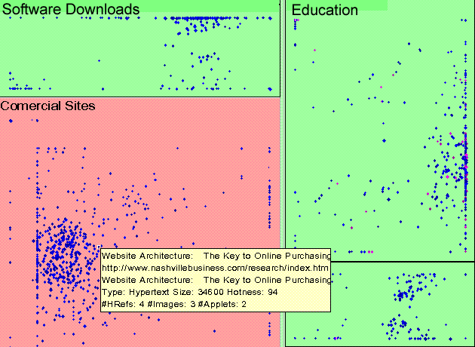
Figure 1: Semantic Treemap Layout of Bookmarked Links
In the 3-D space (cf. Figure 2), each document is represented by a square panel textured by the corresponding web page’s thumbnail image and augmented by a short description such as the web page title which appears when the user moves the mouse over the panel – similar to Robertson et al’s, Data Mountain interface [11]. Upon clicking the panel the corresponding web page is displayed in the web browser interface. Users can collaboratively examine, discuss, and will be able to modify (add and annotate) documents, thereby converting this document space into an ever-evolving repository of the user community’s collective knowledge that members can access, learn from, contribute to, and build upon. The space becomes a shared Memory Palace representing the knowledge of the community.
Currently, we are working on the refinement of the Semantic Treemap algorithm and develop overview maps rendered based on the objects that make up the 3-D world to be displayed in the web interface. Utilizing the maps, users will be able to enter particular search terms to identify areas with matching documents and to click on the map to teleport into the corresponding topic area in the 3-D space.
In parallel, we are conducting usability studies to determine the influence of panel size and panel density on retrieval performance [12]. First results provide evidence that subjects were faster and more accurate if web page panels are large and more dense, but not significantly so. Ratings of different panel size density combinations support this. Interestingly, spatial cognition test results of subjects had no influence on the achieved completion time and accuracy.
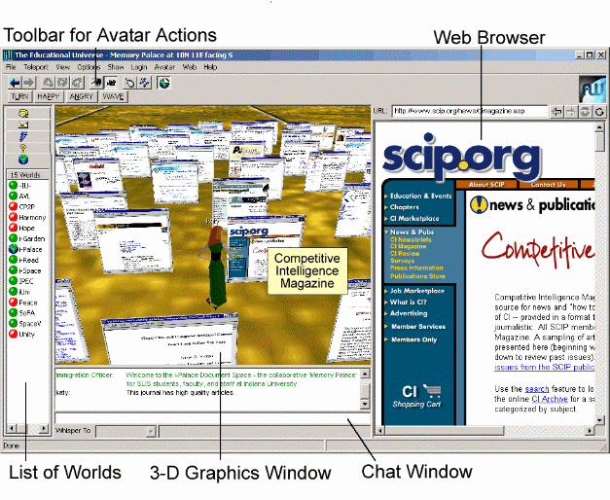
Figure 2: Desktop Interface to the SLIS Document Space

REFERENCES
- Dourish P., Chalmers M. Running out of space: Models of information navigation. Ancillary Proc. BCS HCI'94, 1994.
- Börner, K. and C. Chen. JCDL Workshop: Visual Interfaces to Digital Libraries – Its Past, Present, and Future. In First ACM+IEEE Joint Conference on Digital Libraries. 2001. Roanoke, VA, USA, p. 482.
- Crossley, M., Davies, J., McGrath, A., & Rejman-Greene, M. (1999). The knowledge garden. BT Technology Journal:17(1).
- Chen C., Thomas L., Cole J., Chennawasin C. Representing the semantics of virtual spaces. IEEE Multimedia. 1999:6(2).
- Landauer T.K., Foltz P.W., Laham D. Introduction to Latent Semantic Analysis. Discourse Processes. 1998;25:259-284.
- Börner K., Dillon A., Dolinsky M. LVis - Digital Library Visualizer. Information Visualisation Conference 2000, London, UK, pp. 77-81.
- Börner K. Extracting and visualizing semantic structures in retrieval results for browsing. ACM Digital Libraries Conference 2000; San Antonio, Texas, pp. 234-235.
- Feng Y. & Börner K. Using semantic treemaps to categorize and visualize bookmark files. In Proceeding of SPIE - Visualization and Data Analysis. Volume 4665, January 2002, San Jose, CA, USA, pp. 218-227.
- Shneiderman B. Tree visualization with tree-maps: A 2-D space filling approach. ACM Transactions on Graphics. 1992.
- Fruchterman T.M.J. and Reingold E.M. Graph Drawing by Force-Directed Placement. Software-Practice & Experience. NOV 1991;21(11):1129-1164.
- Robertson G., Czerwinski M., Larson K., Robbins D., Thiel D., van Dantzich M. Data mountain: Using spatial memory for document management. 11th annual ACM Symposium on User Interface Software and Technology (UIST '98), 1998.
- McMahon, T.M. and K. Börner, A Study on the Effects of Web Page Panel Size and Layout Density on Information Access in a 3-Dimensional Collaborative Virtual World, unpublished manuscript. 2001.

