Semantic Correspondence in Federated Life Science Data Integration Systems
Malika Mahoui¹, Harshad Kulkarni², Nianhua Li³, Zina Ben-Miled², Katy Börner⁴
- School of Informatics, IUPUI
Walker Plaza, 719 Indiana Avenue,suite WK307, Indianapolis, IN 46202, USA
mmahoui@iupui.edu, 1-317-278-9205
2. Department of Electrical and Computer Engineering, IUPUI
{hkulkarn,zmiled}@iupui.edu
3. Department of Computer and Information Science, IUPUI
niali@iupui.edu
4. School of Library and Information Science, Indiana University
katy@indiana.edu
Abstract. For execution of complex biological queries, data integration systems often use several intermediate sources connected by cross-references because the domain coverage of individual sources is limited. Quality of intermediate sources differs greatly based on method of curating, frequency of updates and breadth of domain coverage. Since this affects quality of the result, integration systems should provide data provenance; i.e. information about the path used to obtain every record in the result. Furthermore, since query capabilities of web-accessible sources are limited, integration systems need to support refinement queries of finer granularity issued over the integrated data. However, unlike the individual sources, integration systems have to handle the absence of data and conflicts in the integrated data caused by inconsistencies among the sources. This paper describes the solution proposed by BACIIS, the Biological and Chemical Information Integration System, for providing data provenance and for supporting refinement queries over integrated data. Semantic correspondence between records from different sources is defined based on the cross-references among them. Two characteristics of semantic correspondence, namely degree and cardinality, are identified based on the closeness of cross-references that link data records and based on the mappings between domains of data records respectively. A mechanism that provides semantically meaningful provenance for records in the integrated data is discussed. Furthermore, to process refinement queries, an algorithm based on semantic correspondence is presented to handle absence of data and conflicts in the integrated data.
1. Introduction
The rapid development of experimental biology has led to the emergence of a large number of web-accessible biological data sources [1]. Together, these data sources cover a wide range of subjects and data types including gene sequences, gene expression data, protein structures, protein sequences, and metabolic pathways. However, each individual database often focuses on a specific subject area; and thus represents only a fraction of all the available data. For today's research needs, scientists often want to issue complex queries across multiple subject areas. Therefore, significant research efforts have been put into systems that integrate different data sources. Mediator wrapper based federated integration systems form a major part of these efforts.
Entities in molecular biology are complex and scientists are interested in many different characteristics of these entities. A typical query will consist of a predicate defined on one or more of these characteristics and require several other characteristics as output. For example, given a protein name and source organism as the predicate, scientists may be interested in the corresponding sequences, domains/families, 3-D structures and coding genes. In most cases, any single data source will either not be able to process the entire query; i.e. it will either not be able to process the predicate or provide all parts in the output. However, sources that can process the predicate will usually provide cross-references to other sources where parts of the output may be located. For complex queries, there may be a chain of cross-references connecting several sources. However, due to factors such as the method of annotation, update frequency and overall coverage of the subject area, not all of these sources are trusted equally. The knowledge of cross-references used to obtain records in the result, helps scientists choose the ones that come from the trusted sources. An effective way to represent this knowledge is aggregating each set of records with cross-references to each other.
Query capabilities of web-accessible data sources are limited and it is often not possible to use every characteristic of biological entities in the query predicate. Therefore, most initial queries are not specific enough and their results contain several unwanted records. In such cases, once the integrated result of an initial query is available, the integration system can allow scientists to issue refining queries. However, unlike the initial query, while processing a refining query, complex inter-relationships among records from different sources must be considered. Most integration systems assume that different sources cover different characteristics of the biological entities and hence, do not deal with absence of data or contradictory data [2]. However, this does not represent the true nature of relationships among records and consequently, the results of such systems are not complete and reliable. In reality different sources have significant overlap of information and data inconsistencies are present in the overlapping portions due to different methods of curating the data. Therefore, to process refining queries in a comprehensive and correct manner, we must assume an overlapping coverage of the global schema by different sources and deal with the data absence and inconsistency.
The objective of this paper is to describe the solution proposed by BACIIS, the Biological and Chemical Information Integration System [13], for providing data provenance for result records and for supporting queries over integrated results. Section 2 briefly introduces BACIIS system and its main data integration features. Section 3 discusses the processing of complex multi-database queries using a query execution plan. In section 4, the concept of semantic correspondence is defined and its characteristics are described. .In section 5, we present, the provenance table which provides semantically meaningful provenance for aggregated records, and the impact of semantic correspondence on its construction. Finally, in section 6, processing of refinement queries over the integrated data is discussed and an algorithm is presented to handle the conflicts in the integrated data.
2. BACIIS: An Ontology Augmented Database Integration System
Substantial research efforts [3, 4, 5, 6, 7] have been devoted to the integration of heterogeneous, distributed, and autonomous databases. There are three main data integration approaches: data warehousing, link driven, and federated databases. In data warehousing systems (e.g. GUS [8]), data is extracted from source databases, and reorganized into a single database [3]. In link driven approaches, physical links are pre-defined to link related records from different databases. Physical links are either stored in local provenance files [9] or embedded in database records [9]. Both approaches pre-define the relationships among data by storing either data or physical links locally. Data update becomes an important challenge and system scalability is not well addressed. In contrast, federated databases only specify relationships among the schema of source databases. Individual data records are linked on demand during query processing. Schema relationships can be specified in user queries using a multi-database query language as in a loosely coupled federated databases system (e.g. BioKleisli [10] ), or established by mapping to a global schema as in a tightly coupled federated database (e.g. TABMIS [11] ). Tightly coupled federated database systems are suitable for the integration of a large number of databases because they provide good system scalability and source transparency to end-users.
BACIIS (Biological and Chemical Information Integration System) [12], is a highly coupled federation of life science web-databases. It uses a mediator-wrapper approach, augmented with a knowledge base. The wrapper extracts information from a given remote data source. The mediator transforms data from its format in the source database to the internal format used by the integration system The BACIIS knowledge base has two components; the ontology and data source schema. The ontology [13, 14], provides a method for mapping differences in terminology to a common term that is recognized throughout the domain. In addition to syntactic reconciliation, the ontology is used for semantic reconciliation as well as a global schema in BACIIS. Global queries are built by using concepts from the ontology. These global queries are decomposed within BACIIS into database specific sub-queries. The query planner in BACIIS identifies the data sources that can answer the sub-queries based on the description of the data sources that is included in database specific data source schema. Finally, each database is associated with a specific wrapper and these wrappers are responsible for executing the sub-queries on the web databases and retrieving the result.
3. Query Processing Over Distributed Data
Most queries issued by biologists are complex, such as “Which protein family does chaperonin hsp60 precursor in Arabidopsis thaliana belong to?, What is its coding gene sequence? What are the 3D structures of proteins that belong to the same family?” The predicate of this query has two constraints (i.e., Protein Name = chaperonin HSP60 precursor and Organism Name = Arabidopsis thaliana), and the output requires four characteristics (protein family, coding gene sequence, and 3D structure). To the best of our knowledge, no individual life science data source can answer the above query directly due to limited query capabilities and domain coverage [15]. For example, PDB can not be queried on protein name and organism. Also, PDB contains the 3D structure information but does not provide gene sequence and protein family information. On the other hand, SwissProt and PIR can identify proteins based on protein name and source organism; but they do not contain the 3D structure information.
In order to address this limitation, BACIIS adopts a graph model for building queries that span more that one database. The nodes of this graph represent data sources and an edge is present between two nodes if a cross-reference can be established between the corresponding data sources (see section 4.1 for a discussion of types of cross-references). In BACIIS, this graph is pre-defined and used for navigation path discovery in the following way.
Within this graph, the BACIIS query planner finds all the paths from the data sources that can accept query input constraints (e.g. Protein Name = chaperonin HSP60 precursor and Organism Name = Arabidopsis thaliana) to the data sources that contain the output information (e.g. 3D structure). When the output information is available in more than one data sources, one path will be identified for each source to maximize the result coverage. Some possible paths for the example query are shown in Figure 1. Paths are labeled A1 and A2 for coding gene sequence, B1 through B4 for protein family information, C1 through C4 for protein structure. All the paths from C1 to C4 lead to the same source, PDB. Therefore, only the most efficient path should be included in the final query plan. The same applies to path A1 and A2 for GenBank. The query planner in BACIIS is cost-based and therefore selects the most efficient path according to network traffic, query-processing time of remote databases, and result cardinality. For example, if the connection to PIR site is broken temporarily, then SwissProt will be used to identify the desired protein, and the final plan is the union of paths A1, C2, and B1 through B4.
From this discussion, it is clear that the actual query plan used by BACIIS is one of the many possible path expressions over the various data sources. When a typical query plan is executed by BACIIS, the result is a large collection of web pages from various sources; one page for each record. It is important for the scientists to know how each of these records qualified for the result, i.e. the provenance of each data item. Therefore, BACIIS needs to indicate the path expression used to obtain each of the records. Furthermore, as explained in section 1, records from any given path expression represent different characteristics of the same biological entity. Therefore, they are semantically related and it will be very helpful to aggregate them. For example, consider the query plan corresponding to the path expression SwissProt→PROSITE→PDB. Each SwissProt record obtained using this query plan, will have one or more semantically related PROSITE and PDB records.
The two important tasks of providing data provenance and grouping semantically related data records are accomplished by using the provenance table, which is explained in the next section along with characteristics of semantic correspondence.

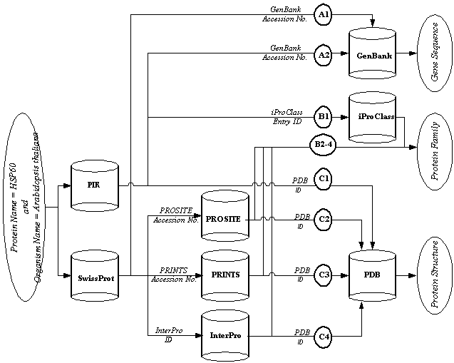
Fig. 1. BACIIS query plan
4. Semantic Correspondences among Heterogeneous Data
In section 4.1, the concept of semantic correspondence is explored in the context of integration of web-accessible life science data sources. In section 4.2, two characteristics of semantic correspondence are then introduced: degree and cardinality. Degree is a measure of how closely two data records from different databases correspond with each other. Cardinality is a measure of domain mapping between two real world objects with some semantic correspondence. The mechanism of grouping of semantically corresponding records using the provenance table is explained in section 5.

4.1 Concept of Semantic Correspondence (SC)
The issue of semantic correspondence between two objects that have significant representational differences was examined in [16]. It also provides a way to distinguish between different degrees of semantic correspondence using factors like the context, abstraction, domains and the state of objects. However, in the context of integrating domain specific data from autonomous, heterogeneous and semi-structured sources, we maintain that the SC is established solely by the cross-references among them. This is similar to the concept of hyperlink authority explored in [17].
In section 3, a graph model was introduced where edges between the nodes denote the cross-references among the respective data sources. There are two types of cross-references; explicit cross-references and implicit cross-references. Explicit cross-references are provided by the data sources, and usually defined by domain experts. These hyperlinks are coded in the web page of the record using HTML by the designers of the source database. For example, web pages containing records of protein sequences from SwissProt provide hyperlinks to related web pages containing records of protein 3D structures in PDB. An implicit cross-reference, however, is not coded into the web page containing the record. It is created by BACIIS when field values of record from one source can be used to identify one or more records from another source. BACIIS can use these values to generate a HTTP query for the other source and obtains those data records. Consider the case of BIND [18], which does not have explicit hyperlinks to SwissProt records. However, BIND records contain attributes ‘protein-name’ and ‘organism-name’, which can be combined to identify a protein sequence record from SwissProt. For example, BIND record 29947 can link to SwissProt record Q05856 through implicit cross-reference "protein name=SmB and organism name=Drosophila melanogaster".
4.2 Characteristics of Semantic Correspondence

As explained in the previous section, cross-references between data records are used to establish SC among them. In this section, we discuss important characteristics of the SC.
Figure 2 shows the partial result of the example query from section 3. The predicate criteria ‘protein-name’ and ‘organism-name’ are combined and submitted to SwissProt, which provides the sequence-info part of the output. The SwissProt data record matching the protein name, also provide explicit cross-references to related data records in GenBank and PROSITE. These sources provide the gene sequence info and the pattern description part of the output, respectively. Finally, PROSITE data records provide explicit hyperlinks to the related PDB data records, which contain the 3-D structure part of the output. Thus, the result of this query consists of data records that are obtained from four different sources.
Consider the SC between SwissProt record P29197 and the PROSITE record PS00296 in figure 2. This semantic correspondence is established because the SwissProt record has a cross-reference to the PROSITE record. In terms of domain knowledge, this SC denotes the fact that the protein represented by the sequence in SwissProt record belongs to the family represented by the PROSITE record. Similarly, the SC between SwissProt and GenBank records denote the domain knowledge that the protein represented by the SwissProt record is a product of the gene represented by the GenBank record.
Now consider the PROSITE and GENBANK records. Do they have SC among them? In terms of domain knowledge, the protein family represented by PROSITE record and the gene represented by the GENBANK record, both are definitely related to the sequence represented by the SwissProt record. i.e., these records represent different characteristics of the same protein. Therefore, GENBANK and PROSITE records do have certain SC. However, this SC is not as strong as the one that links GENBANK and SwissProt records; because there is no direct cross-reference between GENBANK and PROSITE records. Therefore, we need a way to distinguish between the different types of semantic correspondence. This is done using a characteristic of SC called the ‘degree’. Two degrees of SC are defined next; strong SC and weak SC.
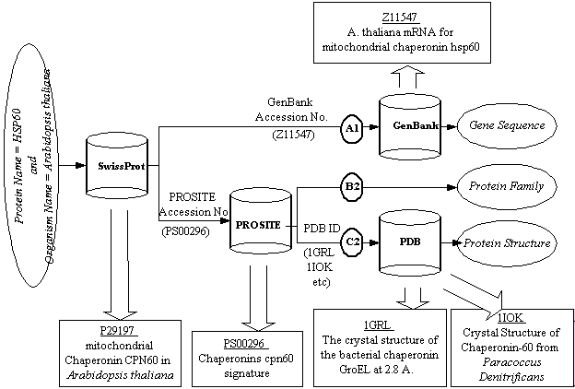
Fig. 2. . Partial result of a query

Strong SC (SSC): Two data records are said to have strong SC, if there exists a direct cross-reference among them. These data records are immediate neighbors in the graph model used by the query plan. In case of explicit cross-references, the strength of this correspondence is based on the fact that the cross-reference is provided by the domain experts at the source. And in case of implicit cross-references, it is based on the fact that one record has enough information to identify the other. From this, it can be noted that SwissProt and PROSITE records mentioned in the example above, have strong SC, as do SwissProt and GenBank records.
Weak SC (WSC): Two data records are said to have weak SC, if they are connected but not immediate neighbors in the graph model. They are connected using a chain of cross-references that travels through at least one other data source. The basis for WSC is the possibility that records connected in such a way may represent different characteristics of the same biological entity. However, WSC is just a possibility and its validity must be confirmed using some other means than just the cross-references as explained in the next section.

5. Provenance Table
Result of a complex multi-source query is a large collection of records from many different sources. Each of these records is obtained using a specific path expression which possibly traverses one or more additional data sources. For scientists, some of these sources are more reliable than others due to factors such methods used for populating the data in those sources, frequency of updates and breadth of their coverage. It is therefore necessary to indicate the path used to obtain each record in the result. A structure called provenance table can be used to juxtapose all the records obtained using a path expression. Table 1 shows such a provenance table for the query plan in section 3. Each column in the provenance table belongs to one data source and each row represents a path expression. For each record, a tag is added indicating its predecessor record in the path expression.
Table 1. Provenance table using path expression
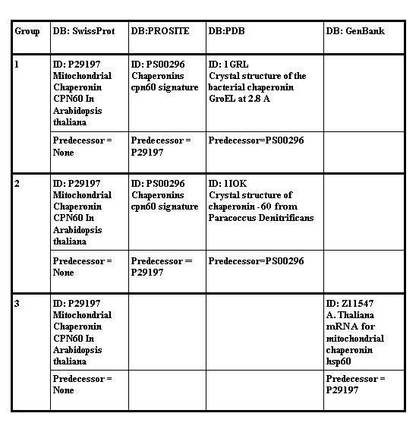
However, looking from a biological point of view, table 1 is misleading. Group 1, for example, contains SwissProt record P29197 and PDB record 1GRL; which represent two different proteins. Similar argument holds from group 2. Moreover, this table puts GenBank and PROSITE records in different groups, each independently paired with the same SwissProt record. Again, this is misleading because the gene record and the protein family record are both characteristics of the protein represented by the connecting SwissProt record. In other words, the WSC between SwissProt and PDB records is invalid while the WSC between PROSITE and GENBANK is valid. The validity of WSC between two records thus depends on whether or not we can biologically pair them with each other.
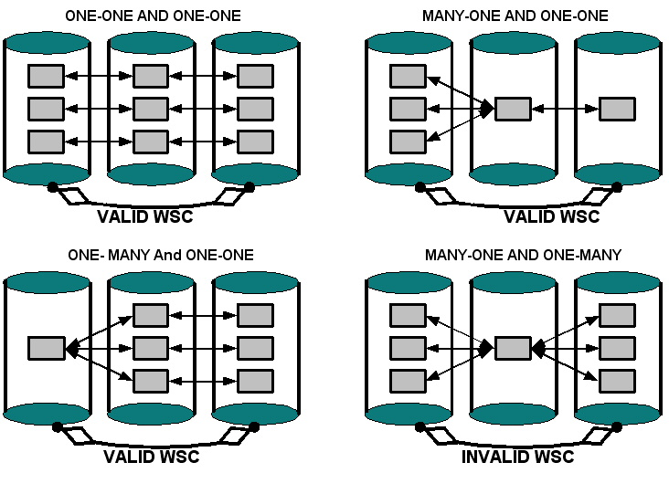
Fig. 3. Domain mapping and validity of WSC

This can be determined from the mapping of domains of the biological entities involved. For example, each protein record will have a corresponding Gene record that it can be biologically paired with; however, each protein family record can be paired with several corresponding protein records. Figure 3 shows the possible cases of domain mappings and corresponding validity or invalidity of the WSC. The mapping between the domain of intermediate source and its neighbors is the most important factor in deciding validity of WSC. If the intermediate record maps to multiple records with both its neighbors, its SC has a plural cardinality; otherwise it has singular cardinality. When an intermediate record has plural cardinality, we can not reliably pair its neighbors and the WSC between them is labeled invalid. Using these concepts in the creation of provenance table, we can now group the records of protein, its family and the corresponding gene together; and keep different proteins in separate groups while still pairing them individually with the protein family record. Table 2 shows the new provenance table created using this method.

6. Refinement Query Processing Over Integrated Data

Query processing capabilities of web-accessible data sources are limited and not every field in the record can be used in the predicate. For example, it is not possible to use the field ‘induction’ as predicate in the initial query. Therefore, there will be many records in the result of initial query with values of ‘induction’ different than the desired value. However, since BACIIS now has all the data locally, it can apply the additional criterion to that data regardless of the sources’ capabilities. In general, BACIIS can provide refinement query capabilities of arbitrary granularity over the global schema and process those queries over the integrated data.
Table 2. Modified provenance table using semantic correspondence
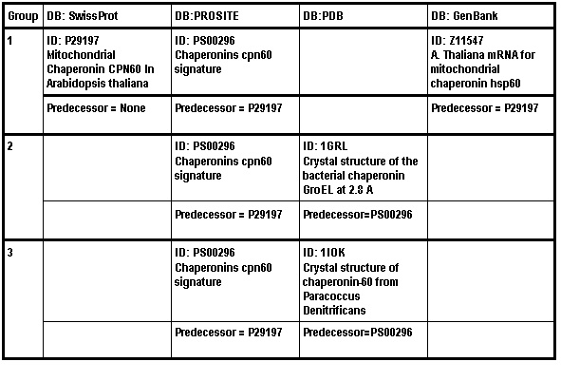
For example, consider the example query from section 3 and its result. Now suppose a refinement query is issued on this result, such as ‘induction = heat shock’. Among various records in the result, only SwissProt records have the ‘induction’ field. Therefore, records from other sources can not be evaluated directly for the predicate in the refinement query. BACIIS has to handle both the absence of data in some records and inconsistency in the data from different sources. Furthermore, since the domain for refinement query is result of the initial distributed query, it must preserve the semantic correspondences among records from that result. Provenance table is used to establish semantic correspondence between records that can be directly evaluated and those that can not be. However, if there are multiple records from one group that can be evaluated for the predicate and if their values are inconsistent with each other, some of the WSC from provenance table may no longer be valid. This case and its solution are presented in next section.

6.1. Invalid WSC Due To Data Inconsistency among Sources

Given the rich population of biological databases available online, it is not surprising that some portions of the domain be covered by multiple sources. For example, protein sequence information is available from several sources such as SwissProt, PIR, etc. As explained in section 1, BACIIS does assume this overlap of coverage among data sources. Therefore, if a field used in the predicate of a refinement query is present in multiple sources, records from all of those sources must be evaluated. It is therefore possible that for a group in the provenance table there are multiple records that can be directly evaluated. And as is explained next, if there are inconsistencies in the data from these records, it creates a problem in processing the refinement queries.
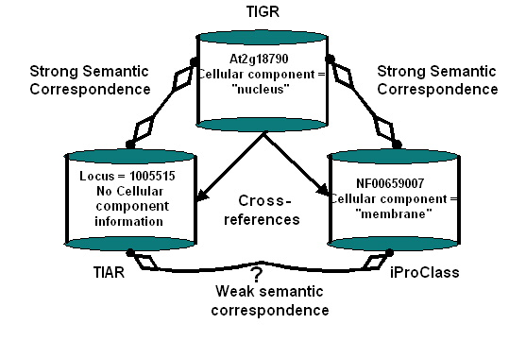
Fig. 4. Invalid WSC due to Data Inconsistency
Consider the following query issued to BACIIS “What is the GENE ontology classification of protein featured for the protein phytochrome B in Arabidopsis thaliana?” Along with many others, the result for this query contains the following three records; At2g18790 from TIGR, NF00659007 from iProClass and 1005515 from TIAR. Figure 5 shows the cross-references among these records and using those along with domain mapping information; we can state that there is a valid WSC between the iProClass record and the TIAR record.
Now, consider the following refinement query issued on this result: “cellular component = membrane”. From the data source schema, BACIIS finds out that only TIGR and iProClass records can be directly evaluated for this predicate. Therefore, TIAR record’s selection is completely dependent on its having valid semantic correspondence with a record that can be evaluated. However, the value of this field is different in both of such records, where iProClass record satisfies the predicate and TIGR does not. This inconsistency of data can be attributed to the different methods of annotation employed by the two sources. Nevertheless, the TIAR record now corresponds to one record that satisfies the predicate and another that doesn’t. However, BACIIS has to take into account the relative degree of SC between these records and since the TIAR record has a SSC with the mismatching TIGR record, its WSC with iProClass record should be considered invalid and it should not be included in the result. The algorithm used for processing the refinement queries is presented in following pseudopodia.

FOR each record in provenance table
Cursor = current record
Neighbor = any record from the same group
CurGroup = group of current record

IF predicate field present in data source
IF field value = predicate value
SET cursor::valid = true
SET CurGroup::valid = true
ELSE
SET cursor::valid = false
ELSE IF CurGroup::valid = true AND
any Neighbor::checked=true
IF cursor::predecessor::valid = false
SET cursor::valid = false
ELSE IF any Neighbor::valid = true
SET cursor::valid = true
ELSE
SET cursor::valid = false
Cursor::checked = true

Using the data source schema, the algorithm first finds out all the records that can be directly evaluated for the predicate. Based on this test, groups in the provenance table are marked as either valid or invalid; where only the valid groups contain candidates for the further examination. Within such a valid group, if a records predecessor is not marked invalid and if any of its neighbors are marked valid, then that record itself becomes valid. Thus, the validity of a record for the refinement query is based on its being part of an unbroken chain of records in a path expression. Therefore, records with cross-references to invalid records are eliminated.

7. Conclusion

In this paper two challenges were addressed; providing provenance for records in integrated data and processing queries over integrated data in a semantically meaningful way. The concept of semantic correspondence was introduced for heterogeneous data obtained using several query paths. Two characteristics of semantic correspondence were also defined. First, the degree of semantic correspondence which represents the closeness of entities represented by different records and second, the cardinality which represents the mapping between domains of entities. Cardinality of semantic correspondence was used to create a semantically meaningful provenance table which can be used to explain how each record in the integrated data [i.e. link to the rest of the results] got there. Provenance table juxtaposes records obtained using a chain of cross-references in a biologically meaningful way.
Data quality in biological data sources varies greatly based several factors. Therefore, overlapping data from different sources has missing data items or contains inconsistencies. The algorithm provided in this paper deals with these conflicts based on the degree of semantic correspondence among the records. It makes no assumption about the correctness of any data source involved. Furthermore, by removing semantically distant records from the integrated data, it achieves a better consistency for the integrated results.
References

[1]A. D. Baxevanis, The Molecular Biology Database Collection: 2003 update, Nucleic Acids Res., 31(1): 1-12, 2003.
[2] T. Hernandez, and S. Kambhampati, “Integration of Biological Sources: Current Systems and Challenges Ahead”, To appear in SIGMOD Record, Vol 33, No3, September 2004.
[3] P. Karp, “A strategy for database interoperation”, Journal of Computational Biology, 2(4): 573-586, 1995.
[4]S. Schulze-Kremer, “Integrating and Exploiting Large-Scale, Heterogeneous and Autonomous Databases with an Ontology for Molecular Biology”, In R. Hofestaedt, and H. Lim, editors, Molecular Bioinformatics, Sequence Analysis - The Human Genome Project, pages 43-56. Shaker Verlag, Aachen, 1997.
[5] W. Sujansky, “Heterogeneous database integration in biomedicine”, Computers and Biomedical Research, v.34 n.4, p.285-298, August 2001
[6] V. M. Markowitz, and O. Ritter, “Characterizing heterogeneous molecular biology database systems”, Journal of Computational Biology., 2(4): 547-556, 1995.
[7] A. C. Siepel, A. N. Tolopko, A. D. Farmer, P. A. Steadman, F. D. Schilkey, B. D. Perry, and W. D. Beavis, “An integration platform for heterogeneous bioinformatics software components”, IBM Systems Journal, 40(2): 570-591, 2001.
[8] S. B. Davidson, J. Crabtree, B. P. Brunk, J. Schug, V. Tannen, G. C. Overton, and C. J. Stoeckert, Jr., “K2/Kleisli and GUS: Experiments in integrated access to genomic data sources”, IBM Systems Journal, 40(2): 512-531, 2001
[9] E. M. Zdobnov, R. Lopez, R. Apweiler, and T. Etzold, “The EBI SRS server-recent developments”, Bioinformatics, 18(2): 368-73, 2002.
[10] S.B. Davidson, C. Overton, V. Tannen, and L. Wong, “BioKleisli: A Digital Library for Biomedical Researchers, Journal of Digital Libraries”, 1(1): 36-53, 1997.
[11] C. A. Goble, R. Stevens, G. Ng, S. Bechhofer, N. W. Paton, P. G. Baker, M. Peim, and A. Brass, “Transparent access to multiple bioinformatics information sources”, IBM Systems Journal, 40(2): 532-552, 2001.
[12] Z. Ben Miled, O. Bukhres, Y. Wang, N. Li, M. Baumgartner, and B. Sipes, “Biological and Chemical Information Integration System”, Network Tools and Applications in Biology, Genoa, Italy, May 2001
[13] Z. Ben Miled, Y. Webster, N. Li, and Y. Liu, “An Ontology for the Semantic Integration of Life Science Web Databases,” International Journal of Cooperative Information Systems, Vol. 12, N0.2, 2003
[14] Z. Ben Miled, Y. Wang, N. Li, O. Bukhres, J. Martin, A. Nayar, and R. Oppelt, "BAO, A Biological and Chemical Ontology For Information Integration", Online Journal of Bioinformatics, Vol. 1, pages 60-73, 2002
[15] Z. Ben-Miled, N. Li, G. Kellett, B. Sipes, and O. Bukhres, “Complex Life Science Multidatabase Queries”, Proceedings of the IEEE, 90(11), 2002.
[16] A. Sheth, and V. Kashyap, “So Far (Schematically) yet So Close (Semantically)”, Proceedings of the MT DS-5 Conference on Semantics of Interoperable Database Systems, Lorne, Australia, Elsvier Publishers, November 1992;
[17] J. Kleinberg., “Authoritative sources in a hyperlinked environment”, Proc. 9th ACM-SIAM Symposium on Discrete Algorithms, 1998. Extended version in Journal of the ACM 46(1999). Also appears as IBM Research Report RJ 10076, May 1997
[18] [http://www.blueprint.org/bind/bind.php]

