Taxonomy Visualization in Support of the Semi-Automatic Validation and Optimization of Organizational Schemas

Katy Börner ^{a,*}, Elisha Hardy ª, Bruce Herr ª, Todd Holloway ^{b}, and W. Bradford Paley ^{c}

ª Indiana University, SLIS, 10th Street & Jordan Avenue, Wells Library, Bloomington, IN 47405, USA
^{b} Indiana University, Computer Science Department, Bloomington, IN 47405, USA
^{c} 170 Claremont Avenue, Suite 6, New York, NY 10027, USA

*Corresponding author. Email address: katy@indiana.edu (K. Börner), Phone: + 1 (812) 855-3256

Abstract
Never before in history, mankind had access to and produced so much data, information, knowledge, and expertise as today. To organize, access, and manage these highly valuable assets effectively, we use taxonomies, classification hierarchies, ontologies, and controlled vocabularies among others. We create directory structures for our files. We use organizational hierarchies to structure our work environment. However, the design and continuous update of these organizational schemas that potentially have thousands of class nodes to organize millions of entities is challenging for any human being.
The Taxonomy Visualization and Validation (TV) tool introduced in this paper supports the semi-automatic validation and optimization of organizational schemas such as file directories, classification hierarchies, taxonomies, or any other structure imposed on a data set as a means of organization, structuring, and naming. By showing the “goodness of fit” of a schema and the potentially millions of entities it organizes, the TV eases the identification and reclassification of misclassified information entities, the identification of classes that grew over-proportionally, the evaluation of the size and homogeneity of existing classes, the examination of the “well-formedness” of an organizational schema, etc. The TV is exemplarily applied to display the United States Patent and Trademark Office patent classification, which organizes more than three million patents into about 160,000 distinct patent classes. The paper concludes with a discussion and an outlook to future work.

1. Why and How the TV Came Into Existence -- A Foreword by Katy Börner
Most scholarly works report research results and findings exclusively. They provide little information on how a certain idea or innovation was born, who helped in what way to evolve it over time, and what factors were responsible to make it into a product. This foreword motivates the need for the TV, gives a time line of events that lead to its implementation, and introduces major developers and their contributions.
In October 2004, I attended three meetings with substantial discussions about the update and optimization of existing classification hierarchies and taxonomies. The first meeting was at the National Science Foundation (NSF) where my talk on Knowledge Domain Visualizations [1, 3] inspired a discussion about the goodness of fit among NSF research divisions and NSF research proposals and awards. The next day I attended a panel meeting on Science and Engineering Taxonomies convened by the National Science Foundation and organized by SRI International. It brought together a very interdisciplinary group of scholars and practitioners to brainstorm an evaluation and optimization of taxonomies in the field of science and engineering (S&E). These taxonomies are used to report research and development (R&D) results to Congress and also to decide about and communicate R&D budgets and spending. Several taxonomies had been last updated in the mid 90s. Since then, many new research results had been published and new funding had been allocated. A manual update of the taxonomy seemed impossible due to the amount of data that needed to be incorporated. The third meeting was by the Association of Computing Machinery (ACM) Board and took place in New York City. Among others, an update of the ACM computing classification system was discussed. This hierarchy had last been first published in 1964, been replaced by an entirely new system in 1982, and new versions of the 1982 system were published in 1983, 1987, 1991, and 1998, see http://www.acm.org/class. Since 1998, many more documents had been added to the ACM library. Yet, the manual update of the hierarchy seemed to be too daunting of a task. Interestingly, the 1998 version of the classification system is still in use today.
Taken together, there seemed to exist a need to evaluate the goodness of fit among an organizational schema (e.g., NSF directorate structure / S&E taxonomy / ACM computing classification system) and the data it organizes (e.g., NSF proposals and awards / research results and spending / documents in the ACM library). Based on the evaluation result, a librarian (or those in charge of updating the organizational schema) could then make informed decisions about, e.g., where new data items should go, what classes need renaming, what new classes are required, and what major re-organizations of the schema make sense.
Note that October 2004 was also a time when major software companies and search engine providers started to tell their customers that they can ‘live in flatland’. They claimed that directory structures or meaningful file names are not needed any more. Information can simply be found via entering a few search terms. I argue here that search engines are great for finding facts. However, they do not provide an ‘up’ button, no global view, no structure that one could use to organize and make sense of knowledge, actions, and insights. The usage of search engines can be compared to navigating our physical world by teleporting from one place (search result) to the next without ever getting to climb up a tower or mountain or without ever seeing a map. This might be very enjoyable for a guided sight seeing tour. Yet, if you loose your guide then you are lost as you had no means to build a comprehensive mental map of the world you live in. While there are many tasks which are well supported by search engines there are also diverse tasks that require a mental map of data, information, knowledge, and expertise for their solution. The identification of how knowledge interrelates and groups or what trends and patterns exist are just a few out of many examples.
To address the need for a semi-automatic validation and optimization of organizational schemas, I started to design the interface and basic system architecture of a system – today called Taxonomy Visualizer and Validator (TV). Later, I met W. Bradford Paley an interaction designer and artist from New York City who specializes in the design of readable, clear, and engaging representations of complex data. He carefully listened to my description of the needs and looked at my first sketches. Then, within a few more hours, we jointly conceptualized the main parts of the TV interface many of which can be seen in Figures 5 and 6. It was a rather unusual experience to merge my engineering brain with the brain of a professional designer and artist. Yet, the result was worth the struggle and Brad Paley and my lab have since been collaborating on several other projects.
Back in Bloomington, I wrote a detailed specification of the TV functionality. The static visualization functionality has been implemented and is detailed and exemplified in this paper. The dynamic visualization functionality and the semi-automatic validation and optimization functionality is under development and sketched in the future work section.
I would like to point out that it took about 17 months to fully specify the TV, to implement and test first prototypes, to learn how to deal with millions of data objects and how to render them into files that can be printed in large-format and high resolution. Bruce Herr, programmer at the Cyberinfrastructure for Network Science Center at Indiana University did the majority of the programming with input by Brad Paley and Shashikant Penumarthy. Todd Holloway, a computer science Ph.D. student at Indiana University worked on the database backend and the data preparation. Elisha Hardy, undergraduate student and designer, Brad Paley, and myself worked on the layout and design.
Today, the image in Figure 5 is part of the Places & Spaces: Mapping Science exhibit currently on display at the SIBL branch of the New York Public Library (NYPL). The image was also added to the map archive of the NYPL. It was because of this exhibit that the TV received my lab’s high priority attention. It is my hope that this paper will create (financial) interest into the TV’s dynamic visualization and semi-automatic validation and optimization functionality. The fully functional TV might very well become an invaluable tool for improving many of the organizational schemas we are using today.

The subsequent sections are organized as follows: Section 2 introduces the TV functionality and the terminology used throughout the paper. Section 3 sketches a system architecture that supports the specified functionality. Section 4 details the TV interface. Section 5 exemplifies the TV using United States Patent and Trademark data. Section 6 and 7 conclude the paper with a discussion of results and an outlook to future work.
Note that sections 2, 3, 4, and 6 explain the full functionality of the TV while section 5 exemplifies the static interface part of the TV.

Interestingly, we are not aware of any work that aims to support the validation and optimization of organizational schemas. Pointers to related work will be appreciated by the authors of this paper.

2. TV Functionality and Used Terminology
This section details the functionality of the TV on the basis of the wish lists collected during the three meetings mentioned in section 1. In order to define the TV functionality in detail we will use the following terminology:
- ‘Entity type’ refers to the type of an entity, e.g., paper, author, patent, grant, email, image.
- ‘Entity’ refers to a specific instantiation of an entity type, e.g., a specific paper or author.
- ‘Links’ refer to connections among entities.
- ‘Link type’ refers to the type of a link, e.g., identical, similar-based-on-x, paper-citation, co-author. A data set can have multiple link types.
- ‘Organizational schema’ refers to a tree structure imposed on a set of entities for means of organization, and structuring. Examples are classification or file hierarchies, taxonomies, and ontologies.
- ‘Organizational label’ refers to a textual means to label a set of entities. Examples are class or category names, taxonomy or mesh terms.
- ‘Organizational node’ refers to a node in the organizational schema. Examples are classes or categories.
- ‘Size’ refers to the number of information entities in one organizational node.
- ‘Similarity’ indicates how much a set of entities have in common. The similarity of an entity set is typically computed by means of a similarity measure. It can also be specified a-priori.

Obviously, there exists an interesting interplay between the structure of the organizational schema and the set of entities it organizes: The organizational schema strongly depends on the set of entities it organizes and the organization of the entities depends on the structure of the organizational schema. Yet, it is beneficial to distinguish functionality that is mostly related to the optimization of the organizational schema and functionality mostly related to the best possible organization of entities. Subsequently, we list the properties of an ideal organizational schema and an ideal entity organization.

I. Ideally, the organizational schema
I.1 Is well-formed, i.e., is it is a well balanced tree in which the main braches have approximately the same depth and approximately the same number of subtrees or leaf nodes.
I.2 Is evenly used, i.e., there is an equal number of entities in each organizational node.
I.3 Organizes the entities in a way that there is a high within organizational node similarity and a low between organizational node similarity.

II. Ideally, entities are organized in a way that
II.1 All entities in an organizational node are similar to each other, but see also I.3.

These ideals are only obtainable to a certain degree. In most cases, the organizational schema and the entity set are not static. Often, a growing stream of new entities needs to be sorted into existing organizational nodes and the organizational schema needs to be continuously modified to best fit old and new entities. Secondly, the organizational schema needs to be changed gradually as it is the only means for people to make sense of a potentially very large set of entities. Replacing an existing organizational schema by a completely new one is not only problematic in supermarkets but also in information spaces. It is possible that the perfect classification of one new entity requires a complete reorganization of the schema to fulfill all other criteria. However, re-organizing an existing schema whenever a new product or entity comes in, i.e., several times a day, would considerably lower the value of any organization. The troubles caused by a re-organization need to be weighted against the troubles of a not completely perfect organization.
Given the need for continuous, gradual optimization of the organizational hierarchy, the TV needs to support the examination of time-based variables such as
T.1 Growth of the organizational schema, i.e., what nodes are new, which ones have been renamed, etc.
T.2 Growth of the size of organizational nodes over time.
T.3 Changes in the similarity of entities that are classified into the same organizational node over time.

There also is a need to see a major part of the organizational schema and all the entities it organizes at once. For example, librarians wanted to see all ACM classes that contain papers published in journal x, all people attending conference y, all graduate students in computer science. They also wanted to know if entities in related organizational nodes are interlinked more often, e.g., papers cite each other more often or authors co-author more often.

Last but not least, there was a need for the
A.1 Automatic reorganization of subtrees in the organizational schema.

For example, a user might identify an organizational node with highly diverse information entities and request a re-organization of this node and its children nodes using a certain similarity measure and clustering algorithm, e.g., she may like to request that all papers that highly cite each other or papers that share many words are grouped together.

3. TV Interface
The TV interface needs to support the functionality identified in section 2. It needs to be easy to learn, communicate information effectively, and be aesthetically pleasing. It should optimally split work among human users with powerful visual processing and the ability to judge the quality and to name entity groupings and computers which are able to analyze and visualize very large amounts of data.

3.1 Major Interface Parts
Given the requirement specification in section 2, the TV interface needs to provide a means to examine and evaluate
- The current organizational schema (to check I.1).
- Changes in the organizational schema (to check T.1)
- Organizational nodes and the entities they contain (to check I.2 and partially I.3).
- The similarity of entities belonging to one organizational node (to check II.1).
- Entity links (to check I.2).
- Number of new items sorted by time (to check T.2)
- Entity attributes, e.g., similarity, sorted by time (to check T.3)
- Entity search (for new entities to check T2 and T3 and for entities with certain properties to check I.3 and II.1) and to retrieve more details on demand.
Subsequently, we describe the visual rendering of these interface parts.

3.2 Organizational Schema
Conceptually, the organizational schema is the main reference system that organizes all entities. Given its function as a frame of reference, it is visually rendered as a base map. All other information is laid out using this base map. Commonly, each node in the organizational schema has an organizational label comprised of one or more words. People need to be able to read these words to understand and navigate this abstract information space. Hence, a layout needs to be found that supports the ordered display of as many words as possible. An organizational schema could be rendered as a tree (cf. Figure 1a) or as an indented list (cf. Figure 1b). The latter is analogous to a table of contents or a file directory structure where node depth in the hierarchy is indicated by the amount of indenting. In Figure 1, circles represent organizational nodes, rectangles organizational labels. Black filled circles and rectangles indicate the root node. Gray and white filled nodes denote intermediate and leaf nodes respectively. Both representations quickly reveal if a schema is well-formed (I.1). However, the labels in the tree representation occlude each other – particularly if many nodes share the same level. Node labels are easy to read in the indented list representation. Hence, it is beneficial to use the indented list representation for schemas with many nodes.

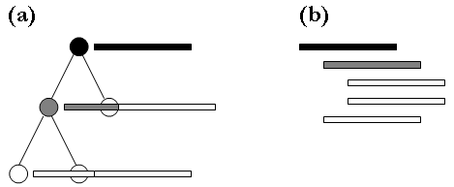

Fig. 1. (a) Tree structure and (b) indented list representation of an organizational schema.

Color coding can be applied to visualize changes in the organizational schema (T.1). Let’s assume the black node in Figure 1 came into existence first, then the gray node was added, then the white nodes. In this case, the color coding also reflects the age of the nodes. Different colors can be employed to differentiate node renaming from node insertion and deletion.

3.3 Organizational Nodes and Entity Attributes
The size of an organizational node, i.e., the number of entities it contains can be visualized using a bar graph in which each bar represents exactly one entity, see Fig. 2. Entities can be counted non-recursively (cf. Fig. 2b) or recursively (cf. Fig. 2c).
The height and color of bars can be used to depict attribute values of entities. For example, the distance of an entity from the mean of the other entities in an organizational node can be expressed by the height of the bar – in an analogy of nails that stick out and simply do not fit. Color can be used to highlight entities that match a certain search query, e.g., all entities published in 2004 or in the last month or that contain a certain word in the title or have a certain author.
The bar graphs can be sorted by time, e.g., to indicate if entity similarity increases or decreases over time (T.3). They can be sorted by similarity or any other attribute value to gain a quick overview of the attribute distribution.

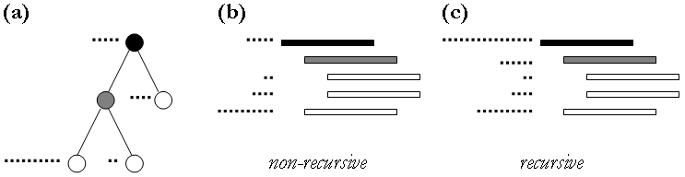

Fig. 2. (a) Tree structure and (b, c) indented list representation of an organizational schema. See Fig. 1 for shape and color coding. Dots to the left of organizational nodes denote the number of entities they contain. (b) Lists the entities in each node exclusively. (c) Recursively counts the number of entities under a certain node, i.e., the root node contains all entities.

The width of a bar can be used to encode how many information entities are represented. For example, bars that represent 10 information entities might be twice as wide as bars that represent one information entity. Bars that represent 100 information entities might be three times as wide as bars that represent one information entity, etc. Entities that match a certain search query can be color coded as well. Examples are given in Fig. 3.

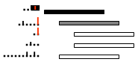

Fig. 3. Bar graph height and color (red) coding and exemplary bar graph aggregation.

3.4 Line Overlays
Line overlays can be used to indicate citation, co-author, class-inheritance or any other linkages among entities. Lines can interconnect the bars that represent certain entities or interconnect the organizational nodes that contain related entities. Text occlusion by links needs to be minimized. Link direction can be indicated by color coding, e.g., by drawing the beginning of a link in a darker and the end in a lighter color. Slightly random or attribute based (e.g., time based, see Fig. 5) color assignments also help to distinguish different links.

3.5 Interaction Design
The display of an organizational schema with 100,000 nodes using 6pt type font and 1pt line spacing, i.e.,7pt or 4mm space per line, results in a list of 400,000 mm or 400m length – too long to make sense of or manage. Hence, interactive manipulation becomes extremely important. In particular, it appears to be desirable to facilitate the subsequent activities
- Parts of the organizational schema can be collapsed and expanded as needed.
- Alternative organizational labels can be selected.
- Bar graphs can be sorted according to different entity attributes.
- Search queries can be run and matching entities highlight.
- Detailed information on selected entities can be retrieved.

3.6 Animation Design
To address the needs T1-T3 identified in section 2, the TV needs to support an animation of the
- Evolving organizational schema, i.e., renamings of organizational labels but also the addition and deletion of organizational nodes.
- The growth of entities per organizational nodes, i.e., the growth of bar graphs and their properties but also the re-organization of entities.
- Line overlays, e.g., evolving citation linkages or co-authorship relations.
The animation needs to be controllable in speed and direction (forward and backward) to examine specific changes in detail.

4. General System Architecture
The Taxonomy Visualization and Validation tool currently runs as a stand alone tool using a precompiled, static dataset. In the near future it will also become available as a Web service and able to process streaming data, see section 7.
The general system architecture is shown in Figure 4. It consists of four major components: An engine responsible for maintaining communication between the other TV components, a PostgreSQL database, a visualization component, and the user interface. All four parts are explained subsequently.

Engine
The engine is the heart of the TV architecture as it organizes and maintains the communication between all components. The engine is responsible for establishing database connections, handling SQL queries, resolving data type issues related to data mapping, listens to events from other components and visual element representations. It also maintains an internal data structure that monitors the current TV status and its change based on user actions. The engine also performs memory management, i.e., the internal representation of the data, its temporary database persistance, and the 'intelligent' creation of indexes for speed-up. Memory management is a large part of the TV by virtue of the size of the datasets, complexity of the application of the 'goodness of fit' measures, and number of elements in the visualization.

PostgreSQL database
Input data comprises an organizational schema and a set of information entities with assigned organizational labels. The computation of the fit of entities into an organizational node and the automatic restructuring of organizational schemas require a means to identify the similarity of information entities.
A postgreSQL database is used and a generic database schema was designed to store these data types in multiple tables. Parent-child information from the organizational schema is stored in one of the tables with child node entries being unique. Another table stores labels and levels information related to each child node. A third table is used to store labels of the organizational hierarchy nodes. Two more tables capture information on entities associated with organizational nodes and different variables of entities. These tables are useful when it comes to querying and classifying entities.

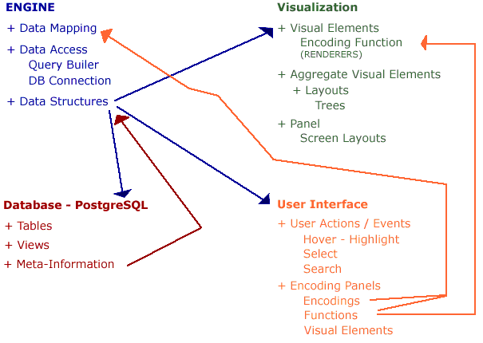

Fig. 4: Components of the TV system architecture and their major interactions

Visualization
The visual interface was implemented using the Java-Swing component. The panel provides the essential drawing area upon which the visual elements are rendered. The layout component of the visualization determines the location of layout for the visual component. Another component of visualization called the ‘Renderer’ is responsible for visual encoding of the visual component based on the underlying data.
The taxonomy visualization can also be rendered into a postscript file supporting truly global views in high resolution and on large sheets of paper. Printing into postscript takes as input the hierarchy and entity data to be displayed as well as configuration information, e.g., color, size, type font selections. It then re-computes the layout and renders the result into a file.

User Interface
The user interface component handles all user-based queries. It captures user actions, sends them to the Engine and Visualization components and displays the result of the interactions via changes in the visual display.
All data preprocessing, analysis and visualization algorithms are implemented as plugins. This eases the combination, utilization, and comparison of algorithms and continuous improvement of TV functionality.

5. Visualizing the United States Patent and Trademark Hierarchy
The TV was applied to visualize the United States Patent and Trademark Office patent classification which organizes about 3.2 Million patents into about 160,000 distinct patent classes. Our original plan was to print the complete hierarchy – all 160,000 classes organized in an organizational schema that is up to 15 levels deep. However, a quick calculation let us realize that this would require much more space than we had available – even if very small type font was used and partial over plotting of category label names was employed. We therefore decided to plot only the first three levels of the hierarchy using rather small type font.
Specifically, 7 pt is used for level 1, 3.5 pt and indented by 1.5 pt for level 2, and 1 pt and indented by 3 pt for level 3. It still took 25 columns to render those 51,391 categories. The result is the fabric like pattern shown in the middle of Figure 5. The area can be seen as a 1 ½ dimensional reference system that captures the main structure of this complex information space.
The reference system was used to exemplarily depict the impact (Fig 5, left) and prior art (Fig 5, right) of two patents. The patent on Gortex -- the lightweight, durable synthetic fiber used as a tissue filler in cosmetic implants, waterproof clothing, and many other products -- was selected to show the impact a patent might have. The Gold Nanoshell patent was exemplarily selected to show the prior art of a patent. Gold Nanoshells are a new type of optically tunable nanoparticles. Their ability to "tune" to a desired wavelength is critical to in vivo therapeutic applications such as thermal tumor destruction, wound closure, tissue repair, or disease diagnose. The cover pages of both patents and their position in the 25 column classification hierarchy are shown. Line overlays represent citation linkages. Red lines denote 182 citations to the Gortex patent. They are sorted in time with dark red indicating older and bright red younger citations. Blue lines represent the 16 prior art references of the Gold Nanoshell patent to the classes of the cited patents.

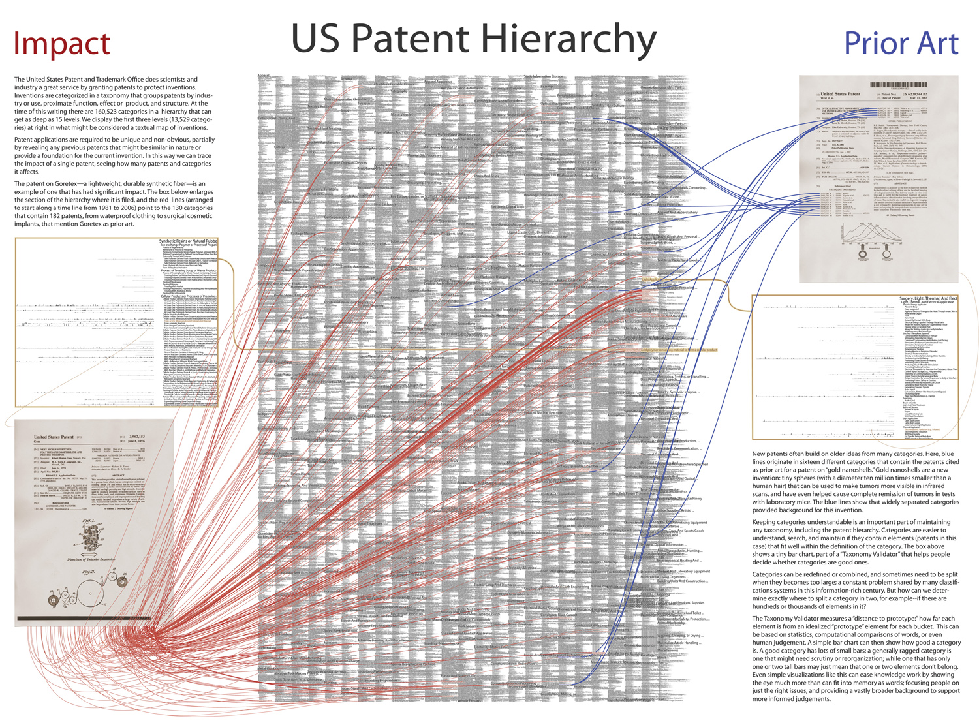
Fig. 5. Taxonomy visualization of patent data

Figure 6 shows a zoomed in version of the Gortex patent. The class of the patent is highlighted in brown, The bar that represents the patent is circled and linked to the cover page of the patent via a brown line. The number of patents in this and neighboring classes can be easily seen. The bar graphs next to each class indicate how many patents are in this class, together with their age, and their similarity to each other. The bars show the ‘goodness of fit’ between the hierarchy and the patents it organizes.
The visualization shows how large this taxonomy is and how well it organizes the millions of patents. Patents that do not fit into their respective category should be examined in more detail. The 25 column rendering of the hierarchy can also be used as a reference system over which, e.g., citation patterns can be overlaid.
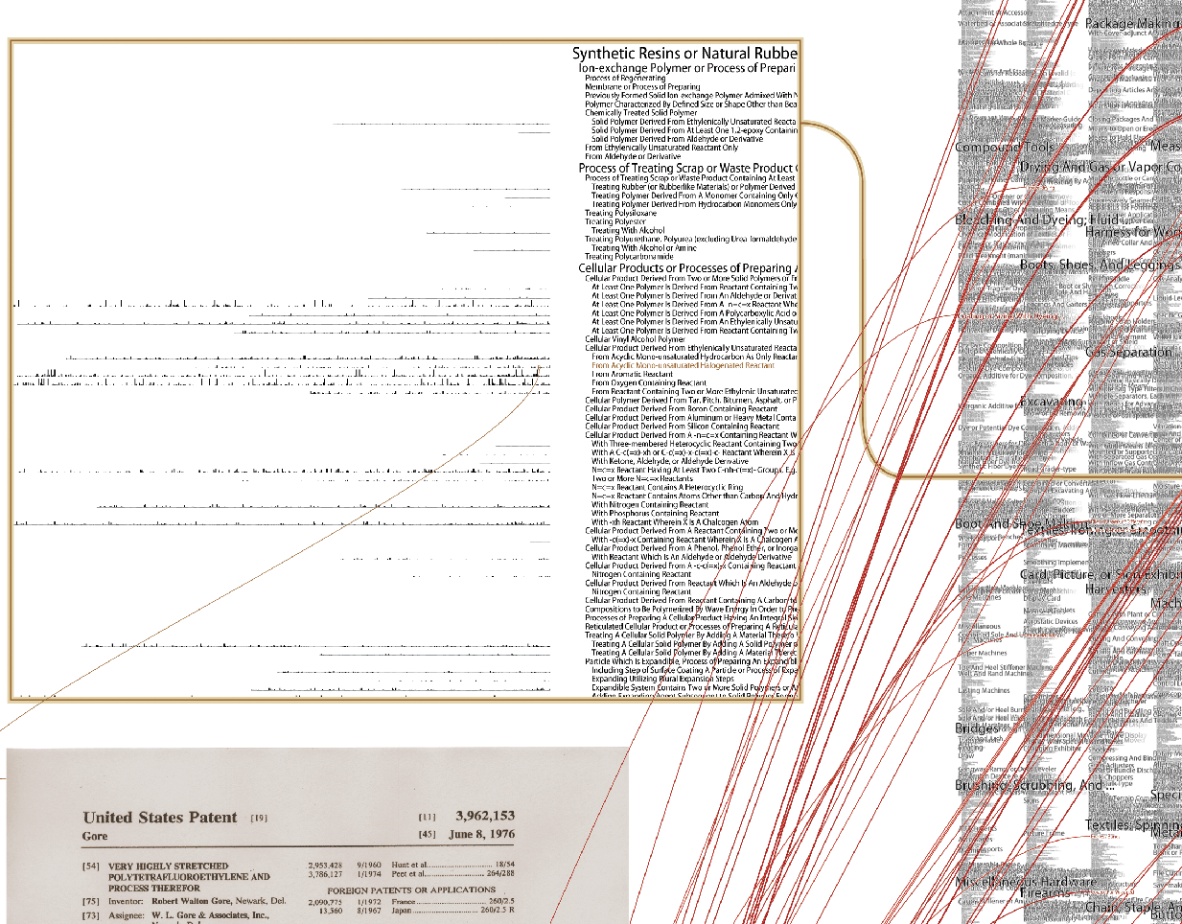

Fig. 6. Zoom into the taxonomy visualization given in Fig. 5. Shown is a close-up of the patent classification environment of the patent on Gortex.

6. Discussion
This paper motivated and explained the Taxonomy Visualization and Validation tool. The TV helps combine the expertise of human specialists and automatic data analysis and visual rendering. It requires the existence of an organizational schema and a set of information entities that are classified into this schema. A similarity measure is needed to compute the fit of entities into an organizational node. Some of the TV analysis, display, and interaction techniques are newly developed; others were combined in an unusual way. The TV is unique in
- Its usage of bar graphs to display properties of organizational nodes, e.g., size, and entities, e.g., similarity, age.
- Its usage of a static (yet interactively navigatable) ‘substrate map’ of the organizational schema and dynamically changing ‘bar graphs’ and ‘line overlays’.
- Its usage of organizational nodes to apply a divide and conquer strategy during the analysis and visualization of potentially very large-scale data sets.

Applicability
The TV might be applicable to help examine, validate, and optimize organizational schemas as diverse as: the ACM computing classification system, S&E taxonomies, patent classification hierarchy, MeSH Controlled Vocabulary Thesaurus, Google’s categories at http://www.google.com/dirhp, file directories, Yellow page directory of businesses, and many others.

Customizability
Each new data set and user group will require a customized user interface that matches existing conceptualizations and information needs. The visual appearance of the TV interface will have to be customized to the specific data sets and user tasks. Ideally, the TV interface reflects the business practices librarians and other decision makers have worked with for years and spent decades mastering.
The use of the CIShell software framework discussed in section 4 and the ‘interface configuration’ detailed in section 7 support easy and fast customizability.

Scalability
The TV has been used to render 160,000 organizational nodes at once. The number of nodes and entities that can be rendered is only limited by the amount of memory available. Computing the goodness of fit for large dataset is very computation and memory intensive but can be done offline in advance and in a parallel fashion.
Note that the automatic reclassification is applied to organizational nodes (excluding the root node) only. This corresponds to a ‘divide and conquer’ strategy for the examination of the homogeneity of entities in a node and the re-organization of parts of the organizational schema.

Open Questions
As the TV is applied to help organize diverse datasets new questions arise. Among them are: What information should be encoded in which way? For example, the age of an entity can be encoded via the color of bar graphs or can be actively queried for via search. The identity of two data files stored in different directories can be visually depicted by coloring their bars identically or by inter-linking their bars. Also, what is the ‘optimal’ data density? How many nodes and bar graphs should be shown to support efficient work? What similarity measures are best to compute the goodness of fit? How to display and interact with potentially very large hierarchies on a monitor screen with a very limited number of pixels?

7. Future Work
This section discusses planned work that aims to extend the current TV implementation so that it supports the functionality detailed in section 2.

Web Services
In many cases, clients might like to run the TV as a web service. This way, they login to an online site, select the organizational schema they would like to work with and start the validation and optimization process. The CIShell discussed in [2] is a plug-and-play architecture that supports the plug and play different datasets and algorithms. Using CIShell’s as the TV core supports its deployment as Web service, stand alone tool, or peer-to-peer application.

Handling Streaming Data
Most datasets evolve dynamically over time. The easier and faster new data entities can be incorporated and the organizational schema can be adapted the more valuable the TV becomes.

Interface Configuration
To ease the adaptation of the interface appearance and functionality to serve different datasets to different user groups there needs to be a way to quickly configure the general layout of an organizational schema (e.g., what subset of the hierarchy is shown, in how many columns and with what type font, font size, indenting and on what background), the layout and encoding of bar graphs (e.g., sorted by time, in a certain color, with or without (non)recursive aggregation), lines (e.g., what do the lines represents and in what color, thickness are they drawn), and interactivity elements (e.g., search field, means to zoom, pan, request details).

Semi-Automatic Optimization of the Organizational Hierarchy
A user should be able to select any part of the organizational schema that has an organizational label and request an automatic reorganization. They will need to specify a similarity measure and clustering algorithm, e.g., entities that share words are assumed to be similar, apply k-means clustering with a given k. Each of the resulting k cluster nodes will contain entities that share many words. Users can then assign organizational labels to those organizational nodes. Users might like to test and compare different similarity measures and clustering approaches to find a combination that best matches their intuition of a good data organization.

User Management
To restrict access rights and to keep a record of who made what changes and when, a user access and control management similar to concurrent version control (cvs) is needed. All user interaction is stored in a log file as a personal and corporate record. The user can also leave comments about major restructuring, interesting observations, etc. that are also saved into the log file. Based on these user logs, the evolution of the organizational schema can be recorded and visualized over time. All actions of a specific user, user group or all users can be analyzed and replayed.

Acknowledgements
We would like to thank Josh Bonner and Alaa Elie Abi Haidar for programming initial TV prototypes, Shashikant Penumarthy for his expert advice regarding the specification and implementation of the current system, and Eric Giannella for his guidance in the selection of patent examples.
This research is supported by the National Science Foundation under IIS-0513650, CHE-0524661, and a CAREER Grant IIS-0238261 as well as by a James S. McDonnell Foundation grant in the area Studying Complex Systems.

References
1. Börner, K., Chen, C. and Boyack, K. (2003). Visualizing Knowledge Domains. in Cronin, B. ed. Annual Review of Information Science & Technology, Information Today, Inc./American Society for Information Science and Technology, Medford, NJ, 179-255.
2. Huang, W., Herr, B., Penumarthy, S., Markines, B. and Börner, K. (2006) CIShell -- A Plug-in Based Software Architecture and Its Usage to Design an Easy to Use, Easy to Extend Cyberinfrastructure for Network Scientists. In Network Science Conference, (Bloomington, IN).
3. Shiffrin, R. and Börner, K. (2004) Mapping Knowledge Domains, Proceedings of the National Academy of Sciences, (Suppl. 1), Volume 101.

