A Semantic Landscape of the Last.fm Music Folksonomy Using a Self-Organizing Map

Biberstine, J. ¹, Börner, K. ¹, Duhon, R. J. ¹, Hardy, E. ¹, Skupin, A.²

¹School of Library and Information Science, Indiana University, Bloomington, IN 47405

²Department of Geography, San Diego State University, San Diego, CA 92040, USA
Email: skupin@mail.sdsu.edu

1. Introduction
What does the world of music look like? We present a visualization derived from a repository of user-generated tags attached to music items within the social radio website Last.fm. On it, users can discover new music based on their listening history and – crucial for our study – they can annotate music items such as artists and songs with arbitrary tags, ranging from categories like “rock” or “jazz” to event-related attributes (e.g. “seen live”) and affective utterances (e.g., “songs I absolutely love”).
Tags also range in coverage scale, from rather broad categories, like “classical”, to finer distinctions, like “britpop” or “female fronted metal”. The 1000 most frequently applied tags were used to generate a fine-grained two-dimensional model of over one million songs annotated in early 2009. Labels in the resulting map reflect the dominance of terms in particular regions, with label size and color expressing different degrees of dominance. Tags that tend to be attached to the same songs end up in close proximity on the map. Height in the topography is determined by the relative dominance of the tags most strongly associated with a particular region and can thus be interpreted as that region’s specificity.
The map offers viewers a mix of recognition, surprise, and discovery. Viewers appreciate the coherent patterns of hierarchical relationships among musical styles. At the same time, by examining areas of personal interest, the map offers true opportunities for discovering new musical categories, from the various flavors of “metal” to such niche terms as “shoegaze” or “drone”.
Two hundred days of processor time on Indiana University’s supercomputer Big Red were used to train the model for this map. To our knowledge this is the most comprehensive self-organizing map of music ever created. For a novel geographic metaphor, geographic information system (GIS) software was used to render and label.

2. Data and Methods
The original data set, collected during the first half of 2009 (Schifanella et al 2010), was sampled by removing all but the 1,000 most frequently used tags (out of 281,818 total), then discarding items not annotated with one of those tags. This reduces the number of items from 1,393,559 to 1,088,761. After sampling, the average item has 6.8 tags (3.8 unique tags). The top ten tags include: rock, electronic, seen live, indie, alternative, pop, female vocalists, jazz, classic rock, experimental.

The landscape is a 180 by 180 grid of hexagonal neurons.
…

3. Results and Interpretation

Regions on the landscape are labeled by the tags with which their constituent neurons associate most strongly.
Dark brown borders separate regions defined by each neuron’s single strongest tag association; those regions are marked with black tags. Dark blue tags identify regions defined by the second-strongest association of each neuron, and so on, as shown in the legend below.
The size and shape of each tag roughly reflects the extent of its region. The actual size and shape are somewhat flexible to guard against label overlap.
Note that tags can appear in multiple locations, especially if they have strong associations with multiple terms that are not themselves strongly associated. For instance, “alternative” shows up as a second-level region within “seen live”, but also exists as a top-level region elsewhere on the map.

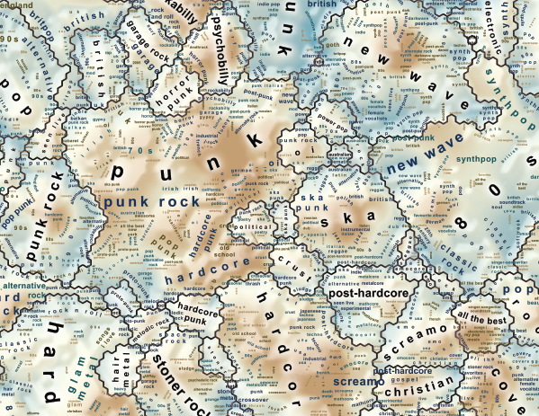

Figure 1. Small snippet from the finished last.fm visualization.

4. Future Plans
- leverage Web GIS to deploy interactive maps like this one
- comparative study with other dimensionality reduction techniques, in the context of very large collections of knowledge artefacts
- topic modelling for intelligent preprocessing of high-dimensional data

Acknowledgements

This work was funded by the Cyberinfrastructure for Network Science Center at Indiana University, the James S. McDonnell Foundation, and the National Science Foundation under grant SBE-0738111. Any opinions, findings, and conclusions or recommendations expressed in this material are those of the author(s) and do not necessarily reflect the views of the National Science Foundation.

References
Börner, K., 2010, Atlas of science: visualizing what we know (Cambridge, Mass.: MIT Press)
Boyack, K.W., Newman, D., Duhon, R.J., Klavans, R., Patek, M., Biberstine, J.R., Schijvenaars, B., Skupin, A., Ma, N.A.L. and Börner, K., 2011, Clustering More than Two Million Biomedical Publications: Comparing the Accuracies of Nine Text-Based Similarity Approaches. In Plos One, p. e18029
Kohonen, T., Hynninen, J., Kangas, J. and Laaksonen, J., 1996, SOM_PAK: The Self-Organizing Map Program Package (Espoo, Finland: Helsinki University of Technology, Laboratory of Computer and Information Science)
Kohonen, T., Kaski, S., Lagus, K., Salojärvi, J., Honkela, T., Paatero, V. and Saarela, A., 1999, Self Organization of a Massive Text Document Collection. In Kohonen Maps, E. Oja and S. Kaski (Eds.), pp. 171-182 (Amsterdam: Elsevier)
Lawrence, R.D. and Almasi, G.S.R., H.E., 1999, A scalable parallel algorithm for self-organizing maps with applications to sparse data mining problems. Data Mining and Knowledge Discovery, 3, pp. 171-195.
Schifanella, R., Barrat, A., Cattuto, C., Markines, B., and Menczer, F. (2010). Folks in Folksonomies: Social Link Prediction from Shared Metadata. Proc. 3rd ACM International Conference on Web Search and Data Mining (WSDM).

