MOOC Visual Analytics: Empowering Teachers, Students, Researchers, and Developers of Massively Open Online Courses

Robert P. Light
Cyberinfrastructure for Network Science Center, Indiana University
1320 W 10th Street Bloomington, IN 47405, USA
1-812-856-3465 lightr@indiana.edu
David E. Polley
Cyberinfrastructure for Network Science Center, Indiana University
1320 W 10th Street Bloomington, IN 47405, USA
1-812-855-3259 dapolley@indiana.edu
Miguel E. Lara
California State University Monterey Bay
Media Learning Center 140
1-831-582-5038
milara@csumb.edu
Katy Börner
Cyberinfrastructure for Network Science Center, Indiana University
1320 W 10th Street Bloomington, IN 47405, USA
1-812-855-3256 katy@indiana.edu

ABSTRACT
Massively open only courses (MOOCs) offer instructors the opportunity to reach students in orders of magnitude greater than they could in traditional classroom settings, while offering students access to free or inexpensive courses taught by world-class educators. However, MOOCs provide major challenges to teachers (keeping track of thousands of students and supporting their learning progress), students (keeping track of course materials and effectively interacting with teachers and fellow students), researchers (understanding how students interact with materials and each other), and MOOC platform developers (supporting effective course design and delivery in a scalable way). This paper presents novel analysis and visualizations that aim to address the needs of teachers, students, researchers, and MOOC platform developers by answering When, Where, What, and With Whom questions using temporal, geospatial, topical, and network analyses of MOOC data. Exemplarily, we report results for the Information Visualization MOOC taught in spring 2013.
Categories and Subject Descriptors
Visual analytics, collaborative learning, distance learning, visualization toolkits
General Terms
Design, Measurement
Keywords
Distance learning, MOOC, Visualization, Visual analytics

1. INTRODUCTION
Massive Open Online Courses (MOOCs), a relatively new approach to distance education, involve the delivery of free instructional content to thousands of students around the world through the Internet. Due in part to their relative newness, there are still several areas that need to be investigated about the design and delivery of an effective MOOC, reducing in this way the probabilities of students dropping out while promoting motivation and facilitating learning. In several currents MOOCs the percentage of students who complete the course is less than 10% [3]. Duke’s Fall 2012 course on bioelectricity saw less than 3% of the 12,725 registered students attempt the final exam [1]. Fortunately, all student and teacher activities in MOOCs can be recorded and analyzed to:
- Empower teachers: How to make sense of the activities of thousands of students? How to guide them?
- Support students: How to navigate learning materials and develop successful learning collaborations across disciplines and time zones?
- Inform MOOC platform designers: What technology benefits the learning process? What acts as a barrier?
- Conduct research: What teaching and learning methods work well in a MOOC environment?
This paper introduces plug-and-play-macroscopes [2] and other free software, e.g., the R statistical computing software, to run temporal, geospatial, topical, and network analyses of MOOC data and to visualize results. To provide an easy introduction of these qualitatively new ways to look at MOOC data, we first introduce the Information Visualization MOOC taught in spring 2013 as well as the data acquired from it in Section 2. Section 3 presents different types of visual analytics and discusses insights gained. Section 4 concludes the paper with a discussion of planned work.

2. INFORMATION VISUALIZATION MOOC
In the spring of 2013, Dr. Katy Börner and the Cyberinfrastrcture for Network Science (CNS) Center at Indiana University taught the Information Visualization MOOC at the graduate level (referred to as the IVMOOC). This paper describes the course, reviews enrollment numbers, describes the breadth of data collected during the course , examines participation numbers and feedback provided by students, presents first results of an in-depth analysis of IVMOOC data, and concludes with a discussion of the findings and planned activities related to the further MOOC development.

2.1 Course Structure
The Information Visualization MOOC was designed to run over seven weeks from January to March 2013. The course was broken into three components: theoretical lectures, hands-on training and projects involving interaction with a real-world client. The theoretical lectures were recorded by Dr. Katy Börner. Most of these weekly units focused on a subset of visualizations aimed at answering a specific type of analytic question. David E. Polley performed the hands-on training using screen captures of visualization tool usage. The majority of these videos focused on the free Science of Science (Sci2) Tool, but other freeware visualization packages such as Gephi and Pajek were also integrated into the course. Client projects were run via a forum, allowing students to form teams and interact with a client with a real information visualization need. Progress reports were submitted midway through the project and final results were graded by Dr. Börner based on the quality of the product and how well it filled the client’s need.
Final grades were based off of the client project, in conjunction with two exams that were administered after 3 weeks and at the end of the seven weeks. Online badges, administered via the Mozilla Persona service were offered at two tiers, a Certificate of Completion for those who scored more than half of all available points and a Certificate of Achievement for those who scored more than 80% of all available points.

2.2 Enrollment
The IVMOOC opened to registrations on January 9, 2013. By the first day of class on January 22, 2013, 953 students had signed up. Figure 3 shows a graph of enrollment over time, with relevant milestones attached. Note that enrollment has not ceased, up to the time of submission, though the interactive aspects of the course are not currently in operation and no certificate is currently available. As of May 11, 2013, 1,901 students had joined and by mid-October 2013, the number stood at 2,347. Table 1 provides basic descriptions of the latest view of the student body as taken from registration data.
Table 1: Student Characteristics Divided by Gender
 | Male | Female | No Reply* | Total
Age
Under 20 | 22 (79%) | 3 (11%) | 3 (11%) | 28
21-30 | 562 (69%) | 234 (29%) | 21 (3%) | 817
31-40 | 494 (67%) | 220 (30%) | 24 (3%) | 738
41-50 | 263 (70%) | 108 (29%) | 5 (1%) | 376
51-60 | 106 (60%) | 67 (38%) | 3 (2%) | 176
60+ | 35 (70%) | 14 (28%) | 1 (2%) | 50
No Reply | 38 (23%) | 19 (12%) | 105 (65%) | 162
Education
High School | 104 (79%) | 22 (17%) | 5 (4%) | 131
College | 346 (70%) | 136 (27%) | 13 (3%) | 495
Graduate | 810 (66%) | 389 (32%) | 31 (3%) | 1230
Ph.D. | 225 (64%) | 110 (31%) | 15 (4%) | 350
No Reply | 35 (25%) | 8 (6%) | 98 (70%) | 141
Current Visualization Knowledge
Very Low | 223 (61%) | 131 (36%) | 9 (2%) | 363
Low | 392 (61%) | 243 (38%) | 11 (2%) | 646
Medium | 453 (72%) | 157 (25%) | 16 (3%) | 626
High | 65 (68%) | 27 (28%) | 3 (3%) | 95
Very High | 15 (88%) | 2 (12%) | 0 (0%) | 17
No Reply | 372 (62%) | 105 (18%) | 123 (21%) | 600
Continents
Africa | 33 (75%) | 8 (18%) | 3 (7%) | 44
Asia | 269 (83%) | 40 (12%) | 16 (5%) | 325
Europe | 443 (68%) | 183 (28%) | 26 (4%) | 652
N America | 541 (59%) | 298 (33%) | 71 (8%) | 910
Oceania | 30 (73%) | 9 (22%) | 2 (5%) | 41
S America | 63 (73%) | 20 (23%) | 3 (3%) | 86
No Reply | 141 (49%) | 107 (37%) | 41 (14%) | 289
Grand Total | 1520 (65%) | 665 (28%) | 162 (7%) | 2347
* No reply indicates that either no response was given or that “N/A” was selected.
As expected, the majority of participants hailed from North America or Europe and few claimed to have more than Medium knowledge of the course material upon registration. Over half of all registrations claimed some level of graduate education. Curiously, the higher the general level of education, the more likely a participant was to be female, while the higher the level of professed knowledge in visualization, the less likely the participant was to be female. Whether this shows a scarcity of females in the field of visualization, or a scarcity of modesty in the average male is difficult to tell from the data available.
Not all students enrolled with the same expectations or aspirations. In the pre-course questionnaire, students were asked in which portions of the course they planned to participate. Among the 1,901 students included in the analysis (those enrolled as of May 2013), there was an 85% response rate to this question with 98% of students indicating they planned to watch videos, 67% indicating they planned to take the exams, and 32% indicating they planned to work with clients. While these numbers were of course, far higher than those who actually participated, the 2.09:1 response ratio for exams to projects was incredibly close to the ratio of actual participation in those activities (1.97:1). While initial responses will greatly overestimate the raw numbers of eventual participants, these results suggest that there may be some value in determining the relative appeal of various aspects of the course from pre-course questionnaires. When registering for the course, students were asked to identify their job category from the list. The IVMOOC participants consisted of faculty (21%), industry professionals (15%), students (10%), non-profit professionals (5%), people working in government (4%), and people working in an area other than these (8%). There were a significant number of participants who did not identify their job category (35%). Participants were asked to identify relevant subjects with which they have some experience, and 925 participants provided feedback. This feedback is displayed in the form of a Wordle, a visualization in which more prevalent words are given larger fonts. The three most prevalent words are “Data”, “Analysis” and “Design”.

2.3 Course Delivery Tools
There are many different content delivery tools and platforms for prospective MOOC designers to pick and choose from. What follows is a description of the tools and services used to build and deliver the Information Visualization MOOC.
Google Course Builder
Indiana University adopted Google Course Builder (GCB) v 1.0 and it was used to provide the central registration, validation and assessment functionality for the IVMOOC. GCB enables course staff to create pages with content, self-assessments and exams and to manage registrations via Google IDs. Customized code was added to GCB to make possible the transfer of user data in real-time to a centralized database for means of grading and to link registration in the course to registration with other tools, e.g. the Drupal forum, eliminating the need for students to complete multiple online forms.


Figure 1. IV MOOC students’ areas of experience

YouTube and the TinCan API
YouTube was the primary method for delivery of the video lectures that formed the core of the course’s content. While this provided a free platform for the hours of footage that needed to be shared, extra steps were needed to ensure that student interaction with this content could be tracked. The makers of the TinCan API generously offered their services, allowing the course administrators to track when students followed links from the course pages in Google Course Builder to YouTube and to determine how much time they spent watching the videos there. Therefore, it was possible to discern between a student who was fully engaged with the content and one who only watched the opening few seconds of a video.
Drupal
One of the largest challenges to overcome in a MOOC is that of student interaction. For the IVMOOC, we wanted a forum system that was highly flexible and easily tracked. Drupal was selected for its low cost, ease of installation and flexibility. Students could create and join the groups that they would need to complete their projects, as well as up and down vote questions, bringing truly important issues more easily to the attention of the course managers. Since registration was linked to Google via the Janrain service and limited to those IDs already registered for the course, it was also easy to associate Drupal activity with registration data, exam performance and usage of other elements of the course.
The Science of Science (Sci2) Tool
In order to teach the hands-on aspect of the IVMOOC, students needed access to a visualization tool that they could use. The Science of Science (Sci2) Tool is a free and open-source visualization tool created by the CNS Center at Indiana University [6]. This tool is designed to allow a user to navigate the entire visual analytics pipeline from data preparation and analysis through to a final visualization. The tool also includes bridges to other popular freeware tools Gephi and R. Most of the hands-on material in the IVMOOC was taught using the Sci2 Tool.
The Scholarly Database
In addition to a visualization tool, students also needed access to data that they could use to power their creations. The Scholarly Database (SDB) was created in 2005 to provide researchers and students easy access to various datasets offered by different publishers and agencies [4]. Today, the Scholarly Database provides easy access to over 26 million paper, patent, grant, and clinical trials records, interlinked by 58 million patent citation links, and over 2.5 million links connecting grant awards to publications and patents. The SDB is designed to minimize the hurdles to data usage by offering free access to open data via simple user interfaces and federated search functions. It also provides bulk download of data in common file formats as well as solid documentation of all datasets offered.

2.4 Data Collection
The foundation of any analytics plan is solid data. Given that all aspects of a MOOC take place in the digital world, there are opportunities to collect data on virtually every activity associated with a course, creating a comprehensive view of student and teacher behavior, associations, and related performance. However, this level of data collection must be planned prospectively. While many tools exist to capture an aspect of the data such as page views or exam responses, effort needs to be invested to ensure that there are means to later combine these heterogeneous data sources into a single repository.

IVMOOC data was harvested from GCB, the core software used to deliver course content and to run assessments; CNS web servers that hosted the course home page, client project instructions, FAQ, and Drupal forum; YouTube and the TinCan API to log MOOC-related video downloads, Twitter and Flickr to count the number of comments and visualizations shared using the #IVMOOC tag. Student activities were recorded in the IVMOOC Database to calculate final grades but also to help teachers understand and respond to the demographics (e.g., level of expertise) and the continuous progress (Twitter, Flicker activity or Exam submissions) of several thousand students. Table 2 gives a breakdown of the volume of data collected from the IVMOOC as of May 2013.

Table 2: Data Collected by Type and Quantity
Data Type | Records | Distinct Users
Registrations | 1901 | 1901
Exams | 184 | 135
Project Submissions | 64 | 64
Video Views | 9857 | 865
Twitter Messages | 730 | 193
Forum Posts | 661 | 91
SDB Searches | 2868 | 266
SDB Downloads | 932 | 173

3. DATA ANALYSIS

3.1 WHEN: Teacher-Student Activity over Time
One of the greatest challenges that MOOC teachers face is that of encouraging students to remain engaged with the course [3]. Dropout rates of over 90% are considered to be the norm. The ability to measure activity over time provides a window to see when these students are losing interest as well as to measure what interventions may work best to reduce the loss of students over the course of a MOOC.
The IVMOOC opened for registration on Jan 22, 2013. By May 11, 2013, 1,901 students had registered. Figure 3, produced in R, shows registrations sorted vertically by time of registration over time (x-axis). Blue dots indicate when a student registered. Green squares show when a student watched videos on YouTube. Red triangles indicate taking the midterm or final exam. Purple dots indicate Twitter activity.

YouTube watching started as soon as the videos were released (weekly) and was most active between course start and midterm, less frequent between midterm and final exam, and decreased substantially after the final exam, see also Section 3.3. Exam submissions (red triangles) were restricted to set time frames and are clustered in two tight bands on the graph, as to be expected. As a graduate level course, the midterm and final were particularly demanding and many students could not complete the client work due to prior commitments. Only some students tweeted on Twitter; some were making posts about the IVMOOC before registering. Twitter posts were frequent early on, but after the course ended, only a few dedicated users were regularly posting updates to the site. Now that the course is in maintenance mode, Twitter activity has nearly stopped, but video views continue to aggregate as new users find the site or old ones revisit a video to refresh their knowledge.

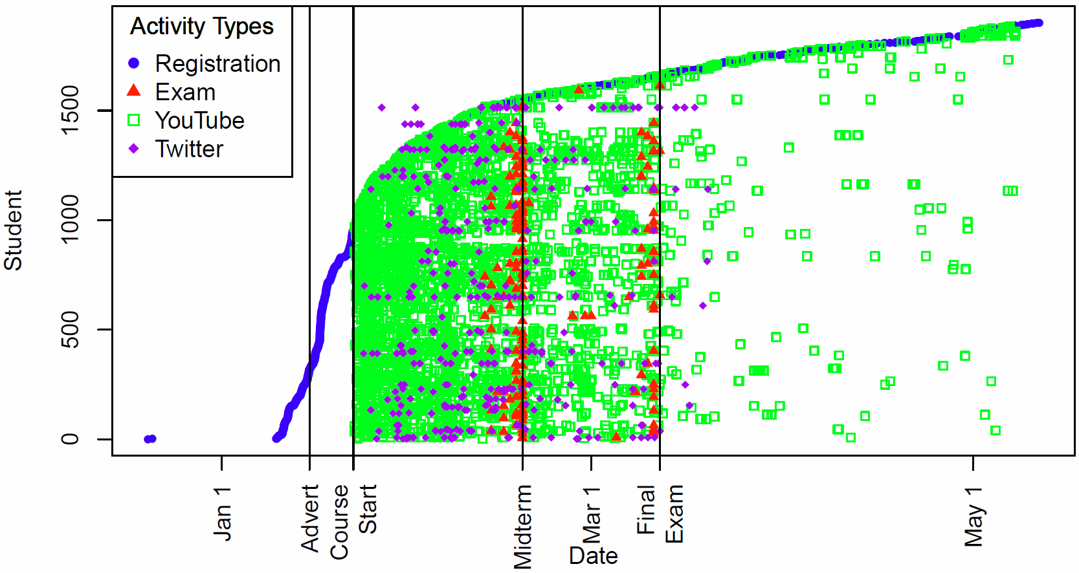

Figure 3 Student registration, exam taking, YouTube, and Twitter activity over time

The IVMOOC at Indiana University attracted more students than Dr. Börner would teach in a century (assuming one section of the Information Visualization course per year). However, as can be seen on the graph, drop off in participation over the weeks was substantial and few of the IVMOOC 2013 students completed the course. Note a few purple dots to the left of the curve. These are people tweeting about the MOOC prior to actual registration. The left side of the graph provides an interesting story of the power of a MOOC in a non-interactive state. Even without active advertisement, teacher interaction or graded assessments, students continue to register and videos continue to be watched on a regular basis.

3.2 WHERE: Students’ Country of Origin
One of the advertised selling points of the MOOC movement is the ability to offer content to a global audience. Collecting data on the geographic backgrounds of students lets a MOOC teacher visualize just how wide an audience they are reaching and to determine what might be keeping the course from reaching a wider audience.
By May 11, 2013, students from 93 countries had registered (by September 4, 2013, these numbers had swelled to include students from 11 more nations). A proportional symbol map of the 1,648 students that had given their nationality by May 2013 is shown in Figure 4. This proportional symbol map with circles size coded by area to the number of students per country of origin was produced using the Sci2 Tool. Students from the United States account for the majority (33%), followed by India (6%), the United Kingdom (5%), Canada (4%), and the Netherlands (3%). 253 students did not provide any information on their country of origin.

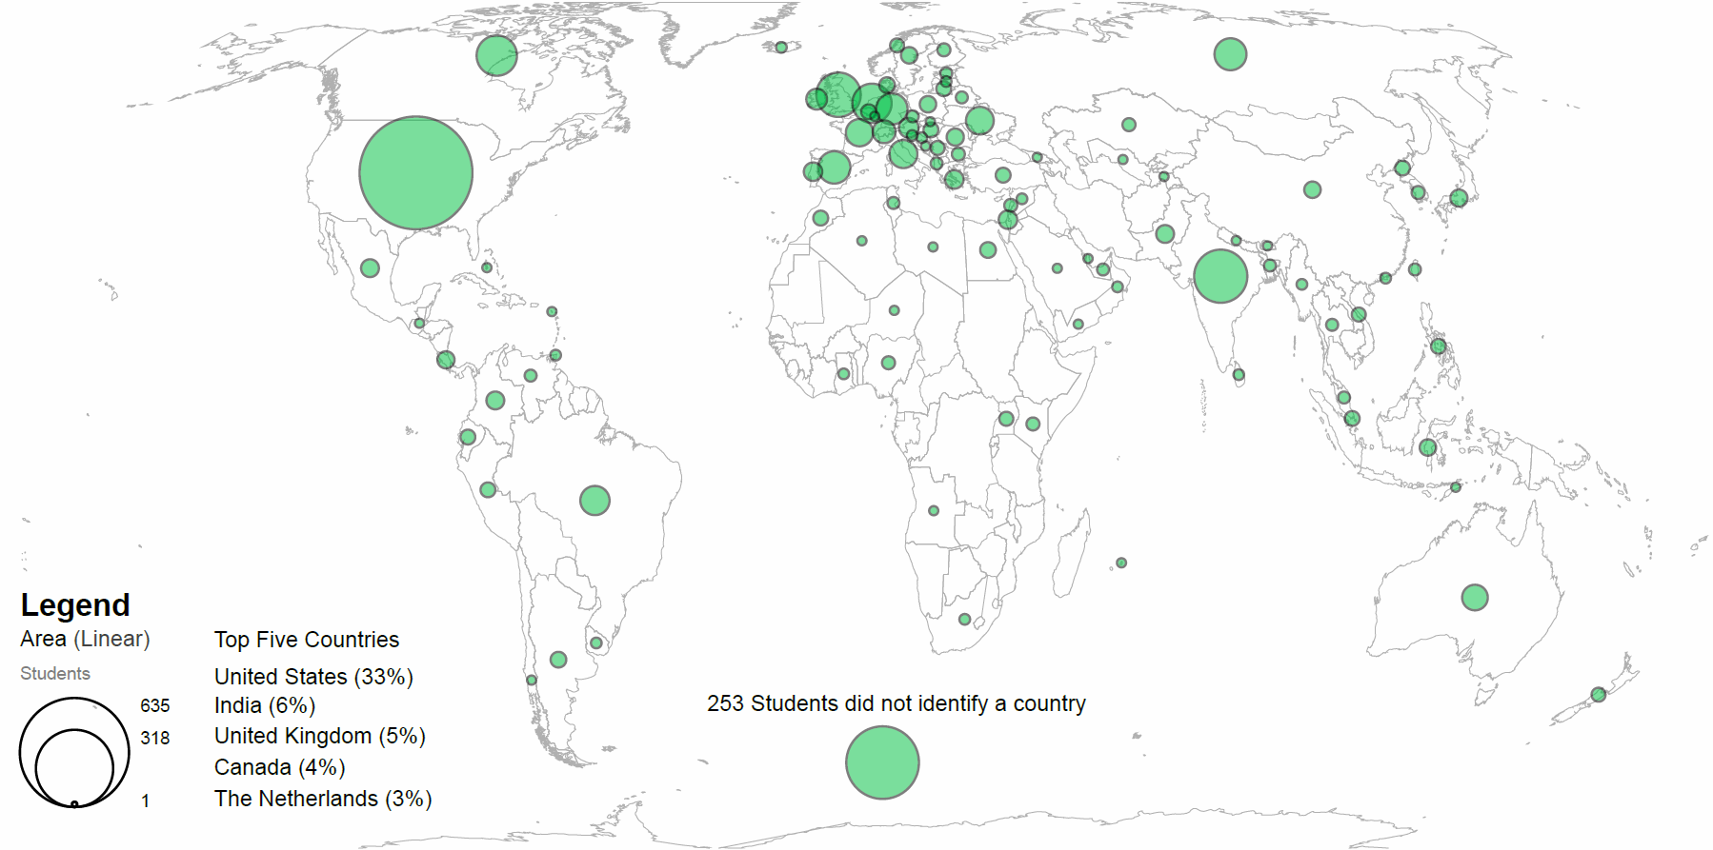
Figure 4 World map showing the origin of IVMOOC students by country
Table 3 takes a different look at the data, asking how well the course penetrated into a given country. Smaller countries will naturally have fewer enrollees, so this table lists the top 10 countries by students per million people for those countries with at least 10 million people (as listed by the World Factbook.

Table 3: Countries by Highest Percentage Enrolled
Country | Students | Population (M) | Stdnts/ Pop (M)
Netherlands | 67 | 16.81 | 3.987
Canada | 71 | 34.57 | 2.054
United States | 635 | 316.67 | 2.005
United Kingdom | 88 | 63.40 | 1.388
Australia | 25 | 22.26 | 1.123
Greece | 11 | 10.77 | 1.021
Portugal | 11 | 10.80 | 1.019
Spain | 43 | 47.37 | 0.908
Ukraine | 30 | 44.57 | 0.673
Belgium | 6 | 10.44 | 0.574

What should be clear immediately is that 4 of the 5 top countries have English as a primary language. This implies that language may be a barrier to participation, however the effects of poverty and internet accessibility should not be discounted in a rush to conclusions. The Netherlands seems to be an outlier, although strong support from information science centers in that country may account for the discrepancy.

3.3 WHAT: What Materials Were Used How Often?
Figure 5 shows how often the class videos for the seven weeks were accessed. Vertically, videos are sorted by week, and then by presentation order in this visualization generated in R. The bars are color-coded based on whether they correspond with a theoretical lecture or a hands-on instructional video. The chart shows the expected decline over time, with video views largely stabilizing by Week 5, after the mid-term.

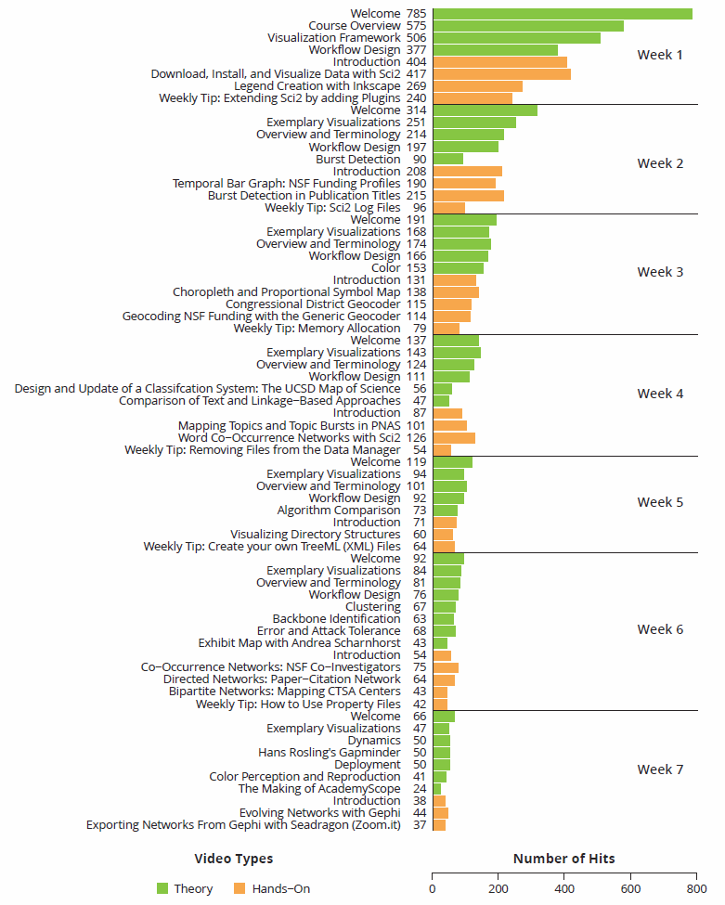
Figure 5 Number of views for theory and hand-on videos

This visualization reveals several interesting facets of student behavior: in particular, the swiftness of student disengagement. Even moving from video to video in the first week, numbers drop substantially. While this trend is somewhat present in Week 2 as well, by the third week, numbers have largely stabilized within weeks, though steady week-to-week attrition continues until after the midterm. Also, once those numbers stabilized, the lecture videos were only slightly more popular than the hands-on content. This implies that, even among those who were not interested in exams or client projects, learning a usable skill was just as important as conceptual understanding.

3.4 WITH WHOM: Student Interaction Networks
While participation in a MOOC seems to, by nature, be a solitary experience, researchers are increasingly recognizing that social interaction is as much a key component of online learning as it is the traditional classroom [5]. As part of the course, students were required to form groups of 4-5 students to work on client projects. In total, there were 15 groups with a total of 77 students participating in these groups. Group formation and communication was facilitated by the Drupal course forum. In addition, students interacted via Twitter. Of the 193 students using Twitter, only 28 setup Drupal forum profiles making it possible to link their Google ID on the forum to their Twitter ID.

Student interaction networks are shown in Figure 6. The networks contain two different types of interaction: group membership and direct communication between students on Twitter (one student tweeting at another).

Figure 6 Student interaction networks with nodes colored based on previous experience with information visualization.

This network, drawn in the GUESS module of Sci2 and refined in Adobe Illustrator, shows student interaction either via Twitter interactions or client collaboration. Each node represents a single student, while colors represent that student’s self-reported level of expertise. The “constellations” connected by dark grey edges are the various client project teams and single nodes connected by orange dotted edges are either staff (in dark red) or students that Tweeted about the course but never joined a team. It is interesting to note that most groups only had a single spokesperson that would interact with others outside that group. It is also interesting to note that the majority of individuals with a high level of information visualization experience did not participate in the client projects. Figure 7 shows the student interaction network with the same layout but the nodes are colored based on the students area of expertise. This network shows a relatively high level of heterogeneity in the expertise with in the student groups.
Figure 7 Student interaction networks with nodes colored based on areas of expertise.

3.5 Knowledge Gained
Taking a massively open online course provides a world of new experiences, connections to students and experts, and stimulating discussions. Ideally, students gain knowledge in the topic area of the course. However, as more and more educators begin blazing trails into this new learning format, it is critical that they too, gain knowledge about the effects of their efforts to understand how the MOOC environment can best be utilized for their specific discipline and level of education.
One final example looks at students’ self-professed experience in the field prior to taking the course and how well it correlates with actual performance. Students taking the IVMOOC were asked to provide information on their expertise in information visualization as part of the registration form. This self-reported expertise was used to chart performance on the three graded elements (midterm, final, and client project), see Figure 8 (also generated with R).

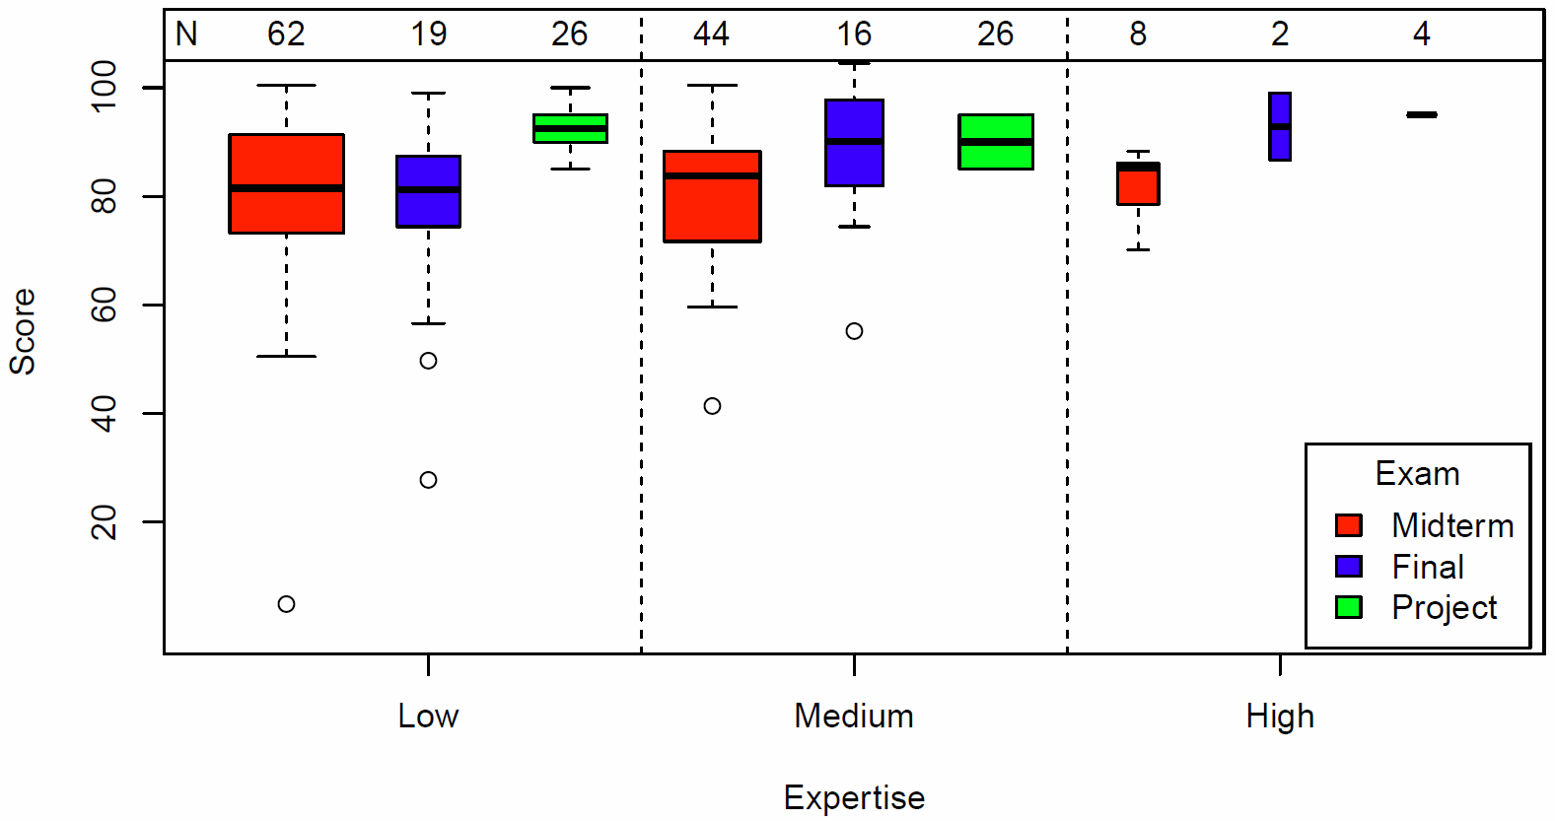
Figure 8 Exam scores by self-reported expertise

While there was a noticeable correlation between initial expertise and final exam score (Spearman rho = 0.39, p=0.016), the same effect for the midterm was not significant. This could imply that the midterm was less challenging, or that the knowledge that the students self-identified as relevant to the course was not covered until the latter sessions. However, this analysis is limited because the number of students per expertise level is rather small. Not all students reported their level of expertise at registration and few students took the midterm and final exams and participated in client project work.

4. FUTURE WORK
All software used to run the analyses and visualizations presented here is freely available online. It can be used to study other MOOCs and modified to meet specific needs. In September 2013, Google announced that it will be teaming up with open-source Open edX to further enhance the MOOC platform and enrich the number, quality, and diversity of courses offered through it. We plan to adapt the visual analytics tools as needed to this new platform and to use this revised setup in Spring 2015. Ultimately, teachers and students will most benefit from seeing the analyses and visualizations in near real-time, making it possible for all in a MOOC to monitor progress, to interact with near-by students, to keep track of success, improve learning results and retention, and to feel part of a whole that is larger than the sum of its parts.

5. ACKNOWLEDGEMENTS
The IVMOOC would not have been possible without the institutional support by Robert Schnabel, Debora Shaw, Lauren K. Robel, Munirpallam A. Venkataramanan, Jennifer W. Adams, Barbara Anne Bichelmeyer, and Ilona M. Hajdu as diverse copyright, terms of service, and legal issues had to be resolved before any student could register. We would like to thank Samuel Mills for designing the IVMOOC web pages; Thomas Smith for extending the GCB platform; Mike Widner, Scott B. Weingart, and Mike T. Gallant for adding the Drupal forum to GCB. We would also like to thank Scott Emmons for editorial comments and review. Last but not least, we thank all 2013 IVMOOC students for their feedback and comments, enthusiasm, and support.
This work is partially supported by the Cyberinfrastructure for Network Science Center, the Center for Innovative Teaching and Learning, the School of Informatics and Computing (SoIC), the Trustees of Indiana University, and Google. Open data and open code development work is supported by the National Science Foundation under Grants No. SBE-0738111, DRL-1223698, and IIS-0513650 and the National Institutes of Health under Grant No. U01 GM098959.

6. REFERENCES
[1] Belanger, Y. & Thornton, J. Bioelectricity: A Quanttiative Approach. 2013. Retrieved from: http://dukespace.lib.duke.edu/dspace/bitstream/handle/10161/6216/Duke_Bioelectricity_MOOC_Fall2012.pdf

[2] Börner, K. 2011. Plug-and-Play Macroscopes. Communications of the ACM 54 (3): 60-69.

[3] Kolowich, S. 2012. The MOOC Survivors. Inside Higher Ed. Retrieved from
http://www.insidehighered.com/news/2012/09/12/edx-explores-demographics-most-persistent-mooc-students
[4] La Rowe, G., Ambre, S. A., Burgoon, J. W., Ke W. & Börner, K. 2007. The Scholarly Database and Its Utility for Scientometrics Research. In Torres-Salinas, D. and Moed, H. F. Eds., Proceedings of the 11th International Conference on Scientometrics and Informetrics, (Madrid, Spain, June 25-27, 2007), 457-462.
[5] Liang, R. & Chen, D. V. (2012) Online Learning: Trends, Potentials and Challenges. Creative Education. 3(8): 1332-1335.
[6] Sci2 Team. (2009). Science of Science (Sci2) Tool. Indiana University and SciTech Strategies, http://sci2.cns.iu.edu.

http://cishell.org
http://www.r-project.org
http://www.wordle.net/
http://sdb.cns.iu.edu
https://www.cia.gov/library/publications/the-world-factbook
http://mooc.org

