Jetstream: Hosting Network Workbench and a valuable resource for network scientists generally

Jeremy Fischer¹, Valentin Pentchev², David Y. Hancock¹, Craig Stewart¹, Katy Börner³

¹ Indiana University Pervasive Technology Institute, Bloomington, IN, USA
² Indiana University Network Science Initiative, Bloomington, IN, USA
³ Indiana University School of Informatics and Computing and Indiana University Network Science Initiative, Bloomington, IN, USA

The NSF-funded Network Workbench (NWB) Tool [1] is a network analysis, modeling and visualization toolkit for biomedical, social science and physics research that is used by more than 200,000 researchers and practitioners worldwide. It is now available for interactive use via the NSF-funded Jetstream cloud system [2, 3]. Using the NWB Tool, users can read publication and other data to extract and view co-author networks, see Figure 1, among others.

Jetstream is a “managed science cloud” - a cloud managed specifically for interactive scientific analyses. Users of Jetstream can launch VMs from a library available on Jetstream through an intuitive web-based GUI. Jetstream is designed to support interactive research and investigation by students, Network science is one of the user communities that Jetstream is intended to serve.

We describe our work in making NWB available to network scientists and practitioners through Jetstream, including its use in MOOCs [4] which welcomes students from more than 100 countries each spring.

We will also describe how network scientists can make use of Jetstream to create their own customized VMs with their favorite network analysis tools in them. Scientists who create network analysis tools may also make them available to the research community by putting them in a VM that is available to the community of Jetstream users generally. Jetstream is funded by the NSF, so access to it comes without cost. We will explain the process for getting accounts and computing time on Jetstream.
This work was supported in part by NSF Award 1445604, the Indiana University Network Institute, and the IU Pervasive Technology Initiative.

References
[1] Network Workbench: A Workbench for Network Scientists. Home Page. http://nwb.cns.iu.edu
[2] Jetstream. Home Page. http://jetstream-cloud.org
[3] Stewart, C.A., Hancock, D.Y., Vaughn, M., Fischer, J., Cockerill, T., Liming, L., Merchant, N., Miller, T., Lowe, J.M., Stanzione, D.C., Taylor, J., Skidmore, E. (2016). Jetstream – performance, early experiences, and early results. Proceedings of the 2016 XSEDE Conference: Diversity, Big Data & Science at Scale, doi: 10.1145/2949550.2949639.
[4] Information Visualization MOOC 2017. Home Page. http://ivmooc.cns.iu.edu

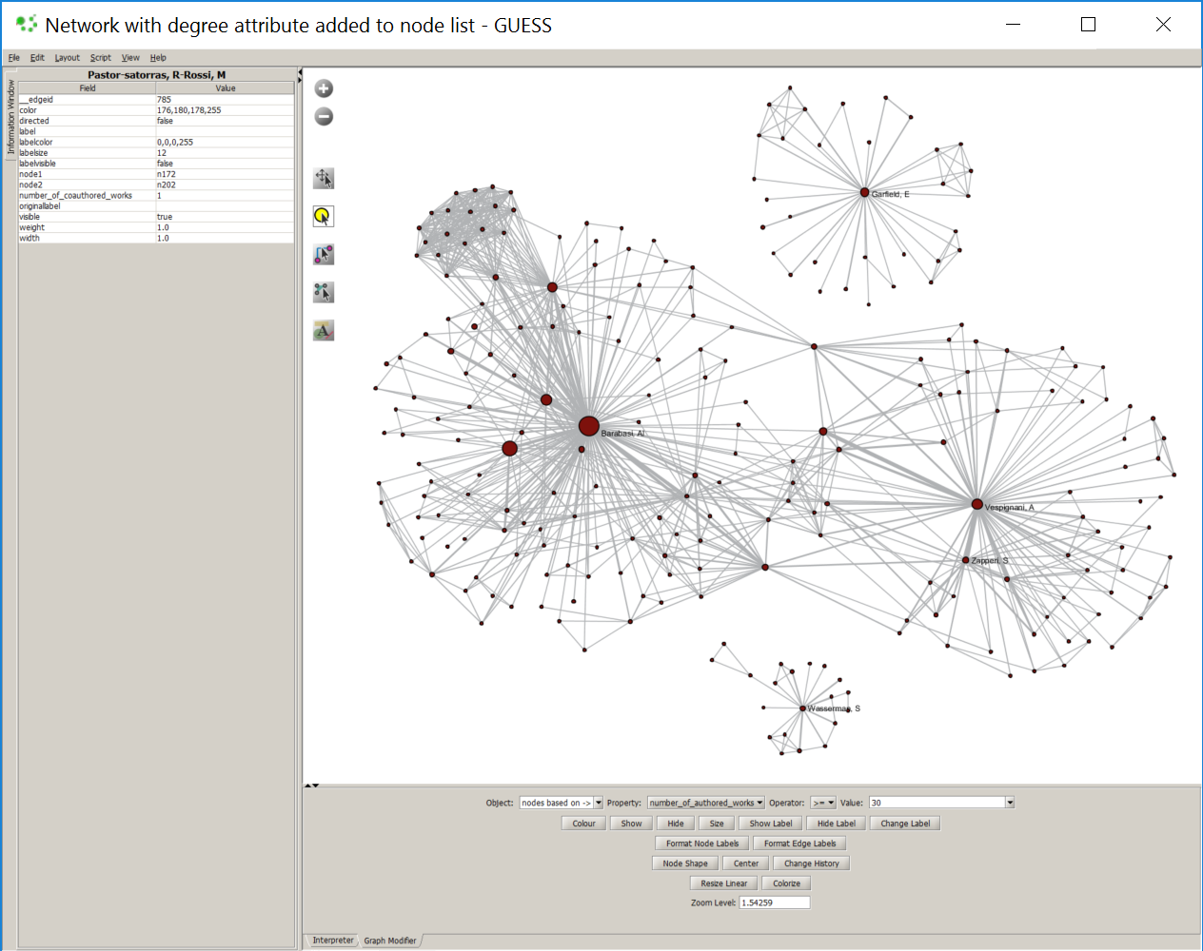

Figure 1: Example of a co-author network visualization. Authors (nodes) with more than 30 papers are labelled; nodes are area size coded by number of citations. Collaboration edges are size coded by number of joint papers.

