Adaptation and Evaluation of 3-Dimensional Collaborative Information Visualizations
Katy Börner
Information Science & Cognitive Science
Indiana University, SLIS
10th Street & Jordan Avenue
Bloomington, IN 47405, USA
katy@indiana.edu
http://ella.slis.indiana.edu/~katy

Abstract: This paper reports work in progress on the adaptation and evaluation of 3-dimensional (3-D) Collaborative Information Visualizations (CIVs). It starts with a motivation for 3-D CIVs that adapt to single users as well as user groups. Next, a sample adaptive CIV is introduced – a virtual 'Document Space' that provides access to online documents (Web pages, papers, images, videos, software demo's) for faculty and students at the School of Library and Information Science at Indiana University. In order to evaluate the Document Space and its adaptation over time, user interaction data is visualized in a second space, the UserInteraction Visualization Space. The paper details the adaptivity of the multi-user 3-D space as well as the associated single-user 2-D Web space. Last but not least, we outline and discuss the planned evaluations of the system.
1 Introduction
Interactive computer systems that can be adapted or adapt themselves to their current users are expected to improve the effectiveness, efficiency, and satisfaction of human-computer interaction (Fink & Kobsa, 2000).
Today, most research on adaptable Web-based applications concentrates on single users. These applications maintain a model of the goals, interests, preferences, and knowledge of the individual user and apply the model throughout the interaction to adapt the system to the needs of that user.
However, a growing number of projects are collaborative efforts that bring people with different skills and expertise together. Domain experts are often spread out in space and time zones, and consultation and collaboration has to proceed remotely instead of face to face. In addition, the low cost and ease with which information can be placed, for example, on the Internet means that much of it is of questionable value, creating a serious need for annotation and evaluation by others. While computer systems exist that support collaborative activities, very few of those adapt to the needs of their user communities.

This paper presents work in progress on collaborative information visualizations (CIVs) that consist of a 3-D space – acting as a meeting place – and interconnected 2-D Web pages. While the 3-D space adapts to its user community, the 2-D Web space adapts to fit the needs and preferences of single users.
To exemplify adaptive 3-D CIVs, we introduce a Document Space, a collaborative resource space of online documents (Web pages, papers, images, videos, software demo's) for faculty and students at the School of Library and Information Science at Indiana University that adapts to the information needs of its changing user population. A second CIV will be used to visualize user interaction data collected in the Document Space to study and evaluate its adaptation.
The subsequent section introduces and describes CIVs. Section 3 details and discusses the adaptation of the Document Space. Section 4 outlines the planned evaluations. The paper concludes with a discussion.
2 3-Dimensional Collaborative Information Visualizations
CIVs can be constructed using commercially available 3-D Online Browser Systems. Frequently used systems are Blaxxun's online community client-server architecture (http://www.blaxxun.com/community), Microsoft's Virtual Worlds Platform (http://www.vworlds.org/), and Active Worlds technology by Activeworlds.com, Inc. (http://www.activeworlds.com/). Each of the 3-D browser systems facilitates the creation of multi-modal, multi-user, navigable, and collaborative virtual worlds (VWs) in 3-D that are interconnected with standard Web pages and that are accessible from standard computer platforms via the Internet, 24/7. Damer (1997) provides an excellent review of different systems and existing virtual communities. To appreciate the potential of 3-D browser systems one has to try them out for oneself.
Collaborative 3-dimensional VWs differ from single user systems in that they equip their users with sophisticated self-representations called avatars (acting as placeholders for human users) that wave, dance, and share space. Avatars provide a means of interacting with objects in the VW, embedded information sources and services, or other users. In all these systems, users can communicate synchronously via a chat facility. In addition, VWs facilitate natural, multi-perceptual interaction using spatial sound, animation, and video.
The selection of the appropriate browser system is critical since the technology that mediates user interaction has a great impact on the forms that interaction will take (Jakobsson, 1999; Preece, 2000). Active Worlds (AW) is one of the most popular VW systems. It hosts over six hundred different worlds in the main, entertainment oriented universe, and more than one hundred worlds in EduVerse, a special universe with an educational focus. AW is based on Render Ware, an interactive 3-D Graphics API. It differs from VRML-based systems in the ease with which participants can build within the world. A user simply selects an existing object, makes a copy of it, and renames it as a different object.
Figure 1 (left) shows the AW interface. In contains three main windows: a 3-D graphics window populated by avatars, a Web browser window and a chat window. At the top are a menu bar and a toolbar for avatar actions. Users can collaboratively navigate in 3-D, move their mouse pointer over an object to bring up its description (see Fig. 2), click on 3-D objects to display the corresponding Web page in the right Web frame of the AW browser, or teleport to more fruitful information patches. The Web browser maintains a history of visited places and Web pages so that the user can return to previous locations. Figure 1 (right) shows an overview map with area labels of the iUni world (Börner, 2001) rendered in 2-D based on the list of objects that made up the world on Dec 6th, 2000.

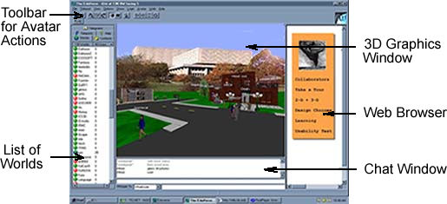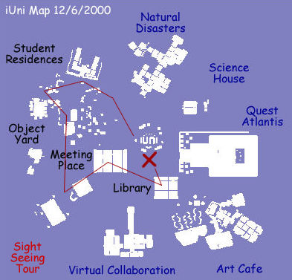
Fig. 1. 3-D AW interface and a 2-D map of a VW

Subsequently, we exemplify CIVs in terms of a Document Space and a User Interaction Visualization Space.
The Document Space refers to a shared resource of online documents for faculty and students at the School of Library and Information Science (SLIS) at Indiana University. It will be seeded with about 8,000 links to online documents (text, images, video, software demonstrations, etc.) collected from bookmark lists created by SLIS faculty.
Using data mining techniques such as Latent Semantic Analysis (Landauer et al., 1998) and information visualization techniques such as Pathfinder Network Scaling (Schvaneveldt, 1990) the links are semantically mined and visualized. The 2-D Web interface will display a 2-D, Starfield Display-like map (Ahlberg & Shneiderman, 1994) that eases navigation (see Figure 1, right for an example). Users will be able to click on the map in order to teleport into the corresponding area in the 3-D Document Space.
About 530 people – including about 300 students in Bloomington and 200 students in Indianapolis - will have access to this Document Space. They will be able to examine, discuss, annotate, and add documents collaboratively.
User interaction data collected in the Document Space will supply the raw material to generate, populate, and evaluate the User Interaction Visualization Space. Below are two scenarios that aim to convey the appearance and functionality of both worlds.
Scenario#1 - A Document Space for SLIS: Imagine you are a student who is taking the Human-Computer Interaction course and you are interested in documents on 'usability.' You launch the 3-D online browser and login to the Document Space world using your self-selected virtual nickname and avatar. Your avatar is placed in the middle of a square world; the sky is filled with photos of influential people in the fields of Human Computer Interaction, Usability Studies, Human Factors, Interface Design, etc. guiding your navigation (see Fig. 2, left). In front of you are different 'teleports.' You click on the one that says 'Usability Studies' and your avatar is instantly 'teleported' to an area filled with 3-D objects that link to documents on this topic. The objects are texturized with thumbnail images of corresponding documents. You quickly recognize some new objects. Objects at higher elevations link to documents that other users found particularly relevant. Moving the mouse pointer over an object brings up a short description of the document and its number. Clicking on objects brings up the corresponding document in the 2-D Web interface for reading, printing etc. Alternatively, you can enter a search term in the 2-D Web interface which highlights relevant documents on the 2-D map. Clicking on a document displayed in the 2-D map instantly teleports you to the corresponding 3-D space so that similar references can be explored. You might also see other users in this space whom you can ask for relevant documents and advice. Lonely Web searching and browsing can thus be converted into a collaborative examination and discussion of documents.
In addition, you can modify this world. For example, you can change the relevance of a document by communicating with a helpful bot (machine program) named 'Jeeves.' The corresponding chat messages would read 'jeeves document#:=relevance#.' The relevance value can be set between 0 and 99 and its average number will be reflected by the height of the document's object. Alternatively, you can add documents via the Web interface. The new documents will be accessible in the 3-D world after the next update.
You may also want to find users that are interested in similar topics. You teleport into the User Interaction Visualization Space (see scenario #2) to find chat or document access activity that matches certain topics.

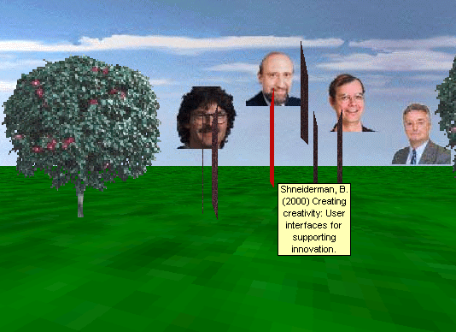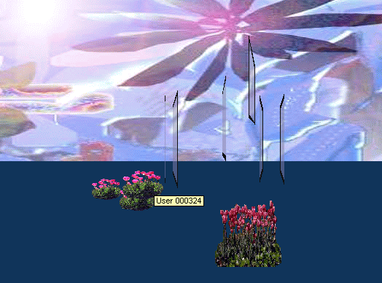
Fig. 2. Design sketches of Document Space (left) and User Interaction Visualization Space (right)

Scenario #2 - User Interaction Visualization Space: Imagine you are part of the Document Space 'Wizard' group and interested in examining the usage patterns of the world. You enter the User Interaction Visualization Space - a magic world of glass and flowers. All objects you remember from the Document Space are replaced by transparent objects of similar shapes. Some of these objects carry abstract symbols to indicate that they linked to Web pages, functioned as teleports, activated sound sources, etc. Another set of abstract symbols, e.g. flowers, is used to visualize user interaction data.
You are especially interested in Web access patterns during the last two months. Utilizing the 2-D map, you filter out user activity in this time span and quickly identify the most often accessed Web links. Also, you are curious to see if the new design of the entrance area improves communication. You click on the corresponding 2-D map to teleport into the 3-D entrance area. Happily, you see that there are many new flower patches in this area indicating that many discussions have taken place. Additionally, you would like to know if the latest teleport to the meeting area was used. At this point, you consult the 2-D map again and notice that so far it has only been used twice. In order to find out where people talk about usability issues you enter the term into the 'search for semantically similar chat text' window and the 2-D map shows dots at all the places in which users discussed usability. At any time, you can hit a button on the 2-D Web interface and you will be transported into the corresponding place in the Document Space.

Note that both worlds are automatically (re)created in fixed cycles to ensure incorporation of new documents into the Document Space and an up-to-date status of the User Interaction Visualization Space. Both worlds can be seen as adaptive, collaborative information visualizations that provide access to either online documents or user interaction data.
3 Adaptation of the Document Space
This section details the adaptation of the Document Space and its associated Web space. While the 3-D space serves as a common meeting and collaboration place for many simultaneous users, the 2-D Web space is used by single users to display documents and to ease document search and navigation using a map. Consequently, the 3-D space will be adapted to its user community whereas the 2-D Web space can be adapted to each user separately. In general, the system adapts by performing routine tasks on behalf of the user in order to ease:
- document search (help find documents, recommend documents);
- document navigation (suggest paths, overview map); and
- collaboration between users (ease information exchange).
Subsequently, we will use the framework proposed by Weibelzahl & Lauer (2001) for the evaluation of adaptive, case-based reasoning systems to detail the acquisition of input data, the inference of user (group) models, and the adaptation of the user interface for both the 2-D and 3-D parts of the Document Space.

Acquisition of input data proceeds by recording users’ interactions with the 2-D Web space, such as search queries issued, retrieved documents accessed, submitted document links, teleports activated in the map, as well as optional self-reports of personal characteristics such as age, gender, interests, etc..
In the 3-D space, we automatically log usage regularities (frequency and origin of logins), avatar selection (male/female, number of avatar changes, etc.), navigation, manipulation (document access patterns), and chatting behavior.
Note that self-reports of personal interests are rather subjective while the data acquired from 2-D and 3-D logs are objective.

Frequency of data acquisition: While the number of self-reports is rather small, log files are continuously acquired.

User model construction: Typical methods used to construct user models include statistics, case-based reasoning, decision trees, neural networks, stereotype reasoning, and acquisition rules, to name just a few. Oftentimes, user models are neither visible nor accessible to the user. In order to make adaptation more opaque for the user, we propose to visualize the results of the statistical analysis of observable usage data. For example, the 2-D map will present areas of interest that are tailored to specific users and that are generated by averaging previous points of interest.
In the 3-D space, the rating of a document corresponds to the average of all user ratings of that document. Newly contributed links are incorporated in the 3-D Document Space and the final semantic layout of documents corresponds to the result of Latent Semantic Analysis and Pathfinder Network Scaling over the entire document set. Thus, each user can influence the semantic layout considerably by submitting new documents.
In addition, we will model (1) Action-to-item affinities between user actions and information attributes, e.g., the system uses the Web page space to recommend documents on ‘user modeling’ based on the user’s past queries issues in the 2-D Web space as well as past accesses of documents in the 3-D space that belong in this category and (2) User-to-user affinities between a user and like-minded users, e.g., the system recommends documents on ‘machine learning’ based on the fact that other users with an interest in ‘user modeling’ have been interested in this topic as well. Affinity groups are automatically built based on correlations in users’ rating and annotations of documents. This approach has also been called ‘collaborative filtering’ or ‘clique-based filtering’ (Alspector et al., 1997).
In the 2-D Web space, there exists a separate model for each user. However, there exists only one user group model (Paliouras et al., 1999) for the 3-D space. All user models are dynamically updated.
Note that the 2-D Web space and 3-D world are intertwined. User information acquired in the Web space is employed in the 3-D space and vice versa. This will lead to synergistic effects with respect to acquisition and usage of user models such as those reported for news readers (Resnick et al., 1994) or collaborative filtering using personal agents (Good et al., 1999).

Adaptation of the user interface: Over time, the Document Space adapts to its user community in several ways. First of all, user annotations and new documents are incorporated in the semantic layout of documents. In addition, the relevance of documents is adjusted to reflect the judgments of users. Ultimately, the Document Space can evolve into a repository of the user community's knowledge that members can discuss, learn from, contribute to and collectively build upon. In this way, the Document Space supports the human habit to gather bits of information in one place and to group, classify, and otherwise annotate them.
In addition, the single-user 2-D Web space is personalized in a more conventional fashion. Data from previous user interactions, such as search terms and selected places/documents, are used to gather usage habits and personal preferences. Personalization proceeds based on the results of induction of historical data acquired for each individual user. At the same time, the user will be able to modify the look and feel of content offered on the Web page (additional info, tailored presentation, color schemes, favorite starting point, etc.).
As exemplified by the above, the Document Space adapts to user habits and preferences (standard user modeling approach) as well as to community usage patterns.
4 Planned Evaluations
We assume that CIVs that offer personalized services will attract and retain significantly more users. We will test this assumption by conducting diverse evaluations of the proposed Document Space.
Usability evaluations of adaptive systems are known to be time consuming and frequently require longitudinal user studies. To our knowledge, there exists no research on evaluating collaborative, adaptive CIVs. We therefore propose to use a second CIV to study the adaptation of a CIV such as the Document Space. The second CIV would visualize user interaction data and facilitate the comparison of adaptive and non-adaptive CIVs.

In their framework, Weibelzahl & Lauer (2001) propose to separately evaluate the different stages of an adaptive system, including:
- Correctness of user input data;
- Correctness of inferred user model;
- Appropriateness of adaptation;
- Appropriateness of system behavior; and
- Changes in user behavior and number of total interactions as the system adapts.

Keeping all these stages in mind, we plan to concentrate on the correctness of the inferred user model and the appropriateness of adaptation and system behavior. In particular, we would like to ensure that the spatial layout of documents in the 2-D map and the 3-D Document Space resembles the result of human sorting behavior. Therefore, we plan to compare free sorting results of documents by human users with the results derived by data mining and layout algorithms – see also section 3 and (Börner, 2000a). In addition, we will conduct longitudinal studies of the Document Space by comparing adapted versions of its 2-D and 3-D interfaces with a non-adapted control version. In the latter study, we are especially interested in the accuracy and efficiency of document access and navigation as well as user satisfaction.
5 Summary
The research aims to improve our understanding of design and usability issues connected with the creation and evaluation of adaptive, 3-D Collaborative Information Visualizations.
While single user modeling will be used to adapt the 2-D Web space, user group modeling is required to adapt the collaborative Document Space to the needs of its evolving user community. In fact, the 3-D Document Space can be seen as the community model itself and presents a kind of ‘Collaborative Memory Palace’. Originally, memory palaces were developed in classical Greek culture to enable a single user to manage and recite great quantities of information. The more elaborate the palaces, the more information that could be stored, and the more paths that lead to the same kind of information. Today, they could resurface in the form of CIVs that resemble interactive mnemonic structures to be shared and passed from one generation to the next (Anders, 1998).
We believe that the visualization of previous user interaction data in form of an updated 2-D map or 3-D virtual space will improve user satisfaction and users’ trust in an adaptable system.
The proposed 3-D visualization of user interaction data in a second CIV may provide a new powerful tool to evaluate adaptive CIVs.
I am looking forward to discussing the proposed adaptations and planned evaluations of CIVs at the UM01 WS on Empirical Evaluations of Adaptive Systems.
6 Acknowledgements
We acknowledge ActiveWorld’s generous support in providing free hosting of 3-D VWs and an active research environment in EduVerse, a special universe with an educational focus. Several students are involved in the design of the Twin Worlds. Among them are Sy-Miaw Lin, Yu-Chen Lin, Maggie Swan, and Min Xiao. The author would like to thank the anonymous UM01 WS reviewers for their valuable comments on a previous version of this paper.
References
Ahlberg, C. & Shneiderman, B. (1994) Visual Information Seeking: Tight Coupling of Dynamic Query Filters with Starfield Displays, Proceedings of CHI'94 Conference on Human Factors in Computing Systems, ACM Press, pp. 313-480.
Alspector, J., Koltcz, A. and Karumanithi, N. (1997) Feature-based and clique based user models for movie selection: A comparative study. User Modeling and User Adapted Interaction 7(4), pp. 279-304.
Anders, P. (1998) Envisioning Cyberspace: Designing 3-D Electronic Spaces, McGraw-Hill Professional Publishing.
Börner, K., Dillon, A. & Dolinsky, M. (2000) LVis - Digital Library Visualizer. Information Visualisation 2000, Symposium on Digital Libraries, London, England, 19 -21 July, pp. 77-81.
Börner, K. (2000a) Searching for the perfect match: A comparison of free sorting results for images by human subjects and by Latent Semantic Analysis, Information Visualisation 000, Symposium on Digital Libraries, London, England, 19 -21July, pp. 192-197.
Börner, K. (2000b) Extracting and visualizing semantic structures in retrieval results for browsing. ACM Digital Libraries, San Antonio, Texas, June 2-7, pp. 234-235.
Börner, K. (2001) Using Active Worlds Technology to build an iUniverse of 3-D collaborative learning environments. IEEE Learning Technology newsletter. January.
Damer, B. (1997) Avatars!: Exploring and Building Virtual Worlds on the Internet. Peachpit Press.
Fink, J. & Kobsa, A. (2000) A Review and Analysis of Commercial User Modeling Servers for
Personalization on the World Wide Web, User Modeling and User-Adapted Interaction, 10:209-249.
Good, N., Schafer, J., Konstan, J., Borchers, A., Sarwar, B., Herlocker, J. and Riedl, J. (1999) Combining collaborative filtering with personal agents for better recommendations. Proceedings of the Conference of the American Association of Artificial Intelligence (AAAI-99), pp. 439-446.
Jakobsson, M. (1999). Why Bill was killed - understanding social interaction in virtual worlds. In Nijholt, A. et al. (eds.). Interactions in virtual worlds. Proceedings of the fifteenth Twente workshop on language technology. Enschede, The Netherlands: Twente University.
Kim, A. J. (2000) Community Building on the Web: Secret Strategies for Successful Online Communities, Peachpit Press.
Landauer, T. K., Foltz, P. W. & Laham, D. (1998) Introduction to Latent Semantic Analysis. Discourse Processes, 25, 259-284.
Paliouras, G., Karkaletsis, V., Papatheodorou, C. & Spyropoulos, C. (1999) Exploiting Learning Techniques for the Acquisition of User Stereotypes and Communities. In: Kay, J. (ed.): UM99 User Modeling: Proceedings of the Seventh International Conference. Wien, New York: Springer-Verlag, pp. 169-178.
Preece, J. (2000) Online Communities: Designing Usability and Supporting Sociability. John Wiley & Sons.
Resnick, P., Iacovou, N., Sushak, M., Bergrstrom, P. & Riedl, J. (1994) GroupLens: An open architecture for collaborative filtering of Netnews. Proceedings of the Conference on Computer Supported Cooperative Work, pp. 175-186.
Schvaneveldt, R. (Editor) (1990) Pathfinder Associative Networks: Studies in Knowledge Organization. Norwood, NJ: Ablex.
Weibelzahl, S., & Lauer, C. U. (2001). Framework for the evaluation of adaptive CBR-systems. In I. Vollrath, S. Schmitt, & U. Reimer (Eds.), Experience Management as Reuse of Knowledge. Proceedings of the 9th German Workshop on Case Based Reasoning, GWCBR2001 (pp. 254-263). Baden-Baden, Germany.

The explanation of these techniques would go beyond the scope of this paper. The reader may consult the author’s work on the LVis – Digital Library Visualizer project (Börner, 2000b; Börner et al., 2000) for details.
Basically, they resemble non-linear storage systems or random access memories which are responsive to a user’s position in an imagined space.

