In preparation for submission to Global Environmental Change, special issue on Resilience, Vulnerability and Adaptation.

Scholarly networks on resilience, vulnerability and adaptation within the human dimensions of global environmental change

Marco A. Janssen^{1,2,3*}, Michael L. Schoon^{3,4}, Weimao Ke⁵ and Katy Börner⁵

¹School of Human Evolution and Social Change, Arizona State University
²Department of Computer Science and Engineering, Arizona State University
³Workshop in Political Theory and Policy Analysis, Indiana University
⁴School of Public and Environmental Affairs, Indiana University
⁵School of Library and Information Science, Indiana University
*Contact person:
School of Human Evolution and Social Change
Arizona State University
Box 872402
Tempe AZ 85287-2402, USA
Marco.Janssen@asu.edu

Abstract
This paper presents the results of a bibliometric analysis of the knowledge domains resilience, vulnerability and adaptation within the research activities on human dimensions of global environmental change. We analyzed how 2,286 publications over the last 30 years are related in terms of co-authorship relations, and citation relations.
The number of publications in the three knowledge domains increased rapidly during the last decade. However, the resilience knowledge domain is only weakly connected with the other two domains in terms of co-authorships and citations. The resilience knowledge domain has a background in ecology and mathematics with a focus on theoretical models, while the vulnerability and adaptation knowledge domains have a background in geography, natural hazards research with a focus on case studies and climate change research. There is an increasing number of cross citations and papers classified in multiple knowledge domains. This seems to indicate on a merge of the different knowledge domains.
Introduction
In recent years the concepts of resilience, vulnerability and adaptation have increasingly been used in the research on human dimensions of global environmental change. We are interested to identify the structure and dynamics of major fields contributing to the particular concepts within the research on human dimensions of global environmental change (HDGEC). The study of HDGEC is performed by scholars from many different disciplines, including geography, political science, economics, ecology, environmental science, psychology, archaeology, mathematics, etc. In recent years, reviews have appeared on separate knowledge domains, such as Gunderson (2000), Cutter (2003), Smit (1999, 2000). Four other papers in this special issue of Global Environmental Change, discuss the theoretical and methodological developments of the concepts resilience, vulnerability and adaptation with regard to human dimensions on global environmental change (Folke, 2005; Adger, 2005; Smit, 2005), as well as their conceptual similarities and differences (Gallopin, 2005).
The concept of resilience has been introduced by Holling (1973) in the field of ecology. According to Holling (1973, p.17) “resilience determines the persistence of relationships within a system and is a measure of the ability of these systems to absorb change of state variable, driving variables, and parameters, and still persist”. Originally the concept had been used by ecologists in their analysis of population ecology, and in the study of managing ecosystems. As such, it is mathematically based and model-oriented. Since the late 1980s the concepts has increasingly been used in the analysis of human-environmental interactions. A number of scholars working on resilience of social-ecological systems have organized themselves since in 1999, forming the Resilience Alliance.
The concept of vulnerability has its roots in the study of natural hazards. Vulnerability is defined as “the characteristics of a person or group in terms of their capacity to anticipate, cope with, resist, and recover from the impact of a natural hazard. It involves a combination of factors that determine the degree to which someone’s life and livelihood is put at risk by a discrete and identifiable event in nature or in society”(Blaike et al. 1994, p 9.). In the 1990s natural hazards scholars started to focus on the vulnerability of people to impacts of environmental change, especially climate change. There is a disciplinary legacy of geography. In contrast to resilience there is no focus on mathematical models, but a focus on the comparative analysis of case studies.
Adaptation to environmental variability has been a focus of anthropology since the early 1900s. In the 1990s scholars began to use the term adaptation for the study of the consequences of human induced climatic change, without explicitly relating this back to the conceptal origins in anthropology. The Intergovernmental Panel on Climate Change defines adaptations as an “adjustment in ecological, social, or economic systems in response to actual or expected climatic stimuli and their effects or impacts. This term refers to changes in processes, practices, or structures to moderate or offset potential damages or to take advantage of opportunities associated with changes in climate. It involves adjustments to reduce the vulnerability of communities, regions, or activities to climatic change and variability” (McCarthy et al., 2001, p. 643).
A manual compilation and review of all major works on resilience, vulnerability and adaptation seems impossible due to the large amount of papers and books published in the last 30 years and the diversity of the scientific disciplines involved. Here we present a bibliometric analysis of the three knowledge domains using tools and techniques developed for the large-scale mapping of knowledge domains (Börner et al., 2003; Shiffrin and Börner, 2004). This analysis requires the acquisition of a high quality, comprehensive dataset of relevant papers; the analysis and correlation of these paper records; and the visualization of the results for means of communication. In particular, we are interested to objectively identify major knowledge domains, experts, papers, etc. in the three knowledge domains of interest. In addition, we would like to identify interconnections among and the import and export of research between the three knowledge domains.
The remainder of this paper presents the results of analyzing 2286 publications related to the study of resilience, vulnerability and adaptation over the last 30 years. General statistics are provided, major journals, most productive authors and best connected authors are identified, and co-author and paper citation networks for the three areas as well as for the complete dataset are presented and discussed. Last but not least we tried to answer if the different scientific communities interact and overlap more (leading to a merge of the fields) or less (due to increasing flood of information and responding specialization) over time.

Data collection
Most research results in the domains of resilience, vulnerability and adaptation is published in journals. All three knowledge domain are rather young and a majority of work in these three areas was published over the last 30 years. Therefore, the Arts and Humanities Index, the Social Science Citation Index and the Science Citation Index as provided by the Institute of Scientific Information (ISI) was used to acquire the raw material for the bibliometric analysis. A manual check of ISI’s journal coverage conformed that all relevant journals are covered.
The data was retrieved from ISI’s Web of Science online interface (http://www.isiknowledge.com) between October 4 and 14, 2004. Based on expert feedback on a draft of this paper, additional data was downloaded between March 14 and 20, 2005. For each paper the complete author, title, language, abstract, keywords, address, cited references, times cited, publisher information and subject category was saved. Two types of searchers were performed: (1) keyword based search and (2) cited reference search using seminal papers.

Keyword-Based Search
In collaboration with domain experts, we created a set of keywords that cover major dimensions of global environmental change research. The complete set of keywords used to retrieve papers on resilience, vulnerability and adaptation within the area of human dimensions of global environmental change is given in Table 1.

Table 1:Keyword combinations used to retrieve papers for the three knowledge domains.
Resilience | Vulnerability | Adaptation
Resilience & adaptation  Resilience & vulnerability  Resilience & coastal  Resilience & coral  Resilience & eutrophication  Resilience & desertification  Resilience & global change  Resilience & deforestation  Resilience & climatic change  Resilience & climate change  Resilience & environmental change  Resilience & land use change  Resilience & food security  Ecological resilience  Social resilience  Resilience assessment | Vulnerability & adaptation  Vulnerability & resilience  Vulnerability & coastal  Vulnerability & coral  Vulnerability & eutrophication  Vulnerability & desertification  Vulnerability & global change  Vulnerability & deforestation  Vulnerability & climatic change  Vulnerability & climate change  Vulnerability & environmental change  Vulnerability & land use change  Vulnerability & food security  Ecological vulnerability  Social vulnerability  Vulnerability assessment  Human security  Environmental security² | Adaptation & vulnerability  Adaptation & resilience  Adaptation & coastal  Adaptation & coral  Adaptation & eutrophication  Adaptation & desertification  Adaptation & global change  Adaptation & deforestation  Adaptation & climatic change  Adaptation & climate change  Adaptation & environmental change  Adaptation & land use change  Adaptation & food security  Adaptation & human ecology  Adaptation & climate policy  Social adaptation  Social adaptability  Human adaptation  Human adaptability  Adaptive response  Adaptive capacity  Adaptive strategies  Human biology²  Adaptation & environment²(only social science and humanity)  Adaptability & environment² (only social science and humanity)

Cited Reference Search
A set of seminal papers, also called ‘seeds’, that are referred to frequently by scholars publishing on resilience, vulnerability and adaptations in HDGEC was identified in consultation with various experts in the field (see Acknowledgements). These seeds include books, journal articles, and other types of papers and are given in Table 2.

Table 2: Seminal papers used to retrieve papers for the three knowledge domains based on cited reference search

Resilience | Vulnerability | Adaptation
Holling (1973, 1986)  May (1977)  Ludwig et al. (1978)  Timmerman (1981)  Walker et al. (1981)  Pimm (1984)  Gunderson et al. (1995)  Berkes and Folke (1998)  Adger (2000)  Scheffer et al. (2001)  Gunderson and Holling (2002)  Berkes et al. (2003) | White and Haas (1975)  Burton et al. (1978)  Sen (1981)  Timmerman (1981)  Clark (1985)  Chambers (1989)  Swift (1989)  Dow (1992)  Liverman (1990)  Watts and Bohle (1993)  Bohle et al. (1994)  Blaikie et al. (1994)  Kasperson et al., (1995)  Cutter (1996)  Ribot et al. (1996)  Watson et al. (1996, 1998)  Hewitt (1997)  Adger (1999)  Klein and Nicholls (1999)  McCarthy et al. (2000)  Kates et al. (2001) | Rappaport² (1968, 1976)  Butzer (1980)  Timmerman (1981)  Rosenberg (1992)  Easterling (1996)  Smit et al. (1996, 2000)  Watson et al. (1996)  Smithers and Smit (1997)  Smit et al. (1999)  Tol et al. (1998)  McCarthy et al. (2001)

One seed is handled in a special way. Sen (1981) is a highly cited book in various study areas related to poverty. Also within the study of vulnerability it has been used as a major source. Due to the large number of citations of Sen (1981) in the ISI database, more than 400, of which many are not directly related to vulnerability, we decided only to include publications referring Sen (1981), when they also use the word vulnerability in the title, abstract or keywords.

Data Cleaning
The title, keywords and abstract of each document retrieved by keyword based and cited reference search was checked manually by two independent experts. Only publications in the area of human dimensions of environmental change were kept. Studies which focused exclusively on ecological dynamics (resilience of plankton communities, for example) or on social dynamics (such as adaptation of organizations) were excluded. Only the 2286 papers relevant to the area of human dimensions of environmental change were kept. All data collection and manual cleaning was performed by the first two authors. For each knowledge domain one researcher used seed documents, and the other used keywords, so that many publications have been evaluated by two researchers independently to determine whether it needed to be included or not. Publications listed as book reviews were excluded.
Subsequently, all retrieved papers as well as the seeds were loaded into an MS Access database for further data cleaning such elimination of duplicate records and unification of different spellings of authors’ names.
A number of very specific decisions were made. For example, the paper by Arrow et al. (1995) was published first in Science on April 28, 1995, and was reprinted in November 1995 in Ecological Economics, and in February 1996 in Ecological Applications. We decided to keep only the Science paper and to count citations to the other versions as citations to the original Science paper. Other data cleaning details are provided on a supplementary webpage available online at http://www.public.asu.edu/~majansse/pubs/SupplementIHDP.htm

Discussion of the Data Set
The acquired dataset has a number of potential shortcomings. It mostly covers journal papers. Relevant books and book chapters might have been missed as they are not included in the ISI database. This might introduce biases for particular streams of research. A second issue is the coverage of the dataset. The concepts of resilience, vulnerability and adaptation have developed over time, have been used in various ways, often unrelated to the study of human dimensions of global environmental change. Relevant papers that did not use the keywords given in Table 1 or did not cite the seeds listed in Table 2 were not retrieved.
In sum, while we aimed for the best and most complete set of relevant publications, we might have missed important contributions. Still, we believe we have a comprehensive dataset that covers the three areas well and can be used to analyze the structure and dynamics of research on resilience, vulnerability and adaptation within the area of human dimensions of global environmental change.

Data Analysis and Visualization

General Statistics
The final dataset contains 2,266 unique journal papers and 20 books and other non-journal paper published between 1967-2005. From those, 1,084 report research on resilience, 939 are related to research in vulnerability, and 650 discuss research on adaptation. Some papers are classified into two or all three knowledge domains: 78 in adaptation and resilience, 258 in adaptation and vulnerability, 95 in resilience and vulnerability, and 44 in all three. In recent years, more papers seem to make contributions to more than one knowledge domain.
Figure 1 shows the number of papers in the three knowledge domains over the last 30 years. There appears to be a stable number of papers for all three areas till the early 1990s, after which the number of papers increases rapidly. This is surprising as an analysis of all ISI paper data shows a linear increase of papers over time (Boyack and Bäcker, 2004). A potential explanation is the increased interest in global environmental change, especially human induced climatic change around the same time. The creation of various institutions and networks such as IHDP, the Resilience Network/Alliance, the Sustainability Science group (organized in 2000/2001), the Beijer Institute for Ecological Economics (organized in 1991), and other research groups also served to increase the amount of research conducted within the knowledge domains.

[Figure 1]

A closer examination of the dataset reveals that the number of authors per paper increased from 1.5 authors to 2.5 authors per paper over the last 30 years. This might be a consequence of more collaboration, for example, via international interdisciplinary networks. This trend is similar for all three knowledge domains.

Journal Statistics
If we exclude the 20 books and other non-journal publication, we have 2266 papers, which have been published in about 568 different journals. This shows a very disperse nature of the research topics covered in this paper.
Table 3 (left) lists the top 10 journals in which most papers have been published. On top of the list are climatic change oriented journals, followed by ecology and ecosystem management oriented journals. Note that a number of these journals (e.g., Global Environmental Change, Conservation Ecology, Ecosystems) were created after 1990.
Table 3 (right) shows citation counts per journal compiled using the HistCite™ software (Garfield, 2004). Note that these counts represent citations by and to publications within the set of 2266 papers. The most cited journal is the Annual Review of Ecology and Systematics due to the publications citing the key paper in the field Holling (1973). Compared to the number of papers it is remarkable that Ecological Economics and Environmental Management are not among the highly cited journals. Publications in Science and Nature are highly cited and this is reflected in the ranking as well.

Table 3: The top 10 journals with the largest number of papers (left) and the highest number of citations (right) within the whole database over the period 1977-2005.
 | Papers published 1977-2005 |  | Paper cited 1977-2005
 | Journal | #articles | Journal | # citations
1  2  3  4  5  6  7  8  10 | Climatic Change  Global Environmental Change  Climate Research  Ecological Economics  Environmental Management  Ambio  Ecological Applications  Human Ecology  Conservation Ecology  Ecosystems, Env Monitoring and Assessment | 96  74  62  58  57  50  34  31  30  29 | Ann. Review Ecology  Climatic Change  Nature  Global Env. Change  Ecosystems  Science  Journal of Range. Manag.  Ecological Applications  Ambio  Progress in Human Geog. | 400  334  289  258  199  158  135  132  123  94

Table 4 shows the top ten journals that have the highest number of papers published in the three knowledge domains. Resilience oriented papers are mainly published in ecology and ecosystem management oriented journals, which is quite different from the other two knowledge domains. Climate change oriented journals are frequently used to disseminate research results in vulnerability and adaptation. The list of journals for vulnerability papers shows that this concept has a background in geography (Annals of the American Association for Geography (AAAG)) and natural hazard research (Disasters, Natural Hazards). The list of journals for adaptation papers shows the roots in anthropology (American Anthropology, Human Ecology, Current Anthropology) and the current focus of climate and global change research on adaptation.

Table 4: The top 10 journals with the largest number of papers in resilience, vulnerability and adaptation over the period 1977-2005. (The # sign refers to the number of papers).
 | Resilience |  | Vulnerability |  | Adaptation
 | Journal | # | Journal | # | Journal | #
1  2  3  4  5  6  7  8  9  10 | Ecological Economics  Env. Man.  Ambio  Ecological Applications  Conservation Ecology  Ecosystems  Ecological Modelling  Conservation Biology  Forest Ecology and Man.  Journal of Env. Man. | 57  44  37  31  28  28  21  16  16  15 | Climatic Change  Global Env Change  Climate Research  AAAG  Disasters  Water Air and Soil Pol  Ambio  Env Monitoring & Ass  Ocean & Coastal Man  Natural Hazards, Climate Policy | 61  52  46  23  23  17  16  16  14  13  13 | Climatic Change  Global Env Change  Climate Research  American Anthropology  Human Ecology  Env Mon & Ass  Climate Policy  Building Research  Ecological Economics  IDS Bulletin, Current Anthro, Water Air & Soil Pol | 57  44  34  15  14  12  12  9  9  8  8  8

Using HistCite™ we ranked the journals according to their citation counts (analogous to Table 3) separately for each knowledge domain. Table 5 shows the dominance of ecology journals for the domain resilience, and geography and climate change for vulnerability and adaptation. We also see two journals on development studies in the domain of vulnerability (World Development, and the Institute for Development Studies (IDS) Bulletin).

Table 5: The top 10 journals with the largest number of citations in resilience, vulnerability and adaptation over the period 1977-2005. (The # sign refers to the number of received citations).
 | Resilience |  | Vulnerability |  | Adaptation
 | journal | # | journal | # | Journal | #
1  2  3  4  5  6  7  8  9  10 | Ann Review Ecology  Nature  Ecosystems  J. of Range Manag.  Ecological Appl.  Ambio  Science  Journal of Ecology  Ecological Economics  Conservation Biology | 398  263  180  130  114  94  80  66  64  62 | Global Env Change  Climatic Change  Prog in Hum Geog  IDS Bulletin  Science  AAAG  Climate Research  World Development  Ambio  Geoforum, Disasters, Env Mon & Ass | 154  152  80  74  53  50  37  34  25  23 | Climatic Change  Global Env Change  Climatic Research  Agr. and Forest Meteo  Prog. in Hum Geog.  Building Research & Info  Prof. Geographer  Ambio  Env Mon & Ass  Nature / American Anthro | 189  113  28  24  19  17  15  14  14  12

Author Statistics
Next, we were interested in analyzing the most productive and most collaborative authors within our database (including the 20 publications we excluded in the journal analysis). Table 6 shows the top 10 authors who have been the highest number of publications (left) and the highest number of citations (right) in our dataset. Professor Folke, (Department of Systems Ecology at Stockholm University), leads with the highest number of publications. Using HistCite™ to calculate the number of times authors are cited, C.S. Holling, currently emeritus Professor at the University of Florida, and before at British Columbia University (Canada) and the International Institute for Applied Systems Analysis (Austria), is by far the most cited author, followed by Folke.

Table 6: Top authors of the complete data set. The left part of the table lists the authors with the most publications. The right part of the table shows the authors with the largest number of times cited.
 | Number of publications |  | Number of times cited
 | Author | # Publications | Author | # Citations
1  2  3  4  5  6  7  8  9  10 | C. Folke  C.S. Holling  S.R. Carpenter  B.H. Walker  F. Berkes  C. Perrings  J.B. Smith  W.N. Adger  R.W. Kates  B.L. Turner | 50  23  20  19  17  16  15  14  14  14 | C.S. Holling  C. Folke  L.H. Gunderson  B.H. Walker  R.W. Kates  F. Berkes  S.S. Light  I. Burton  G.F. White  S.R. Carpenter | 1,280  481  325  307  229  229  218  188  183  183

Table 7 presents the most productive institutions and countries. Papers are allocated to institutions and countries based on the affiliations of the first author. The most successful institution is Stockholm University, where Folke is professor. Following institutions are Wisconsin University (Carpenter), CSIRO (Walker), University of East Anglia (Adger), UBC (Holling), and the University of Florida (Holling). The most productive countries (as measured by affiliation of first author) are USA, UK and Canada. Since 97% of the papers are published in English it is no surprise that the most productive countries are native English speaking countries. Interestingly, small countries such as the Netherlands and Sweden, do much better than larger non-native English speaking countries like Germany and France, where scholars may publish more frequently in non-English journals that are less frequently included in the ISI Web of Knowledge.

Table 7: The top 10 highly productive institutions (left) and countries (right). The publications are allocated to the institutions and countries of the lead author. For 91 publications this information was not available.
 | Number of publications |  | Number of publication
 | Institution | # Publications | Country | # Publications
1  2  3  4  5  6  7  8  9  10 | Stockholm University  Wisconsin University  CSIRO  Univ of East Anglia  Univ of British Colombia  University of Florida  Wageningen University  University of Guelph  University of Colorado  Royal Swedish Academy/US EPA | 69  60  58  53  51  38  38  35  33  32 | USA  UK  Canada  Australia  Netherlands  Sweden  Germany  France  South Africa  India | 1045  282  272  152  116  112  69  62  46  39

Using HistCite™, highly cited papers that are not part of our database were identified. These are Holling (1978) with 135 citations, Walters (1986) with 121, Ostrom (1990) with 110, Hardin (1968) with 77, Ludwig et al. (1993) with 73, Blaikie and Brookfield (1987) with 68, Vitousek et al. (1997) with 60, Costanza et al. (1997) with 55, Rosenzweig et al. (1994) with 52 and Levin (1992) with 45 citations. The reason that they are not included is that some of them are not in the ISI Web of Knowledge (books, and papers before 1977) and were not used as seeds. Those who are in the ISI Web of Knowledge, and are not included in our database, did not refer to seed publications and/or use the keywords given above.

Co-Author Networks
Next, we were interested to understand the scholarly interactions and the structure of the research community based on co-authorship relations. A total of 3,860 unique authors and 10,286 co-authorship relations were identified in the complete dataset. By representing authors as nodes and their co-authorship relations as edges, co-author networks can be analyzed and visualized.
Different thresholds were applied to identify and map the most productive authors, the best connected authors and the strongest co-authorship relations. In particular, we identified all 9 authors that had at least 50 unique co-authors. Next, we selected the 17 most productive authors with a minimum of 10 papers. Both sets make up the set of 22 authors who are very productive and/or collaborative. Next we determined all co-authors for those 22 authors, but keep only those 67 authors that had a minimum of 5 papers. The thresholds were manually selected such that the number of authors and their co-authorships was sufficiently large to derive meaningful structures.
The resulting network was laid out using the Pajek (Batagelj and Mrvar, 1997) network visualization package, see Figure 2. The most densely linked group of authors around the Folke node publishes in the domain of resilience. The other knowledge domains are more dispersed. On of the reasons for the dense connections might be the activities of the Beijer Institute for Ecological Economics and the Resilience Alliance who have brought many authors together.

[Figure 2]

Next, we analyzed the participation of authors in various international research networks like International Human Dimensions Programme on Global Environmental Change (IHDP), Intergovernmental Panel on Climatic Change (IPCC), Sustainability Science (SS) and Resilience Alliance (RA). An author is defined to be participating when (s)he is listed as an author or reviewer in McCarthy et al. (2001), the http://www.ihdp.uni-bonn.de/html/who/whoiswho.html (accessed on January 13, 2005), is a board member of the Resilience Alliance in 2004, or is listed in the research group on Sustainability Science see http://sust.harvard.edu/people.htm (accessed on January 12, 2005).
Figure 3 shows four networks that have the identical layout shown in Figure 2 but that are color coded according to the author’s participation IHDP, IPCC, SS and RA. Author nodes are given in white when the author is not listed as an official member and are colored otherwise.

[Figure 3]

We see that Resilience Alliance and Sustainability Science, which are self organized research networks, are clustered in a small area of the author network space. IPCC and IHDP cover a larger part of the whole co-author network, although we see also clusters in those networks. The figure suggests that international networks stimulate co-authorship networks.

Paper-Citation Networks
To analyze and communicate the paper-citation network, we imported the complete dataset (Citations in the 20 publications that were not in the ISI database were entered manually) into HistCite™ (Garfield, 2004). The resulting graph for the complete data set is given in Figure 4. The graphs for each of the three domains are shown in Figure 5-7. In all graphs, nodes represent highly cited papers and edges denote citation links. The nodes are sorted in time with old papers on the top and young papers at the bottom.
Figure 4 shows papers which are cited at least 30 times within the whole database, and if one of these highly papers cites another highly cited paper, they are linked. Holling (1973) is the most cited paper (362 times). Papers from very different knowledge domains cite Holling (1973). Another major publlication that is highly cited across disciplinary boundaries is Burton et al. (1978). Interestingly, the knowledge domain resilience develops quite separately from the knowledge domains vulnerability and adaptation. Very few cross citations exist. Only Holling (1986) cited Burton et al.’s (1978) and a few “vulnerability/adaptation” papers and books refer to major resilience publications.

[Figure 4]

We also generated citation networks for the separate knowledge domains (Figures 5-7). For the knowledge domain resilience we used a threshold of 20 citations, and this figure is similar to the left part of Figure 4. In the earlier years of this knowledge domain we see papers on non-linear ecosystem properties (Holling, 1973; May, 1977; Pimm, 1984). Since the late 1970s a number of key application areas developed. Among them are the management of forest for insect outbreaks (Ludwig et al., 1978), rangeland management (Walker et al., 1981; Westoby et al., 1989; Laycock, 1991; Friedel, 1991), and the management of lakes (Carpenter et al., 1999). Holling (1986) was instrumental to bring the concept to the human dimensions of environmental change, leading to major papers on ecosystem management (Walters and Holling, 1990; Holling and Meffe, 1996). Gunderson et al. (1995), Berkes and Folke (1998), Gunderson and Holling (2002), and Berkes et al. (2003) have focused on comparing case studies of various regional social-ecological systems to understand how systems can deal with change and disturbances. The network of major papers shows the development of theoretical ecosystem properties to current applications to social-ecological systems.
The knowledge domain vulnerability mapped using a threshold of 15 citations shows the centrality of Burton et al.’s (1978) research on the environment as a natural hazard. Chambers (1989) and Swift (1989) use the term vulnerability, but mainly in relation to poverty and development. Liverman’s work connects the term vulnerability to global environmental change. A conceptual framework for vulnerability has been introduced in Blaikie et al. (1994). The vulnerability research got increasingly influenced by impacts of climate change which explains the occurrence of the IPCC reports (Watson et al., 1996; 1998 and McCarthy, 2001). Kates et al. (2001) is a paper of a recently formed network on sustainability science, which may affect the citation and coauthorship dynamics in this knowledge domain in the long run.
Rappaport (1967) was recommended to be included as a seed for the adaptation knowledge domain, but it is not cited by the other highly cited papers on adaptation. The geographer Butzer (1980) wrote a remarkable paper on adaptation to global environmental change, where he connected the insights from anthropology to the emerging literature on global environmental change. This anthropological perspective is not directly connected with the dominant use of the term adaptation since the 1990s in the climate change research. Since the 1990s there is an increasing use of the term adaptation with regard to climatic change. Rosenberg (1992) published on adaptation of agriculture to climatic change. Most of the adaptation research has focused on the sector agriculture, but since the late 1990s the scope of sectors adapting to climate change has been broadened, but still climate change oriented (e.g. Smithers and Smit, 1997; Tol et al., 1998).
It might be interesting to point to the remarkable paper of Timmerman (1981) that appears to have been an intellectual forerunner for much of the current research combining the concepts of resilience, vulnerability, and adaptation. Timmerman (1981) does not appear in the highly cited papers within the whole database. It is not cited among the highly cited papers in resilience, but is in the knowledge domains vulnerability and adaptation. It also cites Rappaport (1977).

[Figure 5]
[Figure 6]
[Figure 7]
Next, we used a threshold of zero to identify the complete paper citation network using HistCite™. The result was converted it into Pajek format. The 330 papers that were not cited or did not cite any paper in the whole database were excluded. The final paper citation network contains 1,956 papers.
The Fruchterman and Reingold (1991) layout algorithm was applied to generate the map shown in Figure 8. Paper nodes were color coded according to their knowledge domain. When papers are categorized into two knowledge domains, the colors of the inner circle and the border differ. When a paper falls into all three knowledge domains, it is given in yellow.
The Figure shows that papers cluster according to their topics. That is papers on resilience are much more likely to cite other resilience papers than they are to cite research from other domains. Resilience papers are strongly clustered. The knowledge domains vulnerability and adaptation are weakly interlinked.

[Figure 8]

Next, we analyzed the complete paper-citation networks (see Figure 8) to analyze if there is a general trend for papers to fall into multiple knowledge domains. The results are given in Figure 9. About 20% of the papers published in the last five years can be categorized into two or three knowledge domains. One of the reasons of the increasing overlap might be the more complete coverage of abstracts in the ISI database since 1995. It appears that scholars more frequently use keywords from different knowledge domains or cite seminal papers from various knowledge domains.
When we analyze the cross-citations between papers that are not members of the same knowledge domain, we see a sharp increase from 3% to 13% in the number of citations since the mid 1980s. The main increase is caused by cross citations between “resilience” and “vulnerability”. This includes citations between any paper in one knowledge domain, and any other paper in the other two knowledge domains. In Figure 10, the percentage of inter-citations is given for the three knowledge domains. Note that we exclude in this figure citations of papers which are members of two knowledge domains.

[Figure 9]

[Figure 10]

Discussion
The analysis of the publications related to resilience, vulnerability and adaptation of human dimensions of global environmental change shows that this research area experienced a major and still continuing increase in the number of published papers. It also shows that there are few interlinkages among the three knowledge domains, especially between resilience, and vulnerability/adaptation.
The knowledge domain resilience is dominated by scholars related to the Beijer Institute of Ecological Economics and the Resilience Alliance. This knowledge domain has a number of very productive scholars who cite each others work. The knowledge domains vulnerability and adaptation overlap and have similar dynamics. There is no theory or organizing framework which has been the seed for the development of these two domains. Given the high presence of scholars related to the IPCC, the research on human induced climatic change and the changing vulnerabilities and unavoidable necessities for adaptation stimulated the development of the research in the knowledge domains vulnerability and adaptation. It is remarkable that there is such a low frequency of citations between the knowledge domain resilience and the other two knowledge domains vulnerability and adaptation. This observation reflects the historical developments. However, in recent years scholars from different knowledge domains start to use similar keywords and cross cite each others work more frequently. This suggest a merge of the different knowledge domains is looming.

Acknowledgements
This paper is part of a larger effort to analyze the cross-cutting theme of resilience, vulnerability and adaptation for the study of human dimensions of global environmental change by a committee chaired by Lin Ostrom. We thank Neil Adger, Marty Anderies, Bill Clark, Carl Folke, Gilberto Gallopin, Roger Kasperson, Emilio Moran, Lin Ostrom, and Oran Young, for providing suggestions on relevant literature and providing feedback on earlier versions of this paper. We acknowledge financial support of the IHDP and the National Science Foundation CAREER grant under IIS-0238261 to the last author.

References
Adger, W.N. (1999) Social Vulnerability to Climate Change and Extremes in Coastal Vietnam. World Development 27(2), 249-269.
Adger, W.N. (2000) Social and Ecological Resilience: Are They Related? Progress in Human Geography 24(3), 347-364.
Arrow, K., Bolin, B., Costanza, R., Dasgupta, P., Folke, C., Holling, C.S., Jansson, B.O., Levin, S., Mäler, K.G., Perrings, C. and Pimentel, D. (1995) Economic growth, carrying capacity, and the environment. Science 268(5210), 520-521.
Batagelj, V. and Mrvar, A. (1997) Pajek: Program Package for Large Network Analysis, University of Ljubljana, Slovenia, http://vlado.fmf.uni-lj.si/pub/networks/pajek/.
Berkes, F., Colding, J. and Folke, C. (eds.) (2003) Navigating Social-ecological Systems: Building Resilience for Complexity and Change. Cambridge University Press, Cambridge, UK.
Berkes, F. and Folke, C. (eds.) (1998) Linking Social and Ecological Systems: Management Practices and Social Mechanisms for Building Resilience. Cambridge, UK: Cambridge University Press.
Blaikie, P. and Brookfield, H. (1987) Land Degradation and Society, Methuen, London.
Blaikie, P., Cannon, T., Davis, I. and Wisner, B. (1994) At Risk: Natural Hazards, People’s Vulnerability, and Disasters. New York, NY: Routledge.
Bohle, H.-G., Downing, T.E. and Watts, M.J. (1994) Climate Change and Social Vulnerability – Toward a Sociology and Geography of Food Insecurity. Global Environmental Change 4 (1), 37-48.
Börner, K., Chen, C. and Boyack, K. (2003) Visualizing Knowledge Domains. Annual Review of Information Science & Technology. B. Cronin. Medford, NJ, Information Today, Inc./American Society for Information Science and Technology. 37: 179-255.
Boyack, K.W. and Bäcker, A. (2004) The growth and memory of science. Sandia National Laboratories report SAND2004-2779J.
Burton, I., Kates, R.W. and White, G.F. (1978) The Environment as Hazard. New York, NY: Oxford University Press.
Butzer, K.W. (1980) Adaptation to Global Environmental Change. Professional Geographer 32 (3), 269-278.
Carpenter, S.R., Ludwig, D. and Brock, W.A. (1999) Management of eutrophication for lakes subject to potentially irreversible change. Ecological Applications 9(3), 751-771.
Carpenter, S.R., Walker, B.H., Anderies, J.M. and Abel, N. (2001) From metaphor to measurement: Resilience of what to what? Ecosystems 4(8), 765-781
Chambers, R. (1989) Vulnerability, Coping and Policy - Introduction. IDS Bulletin – Institute of Development Studies 20(2), 1-7.
Clark, W.C. (1985) Scales of Climate Impacts. Climatic Change 7(1), 5-27.
Costanza R d’Arge, R., de Groot, R.S., Farber, S., Grasso, M., Hannon, B., Limburg, K., Naeem, S., O’Neill, R.V., Paruelo, J., Raskin, R.G., Sutton, P., van den Belt, M., (1997) The value of the world’s ecosystem services and natural capital, Nature, 387: 253
Cutter, S.L. (1996) Vulnerability to Environmental Hazards. Progress in Human Geography 20(4), 529-539.
Cutter, S.L. (2003) The vulnerability of science and the science of vulnerability. Annals of the Association of American Geographers 93(1), 1-12.
Dow, K. (1992) Exploring Differences in Our Common Future(s) – The Meaning of Vulnerability to Global Environmental Change. Geoforum 23(3), 417-436.
Easterling, W.E. (1996), Adapting North American Agriculture to Climate Change in Review. Agricultural and Forest Meteorology 80(1), 1-53.
Friedel, M.H. (1991) Range Condition Assessment and the Concept of Thresholds – A Viewpoint. Journal of Range Management 44(5), 422-426.
Fruchterman, T.M.J. and Reingold, E.M. (1991) Graph Drawing by Force-directed Placement. Software - Practice and Experience 21(11), 1129-1164.
Garfield, E. (2004) Historiographic mapping of knowledge domains literature. Journal of Information Science 30(2): 119-145.
Gunderson, L.H. (2000) Resilience in theory and practice. Annual Review of Ecology and Systematics 31, 425-439
Gunderson, L.H., Holling, C.S. and Light, S.S. (eds.) (1995) Barriers and Bridges to the Renewal of Ecosystems and Institutions, Columbia University Press, New York, NY.
Gunderson, L.H. and Holling, C.S. (eds.) (2002) Panarchy: Understanding Transformations in Human and Natural Systems. Island Press.
Hardin, G (1968) Brown, J.S. (1998) Habitat selection and game theory. The tragedy of the commons. Science, 162, 1243–1248.
Hewitt, K. (1997) Regions of Risk: A Geographical Introduction to Disasters. Addison Wesley Longman, New York, NY.
Holling, C.S. (1973) Resilience and Stability of Ecological Systems. Annual Review of Ecology and Systematics 4, 1-23.
Holling CS (ed.) (1978) Adaptive environmental assessment and management. John Wiley, New York, New York, USA.
Holling, C.S. (1986) The Resilience of Terrestrial Ecosystems: Local Surprise and Global Change. In Sustainable Development o f the Biosphere, edited by W.C. Clark and R.E. Munn. Cambridge University Press. Cambridge, UK.
Holling, C.S. (1992) Cross-scale Morphology, geometry, and dynamics of ecosystems. Ecological Monographs 62(4), 447-502.
Holling, C.S. (1996) Engineering resilience versus ecological resilience. In P. Schulze, (ed.) Engineering within ecological constraints. National Academy, Washington, D.C., USA, pp: 31-44.
Holling, C.S. and Meffe, G.K. (1996) Command and control and the pathology of natural resource management. Conservation Biology 10(2), 328-337.
Kasperson, J.X, Kasperson, R.E. and Turner II, B.L. (1995) Regions at Risk, United Nations Press, New York, NY.
Kates, R.W., Clark, W.C., Corell, R., Hall, J.M., Jaeger, C.C., Lowe, I., McCarthy, J.J., Schellnhuber, H.J., Bolin, B., Dickson, N.M., Faucheux, S., Gallopin, G.C., Grubler, A., Huntley, B., Jager, J., Jodha, N.S., Kasperson, R.E., Mabogunje, A., Matson, P. and Mooney, H. (2001) Environment and Development – Sustainability Science. Science 292 (5517), 641-642.
Kelly, P.M., and Adger, W.N. (2000) Theory and practice in assessing vulnerability to climate change and facilitating adaptation. Climate Change 47(4), 325-352.
Klein, R.J.T. and Nicholls, R.J. (1999) Assessment of Coastal Vulnerability to Climate Change. Ambio 28(2), 182-187.
Laycock, W.A. (1991) Rangelands – a viewpoint. Journal of Range Management 44(5), 426-433.
Levin, SA (1992) The problem of pattern and scale in ecology, Ecology, 73: 1943-1967
Liverman, D.M. (1990) Vulnerability to Global Environmental Change. In Understanding Global Environmental Change: The Contributions of Risk Analysis and Management, edited by R.E. Kasperson, D.G. Dow and J.X. Kasperson. Worchester, MA: Clark University.
Ludwig, D., Jones, D.D. and Holling, C.S. (1978) Qualitative-Analysis of Insect Outbreak Systems – Spruce Budworm and Forest. Journal of Animal Ecology 47(1), 315-332.
Ludwig D., R. Hilborn, and C. Walters (1993) uncertainty, resource exploitation, and conservation: Lessons from history, Science, 260: 17-36
May, R.M. (1977) Thresholds and Breakpoints in Ecosystems with a Multiplicity of Stable States. Nature 269, 471-477.
McCarthy, J.J. Canziani, OF, Leary, N.A., Dokken, D.J. and White, K.S. (eds.) (2001) Climate Change 2001: Impacts, Adaptation, Vulnerability. Cambridge University Press, Cambridge, UK.
Ostrom E (1990) Governing the Commons: The Evolution of Institutions for Collective Action, Cambridge University Press, Cambridge, UK
Pimm, S.L. (1984) The Complexity and Stability of Ecosystems. Nature 307(26), 321-326.
Peterson, G.D., Allen C.R. and Holling, C.S. (1998) Ecological resilience, biodiversity, and scale. Ecosystems 1(1), 6-18
Rappaport, R.A. (1967) Pigs for the Ancestors, New Haven, Conn.: Yale University Press
Rappaport, R.A. (1977) Maladaptation in social systems. Pages 49-71 in J. Friedman, editor. Evolution of social systems. Duckworth, London, UK.
Reilly, J.M., Hohmann, N. and Kane, S.M. (1994) Climate-Change and Agricultural Trade – Who Benefits, Who Loses, Global Environmental Change 4(10), 24-36.
Ribot, J.C., Magalhães, A.R., and Panagides S.S. (1996) Climate Variability, Climate Change and Social Vulnerability in the Semi-arid Tropics. Cambridge University Press, New York, NY.
Rosenberg, N.J. 1992. Adaptation of Agriculture to Climate Change. Climatic Change 21 (4):385-405.
Rosenzweig, C and Parry, M.L. (1994) Potential impact of climate change on world food supply. Nature, 367, 133138.
Scheffer, M. Carpenter, S.R., Foley, J.A., Folke, C. and Walker, B.H. (2001) Catastrophic Shifts in Ecosystems. Nature 413, 591-596.
Schneider, S.H., Easterling, W.E. and Mearns, L.O. (2000) Adaptation: Sensitivity to Natural Variability, Agent Assumptions and Dynamic Climate Changes. Climatic Changes 45(1), 203-221.
Sen, A. (1981) Famines and Poverty. Oxford University Press, London.
Shiffrin, R. and Börner, K. (2004). Mapping Knowledge Domains. Proceedings of the National Academy of Sciences 101 (S1).5183-5185.
Smit, B., Burton, I., Klein, R.J.T. and Street R. (1999) The Science of Adaptation: a framework for assessment, Mitigation and Adaptation Strategies for Global Change 4(3-4), 199-213.
Smit, B, Burton, I., Klein, R.J.T. and Wandel J. (2000) An Anatomy of Adaptation to Climate Change and Variability. Climatic Change 45 (1), 223-251.
Smit, B, McNabb, D. and Smithers, J. (1996) Agricultural Adaptation to Climatic Variation. Climatic Change 33(1), 7-29.
Smith, J.B. and Lenhart, S.S. (1996) Climate change adaptation policy options. Climate Research 6(2), 193-201.
Smithers, J. and Smit, B. (1997) Human Adaptation to Climatic Variability and Change. Global Environmental Change 7(2), 129-146.
Swift, J. (1989) Why Are Rural People Vulnerable to Famine. IDS Bulletin – Institute of Development Studies 20(2), 8-15.
Timmerman, P. (1981) Vulnerability, Resilience and the Collapse of Society. Environmental Monograph 1, Institute for Environmental Studies, Toronto University,
Tol, R.S.J., Fankhauser, S. and Smith, J.B. (1998) The scope for adaptation to climate change: what can we learn from the impact literature? Global Environmental Change 8(2), 109-123.
Vitousek PM, H.A. Mooney, J. Lubchenco and J.M. Melillo (1997) Human Domination of Earth’s Ecosystems, Science 277: 494-499.
Walker, B.H., Ludwig, D., Holling, C.S. and Peterman, R.M. (1981) Stability of Semi-Arid Savanna Grazing Systems. Journal of Ecology 69(2), 473-498.
Walters, CJ (1986) Adaptive Management of Renewable Resources, MacMillan, New York
Walters, C.J. and Holling, C.S (1990) Large-scale Management Experiments and Learning by Doing. Ecology 71(6), 2060-2068.
Watson, R.T., Zinyowera, M.C. and Moss, R.H. (eds.) (1996) Climate Change 1995: Impacts, Adaptations, and Mitigation of Climate Change. Cambridge University Press, Cambridge, UK.
Watson, R.T., Zinyowera, M.C. and Moss, R.H. (eds.) (1998) The regional impacts of climate change: an assessment of vulnerability. Cambridge University Press, Cambridge, UK.
Watts, M.J. and Bohle, H.G. (1993) The Space of Vulnerability – The Causal-Structure of Hunger and Famine. Progress in Human Geography 17(1), 43-67.
Westoby, M., Walker, B.H. and Noymeir, I. (1989) Opportunistic Management for Rangelands not at Equilibrium. Journal of Range Management 42(4), 266-274.
White, G.F. and Haas, J.E. (1975) Assessment of Research on Natural Hazards. MIT Press, Cambridge, MA.
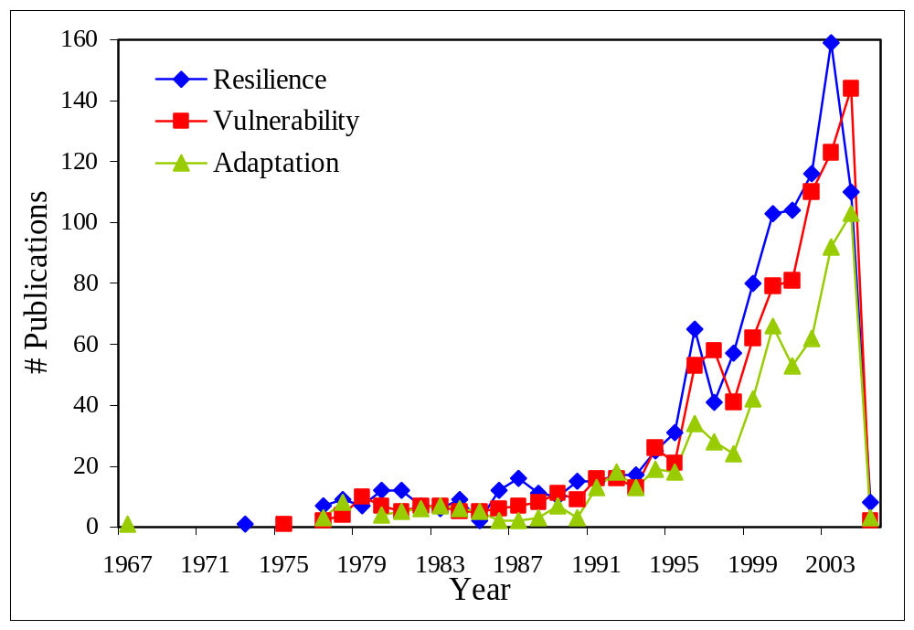
Figure 1: Number of papers published in the three knowledge domains per year. Data for 2004 and 2005 is incomplete.

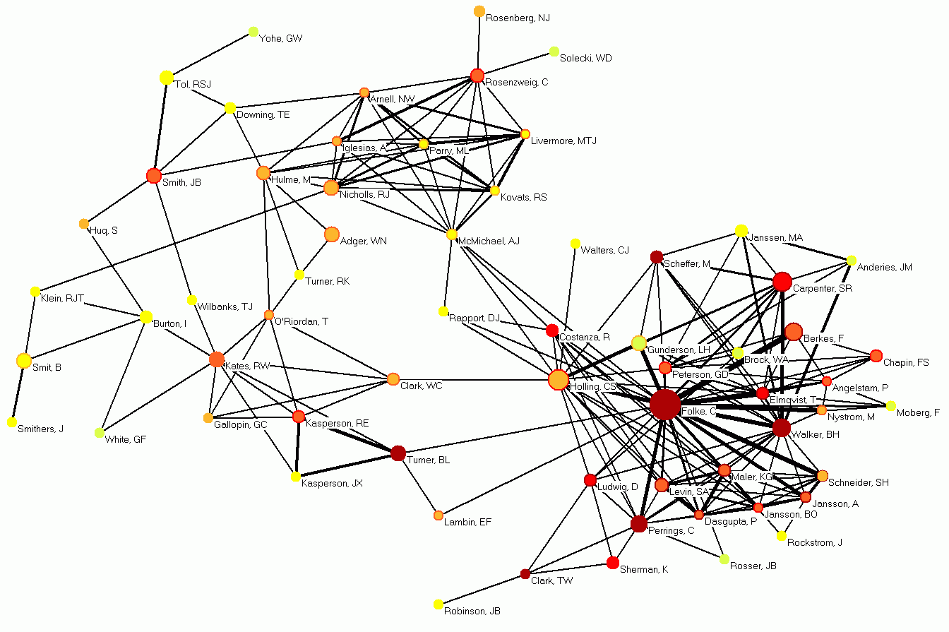
Figure 2: Co-author network of most productive and best connected authors with the strongest co-authorship relations. Circles denote author nodes and are labeled by the authors last name and first initials. Edges represent co-authorship relations.
Legend:
Node – author
Node area size - # of publications.
Node area color - # of unique co-authors
Node edge color - # of co-authorships.
■ 1-9
■ 10-19
■ 20-29
■ 30-39
■ 40-49
■ 50 or more

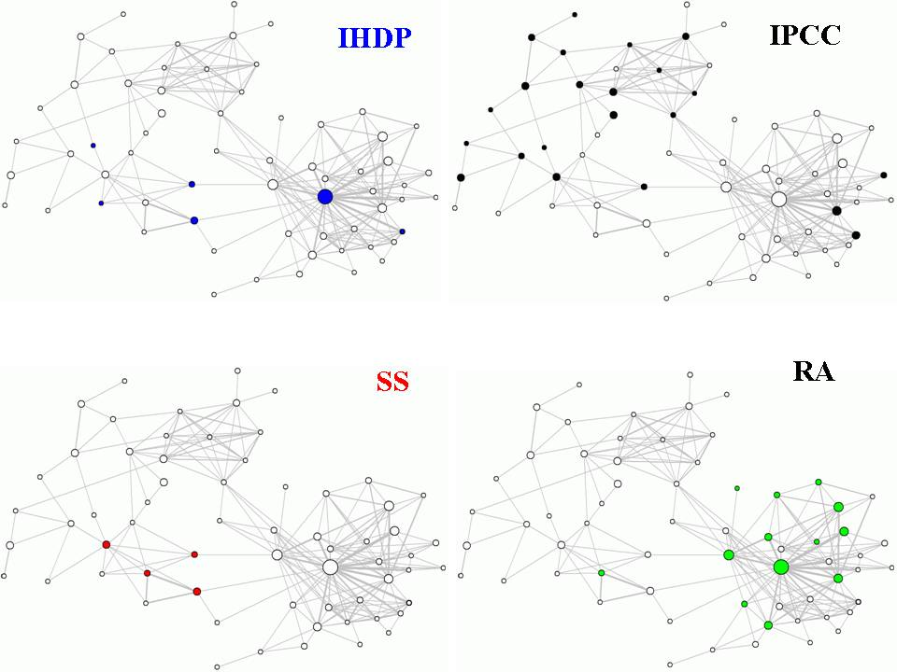
Figure 3: Participation of scholars in different international networks using the spatial lay-out of co-authorship network given in Figure 2. IHDP is the International Human Dimensions Programme on Global Environmental Change, IPCC is the Intergovernmental Panel on Climate Change, SS is the Sustainability Network, and RA denotes the Resilience Alliance
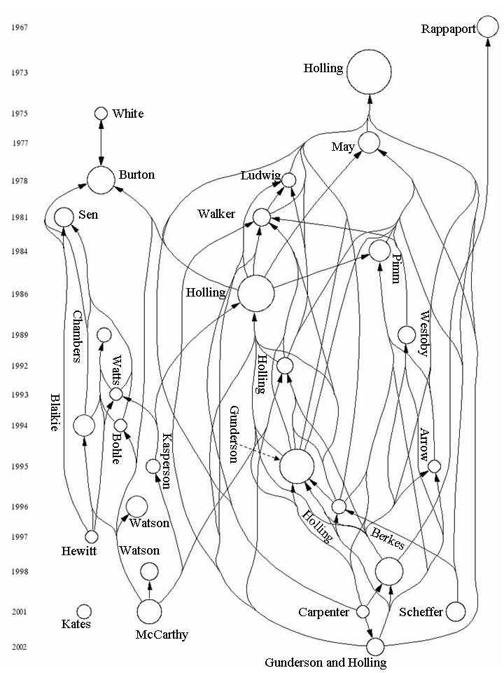Figure 4: Paper citation network of the most highly cited papers within the whole database (Threshold 30 citations within the database). The node size denotes the number of citations.
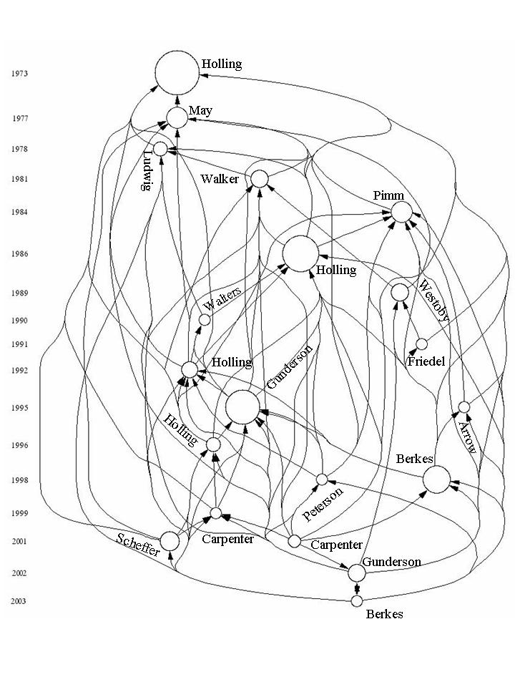
Figure 5: Paper citation network of the most highly cited papers within the knowledge domain resilience (Threshold 20 citations within the database). The node size denotes the number of citations.

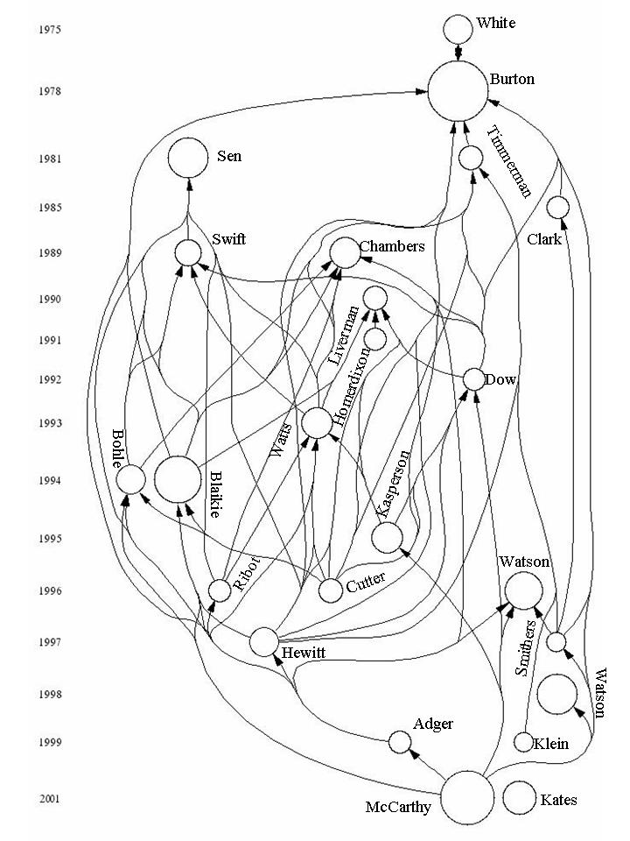
Figure 6: Paper citation network of the most highly cited papers within the knowledge domain vulnerability (Threshold 15 citations within the database). The node size denotes the number of citations.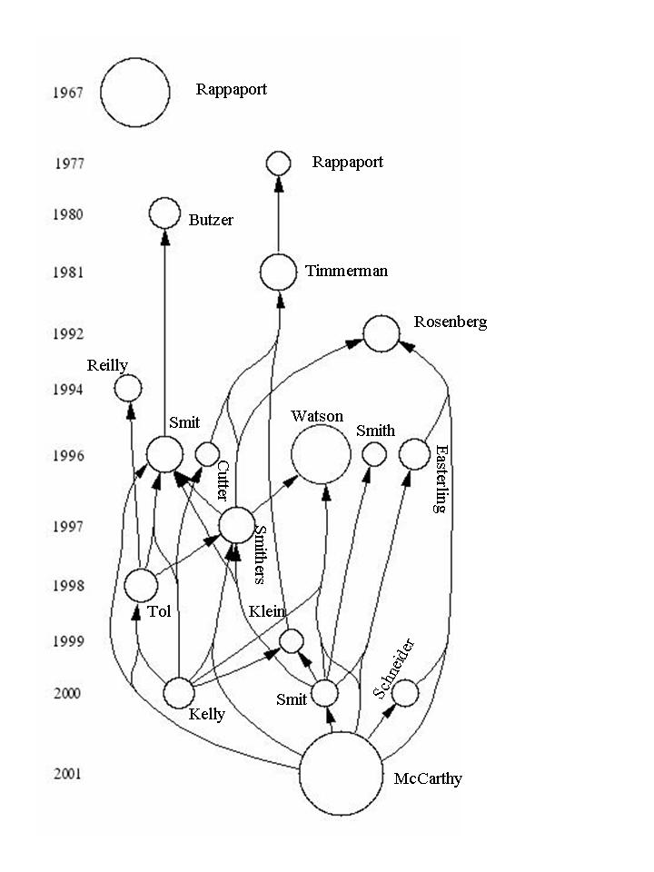 Figure 7: Paper citation network of the most highly cited papers within the knowledge domain of adaptation (Threshold 10 citations with the database). The node size denotes the number of citations.
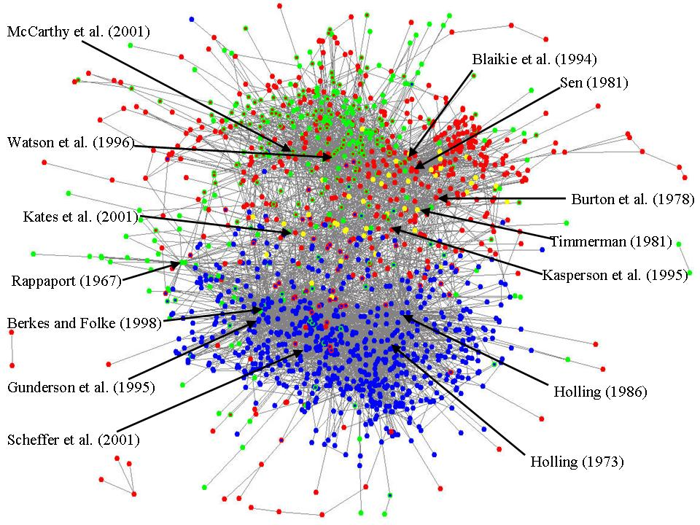
Figure 8: Paper citation network of 1956 papers. Blue refers to resilience, red to vulnerability, and green to adaptation. When papers are within two knowledge domains, the colors of the inner circle and the border differ. When a paper is categorized into all three knowledge domains, it is yellow.
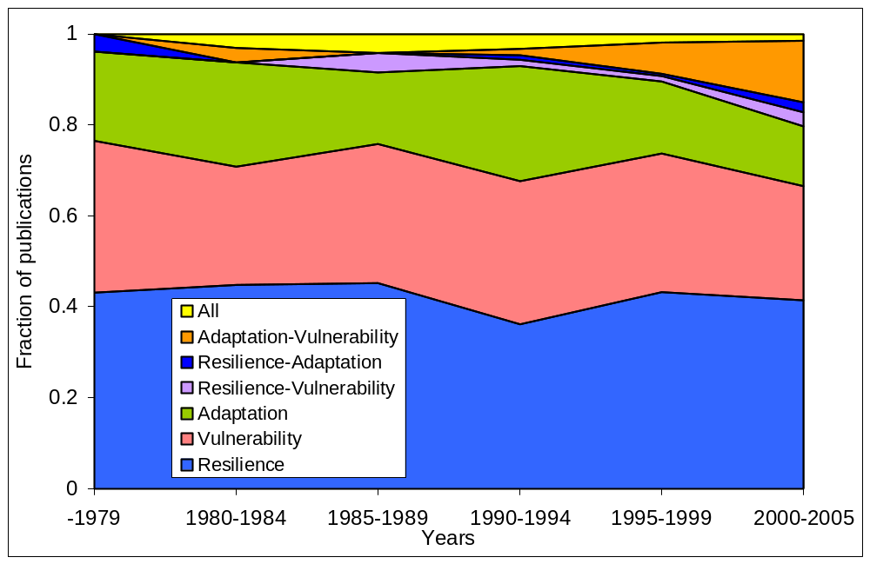
Figure 9: Relative number of publication for the different knowledge domains for six five year periods.

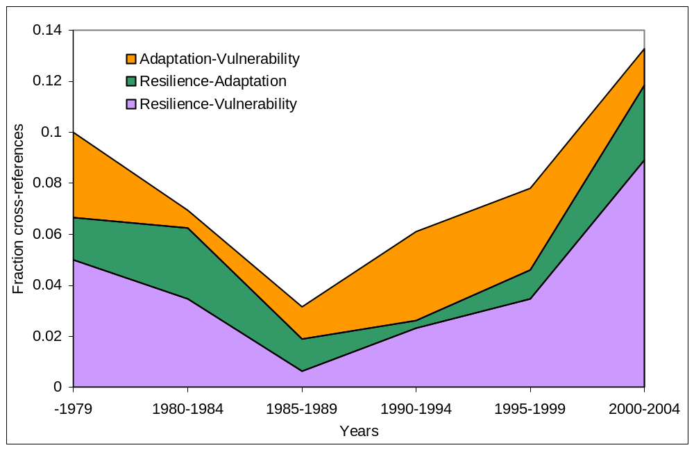
Figure 10: Citations between distinct knowledge domains as fraction of the total number of citations for six five-year periods.

These concepts are defined as a cross-cutting theme of the IHDP, International Human Dimensions Programme on Global Environmental Change. These concepts can have different meaning to different scholars. For example, “ecological resilience”, “engineering resilience” and “social resilience” are covered by “resilience” (Holling, 1996; Adger, 2000).
Add in the second round of information retrieval in March 2005.
We used HistCite Version: 2004.11.12
Note that we combined citations referring to the 1978 and 1993 editions.

