Visualizing the Topic Space of the United States Supreme Court

Peter A. Hook
pahook@indiana.edu
Indiana University, School of Law, 211 South Indiana Ave., Bloomington, IN 47405 (United States)
Abstract
This article describes the creation of several domain maps based on the topic space of opinions issued by the United States Supreme Court. Topics assigned by West Publishing were harvested off of the Westlaw database and visualized using Principal Components Analysis (PCA), Multidimensional Scaling (MDS), and graph visualization software (Pajek). Peculiar topic adjacencies were noted and attributed to the unique nature of cases argued at the level of the United States Supreme Court. The work is contextualized throughout by the author’s desire to create a rigorous base map on which to layer additional data for teaching purposes.

Keywords
Domain Maps; Visualizations; United States Supreme Court; Law; Political Science; Westlaw

Introduction

Background and Purpose
Scientometrics and bibliometrics owe a debt of gratitude to the legal research publishing industry in the United States. Frank Shepard’s legal citator (Ogden, 1993) was part of the inspiration for Eugene Garlfield’s Science Citation Index and subsequent products (Garfield, 1955 & 1979). This in turn was part of the inspiration for Page and Brin’s PageRank algorithm—the foundation for Google (Hopkins, 2005; Battelle, 2005). Now, the tools of scientometrics may assist the legal research publishing industry to more optimally organize its materials. Legal information is itself exciting because it is one of the largest and most atomistically indexed bodies of information.

This research seeks to identify the topical adjacencies of subjects addressed in legal cases by the United States Supreme Court based on the co-occurrence of top level topics assigned by West Publishing (Thomson/West, 2006). It is in furtherance of the author’s goal of creating a rigorous substrate map on which to layer over sixty years of Supreme Court topic data to be used for teaching purposes. In addition, the research is related to a growing body of work detailing and analyzing the network structure of legal opinions and their citation linkages (Chandler, 2005; Cross & Smith, In Press; Cross, Smith & Tomarchio, In Press; Fowler et. al., In Press; Smith, In Press), judicial and legislative co-voting networks (Fowler, 2006; Epstein et. al., 2005; Johnson et. al., 2005; Poole, 2005; Porter et. al., 2005; Sirovich, 2003; Brazill, 2002; Grofman, 2002; Martin & Quinn, 2002; Spaeth & Altfeld, 1985; Schubert, 1962 & 1963; Thurstone & Degan, 1951; Pritchett, 1941), and the move in legal academia toward quantitative empirical scholarship (George, 2006).

Maps of inherently non-spatial data that use a spatial substrate on which to layer additional information are common in information science (Hook & Börner, 2005). These maps employ the distance-similarity metaphor by which the viewer infers that items more proximate in space are more related than items further apart (Montello et al., 2003; Skupin and Fabrikant, 2003). The benefit of a substrate map is that it provides a common background from which changes may be readily perceived and is thus useful for pedagogy and illustrating changes over time.

Spatial layouts of inherently non-spatial data may be created in several ways. The first way is by the opinion of experts as to which topics are most similar and by laying out those topics by intuitive warrant or heuristics (See Bernal, 1939; Ellingham, 1948). The second way is by algorithmic comparisons of similarity and automated layouts using objective measures such as citation linkages or the co-occurrence of terms (Börner, Chen, & Boyack, 2002). Finally, a third method is a fusion approach which combines elements of each of the first two methods. For the most part, this paper employs multivariate statistical techniques that fall into the second category. These techniques are principal component analysis (“PCA”) and multidimensional scaling (“MDS’). However, elements of the fusion approach were used when the author placed data elements into higher level categories based on his training in and experience of the United States legal system before employing the multivariate statistical techniques.

Methods, Materials, Procedures, and Equipment Used

Data Summary
The dataset used for this research consists of bibliographic information about all United States Supreme Court cases that have been issued West topics by West Publishing from the 1944 Term through the end of the 2004 Term (October 1944 through July 2005). The author harvested the data as an academic end user from the Westlaw database. The data contains information about 7,948 unique Supreme Court cases to which 19,789 topic assignments have been made. Of the 405 top level topics in the West taxonomy, 290 appear in opinions issued by the Supreme Court for this time period. All but one (“Reference”), co-occur with other topics resulting in 22,345 edges between cases sharing a similar topic. There are 3743 unique topic pairings.

About the Data
For over a hundred years, West Publishing has identified unique statements of law within court cases (Surrency, 1990). Human editors working at West assign these unique and legally controlling statements topic identifiers from its taxonomy of the law known as the West Topic and Key Number System (Doyle, 1992; Snyder, 1999; Thomson/West, 2006). Before the advent of online full-text searching, the West Topic and Key Number System was one of the only ways to research cases on a given issue. Now, the Topic and Key Number System is used primarily to augment free text searching and to convince a researcher that he or she has found all of the appropriate cases on a particular topic. The Westlaw Database, owned by Thomson/West Publishing, provides online access to United States Supreme Court opinions, numerous other cases, and additional legal material. It is a proprietary subscription database that includes both the actual language of court opinions plus editorial enhancements provided by West such as topic assignments from the West Topic and Key Number System.

Data Harvesting
The data was harvested off of the Westlaw database during March through April, 2004. As of March 18, 2004, there were 405 top level topics in the West Topic and Key Number System. A search as to each of the 405 topics was conducted by hand using the conventional end user interface. A typical search statement was: TO("2 Abatement and Revival"). The TO in this case means topic and the scope of the database at the time included all Supreme Court opinions from the 1944 term to date. The resultant list of cases for each of the 405 topic searches were placed into a spreadsheet along with the topic that caused the case to be returned by the database. Topic assignments were aggregated such that each case was listed with all of its topic assignments and did not appear more than once. Subsequent Supreme Court cases and their topic assignments were added later. Annually, West makes changes to its taxonomy. In order for the dataset to include cases after the original March through April 2004 harvesting period, the author had to account for these changes. On several occasions, new topics were converted to their previous equivalents to bring the dataset current through the end of July 2005.

Additional Human Coding of the Data
Additionally, the author employed his legal training and knowledge of how concepts are taught in law school to make additional subject matter assignments to the 405 West topics: (1) Doctrinal – relevant to a specific subject taught in law school. (Constitutional Law, Administrative Law), (2) Factual – with unique factual circumstances relating to the topic but whose doctrinal elements are drawn from other topics (Aviation Law, Automobile Law), and (3) Procedural – capable of arising in almost any factual or doctrinal situation (Federal Courts, Federal Civil Procedure). For the doctrinal and procedural topics, the author also assigned categories to the topics based on in what course they are most likely to be covered in law school.

Data Manipulation and Visualization
The data was imported to the R statistical computing environment. Before applying the multivariate statistical visualization techniques, the data had to be put into matrix form. The data comprises a sparse matrix of 3743 unique topic pairings out of a theoretically possible 83,521 (289 x 289). The range of topic co-occurrence counts is 1 to 896 (with Constitutional Law and Federal Courts (896) being the most commonly co-occurring topics and Constitutional Law and Criminal Law (468) being the second most common). The mean topic co-occurrence count was only 5.97 and the median and mode were both 1. Both PCA and MDS were performed on the data. PCA was performed using Singular Value Decomposition (SVD). The resultant plots were useful to characterize the major dimensions in the variation in the data of topic co-occurrence. (See generally Paolillo and Wright, 2006). Additionally, the dataset was visualized in its network form using the network visualization and analysis tool, Pajek (Batagelj & Mrvar, 1998). In the parlance of network science, the nodes represented West Topics and the edges represented the co-occurrence of those topics in Supreme Court cases.

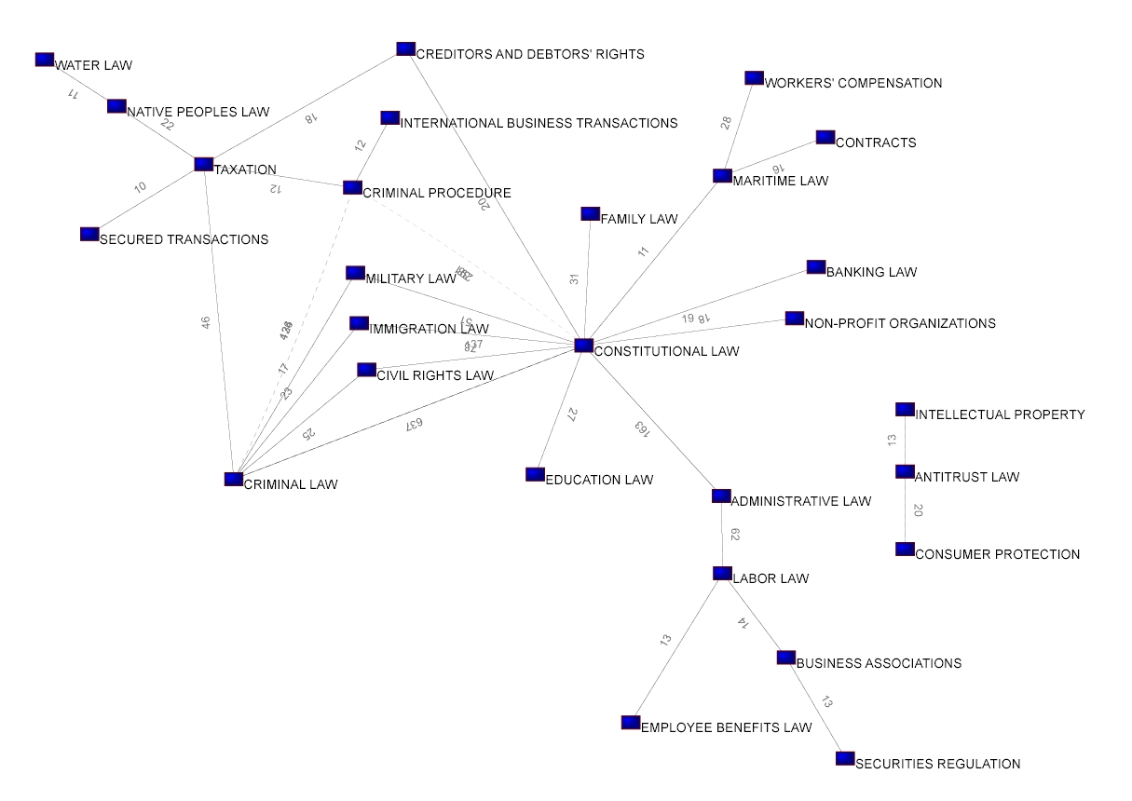
Figure 1: West Topic Space of the United States Supreme Court—Network Layout
Findings, Discussion and Conclusions

Network Graph Approach
Initial network based attempts to create a domain map of the topic space of Supreme Court cases using the spring force layout algorithm in Pajek proved unsatisfying. The procedural and factual topics, which may co-occur with just about any doctrinal topic, pulled everything to the center of the graph. In order to derive any insight using this approach, the author had to visualize just the doctrinal topics. Furthermore, to obtain readable visualizations, all of the co-occurrences were aggregated up from the West Topic level to the law school subject level (the course offered in law school most likely to teach that particular topic). The graph was then subjected to another double treatment. First, the most tenuous (least numerous) co-occurrences between subjects were discarded. This was a bit subjective and was again informed by the author’s familiarity with legal topics. It was necessary because almost every subject co-occurred with Constitutional Law and a few other similarly ubiquitous topics. Second, amongst the remaining subjects, the graph was thresholded at 10 or more case co-occurrences between the subjects. This resulted in network visualization pictured in Figure 1.

Apparent from the visualization were several counterintuitive adjacencies that reflect the unique jurisdiction of the United States Supreme Court. Maritime cases invoke federal jurisdiction. Furthermore, to the extent that maritime cases involve contract disputes or workers’ compensation claims, these issues are heard by the Federal Courts. Outside of the context of maritime law, contracts and workers’ compensation cases are state court issues not typically heard by the Federal Courts. Thus, the resultant base map reflects an inherent bias in the dataset. No expert in the law would intuitively co-locate Maritime Law, Workers’ Compensation, and Contracts outside the unique context of cases being heard in the Supreme Court.

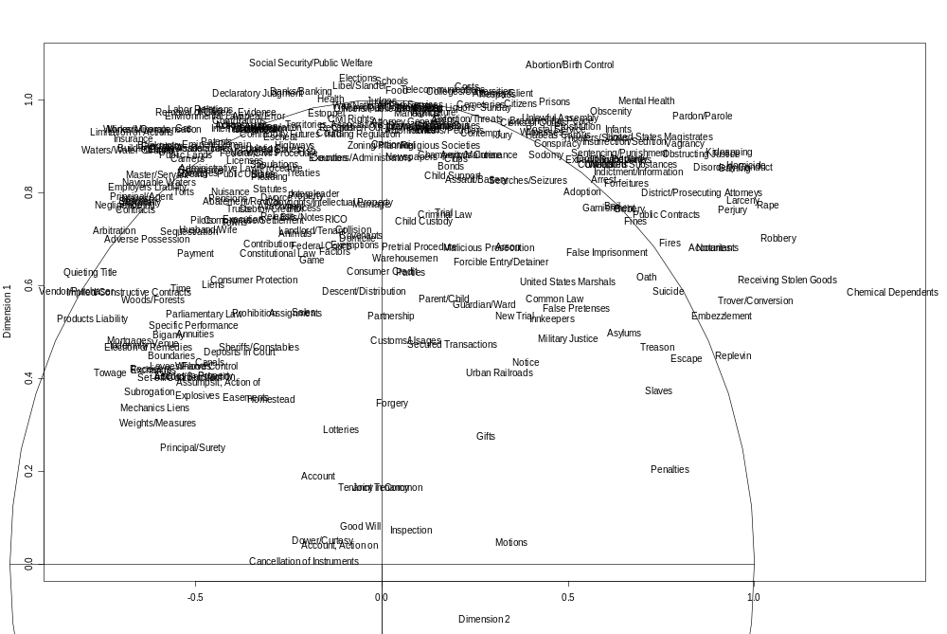
Criminal Matters (Life & Limb)
Business Matters (Property)
Figure 2: PCA (2nd and 1st Dimensions)
PCA Approach
A plot of the amount of the variance contained in each of the singular values reveals that the first twenty-five dimensions account for almost 4/5th’s of the variance. On the whole, the dimensionality plots do not reveal easily identifiable continuums. However, the plot of the 1st and 2nd principal components reveal a readily identifiable continuum between criminal matters on one end (Receiving Stolen Goods, Rape, Robbery, Larceny, Homicide, etc.), and business matters on the other (Quieting Title, Constructive Contracts, Mortgages, etc.). This division between matters of life and limb and those of property corresponds with the popular perception of the justice system as being composed largely of two parts—criminal and non-criminal matters. See Figures 2. This same continuum may also be seen in a non-PCA layout of the topic relationships of one particular Supreme Court term (2004). Cases as nodes are linked to the topics they contain which are also portrayed as nodes. The spatial layout was generated by hand employing the heuristic charge to minimize edge crossings. See Figure 3.

The layout of topics of the first two principal components revealed topic adjacencies that are contrary to traditional categorizations. For instance, the topic Bigamy, which is a crime, appears on the Business Matters end of the previously identified continuum. This at first appears to be an error. However, further research reveals that the topic Bigamy appears only once in the entire dataset. It occurs in the context of a divorce case in which alimony and the division of marital property were hotly contested. In fact, the alleged bigamy (one spouse got a divorce and remarried in a different state and these actions were not recognized by the original state) was the means to the end of acquiring more marital assets in the divorce proceeding. Thus, the appearance of the topic Bigamy at the Business/Property side of the continuum makes sense even though it is contrary to how a law student would encounter the topic. See Figure 4.

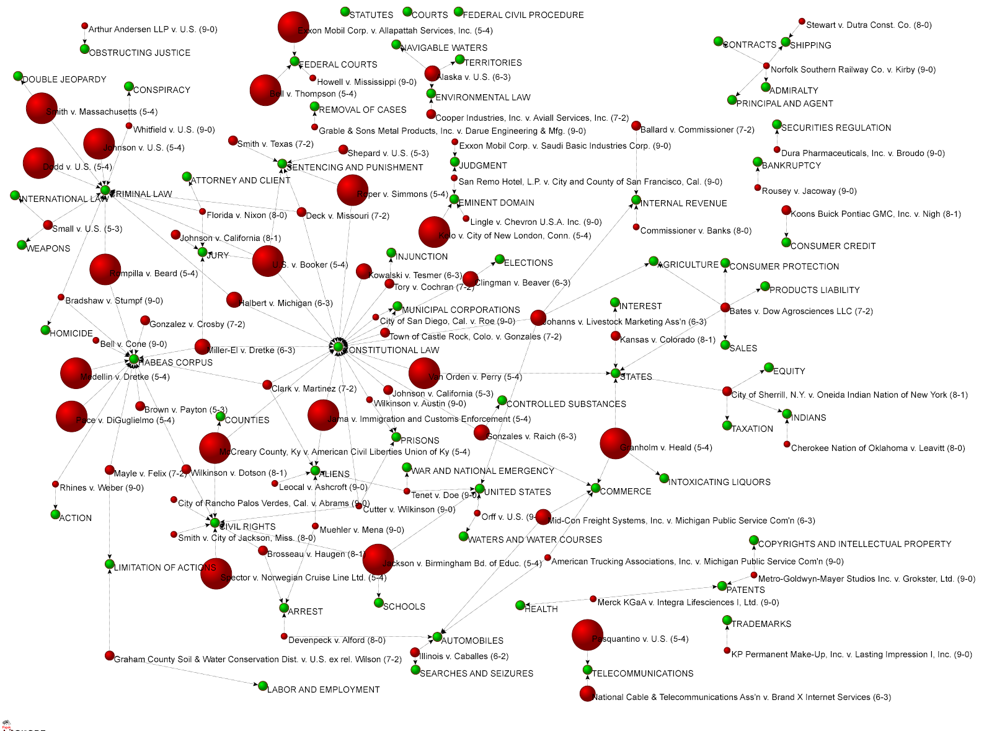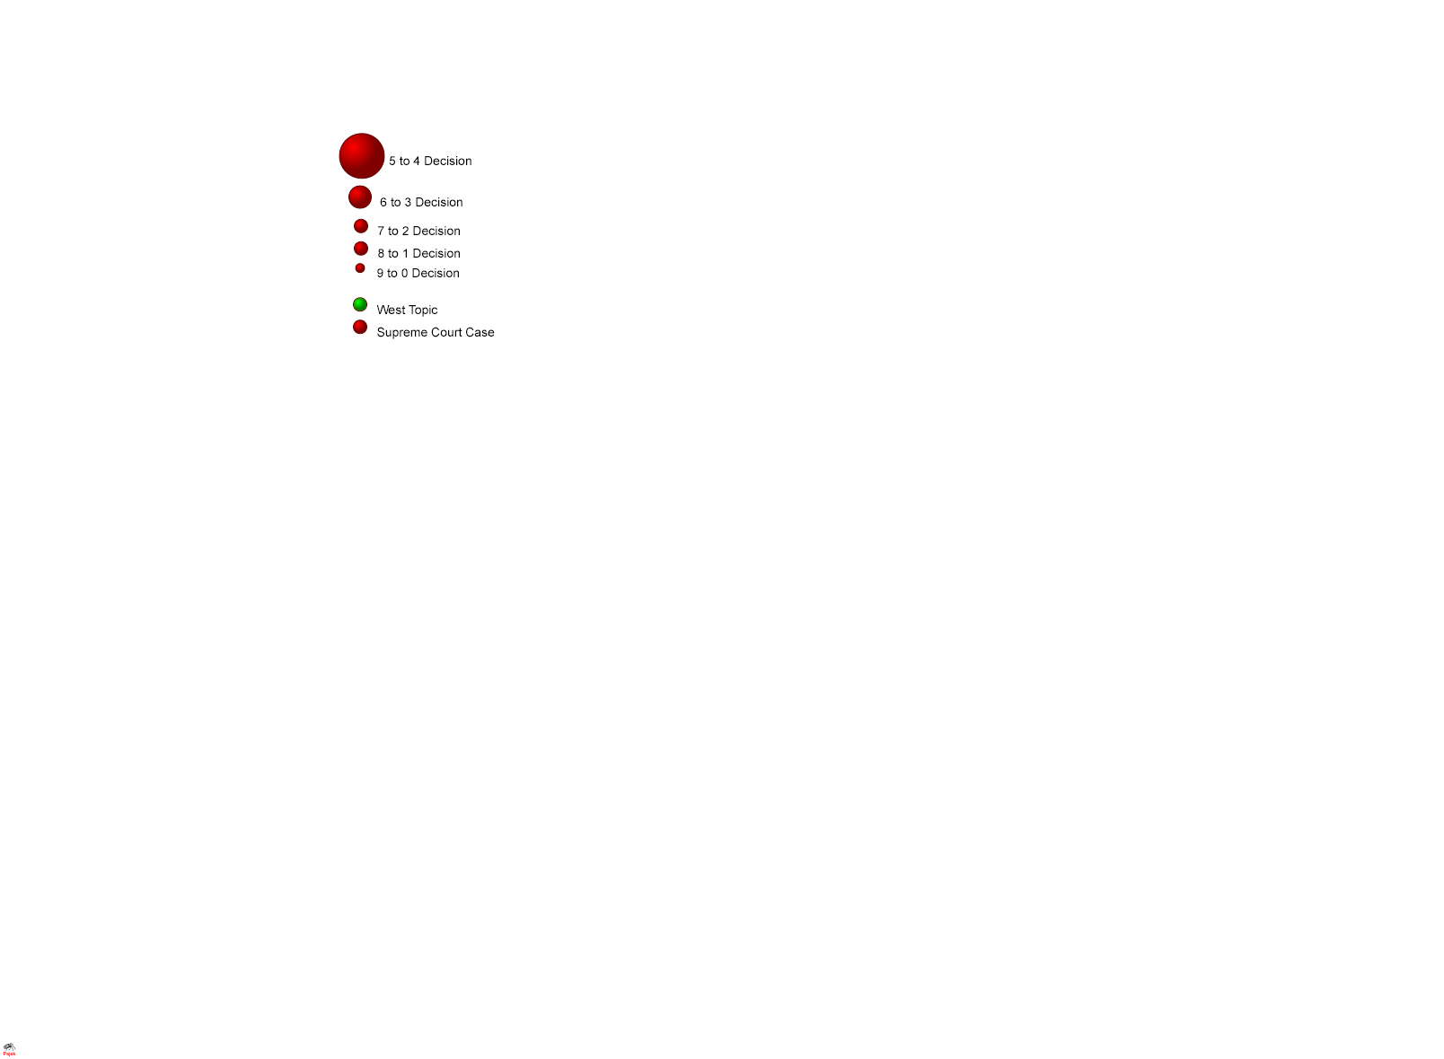
Figure 3 - 2004 Supreme Court Term West Topic Space
(Procedural Topics Removed)
Criminal Matters (Life & Limb)
Business Matters (Property)

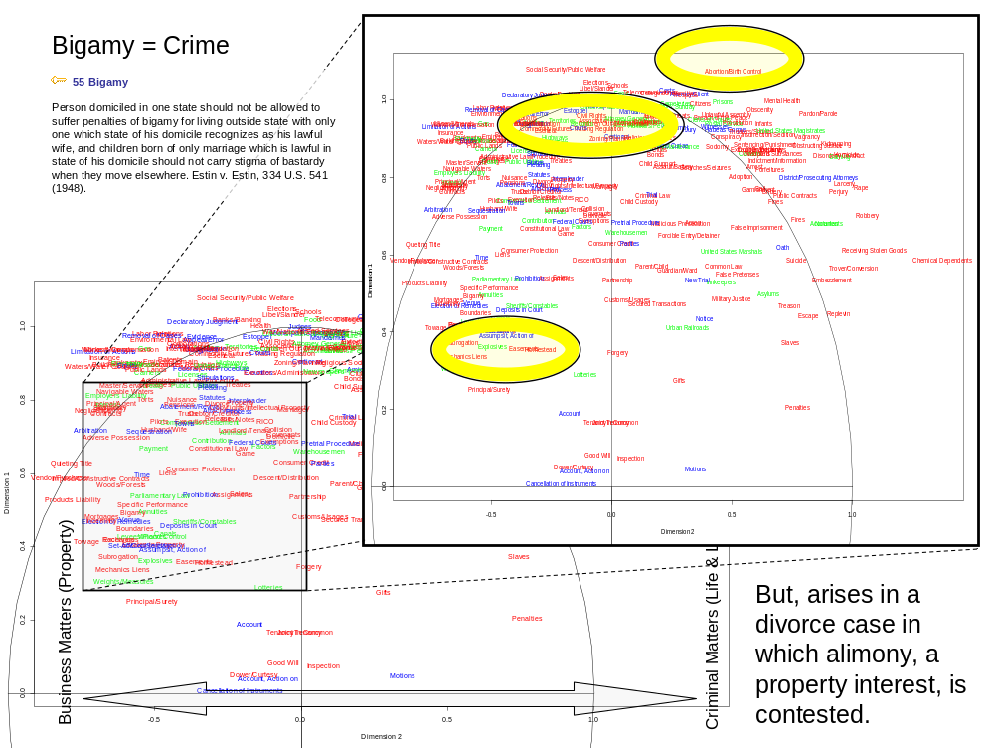

Figure 4: Placement of the Topic Bigamy

As explained above, the author assigned the West Topics one of three additional labels—doctrinal, procedural and factual. The impetus for this was the fact that when the topic space was rendered using only a node link approach coupled with a spring force algorithm, many of the procedural and factual topics, which may co-occur with just about any doctrinal topic, pull everything to the center of the graph. Fortunately, this appears to be less of a problem using the PCA approach. Interestingly, the layout of the fifth and sixth principal components bears out a separation of the doctrinal (red) and procedural topics (blue) with the factual topics (green) clustered in between the two. See Figure 5.

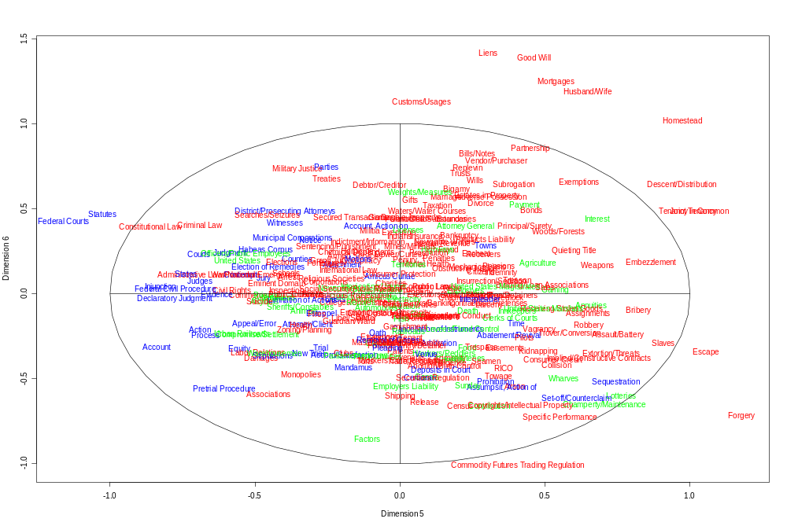
Doctrinal (red)
Procedural (blue)
Figure 5: PCA (5th and 6th Dimensions)

Furthermore, the layout of the seventh and eighth principal components reveals a continuum between family obligations (Bigamy, Marriage, Estates in Property, Divorce, Homestead, Husband & Wife, etc.) and business obligations (Subrogation, Mechanics Liens, Principal/Surety, Assignments, Payment, etc.). See Figure 6. There were no additional continuums in the remaining first twenty-five principle components that the author could identify.

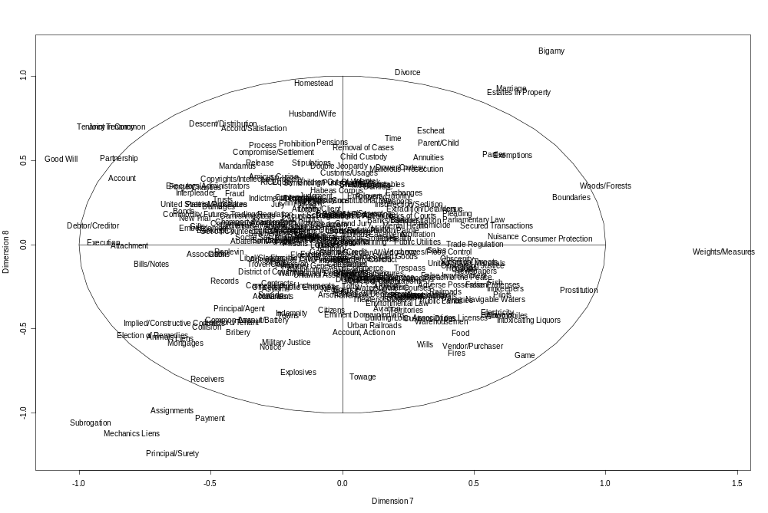
Family Obligations
Business Obligations
Figure 6: PCA (7th and 8th Dimensions)

PCA Just Doctrinal
As the author’s ultimate goal is to create a substrate map based on the layout of topics for use in legal education, he decided to conduct PCA with just the doctrinal topics. To this end, he aggregated the co-occurrence counts up from the West Topic level to the law school subject categories he assigned the doctrinal topics. These additional category assignments are based on where the topic would most likely be encountered in a law school course. The plots of the various dimensions produced adjacencies that were for the most part expected. See Figure 7. The upper left quadrant of the plot nicely co-locates various aspects of the law that deal with land in general (Public Land Law, Water Law, Environmental Law, Oil & Gas Law, Property Law, Native Peoples Law, and Taxation.) The later two course topics most likely cluster in this region because the underlying events that resulted in the cases to which these topics are assigned most likely involved land. Presumably, most of the taxation cases that reach the Supreme Court involve property taxes. Similarly, it is presumed from the PCA analysis that cases assigned the topics involving native peoples most likely also deal with land controversies.

It is similarly consistent with expectations that Criminal Law and Criminal Procedure appear adjacent to one another. These subjects, along with Constitutional Law, are inextricably linked. It is also appropriate that Estate Planning and Wills and Trust are proximate to one another. Taxation would be another subject that the author would expect to cluster closely with Estate Planning and Wills and Trusts. However, as mentioned previously, it is adjacent to topics involving land. It is similarly appropriate that Torts and Products Liability are in the same quadrant. The later is a subset of the former. Likewise, it is satisfying to one’s intuition that Juvenile Justice and Education Law are proximate as both involve children.

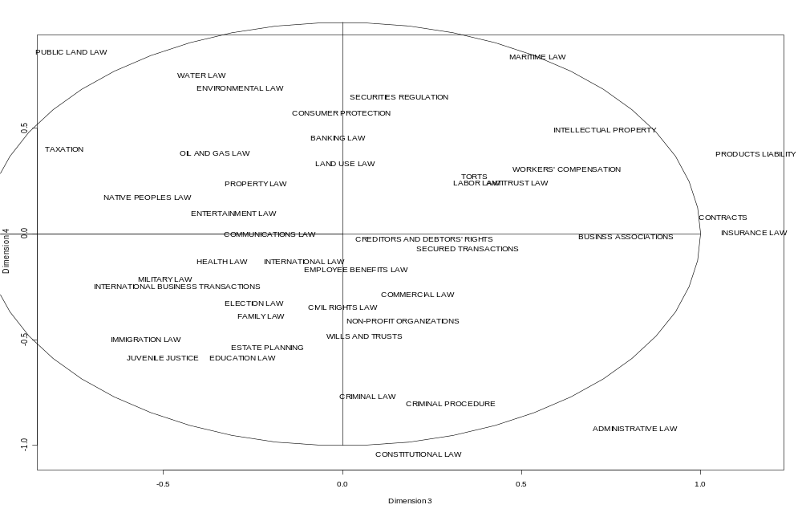

Figure 8: PCA, Doctrinal Subjects Aggregated to Law School Course Offerings

MDS
As the dataset could easily be converted from a matrix of counts, to a matrix of distances, multidimensional scaling (“MDS”) was utilized and to compare the results with those obtained from PCA. Co-occurrence counts were subtracted from the maximum number of co-occurrences (896) to get a measure of the distance between topics. The results were not as satisfactory as those produced by PCA. While some topic adjacencies made sense ((Searches and Seizures, Sentencing and Punishment, Habeas Corpus) and (Admiralty, Shipping, Seaman) most topics were clustered in an unreadable blob at the center of the plot. Similarly, the just doctrinal plots were also less intuitively satisfactory to one trained in the law as were those produced by PCA. See Figure 8.

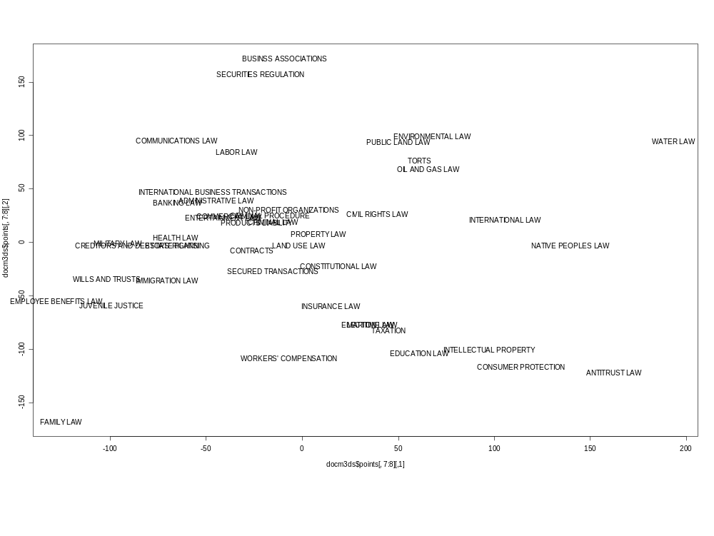 Figure 8: MDS Just Doctrinal (7th & 8th Dimensions)

CONCLUSION
The multivariate statistical techniques employed in this paper contributed some to the author’s ultimate goal of a rigorous topic space substrate map of Supreme Court topics. The techniques reaffirmed the author’s intuitive understanding that the primary divide is between business and criminal matters. While the techniques were helpful in suggesting layouts of the super groupings, it will take a fusion approach to produce a substrate map that resonates with how legal topics are conceptualized, bundled, and taught in law school.

Part of the problem is that the approach might be faulty in part. As demonstrated by the ‘Bigamy’ example, the co-occurrence of topics in cases suggests relationships between topics that though logical, are not how a law student is presented the material. Additionally, part of the problem might also be the need to do the same analysis at an increased level of granularity. While there are only 405 top level West topics, there are about 100,000 sub-topic assignments. The same techniques involving the relationships of all of these sub-topic assignments might produce more intuitively satisfying maps. Also, the fact that the data is only from Supreme Court cases skews the results. Topic co-occurrence data is needed from the two additional levels of Federal Courts and all of the state case material as well. This will require a partnership with the actual database owner to obtain backend access.

References
Batagelj, V., & Mrvar, A. (1998). Pajek - Program for Large Network Analysis. Connections, 21(2), 47-57.
Battelle, J. (2005). The search : how Google and its rivals rewrote the rules of business and transformed our culture. New York: Portfolio.
Bernal, J. D. (1939). The Social Function of Science London: Routledge & Kegan Ltd.
Börner, K., Chen, C., & Boyack, K. W. (2002). Visualizing Knowledge Domains. In B. Cronin (Ed.), Annual Review of Information Science and Technology (Vol. 37, pp. 179-255). Medford, New Jersey: Information Today.
Brazill, T. J., & Grofman, B. (2002). Factor analysis versus multi-dimensional scaling: binary choice roll-call voting and the US Supreme Court. Social Networks, 24, 201-229.
Chandler, S. J. (2005). The Network Structure of Supreme Court Jurisprudence. Paper presented at the 2005 International Mathematica Symposium. from http://ssrn.com/abstract=742065
Cross, F. B., & Smith, T. A. (In Press). The Reagan Revolution in the Network of Law. from http://ssrn.com/abstract=909217
Cross, F. B., Smith, T. A., & Tomarchio, A. (In press). Determinants of Cohesion in the Supreme Court's Network of Precedents. from http://ssrn.com/abstract=924110
Doyle, J. (1992). Westlaw and the American Digest Classification Scheme. Law Library Journal, 84, 229-257.
Ellingham, H. J. T. (1948, 21 June – 2 July). Divisions of Natural Science and Technology. Paper presented at the Royal Society Scientific Information Conference, London: The Royal Society, Burlington House.
Epstein, L., Martin, A. D., Segal, J. A., & Westerland, C. (2005). The Judicial Common Space. Northwestern University. from https://www.law.northwestern.edu/faculty/conferences/research/Epstein.pdf.
Fowler, J. H. (2006). Connecting the Congress: A Study of Cosponsorship Networks. Political Analysis, 14, 456 - 487.
Fowler, J. H., Johnson, T. R., Spriggs, J. F. I., Jeon, S., & Wahlbeck, P. J. (In Press). Network Analysis and the Law: Measuring the Legal Importance of Supreme Court Precedents. Political Analysis
Garfield, E. (1955). Citation Indexes for Science. Science, 122(3159), 108-111.
Garfield, E. (1979). Citation indexing - its theory and application in science, technology, and humanities. New York: Wiley.
George, T. E. (2006). An Empirical Study of Empirical Legal Scholarship: The Top Schools. Indiana Law Journal, 81, 141-160.
Grofman, B., & Brazill, T. J. (2002). Identifying the median justice on the Supreme Court through multidimensional scaling: Analysis of "natural courts" 1953-1991. Public Choice, 112, 55-79.Hopkins, K. (2005). Most Highly Cited. The Scientist, 19(20), 22-27.
Hook, P. A., & Börner, K. (2005). Educational Knowledge Domain Visualizations: Tools to Navigate, Understand, and Internalize the Structure of Scholarly Knowledge and Expertise. In A. Spink & C. Cole (Eds.), New Directions in Cognitive Information Retrieval (pp. 187-208). London: Springer.
Hopkins, K. (2005). Most Highly Cited. The Scientist, 19(20), 22-27.
Johnson, J. C., Borgatti, S. P., & Romney, K. (2005). Analysis Of Voting Patterns In U.S. Supreme Court Decisions. Paper presented at the Sunbelt XXV, International Sunbelt Social Network Conference. (abstract available at: http://www.socsci.uci.edu/~ssnconf/conf/SunbeltXXVProgram.pdf).
Martin, A. D., & Quinn, K. M. (2002). Dynamic Ideal Point Estimation via Markov Chain Monte Carlo for the U.S. Supreme Court, 1953-999. Political Analysis, 10(2), 134-153.
Montello, D. R., Fabrikant, S. I., Ruocco, M., & Middleton, R. S. (2003). Testing the First Law of Cognitive Geography on Point-Display Spatializations. In W. Kuhn, M. F. Worboys & S. Timpf (Eds.), Spatial Information Theory: Foundations of Geographic Information Science: Proceedings of the Conference on Spatial Information Theory (COSIT '03): Lecture Notes in Computer Science, 2825 (pp. 316-331). Berlin: Springer Verlag.
Ogden, P. (1993). "Mastering the Lawless Science of Our Law"; A Story of Legal Citation Indexes. Law Library Journal, 85(1), 1-48.
Paolillo, J. C., & Wright, E. (2006). Social Network Analysis on the Semantic Web: Techniques and Challenges for Visualizing FOAF. In V. Geroimenko & C. Chen (Eds.), Visualizing the Semantic Web: XML-Based Internet and Information Visualization (2nd ed., pp. 229-241). London: Springer-Verlag.
Poole, K. T. (2005). Spatial Models of Parliamentary Voting. Cambridge: Cambridge University Press.
Porter, M. A., Mucha, P. J., Newman, M. E. J., & Warmbrand, C. M. (2005). A Network Analysis of Committees in the U.S. House of Representatives. PNAS, 102(20), 7057-7062.
Pritchett, C. H. (1941). Divisions of Opinion Among Justices of the U.S. Supreme Court, 1939-1941. The American Political Science Review, 35(5), 890-898.Skupin, A., & Fabrikant, S. I. (2003). Spatialization Methods: A Cartographic Research Agenda for Non-geographic Information Visualization. Cartography and Geographic Information Science, 30(2), 95-115.
Schubert, G. (1962). The 1960 Term of the Supreme Court: A Psychological Analysis. The American Political Science Review, 56(1), 90-107.
Schubert, G. (1963). Judicial Attitudes and Voting Behavior: The 1961 Term of the United States Supreme Court. Law and Contemporary Problems, 28, 100-142.
Sirovich, L. (2003). A pattern analysis of the second Rehnquist U.S. Supreme Court. PNAS, 100(13), 7432-7437.
Small, H., & Griffith, B. C. (1974). The Structure of Scientific Literatures I: Identifying and Graphing Specialties. Science Studies, 4(1), 17-40.
Smith, T. A. (In Press). The Web of Law. from http://ssrn.com/abstract=642863
Snyder, F. (1999). The West Digest System: The Ninth Circuit and the Montana Supreme Court. Montana Law Review, 60, 541-597.
Spaeth, H. J., & Altfeld, M. F. (1985). Influence Relationships within the Supreme Court: A Comparison of the Warren and Burger Courts. The Western Political Quarterly, 38(1), 70-83.
Surrency, E. C. (1990). A history of American law publishing. New York: Oceana Publications.
Thomson/West. (2006). West's Analysis of American Law (2006 ed.). St. Paul, MN: Thomson/West.
Thurstone, L. L., & Degan, J. W. (1951). A Factorial Study of the Supreme Court. PNAS, 37(9), 628-635.

Appendix A – 405 Top Level West Topics
(as of March 18, 2004)

1 ABANDONED AND LOST PROPERTY
2 ABATEMENT AND REVIVAL
4 ABORTION AND BIRTH CONTROL
5 ABSENTEES
6 ABSTRACTS OF TITLE
7 ACCESSION
8 ACCORD AND SATISFACTION
9 ACCOUNT
10 ACCOUNT, ACTION ON
11 ACCOUNT STATED
11A ACCOUNTANTS
12 ACKNOWLEDGMENT
13 ACTION
14 ACTION ON THE CASE
15 ADJOINING LANDOWNERS
15A ADMINISTRATIVE LAW AND PROCEDURE
16 ADMIRALTY
17 ADOPTION
18 ADULTERATION
19 ADULTERY
20 ADVERSE POSSESSION
21 AFFIDAVITS
23 AGRICULTURE
24 ALIENS
25 ALTERATION OF INSTRUMENTS
26 AMBASSADORS AND CONSULS
27 AMICUS CURIAE
28 ANIMALS
29 ANNUITIES
30 APPEAL AND ERROR
31 APPEARANCE
33 ARBITRATION
34 ARMED SERVICES
35 ARREST
36 ARSON
37 ASSAULT AND BATTERY
38 ASSIGNMENTS
40 ASSISTANCE, WRIT OF
41 ASSOCIATIONS
42 ASSUMPSIT, ACTION OF
43 ASYLUMS
44 ATTACHMENT
45 ATTORNEY AND CLIENT
46 ATTORNEY GENERAL
47 AUCTIONS AND AUCTIONEERS
48 AUDITA QUERELA
48A AUTOMOBILES
48B AVIATION
49 BAIL
50 BAILMENT
51 BANKRUPTCY
52 BANKS AND BANKING
54 BENEFICIAL ASSOCIATIONS
55 BIGAMY
56 BILLS AND NOTES
58 BONDS
59 BOUNDARIES
60 BOUNTIES
61 BREACH OF MARRIAGE PROMISE
62 BREACH OF THE PEACE
63 BRIBERY
64 BRIDGES
65 BROKERS
66 BUILDING AND LOAN ASSOCIATIONS
67 BURGLARY
68 CANALS
69 CANCELLATION OF INSTRUMENTS
70 CARRIERS
71 CEMETERIES
72 CENSUS
73 CERTIORARI
74 CHAMPERTY AND MAINTENANCE
75 CHARITIES
76 CHATTEL MORTGAGES
76A CHEMICAL DEPENDENTS
76D CHILD CUSTODY
76E CHILD SUPPORT
76H CHILDREN OUT-OF-WEDLOCK
77 CITIZENS
78 CIVIL RIGHTS
79 CLERKS OF COURTS
80 CLUBS
81 COLLEGES AND UNIVERSITIES
82 COLLISION
83 COMMERCE
83H COMMODITY FUTURES TRADING REGULATION
84 COMMON LANDS
85 COMMON LAW
88 COMPOUNDING OFFENSES
89 COMPROMISE AND SETTLEMENT
89A CONDOMINIUM
90 CONFUSION OF GOODS
91 CONSPIRACY
92 CONSTITUTIONAL LAW
92B CONSUMER CREDIT
92H CONSUMER PROTECTION
93 CONTEMPT
95 CONTRACTS
96 CONTRIBUTION
96H CONTROLLED SUBSTANCES
97 CONVERSION
98 CONVICTS
99 COPYRIGHTS AND INTELLECTUAL PROPERTY
100 CORONERS
101 CORPORATIONS
102 COSTS
103 COUNTERFEITING
104 COUNTIES
105 COURT COMMISSIONERS
106 COURTS
107 COVENANT, ACTION OF
108 COVENANTS
108A CREDIT REPORTING AGENCIES
110 CRIMINAL LAW
111 CROPS
113 CUSTOMS AND USAGES
114 CUSTOMS DUTIES
115 DAMAGES
116 DEAD BODIES
117 DEATH
117G DEBT, ACTION OF
117T DEBTOR AND CREDITOR
118A DECLARATORY JUDGMENT
119 DEDICATION
120 DEEDS
122A DEPOSITS AND ESCROWS
123 DEPOSITS IN COURT
124 DESCENT AND DISTRIBUTION
125 DETECTIVES
126 DETINUE
129 DISORDERLY CONDUCT
130 DISORDERLY HOUSE
131 DISTRICT AND PROSECUTING ATTORNEYS
132 DISTRICT OF COLUMBIA
133 DISTURBANCE OF PUBLIC ASSEMBLAGE
134 DIVORCE
135 DOMICILE
135H DOUBLE JEOPARDY
136 DOWER AND CURTESY
137 DRAINS
141 EASEMENTS
142 EJECTMENT
143 ELECTION OF REMEDIES
144 ELECTIONS
145 ELECTRICITY
146 EMBEZZLEMENT
148 EMINENT DOMAIN
148A EMPLOYERS' LIABILITY
149 ENTRY, WRIT OF
149E ENVIRONMENTAL LAW
150 EQUITY
151 ESCAPE
152 ESCHEAT
154 ESTATES IN PROPERTY
156 ESTOPPEL
157 EVIDENCE
158 EXCEPTIONS, BILL OF
159 EXCHANGE OF PROPERTY
160 EXCHANGES
161 EXECUTION
162 EXECUTORS AND ADMINISTRATORS
163 EXEMPTIONS
164 EXPLOSIVES
165 EXTORTION AND THREATS
166 EXTRADITION AND DETAINERS
167 FACTORS
168 FALSE IMPRISONMENT
169 FALSE PERSONATION
170 FALSE PRETENSES
170A FEDERAL CIVIL PROCEDURE
170B FEDERAL COURTS
171 FENCES
172 FERRIES
174 FINES
175 FIRES
176 FISH
177 FIXTURES
178 FOOD
179 FORCIBLE ENTRY AND DETAINER
180 FORFEITURES
181 FORGERY
183 FRANCHISES
184 FRAUD
185 FRAUDS, STATUTE OF
186 FRAUDULENT CONVEYANCES
187 GAME
188 GAMING
189 GARNISHMENT
190 GAS
191 GIFTS
192 GOOD WILL
193 GRAND JURY
195 GUARANTY
196 GUARDIAN AND WARD
197 HABEAS CORPUS
198 HAWKERS AND PEDDLERS
198H HEALTH
200 HIGHWAYS
201 HOLIDAYS
202 HOMESTEAD
203 HOMICIDE
205 HUSBAND AND WIFE
205H IMPLIED AND CONSTRUCTIVE CONTRACTS
206 IMPROVEMENTS
207 INCEST
208 INDEMNITY
209 INDIANS
210 INDICTMENT AND INFORMATION
211 INFANTS
212 INJUNCTION
213 INNKEEPERS
216 INSPECTION
217 INSURANCE
218 INSURRECTION AND SEDITION
219 INTEREST
220 INTERNAL REVENUE
221 INTERNATIONAL LAW
222 INTERPLEADER
223 INTOXICATING LIQUORS
224 JOINT ADVENTURES
225 JOINT-STOCK COMPANIES AND BUSINESS TRUSTS
226 JOINT TENANCY
227 JUDGES
228 JUDGMENT
229 JUDICIAL SALES
230 JURY
231 JUSTICES OF THE PEACE
232 KIDNAPPING
232A LABOR RELATIONS
233 LANDLORD AND TENANT
234 LARCENY
235 LEVEES AND FLOOD CONTROL
236 LEWDNESS
237 LIBEL AND SLANDER
238 LICENSES
239 LIENS
240 LIFE ESTATES
241 LIMITATION OF ACTIONS
242 LIS PENDENS
245 LOGS AND LOGGING
246 LOST INSTRUMENTS
247 LOTTERIES
248 MALICIOUS MISCHIEF
249 MALICIOUS PROSECUTION
250 MANDAMUS
251 MANUFACTURES
252 MARITIME LIENS
253 MARRIAGE
255 MASTER AND SERVANT
256 MAYHEM
257 MECHANICS' LIENS
257A MENTAL HEALTH
258A MILITARY JUSTICE
259 MILITIA
260 MINES AND MINERALS
265 MONOPOLIES
266 MORTGAGES
267 MOTIONS
268 MUNICIPAL CORPORATIONS
269 NAMES
270 NAVIGABLE WATERS
271 NE EXEAT
272 NEGLIGENCE
273 NEUTRALITY LAWS
274 NEWSPAPERS
275 NEW TRIAL
276 NOTARIES
277 NOTICE
278 NOVATION
279 NUISANCE
280 OATH
281 OBSCENITY
282 OBSTRUCTING JUSTICE
283 OFFICERS AND PUBLIC EMPLOYEES
284 PARDON AND PAROLE
285 PARENT AND CHILD
286 PARLIAMENTARY LAW
287 PARTIES
288 PARTITION
289 PARTNERSHIP
290 PARTY WALLS
291 PATENTS
292 PAUPERS
294 PAYMENT
295 PENALTIES
296 PENSIONS
297 PERJURY
298 PERPETUITIES
300 PILOTS
302 PLEADING
303 PLEDGES
305 POSSESSORY WARRANT
306 POSTAL SERVICE
307 POWERS
307A PRETRIAL PROCEDURE
308 PRINCIPAL AND AGENT
309 PRINCIPAL AND SURETY
310 PRISONS
311 PRIVATE ROADS
313 PROCESS
313A PRODUCTS LIABILITY
314 PROHIBITION
315 PROPERTY
316 PROSTITUTION
316A PUBLIC CONTRACTS
317 PUBLIC LANDS
317A PUBLIC UTILITIES
318 QUIETING TITLE
319 QUO WARRANTO
319H RACKETEER INFLUENCED AND CORRUPT ORGANIZATIONS
320 RAILROADS
321 RAPE
322 REAL ACTIONS
323 RECEIVERS
324 RECEIVING STOLEN GOODS
325 RECOGNIZANCES
326 RECORDS
327 REFERENCE
328 REFORMATION OF INSTRUMENTS
330 REGISTERS OF DEEDS
331 RELEASE
332 RELIGIOUS SOCIETIES
333 REMAINDERS
334 REMOVAL OF CASES
335 REPLEVIN
336 REPORTS
337 RESCUE
338 REVERSIONS
339 REVIEW
340 REWARDS
341 RIOT
342 ROBBERY
343 SALES
344 SALVAGE
345 SCHOOLS
346 SCIRE FACIAS
347 SEALS
348 SEAMEN
349 SEARCHES AND SEIZURES
349A SECURED TRANSACTIONS
349B SECURITIES REGULATION
350 SEDUCTION
350H SENTENCING AND PUNISHMENT
351 SEQUESTRATION
352 SET-OFF AND COUNTERCLAIM
353 SHERIFFS AND CONSTABLES
354 SHIPPING
355 SIGNATURES
356 SLAVES
356A SOCIAL SECURITY AND PUBLIC WELFARE
357 SODOMY
358 SPECIFIC PERFORMANCE
359 SPENDTHRIFTS
360 STATES
361 STATUTES
362 STEAM
363 STIPULATIONS
365 SUBMISSION OF CONTROVERSY
366 SUBROGATION
367 SUBSCRIPTIONS
368 SUICIDE
369 SUNDAY
370 SUPERSEDEAS
371 TAXATION
372 TELECOMMUNICATIONS
373 TENANCY IN COMMON
374 TENDER
375 TERRITORIES
376 THEATERS AND SHOWS
378 TIME
379 TORTS
380 TOWAGE
381 TOWNS
382 TRADE REGULATION
384 TREASON
385 TREATIES
386 TRESPASS
387 TRESPASS TO TRY TITLE
388 TRIAL
389 TROVER AND CONVERSION
390 TRUSTS
391 TURNPIKES AND TOLL ROADS
392 UNDERTAKINGS
393 UNITED STATES
394 UNITED STATES MAGISTRATES
395 UNITED STATES MARSHALS
396 UNLAWFUL ASSEMBLY
396A URBAN RAILROADS
398 USURY
399 VAGRANCY
400 VENDOR AND PURCHASER
401 VENUE
402 WAR AND NATIONAL EMERGENCY
403 WAREHOUSEMEN
404 WASTE
405 WATERS AND WATER COURSES
406 WEAPONS
407 WEIGHTS AND MEASURES
408 WHARVES
409 WILLS
410 WITNESSES
411 WOODS AND FORESTS
413 WORKERS' COMPENSATION
414 ZONING AND PLANNING
450 MERIT SYSTEMS PROTECTION

Appendix B – Frequency of West Topics Assigned to
Supreme Court Cases from the 1994 term through the 2004 Term

3032 Federal Courts
2294 Constitutional Law
1231 Criminal Law
785 Statutes
564 Labor Relations
526 States
510 Commerce
488 Courts
447 Federal Civil Procedure
432 United States
420 Civil Rights
398 Internal Revenue
378 Habeas Corpus
370 Administrative Law and Procedure
262 Monopolies
261 Sentencing and Punishment
239 Searches and Seizures
200 Witnesses
192 Taxation
184 Judgment
169 Jury
164 Injunction
153 Elections
144 Armed Services
140 Aliens
135 Bankruptcy
134 Schools
131 Arrest
131 Double Jeopardy
122 Eminent Domain
120 Municipal Corporations
119 Indians
113 Declaratory Judgment
110 Action
106 Social Security and Public Welfare
101 Evidence
100 War and National Emergency
90 Trade Regulation
90 Environmental Law
85 Telecommunications
84 Health
83 Indictment and Information
82 Workers' Compensation
78 Attorney and Client
77 Carriers
77 Patents
76 Limitation of Actions
75 Securities Regulation
74 Officers and Public Employees
74 Shipping
74 Employers' Liability
71 Corporations
71 Automobiles
70 Navigable Waters
68 Contempt
65 Admiralty
65 Conspiracy
58 Gas
56 Appeal and Error
56 Prisons
55 Grand Jury
55 Pensions
54 Banks and Banking
54 Obscenity
53 Seamen
52 Damages
50 Bail
50 Controlled Substances
48 Postal Service
47 Insurance
46 Removal of Cases
44 Contracts
42 Electricity
42 International Law
42 Mandamus
42 Mines and Minerals
41 Judges
41 Records
38 Libel and Slander
36 Arbitration
35 Infants
34 Equity
33 Waters and Water Courses
32 Mental Health
32 Public Utilities
31 Colleges and Universities
31 Customs Duties
31 Estoppel
31 Treaties
30 Railroads
29 Divorce
29 Master and Servant
28 Aviation
27 Fraud
27 Intoxicating Liquors
26 Citizens
26 Public Lands
25 Homicide
24 Abortion and Birth Control
24 Copyrights and Intellectual Property
24 Counties
24 Death
23 Pardon and Parole
22 Weapons
21 Associations
21 Costs
21 Food
20 Agriculture
19 Forfeitures
18 Extradition and Detainers
18 Husband and Wife
18 Interest
18 Torts
18 Zoning and Planning
17 Licenses
16 Territories
16 Trusts
16 Child Custody
16 Children Out-Of-Wedlock
15 Perjury
14 Attorney General
14 District and Prosecuting Attorneys
14 Fish
13 Certiorari
13 Compromise and Settlement
13 Negligence
13 Products Liability
13 Racketeer Influenced and Corrupt Organizations
12 District of Columbia
12 Exchanges
12 Fines
12 Insurrection and Sedition
12 Principal and Agent
11 Bribery
11 Gaming
11 Mortgages
11 Property
11 Theaters and Shows
10 Building and Loan Associations
10 Extortion and Threats
10 Receiving Stolen Goods
10 Release
10 Trespass
10 Trial
10 Consumer Credit
9 Breach of the Peace
9 Disorderly Conduct
9 Landlord and Tenant
9 Process
9 Religious Societies
9 Robbery
9 United States Magistrates
8 Common Law
8 Escheat
8 Executors and Administrators
8 Exemptions
8 Obstructing Justice
8 Pleading
8 Stipulations
8 Consumer Protection
7 Amicus Curiae
7 Collision
7 Kidnapping
7 Marriage
6 Charities
6 Contribution
6 Convicts
6 Highways
6 Larceny
6 Liens
6 Receivers
6 Subrogation
6 Towage
6 Debtor and Creditor
6 Commodity Futures Trading Regulation
5 Adoption
5 Attachment
5 Game
5 Indemnity
5 Interpleader
5 Militia
5 Nuisance
5 Prohibition
5 Quieting Title
5 Implied and Constructive Contracts
5 Child Support
4 Abatement and Revival
4 Adverse Possession
4 Bills and Notes
4 Census
4 Descent and Distribution
4 Fires
4 Parent and Child
4 Partnership
4 Payment
4 Rape
4 Sales
4 Sodomy
4 Sunday
4 Towns
4 Vagrancy
3 Assault and Battery
3 Covenants
3 Domicile
3 Election of Remedies
3 Embezzlement
3 Factors
3 False Imprisonment
3 Garnishment
3 Levees and Flood Control
3 Newspapers
3 New Trial
3 Oath
3 Pilots
3 Principal and Surety
3 Prostitution
3 Set-off and Counterclaim
3 Treason
3 Warehousemen
3 Military Justice
3 Pretrial Procedure
2 Animals
2 Annuities
2 Arson
2 Assignments
2 Canals
2 Clerks of Courts
2 Customs and Usages
2 Escape
2 Estates in Property
2 Execution
2 Forcible Entry and Detainer
2 Gifts
2 Guardian and Ward
2 Hawkers and Peddlers
2 Inspection
2 Lotteries
2 Malicious Prosecution
2 Mechanics' Liens
2 Notice
2 Replevin
2 Sheriffs and Constables
2 Specific Performance
2 Suicide
2 Time
2 Unlawful Assembly
2 Venue
2 Accountants
2 Public Contracts
2 Secured Transactions
2 Chemical Dependents
1 Accord and Satisfaction
1 Account
1 Account, Action on
1 Assumpsit, Action of
1 Asylums
1 Bigamy
1 Bonds
1 Boundaries
1 Cancellation of Instruments
1 Cemeteries
1 Champerty and Maintenance
1 Clubs
1 Deposits in Court
1 Dower and Curtesy
1 Easements
1 Explosives
1 False Pretenses
1 Forgery
1 Good Will
1 Homestead
1 Innkeepers
1 Joint Tenancy
1 Motions
1 Notaries
1 Parliamentary Law
1 Parties
1 Penalties
1 Reference
1 Sequestration
1 Slaves
1 Tenancy in Common
1 Trover and Conversion
1 United States Marshals
1 Vendor and Purchaser
1 Weights and Measures
1 Wharves
1 Wills
1 Woods and Forests
1 Urban Railroads

Appendix C – MODIFICATIONS
(Resulting from Changes to the West Topic and Key Number System)

The data was original harvested off of Westlaw in March – April 2004.

Between March 18, 2004 and June 10, 2004, the following changes were made to the top level topics:

NEW TOPICS:
231H Labor and Employment
241E Limited Liability Companies

DISCONTINUED:
148A Employer's Liability (Now Contained in Labor and Employment)
232A Labor Relations (Now Contained in Labor and Employment)
255 Master and Servant (Now Contained in Principal and Agent)

RENUMBERED:
Kidnapping (232 to 231E)

Changes:

Three cases harvested after the initial search period had one of the new topics (231H, Labor and Employment):

Aetna Health Inc. v. Davila, 124 S.Ct. 2488 (6/21/2004)
Central Laborers' Pension Fund v. Heinz, 124 S.Ct. 2230 (6/7/2004)
Graham County Soil & Water Conservation Dist. v. U.S. ex rel. Wilson, 125 S.Ct. 2444 (6/20/2005)

As to the first two cases, the author assigned them the old West Topic, 296 Pensions, based on what they would have been as indicated by West.

As to the third case, the authored assigned this 232A Labor Relations.

2004-2005 Changes

NEW TOPICS:
315T Public Amusement and Entertainment (No Appearances in 2004 term)
382T Trademarks
392T Unemployment Compensation (No Appearances in the 2004 Term)

DISCONTINUED:
376 THEATERS AND SHOWS

RENUMBERED:
Prostitution (316 to 315H) (No Appearances in the 2004 term)

One Case was assigned 382T, Trademarks:

KP Permanent Make-Up, Inc. v. Lasting Impression I, Inc., 125 S.Ct. 542 (12/8/2004)

It was listed formally as, 382k375.1 (Trade Regulation). Consequently, the author changed it to this top level topic for purposes of the dataset.

Appendix D – Additional Category Assignments Made By the Author

1 | Abandoned and Lost Property | doctrinal | Property Law
2 | Abatement and Revival | procedural | Civil Procedure
4 | Abortion and Birth Control | doctrinal | Constitutional Law
5 | Absentees | factual
6 | Abstracts of Title | doctrinal | Property Law
7 | Accession | doctrinal | Property Law
8 | Accord and Satisfaction | procedural | Civil Procedure
9 | Account | procedural | Civil Procedure
11 | Account Stated | procedural | Civil Procedure
10 | Account, Action on | procedural | Civil Procedure
11A | Accountants | factual
12 | Acknowledgment | procedural | Evidence
13 | Action | procedural | Civil Procedure
14 | Action on the Case | procedural | Civil Procedure
15 | Adjoining Landowners | doctrinal | Property Law
15A | Administrative Law and Procedure | doctrinal | Administrative Law
16 | Admiralty | doctrinal | Maritime Law
17 | Adoption | doctrinal | Family Law
18 | Adulteration | doctrinal | Criminal Law
19 | Adultery | doctrinal | Criminal Law
20 | Adverse Possession | doctrinal | Property Law
21 | Affidavits | procedural | Evidence
23 | Agriculture | factual
24 | Aliens | doctrinal | Immigration Law
25 | Alteration of Instruments | factual
26 | Ambassadors and Consuls | doctrinal | International Law
27 | Amicus Curiae | procedural | Appellate Advocacy
28 | Animals | factual
29 | Annuities | factual
30 | Appeal and Error | procedural | Appellate Advocacy
31 | Appearance | procedural | Civil Procedure
33 | Arbitration | procedural | Alternative Dispute Resolution
34 | Armed Services | doctrinal | Military Law
35 | Arrest | doctrinal | Criminal Procedure
36 | Arson | doctrinal | Criminal Law
37 | Assault and Battery | doctrinal | Criminal Law
38 | Assignments | doctrinal | Contracts
40 | Assistance, Writ of | procedural | Civil Procedure
41 | Associations | doctrinal | Non-Profit Organizations
42 | Assumpsit, Action of | procedural | Civil Procedure
43 | Asylums | factual
44 | Attachment | procedural | Civil Procedure
45 | Attorney and Client | procedural | Professional Responsibility
46 | Attorney General | factual
47 | Auctions and Auctioneers | factual
48 | Audita Querela | procedural | Civil Procedure
48A | Automobiles | factual
48B | Aviation | factual
49 | Bail | doctrinal | Criminal Procedure
50 | Bailment | doctrinal | Property Law
51 | Bankruptcy | doctrinal | Creditors' and Debtors' Rights
52 | Banks and Banking | doctrinal | Banking Law
54 | Beneficial Associations | doctrinal | Non-Profit Organizations
55 | Bigamy | doctrinal | Criminal Law
56 | Bills and Notes | doctrinal | Commercial Law
58 | Bonds | doctrinal | Commercial Law
59 | Boundaries | doctrinal | Property Law
60 | Bounties | factual
61 | Breach of Marriage Promise | doctrinal | Family Law
62 | Breach of the Peace | doctrinal | Criminal Law
63 | Bribery | doctrinal | Criminal Law
64 | Bridges | factual
65 | Brokers | factual
66 | Building and Loan Associations | doctrinal | Banking Law
67 | Burglary | doctrinal | Criminal Law
68 | Canals | factual
69 | Cancellation of Instruments | procedural | Civil Procedure
70 | Carriers | factual
71 | Cemeteries | factual
72 | Census | doctrinal | Constitutional Law
73 | Certiorari | procedural | Appellate Advocacy
74 | Champerty and Maintenance | factual
75 | Charities | doctrinal | Non-Profit Organizations
76 | Chattel Mortgages | doctrinal | Secured Transactions
76A | Chemical Dependents | doctrinal | Health Law
76D | Child Custody | doctrinal | Family Law
76E | Child Support | doctrinal | Family Law
76H | Children Out-Of-Wedlock | doctrinal | Family Law
77 | Citizens | doctrinal | Immigration Law
78 | Civil Rights | doctrinal | Civil Rights Law
79 | Clerks of Courts | factual
80 | Clubs | doctrinal | Non-Profit Organizations
81 | Colleges and Universities | doctrinal | Education Law
82 | Collision | doctrinal | Maritime Law
83 | Commerce | doctrinal | Constitutional Law
83H | Commodity Futures Trading Regulation | doctrinal | Securities Regulation
84 | Common Lands | doctrinal | Property Law
85 | Common Law | doctrinal | Constitutional Law
88 | Compounding Offenses | doctrinal | Criminal Law
89 | Compromise and Settlement | factual
89A | Condominium | doctrinal | Property Law
90 | Confusion of Goods | factual
91 | Conspiracy | doctrinal | Criminal Law
92 | Constitutional Law | doctrinal | Constitutional Law
92B | Consumer Credit | doctrinal | Banking Law
92H | Consumer Protection | doctrinal | Consumer Protection
93 | Contempt | procedural | Courts
95 | Contracts | doctrinal | Contracts
96 | Contribution | factual
96H | Controlled Substances | doctrinal | Criminal Procedure
97 | Conversion | factual
98 | Convicts | factual
99 | Copyrights and Intellectual Property | doctrinal | Intellectual Property
100 | Coroners | factual
101 | Corporations | doctrinal | Business Associations
102 | Costs | procedural | Civil Procedure
103 | Counterfeiting | doctrinal | Criminal Law
104 | Counties | procedural | State and Local Government Law
105 | Court Commissioners | factual
106 | Courts | procedural | Courts
107 | Covenant, Action of | procedural | Civil Procedure
108 | Covenants | doctrinal | Property Law
108A | Credit Reporting Agencies | doctrinal | Consumer Protection
110 | Criminal Law | doctrinal | Criminal Law
111 | Crops | doctrinal | Property Law
113 | Customs and Usages | doctrinal | Contracts
114 | Customs Duties | doctrinal | International Business Transactions
115 | Damages | doctrinal | Torts
116 | Dead Bodies | factual
117 | Death | factual
117G | Debt, Action of | procedural | Civil Procedure
117T | Debtor and Creditor | doctrinal | Creditors' and Debtors' Rights
118A | Declaratory Judgment | procedural | Civil Procedure
119 | Dedication | doctrinal | Property Law
120 | Deeds | doctrinal | Property Law
122A | Deposits and Escrows | doctrinal | Contracts
123 | Deposits in Court | procedural | Civil Procedure
124 | Descent and Distribution | doctrinal | Property Law
125 | Detectives | factual
126 | Detinue | procedural | Civil Procedure
129 | Disorderly Conduct | doctrinal | Criminal Law
130 | Disorderly House | doctrinal | Criminal Law
131 | District and Prosecuting Attorneys | procedural | Courts
132 | District of Columbia | factual
133 | Disturbance of Public Assemblage | doctrinal | Criminal Law
134 | Divorce | doctrinal | Family Law
135 | Domicile | doctrinal | Family Law
135H | Double Jeopardy | doctrinal | Criminal Procedure
136 | Dower and Curtesy | doctrinal | Wills and Trusts
137 | Drains | factual
141 | Easements | doctrinal | Property Law
142 | Ejectment | doctrinal | Property Law
143 | Election of Remedies | procedural | Civil Procedure
144 | Elections | doctrinal | Election Law
145 | Electricity | factual
146 | Embezzlement | doctrinal | Criminal Law
148 | Eminent Domain | doctrinal | Constitutional Law
148A | Employers' Liability | factual
149 | Entry, Writ of | doctrinal | Property Law
149E | Environmental Law | doctrinal | Environmental Law
150 | Equity | procedural | Civil Procedure
151 | Escape | doctrinal | Criminal Law
152 | Escheat | doctrinal | Wills and Trusts
154 | Estates in Property | doctrinal | Property Law
156 | Estoppel | procedural | Civil Procedure
157 | Evidence | procedural | Evidence
158 | Exceptions, Bill of | procedural | Civil Procedure
159 | Exchange of Property | factual
160 | Exchanges | doctrinal | Securities Regulation
161 | Execution | doctrinal | Creditors' and Debtors' Rights
162 | Executors and Administrators | doctrinal | Wills and Trusts
163 | Exemptions | doctrinal | Creditors' and Debtors' Rights
164 | Explosives | factual
165 | Extortion and Threats | doctrinal | Criminal Law
166 | Extradition and Detainers | doctrinal | Criminal Procedure
167 | Factors | factual
168 | False Imprisonment | doctrinal | Torts
169 | False Personation | doctrinal | Criminal Law
170 | False Pretenses | doctrinal | Criminal Law
170A | Federal Civil Procedure | procedural | Civil Procedure
170B | Federal Courts | procedural | Federal Courts
171 | Fences | doctrinal | Property Law
172 | Ferries | factual
174 | Fines | doctrinal | Criminal Procedure
175 | Fires | doctrinal | Criminal Law
176 | Fish | factual
177 | Fixtures | doctrinal | Property Law
178 | Food | factual
179 | Forcible Entry and Detainer | doctrinal | Criminal Law
180 | Forfeitures | doctrinal | Criminal Procedure
181 | Forgery | doctrinal | Criminal Law
183 | Franchises | factual
184 | Fraud | doctrinal | Criminal Law
185 | Fraud, Statute of | doctrinal | Contracts
186 | Fraudulent Conveyances | doctrinal | Creditors' and Debtors' Rights
187 | Game | doctrinal | Property Law
188 | Gaming | factual
189 | Garnishment | doctrinal | Creditors' and Debtors' Rights
190 | Gas | factual
191 | Gifts | doctrinal | Estate Planning
192 | Good Will | doctrinal | Business Associations
193 | Grand Jury | doctrinal | Criminal Procedure
195 | Guaranty | doctrinal | Contracts
196 | Guardian and Ward | doctrinal | Family Law
197 | Habeas Corpus | procedural | Civil Procedure
198 | Hawkers and Peddlers | factual
198H | Health | doctrinal | Health Law
200 | Highways | factual
201 | Holidays | factual
202 | Homestead | doctrinal | Creditors' and Debtors' Rights
203 | Homicide | doctrinal | Criminal Law
205 | Husband and Wife | doctrinal | Family Law
205H | Implied and Constructive Contracts | doctrinal | Contracts
206 | Improvements | doctrinal | Property Law
207 | Incest | doctrinal | Criminal Law
208 | Indemnity | doctrinal | Contracts
209 | Indians | doctrinal | Native Peoples Law
210 | Indictment and Information | doctrinal | Criminal Procedure
211 | Infants | doctrinal | Juvenile Justice
212 | Injunction | procedural | Civil Procedure
213 | Innkeepers | factual
216 | Inspection | doctrinal | Consumer Protection
217 | Insurance | doctrinal | Insurance Law
218 | Insurrection and Sedition | doctrinal | Criminal Law
219 | Interest | factual
220 | Internal Revenue | doctrinal | Taxation
221 | International Law | doctrinal | International Law
222 | Interpleader | procedural | Civil Procedure
223 | Intoxicating Liquors | factual
224 | Joint Adventures | doctrinal | Contracts
226 | Joint Tenancy | doctrinal | Property Law
225 | Joint-Stock Companies and Business Trusts | doctrinal | Business Associations
227 | Judges | procedural | Courts
228 | Judgment | procedural | Civil Procedure
229 | Judicial Sales | procedural | Civil Procedure
230 | Jury | procedural | Civil Procedure
231 | Justices of the Peace | factual
232 | Kidnapping | doctrinal | Criminal Law
232A | Labor Relations | doctrinal | Labor Law
233 | Landlord and Tenant | doctrinal | Property Law
234 | Larceny | doctrinal | Criminal Law
235 | Levees and Flood Control | factual
236 | Lewdness | doctrinal | Criminal Law
237 | Libel and Slander | doctrinal | Torts
238 | Licenses | factual
239 | Liens | doctrinal | Secured Transactions
240 | Life Estates | doctrinal | Property Law
241 | Limitation of Actions | procedural | Civil Procedure
242 | Lis Pendens | procedural | Civil Procedure
245 | Logs and Logging | factual
246 | Lost Instruments | factual
247 | Lotteries | factual
248 | Malicious Mischief | doctrinal | Criminal Law
249 | Malicious Prosecution | doctrinal | Torts
250 | Mandamus | procedural | Civil Procedure
251 | Manufactures | factual
252 | Maritime Liens | doctrinal | Maritime Law
253 | Marriage | doctrinal | Family Law
255 | Master and Servant | doctrinal | Business Associations
256 | Mayhem | doctrinal | Criminal Law
257 | Mechanics' Liens | doctrinal | Property Law
257A | Mental Health | doctrinal | Health Law
258A | Military Justice | doctrinal | Military Law
259 | Militia | doctrinal | Military Law
260 | Mines and Minerals | doctrinal | Oil and Gas Law
265 | Monopolies | doctrinal | Antitrust Law
266 | Mortgages | doctrinal | Secured Transactions
267 | Motions | procedural | Civil Procedure
268 | Municipal Corporations | procedural | State and Local Government Law
269 | Names | factual
270 | Navigable Waters | doctrinal | Water Law
271 | Ne Exeat | procedural | Civil Procedure
272 | Negligence | doctrinal | Torts
273 | Neutrality Laws | doctrinal | Criminal Law
275 | New Trial | procedural | Appellate Advocacy
274 | Newspapers | factual
276 | Notaries | factual
277 | Notice | procedural | Civil Procedure
278 | Novation | doctrinal | Contracts
279 | Nuisance | doctrinal | Torts
280 | Oath | procedural | Evidence
281 | Obscenity | doctrinal | Criminal Law
282 | Obstructing Justice | doctrinal | Criminal Law
283 | Officers and Public Employees | factual
284 | Pardon and Parole | doctrinal | Criminal Procedure
285 | Parent and Child | doctrinal | Family Law
286 | Parliamentary Law | factual
287 | Parties | procedural | Civil Procedure
288 | Partition | doctrinal | Property Law
289 | Partnership | doctrinal | Business Associations
290 | Party Walls | doctrinal | Property Law
291 | Patents | doctrinal | Intellectual Property
292 | Paupers | factual
294 | Payment | factual
295 | Penalties | doctrinal | Constitutional Law
296 | Pensions | doctrinal | Employee Benefits Law
297 | Perjury | doctrinal | Criminal Law
298 | Perpetuities | doctrinal | Property Law
300 | Pilots | doctrinal | Maritime Law
302 | Pleading | procedural | Civil Procedure
303 | Pledges | doctrinal | Secured Transactions
305 | Possessory Warrant | procedural | Civil Procedure
306 | Postal Service | factual
307 | Powers | doctrinal | Estate Planning
307A | Pretrial Procedure | procedural | Civil Procedure
308 | Principal and Agent | doctrinal | Business Associations
309 | Principal and Surety | doctrinal | Contracts
310 | Prisons | factual
311 | Private Roads | doctrinal | Property Law
313 | Process | procedural | Civil Procedure
313A | Products Liability | doctrinal | Products Liability
314 | Prohibition | procedural | Civil Procedure
315 | Property | doctrinal | Property Law
316 | Prostitution | doctrinal | Criminal Law
316A | Public Contracts | doctrinal | Contracts
317 | Public Lands | doctrinal | Public Land Law
317A | Public Utilities | factual
318 | Quieting Title | doctrinal | Property Law
319 | Quo Warranto | procedural | Civil Procedure
319H | Racketeer Influenced and Corrupt Organizations | doctrinal | Criminal Law
320 | Railroads | factual
321 | Rape | doctrinal | Criminal Law
322 | Real Actions | procedural | Civil Procedure
323 | Receivers | doctrinal | Creditors' and Debtors' Rights
324 | Receiving Stolen Goods | doctrinal | Criminal Law
325 | Recognizances | procedural | Civil Procedure
326 | Records | factual
327 | Reference | procedural | Civil Procedure
328 | Reformation of Instruments | factual
330 | Registers of Deeds | factual
331 | Release | doctrinal | Contracts
332 | Religious Societies | doctrinal | Non-Profit Organizations
333 | Remainders | doctrinal | Property Law
334 | Removal of Cases | procedural | Federal Courts
335 | Replevin | doctrinal | Property Law
336 | Reports | factual
337 | Rescue | doctrinal | Criminal Law
338 | Reversions | doctrinal | Property Law
339 | Review | procedural | Appellate Advocacy
340 | Rewards | doctrinal | Contracts
341 | Riot | doctrinal | Criminal Law
342 | Robbery | doctrinal | Criminal Law
343 | Sales | doctrinal | Contracts
344 | Salvage | doctrinal | Maritime Law
345 | Schools | doctrinal | Education Law
346 | Scire Facias | procedural | Civil Procedure
347 | Seals | factual
348 | Seamen | doctrinal | Maritime Law
349 | Searches and Seizures | doctrinal | Criminal Procedure
349A | Secured Transactions | doctrinal | Secured Transactions
349B | Securities Regulation | doctrinal | Securities Regulation
350 | Seduction | doctrinal | Torts
350H | Sentencing and Punishment | doctrinal | Criminal Procedure
351 | Sequestration | procedural | Civil Procedure
352 | Set-off and Counterclaim | procedural | Civil Procedure
353 | Sheriffs and Constables | factual
354 | Shipping | doctrinal | Maritime Law
355 | Signatures | factual
356 | Slaves | doctrinal | Constitutional Law
356A | Social Security and Public Welfare | doctrinal | Employee Benefits Law
357 | Sodomy | doctrinal | Constitutional Law
358 | Specific Performance | doctrinal | Contracts
359 | Spendthrifts | factual
360 | States | procedural | State and Local Government Law
361 | Statutes | procedural | Statutory Construction
362 | Steam | factual
363 | Stipulations | procedural | Evidence
365 | Submission of Controversy | procedural | Civil Procedure
366 | Subrogation | doctrinal | Contracts
367 | Subscriptions | doctrinal | Non-Profit Organizations
368 | Suicide | doctrinal | Constitutional Law
369 | Sunday | factual
370 | Supersedeas | procedural | Civil Procedure
371 | Taxation | doctrinal | Taxation
372 | Telecommunications | doctrinal | Communications Law
373 | Tenancy in Common | doctrinal | Property Law
374 | Tender | doctrinal | Contracts
375 | Territories | factual
376 | Theaters and Shows | doctrinal | Entertainment Law
378 | Time | procedural | Civil Procedure
379 | Torts | doctrinal | Torts
380 | Towage | doctrinal | Maritime Law
381 | Towns | procedural | State and Local Government Law
382 | Trade Regulation | doctrinal | Consumer Protection
384 | Treason | doctrinal | Criminal Law
385 | Treaties | doctrinal | International Law
386 | Trespass | doctrinal | Criminal Law
387 | Trespass to Try Title | doctrinal | Property Law
388 | Trial | procedural | Civil Procedure
389 | Trover and Conversion | doctrinal | Torts
390 | Trusts | doctrinal | Wills and Trusts
391 | Turnpikes and Toll Roads | factual
392 | Undertakings | procedural | Civil Procedure
393 | United States | factual
394 | United States Magistrates | factual
395 | United States Marshals | factual
396 | Unlawful Assembly | doctrinal | Criminal Law
396A | Urban Railroads | factual
398 | Usury | doctrinal | Creditors' and Debtors' Rights
399 | Vagrancy | doctrinal | Criminal Law
400 | Vendor and Purchaser | doctrinal | Contracts
401 | Venue | procedural | Civil Procedure
402 | War and National Emergency | doctrinal | Constitutional Law
403 | Warehousemen | factual
404 | Waste | doctrinal | Property Law
405 | Waters and Water Courses | doctrinal | Water Law
406 | Weapons | doctrinal | Criminal Law
407 | Weights and Measures | factual
408 | Wharves | factual
409 | Wills | doctrinal |  | Wills and Trusts
410 | Witnesses | procedural |  | Evidence
411 | Woods and Forests | doctrinal |  | Property Law
413 | Workers' Compensation | doctrinal |  | Workers' Compensation
414 | Zoning and Planning | doctrinal |  | Land Use Law
450 | Merit Systems Protection | factual
231H | Labor and Employment | doctrinal |  | Employment Law
241E | Limited Liability Companies | doctrinal |  | Business Associations
315T | Public Amusement and Entertainment | doctrinal |  | Entertainment Law
382T | Trademarks | doctrinal |  | Intellectual Property
392T | Unemployment Compensation | doctrinal |  | Employee Benefits Law

Full color images, the text of this paper, and additional appendixes are available at: http://ella.slis.indiana.edu/~pahook/index.html.
One reviewer noted the similarity of the problem encountered by Small and Griffith. In the reviewer’s own words, this problem was “the effect of methods papers on document co-citation clustering/mapping (these must be removed before a structure can be found -- see any number of papers by Small on this).” (See Small & Griffith, 1974). I wish to thank both unknown reviewers for their comments and feedback.

