Mapping the Domain of “Intelligent Perception Technology” Research
HANNING GUO^{1, 2}
KATY BÖRNER²
ZEYUAN LIU¹

1 WISELAB, Dalian University of Technology, Dalian, 116023, China
2 Cyberinfrastructure for Network Science Center, School of Library and Information Science,
Indiana University, Bloomington, IN (USA)
Abstract
This study focuses upon “Intelligent Perception Technology” one of the technological goals listed in “China's economic and social development plan”. Using document co-citation analysis, burst analysis, and information visualization methods, the key research areas of the field of intelligent perception technology from 1989-2008 were extracted and examined. The leading five research areas are computer vision, pattern recognition and neural networks, robotic vision, digital signal and image processing, and brain & cognitive neuroscience. The paper concludes with a discussion of planned future work.

Introduction
Since 1990s, there has been a rapid development in domain mapping and knowledge visualization techniques and applications in scientometrics. Börner, Chen, and Boyack [1] review the history of knowledge domain visualizations and different visualization techniques. Document co-citation analysis [2-4] is one of many approaches to map knowledge domains. It treats references as representative of one or multiple disciplines. From Garfield [5-6] to Small [7], many scientometricians have established increasingly complete theories and methods of citation analysis as a core research area in modern scientometrics and bibliometrics.
In "China's economic and social development plan" available online at http://english.gov.cn/official/2007-03/18/content_553687.htm, Intelligent Perception Technology is viewed as one of the important foundational industries in information technology. The Ministry of Science and Technology of China defined Intelligent Perception Technology as the technology of intelligent information processing and control based upon cognitive theories, especially regarding image processing and perceptive system design. Faisal Zubair Qureshi [8] believes intelligent perception is a fundamental requirement of systems that exhibit sophisticated autonomous operation in complex dynamic worlds. It combines low-level, bottom-up, data-driven vision with high-level, top-down, knowledge-based processes. Intelligent perception is required if we are to realize fully functional, truly intelligent systems. Faisal’s study also developed two embodied, task-oriented vision systems that exhibit autonomous, intelligent, goal-driven behavior through intelligent perception. In 1991, the editorial of Journal of Applied Intelligence [9] viewed Intelligent Perception Technology as one of the primary research areas of Artificial Intelligence. At that time, its emphasis was on solutions to complex problems including high level controls, management of vast amounts of data, the multiplicity of different types of information, resources and activities, and the monitoring, diagnosing, and servicing of system anomalies.
The combination of biological and information sciences in the 21st century further promoted the development of an intelligence science. For this study we focused on Intelligent Perception Technology utilizing document co-citation analysis, burst analysis and visualization methods to obtain a map of the research domain and its evolution over time. The results are intended to inform research and management of Intelligent Perception Technology and related fields.

Data and Method

Data
The source data for this case study was gathered from Thomson Reuters’s Web of Science (WOS) [10] product on July 9th, 2009. As Intelligent Perception Technology is part of Artificial Intelligence (AI) the first search retrieved all AI records using journal names from Journal Citation Report data. Secondly, we ran “percept* or sens*” as a topical query because a considerable proportion of data uses “sense” and “perception” interchangeably. We specified a combination of these two searches and identified all English articles from 1989-2008. There were 8,595 records identified with every record containing the author, title, abstract, and cited references fields in this “intelligent perception” dataset.
Because of the large size of the document co-citation network produced initially, the top 20% most cited articles were extracted using the Science of Science (Sci²) Tool [11] and further processed in the Network Workbench (NWB) Tool [12].

Method and Tool
The analysis and visualization techniques used in this study are briefly explained here.
Document co-citation analysis is commonly used to determine the development of a research domain as a basis for the evaluation and planning of scientific and technological endeavors.
Kleinberg’s burst detection algorithm [13] was applied to identify words that experience a sudden increase in their usage frequency, also called burst. This algorithm can detect the burst items among author names, references, journal names, country names, affiliation names and terms appearing in title, keyword, or abstract fields. Detecting burst can also demonstrate changing trends of research focus within a knowledge domain.
Information visualization combines computer graphics, image processing, and computer vision among other technologies to communicate the structure and/or dynamics of large and complex datasets.
The Network Workbench (NWB) Tool was applied to extract document co-citation networks, network analyses, and to run burst detection. The GUESS [14] graph layout tool—a core plugin of the NWB Tool—was used to visualize results.

Results

3.1 An Overview
The initial co-citation similarity network of the “intelligent perception” dataset has 45,473 nodes, 1,412 unconnected (isolate) nodes, and 1,271,728 edges. Given the large number of edges, this network cannot be laid out using GUESS. Therefore, we applied a simple threshold and deleted all edges with a weight or one or zero. The resulting network had 44,009 isolate nodes which were deleted as well considerably reducing the size of the network. Next, the document co-citation network was extracted and the Network Analysis Toolkit applied to compute the values listed in Table 1.
Table 1: Descriptive statistics of the document co-citation network.
Network Property | Value
Number of nodes  Number of edges  Number of components  Largest component size  Average degree  Density | 1,464  3,213  106  1,107  4.389  0.003

The reduced network has 1,464 nodes and 3,213 edges. The largest component of the network has 1,107 nodes, containing 75.6% of the total nodes in the network. The average degree of the nodes of this weighted network is 4.389. The density of this network is 0.003 which means only 0.3 percent of all possible edges are present.
In addition, the betweenness centrality (BC) [15] was calculated for each node. BC denotes the centrality of nodes in a network, i.e., nodes that bridge between highly connected subnetworks and are on many shortest paths among other nodes have a high BC value.

3.2 Research Domain Analysis
The co-citation network was laid out using the GEM layout algorithm available in GUESS, see Figure 1 for the largest component. Nodes in this network represent papers. The size and color of the node corresponds to their BC value. Edge thickness and color are proportional to the number of co-citations between every two nodes. Labeling of research area was done manually by scanning the titles, abstracts, and keywords of each cluster for major themes. There are 105 other components that have a size equal or smaller than 41 and represent less central research topics within the field of intelligent perception.
According to the information from Fig 1, five major areas can be identified: Area A is computer vision research; Area B is the research of pattern recognition and neural networks; Area C contains studies of robotic vision; Area D investigates digital signal and image processing; and Area E concerns brain & cognitive neuroscience study.
As can be seen, nodes with high betweenness centrality (BC) hold the global structure of the network together. Table 2 lists the top-10 nodes with the highest BC values. In our network, papers by Marr (1982) [16], Geman (1984) [17], Canny (1986) [18], and Turk (1991) [19] are the bridges connecting area A to the other four areas respectively. The paper by Duda (1973) [20] is not only the most highest cited node of the entire network, but also plays the “broker” role in area B [21]. It is interesting to notice that the paper by Perrett (1982) [22] is the mediating node between computer vision area and brain & cognitive neuroscience study. This paper studies the visual neurons responsive to faces in the monkey temporal cortex.

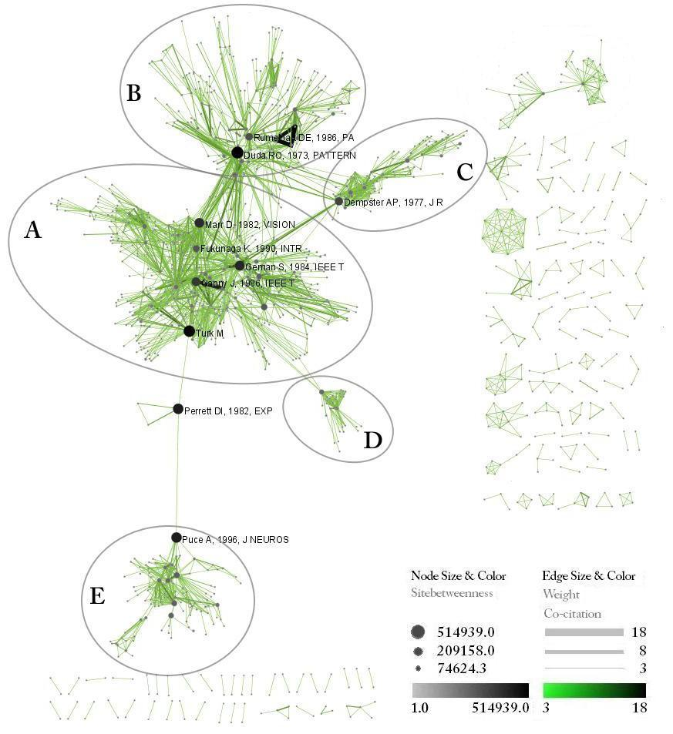
Figure 1: Document co-citation analysis network of “intelligent perception”
Table 2: Major nodes in the document co-citation network of “intelligent perception”
Paper | Times Cited | Degree | Betweenness Centrality
"Duda RO, 1973, PATTERN"  "Turk M, 1991, J COGNIT"  "Perrett DI, 1982, EXP "  "Puce A, 1996, J NEUROS"  "Geman S, 1984, IEEE T "  "Marr D, 1982, VISION"  "Canny J, 1986, IEEE T "  "Dempster AP, 1977, J R"  "Rumelhart DE, 1986, PA"  "Fukunaga K, 1990, INTR" | 70  29  9  7  46  48  39  34  55  19 | 26  25  4  10  45  32  36  19  29  6 | 514,939  480,788  405,114  398,668  357,908  340,533  293,217  247,479  209,158  173,079

It is worth noting that these five seemingly autonomous fields of inquiry in fact are deeply indebted to one another. As Figure 1 shows, areas B, C, D and E connect to area A respectively which reveals that all four areas relate to and are informed by computer vision studies. Science policy makers might like to use these maps to understand the interdependencies of major research areas and to devise appropriate funding and support strategies.

3.3 Burst Analysis
Using the Sci² Tool, burst detection was run on ISI keywords and original keywords which were given by authors. Results are depicted in Figs, 2-4 as a bar chart showing bursting word, burst time, and burst strength. Each burst word is shown as horizontal red bar over time. Bursts with strength above five are colored in dark red, all others are given in light red. Words are sorted by ascending start burst year.
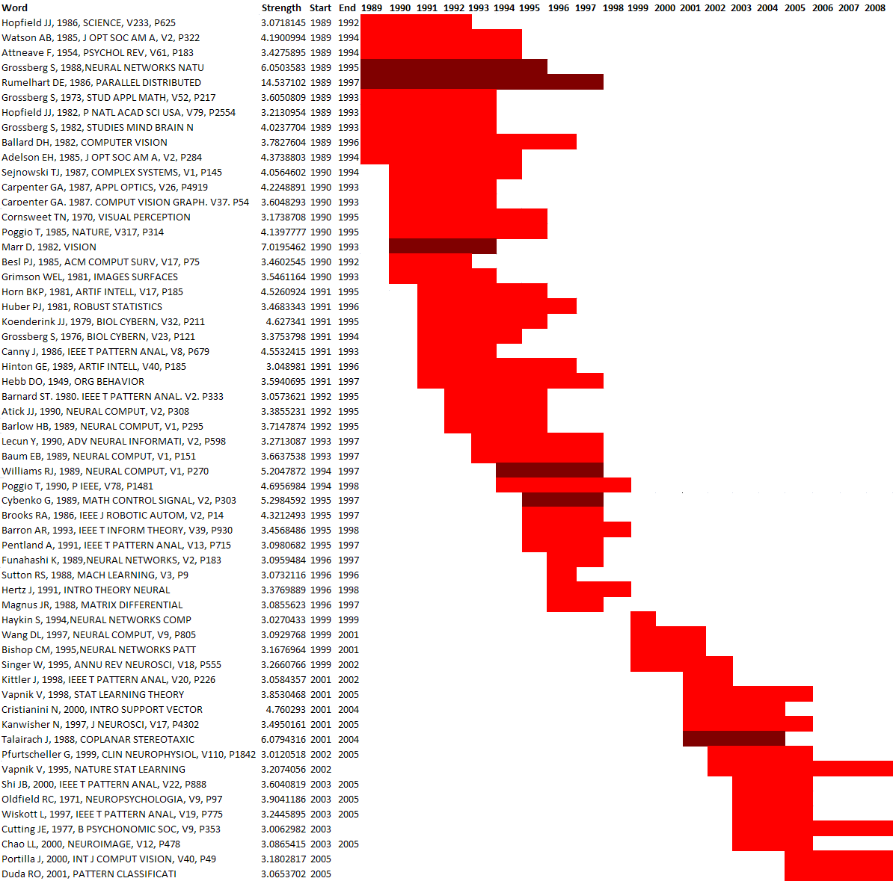
Figure 2: Visual representation of bursting references
Fig 2 shows a total of 59 bursts for cited references that closely resemble research topics previously discussed. There are 27 references about neural network pattern recognition, 17 about computer vision, 10 about brain & cognitive neuroscience study, 4 about robot vision, 1 about digital signal & image processing.
Burst visualization for ISI keywords in Fig 3 indicates two main topics which are computer vision and brain & cognitive neuroscience study. “FMRI” is the only burst which appears twice. It is functional magnetic resonance imaging technology which has been widely applied to brain function research. Many brain science researchers have been engaged in this area and apply FMRI technology to neuroscience study.
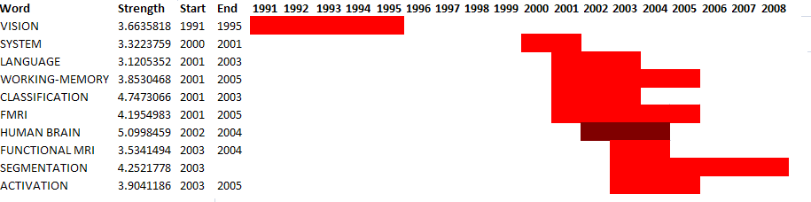
Figure 3: Visual representation of bursting ISI keywords
The visualization of bursts for author provided original keywords in Fig 4 shows that neural network pattern recognition is the main topic which include bursts such as “object recognition”, “neural networks”, “computer vision”, “pattern recognition” and “even-related potentials”. The strongest burst is fMRI starting in 2003.
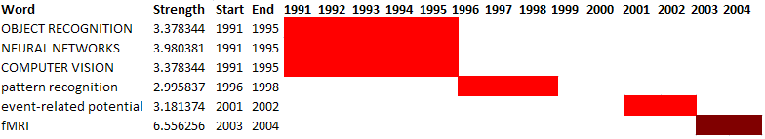
Figure 4: Visual representation of bursting original keywords

From these three burst visualizations, we can see that in early 1990s the primary research areas were pattern recognition, neural networks, and computer vision—and continued to have a dominant role over the last 20 years. “Vapnik V, 1995, NATURE STAT LEARNING”, “Cutting JE, 1977, B PSYCHONOMIC SOC, V9, P353”, “Duda RO, 2001, PATTERN CLASSIFICATI” and “Portilla J, 2000, INT J COMPUT VISION, V40, P49” are four burst references which don’t have an end year. The former three papers are on pattern recognition and neural networks and the last one is on computer vision. It is likely that these topics will be active over several more years. Digital signal & image processing as well as robot vision appeared in the middle of the 1990s, but were not integrated fully into the main research stream of the intelligent perception domain. Toward early 2000s, research interests focused upon brain & cognitive neuroscience study, especially on fMRI technology in medical imaging.

Conclusions
Document co-citation and network analysis together with burst analysis were applied to documents of an intelligent perception data set. The result reveals main research areas and their interconnections but also important shifts in the focus of research in the intelligent perception domain. Computer vision; pattern recognition and neural networks were the main topics for the last twenty years especially for computer vision. They are important research areas in intelligent perception and are closely related to all other major research areas.
Future work will focus on a temporal analysis and animation of the growth of the network. We are also interested to compare research in intelligent perception as performed in the U.S. and China.

Acknowledgements
The authors wish to acknowledge contributions of Mark A. Price, Micah Linnemeier, Elisha F. Hardy, Russell J. Duhon and other colleagues at the Cyberinfrastructure for Network Science Center at Indiana University.
References
- K. Börner, C. Chen, K. Boyack, Visualizing Knowledge Domains. Annual Review of Information Science & Technology, Volume 37：179-355, 2003.
- I. V. Marshakova, System of document connections based on references. Scientific and Technical Information Serial of VINITI, 6, 3-8, 1973.
- H. Small, Co-Citation in Scientific Literature: A New Measure of the Relationship between Publications. JASIS, 24, 265-269, 1973.
- H. Small, E. Greenlee, Collagen Research in the 1970's. Scientometrics, 10, 95-117, 1986.
- E. Garfield, Scientography: Mapping the tracks of science. Current Contents: Social & Behavioral Sciences, 7(45), 5–10, 1994.
- E. Garfield, Sher, I. H., & Torpie, R. J, The use of citation data in writing the history of science. Philadelphia: Institute for Scientific Information, 1964.
- Small H. (1999), Visualizing Science by Citation Mapping, Journal of the American Society for Information Science, Vol. 50(9): 799-813.
- F. Z. Qureshi, Intelligent Perception in Virtual Sensor Network and Space Robotics. Department of Computer Science. Toronto, University of Toronto. Doctor Thesis.
- Editorial, Intelligent and Integrated Problem Solving Systems. Journal of Applied Intelligence, 1: 5-6, 1991.
- Thomson Reuters, ISI Web of Science, http://isiknowledge.com (accessed 9/9/09), 2009.
- Sci² Team, Science of Science Tool. Indiana University and SciTech Strategies Inc., http://sci.slis.indiana.edu, 2009.
- K. Börner, W. Huang, et al, Network Workbench Tool User Manual, 1.0.0 beta. http://nwb.slis.indiana.edu/Docs/NWBTool-Manual.pdf (accessed 9/9/09).
- J. M. Kleinberg, Bursty and Hierarchical Structure in Streams. Paper presented at the 8th ACMSIGKDD International Conference on Knowledge Discovery and Data Mining. ACM Press: 91-101, 2002.
- E. Adar, GUESS: The Graph Exploration System. http://graphexploration.cond.org (accessed 9/9/09), 2007.
- L. C. Freeman, A set of measuring centrality based on betweenness. Sociometry, 40, 35-41, 1977.
- D. Marr, Vision: A Computational Investigation into the Human Representation and Processing of Visual Information. W. H. Freeman and Company, San Fransisco, 1982.
- S. M. German, "Monitoring for deadlock and blocking in Ada tasking" IEEE Trans. Software Eng., vol. SE-10, no. 6, 764-777, Nov. 1984.
- J. F. Canny, A computational approach to edge detection. IEEE Trans. Pattern Anal. Machine Intelligence, vol. PAMI-8, 679-697, 1986.
- M. Turk, Pentland A. Eigenfaces for recognition. Special issue: Face perception. Journal of Cognitive Neuroscience 3, 1, 1991.
- R. O. Duda, Hart, P. F, Pattern Classification and Scene Analysis. Wiley, New York, 1973.
- D. Lusseau, M.E.J. Newman, Identifying the role that individual animals play in their social network. Proc. R. Soc. London B (Suppl.), 271, S477–S481, 2004.
- D. I. Perrett, Rolls E. T., Caan W. Visual neurons responsive to faces in the monkey temporal cortex. Experimental Brain Research, 47, 329-342, 1982.

