Semantic Web Portal: A Platform for Better Browsing and Visualizing Semantic Data
Ying Ding¹, Yuyin Sun¹, Bin Chen², Katy Borner¹, Li Ding³, David Wild², Melanie Wu², Dominic DiFranzo³, Alvaro Graves Fuenzalida³, Daifeng Li¹, Stasa Milojevic¹, ShanShan Chen¹, Madhuvanthi Sankaranarayanan², Ioan Toma⁴

1 School of Library and Information Science, Indiana University,
² School of Computing and Informatics, Indiana University,
47405 Bloomington, IN, USA
³Tetherless World Constellation, Rensselaer Polytechnic Institute, NY, USA
⁴School of Computer Science, University of Innsbruck, Austria
{dingying, yuysun, binchen, katy, djwild, daifeng, madhu, yyqing, chenshan}@indiana.edu; {dingl, agraves, difrad}@cs.rpi.edu; {ioan.toma}@uibk.ac.at
Abstract. One of the main shortcomings of Semantic Web technologies is that there are few user-friendly ways for displaying, browsing and querying semantic data. In fact, the lack of effective interfaces for end users significantly hinders further adoption of the Semantic Web. In this paper, we propose the Semantic Web Portal (SWP) as a light-weight platform that unifies off-the-shelf Semantic Web tools helping domain users organize, browse and visualize relevant semantic data in a meaningful manner. The proposed SWP has been demonstrated, tested and evaluated in several different use cases, such as a middle-sized research group portal, a government dataset catalog portal, a patient health center portal and a Linked Open Data portal for bio-chemical data. SWP can be easily deployed into any middle-sized domain and is also useful to display and visualize Linked Open Data bubbles.
Keywords: Semantic Web data, browsing, visualization
1 Introduction
The current Web is experiencing tremendous changes to its intended functions of connecting information, people and knowledge. It is also facing severe challenges in assisting data integration and aiding knowledge discovery. Among a number of important efforts to develop the Web to its fullest potential, the Semantic Web is central to enhancing human / machine interaction through the representation of data in a machine-readable manner, allowing for better mediation of data and services [1]. The Linked Open Data (LOD) initiative, led by the W3C SWEO Community Project, is representative of these efforts to interlink data and knowledge using a semantic approach. The Semantic Web community is particularly excited about LOD, as it marks a critical step needed to move the document Web to a data Web, toward enabling powerful data and service mashups to realize the Semantic Web vision.
The Semantic Web is perceived to lack user-friendly interfaces to display, browse and query data. Those who are not fluent in Semantic Web technology may have difficulty rendering data in an RDF triple format. Such perceived lack of user-friendly interfaces can hinder further adoption of necessary Semantic Web technologies. D2R server or various SPARQL endpoints display query results in pure triple formats such as DBPedia (e.g., displaying the resource Name: http://dbpedia.org/page/Name) and Chem2Bio2RDF (e.g., displaying the SPARQL query result on “thymidine” as http://chem2bio2rdf.org:2020/snorql/?describe=http%3A%2F%2Fchem2bio2rdf.org%3A2020%2Fresource%2FBindingDBLigand%2F1):they aren’t, however, intuitive and user friendly. Enabling user-friendly data displays, browsing and querying is essential for the success of the Semantic Web. In this paper, we propose a lightweight Semantic Web Portal (SWP) platform to help users, including those unfamiliar with Semantic Web technology, allowing all users to efficiently publish and display their semantic data. This approach generates navigable faceted interfaces allowing users to browse and visualize RDF triples meaningfully. SWP is aligned with similar efforts within medical domains funded by NIH in the USA toward the facilitation of social networking for scientists and facile sharing of medical resources.
The main architecture of the SWP is based upon Longwell (http://simile.mit.edu/wiki/Longwell_User_Guide) and the Exhibit widget (http://simile-widgets.org/exhibit/) from MIT’s SIMILE project (http://simile.mit.edu/). We further extend the system by adding Dynamic SPARQL Query module, Customized Exhibit View module, Semantic Search module and SPARQL Query Builder module to enhance the functionality and portability of the system. This paper is organized as follows: Section 2 discusses related work; Section 3 introduces the SWP infrastructure; Section 4 discusses and exemplifies portal ontology; Section 5 demonstrates four use cases for deploying SWP; Section 6 evaluates and compares SWP to related systems, and; Section 7 presents future work.
2 Related Work
Research on Semantic Web portals began fairly early, in the nascent 2000s. A number of Semantic Web portal designs and implementations were published in research literature such as SEAL (SEmantic portAL) [2] and Semantic Community Portal [3]. Lausen et al [4] provided an extensive survey on a selection of Semantic Web portals published before 2005. Many research groups are currently maintaining their group portals using Semantic Web technologies. For example, Mindswap.org was deployed as “the first OWL-powered Semantic Web site” [5] and Semantic Mediawiki [6] has been used to power several groups’ portals, such as the Institute of Applied Informatics and Formal Description Methods (AIFB, aifb.kit.edu) and Tetherless World Constellation (tw.rpi.edu). Meanwhile, there are many domain-specific Semantic Web portals coming from winners of the “Semantic Web challenge” [7] including CS AKTive Space [8], Museum Finland [9], Multimedia E-Culture demonstrator [10], HealthFinland [11] and TrialX [12]. While these Semantic Web portals are nicely crafted, most of them are too complicated to be replicated by non-specialists. Visualizations are one of the key components of a Semantic Web portal ([13], [14]). There are some general-purpose tools for visually presenting Semantic Web data, including linked data browsers such as Tabulator (http://dig.csail.mit.edu/2005/ajar/ajaw/tab.html) and OpenLink Data Explorer (http://linkeddata.uriburner.com/ode), as well as data mashup tools such as sigma (aggregated instance description, sig.ma) and swoogle (aggregated semantic web term definition, swoogle.umbc.edu). These tools render RDF triples directly via faceted filtering and customized rendering. SIMILE’s Longwell can be used to enable faceted browsing on RDF data, and Exhibit can further enable faceted visualization (e.g., map, timeline). It is notable that these tools differ from information visualization tools, which have more emphasis on rendering data into a graphical format.
3 SWP Architecture
The SWP is a lightweight portal platform to ingest, edit, display, search and visualize semantic data in a user-friendly and meaningful way. It can convert a current portal based on relational databases into a Semantic Web portal, and allows non-Semantic Web users to create a new Semantic Web portal in a reasonable period of time without professional training. Fig. 1 shows the overall architecture, which contains the following main components:

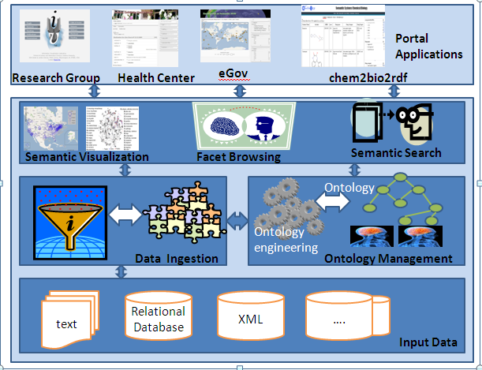
Fig. 1. SWP overall architecture
Data Ingestion (DI) Component: Its main function is to facilitate the conversion of the input data in various formats into RDF triples. It provides different templates and wrappers to handle some common data formats, such as text file, relational databases and Excel sheets. For example, it uses D2R MAP and offers templates to help non-Semantic Web users to semi-automatically create D2R rules to convert their relational data into RDF triples. Ontology Management (OM) Component: Its main function is to enable easy online ontology creation, editing, browsing, mapping and annotation. It is based on Vitro developed by Cornell University [15]. Vitro provides similar functions as Protégé (http://protege.stanford.edu/), but it is online based. Vitro will be further developed and improved by the NIH-funded VIVO project. Faceted Browsing (FB) Component: Based on Longwell, SWP mixes the flexibility of the RDF data model with faceted browsing to enable users to explore complex RDF triples in a user-friendly and meaningful manner. This faceted browser can be multi-filtered, where, for example, for a research group portal, users can browse either all the existing presentations by one research group or only those within one specific year AND at a specific location; for a health center portal, a doctor can know the number of patients who have diabetes AND live in Monroe County, Indiana. Semantic Visualization (SV) Component: It is based on Exhibit developed by MIT Simile project and Network Workbench by the Cyberinfrastructure for Network Science Center at Indiana University ([16], [17], [18]). It displays or visualizes RDF data in tile, timeline, Google map and table formats. It also enables the faceted visualization so that userscan visualize all of the research group members, or only those group members who share common research interests; and Semantic Search (SS) Component: It enables a type-based search that can categorize federated RDF triples into different groups based on ontologies. It is based on Lucene (http://lucene.apache.org/) and integrated with pre-defined portal ontologies to provide type-based searches. For example, if users key in “semantic web” as search query to SWP, they will receive RDF resources which contain the string “semantic web,” wherein these resources are further categorized as person, project, publication, presentation, and event. Subclasses of a Person group can be further categorized into Academic, Staff or Student.
SWP acts as a stand-alone Semantic Web portal platform which can be deployed in any domain or application to input, output, display, visualize and search semantic data. Currently, it has been deployed to: (1) a middle-size research group to semantically manage topics of people, paper, grant, project, presentation and research; (2) a specialty Linked Open Data chem2bio2rdf dataset to display the relationship and association among gene, drug, medicine and pathway data; (3) an eGov dataset to facilitate faceted browsing of governmental data, and; (4) a health center to enable federated patient, disease, medication and family ties to be grouped, associated and networked. For more details, please see Section 5.
4 Portal Ontology
Deploying SWP is domain specific. The user needs to create one or more portal ontologies to convert current relational databases into RDF triples. Creating an appropriate ontology is therefore a critical part of SWP. It should facilitate user queries, and meaningfully display and visualize RDF data. There are some generic requirements for creating ontologies for SWP: 1) the ontology should reflect the database schema of its original datasets; 2) the identified main concepts or relationships from commonly used user queries should be included in ontologies; 3) to enable interoperability, the portal ontologies should try to reuse existing popular ontologies, such as using FOAF to represent people (http://en.wikipedia.org/wiki/FOAF_%28software%29) , using DOAP (http://en.wikipedia.org/wiki/Description_of_a_Project) to represent projects, using Bibontology (http://bibliontology.com/) to represent publications and using SIOC (http://sioc-project.org/) to represent online communities, and; 4) Obeying Linked Open Data (LOD) rules (http://www.w3.org/DesignIssues/LinkedData.html): using HTTP URIs for naming items, making URIs dereferencable and trying to use URIs from other Linked Open Data as much as possible to facilitate easy mapping.
Here we use the Information Networking Ontology Group (INOG) to demonstrate the principle of creating an ontology for research networking of people and sharing medical resources. Part of this ontology group has been implemented in the Research Group Portal use case in Section 5. INOG is one of the efforts funded by NIH and led by University of Florida [19] and Harvard University [20]. It aims to create modularized ontologies to enable a semantic “facebook” for medical scientists to network and share lab resources. The overall INOG framework is shown in Fig. 2. The core part of the framework are the INOG, including the VIVO ontology (modeling research networking) and Eagle-I ontology (modeling medical resources). These two ontologies share some common URIs and map other related URIs, and are aligned with popular ontologies such as FOAF, SIOC, DOAP and BIBO. This enables us to link our data with some existing Linked Open Data sets, such as FOAF, DBPedia and DBLP. Also, in order to model the expertise of scientists and categorize medical resources, we use existing domain ontologies such as MeSH (http://www.ncbi.nlm.nih.gov/mesh), SNOMED (http://www.nlm.nih.gov/research/umls/Snomed/snomed_main.html), Biomedical Resource Ontology (http://bioportal.bioontology.org/visualize/43000) and Ontology for Biomedical Investigation( http://obi-ontology.org/page/Main_Page) to provide categories or controlled vocabularies.

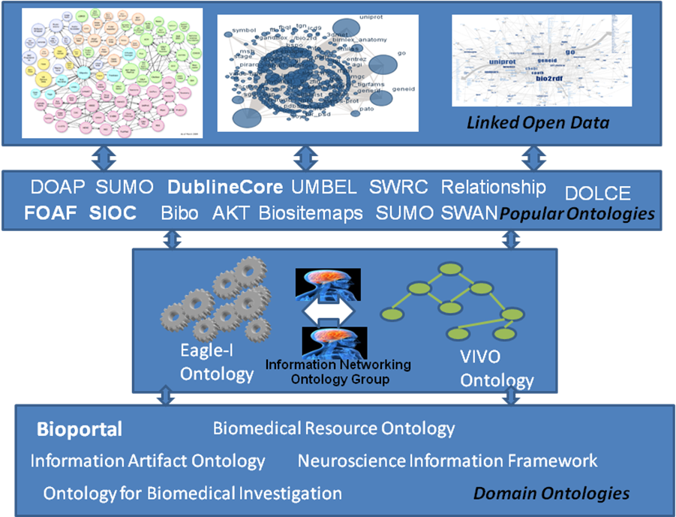
Fig. 2. Information Networking Ontology Group framework
5 Use Cases
In this section, we demonstrate that SWP can be easily deployed to different domains to create various Semantic Web portals.

Research Group Portal
Research Group portals are one of the most common portals used in academic settings. Professors need to manage their research labs, groups or centers in an efficient way to conduct, disseminate and promote their research. The traditional research group websites are normally not easy to maintain, browse and search, especially when the size of groups reaches a certain level. The following use case is based on a mid-size research group (the Information Visualization Lab (IVL) in the School of Library and Information Science at Indiana University Bloomington (http://ivl.slis.indiana.edu/). There are approximately 30 group members, consisting of one professor, several senior research staff and programmers, PhD and master students and hourly students. It has, at any point in time, around ten externally-funded projects, mostly from NIH and NSF. The major activities and datasets for this research group are people, papers, courses, presentations, events, datasets, software, hardware and funding.
Previously all data has been stored in a relational database (e.g., PostgresSQL) with about 20 main tables and more than 50 bridge tables to inter-connect different datasets. One of the major bottlenecks is that it is not simple to harvest all items relating to one entity. For example, it is very difficult to group all information about one group member. Users have to go to the publication page to get information on publications, the presentation page to get information on presentations and the research page to get information on projects. This harvesting limitation also generates the problem of maintaining and updating the data.

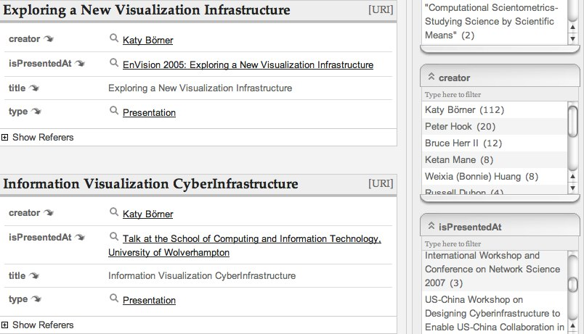 | 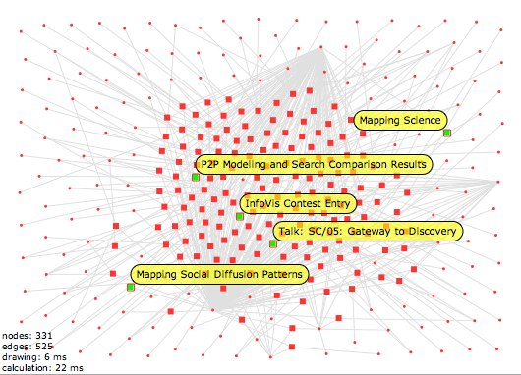
Fig. 3. List view of SWP Fig. 4. Graph view of SWP
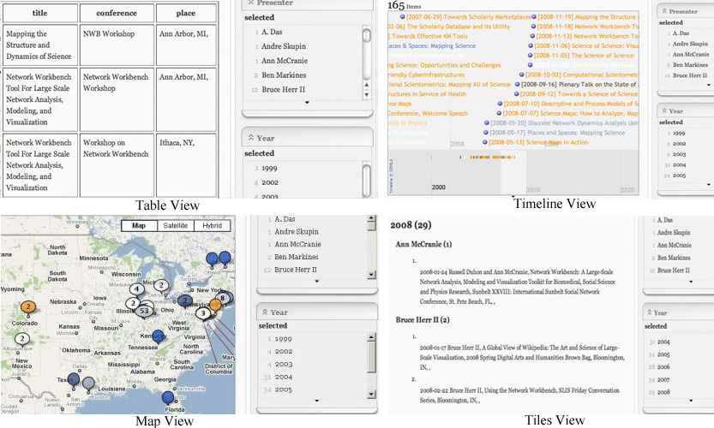
Fig. 5. Screenshots of SWP’s semantic visualization
Using SWP, we create a machine-readable semantic version of this research group portal (http://vivo-onto.slis.indiana.edu/ivl/). We used D2R to convert around 70 relational tables into RDF triples based on the VIVO ontology version 0.9. This portal enables faceted browsing and semantic visualization. For example, by clicking People, users see the list view of federated information for each group member, including his or her publications, presentations, research interest and projects. Using a faceted browser, users can further narrow down their searches. Among all the group members, SWP can display group members who are only interested in the Network Workbench Tool research topic. The default view is List view (see Fig. 3), and Graph view provides basic graph overlay of RDF triples and highlights some nodes with labels (see Fig. 4). Exhibit view contains several view formats, such as tile, timeline, map and table views (see Fig. 5). Tile view groups entities based on multiple criteria, such as grouping presentations based first on year, then on presenter’s last name. Timeline view shows timelines on grouped entities, such as presentations at different time slots. Table view displays entities in table format. Map view uses Google Map to view grouped entities based on locations. All of these views enable faceted visualization so that users, for example, can view presentations in 2005 AND in Indianapolis.
The current semantic search function is very limited. Longwell only provides Lucene text search. Since the People page groups all the related information about one person together, by going to the People page and searching “network,” users can locate people who are interested in “Network Workbench Tool” or who published their papers in “Network Science” conference.
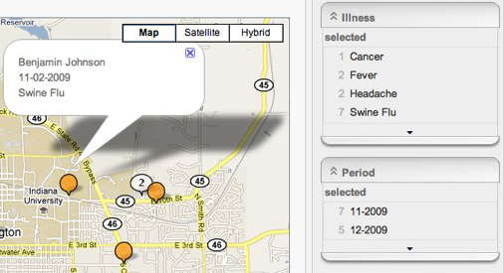 | 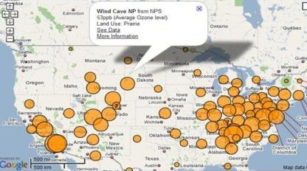
Fig. 6. Screenshots of the Health Center Portal Fig. 7. Screenshots of eGov Portal

Health Center Portal
Indiana University (IU) Health Center (http://healthcenter.indiana.edu/index2.html) provides comprehensive health services to meet the medical and psychological needs of students, spouses and dependents. It serves more than 40,000 potential patients around campus, and each patient can access his or her information online. Doctors and medical staff can pull out the related information about a group of patients from this portal for diagnosis and analysis purposes. It currently uses a relational database and is powered by workflow.com enterprise solutions. IU Health Center data are stored in more than 100 tables and contain information such as person, insurance, medication, clinical document, surgery, immunization, allergies and family ties.
We deployed SWP to IU Health Center and created an easy-to-use Semantic Web portal (see Fig. 6). As it is useful for doctors and staff to look at the overall information at one place, this portal groups together all information related to one patient, such as medication, diagnosis, doctor, disease, location and time factors. The faceted browser allows users to select different criteria by which to view data. For example, the right side of Fig. 6 shows the H1N1 flu patients’ geographical distribution in the Bloomington area. Doctors can further narrow down the geo maps by selecting different time periods or patient status.

eGov Portal
eGov’s current initiative of adopting Semantic Web technology makes converting governmental data into RDF triples and providing meaningful browsing and searching supports essential. In this example, we use Ozone and Visibility data from the EPA’s Castnet project (http://www.epa.gov/castnet/) and convert them into RDF triples. The problem here is that while these datasets have data on Ozone and Visibility for each of the Castnet sites, they do not have data on where these sites are located. Using a second dataset from the EPA’s site (http://www.epa.gov) that has data on the location of each Castnet site, we created this Web application as seen in Fig. 7. In the left side of Fig. 7, yellow dots represent a single Casetnet site and the size of dots corresponds to the average Ozone reading for that site. Users can apply filters to narrow down the results of Castnet sites. When a Castnet site is clicked, a small pop-up opens that displays more information on that site and provides a Web link which takes users to another page. The right side of Fig. 7 displays a timeline for all the Ozone and Visibility data available for that site based on Google Visualization API.

Chem2bio2rdf Portal/Linked Open Data Portal
This use case demonstrates the potential of using SWP to provide better browsing and searching support for some of LOD bubbles. A systems chemical biology network called chem2bio2rdf has been created by integrating bio2rdf and Linking Open Drug Data (LODD) to allow links between compounds, protein, targets, genes and diseases. The chem2bio2rdf contains 18 datasets in the domain of systems chemical biology and is grouped into five categories: chemical (pubchem, ChEBI), chemogenomics (KEGG ligand, CTD chemical, BindingDB, Matador, PubChem BioAssay, QSAR, TTD, DrugBank), biological (UNIPROT), systems (KEGG, Reactome, PPI, DIP), phenotype (OMIM, CTD disease, SIDER) and literature (PubMed). The result is a SPARQL endpoint to support RDF queries (http://chem2bio2rdf.org) and a user-friendly SWP at (http://chem2bio2rdf.org/exhibit/drugbank.html).
6 Evaluation
To evaluate SWP’s usability, we conducted a user evaluation based on 14 users. The survey results demonstrate that semantic web technology provides better integrated information with positive feedback by 78% of our users. As for the faceted browser, more than 57% of users agreed that such function shortens the time they required to find desired information. Additionally, users were very positive about the visualizations function of SWP. Among the 6 methods of visualization available, map view received the highest aggregate score in users’ satisfaction, while graph view the lowest., The survey did reveal limitations to user satisfaction with the SWP., some users felt that too much information is integrated. The predefined filtering conditions need refinement in the faceted-browsing function. users suggested that visualization views should be based on the data type, potential user needs, user system configuration and final output, and currently these views did not match their expectations.
Another evaluation approach is a straightforward comparison of the difference between portals with and without SWP, where we take the afore-mentioned Research Group Portal and chem2bio2rdf Portal as examples. The Research Group Portal comparison demonstrates that the SWP version provides several value-added features (e.g., federating related information about one entity in one place) than the non-SWP version. The second chem2bio2rdf Portal comparison explains that SWP can provide better user-friendly browsing support for Linked Open Data bubbles than normal SPARQL endpoints (see Fig. 8).
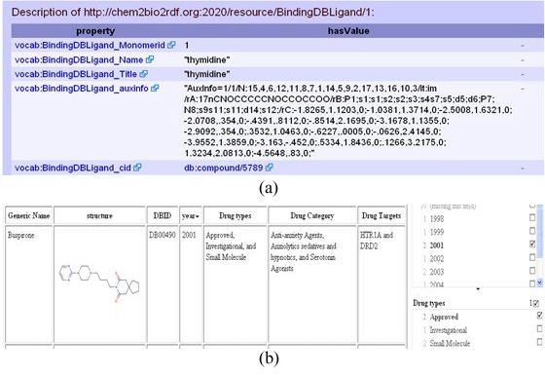
Fig.8. Normal LOD display vs. SWP LOD display
Seven related systems have been identified herein: Disco (http://www4.wiwiss.fu-berlin.de/bizer/ng4j/disco/), Marbles (http://marbles.sourceforge.net/), Zitgist (http://zitgist.com/), Dipper (http://api.talis.com/stores/iand-dev1/items/dipper.html), mSpace (http://mspace.fm/), jSpace (http://www.clarkparsia.com/jspace/), sigma (http://sig.ma), Exhibit (http://www.simile-widgets.org/exhibit/) and Tabular (http://www.w3.org/2005/ajar/tab). We compare SWP with nine systems (see Table 1, Disco (http://www4.wiwiss.fu-berlin.de/bizer/ng4j/disco/), Marbles (http://marbles.sourceforge.net/), Zitgist (http://zitgist.com/), Dipper (http://api.talis.com/stores/iand-dev1/items/dipper.html), mSpace (http://mspace.fm/), jSpace (http://www.clarkparsia.com/jspace), sigma (http://sig.ma), Exhibit (http://www.simile-widgets.org/exhibit/) and Tabular (http://www.w3.org/2005/ajar/tab), where the major function of these systems is to display RDF triples. Except for Dipper and mSpace, these systems only display RDF triples in plain property-value pairs. mSpace provides RSS news style display with headings, pictures and content. Dipper displays RDF triples in plain property-value pairs and provides further categorization of these RDF triples. Sigma allows users to provide feedback on each triple by either accepting or rejecting it. Disco and Marbles only display RDF triples based on the input URI, while the others have their own data sources and ontology. Sigma has the largest data source compared to the others, and also mashes up data from other APIs. Exhibit and Tabular both provide different view types to render the data, such as table view, map view, timeline view. Only mSpace, jSpace and Exhibit provide faceted browsers. In mSpace and jSpace, users can add or delete different facets based on their own needs. None of the systems, however, provide semantic search and visualization. Marble, Zitgist and Tabulator trace data provenance by adding the data source from which the RDF triple is derived. Sigma provides data provenance by allowing users to provide trust of these data sources. Only jSpace provides user-friendly SPARQL template based on the user-selected paths. Tabulator uses the selected data to generate SPARQL query. Through these comparisons, SWP can be enhanced by adding provenance to RDF triples (e.g., Sigma), improving SPARQL query builder (e.g., jSpace) and providing more output formats (e.g., Dipper).
7 Conclusion and Future Work
In this paper, we propose a SWP platform which enables faceted browsing, semantic visualization and semantic search functions of RDF triples. It can be deployed to any domain or application that needs to integrate, federate and share data. It has been tested in several different domains, and requires users to create their own portal ontologies. Some future improvements to this platform include:
- Dynamic SPARQL queries: Currently MIT Simile toolsets (e.g., Exhibit) cannot process dynamic SPARQL queries. It can only read static JSON files. In order to make searching and browsing more interactive, we need to find a way to let Exhibit handle dynamically generated JSON files, mainly via asynchronized service requests;
- Online ontology management: Currently the OM component is not fully integrated from Vitro to SWP,;
- Data ingestion: Currently, SWP only has the read function of RDF triples to display them in different ways. To implement the write function of SWP, data has to be converted separately to become the input of SWP. Also, there is no user-friendly way to let end users add, delete and update their instance data. Vitro provides some good examples for addressing this issue, but the integration of Vitro and SWP has to be investigated;
- Semantic visualization: Currently the semantic visualization of SWP is very limited, with only naïve displays of RDF graphs and labeling nodes. The network analysis is not yet implemented. Future work will be focused on visualizing network and identified paths of the network which are associated with user queries, and;
- Semantic Search: Currently SWP uses Lucene indexing, and the type-based search is very limited. We need to identify a better way to integrate Vitro semantic search with SWP. Meanwhile, we are exploring the potential integration of semantic associations to discover complex relationships in semantic data. As RDF data forms semantic graphs, with nodes and links that have embedded semantics, graph mining technologies can be applied to identify and rank semantic nodes and relationships. By weighing semantics of surrounding nodes and links, semantic associations can be calculated based on ranking of available paths of nodes [21].
This paper addresses the issue of lacking user-friendly displaying and browsing support for semantic data. The Semantic Web is moving successfully from theory development to real data gathering and application building. It is now important to provide user-friendly methods that allow normal users to feel the beauty of semantic data and Semantic Web technologies. This paper confirms that SWP can make Semantic Web meaningful to both Semantic Web specialists and the public. SWP can be easily deployed into any middle-sized domain, and is also useful for displaying and visualizing Linked Open Data bubbles.
Table 1. Comparison of SWP with related systems
 | Disco | Marbles | Zitgist | Dipper | mSpace | jSpace | Sig.ma | Exhibit | Tabulator | SWP
Major functions | Display RDF triples contained in a given URI | Display RDF triples contained in a given URI.  Provide three views: full, summary and photo views | Provide DataViewer and Query Builder for RDF triples | Display RDF triples in a given URI  Categorize properties into several pre-defined classes  Export the output data in different formats: JSON, RDF/XML, Turtle, N-Triple | View data with faceted browser  User can add/delete filters to the faceted browser | Display RDF triples  Provide three views: data, web, and social network views  User-friendly SPAQRL builder through user selected paths | Display RDF triples gathered from crawled sources or other APIs  User can provide their feedback to accept or reject the resources for their own purposes | Display RDF triples in different views, including Tabular View, Timeline View, Map View and Tile View | Browse RDF data and select part of it to display in different views type, such as table, map, calendar, timeline and SPARQL template. | Browse RDF data in different views type, such as list, graph, map, timeline, table. Provide user-friendly SPARQL query builder, semantic search.
Display RDF triples | Purely property-value pair display | Purely property-value pair display | Read all the information available for these entities, and displays it so that users can easily read and understand related, contextual information. | Purely property-value pair display  Classify property-value pairs based on pre-defined categories | User-friendly display RDF triples: RSS news style of display (heading, picssk, and content) | Purely property-value pair display | Purely property-value pair display | Display the data in different views | Display the data in different views. | Display the data in different views.
Have own data and ontology? | No (just displaying data contained in the input URI) | No (mashing up related data from different data sources) | No | Yes | Yes | Yes | Yes (crawl data from web, do not have own ontology) | Yes | No | Yes
Have faceted browser? | No | No | No | No | Yes | Yes | No | Yes | No | Yes
Semantic search | No | No | No | No | No | No | No | No | No | Yes
Visualization | No | No | No | No | No | No | No | Yes | Yes | Yes
Provenance | No | Yes | Yes | No | No | No | Yes | No | Yes | No
User-friendly SPARQL template | No | No | Yes | No | No | Yes | No | No | Yes | Yes

Acknowledgments. This work is funded by NIH VIVO Project (UF09179).
References
1. Berners-Lee, T., Hendler, J., and Lassila, O.: The semantic web: Scientific American. Scientific American (2001)
2. Maedche, A., Staab, S., Stojanovic, N., Studer, R., and Sure, Y.: SEAL - A Framework for Developing SEmantic Web PortALs. In Proceedings of the 18th British National Conference on Databases: Advances in Databases, pp. 1--22 (2001)
3. Staab, S., Angele, J., Decker, S., Erdmann, M., Hotho, A., Maedche, A., Schnurr, H., Studer, R., and Sure, Y.: Semantic community Web portals. Comput. Netw., pp. 473--491 (2006)
4. Lausen,H., Ding, Y., Stollberg, M., Fensel, D., Hernandez, R., and Han,S.: Semantic web portals: state-of-the-art survey. Journal of Knowledge Management, vol. 9(5), pp. 40--49 (2005)
5. Maryland Information and Network Dynamics Lab Semantic Web Agents Project. http://www.mindswap.org/first.shtml (2004)
6. Krötzsch, M.: Semantic Media Wiki. http://semantic-mediawiki.org/wiki/Semantic_MediaWiki (2010)
7. Bizer, C. and Maynard, D.: Semantic Web Challenge. http://challenge.semanticweb.org/ (2010)
8. Schraefel, M.C., Shadbolt N.R., Gibbins, N., Glaser, H. and Harris, S.: CS AKTive Space: Representing Computer Science in the Semantic Web. Proceedings of the 13th International Conference on World Wide Web, pp. 384--392. ACM Press, New York (2004)
9. Hyvönen, E., Junnila, M., Kettula, S., Mäkelä, E., Saarela, S., Salminen, M., Syreeni, A., Valo, A. and Viljanen, K.: Publishing Museum Collections on the Semantic Web: The Museumfinland Portal. Proceedings of the 13th international World Wide Web conference on Alternate track papers & posters, pp. 418--419. ACM Press, New York (2004)
10. MultimediaN N9C Eculture project: Multimedia E-Culture demonstrator. http://e-culture.multimedian.nl/index.shtml
11. Suominen, O., Hyvönen, E., Viljanen, K. and Hukka, E.: HealthFinland-A National Semantic Publishing Network and Portal for Health Information. Web Semantics: Science, Services and Agents on the World Wide Web, 7(4), pp. 287--297 (2009)
12. Applied Informatics, Inc.: TrialX: Enabling Patients to Find New Treatments. http://trialx.com/ (2010)
13. Cole, W. G., Shererta, D. D., Hsu, G., Fagan, L. M., and Carlson, R. W.: Semantic Visualization Of Oncology Knowledge Sources. Proc Annu Symp Comput Appl Med Care, pp. 67--71 (1995)
14. Padgett, T., Maniquis, A., Hoffman, M., Miller, W., and Lautenschlager, J.: A Semantic Visualization Tool for Knowledge Discovery and Exploration in a Collaborative Environment. https://analysis.mitre.org/proceedings/Final_Papers_Files/171_Camera_Ready_Paper.pdf
15. Devare, M., Corson-Rikert, J., Caruso, B., Lowe, B., Chiang, K. and McCue, J.: VIVO: Connecting People, Creating a Virtual Life Sciences Community. D-Lib Magazine, 13(7/8). http://www.dlib.org/dlib/july07/devare/07devare.html (2007).
16. Bruce, H., Huang, W., Penumarthy, S., and Börner, K.: Designing Highly Flexible and Usable Cyberinfrastructures for Convergence. In Bainbridge, William S. & Roco, Mihail C. (Eds.), Progress in Convergence - Technologies for Human Wellbeing vol. 1093, MA: Annals of the New York Academy of Sciences, pp. 161--179, Boston (2007)
17. Neirynck, T. and Börner, K.: Representing, Analyzing, and Visualizing Scholarly Data in Support of Research Management. Proceedings of the 11th Annual Information Visualization International Conference, IEEE Computer Society Conference Publishing Services, pp. 124--129, Zürich, Switzerland (2007)
18. NWB Team: Network Workbench Tool. http://nwb.slis.indiana.edu
19. Conlon, M.W.: VIVO: Engabling National Networking of Scientists. University of Florida, Cornell University, Indiana University, Washington University of St. Louis, Ponce School of Medicine, Weill Cornell Medical College, The Scripps Research Institute: NIH/NCRR, 1U24RR029822-01 (2009)
20. Nadler, M.D., Marshall, L.: Networking Research Resources Across America (Eagle-I project). Harvard Medical School, Dartmouth College, Jackson State Univesity, Morehouse School of Medicine, Montana State University, Oregon Health and Science University, University of Alaska Fairbanks, University of Hawaii Manoa, University of Puerto Rico: NIH CTSA (2009)
21. Anyanwu, K., Maduko, A. and Sheth, A.: SemRank: ranking complex relationship search results on the semantic web. In Proceedings of the 14th international conference on World Wide Web, pp. 117--127 (2005)

