1.Write a C program that contains a String (char) with a value hello world. The program should XOR each character in this string with 0 and display the result.

Program:

#include <stdio.h>

#include <string.h>

#include <math.h>

void main(){

char str[]="hello world";

int i;

int len=strlen(str);

for(i=0;i<len;i++){

char result=str[i]^0;

printf("%c",result);

}

}

Output:

hello world

1. .Write a C program that contains a String (char) with a value hello world. The program should AND and XOR each character in this string with 127 and display the result.

Program:

#include <stdio.h>

#include <string.h>

#include <math.h>

void main(){

char str[]="hello world";

int i;

int len=strlen(str);

for(i=0;i<len;i++){

char and=str[i]&127;

char or=str[i]&127;

char xor=str[i]^127;

printf("and:%c\t, or:%c\t,xor:%c\n",and,or,xor );

}

}

Output:

and:h , or:h ,xor:

and:e , or:e ,xor:

and:l , or:l ,xor:

and:l , or:l ,xor:

and:o , or:o ,xor:_x0010_

and: , or: ,xor:_

and:w , or:w ,xor:

and:o , or:o ,xor:_x0010_

and:r , or:r ,xor:

and:l , or:l ,xor:

and:d , or:d ,xor:

1. a) Write a java program to implement Caesar cipher.

Program:

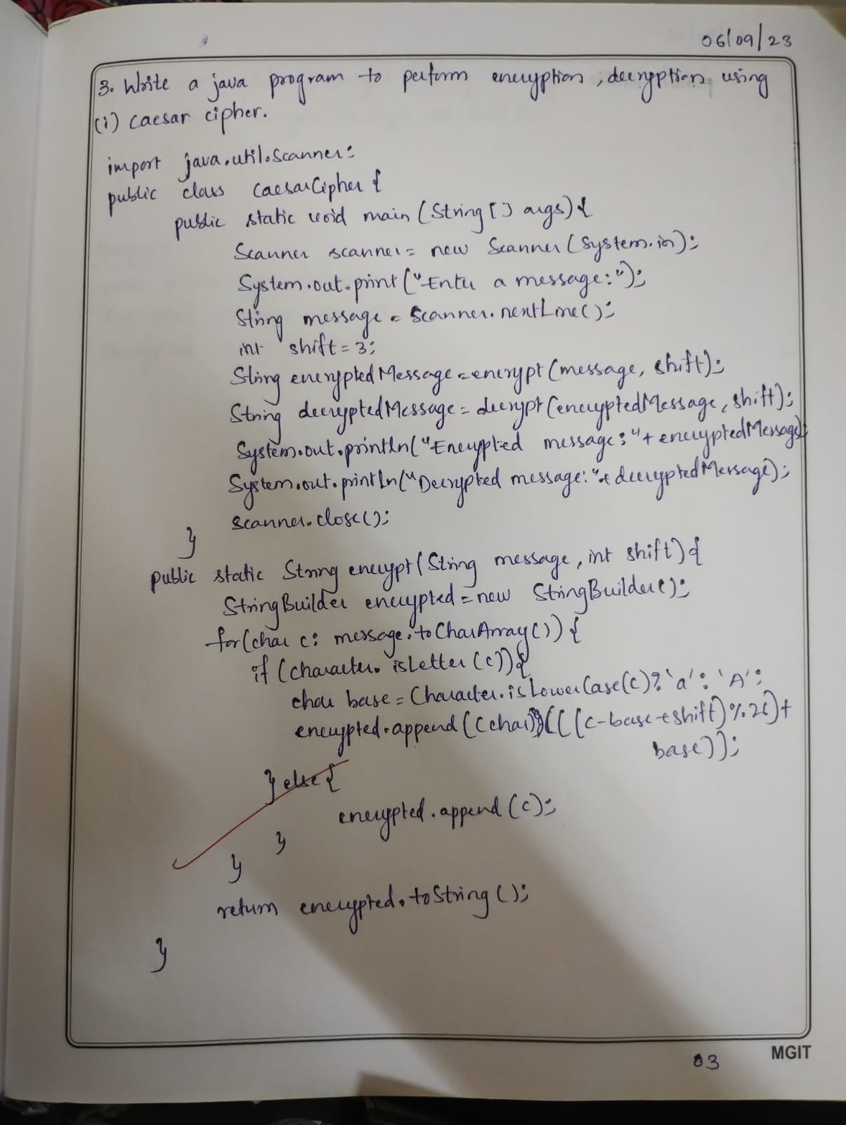

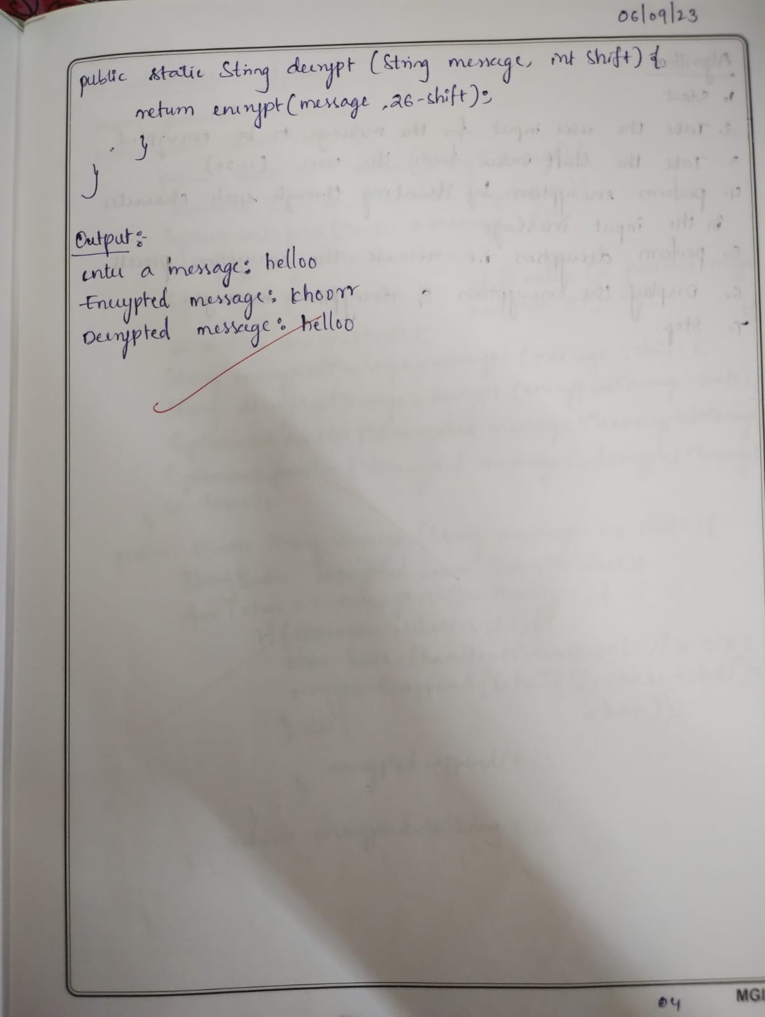

3.b)Write a java program to implement substitution cypher.

Program:

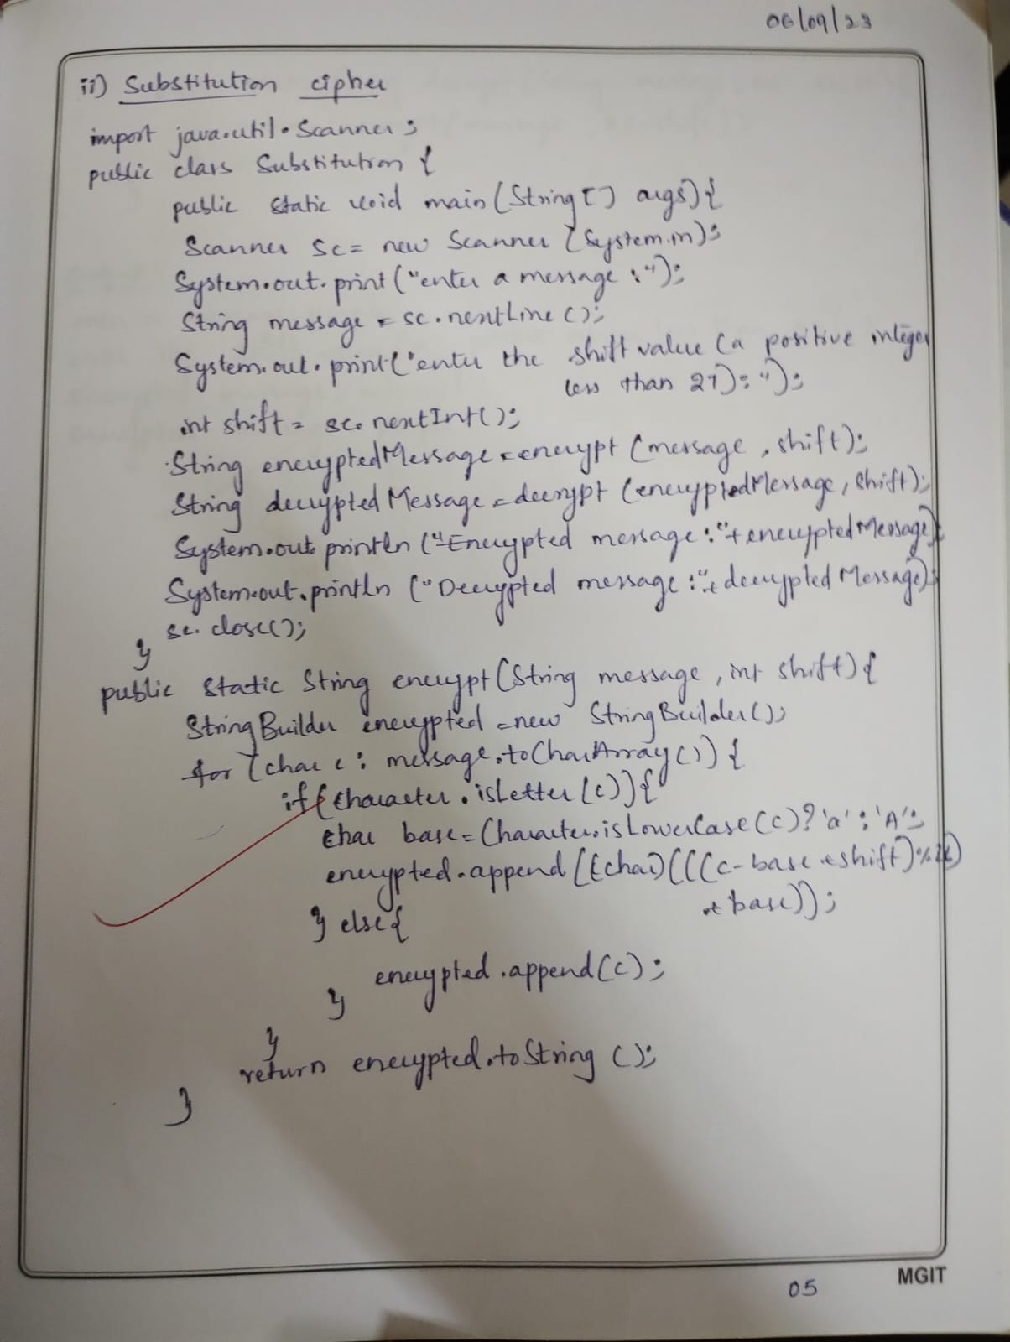

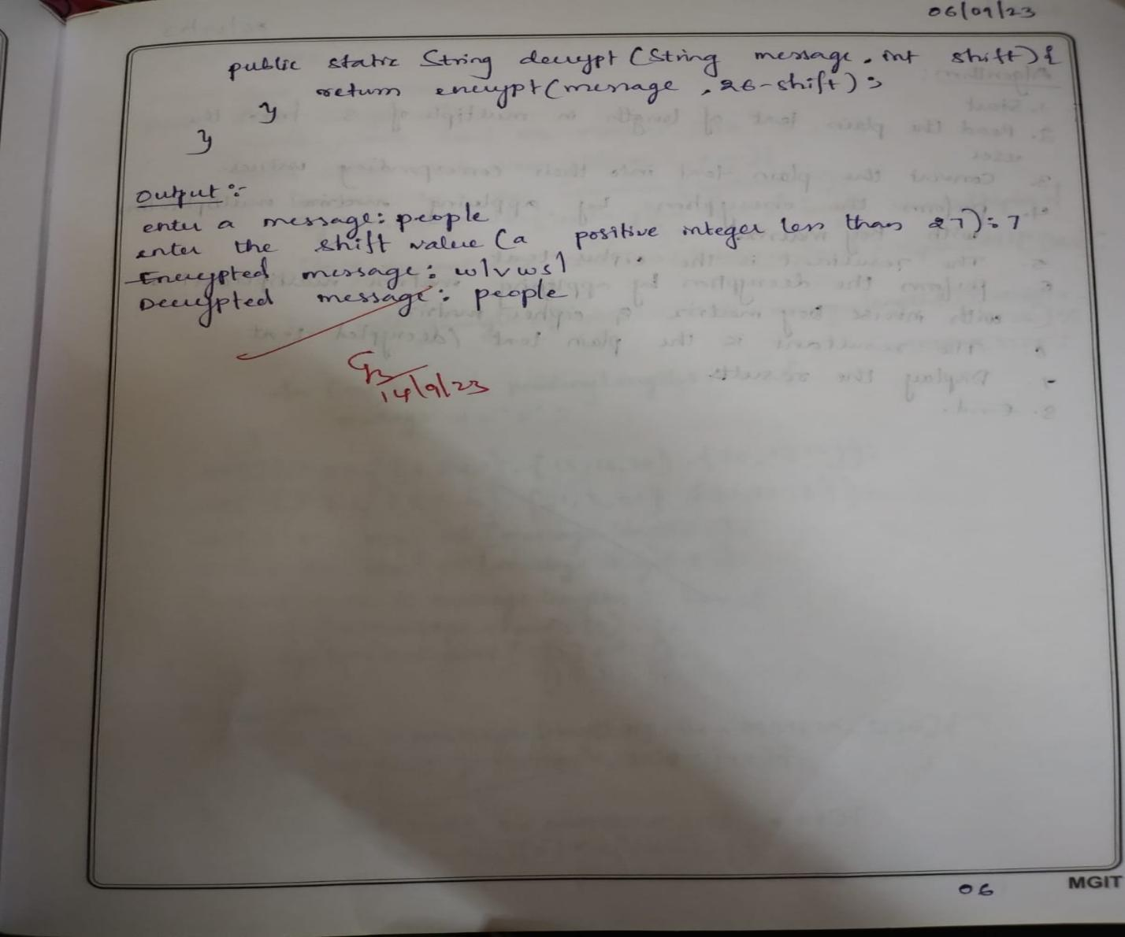

3.c)Write a java program to implement hill cypher.

import java.util.*;

import java.io.BufferedReader;

import java.io.IOException;

import java.io.InputStreamReader;

public class HillCipherExample

{

int[] l_m;

int[][] k_m;

int[] r_m;

static int ch;

int [][] nk;

public void perf_Division(String t, int str)

{

while (t.length() > str)

{

String l = t.substring(0, str);

t = t.substring(str, t.length());

calLineMatrix(l);

if(ch ==1)

{

multiplyLineByKey(l.length());

}

else

{

multiplyLineByInvKey(l.length());

}

showResult(l.length());

}

if (t.length() == str)

{

if(ch ==1)

{

calLineMatrix(t);

multiplyLineByKey(t.length());

showResult(t.length());

}

else

{

calLineMatrix(t);

this.multiplyLineByInvKey(t.length());

showResult(t.length());

}

}

else if (t.length() < str)

{

for (int i = t.length(); i < str; i++)

t = t + 'x';

if(ch ==1)

{

calLineMatrix(t);

multiplyLineByKey(t.length());

showResult(t.length());

}

else

{

calLineMatrix(t);

multiplyLineByInvKey(t.length());

showResult(t.length());

}

}

}

public void calKeyMatrix(String key, int len)

{

k_m = new int[len][len];

int k = 0;

for (int i = 0; i < len; i++)

{

for (int j = 0; j < len; j++)

{

k_m[i][j] = ((int) key.charAt(k)) - 97;

k++;

}

}

}

public void calLineMatrix(String l)

{

l_m = new int[l.length()];

for (int i = 0; i < l.length(); i++)

{

l_m[i] = ((int) l.charAt(i)) - 97;

}

}

public void multiplyLineByKey(int len)

{

r_m = new int[len];

for (int i = 0; i < len; i++)

{

for (int j = 0; j < len; j++)

{

r_m[i] += k_m[i][j] * l_m[j];

}

r_m[i] %= 26;

}

}

public void multiplyLineByInvKey(int len)

{

r_m = new int[len];

for (int i = 0; i < len; i++)

{

for (int j = 0; j < len; j++)

{

r_m[i] += nk[i][j] * l_m[j];

}

r_m[i] %= 26;

}

}

public void showResult(int len)

{

String result = "";

for (int i = 0; i < len; i++)

{

result += (char) (r_m[i] + 97);

}

System.out.print(result);

}

public int calDeter_minant(int A[][], int N)

{

int resultOfDet;

switch (N)

{

case 1: resultOfDet = A[0][0];

break;

case 2: resultOfDet = A[0][0] * A[1][1] - A[1][0] * A[0][1];

break;

default: resultOfDet = 0;

for (int j1 = 0; j1 < N; j1++)

{

int m[][] = new int[N - 1][N - 1];

for (int i = 1; i < N; i++)

{

int j2 = 0;

for (int j = 0; j < N; j++)

{

if (j == j1)

continue;

m[i - 1][j2] = A[i][j];

j2++;

}

}

resultOfDet += Math.pow(-1.0, 1.0 + j1 + 1.0) * A[0][j1]* calDeter_minant(m, N - 1);

}

break;

}

return resultOfDet;

}

public void cofact(int num[][], int f)

{

int b[][], fac[][];

b = new int[f][f];

fac = new int[f][f];

int p, q, m, n, i, j;

for (q = 0; q < f; q++)

{

for (p = 0; p < f; p++)

{

m = 0;

n = 0;

for (i = 0; i < f; i++)

{

for (j = 0; j < f; j++)

{

b[i][j] = 0;

if (i != q && j != p)

{

b[m][n] = num[i][j];

if (n < (f - 2))

n++;

else

{

n = 0;

m++;

}

}

}

}

fac[q][p] = (int) Math.pow(-1, q + p) * calDeter_minant(b, f - 1);

}

}

trans(fac, f);

}

void trans(int fac[][], int r)

{

int i, j;

int b[][], inv[][];

b = new int[r][r];

inv = new int[r][r];

int d = calDeter_minant(k_m, r);

int mi = mi(d % 26);

mi %= 26;

if (mi < 0)

mi += 26;

for (i = 0; i < r; i++)

{

for (j = 0; j < r; j++)

{

b[i][j] = fac[j][i];

}

}

for (i = 0; i < r; i++)

{

for (j = 0; j < r; j++)

{

inv[i][j] = b[i][j] % 26;

if (inv[i][j] < 0)

inv[i][j] += 26;

inv[i][j] *= mi;

inv[i][j] %= 26;

}

}

nk = inv;

}

public int mi(int d)

{

int q, r1, r2, r, t1, t2, t;

r1 = 26;

r2 = d;

t1 = 0;

t2 = 1;

while (r1 != 1 && r2 != 0)

{

q = r1 / r2;

r = r1 % r2;

t = t1 - (t2 * q);

r1 = r2;

r2 = r;

t1 = t2;

t2 = t;

}

return (t1 + t2);

}

public void matrixtoinvkey(int inv[][], int n)

{

String invkey = "";

for (int i = 0; i < n; i++)

{

for (int j = 0; j < n; j++)

{

invkey += (char) (inv[i][j] + 97);

}

}

System.out.print(invkey);

}

public boolean check(String key, int len)

{

calKeyMatrix(key, len);

int d = calDeter_minant(k_m, len);

d = d % 26;

if (d == 0)

{

System.out.println("Key is not invertible");

return false;

}

else if (d % 2 == 0 || d % 13 == 0)

{

System.out.println("Key is not invertible");

return false;

}

else

{

return true;

}

}

public static void main(String args[]) throws IOException

{

HillCipherExample obj = new HillCipherExample();

BufferedReader in = new BufferedReader(new InputStreamReader(System.in));

System.out.println("Menu:\n1: Encryption\n2: Decryption");

ch = Integer.parseInt(in.readLine());

System.out.println("Enter the line: ");

String l = in.readLine();

System.out.println("Enter the key: ");

String key = in.readLine();

double sq = Math.sqrt(key.length());

if (sq != (long) sq)

System.out.println("Cannot For_m a square matrix");

else

{

int size = (int) sq;

if (obj.check(key, size))

{

System.out.println("Result:");

obj.cofact(obj.k_m, size);

obj.perf_Division(l, size);

}

}

}

}

Output:

Menu:

1: Encryption

2: Decryption

1

Enter the line:

pree

Enter the key:

hill

Result:

hoik

Menu:

1: Encryption

2: Decryption

2

Enter the line:

hoik

Enter the key:

hill

Result:

Pree

Menu:

1: Encryption

2: Decryption

1

Enter the line:

pree

Enter the key:

hain

Key is not invertible

4.Write a java program to implement DES Algorithm.

import java.util.*;

import java.io.BufferedReader;

import java.io.InputStreamReader;

import java.security.spec.KeySpec;

import javax.crypto.Cipher;

import javax.crypto.SecretKey;

import javax.crypto.SecretKeyFactory;

import javax.crypto.spec.DESedeKeySpec;

import sun.misc.BASE64Decoder;

import sun.misc.BASE64Encoder;

public class DES

{

private static final String UNICODE_FORMAT = "UTF8";

public static final String DESEDE_ENCRYPTION_SCHEME = "DESede";

privateKeySpec myKeySpec;

privateSecretKeyFactory mySecretKeyFactory;

private Cipher cipher;

byte[] keyAsBytes;

private String myEncryptionKey;

private String myEncryptionScheme;

SecretKey key;

static BufferedReader br = new BufferedReader(new InputStreamReader(System.in)); public DES() throws Exception

{

// TODO code application logic here

myEncryptionKey = "ThisIsSecretEncryptionKey";

myEncryptionScheme =DESEDE_ENCRYPTION_SCHEME;

keyAsBytes = myEncryptionKey.getBytes(UNICODE_FORMAT); myKeySpec= new DESedeKeySpec(keyAsBytes);

mySecretKeyFactory = SecretKeyFactory.getInstance(myEncryptionScheme);

cipher = Cipher.getInstance(myEncryptionScheme);

key = mySecretKeyFactory.generateSecret(myKeySpec);

}

public String encrypt(String unencryptedString)

{

String encryptedString = null;

try

{

cipher.init(Cipher.ENCRYPT_MODE, key);

byte[] plainText = unencryptedString.getBytes(UNICODE_FORMAT);

byte[] encryptedText = cipher.doFinal(plainText);

BASE64Encoder base64encoder = new BASE64Encoder();

encryptedString = base64encoder.encode(encryptedText);

}

catch (Exception e)

{

e.printStackTrace();

}

return encryptedString;

}

public String decrypt(String encryptedString)

{

String decryptedText=null;

try

{

cipher.init(Cipher.DECRYPT_MODE, key);

BASE64Decoder base64decoder = new BASE64Decoder();

byte[] encryptedText = base64decoder.decodeBuffer(encryptedString);

byte[] plainText = cipher.doFinal(encryptedText);

decryptedText=bytes2String(plainText);

}

catch (Exception e)

{

e.printStackTrace();

}

return decryptedText;

}

private static String bytes2String(byte[] bytes)

{

StringBufferstringBuffer = new StringBuffer();

for (int i = 0; i <bytes.length;i++)

{

stringBuffer.append((char) bytes[i]);

}

return stringBuffer.toString();

}

public static void main(String args []) throws Exception

{

System.out.print("Enter the string: ");

DES myEncryptor= new DES();

String stringToEncrypt = br.readLine();

String encrypted = myEncryptor.encrypt(stringToEncrypt);

String decrypted = myEncryptor.decrypt(encrypted); System.out.println("\nString To Encrypt: " +stringToEncrypt); System.out.println("\nEncrypted Value : " +encrypted);

System.out.println("\nDecrypted Value : " +decrypted);

System.out.println("");

}

}

Output:

Enter the string: Welcome

String To Encrypt: Welcome

Encrypted Value : BPQMwc0wKvg

Decrypted Value : Welcome

5.Write a C/JAVA program to implement the Rijndael algorithm logic.

import java.security.*;

import javax.crypto.*;

import javax.crypto.spec.*;

import java.io.*;

public class AES

{

public static String asHex (byte buf[])

{

StringBuffer strbuf = new StringBuffer(buf.length * 2);

int i;

for (i = 0; i < buf.length; i++)

{ if (((int) buf[i] & 0xff) < 0x10)

strbuf.append("0");

strbuf.append(Long.toString((int) buf[i] & 0xff, 16));

}

return strbuf.toString();

}

public static void main(String[] args) throws Exception

{

String message="AES still rocks!!";

// Get the KeyGenerator

KeyGenerator kgen = KeyGenerator.getInstance("AES");

kgen.init(128);

// 192 and 256 bits may not be available // Generate the secret key specs.

SecretKey skey = kgen.generateKey();

byte[] raw = skey.getEncoded();

SecretKeySpec skeySpec = new SecretKeySpec(raw, "AES");

// Instantiate the cipher

Cipher cipher = Cipher.getInstance("AES");

cipher.init(Cipher.ENCRYPT_MODE, skeySpec);

byte[] encrypted = cipher.doFinal((args.length == 0 ? message : args[0]).getBytes());

System.out.println("encrypted string: " + asHex(encrypted));

cipher.init(Cipher.DECRYPT_MODE, skeySpec);

byte[] original = cipher.doFinal(encrypted);

String originalString = new String(original);

System.out.println("Original string: " + originalString + " " + asHex(original));

}

}

Output:

encrypted string: 0595ea453df14e433abe1c0712632d55641af5c25e8c7092b03947163132977e

Original string: AES still rocks!! 414553207374696c6c20726f636b732121

6.Write a java program to implement Blowfish algorithm.

import javax.crypto.Cipher;

import javax.crypto.KeyGenerator;

import javax.crypto.SecretKey;

import javax.crypto.spec.SecretKeySpec;

import java.util.Scanner;

public class BlowFish {

public static void main(String[] args) {

try {

// Get the KeyGenerator

KeyGenerator kgen = KeyGenerator.getInstance("Blowfish");

Cipher cipher = Cipher.getInstance("Blowfish");

// Generate the secret key

SecretKey skey = kgen.generateKey();

byte[] raw = skey.getEncoded();

SecretKeySpec skeySpec = new SecretKeySpec(raw, "Blowfish");

cipher.init(Cipher.ENCRYPT_MODE, skeySpec);

// Input message from the user via command line

Scanner scanner = new Scanner(System.in);

System.out.print("Input your message: ");

String inputText = scanner.nextLine();

byte[] encrypted = cipher.doFinal(inputText.getBytes());

// Decrypt the encrypted message

cipher.init(Cipher.DECRYPT_MODE, skeySpec);

byte[] decrypted = cipher.doFinal(encrypted);

// Display the encrypted and decrypted messages

System.out.println("\nOriginal text: " + inputText +

"\n\nEncrypted text: " + new String(encrypted) +

"\n\nDecrypted text: " + new String(decrypted)

);

scanner.close();

} catch (Exception e) {

e.printStackTrace();

}

}

}

OUTPUT:

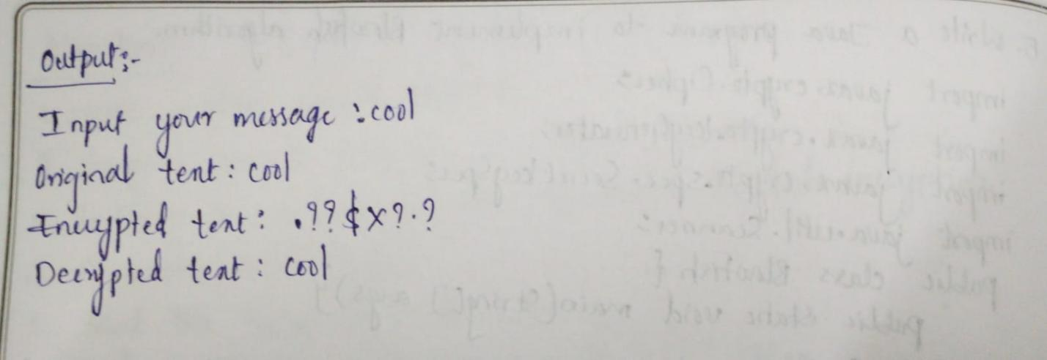

7.Write a Java Program to implement RSA-Algorithm.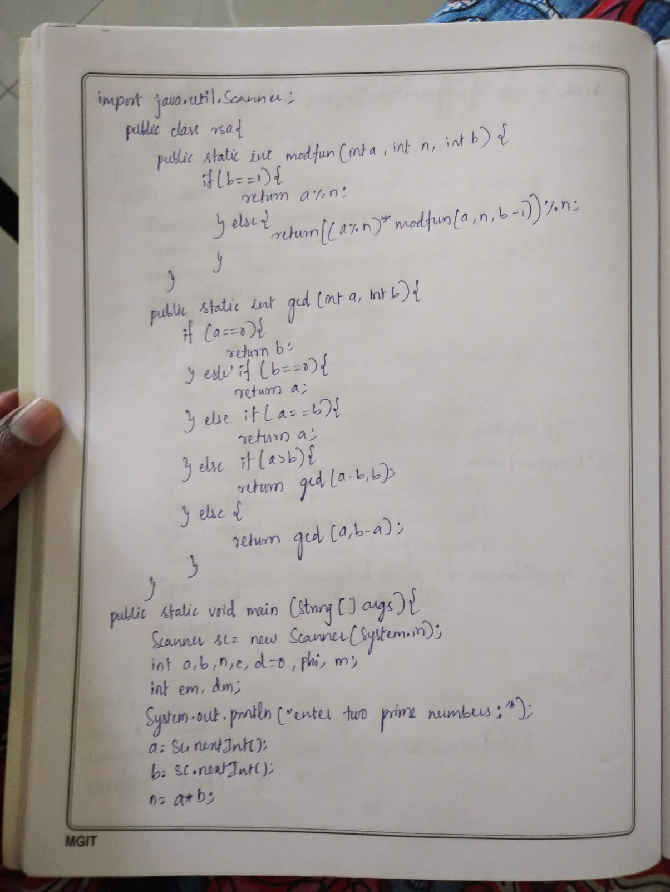

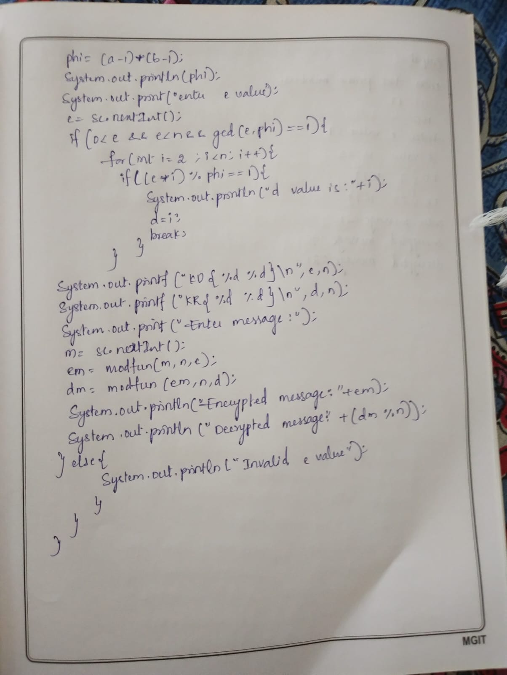

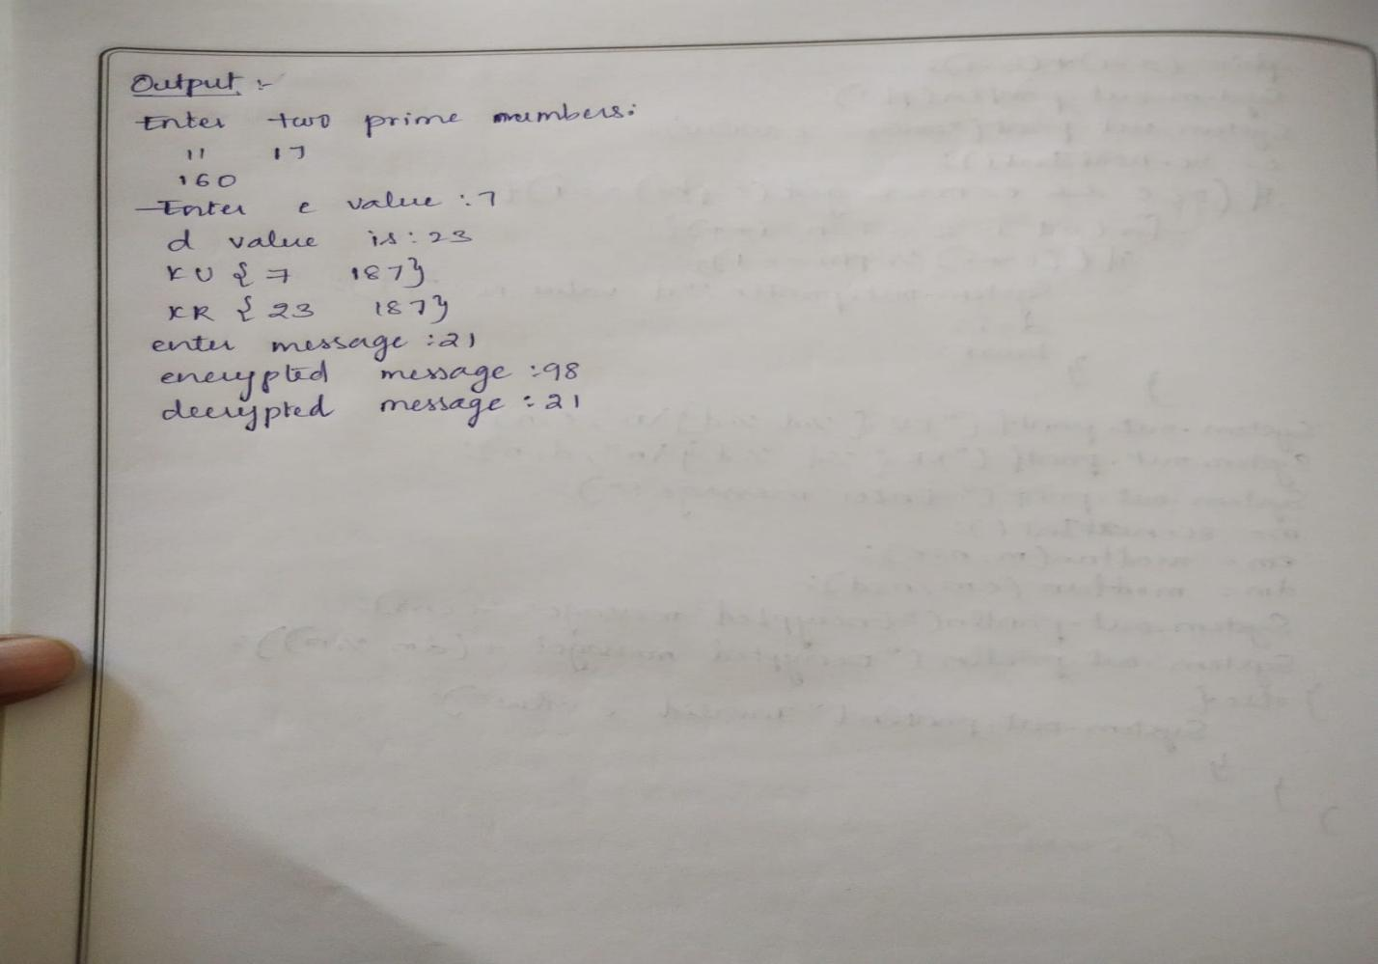

8.Implement Diffie-hellman key exchange mechanism using html & javascript.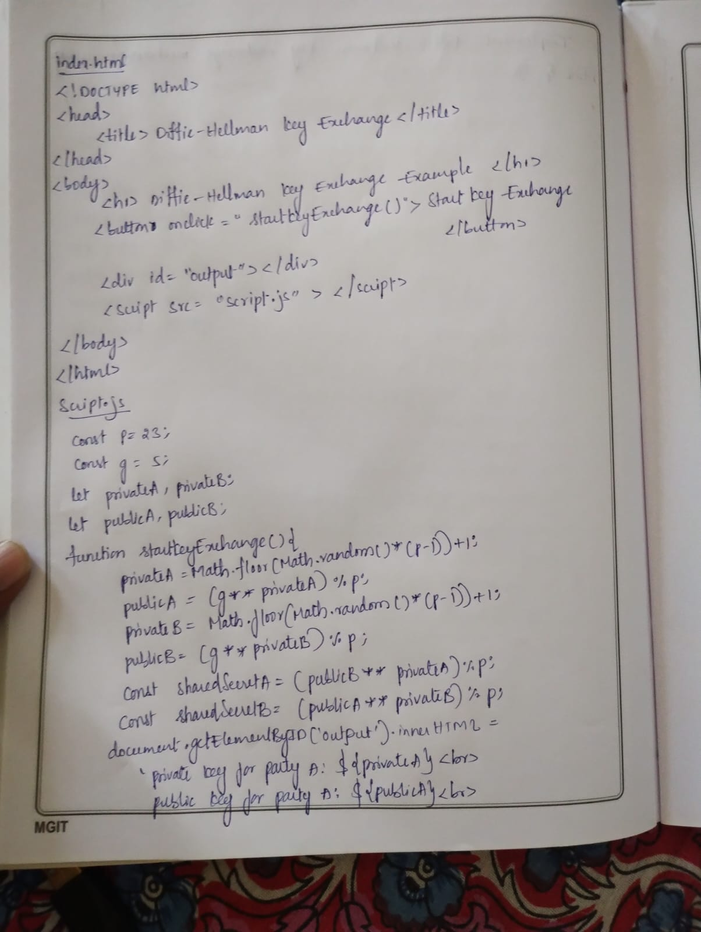

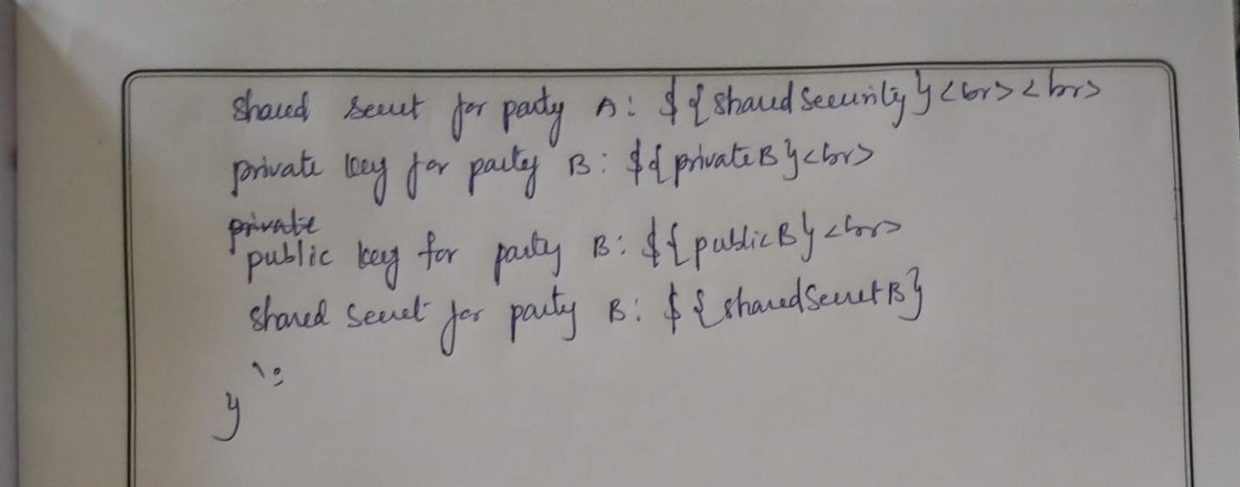

9.Calculate the Message digest of a text using SHA-1 algorithm in java.

import java.security.*;

import java.util.*;

class JceSha1Test {

   public static void main(String[] *a*) {

*try* {

         MessageDigest md = MessageDigest.getInstance("SHA1");

         String input = "";

         md.update(input.getBytes());

         byte[] output = md.digest();

         System.out.println();

         System.out.println("SHA1(\""+input+"\") =");

         System.out.println("   "+bytesToHex(output));

         Scanner sc=*new* Scanner(System.in);

         System.out.println("enter the message:");

         String str=sc.nextLine();

         md.update(str.getBytes());

         output = md.digest();

         System.out.println();

         System.out.println("SHA1(\""+str+"\") =");

         System.out.println("   "+bytesToHex(output));

      } *catch* (Exception *e*) {

         System.out.println("Exception: "+e);

      }

   }

   public static String bytesToHex(byte[] *b*) {

      char hexDigit[] = {'0', '1', '2', '3', '4', '5', '6', '7',

                         '8', '9', 'A', 'B', 'C', 'D', 'E', 'F'};

      StringBuffer buf = *new* StringBuffer();

*for* (int j=0; j<b.length; j++) {

         buf.append(hexDigit[(b[j] >> 4) & 0x0f]);

         buf.append(hexDigit[b[j] & 0x0f]);

      }

*return* buf.toString();

   }

}

OUTPUT*:*

SHA1("") =

DA39A3EE5E6B4B0D3255BFEF95601890AFD80709

enter the message*:*

hello

SHA1("hello") =

AAF4C61DDCC5E8A2DABEDE0F3B482CD9AEA9434D

10.Calculate the Message digest of a text using MD-5 algorithm In java.

import java.math.BigInteger;

import java.security.MessageDigest;

import java.security.NoSuchAlgorithmException;

import java.util.*;

*// Java program to calculate MD5 hash value*

public class MD5 {

    public static String getMd5(String *input*)

    {

*try* {

*// Static getInstance method is called with hashing MD5*

            MessageDigest md = MessageDigest.getInstance("MD5");

*// digest() method is called to calculate message digest*

*// of an input digest() return array of byte*

            byte[] messageDigest = md.digest(input.getBytes());

*// Convert byte array into signum representation*

            BigInteger no = *new* BigInteger(1, messageDigest);

*// Convert message digest into hex value*

            String hashtext = no.toString(16);

*while* (hashtext.length() < 32) {

                hashtext = "0" + hashtext;

            }

*return* hashtext;

        }

*// For specifying wrong message digest algorithms*

*catch* (NoSuchAlgorithmException *e*) {

*throw* *new* RuntimeException(e);

        }

    }

*// Driver code*

    public static void main(String *args*[]) throws NoSuchAlgorithmException

    {

        Scanner sc=*new* Scanner(System.in);

        System.out.println("enter the plain text:");

        String s = sc.nextLine();

        System.out.println("Your HashCode Generated by MD5 is: " + getMd5(s));

    }

}

OUTPUT*:*

enter the plain text*:*

super

Your HashCode Generated by MD5 is*:* 1b3231655cebb7a1f783eddf27d254ca