COMP-SCI 5551 (FS15) - Advance Software Engineering

Project Group 5: *Cuong Cu*, *Tarun Shedhani*, *Ting Xia*

**First increment report - HealthKeeper**

# Research

Research contains six parts:

1. Nutrition API: Research on open public APIs to calculate food nutrition information.
2. Development framework: Finalize development frameworks, databases, and tools that we are going to use.
3. Overweight detection: Research on detection of overweight.

* Formulas of BMI (Body mass index) calculation:
* BMI = weight (lb) / [height (in)]2 x 703
* BMI = weight (kg) / [height (m)]2
* Medical related information:
  + Weight - weekly collect
  + Height - weekly collect
  + Gender - from user account when they register
  + Age - from user account when they register
* Diagnosis:

NOTE: This is only used for adults > 20 years old. For children between 2-20, this diagnosis cannot be applied.

* + BMI Below 18.5 <-----> Underweight
  + BMI 18.5 – 24.9 <-----> Normal weight
  + BMI 25.0 – 29.9 <-----> Overweight
  + BMI 30.0 and Above <-----> Obese

1. Recommended daily kilocalorie intake: Research on calculation of BMR basal (metabolic rate) and suggested kilocalorie intake.

* BMR calculation:
  + Men:

(Metric) BMR = 88.362 + (13.397 x weight in kg) + (4.799 x height in cm) - (5.677 x age in years)

(Imperial) BMR = 88.362 + (6.077 x weight in pounds) + (12.189 x height in inch) - (5.677 x age in years)

* + Women:

(Metric) BMR = 447.593 + (9.247 x weight in kg) + (3.098 x height in cm) - (4.330 x age in years)

(Imperial) BMR = 447.593 + (4.194 x weight in pounds) + (7.869 x height in inch) - (4.330 x age in years)

* Recommended daily kilocalorie intake:
  + Little to no exercise <-----> BMR x 1.2
  + Light exercise (1–3 days per week) <-----> BMR x 1.375
  + Moderate exercise (3–5 days per week) <-----> BMR x 1.55
  + Heavy exercise (6–7 days per week) <-----> BMR x 1.725
  + Very heavy exercise (twice per day, extra heavy workouts) <-----> BMR x 1.9

1. Hypertension detection: Research on detection of hypertension.

* Two parameters to be measured: systolic blood pressure (SBP) and diastolic blood pressure (DBP) / Unit: mm Hg
  + Normal <-----> SBP (90-119) with DBP (60-79)
  + Pre-hypertension (high-normal blood pressure) <-----> SBP (120–139) with DBP < 90, or DBP (80–89) with SBP <140.
  + State 1 hypertension <-----> SBP (140–159) with DBP < 100, or DBP (90-99) with SBP < 160.
  + Stage 2 hypertension <-----> SBP (160–179) with DBP < 110, or DBP (110-109) with SBP < 180.
  + State 3 (severe) hypertension <-----> SBP ≥ 180 mm Hg or DBP ≥ 110 mm Hg.

NOTE: A diagnosis of hypertension requires at least three measurements above 140/90 at least three weeks apart between the first and third measurement. Blood pressure should be consistently elevated to diagnose hypertension.

1. Diabetes detection: Research on detection of diabetes

* Diagnosis:

|  |  |  |  |  |
| --- | --- | --- | --- | --- |
| **Condition** | **2 hour glucose** | **Fasting glucose** | **HbA1c** | |
| Unit | mmol/l(mg/dl) | mmol/l(mg/dl) | mmol/mol | DCCT % |
| Normal | <7.8 (<140) | <6.1 (<110) | <42 | <6.0 |
| Impaired fasting glycaemia | <7.8 (<140) | ≥6.1(≥110) & <7.0(<126) | 42-46 | 6.0–6.4 |
| Impaired glucose tolerance | ≥7.8 (≥140) | <7.0 (<126) | 42-46 | 6.0–6.4 |
| **Diabetes mellitus** | ≥11.1 (≥200) | ≥7.0 (≥126) | ≥48 | ≥6.5 |

Comment 1: satisfy any one parameter in the last line is considered diabetes mellitus.

Comment 2: two fasting glucose measurements above 126 mg/dl (7.0 mmol/l) is considered diagnostic for diabetes mellitus.

Comment 3: "2 hour glucose" means two hours after a 75 g oral glucose load

Comment 4: Glycated hemoglobin (HbA1c) is better than fasting glucose for determining risks of cardiovascular disease and death from any cause. But this parameter can only be obtained in hospital.

# UML

## Class diagram

### Login_Class_Diagram

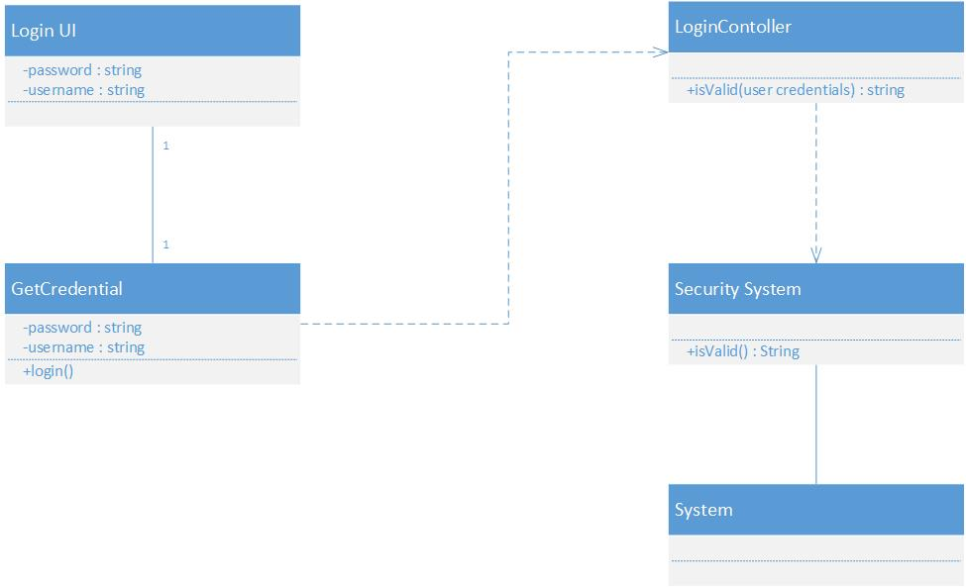

### Logout_Activity_Class_Diagram

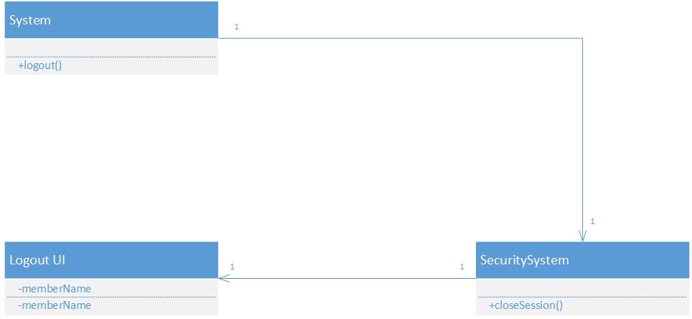

### Registration_Activity_Class_Diagram

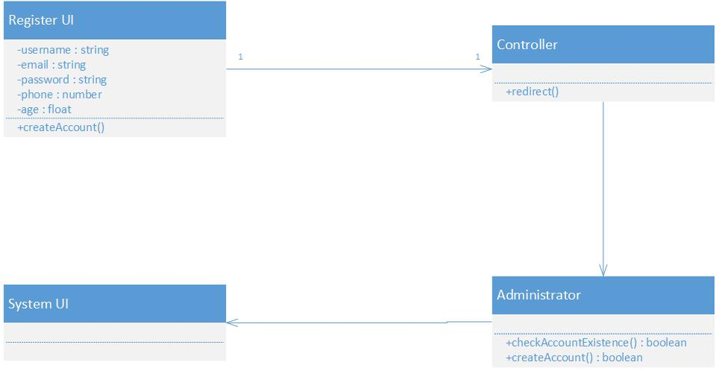

### Diabetes_Class_Diagram

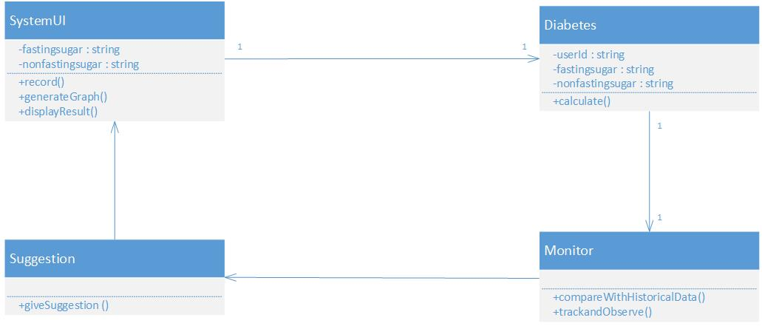

### Hypertension_Class_Daigram

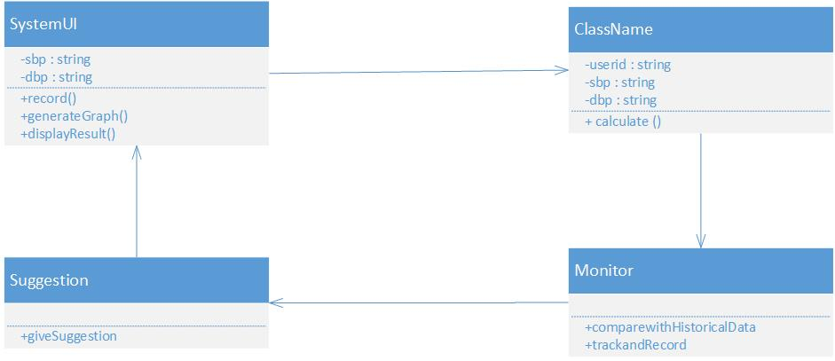

### Overweight_Underweight_Class_Daigram

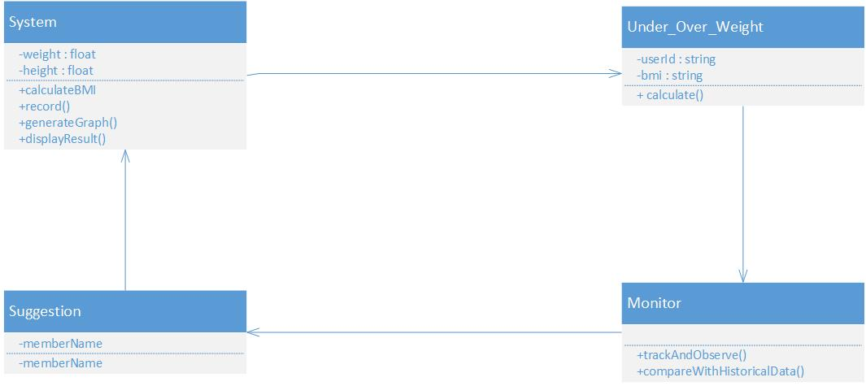

## Sequence diagram

### Login_Sequence_Diagram

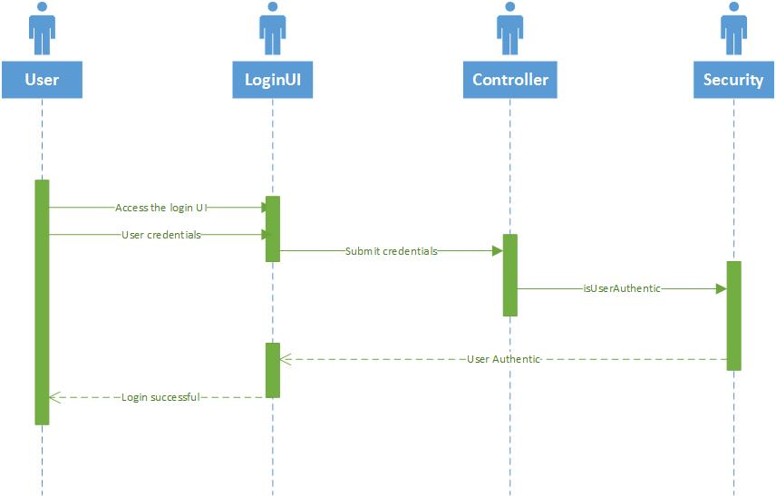

### Logout_Sequence_Diagram

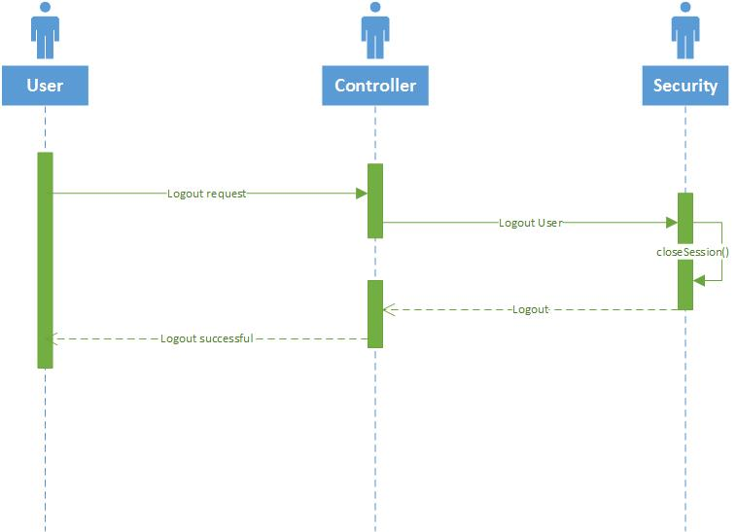

### Registration_Sequence_Diagram

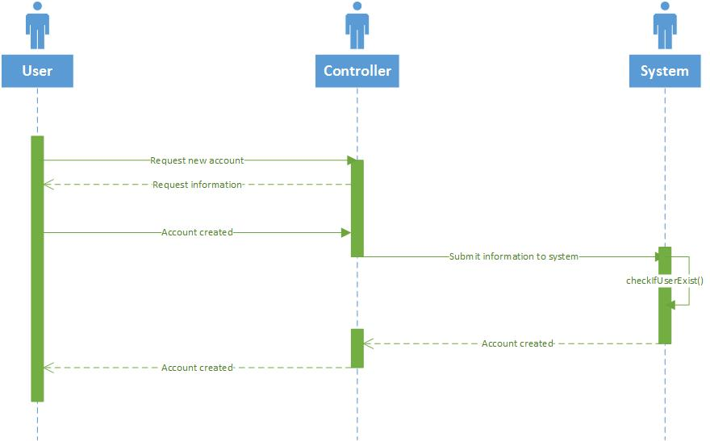

### Diabetes_Sequence_Diagram

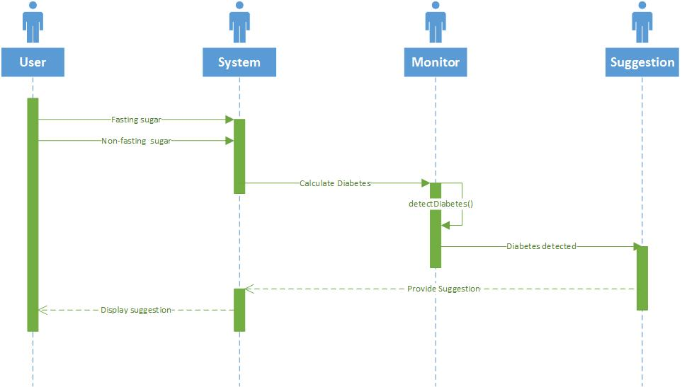

### Hypertension_Sequence_Diagram

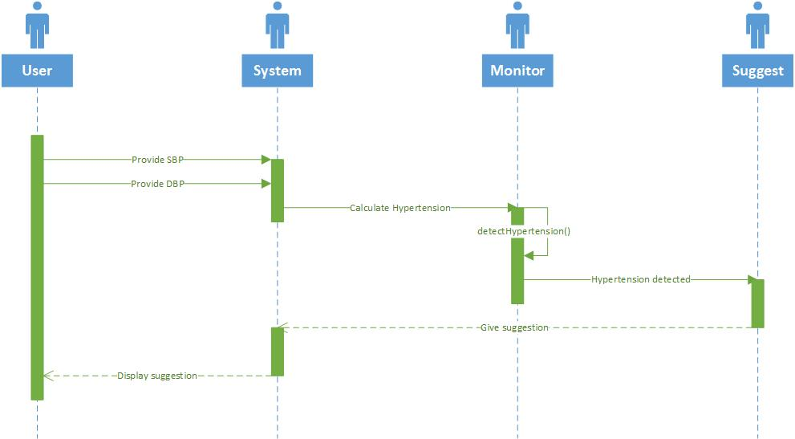

### Overweight_Underweight_Sequence_Diagram

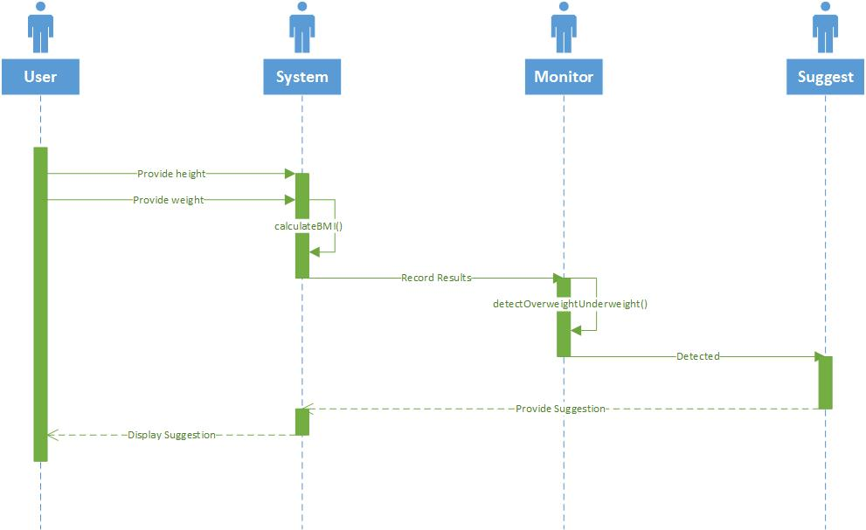

## State diagram

### Login_State_Diagram

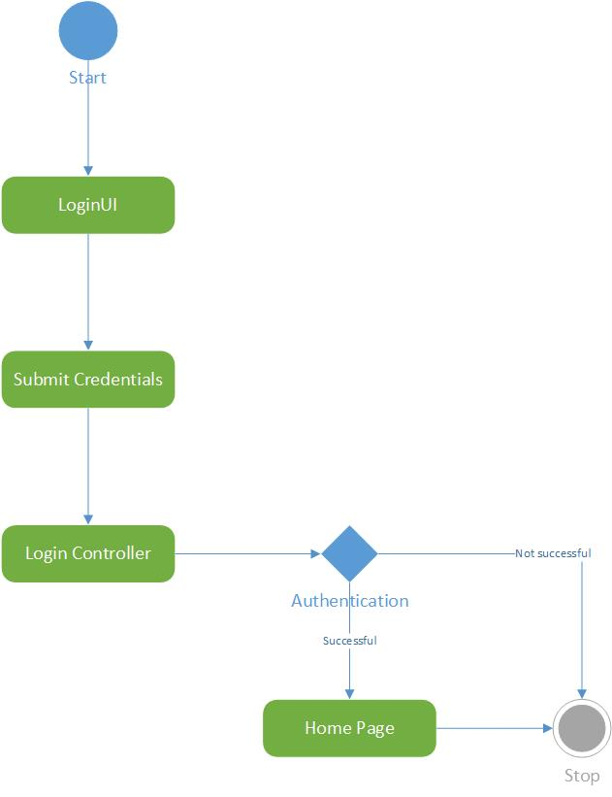

### Logout_State_Diagram

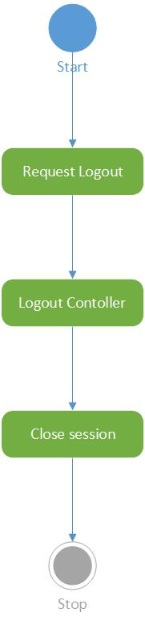

### Registration_State_Diagram

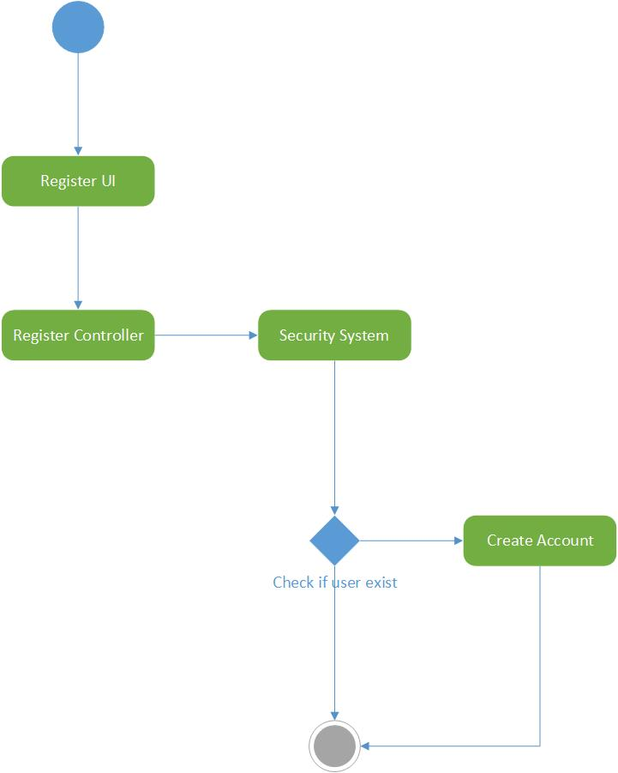

### Diabetes_State_Diagram

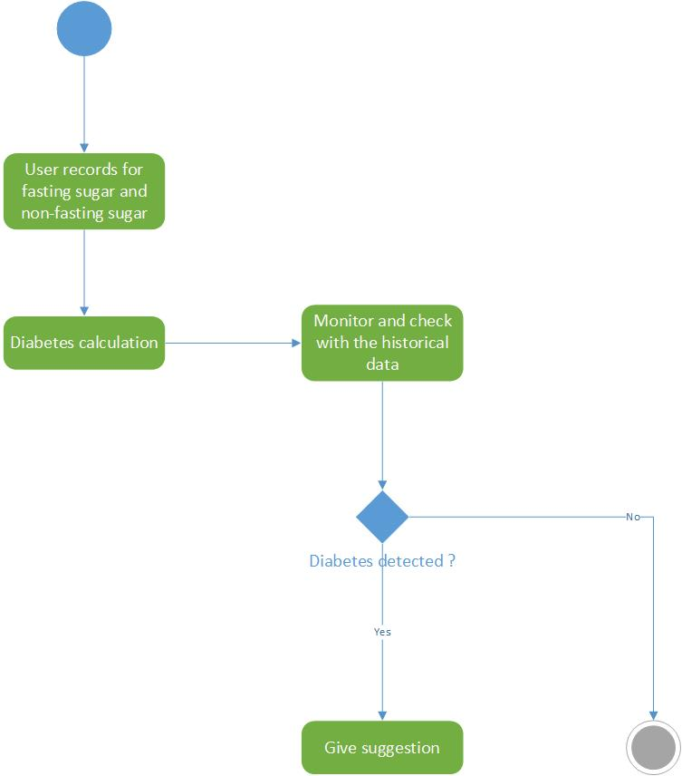

### Hypertension_State_Diagram

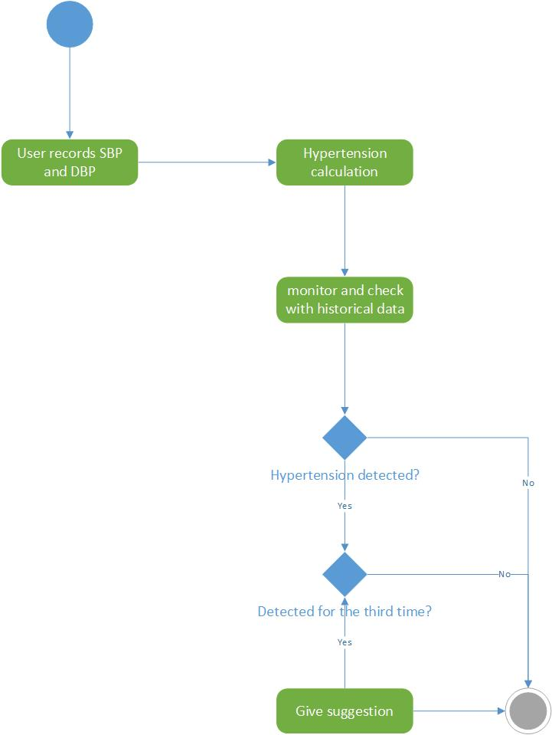

### Overweight_Underweight_State_Diagram

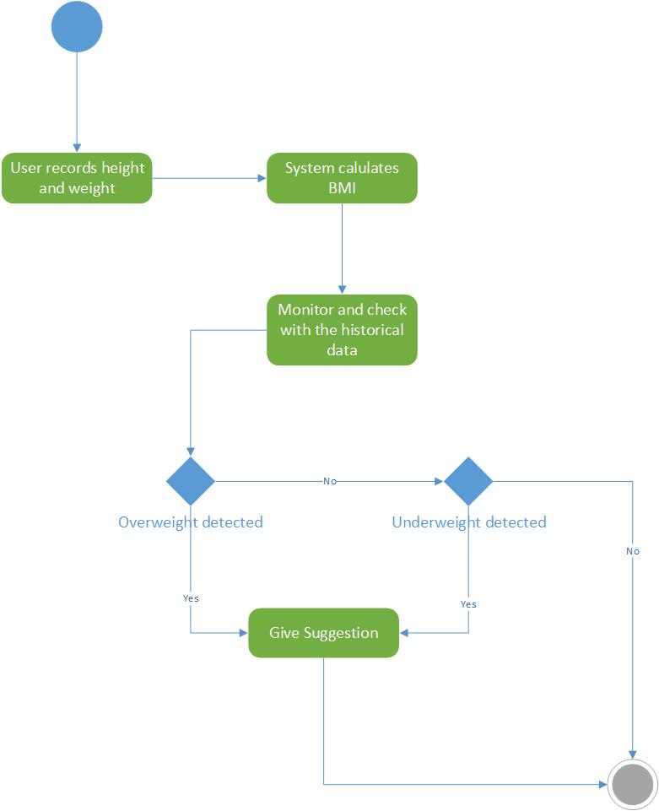

# Wireframe and mockup

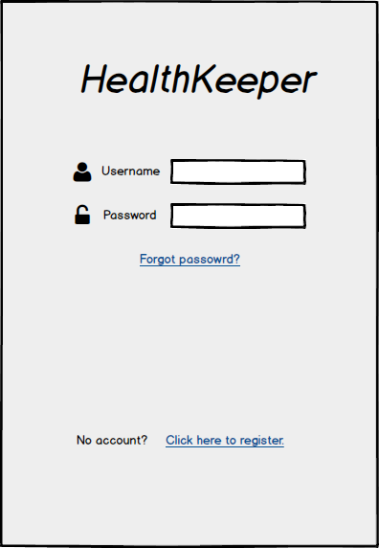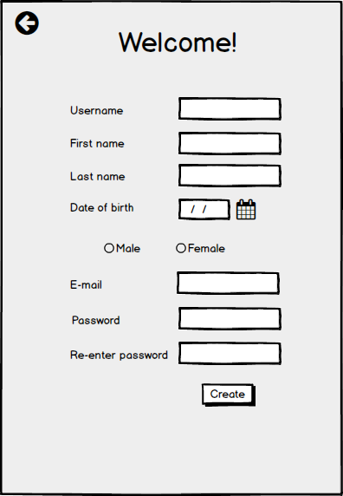

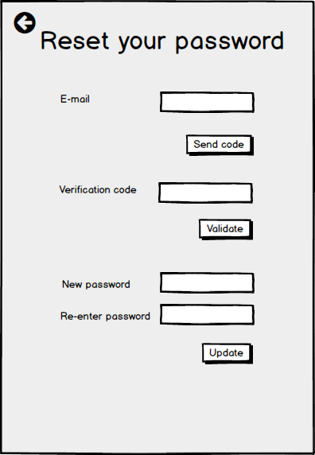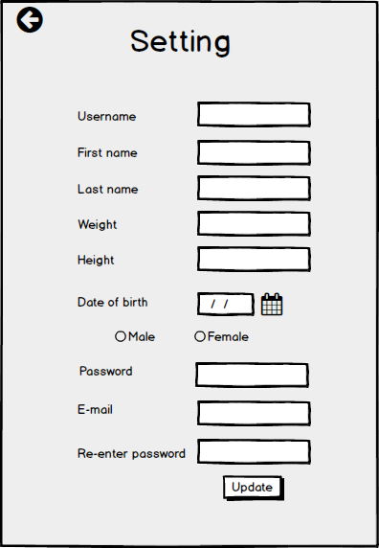

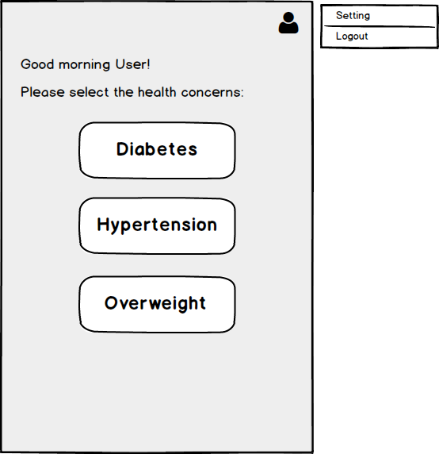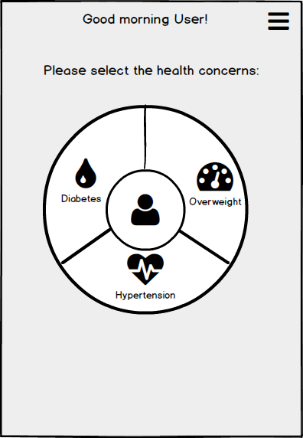

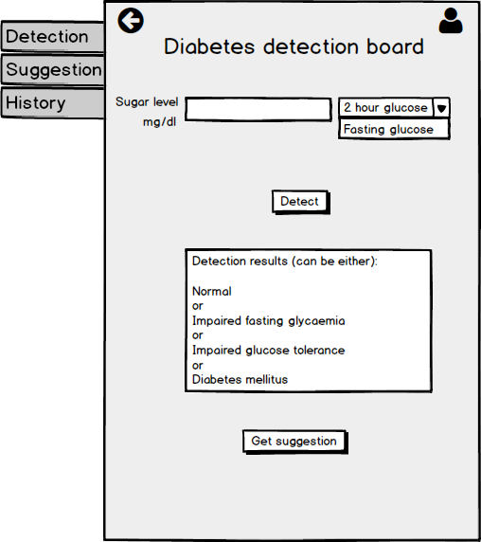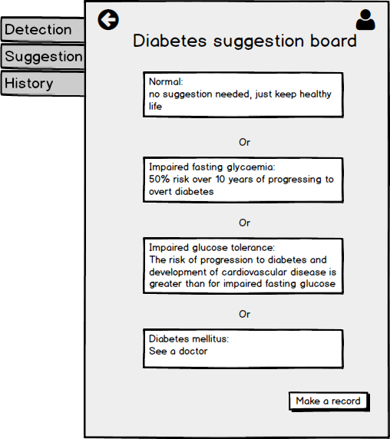

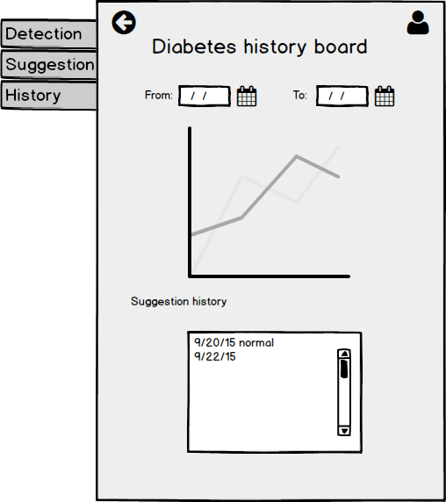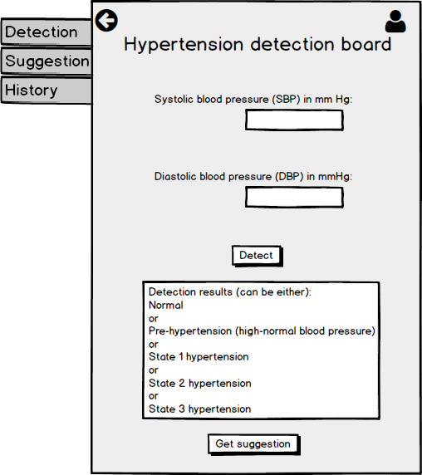

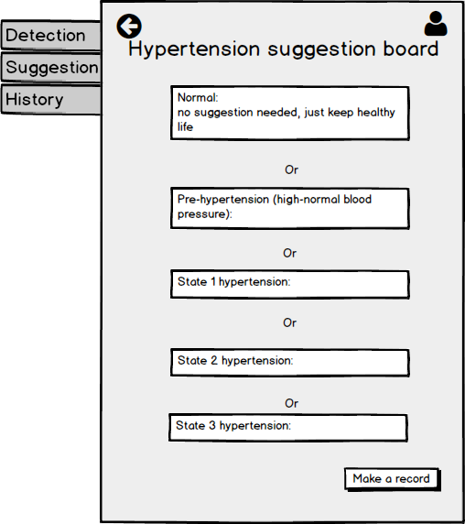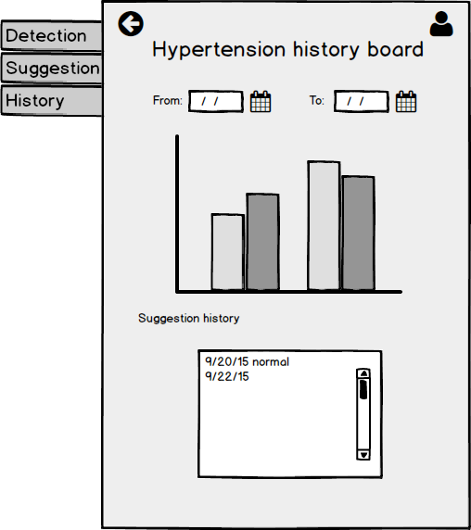

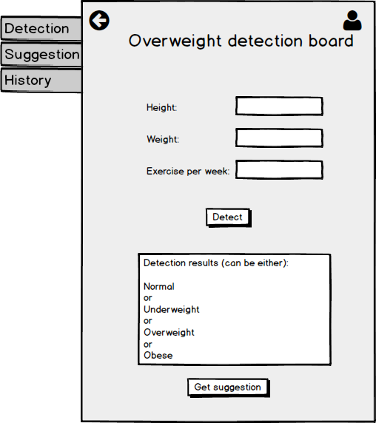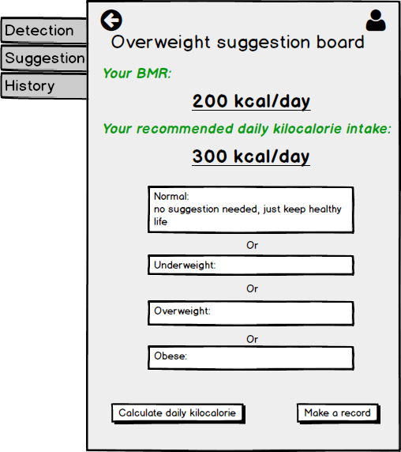

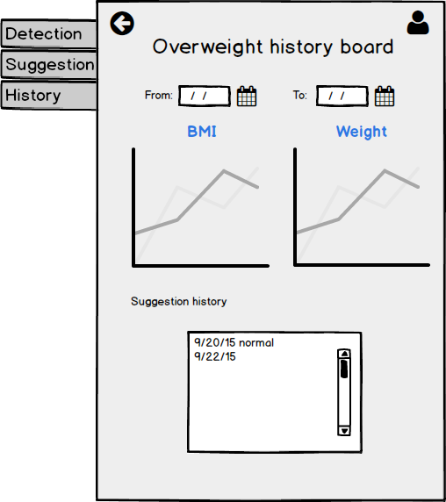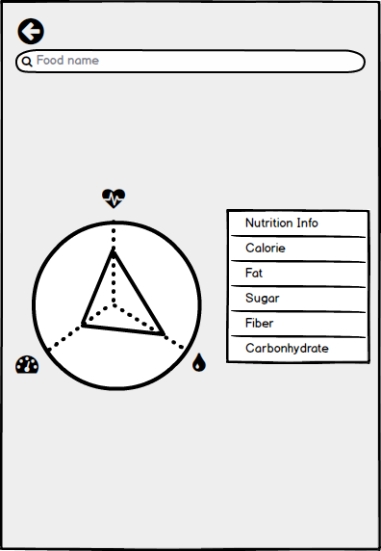

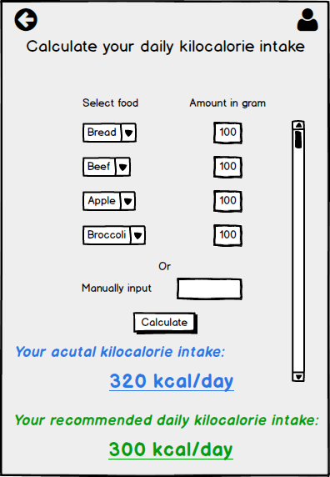

# Architecture/Design

## Kanban Tool

<http://banban.kanbantool.com/b/174772-cs5551-health-app>

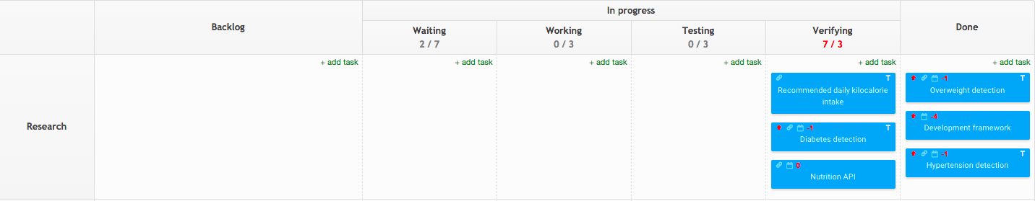

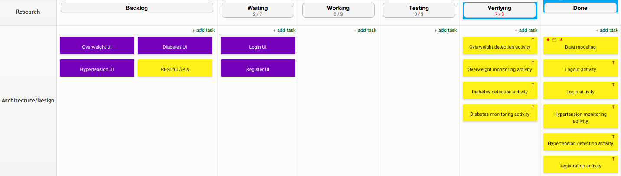

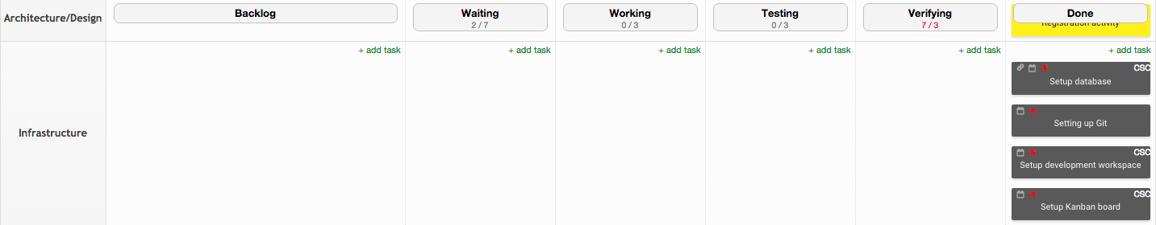

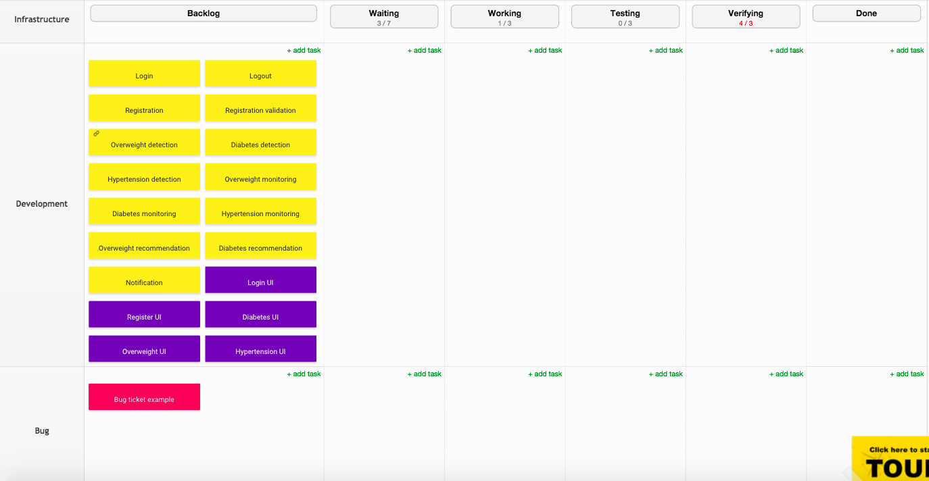



## Github

Three branches: master, DB, and Android:

<https://github.com/cnsgcu/CS5551_Team>