COMP-SCI 5551 (FS15) - Advance Software Engineering

Project Group 5: *Cuong Cu*, *Tarun Shedhani*, *Ting Xia*

**Project Plan - HealthKeeper**

# Project Introduction

This “HealthKeeper” app concerns overweight, diabetes and hypertension, which are the three health issues faced by many people. This app will help people monitor some important parameters for the three health issues, give pertinent suggestions, keep recode, and make graphical analysis.

# App function

## Login/logout

Let user login through username and password. User also can logout whenever they want. If the user forgets password, he/she can retrieve it through email. The system will send the verification code to let the user to reset password.

## Registration

If a user does not have an account, the user can register. In this step, the user needs to provide personal information to create an account.

## Detection

In health dashboard, user can select one of the three health concerns to monitor. When one health concern is selected, the user will first see the detection board. The user can first input the parameters and then know the situation he/she has. The user can also make a record to the database.

## Suggestion

When user knows the detection result, system can provide the suggestion to the user based on the severity of disease/health condition.

## History/Reminder

User can see all the recorded history information. The system provides the graphic analysis. Also, the suggestion history is provided.

The system will also make a recording reminder to the user.

# Stories (features): Scenario & Use case specification template

## Research

Research contains six parts:

1. Nutrition API: Research on open public APIs to calculate food nutrition information.
2. Development framework: Finalize development frameworks, databases, and tools that we are going to use.
3. Overweight detection: Research on detection of overweight.

* Formulas of BMI (Body mass index) calculation:
* BMI = weight (lb) / [height (in)]2 x 703
* BMI = weight (kg) / [height (m)]2
* Medical related information:
  + Weight - weekly collect
  + Height - weekly collect
  + Gender - from user account when they register
  + Age - from user account when they register
* Diagnosis:

NOTE: This is only used for adults > 20 years old. For children between 2-20, this diagnosis cannot be applied.

* + BMI Below 18.5 <-----> Underweight
  + BMI 18.5 – 24.9 <-----> Normal weight
  + BMI 25.0 – 29.9 <-----> Overweight
  + BMI 30.0 and Above <-----> Obese

1. Recommended daily kilocalorie intake: Research on calculation of BMR basal (metabolic rate) and suggested kilocalorie intake.

* BMR calculation:
  + Men:

(Metric) BMR = 88.362 + (13.397 x weight in kg) + (4.799 x height in cm) - (5.677 x age in years)

(Imperial) BMR = 88.362 + (6.077 x weight in pounds) + (12.189 x height in inch) - (5.677 x age in years)

* + Women:

(Metric) BMR = 447.593 + (9.247 x weight in kg) + (3.098 x height in cm) - (4.330 x age in years)

(Imperial) BMR = 447.593 + (4.194 x weight in pounds) + (7.869 x height in inch) - (4.330 x age in years)

* Recommended daily kilocalorie intake:
  + Little to no exercise <-----> BMR x 1.2
  + Light exercise (1–3 days per week) <-----> BMR x 1.375
  + Moderate exercise (3–5 days per week) <-----> BMR x 1.55
  + Heavy exercise (6–7 days per week) <-----> BMR x 1.725
  + Very heavy exercise (twice per day, extra heavy workouts) <-----> BMR x 1.9

1. Hypertension detection: Research on detection of hypertension.

* Two parameters to be measured: systolic blood pressure (SBP) and diastolic blood pressure (DBP) / Unit: mm Hg
  + Normal <-----> SBP (90-119) with DBP (60-79)
  + Pre-hypertension (high-normal blood pressure) <-----> SBP (120–139) with DBP < 90, or DBP (80–89) with SBP <140.
  + State 1 hypertension <-----> SBP (140–159) with DBP < 100, or DBP (90-99) with SBP < 160.
  + Stage 2 hypertension <-----> SBP (160–179) with DBP < 110, or DBP (110-109) with SBP < 180.
  + State 3 (severe) hypertension <-----> SBP ≥ 180 mm Hg or DBP ≥ 110 mm Hg.

NOTE: A diagnosis of hypertension requires at least three measurements above 140/90 at least three weeks apart between the first and third measurement. Blood pressure should be consistently elevated to diagnose hypertension.

1. Diabetes detection: Research on detection of diabetes

* Diagnosis:

|  |  |  |  |  |
| --- | --- | --- | --- | --- |
| **Condition** | **2 hour glucose** | **Fasting glucose** | **HbA1c** | |
| Unit | mmol/l(mg/dl) | mmol/l(mg/dl) | mmol/mol | DCCT % |
| Normal | <7.8 (<140) | <6.1 (<110) | <42 | <6.0 |
| Impaired fasting glycaemia | <7.8 (<140) | ≥6.1(≥110) & <7.0(<126) | 42-46 | 6.0–6.4 |
| Impaired glucose tolerance | ≥7.8 (≥140) | <7.0 (<126) | 42-46 | 6.0–6.4 |
| Diabetes mellitus | ≥11.1 (≥200) | ≥7.0 (≥126) | ≥48 | ≥6.5 |

Comment 1: satisfy any one parameter in the last line is considered diabetes mellitus.

Comment 2: two fasting glucose measurements above 126 mg/dl (7.0 mmol/l) is considered diagnostic for diabetes mellitus.

Comment 3: "2 hour glucose" means two hours after a 75 g oral glucose load

Comment 4: Glycated hemoglobin (HbA1c) is better than fasting glucose for determining risks of cardiovascular disease and death from any cause. But this parameter can only be obtained in hospital.

The following is the screenshot of Kanban board for the research part.

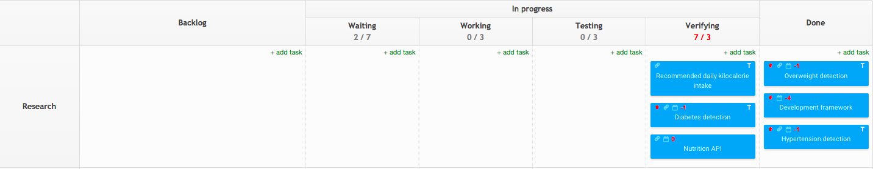

## Architecture/Design

It is divided into two parts: ***UI design*** and ***system design***.

For ***UI design***, it has five specific UIs:

1. Register UI: Design mockup and wireframe for register activity view with user information fields.
2. Overweight UI: Design mockup and wireframe for overweight activity view.
3. Diabetes UI: Design mockup and wireframe of diabetes activity view
4. Login UI: Design mockup and wireframe for login activity view with basic functionality such as user name, password, and login button.
5. Hypertension UI: Design mockup and wireframe for hypertension activity view

For ***system design***, it has 10 activities:

1. Login activity system: Design sequence and activity diagrams when a user login into the system. Update Development backlog if need.
2. Logout activity: Design sequence and activity diagrams for logout scenario.
3. RESTful APIs: Design RESTful APIs for Android client to communicate with server.
4. Diabetes detection activity: Design sequence and activity diagrams for diabetes detection scenario;
5. Overweight detection activity: Design sequence and activity diagrams for overweight detection scenario
6. Hypertension detection activity: Design sequence and activity diagrams for hypertension detection scenario
7. Diabetes monitoring activity
8. Overweight monitoring activity
9. Hypertension monitoring activity
10. Data modeling:

* Modeling user account information
  + usr_id
  + first_name
  + last_name
  + email
  + password
  + gender
  + date_of_birth
  + created_date
* Modeling collected health data for overweight, diabetes, and hypertension.
  + mdr_id
  + usr_id
  + height
  + weightblood_sugar
  + sbp
  + dbp
  + created_date

The following is the screenshot of Kanban board for the architecture/design part.

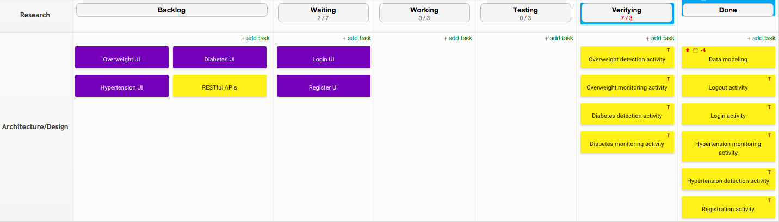

## Infrastructure

This part includes three tickets:

1. Setup database (infrastructure): Set up database with well defined schema.
2. Setup development workspace: Set up GitHub repository and invite Tarun and Ting
3. Setup Kanban board: Add Tarun and Ting into developer list and alternatively activate them so that everyone can share the Kanban board since at most only 2 users can access the board per free account.

The following is the screenshot of Kanban board for the infrastructure.

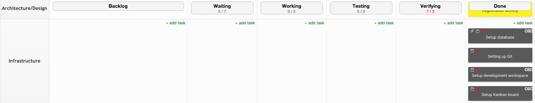

## Development

As for development, it contains 13 ***system designs*** and 5 ***UIs***.

13 ***system design***:

1. Login: Allow users to login into their account. Users use email address and Password to identify themselves.
2. Logout: Allow users to logout of their account
3. Registration: Allow new users to create an account. User information collected during this process:
   * First name
   * Last name
   * Date of birth
   * Email address
   * Password
   * Height
   * Gender

NOTE: Currently, it seems they are all required and should be validated to make sure data in proper format.

CONSIDERATION: Should height and gender be optional then be filled later as users interact with the system. We allow users to skip so they do not get bored filling out form.

1. Registration validation: All fields should be verify in proper format
2. Overweight detection: Gather medical related information from users and provide diagnostic.

NOTE: Medical related information:

* Weight - weekly collect
* Height - from user account when they register
* Gender - from user account when they register
* Age - from user account when they register

1. Diabetes detection: As a user, I would like the application to tell me if I am diabetic given gender, age, blood sugar level.
2. Hypertension detection: Determine if a user has hypertension according to:

* Systolic Blood Pressure(SBP)
* Diastolic Blood Pressure(DBP)
* Age

1. Diabetes monitoring activity: Monitor diabetes in a period of time, providing record and graphic analysis.
2. Overweight monitoring activity: Monitor overweight in a period of time, providing record and graphic analysis.
3. Hypertension monitoring activity: Monitor hypertension in a period of time, providing record and graphic analysis.
4. Overweight recommendation: As a user, I would like the application to suggest the amount of calorie I should consume per day according to my medical condition.
5. Diabetes recommendation: Suggest low carbohydrates type of food.
6. Notification: Provide a notification system to remind users about their meal.

5 ***UIs:***

1. Login UI: Implement login activity UI design
2. Register UI: Implement register activity UI design
3. Diabetes UI: Implement diabetes activity UI design
4. Overweight UI: Implement overweight activity UI design
5. Hypertension UI: Implement hypertension UI design

The following is the screenshot of Kanban board for the development.

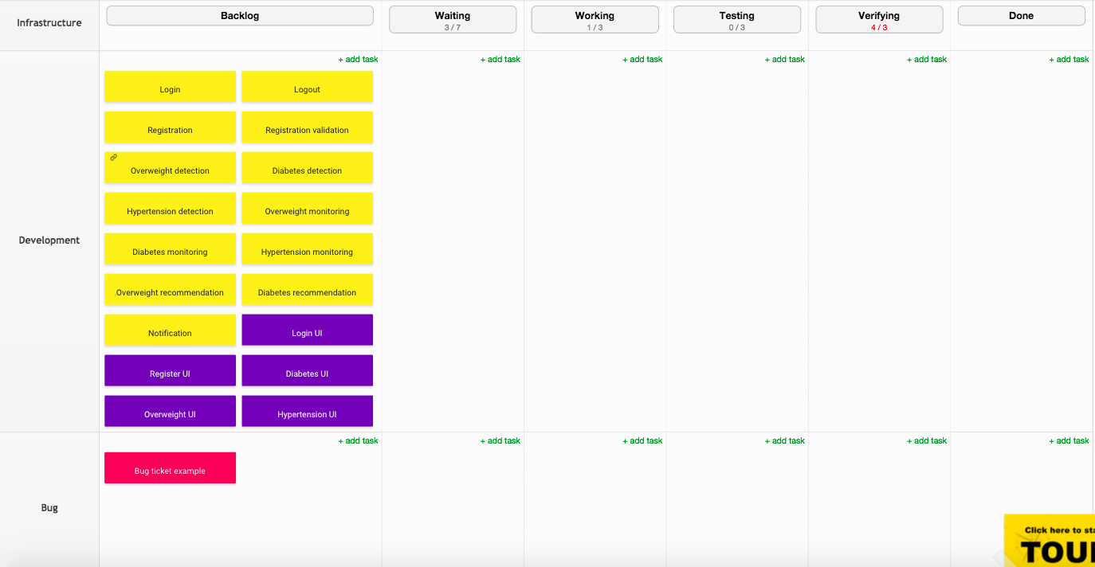

## Bug

This is an example of a bug ticket.

The following is the screenshot of Kanban board for the bug part.



## Database

Following are the tables create along with their definition and relations:

Table: User

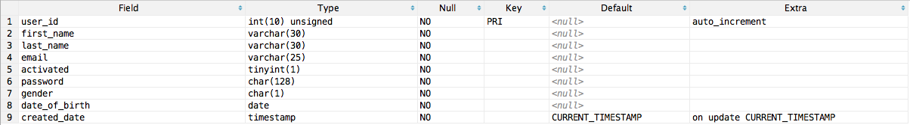

Table: Medical_Record

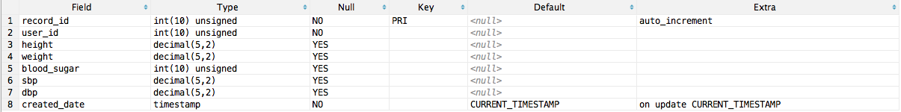

Table: Overweight_diagnosis



Table: Hypertension_diagnosis



Table: Diabetes_diagnosis



# Four Different Increments:

## Increment 1-- Requirement Gathering and Designing the application

1. Research on detection of overweight, recommended daily kilocalorie intake diabetes, and hypertension.
2. Setup Kanban Tool and Github for every team member.
3. Design class diagrams.
4. Design sequence diagrams.
5. Design state diagrams.
6. Design WireFrames and Mockups.

## Increment 2—Coding/Testing

1. Implement Login/logout UI/Registration/ Registration validation.
2. Implement dashboard.
3. Implement overweight detection/monitor/recommendation.
4. Test Login/logout UI/Registration/Registration validation.
5. Test dashboard.
6. Test overweight detection/monitor/recommendation.

## Increment 3 – Coding/Testing

1. Implement diabetes detection/monitor/recommendation.
2. Implement hypertension detection/monitor.
3. Implement notification.
4. Test diabetes detection/monitor/recommendation.
5. Test hypertension detection/monitor.
6. Test notification.

## Increment 4 -- Refine GUI

1. Refine GUI for Login/logout UI/Registration/Registration validation.
2. Refine GUI for dashboard.
3. Refine GUI for overweight detection/monitor/recommendation.
4. Refine GUI for diabetes detection/monitor/recommendation.
5. Refine GUI for hypertension detection/monitor.
6. Refine GUI for notification.

# Project Timelines, Members, Task Responsibility

Member and Responsibilities

|  |  |
| --- | --- |
| **Artifacts** | **Members : Cuong, Tarun, Ting** |
| Research | Hypertension : Tarun | Diabetes : Cuong | Over-Under Weight : Ting |
| Project Plan | Ting |
| UML Diagrams | Tarun |
| Modeling Database | All |
| Initial Mockup | Ting and Cuong |
| Reports | All |
| Development | All |
| Testing | All |
| Maintenance | Cuong |

Project Timelines:

|  |  |
| --- | --- |
| **Increments** | **Tasks** |
| Increment 1 | Initial setup of environments and database tables |
| Increment 2 | Code (login UI, registration and Hypertension detection), Use Case creation |
| Increment 3 | Code + Test (Hypertension, Diabetes, Overweight and Underweight API) and use case execution |
| Increment 4 | Cosmetic changes and deployment |