cpedialog
blog implemented by python and can be hosted on google appengine

How_To_Install_cpedialog
One-sentence summary of this page.
Introduction

Add your content here.
Details

Add your content here. Format your content with:

* Text in bold or italic
* Headings, paragraphs, and lists
* Automatic links to other wiki pages

AuthSub
AuthSub Authentication for Web Applications

http://code.google.com/apis/accounts/docs/AuthSub.html

ProjectOverview
Want to join this project? Just send email to me.
blog implemented by python and can be hosted on google appengine
Now you can access the Demo at: http://blog.cpedia.com

Screenshots

Main Page
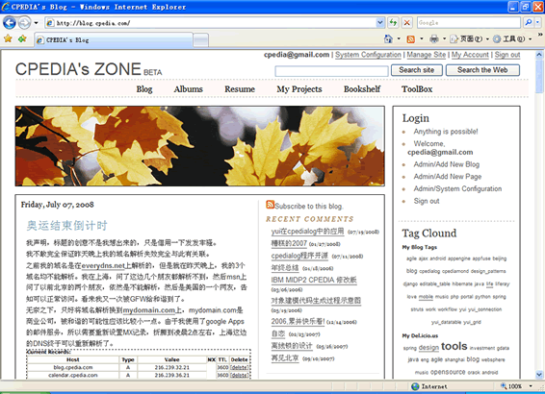

Add/Edit Blog
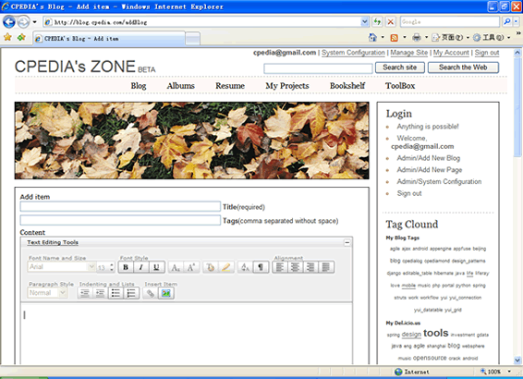

Insert/Upload Images
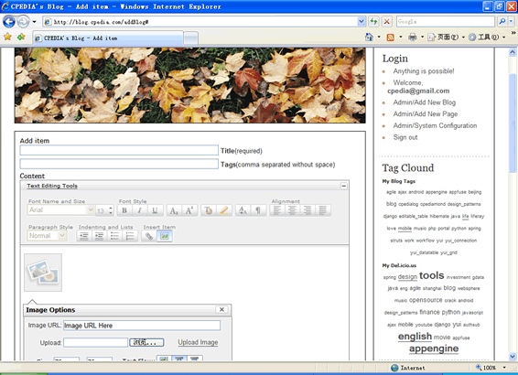

Page/Menu Admin
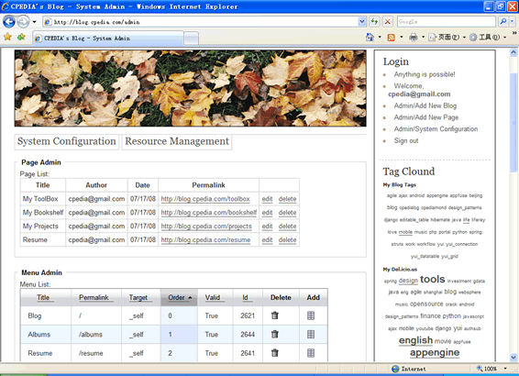

Uploaded Images/Other Resources Admin
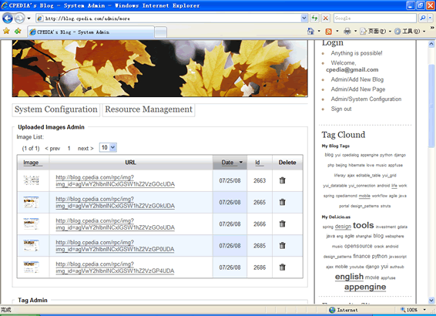

Access picasaweb albums
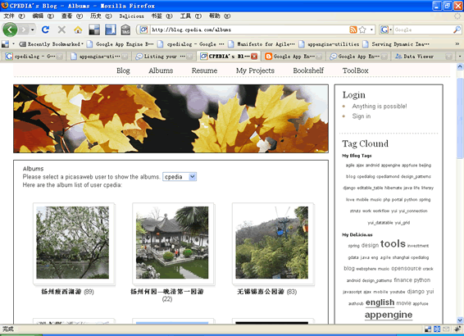

Features:

blog
- using yui grid, so it's very easy to change or extend the page layout.
- auto-generate permalink url through translating the blog title by google.
- tags for the blog entry.
- rich content editor by yui rich editor.
- Ajax implemented by simplejson & yui Connection Manager. (Such as inline editable table.)
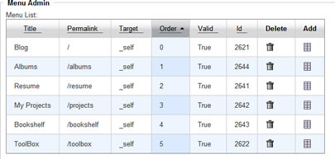
- Upload images file to bigTable in yui rich editor.
- Uploaded images, tags, archives, albums management.
- Menu & pages management.
- AuthSub Session Token and System cache management.

albums
- access the picasaweb albums through gdata API.
- authSub implemented by decorating the python method.

