How_to_integrate_picasaweb_album_with_cpedialog

You must want your own albums shown on your blog, here is the tips tell you how to integrate picasaweb album with cpedialog.

Preface
Before you start to integrate picasaweb album with cpedialog, you must have an picasaweb account. If you have not got one yet, you can apply from: http://picasaweb.google.com You can also upload your photos to picasaweb by picasa.

Details

Add album menu for your site
If you want to make your album can be accessed by public, you need to add a menu for album firstly. Login as the system administrator to your blog, then switch to the system configuration module. You will see some tabs in this page, select the "Pages" Tab. Now in the "Menu Admin" table, you can add a row. If you still have not any menu yet, just double-click the "Add" column at the table header to add a record.
A alert message will pop-up to ask you whether to add a row. Click "OK", a default menu will be added to the table, then you can edit the default menu value directly.
Click the default menu title and set it to "Albums", click the default menu permalink and set it to "/albums"(this value is very import, the system will access albums from http://your_site_url/albums, so make sure you have set the correct value), click the default menu valid column and set it to "true".
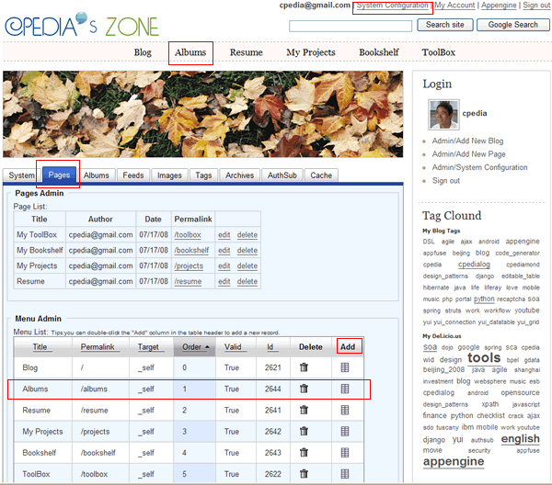

Manager you picasaweb alubms accounts
After you add the album menu to your blog, you can access the album by click the link from the page menu area below the page header. Maybe you will get the follow page.
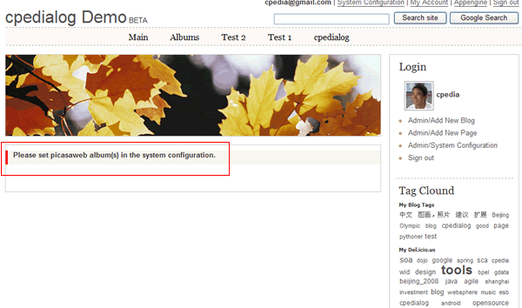
Don't worry, you just still need to add you picasaweb album username to the "Albums" table. In the system configuration module, swith to "Albums" tab, double-click the "Add" column in the album table header to add a new record.
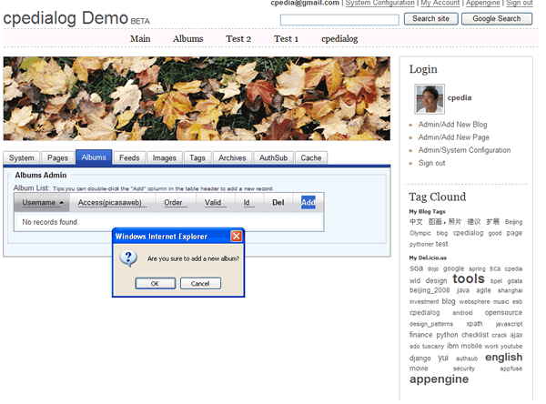
Don't forget to modify the default username, set as your picasaweb album username. (For example, cpedia). Change the valid property of the record to be "true".
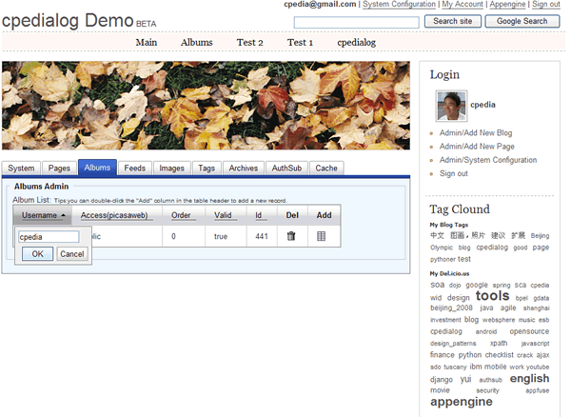
Then you can access your album.
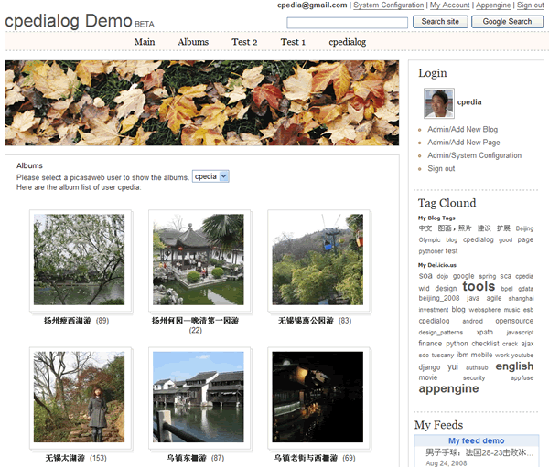
You can add one or more albums to be shown for public.

How_To_Install_cpedialog
This article will tell you how to install cpedialog on appengine.

Preface
Before you start to install cpedialog, you need to know what appengine is and what appengine can do. If you still have some uncertainty, please refer to: http://code.google.com/appengine/docs/whatisgoogleappengine.html
Make sure Google App Engine has been installed correctly.
And we also recommend you to read the article for "Uploading an App" to appengine: http://code.google.com/appengine/docs/appcfgpy.html

Details
1.Download cpedialog from googlecode site (http://code.google.com/p/cpedialog/downloads/list) and decompress it to a folder, for example, extract it to "D:\My projects\cpedialog", make sure file "app.yaml" is located in the folder of cpedialog.
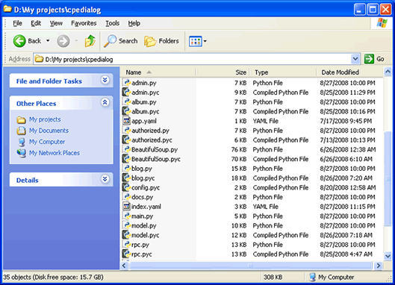
2.Open the file app.yaml with some text editor (such as Microsoft Notpad). Change the applocation property in the first line to your own appengine app name. For example: application: pchen change to: application: your_app_id
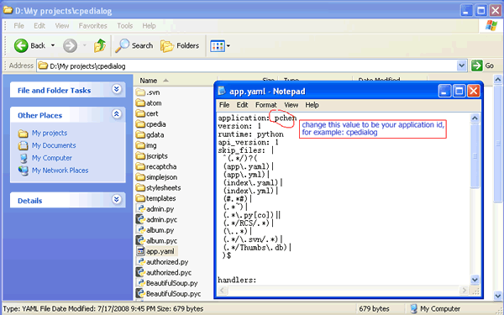
3.Run the appcfg.py update command to upload cpedialog to your appengine app.
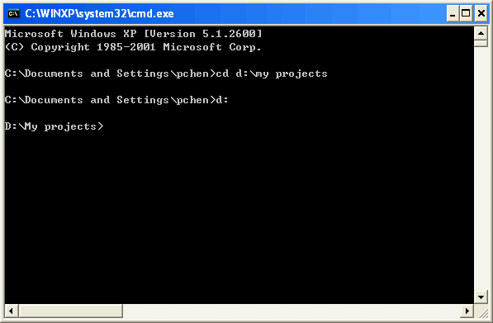
cd D:\My projects
appcfg.py update cpedialog
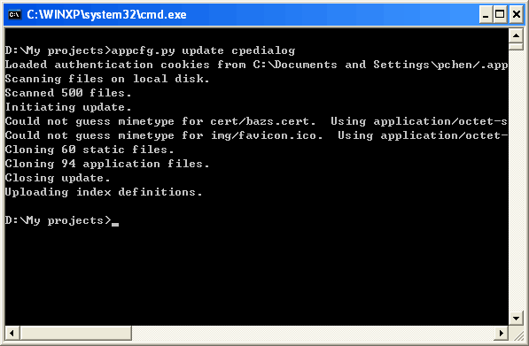
wait until the command execute finished.
Now you can access your app running on App Engine: http://your_app_id.appspot.com
Comment by macauboy429, Sep 02, 2008
how to setup admin privilege? thank you
Comment by cpedia, Sep 04, 2008
Just login with the google account which you used for creating the GAE app.
Comment by hareem.haque, Dec 18, 2008
I get the following error:
Traceback (most recent call last):
File "/base/python_lib/versions/1/google/appengine/ext/webapp/init.py", line 498, in call
handler.get(groups)
File "/base/data/home/apps/hlabsblog/1.330079895166875385/blog.py", line 85, in get
obj_page = util.getBlogPagination(page)
File "/base/data/home/apps/hlabsblog/1.330079895166875385/util.py", line 127, in getBlogPagination
obj_page = GqlQueryPaginator?(blogs_query,page,cpedialog.num_post_per_page).page()
File "/base/data/home/apps/hlabsblog/1.330079895166875385/cpedia/pagination/GqlQueryPaginator?.py", line 32, in init
self.count = int(gqlQuery.count()) ##todo:google GqlQuery? has 1000 records limit.
File "/base/python_lib/versions/1/google/appengine/ext/db/init.py", line 1353, in count
return self.get_query().Count(limit=limit)
File "/base/python_lib/versions/1/google/appengine/api/datastore.py", line 960, in Count
raise ToDatastoreError?(err)
File "/base/python_lib/versions/1/google/appengine/api/datastore.py", line 1637, in ToDatastoreError?
raise errorserr.application_error?(err.error_detail)
NeedIndexError?: no matching index found.
please advise
Email: hareem.haque@gmail.com
Comment by zhaoxiyoth, Dec 27, 2008
yes mine is like this too
Comment by luckypoem, Dec 29, 2008
hi,你这个博客程序里的编辑器好像不支持源代码的编辑，我放入一个视频的embed代码，发表后并无播放器显示，怎么回事？望回复。
Comment by applefuitapps, Dec 29, 2008
hello,
I installed this blog program successfully, but I can not log in to get admin privilege with the account which I installed it. I use Apps standard account: changhe@changblog.com. The home page is fine and it works well on local. My site is applefruitade.appspot.com
你好，
我按照说明安装了这个程序，可以访问主页，但是我用相应的 app engine帐户登录blog，却没办法获得管理权限。在本地运型模你器一切正常。但是在网上怎么弄也不成。我的帐号是apps的，绑在我的域名下 边，changhe@changblog.com。到底是什么原因呢？我后来又用这个邮件注册了现在的这个gmail邮件，还是不行。我的网站是 applefruitade.appspot.com。
Comment by giqcass, Jan 04, 2009
Here is what happens to me every time I try to upload an app.
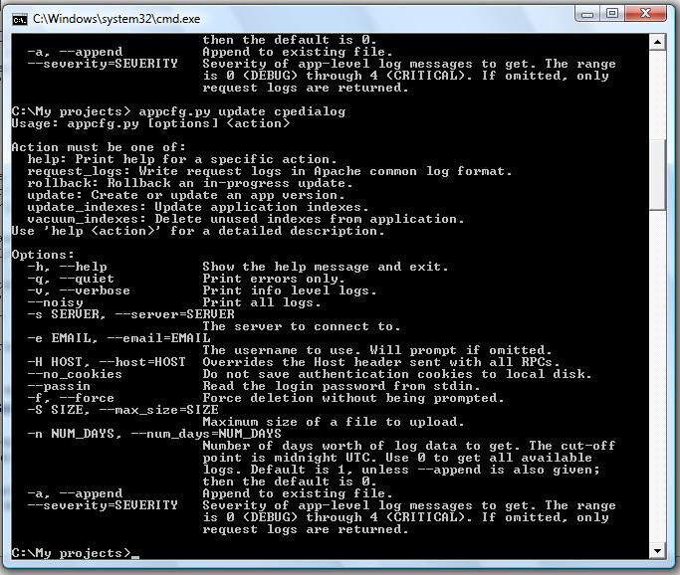
Comment by ahwahk, Jan 14, 2009
我安裝之後，每次添加blog 都顯示是一月一日的。

