White Paper



Qt Creator 1.0

As the name implies, Qt Creator is a complete integrated development environment (IDE) for creating applications with the Qt application framework. Qt is designed for developing applications and user inter- faces once and deploying them across several desktop and mobile operating systems . This paper provides an introduction to Qt Creator and the features it provides to developers.

1 Introduction
As the name implies, Qt Creator is a complete integrated development environment (IDE) for creating applications with the Qt application framework. Qt is designed for developing applications and user interfaces once and deploying them across several desktop and mobile operating systems1 .

The main drivers for Qt Creator have been Qt‐specific development needs, simplicity, usability, productivity, extendibility, openness, as well as trying to lower the barrier of starting to use Qt. The key features of Qt Creator aid the application developer in, for example, the following ways:

• Fast and easy start of Qt application development with a project wizard, and quick access to recent projects and sessions.

• Easy access to information with context‐sensitive, integrated Qt Help
system.

• Develop applications with the advanced C++ code editor and integrated Qt Designer. Enjoy new powerful features for navigating between project files as well as functions and classes quickly.

• Debug with the GDB debugger using a graphical user interface with
increased awareness of Qt class structures.

• Build and execute Qt projects with the qmake crossplatform build tool.

Qt Creator does not compete with the Qt plug‐ins for Eclipse or Microsoft Visual Studio, but rather complements Qt tools offering by providing a complete development environment for Qt that is easy and quick to take in to use, and facilitates the use of Qt‐specific features.

In general, Qt Creator runs on every platform supported by Qt. Pre‐built binaries are available for Microsoft Windows, Macintosh OS X, and Linux. Qt Creator can be run other platforms, but that requires the compilation of the publicly available source code. Building and running Qt Creator may require a separate installation of Qt 4.x to your computer.

1 For more information, please see http://www.qtsoftware.com/products/appdev/files/pdf/qt‐4.4‐whitepaper http://www.qtsoftware.com/products/appdev/files/pdf/qt‐cross‐platform‐application‐framework‐datasheet

© 2008 Nokia Corporation and/or its subsidiaries. – Qt Creator 1.0 – 1

The easiest way to get started is the Qt SDK (Software Development Kit). It is a single package that contains both Qt Creator and the latest version of Qt application framework for creating applications. Qt SDK is available for Microsoft Windows, Macintosh OS X, and Linux via http://www.qtsoftware.com/downloads

2 Working with Qt Creator
To fulfil the design drivers (simplicity, ease‐of‐use, and productivity) Qt Creator relies on the concept of modes which adapts the user interface to the different application development tasks encountered. Each mode has its own view that shows only the information required for performing the task and provides only the most relevant features and functions related to it. As a result, the majority of the Qt Creator window area is always dedicated for actual application development tasks. To illustrate this, Figure 1 presents the key parts of Qt Creator’s user interface (UI).

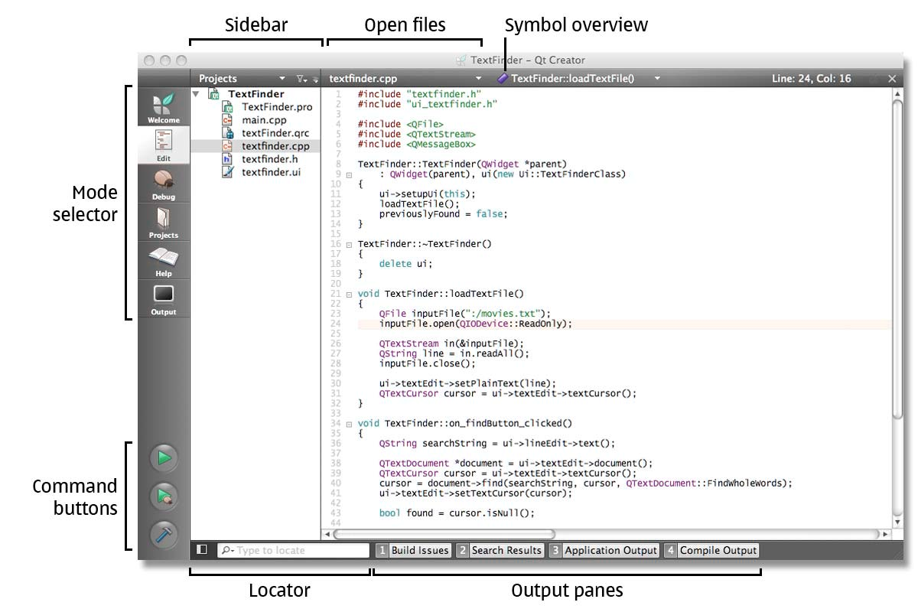

Figure 1. The main parts of Qt Creator user interface in Edit mode

© 2008 Nokia Corporation and/or its subsidiaries. – Qt Creator 1.0 – 2

To swap the modes quickly, Qt Creator has a Mode Selector on the left of the window. With the aid of selector, or using a set of keyboard short‐cuts, the user can access one of the following modes at the time:

• Welcome to load recent sessions or specific projects.

• Edit to modify the active project and its source files.

• Debug to inspect the state of the program while debugging.

• Projects to configure how the projects are built and executed.

• Help to view documentation, such as the Qt reference documentation and the Qt Creator documentation.

• Output enables examining various data in detail, for instance, build issues, compilation and application output.

Beneath the Mode Selector are command buttons for executing, starting debugging, and building the current project.

The Edit and Debug modes show the Sidebar, which displays all the files that belong to the active project. These modes display and provide access to the currently open files in a bar on the top of the window. The bar also displays a Symbol Overview of with the symbols related to the current file as well as the symbol at the current location inside the file.

The Locator below the Sidebar enables the user to quickly locate a file, or access information from the files in the project. Next to the Locator are the controls for showing one of the four different Output panes in the bottom of the window. The panes available are:

• Build issues displays, for instance, the warnings and errors related to current build.

• Search results pane shows the results of global searches within current document, files, or projects.

• Application output shows the status of the application during the execution as well as debug information when debugging the application

• Compile output displays all the output that the compiler provides.

© 2008 Nokia Corporation and/or its subsidiaries. – Qt Creator 1.0 – 3

3 New project wizard for Qt4
Setting up a new project in Qt Creator is aided by a wizard that guides the user through the project creation process in consecutive steps. In the first step the user selects the type of the project from the categories: Qt console application, Qt GUI (graphical user interface) application, or Qt library. Next, the user can select a location for the project, Qt specific settings (such as select the needed modules), before specifying the details of the first class of the application.

When the steps have been completed, Qt Creator will automatically generate the project with required header, source, user interface and project files as defined by the wizard.

4 Advanced C++ code editor
Writing, editing and navigating in source code are core tasks in application development. Therefore the C++ code editor is one of the key components of Qt Creator. Figure 2 shows an example of the Edit view, where the editor fills most of the window area.

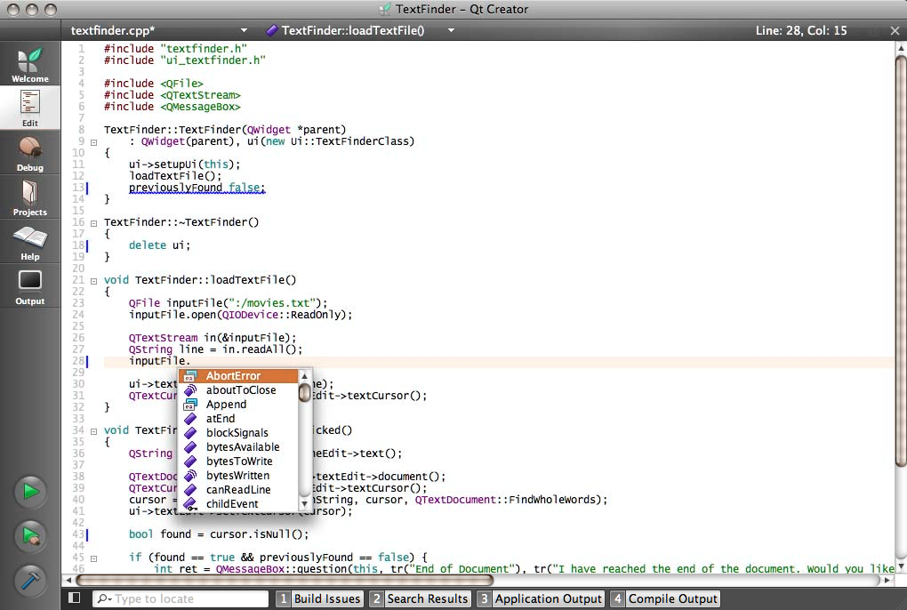

Figure 2. The advanced C++ code editor of Qt Creator

As can be seen in Figure 2, the C++ editor offers:

© 2008 Nokia Corporation and/or its subsidiaries. – Qt Creator 1.0 – 4

• Syntax highlighting for keywords, symbols, and macros.

• Code completion for class members and methods as well as function arguments, accessible through a keyboard short‐cut (ctrl + space) supporting both Qt classes and the user’s own classes in the current project.

• Live marking (“saw tooth” underlining in red) of errors while editing.
Avoids having to compile the code to find typos and syntax mistakes.

• Auto‐indentation for source code layout.

• The ability to collapse and expand functions in the source code.

In addition to abovementioned features, the editor has other useful features, such as:

• Incremental search that highlights the matching strings in the window while typing.

• Line numbering and current line highlight.

• Easy commenting and un‐commenting of code.

• Quick switching between method definition and declaration a function.

• Bookmarks for easier navigation in the code.

In addition to this, the C++ code editor supports different keyboard shortcuts faster editing. It is possible to work without using the mouse at all, allowing the developer to keep their hands on the keyboard and work faster.

5 Integrated Qt Designer
For editing user interface files, Qt Creator provides a fully integrated Qt Designer in the Edit mode. This makes it possible to edit user interfaces by simply dragging and dropping UI components (widgets) in the user interface. The user interfaces that are designed with Qt Designer are fully functional, and can be previewed immediately to ensure that the design is as they intended. There is no need to recompile the entire project to test out a new design. Figure 3 shows integrated Qt Designer with a simple form under editing.

© 2008 Nokia Corporation and/or its subsidiaries. – Qt Creator 1.0 – 5

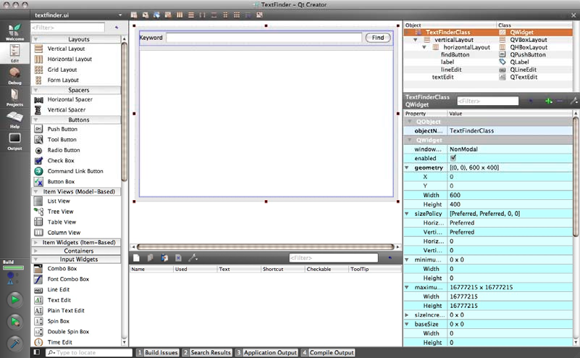

Figure 3. Integrated Qt Designer

The available UI components are shown in the container on the left in Figure
3 and the user interface being edited is shown in the middle of the screen. The top right corner of the window contains the Object Inspector that displays hierarchy of the objects in the current user interface. Below it is the Property Editor for editing the properties of the currently selected widget.

In addition, the user can use the integrated Qt Designer for many other tasks such as connecting signals and slots, and setting the tab order. The Qt Designer integration also includes project management and code completion.

6 Integrated Qt Help
From time to time, application developers may need further information about a certain class, function, and so forth. All Qt's documentation and examples are accessible via Qt Help plug‐in in Qt Creator.

To view the documentation, the Help mode is used, where the most of the window is devoted to the help text. While working with source code in Edit mode, the user can access context sensitive help by moving the text cursor to a Qt class or function and then press F1 key. The documentation will be displayed within a panel on the right side of the code editor as shown in Figure 4.

© 2008 Nokia Corporation and/or its subsidiaries. – Qt Creator 1.0 – 6

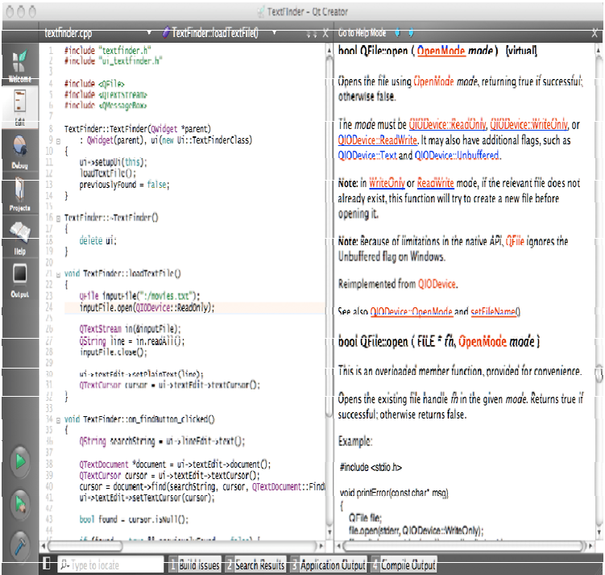

Figure 4. Displaying context sensitive Qt Help information

It is also possible to add external documentation to Qt Creator, to complement or replace the existing documentation.

© 2008 Nokia Corporation and/or its subsidiaries. – Qt Creator 1.0 – 7

7 Locator for navigating between files and information
While editing source code, the developer often needs to move between different files, and to access multiple sources of information. The Locator tool (Figure 5) is designed to assist the user in this with just few keystrokes.

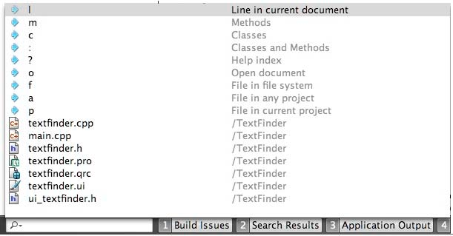

Figure 5. The Locator navigation tool for quick access to files and information

When the user starts typing a text string in Locator , it shows the files which name contains the string in a pop‐up list. As the user continues typing the list is updated automatically. The wildcard characters (* and ?) can be used in search queries.

The user can be more specific when searching by adding a prefix character followed by space before the search string. Currently, the following prefixes are available:

• f locates files anywhere, or in a specific folder of the hard disk.

• p locates files from the current project, while a searches in all projects.

• o searches all open documents.

• c looks for class definitions, m for method definitions, and : for class and method definitions. All in the the current project.

© 2008 Nokia Corporation and/or its subsidiaries. – Qt Creator 1.0 – 8

• ? searches available help topics and the Qt documentation.

• l jumps to a certain line in the current document.

If no prefix is specified, the search tool uses the o, l, and a prefixes by default.

8 Compiling and debugging
Currently, Qt Creator supports the GNU compiler (gcc) and debugger (gdb). While it is possible to use virtually every compiler supported by Qt from within Qt Creator, the debugging features are only available for users of gcc. This means that applications created with, e.g. the Microsoft Visual Studio compiler, cannot be debugged in Qt Creator.

Qt Creator provides a Debug mode, that provides a graphical user interface for GNU debugger. Figure 6 shows Qt Creator in Debug mode with the dock view for debugging tools (or widgets) below the code editor. In this mode, the developer can perform common debugging tasks, such as:

• Step through the program line‐by‐line or instruction‐by‐instruction .

• Interrupt program execution.

• Set breakpoints.

• Examine call stack contents, watchers, and local and global variables.

The debugger is aware of the structure of many Qt classes, thus increasing its ability to display Qt’s data clearly. In addition, Qt Creator displays the raw information by GNU debugger in a clear and concise manner.

© 2008 Nokia Corporation and/or its subsidiaries. – Qt Creator 1.0 – 9

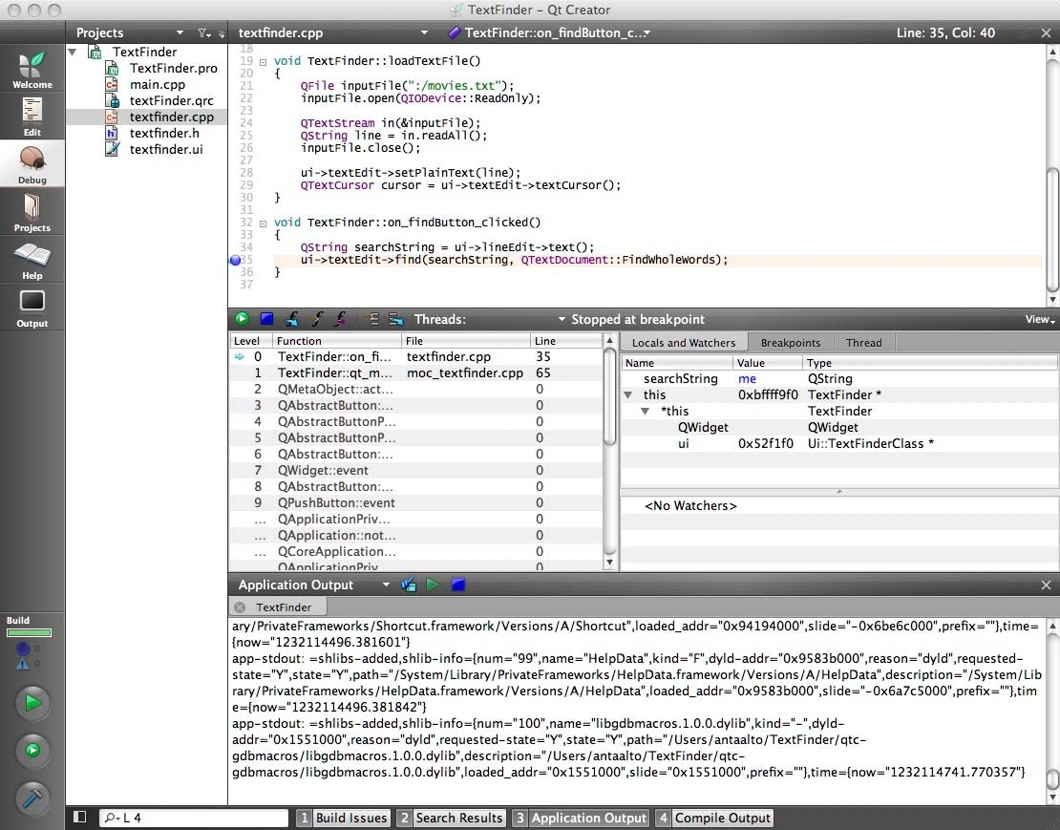

Figure 6. The debug mode of Qt Creator showing a breakpoint in the editor view, and call stack view and a watch view

The developer can select a set of tools to display debugging information in the dock view. The most frequently used panels are shown by default, it is possible to change them to suite your preference. It is also change the panels’ position and size, and the changes are saved for future sessions.

Breakpoints can be set at a specific line or at a specific function. A red marker next to the line number on the left in the code editor shows a breakpoint set at a specific line in the source code (Figure 6).

When the program execution is stopped during the debugging, the Call Stack lists all the frames, which represent the nested function calls leading to the current position. For each function in call stack, Qt Creator tries to retrieve its location (the name of source code file and the related line number) and present it in the Stack view. However, as shown in Figure 6, some functions
in call stack may not have any debug information available. These frames are then shown as greyed out.

© 2008 Nokia Corporation and/or its subsidiaries. – Qt Creator 1.0 – 10

The top stack call frame (or the selected), is displayed in Locals and Watchers view. The view shows the function and the local variables. An example of this can be seen in Figure 6 where the compound variables are displayed as an expandable tree in the Locals view. The figure also shows comprehensive display of data of Qt’s base classes, which is one features that makes the Qt Creator debugger more powerful than other alternatives for developing Qt code.

9 Summary
Qt Creator offers a complete development environment for Qt application creation. It is a lightweight tool with a strict focus on Qt application developer‐specific needs, productivity, and usability. Key features are the advanced C++ code editor and graphical user interface for GNU debugger. Integrating Qt Designer, Qt Help, and the Locator tool for quick navigation, makes Qt Creator the ideal environment developing Qt software.

Qt Creator is available via http://www.qtsoftware.com/downloads.

© 2008 Nokia Corporation and/or its subsidiaries. – Qt Creator 1.0 – 11
White Paper

About Qt Software:
Qt Software (formerly Trolltech) is a global leader in cross-platform application frameworks. Nokia acquired Trolltech in June 2008, renamed it to Qt Software as a group within Nokia. Qt allows open source and com- mercial customers to code less, create more and deploy everywhere. Qt enables developers to build innovative services and applications once and then extend the innovation across all major desktop, mobile and other embedded platforms without rewriting the code. Qt is also used by multiple leading consumer electronics ven- dors to create advanced user interfaces for Linux devices. Qt underpins Nokia strategy to develop a wide range of products and experiences that people can fall in love with.

About Nokia
Nokia is the world leader in mobility, driving the transformation and growth of the converging Internet and communications industries. We make a wide range of mobile devices with services and software that enable people to experience music, navigation, video, television, imaging, games, business mobility and more. Devel- oping and growing our offering of consumer Internet services, as well as our enterprise solutions and soft- ware, is a key area of focus. We also provide equipment, solutions and services for communications networks
through Nokia Siemens Networks.



Oslo, Norway +47 21 60 48 00 Redwood City, CA, USA +1 650-551-1676 Beijing, China +86 10 6588 8836 qt-info@nokia.com www.qtsoftware.com
© 2008 Nokia Corporation and/or its subsidiaries. Nokia, Qt and their respective logos are trademarks of Nokia Corporation in Finland and/or other countries worldwide. All other trademarks are property of their respective owners.

