[原创]Excel VBA之破解工作表/工作簿保护密码 (2008-02-28 09:25:30)
标签：原创 excel vba 工作表 工作簿 密码 破解 it | 分类：Excel VBA系列
平时在用Excel编辑文件时，如果不希望别人修改文件的内容，我们一般会为工作表或工作簿添加上密码，起到保护作用。
而当我们从网上下载了一个Excel文档，如果里面带有工作表/工作簿密码保护，我们又急需修改这个文件，这时我们又该怎么办呢？
今天，我们就来讲一下Excel工作表/工作簿密码的攻与防，正所谓没有最硬的盾，也没有最快的矛，矛与盾的关系就看我们怎么处理了。好了，闲话少说，打板就唱。

怎么样设置工作表/工作簿密码？
制作好Excel表后，点击工具菜单下的保护->保护工作表/保护工作簿，在弹出的对话框中设置上密码即可。密码尽量设置的复杂点，防止暴力破解。
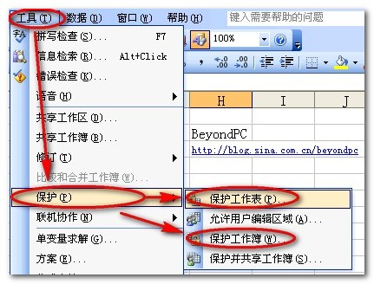

到此，工作表/工作簿密码就设置好了，下面我们就开始讲怎么破解这个密码。

怎么样破解这个密码？
注意：在破解之前最好先备份，免得发生意外！
破解密码，一般人都会想到用软件来破解，而我们今天是用VBA来进行破解。首先打开VBA编辑器。
1、点击工具->宏->Visual Basic编辑器，打开VBA的编辑器。
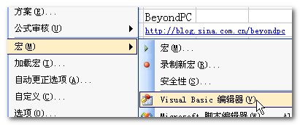

２、在Visual Basic编辑器中，点击插入->模块，插入一个新的模块，我们的代码就是写到这个新的模块中的。
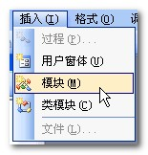

３、将下面的代码复制到模块中，不需改动任何代码。
Option Explicit
Public Sub AllInternalPasswords()
' Breaks worksheet and workbook structure passwords. Bob McCormick
' probably originator of base code algorithm modified for coverage
' of workbook structure / windows passwords and for multiple passwords
'
' Norman Harker and JE McGimpsey 27-Dec-2002 (Version 1.1)
' Modified 2003-Apr-04 by JEM: All msgs to constants, and
' eliminate one Exit Sub (Version 1.1.1)
' Reveals hashed passwords NOT original passwords
Const DBLSPACE As String = vbNewLine & vbNewLine
Const AUTHORS As String = DBLSPACE & vbNewLine & _
"Adapted from Bob McCormick base code by" & _
"Norman Harker and JE McGimpsey"
Const HEADER As String = "AllInternalPasswords User Message"
Const VERSION As String = DBLSPACE & "Version 1.1.1 2003-Apr-04 " & vbCrLf & vbCrLf & "BeyondPC" & vbCrLf & "http://blog.sina.com.cn/beyondpc"
Const REPBACK As String = DBLSPACE & "Please report failure " & _
"to the microsoft.public.excel.programming newsgroup."
Const ALLCLEAR As String = DBLSPACE & "The workbook should " & _
"now be free of all password protection, so make sure you:" & _
DBLSPACE & "SAVE IT NOW!" & DBLSPACE & "and also" & _
DBLSPACE & "BACKUP!, BACKUP!!, BACKUP!!!" & _
DBLSPACE & "Also, remember that the password was " & _
"put there for a reason. Don't stuff up crucial formulas " & _
"or data." & DBLSPACE & "Access and use of some data " & _
"may be an offense. If in doubt, don't."
Const MSGNOPWORDS1 As String = "There were no passwords on " & _
"sheets, or workbook structure or windows." & AUTHORS & VERSION
Const MSGNOPWORDS2 As String = "There was no protection to " & _
"workbook structure or windows." & DBLSPACE & _
"Proceeding to unprotect sheets." & AUTHORS & VERSION
Const MSGTAKETIME As String = "After pressing OK button this " & _
"will take some time." & DBLSPACE & "Amount of time " & _
"depends on how many different passwords, the " & _
"passwords, and your computer's specification." & DBLSPACE & _
"Just be patient! Make me a coffee!" & AUTHORS & VERSION
Const MSGPWORDFOUND1 As String = "You had a Worksheet " & _
"Structure or Windows Password set." & DBLSPACE & _
"The password found was: " & DBLSPACE & "$$" & DBLSPACE & _
"Note it down for potential future use in other workbooks by " & _
"the same person who set this password." & DBLSPACE & _
"Now to check and clear other passwords." & AUTHORS & VERSION
Const MSGPWORDFOUND2 As String = "You had a Worksheet " & _
"password set." & DBLSPACE & "The password found was: " & _
DBLSPACE & "$$" & DBLSPACE & "Note it down for potential " & _
"future use in other workbooks by same person who " & _
"set this password." & DBLSPACE & "Now to check and clear " & _
"other passwords." & AUTHORS & VERSION
Const MSGONLYONE As String = "Only structure / windows " & _
"protected with the password that was just found." & _
ALLCLEAR & AUTHORS & VERSION & REPBACK
Dim w1 As Worksheet, w2 As Worksheet
Dim i As Integer, j As Integer, k As Integer, l As Integer
Dim m As Integer, n As Integer, i1 As Integer, i2 As Integer
Dim i3 As Integer, i4 As Integer, i5 As Integer, i6 As Integer
Dim PWord1 As String
Dim ShTag As Boolean, WinTag As Boolean
Application.ScreenUpdating = False
With ActiveWorkbook
WinTag = .ProtectStructure Or .ProtectWindows
End With
ShTag = False
For Each w1 In Worksheets
ShTag = ShTag Or w1.ProtectContents
Next w1
If Not ShTag And Not WinTag Then
MsgBox MSGNOPWORDS1, vbInformation, HEADER
Exit Sub
End If
MsgBox MSGTAKETIME, vbInformation, HEADER
If Not WinTag Then
MsgBox MSGNOPWORDS2, vbInformation, HEADER
Else
On Error Resume Next
Do 'dummy do loop
For i = 65 To 66: For j = 65 To 66: For k = 65 To 66
For l = 65 To 66: For m = 65 To 66: For i1 = 65 To 66
For i2 = 65 To 66: For i3 = 65 To 66: For i4 = 65 To 66
For i5 = 65 To 66: For i6 = 65 To 66: For n = 32 To 126
With ActiveWorkbook
.Unprotect Chr(i) & Chr(j) & Chr(k) & _
Chr(l) & Chr(m) & Chr(i1) & Chr(i2) & _
Chr(i3) & Chr(i4) & Chr(i5) & Chr(i6) & Chr(n)
If .ProtectStructure = False And _
.ProtectWindows = False Then
PWord1 = Chr(i) & Chr(j) & Chr(k) & Chr(l) & _
Chr(m) & Chr(i1) & Chr(i2) & Chr(i3) & _
Chr(i4) & Chr(i5) & Chr(i6) & Chr(n)
MsgBox Application.Substitute(MSGPWORDFOUND1, _
"$$", PWord1), vbInformation, HEADER
Exit Do 'Bypass all for...nexts
End If
End With
Next: Next: Next: Next: Next: Next
Next: Next: Next: Next: Next: Next
Loop Until True
On Error GoTo 0
End If
If WinTag And Not ShTag Then
MsgBox MSGONLYONE, vbInformation, HEADER
Exit Sub
End If
On Error Resume Next
For Each w1 In Worksheets
'Attempt clearance with PWord1
w1.Unprotect PWord1
Next w1
On Error GoTo 0
ShTag = False
For Each w1 In Worksheets
'Checks for all clear ShTag triggered to 1 if not.
ShTag = ShTag Or w1.ProtectContents
Next w1
If ShTag Then
For Each w1 In Worksheets
With w1
If .ProtectContents Then
On Error Resume Next
Do 'Dummy do loop
For i = 65 To 66: For j = 65 To 66: For k = 65 To 66
For l = 65 To 66: For m = 65 To 66: For i1 = 65 To 66
For i2 = 65 To 66: For i3 = 65 To 66: For i4 = 65 To 66
For i5 = 65 To 66: For i6 = 65 To 66: For n = 32 To 126
.Unprotect Chr(i) & Chr(j) & Chr(k) & _
Chr(l) & Chr(m) & Chr(i1) & Chr(i2) & Chr(i3) & _
Chr(i4) & Chr(i5) & Chr(i6) & Chr(n)
If Not .ProtectContents Then
PWord1 = Chr(i) & Chr(j) & Chr(k) & Chr(l) & _
Chr(m) & Chr(i1) & Chr(i2) & Chr(i3) & _
Chr(i4) & Chr(i5) & Chr(i6) & Chr(n)
MsgBox Application.Substitute(MSGPWORDFOUND2, _
"$$", PWord1), vbInformation, HEADER
'leverage finding Pword by trying on other sheets
For Each w2 In Worksheets
w2.Unprotect PWord1
Next w2
Exit Do 'Bypass all for...nexts
End If
Next: Next: Next: Next: Next: Next
Next: Next: Next: Next: Next: Next
Loop Until True
On Error GoTo 0
End If
End With
Next w1
End If
MsgBox ALLCLEAR & AUTHORS & VERSION & REPBACK, vbInformation, HEADER
End Sub

４、粘帖完后，点击运行按钮，或按F5键，运行代码。
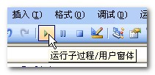

5、程序开始运行后，会弹出两次对话框，直接确定即可。
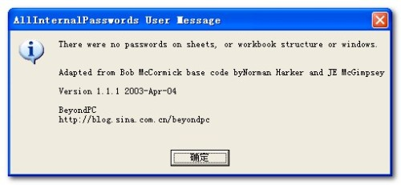

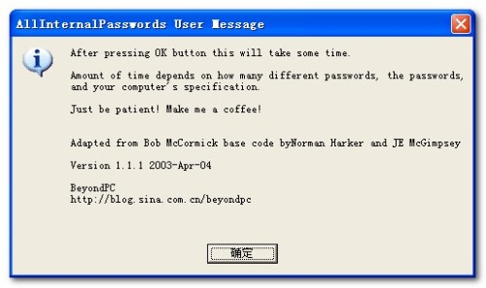

6、大约2分钟左右后，即弹出完成对话框，下图中画红线的地方即是找到的密码（注意：最后的那个也是密码中的一部分），单击确定后，文件中的密码即被清除。
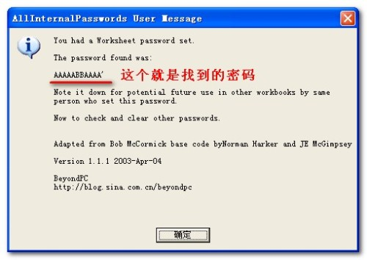

７、如果只想找到密码而不想清除它，只要不保存文件，重新打开后在工具->保护->撤消工作表/工作簿保护，输入刚才找到的密码即可。

8、需要说明的一点是，找到的这个密码并不是真正设置时输入的密码，但确可以使用。比如刚才找到的这个密码，而我设置时用的是123为密码的，不知这种情况是Excel的漏洞还是有意为之的，总之和都可以撤消对工作表的保护。

总结
看到这里，我们要问了，那怎么样的密码才算安全呀？其实安全是需要配合使用的，我们刚才的代码只是破解工作表/工作簿密码的，而我们可以用更多其它方面的保护来防止我们的文件不被破解，比如权限的设置（文件->权限）等。正所谓没有破解不了的密码，我们现在做的，只是将风险降到最低而已，最起码不能让破解者轻易的解密了，其它的，就只能看吧！

