Open the .xlf file

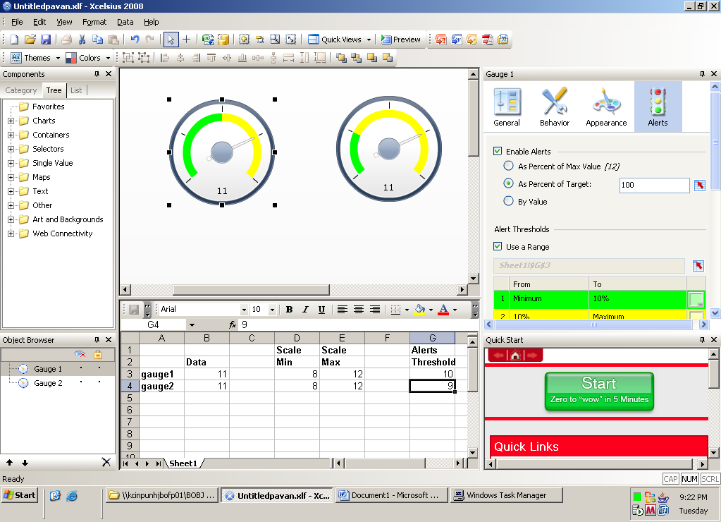

Now copy the initial Gauge and paste it on the canvas

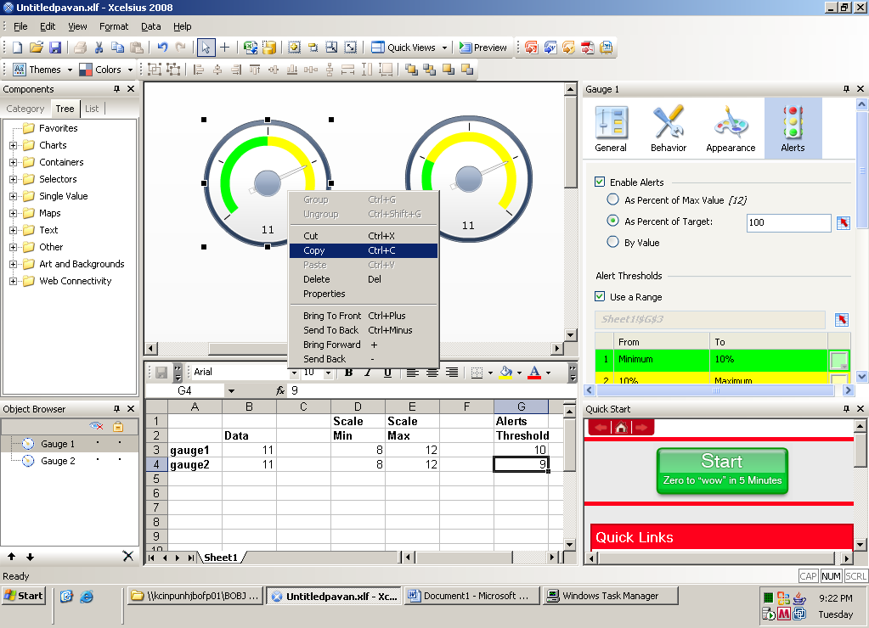

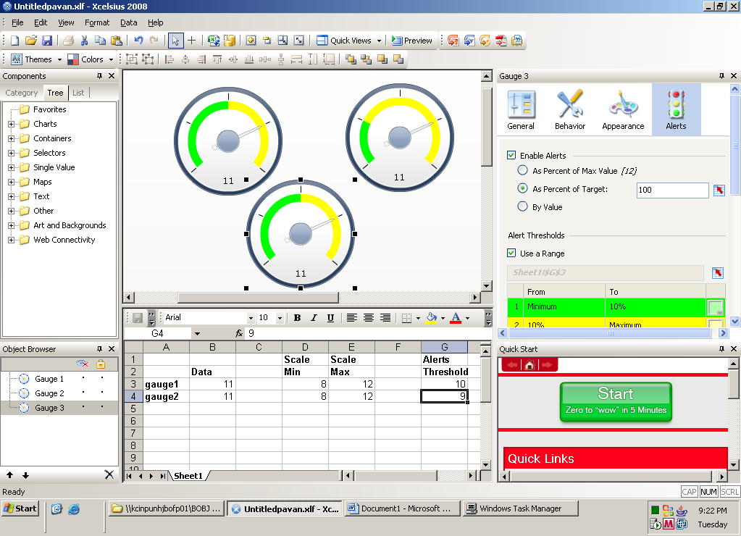

Now go to the Alerts tab and select the range to another gauge.
In this case, Gauge2 as show below:

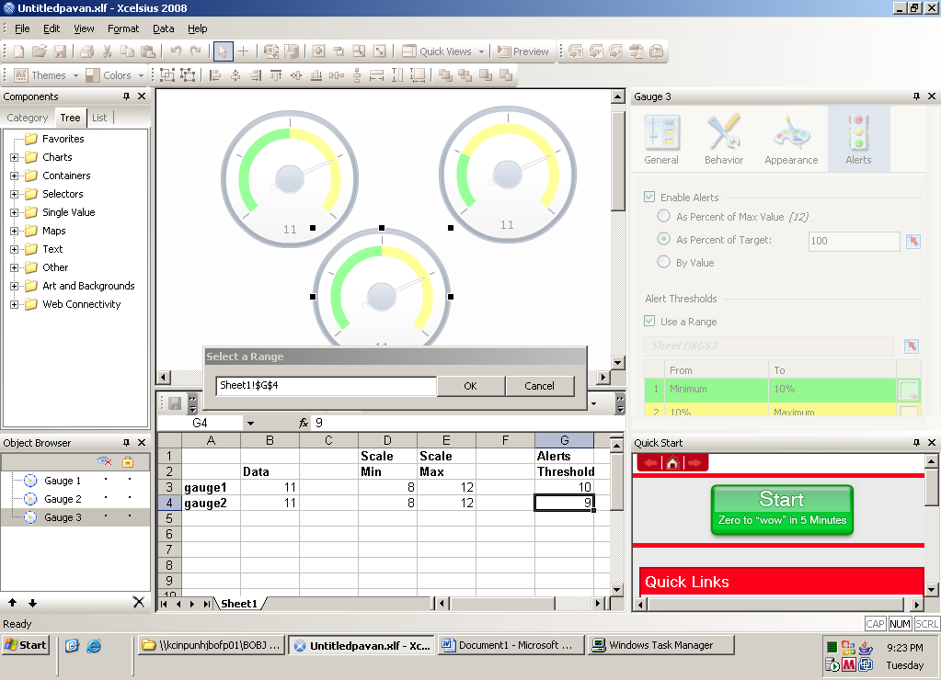

Now you observe that colour of the original Gauge changes to Black.

