RubyOnRails (1.1) and Flex (2.0)

Environment
The first thing lets make sure we have a working Ruby on Rails environment. You’ll also need a database of course.
You are going need at least 1.1 version of Rails for this tutorial. If you don’t have Rails running consider InstantRails for Windows or if you are on a Mac try Locomotive. But for the purpose of this tutorial you might want Windows as Flex Builder is only installable on Windows for now. You can use the Flex compiler on a Mac but the Builder IDE is just so much easier. I’m ok, i have a dual booting MBP ;-)
Then you are going to need to install the beta of Flex2.0 from Adobe. You can get this over at Adobe Labs. If you are on Windows just install the Flex Builder which will have everything you need, including the Flex Player 8.5 beta. If not you are going to need to install Flex PLyaer 8.5 beta and the Flex SDK.

Setup our Rails application
Ok so here we go.
First lets create a Rails application..you know how this goes. On the command line with me..

rails flexiblerails
You’ll also need a database for this application called flexiblerails_development.
We need to create a database table in our application called reviews
So try this for a mysql database
DROP DATABASE IF EXISTS `flexiblerails_development`; CREATE DATABASE `flexiblerails_development` USE `flexiblerails_development`; CREATE TABLE `reviews` ( `id` int(11) NOT NULL auto_increment, `title` varchar(255) default NULL, `text` text, `score` int(11) default NULL, `author` varchar(120) default NULL, PRIMARY KEY (`id`) ) ENGINE=MyISAM DEFAULT CHARSET=latin1;
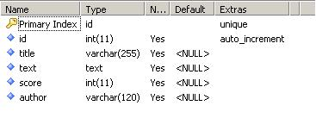
Lets create the model and controller

ruby script/generate model Review
ruby script/generate controller Reviews
Now we have our basic application we are going to add to.

Setup our Flex application
If you are using Flex Builder this is a piece of cake. Startup the builder and use the menu File > New > Flex Application. You don’t need any dataservices, call it flexiblerails and click Finish.
You should see the a new MXML file like this
<?xml version="1.0" encoding="utf-8"?>
<mx:Application xmlns:mx="http://www.adobe.com/2006/mxml" xmlns="*" layout="absolute">

</mx:Application>
Thats it.

Displaying some data
Simple scaffolding thing first. We want our Flex application to show our list of Reviews in a nice grid.
First lets create the Rails back-end. Open app/controllers/reviews_controller. Change it to:
class ReviewsController < ApplicationController
def list
@reviews = Review.find :all
render :xml => @reviews.to_xml
end
end
Rails 1.1 makes this very easy, all models can just be dumped straight to XML.
And start the server
ruby script/server
We shall add some content in the database.

INSERT INTO `reviews` (`id`,`title`,`text`,`score`,`author`)
VALUES (1,'Agile Web Development with Rails',
'This is the text for Rails programming and a fine read all round',5,'David Heinemeier Hansson');
INSERT INTO `reviews` (`id`,`title`,`text`,`score`,`author`)
VALUES (2,'Programming Rails',
'Rubby Russell\'s new Rails book for O\'Reilly. Highly anticipated.',4,'Robby Russell');
And check our Rails controller. Lets go to http://localhost:3000/reviews/list and see the action result XML.
<reviews>
<review>
<score type="integer">5</score>
<title>Agile Web Development with Rails</title>
<text>
This is the text for Rails programming and a fine read all round
</text>
<author>David Heinemeier Hansson</author>
<id type="integer">1</id>
</review>
<review>
<score type="integer">4</score>
<title>Programming Rails</title>
<text>
Rubby Russell's new Rails book for O'Reilly. Highly anticipated.
</text>
<author>Robby Russell</author>
<id type="integer">2</id>
</review>
</reviews>
Lets get Flex to consume this new XML service. In the Flex Builder change the flexiblerails.mxml file to:
<?xml version="1.0" encoding="utf-8"?>
<mx:Application xmlns:mx="http://www.adobe.com/2006/mxml"
xmlns="*" layout="absolute"
creationComplete="reviewRequest.send()">
<mx:HTTPService id="reviewRequest"
url="http://localhost:3000/reviews/list"
useProxy="false"/>
<mx:DataGrid id="dgReviews" x="40" y="85" width="800"
height="134"
dataProvider="{reviewRequest.lastResult.reviews.review}">
<mx:columns>
<mx:DataGridColumn headerText="Title" dataField="title" width="480"/>
<mx:DataGridColumn headerText="Author" dataField="author" width="240"/>
<mx:DataGridColumn headerText="Score" dataField="score" width="80"/>
</mx:columns>
</mx:DataGrid>

<mx:TextArea x="40" y="245" width="800"
htmlText="{dgReviews.selectedItem.text}" />
</mx:Application>
The above MXML code creates fourthings.
<mx:HTTPService id="reviewRequest" url="http://localhost:3000/reviews/list" useProxy="false"/>
Creates a HTTPService which will access the list action on our ReviewsController.
<mx:DataGrid id="dgReviews" x="40" y="85" width="800" height="134"
dataProvider="{reviewRequest.lastResult.reviews.review}">
<mx:columns>
<mx:DataGridColumn headerText="Title" dataField="title" width="480"/>
<mx:DataGridColumn headerText="Author" dataField="author" width="240"/>
<mx:DataGridColumn headerText="Score" dataField="score" width="80"/>
</mx:columns>
</mx:DataGrid>
This MXML creates a DataGrid, a table to display our data. The dataProvider element points to the result of our HTTPService with reviewRequest.result. The last reviews.review is a dot-notation that references the reviews node, then all the review nodes will form the rows.
In the DataGrid all the DataGridColumn elements create a column where the dataField attribute references the XML node child of the review node.
<mx:TextArea x="40" y="245" width="800" htmlText="{dgReviews.selectedItem.text}" />
This textarea will display the review text of the selected item in the DataGrid.
We just need to make sure the request is kicked off, so in the mx:Application element we add:
creationComplete="reviewRequest.send()"
Lets run our Flex application. If you are in builder just hit the green and white button.
You should get something like this:
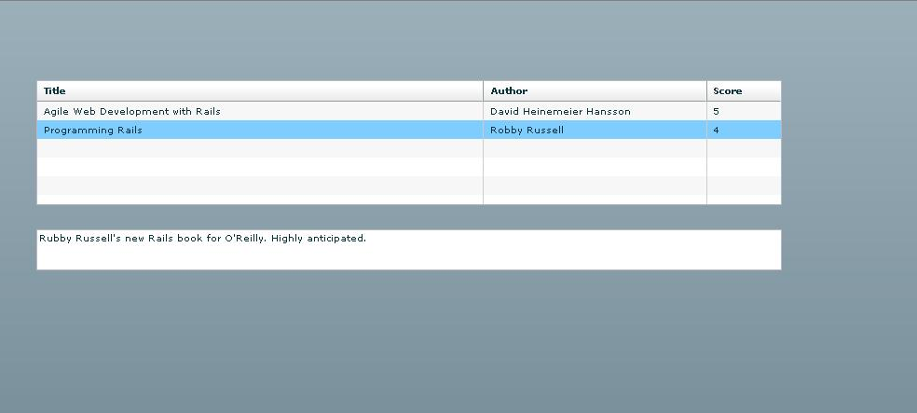

Capturing data
All well and good but how do we capture data from Flex. Again Rails 1.1 makes this very easy.
Let’s start with the Flex side. Add the following the MXML file
<mx:HTTPService contentType="application/xml" id="reviewCreateRequest"
url="http://localhost:3000/reviews/create"
useProxy="false" method="POST">
<mx:request xmlns="">
<review>
<title>{fTitle.text}</title>
<author>{fAuthor.text}</author>
<score>{fScore.text}</score>
<text>{fText.text}</text>
</review>
</mx:request>
</mx:HTTPService>
<mx:Form x="40" y="300" width="800">
<mx:Grid>
<mx:GridRow>
<mx:GridItem>
<mx:Label text="Title"/>
</mx:GridItem>
<mx:GridItem>
<mx:TextInput width="260" id="fTitle"/>
</mx:GridItem>
</mx:GridRow>
<mx:GridRow>
<mx:GridItem>
<mx:Label text="Author"/>
</mx:GridItem>
<mx:GridItem>
<mx:TextInput width="140" id="fAuthor"/>
</mx:GridItem>
</mx:GridRow>
<mx:GridRow>
<mx:GridItem>
<mx:Label text="Score"/>
</mx:GridItem>
<mx:GridItem>
<mx:TextInput width="20" id="fScore"/>
</mx:GridItem>
</mx:GridRow>
<mx:GridRow>
<mx:GridItem>
<mx:Label text="Text"/>
</mx:GridItem>
<mx:GridItem>
<mx:TextArea width="600" height="200" id="fText"/>
</mx:GridItem>
</mx:GridRow>
<mx:GridRow>
<mx:GridItem>
<mx:Button label="Submit"
click="reviewCreateRequest.send();reviewRequest.send()"/>
</mx:GridItem>
<mx:GridItem>
</mx:GridItem>
</mx:GridRow>
</mx:Grid>
</mx:Form>
This adds 2 things to our Flex application. A form and a new HTTPService. The form just lays out a series of fields and a button which calls a send on our new HTTPService.
<mx:HTTPService contentType="application/xml"
id="reviewCreateRequest"
url="http://localhost:3000/review/create"
useProxy="false" method="POST">
<mx:request xmlns="">
<review>
<title>{fTitle.text}</title>
<author>{fAuthor.text}</author>
<score>{fScore.text}</score>
<text>{fText.text}</text>
</review>
</mx:request>
</mx:HTTPService>
This service is going to use a POST to send XML to a new Rails action create. The XML is formed in the request but subsituted with the values of the form fields. Note the contentType=”application/xml” it is important that Flex sends the XML content type to Rails.
For the Rails application we add a new action to ReviewsController
def create
@review = Review.new(params[:review])
@review.save
render :xml => @review.to_xml
end
And thats it! Rails 1.1 will take a submitted request with an application/xml content-type and transform it to a parameter map which can be easily loaded into the models. It is then saved to the database and we return nothing. Equally here you could return error messages to be used in the Flex application.
So we start our new Flex application we get this:
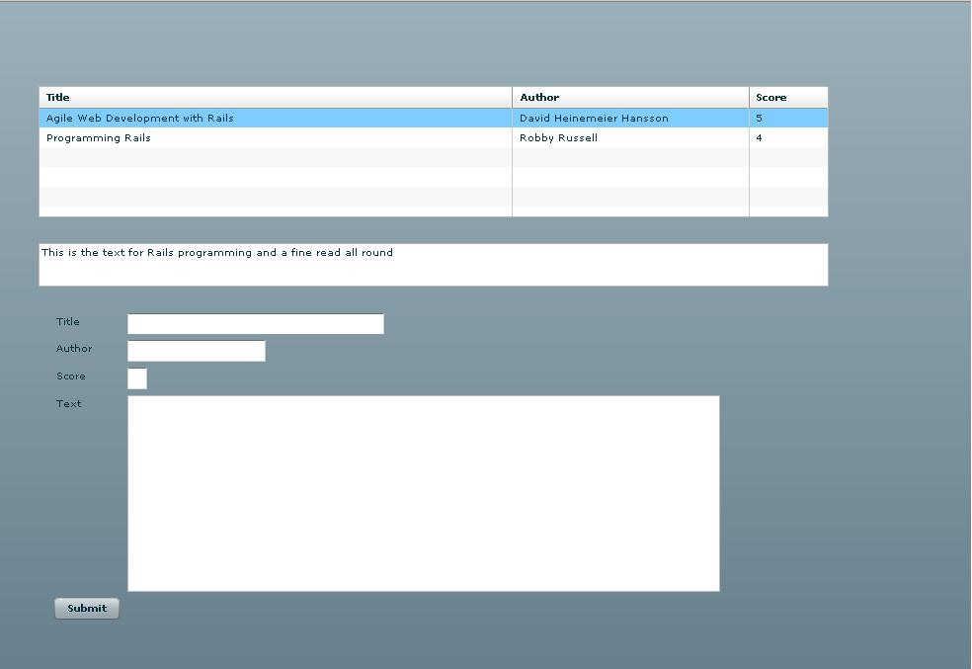
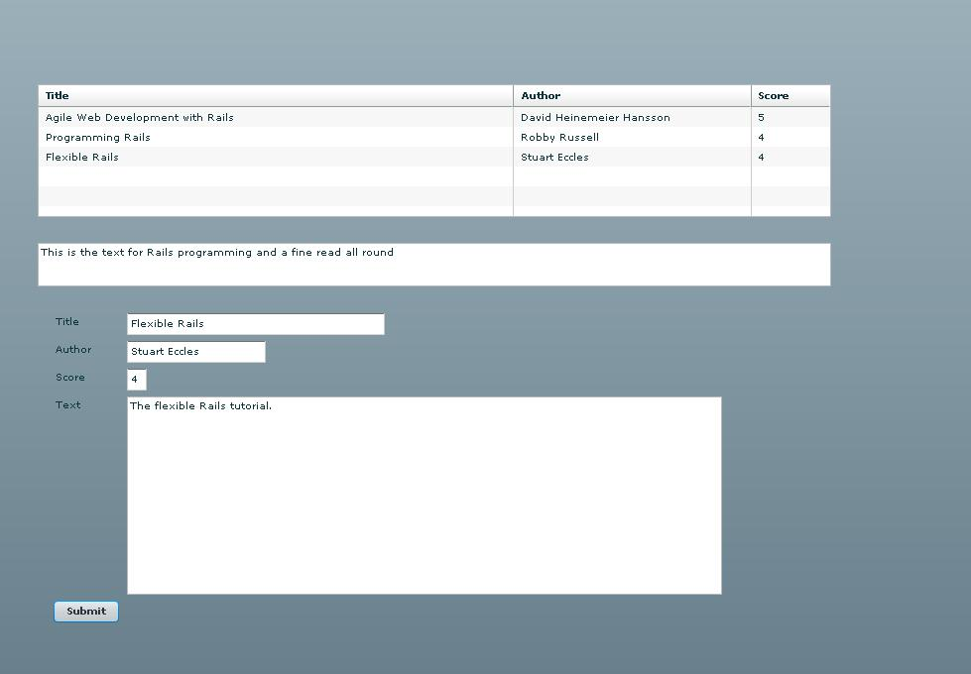
If you enter data on the form and submit it will be added to the database and the list refreshed. A simple Flexible scaffold.

Summary
Ruby On Rails is a great back-end for Flex applications, with new 1.1 REST XML features it’s easy to do XML driven requests for Flash. With Flex it’s easy to consume them.
UPDATE: Part 2 of the tutorial is available
Tags: flash, flex, rubyonrails, tutorial
Filed Under: Flex, RubyOnRails
Richard Marsh
April 19th, 2006
nice stuff matey, see you thursday at the MMUG :)
Alex
April 20th, 2006
Great Tutorial, Looking forward to Part 2
cisnky
April 20th, 2006
I’ve been thinking about doing something like this ever since I ran a scaffold command for the first time.
Top article
Campbell
April 20th, 2006
Yeah! nice. Cisnky I totally agree. I think this is leading somewhere…..
Richard
May 1st, 2006
Just wondering when part 2 is coming out (it’s been two weeks now). Thanks
.Netter
May 2nd, 2006
Is there a .Net version of this ^^?
Stuart Eccles
May 3rd, 2006
Part 2 coming in the next couple of days, just have to write it up ;-)
PsiliPharm
May 10th, 2006
I thought I’d be the first to do this, I have a big project under development with Flex & Rails, but I’m waiting until final release of Flex 2 to launch the site, every Beta release I’ve had to change a bunch of code to get it working again…so I don’t want to launch until it’s a bit more stable.
Andrew Cleland
May 16th, 2006
Great article. I have been using Flex with a Java backend, but it seems like a pain in the a* to get my data from the db. I have heard of Rails, but never looked into it until yesterday. Your example makes it seem so easy, I am sure as with most examples that the logic and code can get quite complex. But you have shown me that I should really investigate Rails. There is a lot of technology out in the world, which gives solutions to either the client, i.e. Flex, or to the server, i.e. Rails. You brought the 2 together, which is what you want to do normally when developing applications.
Toby Beal
May 23rd, 2006
I had difficulty in getting this example to work until I made a change to the dataProvider attribute of the DataGrid. I read somewhere that they made a change from Beta 2 to Beta 3, where you can no longer use “result” but you must intead use “lastResult” for the attribute.
BEFORE reviewRequest.result.reviews.review
AFTER reviewRequest.lastResult.reviews.review
Toby Beal
May 23rd, 2006
Sorry. One more observation. I get an error from the flash client when using the code above. It seems that it doesn’t like the fact that it’s not getting XML return and it’s generating the following error:
“Default decoder could not decode result”
To fix this error I change the Rails code so that it renders the same list again.
Example:
BEFORE @review = Review.new(params[:review]) @review.save render :nothing => true
AFTER @review = Review.new(params[:review]) @review.save render :xml => reviews.to_xml
I should point out that I didn’t follow this tutorial exactly, and it may have been something I did. But to anyone out there getting this error. This was how I got around it.
Stuart Eccles
May 23rd, 2006
Yep its a beta 2 to beta 3 issue with both of them. The first part was written with beta 2 and the second part was beta 2 hence why in part 2 all the actions render an XML result.
I’ll update the article. Thanks for the help
Austin
May 29th, 2006
Amazing Job, I Have been looking for a interaction layer of MySql and Flex forever.
Congrats on an excelent Toturial
Thorsten Brueckner
July 23rd, 2006
Hello,
first of all: Congratulations for doing a great job.
Although I was able to see the Data grid (first half of tutorial), the Data did not come in.
On the other hand I was able to see the xml generated from the table in the browser on http://localhost/reviews/list
In the status line firefox told me “Waiting for localhost” when showing the swf-file
Changing the port from 3000 to 80, using mongrel as Rails-Server, switching off windows firewall and several other tryings did not succeed.
Any suggestions what am I doing wrong?
Thank you
Thorsten
cskidmore
July 27th, 2006
can someone look into what’s going on with this website? I’m trying to look at the tutorials on Rails & Flex but most of the links return an Application error or an Internal Server error.
Gaurav
August 14th, 2006
Great Job. I was looking for such a tutorial integrating rails & flex & I think I have found just that.
Gaurav
August 16th, 2006
I am unable to view the data in the table. Can anybody help me in this.
SEO
August 20th, 2006
Wonderful article, thank you!
Bounce
August 31st, 2006
Hi Thorsten,
I have the same problem. I am able to see the data at http://localhost:3000/reviews/list but not in the flex file. I get the following message from flex:
[RPC Fault faultString=”Security error accessing url” faultCode=”Channel.Security.Error” faultDetail=”Destination: DefaultHTTP”] at mx.rpc::AbstractInvoker/http://www.adobe.com/2006/flex/mx/internal::faultHandler() at mx.rpc::Responder/fault() at mx.rpc::AsyncRequest/fault() at ::DirectHTTPMessageResponder/securityErrorHandler() at flash.events::EventDispatcher/flash.events:EventDispatcher::dispatchEventFunction() at flash.events::EventDispatcher/dispatchEvent() at flash.net::URLLoader/flash.net:URLLoader::redirectEvent()
Can anyone help? Thanks. B.
Pillangószív
September 5th, 2006
Great job! Thank you very much!
AJIT DIXIT
September 10th, 2006
Hi ,
In this example only in rails model Review you put following validation
validates_presence_of :title
How do you capture this in flex ?
Реферат
September 12th, 2006
Wow! Nice work, Stuart!
optimalizálás
September 14th, 2006
Great work,thanks!
Magnus
September 14th, 2006
It seems that I am having the same problems as Bounce and Thorsten: I can see the datagrid but no data. Firefox tells me: “Waiting for localhost”
On IE I get the error:
[RPC Fault faultString=”Security error accessing url” faultCode=”Channel.Security.Error” faultDetail=”Destination: DefaultHTTP”] at mx.rpc::AbstractInvoker/http://www.adobe.com/2006/flex/mx/internal::faultHandler() at mx.rpc::Responder/fault() at mx.rpc::AsyncRequest/fault() at ::DirectHTTPMessageResponder/securityErrorHandler() at flash.events::EventDispatcher/flash.events:EventDispatcher::dispatchEventFunction() at flash.events::EventDispatcher/dispatchEvent() at flash.net::URLLoader/flash.net:URLLoader::redirectEvent()
Any suggestions?
csikung (chi kung, qigong)
September 14th, 2006
Nice work!
Anonymous
September 14th, 2006
Hi Magnus,
I haved the same problem
Put your flexiblerails.swf in your flexiblerails\public directory.
run ruby script\server -p 80
Go to http://localhost/flexiblerails.swf with IE or Mozilla (with Flash Player 9)
Voilà
Anonymous
September 14th, 2006
Sorry
Change
http://localhost:3000/reviews/list
to
http://localhost/reviews/list
in your flexiblerails.mxml
if you use -p 80 with ruby script\server
Magnus
September 15th, 2006
Oh Yes! Now it works :-) Thanks a lot.
Laurent
September 15th, 2006
Great article.
But i have a problem to display the flash UI…i deployed the SWF in app/views/reviews folder then i try the url : http://localhost:3000/reviews/flexiblerails.swf but i get an error (Controller)
Second solution, write a .rhtml view (index.rhtml for example) including the OBJECT tag: but nothing is displayed
Any idea?
Laurent
September 15th, 2006
I’ve got a HTTP error 500..trying with Firefox, Flash 9, on Mac OS X Tiger
Laurent
September 16th, 2006
OK, now it works .. i started the server listening on port 80 and put the SWF in public folder.
But my dataGrid is emty..when i check in a browser window the reviews/list page i got the xml.
M @ SEOG.net
September 21st, 2006
Thanks for the article and screenshots! I’ve been playing with Ruby on Rails at home and starting to learn Flex at work in a Coldfusion environment. This looks like a tasty way to integrate the two frameworks!
Michael @ SEOG
katalog
October 14th, 2006
Oh Yes! Now it works :-) Thanks a lot
Plasma
November 9th, 2006
At the first try io have also the 500 error, but with this help it works…. Merci…
Robert
November 9th, 2006
It´s a helpful tutorial! Thx!
Volker
November 9th, 2006
A thoughtful article and a code as additional help! Thank you from Germany
Pozycjonowanie
November 16th, 2006
I thought I’d be the first to do this, I have a big project under development with Flex & Rails, but I’m waiting until final release of Flex 2 to launch the site, every Beta release I’ve had to change a bunch of code to get it working again…so I don’t want to launch until it’s a bit more stable.
Catalogy
November 17th, 2006
Really useful tutorial, i´m looking forward to Part 2
Energie Heizung
November 19th, 2006
greast article/tuitorial. i love ROR. thx
Moneyletter
November 20th, 2006
Great Tutorial – very helpful!
inou
November 21st, 2006
to read data from other ports than 80 you have to create crossdomain.xml file in public folder
Not necessary when they are in the same folder
Moni
November 21st, 2006
A instructive article in simple terms. W´ve undstanding now (a little bit).
Tom Barnes
November 29th, 2006
It´s a great and very helpful tutorial! Thank you!
Webdesign Köln Gruop
November 30th, 2006
Great article, thanks!
Suchmaschinenoptimierung Schamane
November 30th, 2006
It’s great article und great website, but its dont work with IE to me, why?
Bannerdesign
December 3rd, 2006
Great Job. I was looking for such a tutorial integrating rails & flex & I think I have found just that.
Manga
December 3rd, 2006
Great Job, I Have been looking for a interaction layer of MySql and Flex forever.
Congrats on an excelent Toturial
Andre
December 11th, 2006
Really good job Stuart. Thank you for that :o)
eMule Forum
December 11th, 2006
Just wondering when part 2 is coming out (it’s been two weeks now). Thanks
ranking
December 15th, 2006
to read data from other ports than 80 you have to create crossdomain.xml file in public folder
Not necessary when they are in the same folder ranking and pagerank
Samuel Kreditkarte
December 18th, 2006
@dSL: Why you have posted 4- times???
Brautkleider
December 20th, 2006
Very good summary. I normaly use Flex with the Java backend, but than had the same problems. Now I will try to invest time to see what I can do with Rails (I was too busy to do it in the past, but I think this was a mistake. I will use the Christmas Holiday now to make some test with you combination. Thank you and have a nice x-mas.
Serwery emule
December 23rd, 2006
Just wondering when part 2 is coming out (it’s been two weeks now). Thanks
emule download
December 23rd, 2006
Oh Yes! Now it works :-) Thanks a lot.
?
December 26th, 2006
part 2 is out since may:
http://www.liverail.net/articles/2006/05/06/rubyonrails-1-1-and-flex-2-0-pt-2
Opisy
June 15th, 2007
Amazing Job, I Have been looking for a interaction layer of MySql and Flex forever. Congrats on an excelent Toturial…
Sascha
June 21st, 2007
I have heard of Rails, but never looked at it. Nice stuff. Thank you.
Olli
June 25th, 2007
Nice Tutorial. Adobe Flex 3 beta is out.
Dana
July 6th, 2007
Thanks for the tutorial! One thing isn’t working for me now that I’ve finished it: when I click “Submit” the new record I entered doesn’t show up in the grid. I know it’s entered into database okay and the grid is indeed updated, because if I submit a second new record the first one I submitted will show up. If I submit a third the second will show up and so on. It’s as if rails is reporting back to the flex app before it’s done storing the new record. Is there some simple way to keep what’s in the database and what’s on the screen consistent?
Dana
July 6th, 2007
I think I may have found an answer to my question. Instead of having the submit button have click=”reviewCreateRequest.send();reviewRequest.send()” I cut the reviewRequest.send from there and added it to the reviewCreateRequest so it is now <mx:HTTPService contentType=”application/xml” id=”reviewCreateRequest” url=”http://localhost:3000/reviews/create” useProxy=”false” method=”POST” result=”reviewRequest.send()”>. The result=”reviewRequest.send()” is what I added. I have no idea if this is the way to do it, but it seems to work.
jelenia góa
July 12th, 2007
Nice
Serg
July 15th, 2007
Thanx for this tutorial. But your websitedesign is destroyed in Firefox, the navigation is over the content… Greetings!
Leba
July 16th, 2007
I have used FLEX during my studies and I think, that is really useful tool – but at the beginning it requires a lot of time to get to know about it :P
thrusites design
July 31st, 2007
Well, I would welcome larger font on that black background. It is not easy to read that white text. :-S
On the other hand, the tutorial is perfect, I love it :) .
PCMasters Hardware Forum
August 12th, 2007
Im using FLEX and after the hard working through, im happy to use it. Its a powerfull tool.
Konin
August 12th, 2007
RubyOnRails is great.Im using FLEX .That is really useful tool. Nice stuff. Thank you.
Księgarnia internetowa
August 13th, 2007
Thanks for this very good article … Can i translate this and insert on my site in Poland? … Thanks
Księgarnia internetowa
August 13th, 2007
Thanks for this very good article … Can i translate this and insert on my site in Poland? … Thanks
euro 2012
August 13th, 2007
Thanks for very interesting article. btw. I really enjoyed reading all of your posts. It’s interesting to read ideas, and observations from someone else’s point of view… makes you think more. So please keep up the great work. Greetings
odżywki
August 13th, 2007
It’s really works for me.Thanks dude.
Maler
August 14th, 2007
Great und helpful instruction. Thank you!
Resell Rights
August 15th, 2007
Sounds interesting. I’m going to try your method. Thanks for the tut.
Wyniki na żywo
August 18th, 2007
To read data from other ports than 80 you have to create crossdomain.xml file in public folder
k-net
August 19th, 2007
Thanks for helpful guide.
Mathew @ MB Web Design
August 19th, 2007
Thanks for the tutorial, this Rails stuff is now a little less daunting ;)
Maxomat
August 20th, 2007
?
Kyle
August 22nd, 2007
Thanks for the teachy! One hang-up isn’t working for me now that I’ve down-and-out it: when I click “have” the new record I entered doesn’t trot out up in the basketry. I know it’s entered into database okay and the dressing room is in fact updated, because if I bring up a second new record the first one I complyted with constancy typify up. If I fall in with a diapason the second zealously unfold up and so on. It’s as if rails is reporting back to the flex app before it’s done storing the new record. Is there some simple way to keep what’s in the database and what’s on the screen consistent?
Unternehmensberatung Finanzberatung Mittelstand
August 22nd, 2007
great site with very good look and perfect information…i like it
Heinz
August 23rd, 2007
Cool!
Nick Mayer
August 24th, 2007
Hi!
Amazing Job, I Have been looking for a interaction layer of MySql and Flex forever.
Congrats on an excelent Toturial
Hornäk
August 24th, 2007
Thanks!
Weine
August 26th, 2007
Thanks for helpful guide on Ruby!
jurx
August 28th, 2007
Yes- cool!
rolety
August 28th, 2007
Ruby is a flexible and fast to use framework.
embed
August 29th, 2007
Thanks, very helpful
Click Fraud Cop
September 3rd, 2007
Useful!
Kredite
September 3rd, 2007
I love this Artikel. It is very usefull for me. Thanks ruby

First some pre-amble.
So we are going to work with the same environment and Ruby on Rails application as the last tutorial part so i’m assuming you are up and ready with that.
First some small changes to the Reviews Controller
class ReviewsController < ApplicationController
def list
@reviews = Review.find :all
render :xml => @reviews.to_xml
end

def create
@review = Review.new(params[:review])
@review.save
render :xml => @review.to_xml
end
end
Just making some the reviews controller actually sends something back on a request (Flex likes returns from its HTTPServices)
Now create a new Flex project in Flex Builder…

Creating the reviews component.
Flex allows you to break the UI down into reusable components. Which is nice. So we are going to create a reusable Reviews RIA component we can use in Flex applications.
Create a directory in the Flex project called frComponents.
Now select this directory, and go for File > New > MXML Component. You should now be able to create a new component called reviewsPanel. Enter “reviewsPanel” for the file name. Select Panel for the base component and select vertical for the layout.
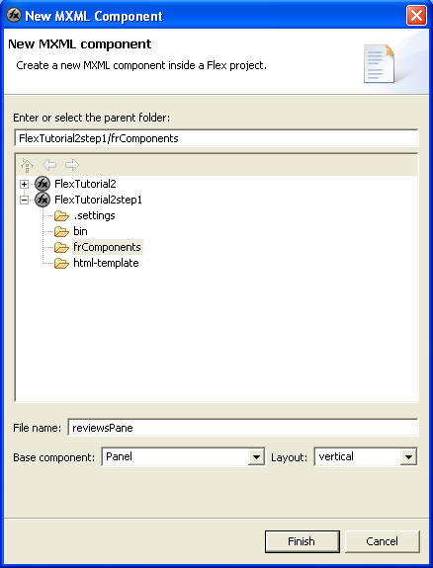
You should now get a component file such as:
<?xml version="1.0" encoding="utf-8"?>
<mx:Panel xmlns:mx="http://www.adobe.com/2006/mxml"
xmlns="*" layout="vertical">

</mx:Panel>
We are going to have a reusable Panel for the Reviews. Change this component file to read
<?xml version="1.0" encoding="utf-8"?>
<mx:Panel title="Reviews" xmlns:mx="http://www.adobe.com/2006/mxml" xmlns="*"
creationComplete="reviewRequest.send()">
<mx:HTTPService id="reviewRequest"
url="http://localhost:3000/reviews/list" useProxy="false"/>
<mx:DataGrid id="dgReviews" width="800"
dataProvider="{reviewRequest.lastResult.reviews.review}"
editable="false" >
<mx:columns>
<mx:DataGridColumn headerText="Title" dataField="title" width="480"/>
<mx:DataGridColumn headerText="Author" dataField="author" width="240"/>
<mx:DataGridColumn headerText="Score" dataField="score" width="80"/>
</mx:columns>
</mx:DataGrid>

<mx:TextArea id="taReviews" width="800" htmlText="{dgReviews.selectedItem.text}"/>

<mx:ControlBar id="cbReviewControlBar">
<mx:Button label="Create New" id="btnCreateNew"/>
</mx:ControlBar>

</mx:Panel>
Like the first tutorial part this creates a DataGrid showing all the entries in the reviews table pulled from the ReviewController method list.
We now need to put this component into the main project application to try it out. Open the main Flex application file for the project (should be called projectname.mxml)
Change it to read:
<?xml version="1.0" encoding="utf-8"?>
<mx:Application xmlns:mx="http://www.adobe.com/2006/mxml"
xmlns="*" layout="absolute" xmlns:fr="frComponents.*">
<fr:reviewsPanel x="0" y="0">
</fr:reviewsPanel>
</mx:Application>
The xmlns:fr=”frComponents.*” namespace declaration tells Flex to load all the component files in the frComponents directory. These can the be added to the application using the XML tag namespace:componentname
Make sure your Rails application is running and Run the Flex project. You should see something like:
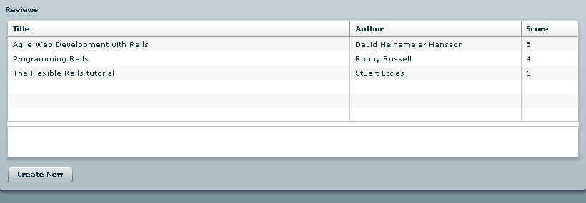

Creating a ‘Add Review’ state
Now unlike the last part we are going to add an Add Review form as a new view state in Flex. Flex uses states to define different user reviews which can be transitioned between based on user input. You can have different state models per components which are handled locally from the application state model.
Lets add the create HTTPService to the component. Add the following under the existing HTTPService.
<mx:HTTPService contentType="application/xml" id="reviewCreateRequest"
result="reviewRequest.send();"
url="http://localhost:3000/reviews/create" useProxy="false"
method="POST">
<mx:request xmlns="">
<review>
<title>{fTitle.text}</title>
<author>{fAuthor.text}</author>
<score>{fScore.value}</score>
<text>{fText.text}</text>
</review>
</mx:request>
</mx:HTTPService>
The _request=”reviewRequest.send();” _ parameter refreshes the DataGrid from the database after the create is completed.
And add code for the new Form state. Add the following as the last child of the component
<mx:states>
<mx:State name="Create">
<mx:AddChild position="lastChild">
<mx:Form width="800" id="frmCreate">
<mx:FormHeading label="Add a new Review"/>
<mx:FormItem label="Title" required="true">
<mx:TextInput width="260" id="fTitle"/>
</mx:FormItem>
<mx:FormItem label="Author" required="true">
<mx:TextInput width="140" id="fAuthor"/>
</mx:FormItem>
<mx:FormItem label="Score">
<mx:NumericStepper id="fScore"/>
</mx:FormItem>
<mx:FormItem label="Text">
<mx:TextArea width="600" height="200" id="fText"/>
</mx:FormItem>
<mx:FormItem direction="horizontal">
<mx:Button label="Submit"
click="reviewCreateRequest.send();currentState=''"/>
<mx:Button label="Cancel" click="currentState=''"/>
</mx:FormItem>
</mx:Form>
</mx:AddChild>
</mx:State>
</mx:states>
This adds a new state called ‘Create’. This state uses mx:AddChild to add a new child to the end of the component. When this state is current. This form will be added to the Panel, when this state is no longer active the form will no longer be part of the Flex model.
The form is created a bit better than the last part. Using mx:FormItem is the best way to layout forms in Flex.
Now all we need to do is be able to change to this state. So lets change the control bar create button to:
<mx:Button label="Create New" id="btnCreateNew"
click="currentState='Create'"/>
The currentState= allows us to switch states. The currentState=’‘ switches back to the default state.
So run the project and click on the Create New button. You should get a little something like:
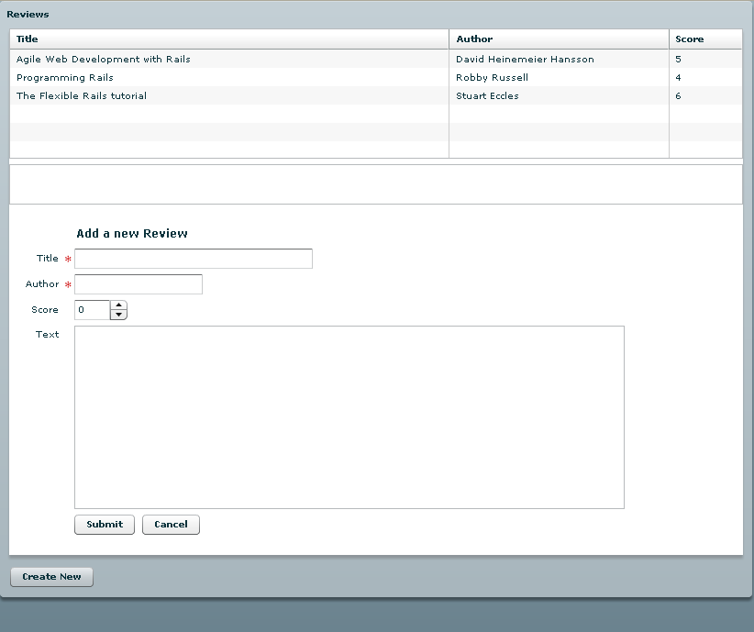

Transitions
Ok so thats a little boring. This is why Flex allows you to add effects to state transitions so lets add a simple WideDown transition effect.
Add the following after the mx:states end tag.
<mx:transitions>
<mx:Transition id="createTransition" fromState="*"
toState="Create">
<mx:Parallel target="{frmCreate}">
<mx:WipeDown duration="1000"/>
</mx:Parallel>
</mx:Transition>
</mx:transitions>
A simple WipeDown effect for 1000ms when going from any state to the Create state.

Parameter passing to Rails
Now its time to delete the rows we have created. The simple method is to select a row in the grid and hit a delete button which sends a request to the rails controller. We need to add a method to our ReviewController
def delete
@review = Review.find(params[:id])
@review.destroy
render :xml => @review.to_xml
end
This method finds the review with the Id sent in the HTTP parameter id and then calls the destroy method which will delete the row from the database. So lets add a Flex HTTPService to our component:
<mx:HTTPService id="reviewDeleteRequest"
result="reviewRequest.send();"
url="http://localhost:3000/reviews/delete"
useProxy="false"/>
And a button to our control bar:
<mx:Button label="Delete"
click="reviewDeleteRequest.send({id: dgReviews.selectedItem.id}); "/>
The HTTPService send() methods allows you to specify HTTP parameters by sending an ActionScript Object with properties defined. We do this with the {id: dgReviews.selectedItem.id} syntax (later on we will do it with a different syntax.
This will now delete rows from the database. All well and good but a little too easy to delete something, we need to add a confirmation selection. To do this we need some ActionScript code in our Flex component file.
Add this to the file
<mx:Script>
<![CDATA[
import mx.controls.Alert;
import mx.events.CloseEvent;
private function deleteHandler(event:Event) : void
{
Alert.show("Are you sure you want to delete this item?", "Delete Item", 3, this,
function(event:CloseEvent):void
{
if (event.detail==Alert.YES)
reviewDeleteRequest.send({id: dgReviews.selectedItem.id});
});
}
]]>
</mx:Script>

And change the delete button to call this new function.
<mx:Button label="Delete" click="deleteHandler(event);"/>
Now clicking on delete should give a little something like this:
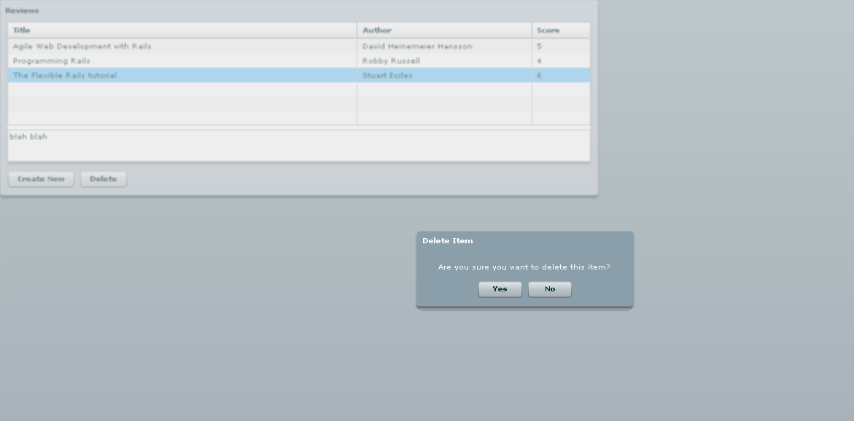

And finally some editing.
Now I guess all we need to create a CRUD is to allow the users to update the data. Well we good just do another Form like the create form and edit the data that way, but that would be a little too easy and we wouldn’t really learn much. I’ll leave that to you at home. Instead what we are going to use is the editable DataGrid. This is a bit harder than what has come before.
First an updating action for our Rails controller:
def update
@review = Review.find(params[:id])
@review.update_attributes(params[:review])
render :xml => @review.to_xml
end
This method finds the review specified by the HTTP Parameter id and then updates any attributes which are given are interrupted as a Map by Rails under the review parameter. Any HTTP parameters given as “review[attname] ” are changed by Rails to be a Map as params:review so passing the update_attributes method params[:review] will give it name value pairs defied in the HTTP parameters using “review[]”. Complex huh.
We need a Flex HTTPService to call this Rails method:
<mx:HTTPService id="reviewUpdateRequest"
result="reviewRequest.send();"
url="http://localhost:3000/reviews/update"
useProxy="false"
method="POST"/>
No we need our code to make the data grid editable:
<mx:Script>
<![CDATA[
import mx.controls.Alert;
import mx.events.DataGridEvent;
import mx.events.DataGridEventReason;
private function updateHandler(event:Event) : void
{
dgReviews.editable=true
btnUpdateData.label = "End Updates"
btnUpdateData.removeEventListener('click', updateHandler)
btnUpdateData.addEventListener('click', endUpdateHandler)
}

private function endUpdateHandler(event:Event) : void
{
dgReviews.editable=false
btnUpdateData.label = "Update Data"
btnUpdateData.removeEventListener('click', endUpdateHandler)
btnUpdateData.addEventListener('click', updateHandler)
}

public function checkUpdate(event:DataGridEvent) : void
{
if (event != null)
{
if (event.reason == DataGridEventReason.CANCELLED ||
event.reason == DataGridEventReason.OTHER )
return;

var params:Object = new Object();
params['id'] = event.currentTarget.editedItemRenderer.data['id']
params['review[' + event.dataField +']']
= TextInput(event.currentTarget.itemEditorInstance).text
reviewUpdateRequest.send(params);
}

}
]]>
</mx:Script>

And a new button to our control bar:
<mx:Button label="Update Data" click="updateHandler(event)"
id="btnUpdateData"/>
Pressing the button will make the DataGrid editable and change the button name to “End Updates”. Pressing it again will make the grid un-editable again. We just need to call the checkUpdate method when a cell in the grid has been edited.
<mx:DataGrid id="dgReviews" width="800"
dataProvider="{reviewRequest.lastResult.reviews.review}"
editable="false" itemEditEnd="checkUpdate(event);">
Try running this and pressing the Update Data button. Then any grid cell can be edited by clicking on it:
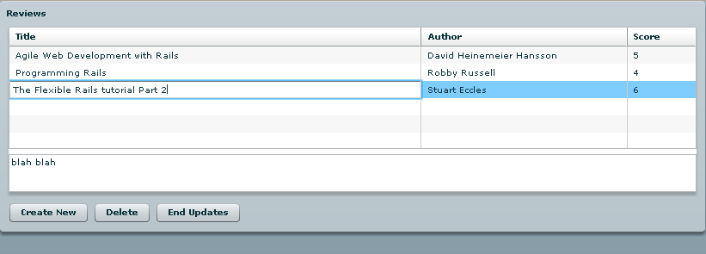

Summary
And that’s it. Hope you enjoyed it. At somepoint in the future we will look at integrating Flex with Rails sessions. Lots of fun i hope.
Tags: flash, flex, rails, ruby, rubyonrails, tutorial
Filed Under: Flex, RubyOnRails
Enrico
May 8th, 2006
Thanks for the second part. The tutorila is great, only thing I have a problem with creating the first HTTPService, the one for creating a new review: Flex Builder complains about ‘request’ as an unknown attribute. I am able to create a new review, but it cannot be displayed immadiately in the grid, only a relod will show it. Enrico
Stuart Eccles
May 8th, 2006
Yes, that’s a typo. Should be result
I’ve edited the article but good spot!!
Alex MacCaw
May 8th, 2006
Great tutorial. Just one thing – the delete button should have a closing tag. Also perhaps you should announce it on the Ruby on Rails mailing list/forum and also the Flex one. I’m sure there are lots of other interested people out there.
Christopher Maloney
May 9th, 2006
Thanks Stuart, Your tute has been most informative. Part 2 has been eagerly awaited.
I wonder… if you could find the time, whether you could please take us one step further and provide a clue as to how such a Flex(ible) unit may be incorporated into an existing Rails (desktop/browser) App.
I have your sample working in a “closed shop” in an isolated (Windows xp) webrick example, but am desperate to get this functionality into my “job dasboard” (ultimatemately using a flex tabbar + list + exploded form, on datagrid item click) . My (experimental) app is sitting on a Linux box served via Apache 2 (xampp + RoRox) and I just cannot figure out how to get such an example served from my App.
Does one take the whole [/bin] directory ( of the generated “flexiblerails” sample) and somehow make a “partial” call?
Any guidance would be GREATLY appreciated. Cheers, Chris
JesterXL
May 10th, 2006
Nice tutorials mangxt! Thanks a lot.
You really outta get yourself aggregated on MXNA with content like this:
http://weblogs.macromedia.com/mxna/
larry
May 11th, 2006
this is very cool stuff. Thanks so much for posting it.
I’m a bit stuck however on how to incorporate flex in a real rails environment. The hardcoded urls that reference ‘localhost” obviously have to go and I have other questions on where it would live on the server, etc. Any chance of a third tutorial with a ‘life-like’ deployment example?
Stuart Eccles
May 11th, 2006
Ok life like deployment example it is. I’ll post it up soon.
Borut
May 13th, 2006
You can use relative URLs: ”...the relative URL is computed automatically based on the location of the SWF running this application.” You can use url=”/reviews/list” instead of url=”http://localhost:3000/reviews/list”.
Ras
May 22nd, 2006
I wanted to create a project that uses rails and flex with sessions but I have no idea where to start. Any ETA on your “integrating Flex with Rails sessions.” turtorial. Thanks
Austin
May 30th, 2006
Nice Job Again
Andrey
June 26th, 2006
Then I create a component with Panel, the application shows nothing. Then I change Panel to, for example, VBox – it’s ok. that’s happended?
Steve Nelson
July 16th, 2006
Stuart; Thank you SO MUCH for this tutorial and the previous. It fills me with renewed energy to pick up RoR again which I had been infatuated with last fall but had to walk away from temporarily when I became clear I wasn’t making any headway with it. But the combination of MySQL, RoR and Flex 2 is AWESOME!
Here’s my situation. I don’t have access to a PC and thus to Builder. I am compiling in Terminal on a Mac with mxmlc. Tutorial 1 went fine. In this one I hit a serious snag. First the thing wouldn’t compile until I changed “result” to “lastResult” in the datagrid data provider. Then it compiled but wouldn’t initialize when I embedded the app in an html page. When I opened the app directly in Flash Player 9 I found out why: it gave a 1009 error, stating that it couldn’t run methods on a null object. I’m guessing that Builder does some smoothing out of stuff that the command line compiler doesn’t – apparently the main app isn’t recognizing the Panel in the mxml component you demonstrate.
Any suggestions on how I can make the main app accept a custom mxml component? When I incorporated the code directly in the main app it runs (placed wrong but functional).
Thanks again for the GREAT material.
Steve Nelson
July 17th, 2006
Retraction…. So sorry. I was compiling using the SDK from beta 3. I hadn’t heard or read that anything had changed with the SKD subsequent to the official release of Flex 2, but I just downloaded it again and something MUST have changed because now it compiles and finds the custom component okay. Sorry. Still had to change the dataprovider line to lastResult though.
Chris
August 30th, 2006
Hi, Just wondering if there has been any revision of this tute? Has anyone got it working?
I am getting the following error on the DataGridEventReason test.
1120: Access of undefined property DataGridEventReason Due tho this error, the Update button does not appear after compile/run.
I’m just not a good enough coder to understand – the help pages seem to agree ok with Stuart’s code.
David
August 30th, 2006
FYI for Flex 2 final you must change:
{reviewRequest.result.reviews.review}
to:
{reviewRequest.lastResult.reviews.review}
otherwise you will get a:
1119: Access of possibly undefined property result through a reference with static type mx.rpc.http.mxml:HTTPService
David
August 30th, 2006
Hey Chris, I ran into the same problem as you with DataGridEventReason. It seems that there is a bug:
http://livedocs.macromedia.com/flex/2/docs/00000871.html (read the comments at the bottom).
I simply removed those Event lines so it works now.
David
August 30th, 2006
Also I noticed this, though it doesnt fix the problem:
import mx.events.DataGridEvent
Should be:
import mx.events.DataGridEvent;
Chris
August 30th, 2006
Thanks for the feedback David, Yeah cheers, I picked up the {reviewRequest.lastResult.reviews.review} from Steve Nelson’s heads-up earlier…
I also noticed the syntax problem with the semi-colon; but thanks.
I have not looked at your notice of the bug yet… just thought I’d report this first on the way thru.
I now have the Update button showing up… I moved the HTTPService for: - reviewDeleteRequest and… - reviewUpdateRequest to up above the <mx:script> tag.
However, after trying an update/end update, I get this:
URL: http://localhost:3000/reviews/update"]
... plus a few more lines of rather cryptic error reporting.
I will go now to investigate the bug report you mentioned…
Thanks again for the input… I will return…
Chris
August 30th, 2006
oops, sorry. I did not realize my error notice was going to generate a url to my localhost.
Thanks for the feedback David, Yeah cheers, I picked up the {reviewRequest.lastResult.reviews.review} from Steve Nelson’s heads-up earlier…
I also noticed the syntax problem with the semi-colon; but thanks.
I have not looked at your notice of the bug yet… just thought I’d report this first on the way thru.
I now have the Update button showing up… I moved the HTTPService for: - reviewDeleteRequest and… - reviewUpdateRequest to up above the <mx:script> tag.
However, after trying an update/end update, I get this:
....RPC Fault faultString=”HTTP request error” faultCode=”Server.Error.Request” faultDetail=”Error: [IOErrorEvent type=”ioError” bubbles=false cancelable=false eventPhase=2 text=”Error #2032: Stream Error. URL: http://localhost:3000/reviews/update”]. URL: http://localhost:3000/reviews/update”....
... plus a few more lines of rather cryptic error reporting.
I will go now to investigate the bug report you mentioned…
Thanks again for the input… I will return…
Chris
August 30th, 2006
oops, sorry AGAIN…
My ”- reviewUpdateRequest to up above the tag.” Should have read: - reviewUpdateRequest to up above SCRIPT the tag.
David
August 30th, 2006
No problem. I am happy with the functionality after removing the datagrid event pieces. It updates, the button is there, but it could be a little better. I’m sure this will be fixed in flex soon )fingers crossed).
Now I’m trying to learn more about filtering results from rails. Today was my first touch of rails. Havent found a good online forum for tech discussion on rails yet.
David
August 30th, 2006
No problem. I am happy with the functionality after removing the datagrid event pieces. It updates, the button is there, but it could be a little better. I’m sure this will be fixed in flex soon )fingers crossed).
Now I’m trying to learn more about filtering results from rails. Today was my first touch of rails. Havent found a good online forum for tech discussion on rails yet.
Chris
August 31st, 2006
Cheers David, Yes, ok; with the DataGridEventReason commented out, I seem to be updating the record… as you you say, not ideal… we will wait and see for next version update… Although with the first try – before htting the “dismiss” button, I did generate an error ( as outlined above). Subsequent to that first edit/update, it worked – without the error!
Still have yet to embrace the challenge of getting the Flex-Bin stuff to be called from my Rails App… have seen the other bits & pieces on this, but yet to get to a point where my Flex RIA is at one with my Rails back end.
I agree “filtering results from rails” is a MUST for a real app. I have seen something on this filtering from a mate of mine who has had a good go at rails… I will come back here if I have news that may be of interest.
Pillangószív
September 5th, 2006
Nice article!
Sanjay
September 6th, 2006
Stuart, great tutorial, just what I have been looking for I think :) one question though, the last section to edit the datagrid is not working for me, I am able to change the data in the grid, but it does not get updated on the db – any ideas ANYONE !!! I have made the changes so that the error due to the ‘undefined property’ above is removed and the ‘delete button’ code has been added. I presume that the data should be updated on the db ?? thanks Sanjay
Chris
September 15th, 2006
Re the DataGridEventReason issue and commenting out the if (event.reason DataGridEventReason.CANCELLED || event.reason DataGridEventReason.OTHER ) { return; }
if you put this line import mx.events.DataGridEventReason; just above the public function checkUpdate(event:DataGridEvent) : void line, the above event.reason test is OK.
I am still not able to update the DB however… same as Sanjay above. Cheers, Chris
Chris
September 15th, 2006
I will try that again so it might be readable… Re the DataGridEventReason issue and commenting out the
if (event.reason DataGridEventReason.CANCELLED || event.reason DataGridEventReason.OTHER ) { return; }
if you put this line
import mx.events.DataGridEventReason;
just above the
public function checkUpdate(event:DataGridEvent) : void
line, the above event.reason test is OK.
I am still not able to update the DB however… same as Sanjay above. I know I am connected to mysql because the datagrid populates OK. Cheers, Chris
Roberto
October 16th, 2006
Amazing !!! Thank you very much. This is my first mini app using Ruby.. and I definately will use it with Flex now that I know it really speeds up the development time. Hope to hear more tutorials like this.
chtrinh
November 17th, 2006
Can someone clarify this? So, if i want to do some AJAX style effects inplace edit and such, I would have to use actionscripts? When would i use actionscripts and when would i use mxml? They seem to blend nicely but whats the seperations?
Antyki
December 11th, 2006
Thank’s for that but what do you mean “hobbyst” ?
Cheers.
Alan Buses
December 16th, 2006
Nice tutorials! I presume that the data should be updated on the db and I have made the changes so that the error due to the above is removed and the code has been added- I hope that this is going to walk! Thanks a lot.
doowhsalf@mac.com
December 30th, 2006
Nice tutorial ! I managed almost to get everything working, but I got a problem with the if (event.reason DataGridEventReason.CANCELLED || event.reason DataGridEventReason.OTHER ) return; condition. The event.reason alwasys gets the value “other” and consquently I never reach the update method in Ruby.
I’m working on my Mac Pro with the Beta flex builder and ruby 1.8.x Thank’s for any tip. Cheers !
Jonny
July 23rd, 2007
Hey Good Job,
My my issue is different, I am looking for Simple example to demonstrate the TabBar control with submit button using PHP. The data has to be entered in MYSQL DB. Can anyone help me. Just imagine you are using this for a Multiple tax for on one page using different Tabs (Navigator).
regards John
Mark S
July 30th, 2007
What about RESTful Rails + Flex?
Greg P
August 11th, 2007
Hi, I found that I needed the import mx.controls.TextInput; or it didnt recognize the TextInput directives. This may be a flex 2.0.1 thing .. dont know for sure.

