MWF quick start guide

Practice with MWF demo site in 10 minutes

Create your own workflow template
- Create workflow template with MWF workflow designer.
- Write workflow template manually.
- Upload local template files to template library.

Programming with MWF API in 10 minutes
- Get access session key.
- Start a workflow process.
- Check work list.
- Do task.

Advanced topics

Is MWF multi-tenant?
Yes, MWF is multi-tenant;

How MWF manage multi-tenant?
MWF use organization (ORG) to manage tenant
A user can create and belong to one to many ORGs,
A user can see other users (peers) who belong to any ORG the user belongs to.
A process started with a user (the starter) can dispatch tasks to starter’s peers.
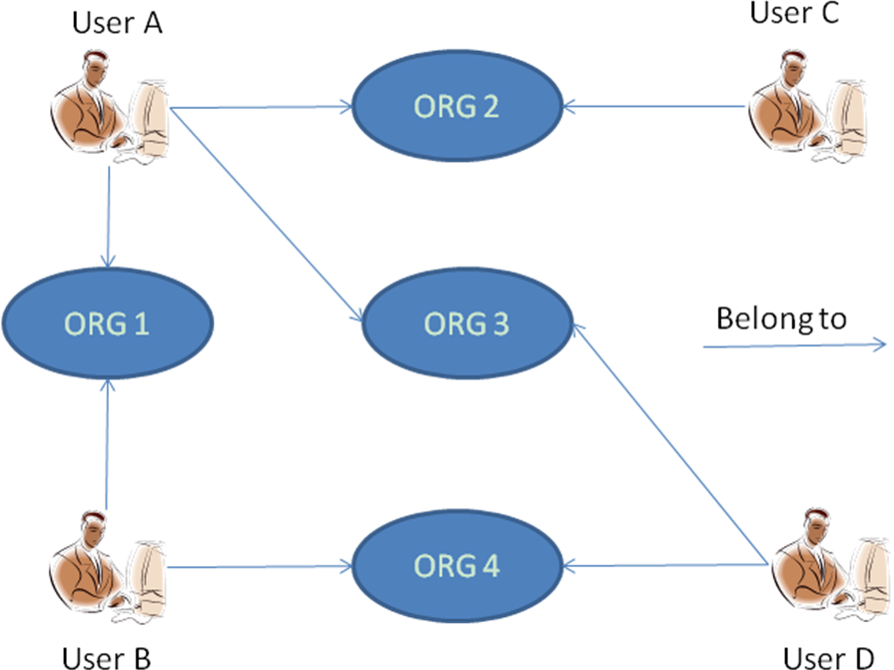

User | Peers
A | B, C, D
B | A, D
C | A
D | A, B

Create a workflow template.
You may start with getting an example template and putting it into your template library, or create an new one with workflow designer, you may also create a template manually.
2.1 Getting an example.
Download one of the following examples, then upload it to your templates library.
2.2 Create new template with MWF workflow designer, which will put templates to your library automatically.
2.3 Write a workflow template manually. You will need to upload local workflow templates to your templates library. Manually created workflow templates is an XML files, you need the schema file to validate template XMLs.

Upload local template files to templates library
Use demo site
Use API.

See what you have in your templates library
Use demo site
Use API

Start a workflow.
Use demo site
Use API

Check worklist
Use demo site
Use API

Do a task
Use demo site
Use API

Monitor Processes
Use demo site's process monitor
Use API

How to customize task form
MWF API give you all the taks context information.
With JavaScript
Codes
With Java
Codes
You decide how these context are displayed. Use an template engine such like Velocity is suggested.
You may need to dispaly different task with different form, you may use task name or customization tag to differenciate different tasks.

How to integrate with other applications.
You need a SCRIPT node in your template to integrate with other applications.
1. With JavaScript
2. Call an remote WebService
Codes
Parameters passed. MWF pass process context information to Web Service with ...
In your webservice, you can read these information this way:
...
Webserive simply return a String value by writing it to HTTPResponse.
...

3. With local Java calling
This method require you run MWF on your own server, so you can put your business application JARs into MWF classpath.
For example, you have an method com.xyz.app.Demo.caculate(), you write script this way:

This method should return a String value.

MWF take the return value of the script as the result of SCRIPT node. It then can be used to decide process route. For example, next workflow use an SCRIPT node to caculate the credit of a customer, then decide the approval path based on the credit level.

How to assign works to people.
MWF will dispath all works of a workflow to whom start the workflow process (the STARTER), unless these works are assigned to other people (the DOERS) explicitely. Doers can be MWF user(s) or roles, if the doer is an role, MWF will firstly get the role participation from the team (a TEAM defines role-user mapping), then dispatch tasks to these users. If mapping failed(for example, the specified role has no mapping in the specified TEAM, the task will be delivered to STARTER)
The following task will be done by user: john and Ari.
Picture.
The following show a task will be done by roles : Approver.

TeamA map role Approver to Steve and John

Then, if the workflow is started with teamA. Steve and John will get the work "Approve" in their worklist.

Related API:
Create a team
Add role-user mapping to team(link to anchor)
Start a workflow with team.

How to delegate

Related API

How to control task completedness when there are multiple doers for one task.
Any doer done, then done.
Any doer complete the task, then the task will be removed from other doers worklist, process move forward.

All doer done, then done.
Process will move forward only when every doer complete their task.

Workflow designer can embed codes to caculate the task result depend on every doer's input, for example, you may design a voting task like this:
....

How to occupy a work.
Occupying a task means that when one doer occupy a task, this task will be removed from other doers' worklist.
A task is occupiable only when mark it's attribute "..". To "true", default is false.

Create new org
Add users to an org
API

