**package** Printf;

**public** **class** Printf {

**public** **static** **void** main(String[] args) {

XC xc = **new** XC();

Thread[] thread = **new** Thread[3];

thread[0] = **new** Thread(xc, "A");

thread[1] = **new** Thread(xc, "B");

thread[2] = **new** Thread(xc, "C");

**for** (**int** i = 0; i < 3; i++) {

thread[i].start();

**try** {

thread[i].*sleep*(20);

} **catch** (Exception e) {

}

}

}

}

**package** Printf;

**import** java.util.concurrent.locks.Lock;

**import** java.util.concurrent.locks.ReentrantLock;

**public** **class** XC **implements** Runnable {

**private** **final** Lock myLock = **new** ReentrantLock(**true**);

**public** **void** run() {

**for** (**int** i = 0; i < 10; i++) {

myLock.lock();

System.*out*.print(Thread.*currentThread*().getName());

**try** {

Thread.*sleep*(200);

} **catch** (Exception e) {

} **finally** {

myLock.unlock();

}

}

}

}

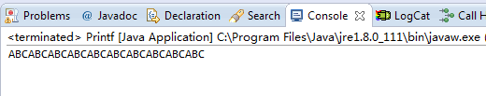

原理：

