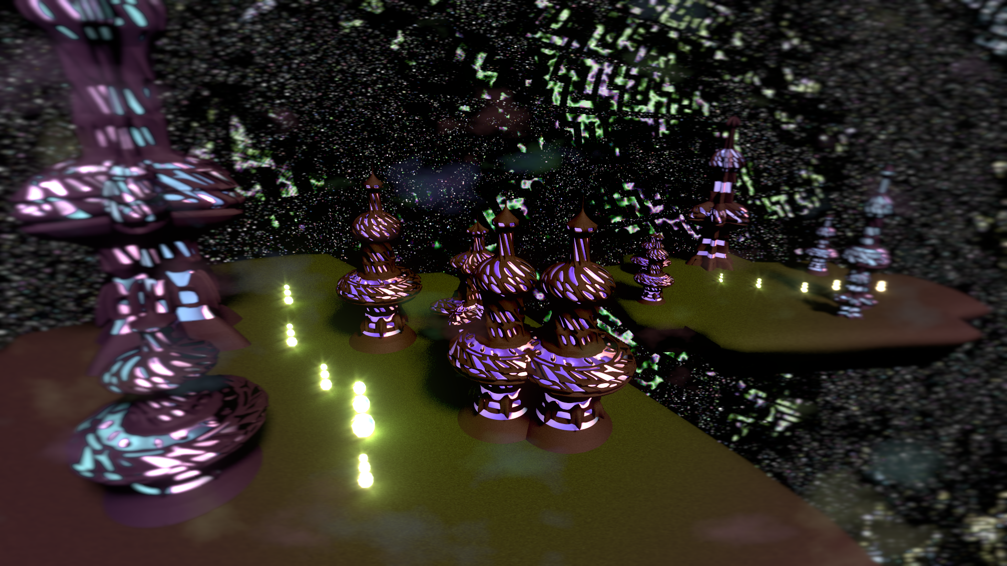
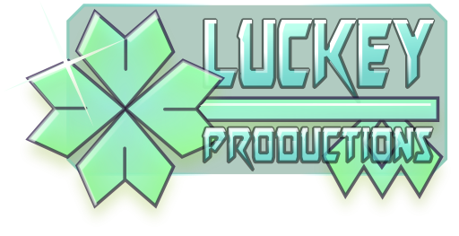
Design Document for:

the Plane of

Oneiron

Strategic arcade in between dreams

All work Copyleft 2015 by LucKey Productions

Written by Frode Lindeijer

Version # 1.1

Thursday, March 05, 2015Table of Contents

Planes of Oneiron 1
Design History 5
Version 1.0 5
Game Overview 6
Philosophy 6
Unique combination of gameplay elements 6
Other worldly setting 6
Built for keyboard and mouse. 6
Common Questions 6
What is the game? 6
Why create this game? 6
Where does the game take place? 6
What do I control? 6
How many platforms do I control? 6
What is the main focus? 6
What’s different? 7
Feature Set 8
General Features 8
Multiplayer Features 8
Editor 8
Gameplay 8
The Game World 9
Overview 9
2.5D 9
Mineable 9
The Physical World 9
Overview 9
Key Locations 9
Travel 9
Scale 9
Objects 9
Day and Night 10
Time 10
Rendering System 10
Overview 10
3D Rendering 10
Camera 10
Overview 10
Altitude 10
Scripted 10
Game Engine 10
Overview 10
Collision Detection 10
Lighting Models 10
Overview 10
The World Layout 11
Overview 11
Game Characters 12
Overview 12
Creating a Character 12
Enemies and Monsters 12
User Interface 13
Overview 13
Shortkeys and mouse 13
Weapons 14
Overview 14
Fighters 14
Turning turrets 14
Directional weapons 14
Musical Scores and Sound Effects 15
Overview 15
Single-Player Game 16
Overview 16
Story 16
Hours of Gameplay 16
Victory Conditions 16
Multi-player Game 17
Overview 17
Max Players 17
Servers 17
Customization 17
Internet 17
Persistence 17
Saving and Loading 17
Character Rendering 18
Overview 18
Character Rendering Detail #1 18
Character Rendering Detail #2 18
World Editing 19
Overview 19
Platforms 19
Tiles 19
Crazy Ideas 19
Resources Reference 19
Building Reference 19

Design History

Studying to become a certified game developer I keep getting these assignments. Every semester – this being the third – everyone in our class is expected to create an entire game in two months. Naturally speaking this goal is never reached. Anyway... this is the fourth game planned to be released someday™ under the brand LucKey Productions. The earlier titles include two platform games – Blip 'n Blup: Skyward Adventures and Maria's Unexpected Delivery – an addictive dual stick arcade shooter called heXon. This document focuses on the latest addition current given the name Oneiron. More about this game in the rest of this document.
This section tells more about the development of everything else in this document.

Version 1.0

This design document started out as Chris Taylor's Game Design Document Template. In this version I went by every bit and adapted it all to fit this project.

Version 1.1

Added on the story and indented every first line of each paragraph.

Game Overview

Philosophy

Unique combination of gameplay elements

PoO combines gameplay elements from games like Star Craft, Project Nomads and Minecraft.

Other worldly setting

The world is inspired by a dream I had. I was standing high up in a beautiful tower overlooking a floating platform in vast space crowded with a network of more of these platforms when I realised I was dreaming. There was grass everywhere and footpaths connecting other towers that spotted the platform. One of these towers had vertical-axis windmill construction attached to it's side which was interacting with some energy vortex. Unfortunately that's when I woke up. But the image stayed quite vividly and now – a year and a half later – it is combined with a game concept it fits perfectly.
In my dream there were no signs of battle.

Built for keyboard and mouse.

The game will be combine pointing with the mouse and clicking its buttons with keyboard short-keys to strife for seamless control. GUI buttons are optional.

Common Questions

What is the game?

An RTS in which you build platforms to send into battle.

Why create this game?

I havn't seen this combination of gameplay elements anywhere and the world was awesome to be in.

Where does the game take place?

A world inspired by a dream I had. It has flying platforms with buildings on it.

What do I control?

The player builds platforms and tells these where to go and what to do. Also he alone controls the fate of the universe.

How many platforms do I control?

The number of platforms you can create is limited by the available matter. The player decides how many platforms he creates from this available matter.

What is the main focus?

Creating a strategy game in which the bases you build are units on their own. The engines providing thrust should be automatically controlled in a realistic way.

What’s different?

Planes of Oneiron combines elements of tower defence, voxel sandboxes and real time strategy in a way that makes Minecraft look like Homeworld.

Feature Set

General Features

2D gameplay
Spacesmurfs
3D graphics
32-bit color

Multiplayer Features

Automatically growing galaxy with infinite players.
One server
Can only chat with players that are near
Live online and in-game map of matter control

Editor

You could say editing the world is an important part of PoO's gameplay. The goal is to create a TMX parser to import maps made in the intuative market standard for 2D map editing: the Tiled Mapeditor.
Levels will be small and easily transferable.

Gameplay

In Planes of Oneiron the land itself is a mineable resource required to construct platforms floating is dreamspace. The land – in it's resource form known as matter – is broken down by so called masons. These units are also able to edit and repair platforms. Their operations take time so having multiple helps. These masons belong to a building which can be placed on a platform. Their rock breaking ability doubles as a mediocre meelee attack. They are slow and weak.
Platforms can are built up out of squares on which buildings can be placed. These buildings can provide other resources like energy and people. Yet other structures provide thrust, firepower or armor

The Game World

Overview

The world is a two and a half dimensional solar system with a star in the middle with spherical asteroid belts arranged in shells or planes dotted with platforms/islands facing the star. Each plane has a different climate, flora, fauna and culture.

2.5D

The game features 3D graphics but concerning gameplay it is 2D.

Mineable

It is the world that you break down, it is the same earth with which you build your ships, it is the matter you burn as fuel. It may appear.

The Physical World

Overview

Life on the inner plane is hot. Energy is free, but water scarce. The middle plane is rich in mass as well as food. The outer plane is cold. Matter is scarce, solar panels don't do much. But there's a higher number of energy vortexes here.

Flora
The plane of Oneiron

Key Locations

Describe the key locations in the world here.

Travel

The different planes will mainly just be different tilesets. In story mode transision from one plane to another will be part of the story. Changing planes is believed to be impossible and some form of black magic if it happens.

Scale

The story world is quite huge and will not be visited in it's entirety. The multiplayer world will dynamically scale along with the number of players. This is perfectly possible because of the space in between the platforms. A freak black hole here and there will take care of the shrinking.
A typical platform is somewhere between 3x3 and 13x13 squares. Each square can be occupied by a building. The creatures occupying the buildings take up about one tenth to one fifth the area of a square.

Objects

Most of the visible world consists of matter. This can be mined and used to build structures.
Energy vortexes are part of an existing platform. They are highly evolved crystals that have reached a hyperdimentional state which have their own bioglass ecosystem. By building an energy siphon over the vortex the energy can be used on the platform the siphon was built on. If the blocks around the vortex are destroyed or otherwise removed the vortex is forever lost.

See the “Objects Appendix” for a list of all the objects found in the world.

Day and Night

All platforms face the weak sun.

Time

“Time is an illusion, lunchtime double so.”

Rendering System

Overview

Give an overview of how your game will be rendered and then go into detail in the following paragraphs.

3D Rendering

Objects will mainly be 3D moving in a 2D plane.

Camera

Overview

The view will be an eagle eye view during most of the game.

Altitude

The camera altitude can be changed to zoom in on the action or construction site or zoom out to get an overview.

Scripted

Some story events might have a scripted cinematic camera.

Game Engine

Overview

Unity3D first. Preferably Urho3D later.

Collision Detection

PhysX first. Bullet later.

Lighting Models

Overview

Twilighting.

The World Layout

Overview

The planar system consists of three layers or shells of flat asteroids or islands

Game Characters

Overview

Ultimately PoO will feature multiple factions each of which has their own unique structures and strategies.

Creating a Character

The player is an eye (I) quantum-magically controlling the outcome of what he looks at. You can pick two iris colors and a faction. The faction you pick determines the shape of your pupil.

Enemies and Monsters

Bioglass organisms defend the energy vortexes well. It is the source of their continued existence.

User Interface

Overview

The game starts up with a menu with some options. During the game there will be buttons to select commands with. When a platform is selected the available options depend on the structures it has.

Shortkeys and mouse

All commands are given with either the mouse or the mouse in combination with the keyboard. The keyboard provides hotkeys for buttons that can also be clicked with the mouse.

Weapons

Overview

The melee attack of the masons is one way to attack, but most other ways have a bigger chance of delivering a punch.

Fighters
Like masons fighters belong to a building which can be built on a platform; the hangar. These small and swift crafts can attack nearby enemies with their simple cannons. Firing uses energy. To refill its energy the craft needs to return to its hangar and stay there for a while.

Turning turrets
Platforms can also be equipped with turning turrets. Stronger then fighters but with a shorter range, these structures are mostly used for defensive purposes.

Directional weapons
These long range energy beam cannons can be placed in rows, increasing both their range and firepower. They have a low fire rate but are very destructive.

Musical Scores and Sound Effects

Overview

The music will probably be creative commons ambient psy-trance from Ektoplazm.

Single-Player Game

Overview

Start out small. Grow and learn new techniques as you progress. Save the cheerleader.

Story

A. These creatures chose to leave the third dimension looking to make life simpler. Instead it caused a great war and planification. Will the Kekelplifths ever know peace again? They will if you stop playing around and start living your dreams!

B. Islands form around magnite clusters. There are two factions of the same species that each live on these platforms. Their main difference is the side they like to live on. They both live on the sunny side, but the orientation of the magnite cluster determines which side of the land faces the sun. In this case this means different food because the cultures coevolved with a single side. It started out as a sort of superstition which over time turned into a matter of taste.
All magnite is interlocked on a shared plane and the net direction of the magnite causes the plane to shrink towards the sun or to float away from it. Therefor a certain balance is of the essence to the survival of these creatures and basically the climate makes them switch sides.

Hours of Gameplay

23

Victory Conditions

Win final battle

Multi-player Game

Overview

Multi-player will look a lot like single-player except for the fact that multi-player involves an endless amount of players waging constant war in an ever conveniently expanding and shrinking galaxy.

Max Players

Ad infinitum et nauseam.

Servers

Peer-to-peer network architecture

Customization

The player can create maps, pick a faction, two colors and an emblem.

Internet

W007 internet!

Persistence

The world is dynamically persistent.

Saving and Loading

The multi-player world is continuous and does not need or allow for saving or loading.

Character Rendering

Overview

Provide an overview as to how your characters will be rendered. You may have decided to include this elsewhere or break it out to provide more detail to a specific reader.

Character Rendering Detail #1

Character Rendering Detail #2

World Editing

Overview

A great part of the world editing will happen during play with the building of the platforms. The game might also feature a level editor to set up initial circumstances for campaigns, but basically the game world will expand procedurally.

Platforms

Platforms consist of tiles

Tiles
Tiles can contain buildings

Crazy Ideas

It should be possible to couple platforms making them share thrust and energy reserves, effectively turning them into a single platform until the coupling is deactivated. These bridges are weak.

Resources Reference

Matter
Energy
People

Building Reference

Matter
- Mason Hall
Energy
- Power leaves
- Energy siphon
- Annihilator
People
- House

Thrust
- Side thruster
- Great engine
Weapons
- Fighters
- Rotary guns
- BigBeamBlaster
Defence
- Armor

