
Masters of Oneiron
...a technical story.

Company name: LucKeyProductions
Autheur: Frode Lindeijer
Date: Prickle-Prickle, the 41st day of Discord in the YOLD 3181
Inhoud
1Preface 1
2System 2
2.1Eisen 2
2.2Randsystemen, externe code 2
3Game flow 3
4UML 4
4.1Use-cases 4
4.2Game Control 4
4.3Input 4
4.3.1Eventuele subkopjes 5
4.4En zo verder. 5
5Physics 6
5.1Collision matrix 6
5.2Eventueel eigen systeem 6
6Data Flow 7
6.1Uitleg 7
6.2Kritieke momenten 7
6.3Locatie data 7
7AI 8
7.1Algoritmes 8
7.2State transitions 8
7.2.1Warrior 8
7.2.22e unit 8
8Multiplayer 9
8.1Eisen 9
8.2Aannames 9
8.3Synchronisatie 9
9User Interface 10
10Game Screens 11
10.1Main menu 11
10.2Andere scherm 11
11Technische afspraken 12
11.1Artists 12
11.2Folder structuur 12
11.3File types 12
12Geluid en muziek 13
12.1Onderdeel x 13
13Level specifieke code 14
13.1Level 12 14
13.2Boss X - Final final boss 14
14Versiebeheer 15
14.1Versie 0.1 15
14.1.1Versie 0.1.0001 15
14.2Versie 0.2 15

Preface

This is the technical design document for the LucKey Production called Masters of Oneiron henceforth adressed as MoO. This document will eventually reflect the technical structure of the game; it's class structure, their functions and build requirements.

System

Requirements

- 2 gHz processor
- 1 gb graphics card
- 64-bit Linux (or any platform for custom builds)

Peripherals, external code

MoO uses the Urho3D game engine. Modanung's fork on GitHub is required to compile and play the game. More information about building the Urho3D game engine can be found on: urho3d.github.io

Game flow

3.1 Initial situation
You start out with at least one platform some People, some wild Frop, a former and no weapons or engines. You are surrounded by neutral or friendly Platforms for resources.
At the beginning of a new game the player will be explained the function of each provided Platform element. Then he/she will be guided through building each of the following structures:
- Frop Farm
- Decorticator
- Former Bay
- Barrel
- Spirit Lodge
- Engine
- Fighter Bay

3.2 Rest of the game
The player then explores the world of Oneiron using a growing armada encoutering random events that are downloaded from the mission database.

UML

Hier komen enige UML diagrammen.

Use-cases

4.1.A Afbeelding 1

Game Control
Platforms or Structures are selected and then commanded using either the keyboard and mouse or a dual axis joystick. The same input methods can be used to control the camera.

Input

Keyboard & mouse

Joystick

Physics

5.1 Platform Physics
Platform physics are restricted to a 2D plane.

5.1.1 Autonomous steering
Platforms calculate what thrust is required to reach its ordered target.

Data Flow

6.A Afbeelding 1 - Data Flow Diagram

Explanation

In single-player it should be possible to save what is under your influence on the local machine in a savegames folder.
In god mode (level editor) islands can be design and campaigns can be created which can be saved and uploaded to the mission database.

Autosave

On critical moments, like before cut-scenes, the single-player game should be autosaved.

Data locations

Saved single-player games go in the Savegames folder.
Campaigns files are stored locally and can be uploaded to a git repository. Players can edit campaigns by forking them. Also campaigns can be rated to – hopefully – make the highest rated occur more.

AI

AI handles both the player's units following orders as well as possible opponents and allies. The latter should simulate player input, the former handles the rest.
Below will be preseted the AI's state machine UML diagram:

7.A Figure 1 - AI UML

Algorithms

Torque calculation:
Vector3 Vector3::Cross(Vector3 lhs, Vector3 rhs);

State transitions
Units keep track of their last command and changes states accordingly.

Former
The Former Bay holds a Former. This is a flying machine able to grind ground and build or repair structures.
Formers are commanded by first selecting either the Former or the Former Bay. Each has the same result, namely selecting both with a very interesting line connecting them. The Former has an auto-repair option which will make it repair any friendly structure within range that does not have full health. Strutures on its own Platform receive priority when auto-repair is activated. By right-clicking on a structure with less then full health makes the Former repair that specific structure.
When told to grind ground or a structure the Former will keep collecting grind until it is full in which case it will return to the Formar Bay and cast its burden. The Former Bay is capable of storing some Grind but is also subterraineally connected with every Barrel on the same Platform. When all Barrels are full the Former will stop collecting Grind.
Through short-keys or clicking GUI-buttons commands can be given to build Ground or Structures. All idle Formers will autogladly join in with this constructive activity.
7.2.1.A Figure 1 - Former State Diagram

A Former is either:
-Stand-by
-Collecting
-Building
-Repairing
-Returning to Former Bay

Fighter

7.2.2.A Afbeelding 1 - 2e unit

The fighter is either:
-Stand-by
-Recharging
-Attacking
-Returning

Multiplayer

8.A Afbeelding 1 - UML multiplayer

Multiplayer mode is allowed because it is guaranteed to be fun. Victimless fun shall not be obstructed. QED

Demands

Network card connection, fellow players.

Assumtions

Internet connection is available and someone else wants to play.

Synchronisation

Algoritmes (prediction (interpolation, extrapolation), etc)

User Interface

In-game HUD

The in-game HUD has buttons for all available commands that can be clicked. It also features faint transparent radar style minimap that rotates with the cameras orientation.
Below will be featured a mock-up or screenshot of the in-game HUD.

9.1.A Figure 2

Game Screens

Main menu

When the game starts the player is shown the main menu where a new game can be started or a previous one resumed. Also the main menu has a submenu where audio, visual and control options can be changed. Leaving the world of Oneiron is the bottom right most option in the main menu. The menu will use a state machine for keeping track of the menu's state. Since the menu is constructed like a gameworld with neutral platforms with clickable button structures the same InputMaster handles user input.
Below is a mock-up image of what the menu will look like:
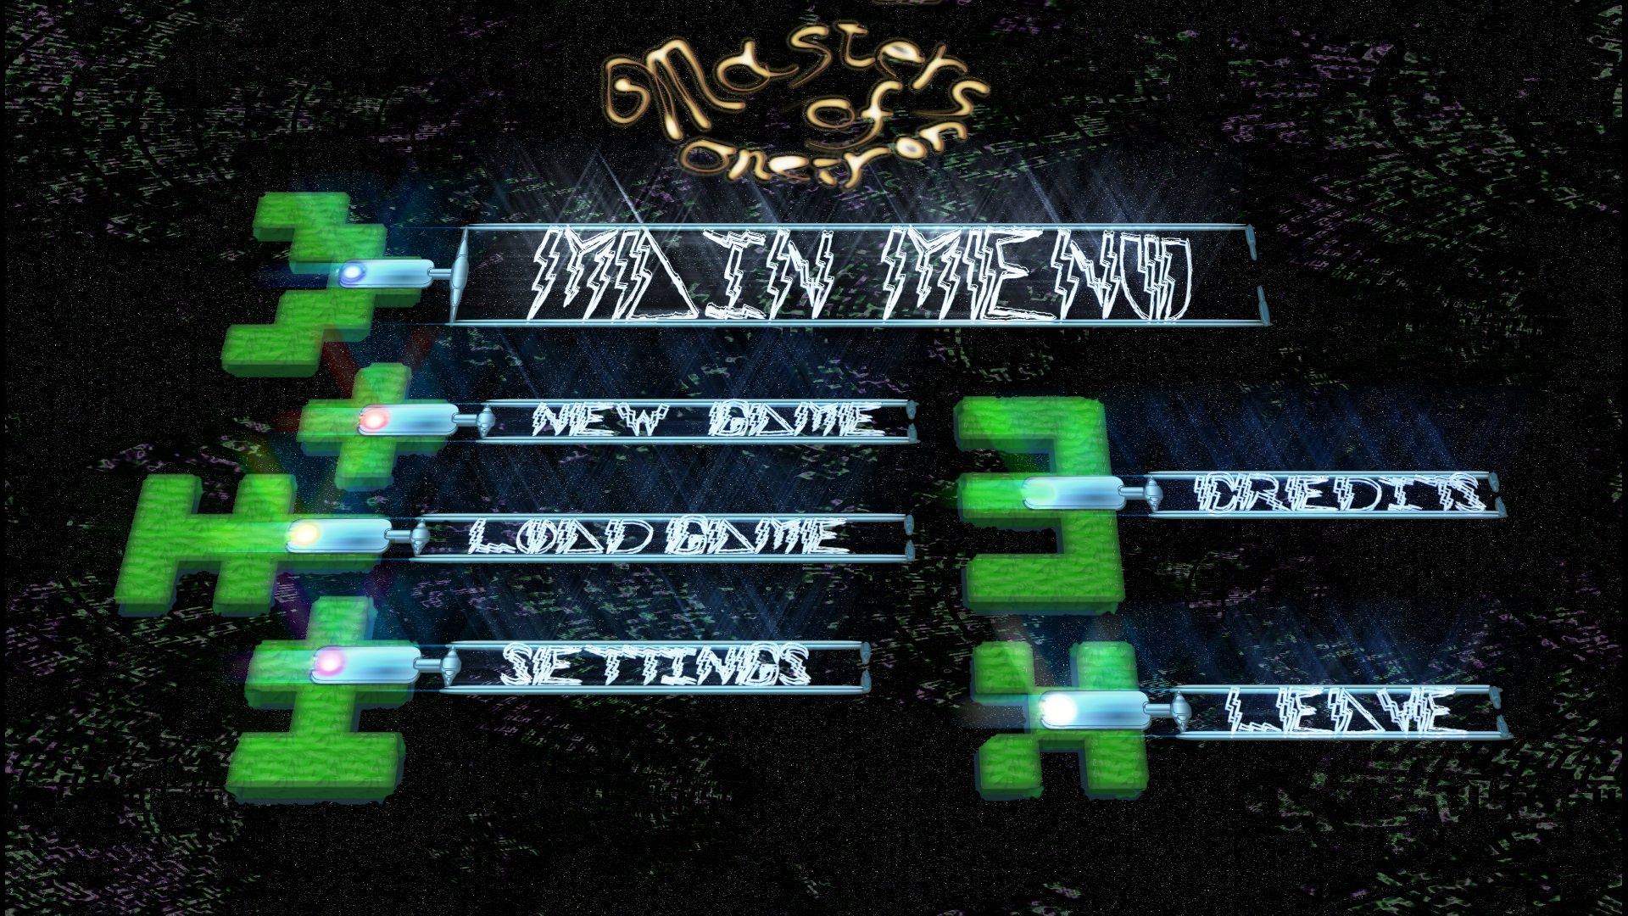
10.1.A Figure 1

This is where the menu state machine's UML diagram will be featured:

10.1.B Figure 2

Technische agreements

Artists

- Three LODs for all models more complex then a plane
- Detail beyond a CPU-friendly level should be rendered to a normal map

Folder structuur

- Resources
  - Animations
  - Fonts
  - Models
  - Textures
  - Materials
  - Music
  - Prefabs
  - Samples

File types

- End used file types
  - PNG (for textures)
  - TTF (for fonts)
  - MDL (Urho3D model format, exported by Urho3DBlender plugin)
  - ANI (Urho3D animation format, exported by Urho3DBlender plugin)
  - XML (for materials)
- Raw file types
  - Blend (for raw 3D models, including rigs and animations)
  - XCF (for raw rasterized images)
  - SVG (for raw vector images)

11.4 At least free for non-commercial use

Since Urho3D is licensed under the MIT license and MoO under the GNU General Public license all resources for MoO should be free to use for non-commercial purposes. Preferably they are created using a fully open source environment, since this is the main mission of LucKey Productions.

Music & SoundFX

The soundtrack is by Macroform and was found on Jamendo.com
SoundFX will be created using SuperCollider. The goal is to evenually have all soundFX synthesixed real time during play to add to the reality of the world. This way the samples can be more situation specific and variations can be richer then merely changing the sample's pitch.

Music

The soundtrack can be found here: https://www.jamendo.com/en/list/a142918/meditations
The artist that made the soundtrack is Macroform. The name of the album is Meditations. The production is licensed CC-BY-SA and may thus even be used for commercial uses. Pretty fuckin' awesome.

12.2 SoundFX

SuperCollider will be used as sound synthesis engine. More information on SC can be found at: https://supercollider.github.io/
It should be possible to have MoO run a SC server alongside it's main loop. Communicating with the SC server would probably be best to implemented using open sound control or OSC.
SuperCollider could also convert text to speech for NPC's.
Realtime audio should be an option in the options menu since it might be quite a heavy load on the CPU.

Version control

Github is used for version control. The latest version of MoO's master brach can be found here: https://github.com/LucKeyProductions/oneiron

