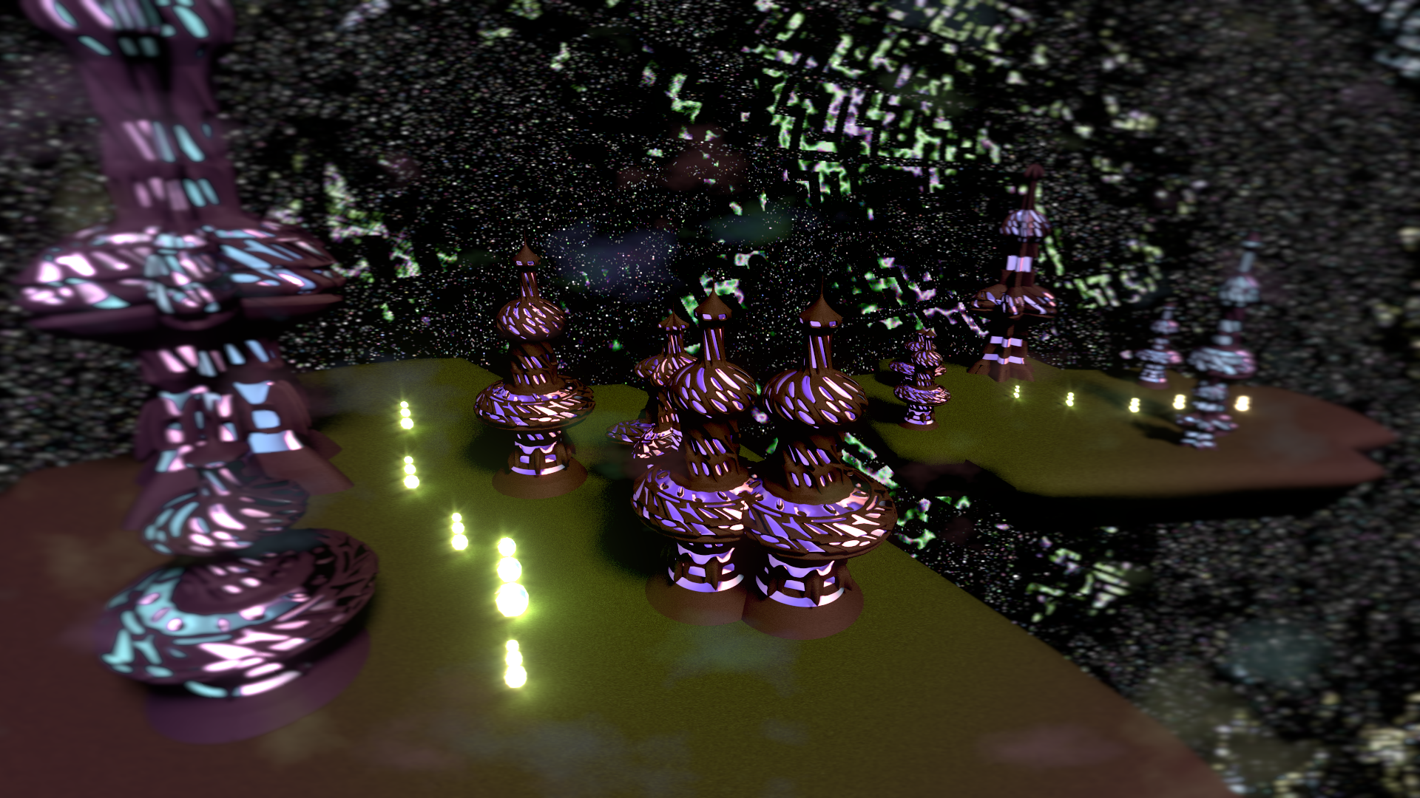
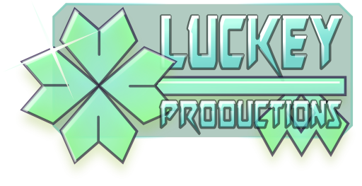
Design Document for:

Masters
of

Oneiron

Strategic arcade in between dreams

a LucKey Production

Written by Frode Lindeijer

Version 1.2

Thursday, April 23, 2015Table of Contents

Planes of Oneiron 1
Design History 5
Version 1.0 5
Game Overview 6
Philosophy 6
Unique combination of gameplay elements 6
Other worldly setting 6
Built for keyboard and mouse. 6
Common Questions 6
What is the game? 6
Why create this game? 6
Where does the game take place? 6
What do I control? 6
How many platforms do I control? 6
What is the main focus? 6
What’s different? 7
Feature Set 8
General Features 8
Multiplayer Features 8
Editor 8
Gameplay 8
The Game World 9
Overview 9
2.5D 9
Mineable 9
The Physical World 9
Overview 9
Key Locations 9
Travel 9
Scale 9
Objects 9
Day and Night 10
Time 10
Rendering System 10
Overview 10
3D Rendering 10
Camera 10
Overview 10
Altitude 10
Scripted 10
Game Engine 10
Overview 10
Collision Detection 10
Lighting Models 10
Overview 10
The World Layout 11
Overview 11
Game Characters 12
Overview 12
Creating a Character 12
Enemies and Monsters 12
User Interface 13
Overview 13
Shortkeys and mouse 13
Weapons 14
Overview 14
Fighters 14
Turning turrets 14
Directional weapons 14
Musical Scores and Sound Effects 15
Overview 15
Single-Player Game 16
Overview 16
Story 16
Hours of Gameplay 16
Victory Conditions 16
Multi-player Game 17
Overview 17
Max Players 17
Servers 17
Customization 17
Internet 17
Persistence 17
Saving and Loading 17
Character Rendering 18
Overview 18
Character Rendering Detail #1 18
Character Rendering Detail #2 18
World Editing 19
Overview 19
Platforms 19
Tiles 19
Crazy Ideas 19
Resources Reference 19
Building Reference 19

Design History

Studying to become a certified game developer I keep getting these assignments. Every semester – this being the third – everyone in our class is expected to create an entire game in two months... or are they? Naturally speaking this goal is never reached.
This is the fourth game planned to be completed someday™ under the brand of LucKey Productions. The earlier titles include two platform games – Blip 'n Blup: Skyward Adventures and Maria's Unexpected Delivery – and a highly addictive dual stick arcade shooter called heXon. The game engine intended to be used for all of these projects is the FOSS Urho3D game engine. heXon is undergoing a remake as you read.
This document focuses on the first try at this engine, a project named Masters of Oneiron. More about this game in the rest of this document.
This section tells more about the development history of this very document.

Version 1.0

This design document started out as Chris Taylor's Game Design Document Template. In this version I went by every bit and adapted it all to fit this project.

Version 1.1

Added on the story and indented every first line of each paragraph.

Version 1.2

Quick update before final deadline.

Game Overview

Philosophy

Unique combination of gameplay elements

Masters of Oneiron combines elements from games like Total Annihilation, Star Craft, Dune, Project Nomads, Minecraft, Plants vs. Zombies and Black & White.

Other worldly setting

The world is inspired by a dream I had. I was standing high up in a beautiful lathewoodcarvinglike tower overlooking a floating platform in vast space crowded with a network of more of these platforms when I realised I was dreaming. There was grass everywhere and footpaths connecting other towers that spotted the platform. One of these towers had verticalaxiswindmilllike construction attached to it's side which was interacting with some energy vortex. Unfortunately that's when I woke up. But the image stayed quite vividly and now – a year and a half later – it is combined with a game concept it fits perfectly.
In my dream there were no signs of battle.

Built for either keyboard and mouse or joystick.

The game will be combine pointing with the mouse and clicking its buttons with keyboard short-keys to strife for seamless control. GUI buttons are optional.
Since the in-game UI can be compared of that of a first person shooter dual joystick integration is also planned.

Common Questions

What is the game?

An RTS in which you build platforms to grow and progress.

Why create this game?

I havn't seen this combination of gameplay elements anywhere and the world was awesome to be in.

Where does the game take place?

A world inspired by a dream I had. It has flying platforms with buildings on it. These platforms are arranged in spherical layers around a central star. These layers are known as Fate Planes and obey slightly different rules (story/single/multi play modes).

What do I control?

The player builds platforms and tells these where to go and what to do. Also he alone controls the fate of the universe, just like everyone else.

How many platforms do I control?

The number of platforms you can create is limited by the available Grind one can find or produce from Frop. The player decides how many platforms he creates from this available Grind.

What is the main focus?

Creating a strategy game in which the bases you build are units on their own. The engines providing thrust should be automatically controlled in a realistic way.

What’s different?

Planes of Oneiron combines elements of tower defence, voxel sandboxes and real time strategy in a way that makes Minecraft look like Homeworld.

Feature Set

General Features

2D gameplay
Spacesmurfs
3D graphics
32-bit color

Multiplayer Features

Automatically growing galaxy with infinite players.
One server
Can only chat with players that are near
Live online and in-game map of matter control

Editor

You could say editing the world is an important part of MoO's gameplay. The goal is to create a TMX parser to import maps made in the intuative market standard for 2D map editing: the Tiled Mapeditor.
Levels will be small and easily transferable.

Gameplay

In Planes of Oneiron the land itself is a mineable resource required to construct platforms floating is dreamspace. The land – in it's resource form known as matter – is broken down by so called masons. These units are also able to edit and repair platforms. Their operations take time so having multiple helps. These masons belong to a building which can be placed on a platform. Their rock breaking ability doubles as a mediocre meelee attack. They are slow and weak.
Platforms can are built up out of squares on which buildings can be placed. These buildings can provide other resources like energy and people. Yet other structures provide thrust, firepower or armor

The Game World

Overview

The world is a two and a half dimensional solar system with a star in the middle with spherical asteroid belts arranged in shells or Planes dotted with Platforms/Islands facing the star. Each Plane has a different climate, flora, fauna and culture and gameplay mode.

2.5D

The game features 3D graphics but concerning gameplay it is 2D.

Mineable

It is the world that you break down, it is the same earth with which you build your ships, it is the matter you burn as fuel. It may appear.

The Physical World

Overview

Life on the inner plane is hot. Energy is cheap, but water scarce. The middle plane is rich in mass as well as food. The outer plane is cold. Ground is scarce, Frop grows slow. But there's a higher number of Magnite Vortexes here.

Flora and Fauna
The world of Oneiron is diverce in both flora and fauna.
Flora
Vines grow horizontally from the rocky sized of Platforms. When given enough time they attach to another platform and restrict its movement. Occasionally when a Vine is destroyed it drops a seed that can be used to add a Vineyard to the side of your Kekelplithf Platforms and Stabicles on Critite Platforms.
Frop grows on top Platforms and is the main food source for Kekelplithfs and can be ground to Grind in Decorticators or converted into Energy in Spirit Lodges.
Fletops grow on the dark side of the Platforms and are required for Summoning Kekelplithfs or building Critite Structures.
Fauna
Sees look like tiny floating fluffy balloons and are make Frop grow faster and bigger.

Travel

The different planes will mainly just be different tilesets for different climates. In story mode transision from one plane to another will be part of the story. Changing planes is believed to be impossible and some form of black magic if it happens.

Scale

The world is quite huge and procedurally generated as you go with missions randomly picked from a automatically updated database. When multiplayer is activated the game looks for other players and tries to connect the worlds out of sight. Multiplayer use GNUNet to find and to connect to peers. A freak black hole here and there will take care of the shrinking on connection timeouts.
A typical platform is somewhere between 3x3 and 13x13 squares. Each square can be occupied by a building. The People occupying the buildings take up about one tenth to one fifth the area of a square.

Objects

Most of the visible world be reduced to Grind by Formers. This can be mined and used to build structures.
Energy Vortexes are part of an existing platform. They are highly evolved crystals that have reached a hyperdimentional state which have their own (hostile) bioglass ecosystem. By building an Energy Siphon over the Vortex the energy can be used on the platform the Siphon was built on. If the Ground around the Vortex is destroyed or otherwise removed the Vortex is forever lost.

See the “Objects Appendix” for a list of all the objects found in the world.

Day and Night

All platforms face the weak sun. So instead of day and night the Platforms have a light and a dark side. Each side as its own ecosystem.

Time

“Time is an illusion, lunchtime double so.”
-Ford Prefect

“Time flies like an arrow, fruit flies like a banana.”
-Seen on a bathroom wall

Rendering System

Overview

Give an overview of how your game will be rendered and then go into detail in the following paragraphs.

3D Rendering

Objects will mainly be composed of 3D models moving in a 2D plane. The Urho3D engine is used for development and thus also rendering. I will compile using OpenGL for Linux 64-bit.

Camera

Overview

The view will be an eagle eye view during most of the game. Controlled in an FPS-like way.

Altitude

The camera altitude can be changed to zoom in on the action or construction site or zoom out to get an overview.

Scripted

Most scripted events like missions, stories or decoration will come from a growing database of Oneiric Scripts. These .moo files are created, flagged and rated by the community. A player can pick filters to leave out unwanted MoO files. And choose the ratio between flags.

Game Engine

Overview

Urho3D all the way!

Physics Engine

Urho3D uses the Bullet Physics Engine for its physics calculation.

Pathfinding
Urho3D uses Recast and Reroute for as navmesh and pathfinding algorithms.

Lighting Models

Overview

The central star is located perpendicular to the platforms and thus the main light comes from the zenith. Outer Planes reflect light from the Zenith and have structures that emite light causing a faint light from below.

The World Layout

Overview

The planar system consists of many shells or Fate Planes of flat Platforms.

Game Characters

Overview

Ultimately MoO will feature multiple factions each of which has their own unique structures and strategies.
The Kekelplithfs
Can build Frop farms from Frop and Grind, has Magnite Vortex as big energy bonus. Needs wild Flatops to multiply.
The Critites
Can build Magnite Vortexes as main expensive energy structure. Needs wild Frop and Fletops to build structures.

Creating an I

The player is an eye (I) quantum-magically mindcontrolling the Kekelplithfs. You can pick two iris colors and a faction. The faction you pick determines the shape of your pupil and the type of your structures, including bannerlike structures. The colour of your banner is the same as your iris.

Enemies and Monsters

Critites defend the Magnite Vortexes and the Platform it occupies well since it is the source of their continued existence. Destroying the Magnite Vortex would destroy all Critites, but that would be foolish because a Magnite Vortex is a cheap sustainable high energy source. Critites can be ground to Grind.
Vines restrict movement of your platforms and evidently the operation of your Structures. The combination of these two is quite destructive to your structures.

User Interface

Overview

The game starts up with a menu with some options. During the game there will be buttons to select commands with. When a platform is selected the available options depend on the structures it has.

Shortkeys and mouse

All commands can be given with either the mouse or the mouse in combination with the keyboard. The keyboard provides hotkeys for buttons that can also be clicked with the mouse.
Camera movement is done through a combination of mouse movent and keyboard keys.

Jostick

Camera movement can also be done using a dual analog joystick. A joystick oriented GUI will also be implemented. The GUI automatically switches based on received input.

Weapons

Overview

The digging tools of the Formers is one way to attack. This deals quite some damage to unfortified Ground, but the Formers cannot take a lot of damage.

Fighters
Like Formers Fighters belong to a building which can be built on a Platform; the Hangar. These small and swift crafts can attack nearby enemies with their simple cannons. Firing uses energy. To refill its energy the craft needs to return to its hangar and stay there for a while.

Turning turrets
Platforms can also be equipped with turning turrets. Stronger then fighters but with a shorter range, these structures are mostly used for defensive purposes against hostile fighters.

Directional weapons
These long range energy beam cannons can be placed in rows, increasing both their range and firepower. They have a low fire rate but are very destructive. Once your shields are down these cut through you platforms like butter.

Musical Scores and Sound Effects

Overview

The soundtrack is by Macroform and was found on Jamendo.com.

Single-Player Game

Overview

Start out small. Grow and learn new techniques as you progress. Save the cheerleader.

Story

A. These creatures chose to leave the third dimension looking to make life simpler. Instead it caused a great war and planification. Will the Kekelplifths ever know peace again? They will if you stop playing around and start living your dreams!

B. Islands form around Magnite. There are two factions of the same species that each live on these platforms. Their main difference is the side they like to live on. They both live on the sunny side, but the polarity of the Magnite determines which side of the land faces the sun. In this case this means different food because the cultures coevolved with a single side. It started out as a sort of superstition which over time turned into a matter of taste.
All magnite is interlocked on a shared plane and the net direction of the magnite causes the plane to shrink towards the sun or to float away from it. Therefor a certain balance is of the essence to the survival of these creatures and basically the climate makes them switch sides.

Hours of Gameplay

23

Victory Conditions

Save the cheerleader.

Multi-player Game

Overview

Multi-player will look a lot like single-player except for the fact that multi-player involves an endless amount of players waging constant war in an ever conveniently expanding and shrinking galaxy.

Max Players

Ad infinitum et nauseam.

Servers

Peer-to-peer network architecture using GNUNet

Customization

The player can pick a faction, two colors and an emblem. Also elements from the sandbox mode can be exported as MoO files that are shared rated using a peer to peer GNUNet based system.

Internet

W007 GNUNet!

Persistence

The world is dynamically persistent.

Saving and Loading

What is in your control can be saved for later use. Players are matched based on what they control.

Character Rendering

Overview

Provide an overview as to how your characters will be rendered. You may have decided to include this elsewhere or break it out to provide more detail to a specific reader.

Character Rendering Detail #1

Character Rendering Detail #2

World Editing

Overview

A great part of the world editing will happen during play with the building of the platforms. The game might also feature a level editor to set up initial circumstances for campaigns, but basically the game world will expand procedurally.

Platforms

Platforms are the main controlled unit in the world of MoO. They are basically 2D-space ship islands. Unless provided with thrust these terrain masses remain still.

Tiles

Platforms are made up of Tiles. These are square spaces on which Structures can be built.
Structures

Structures add functionality to Platforms. Formers allow for the building of Structures from Ground. From farms provide food for your People and Ground for your Formers.

Crazy Ideas

Vineyards should be applicable as drawbridges.

Resources Reference

Ground
Energy
Frop
People

Building Reference

Ground
- Former Bay
Energy
- Magnite Siphon
- Spirit Lodge
People
- Procreator

Thrust
- Enginette
- Tubooster
Weapons
- Fighters
- Rotary guns
- Zapparay
Defence
- Plating
- Mesharmor

