METHODIQ / INTERNAL DEMO REVIEW

App demonstration recommendations
and PPTX Editor quality review
Prepared for audience-facing introduction | 4 November 2026
Recommendation: keep PPTX Editor in the three-app lineup, but demonstrate it as an editable PowerPoint outline and revision workspace—not yet as an automatic professional deck designer.

Recommended three-app lineup
This sequence gives the audience a clear progression: familiar office work, rigorous knowledge work, then analytical depth. Each demonstration should end with a visible, useful artifact.
Role | Recommended app | Best demo moment | Risk control
Common office work | PPTX Editor | Import a prepared branded deck, revise text/notes, then export an editable .pptx. | Do not generate a new deck live; use a rehearsed template and short edits.
Serious report writing | CI Research Hub | Show a financial-planning survey moving from evidence to a structured report. | Preload sources and keep one reviewed report ready as a fallback.
Data analysis | MethodIQ Analysis Studio | Load a compact dataset, produce one clear analysis, and explain the finding. | Use a small clean dataset and preselect the question to avoid live-data surprises.

Suggested live sequence
1. Begin with familiarity — Use PPTX Editor for a small, controlled revision to an existing branded deck. This makes the opening easy to understand and visually immediate.
2. Move to substance — Use CI Research Hub to show evidence becoming a structured financial-planning survey report. Emphasize traceability and professional usefulness.
3. Finish with analytical impact — Use Analysis Studio to answer one concrete question from a compact dataset. End on a single chart or finding the audience can repeat.

PPTX Editor: PR judgment
The colleague’s concern is justified. The application reliably creates editable PowerPoint files, but its net-new output is visually underdeveloped: fixed bullet layouts, little hierarchy, large unused space, and no content-aware composition. In a dense case, content visibly overlapped and the file was still exported.
What is dependable now
- Valid, editable .pptx files opened and rendered successfully in Microsoft PowerPoint 16.0.
- Text, bullets, notes, and Korean characters survived actual PowerPoint rendering.
- All 43 repository tests passed, supporting the core file and editing mechanics.
What prevents a polished claim
- Every generated slide uses essentially the same title/subtitle/bullet composition.
- There is no mature cover, section, comparison, image, table, chart, or branded-theme system.
- The quality gate warns about long content but does not prevent visible overlap or clipping.
- The documented browser QA check currently fails from a clean checkout because the local page origin is rejected.

Observed performance
Review basis: clean main branch synchronized to origin/main at commit 28ac89d; repository tests; generation through the app’s own slide-plan path; and rendering through desktop Microsoft PowerPoint rather than an HTML approximation.
Check | Result | Observed evidence
Remote synchronization | PASS | Clean main branch at 28ac89d, matching origin/main.
Automated repository tests | PASS | 43 of 43 tests passed after a clean dependency install.
Microsoft PowerPoint open/render | PASS | Generated files opened and rendered in PowerPoint 16.0.
Korean text rendering | PASS | Korean glyphs rendered correctly in PowerPoint.
Dense-slide quality gate | FAIL | A long title visibly overlapped subtitle/body; export was still allowed.
Documented browser QA | FAIL | The clean-checkout browser check received HTTP 403: Origin not allowed.

Visual evidence
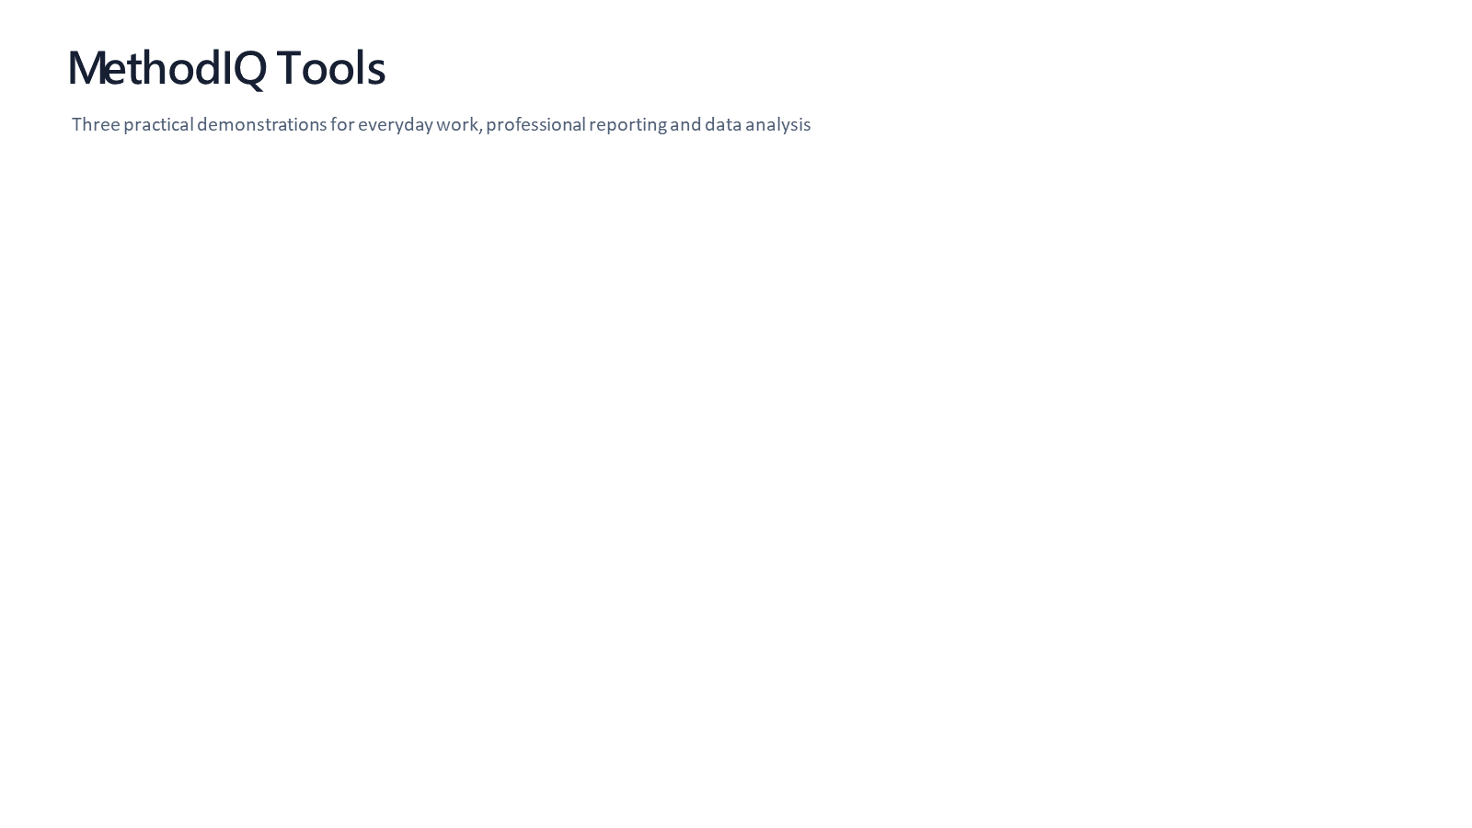
Normal case: technically clean and editable, but the title slide is sparse and has no visual or brand system.
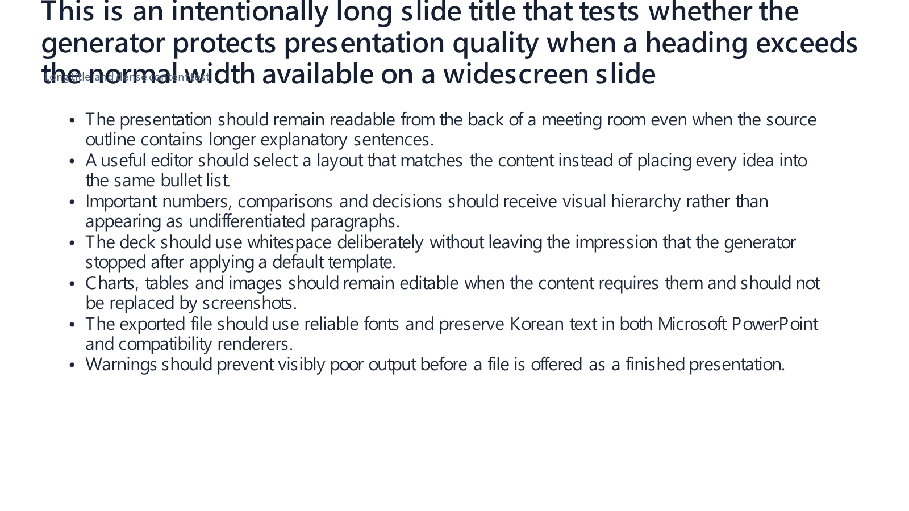
Failure case: the long title overruns its fixed area and overlaps the subtitle/body; export was not blocked.

Recommended public positioning
Safe claim: “PPTX Editor creates editable PowerPoint outlines and supports targeted revision, notes, and export.”

Avoid for now: “PPTX Editor automatically creates finished professional presentations.”

Immediate demo plan
- Import a predesigned MethodIQ template instead of generating a blank deck live.
- Prepare a three-slide file: title, one comparison, and one closing takeaway.
- Demonstrate one text revision, one speaker-note update, and the exported editable PowerPoint.
- Keep the reviewed export open locally as a fallback; do not depend on the browser QA path until its origin configuration is fixed.
- If asked about design quality, say the product currently prioritizes editability and workflow integration while richer layouts are being developed.

Product improvement priorities
1. Add a real layout system — Cover, section, statement, two-column, comparison, image, editable table, and editable chart layouts.
2. Introduce themes and templates — Brand fonts, colors, spacing, reusable masters, and content-aware layout selection.
3. Make preflight protective — Block export for overlap, clipping, unreadably small shrink-to-fit text, or excessive density.
4. Add visual regression testing — Render representative decks and compare layout results, including multilingual and dense-content cases.
5. Repair the browser QA path — Allow the test server’s own local origin—or inject it explicitly—so the documented check passes from a clean checkout.

Bottom line
Demo it, but control the promise. PPTX Editor can make a smooth opening demonstration when it edits a prepared deck. Its current generated designs are not strong enough to serve as the visual proof point of the MethodIQ portfolio; CI Research Hub and Analysis Studio should carry the deeper credibility and “wow” moments.

