

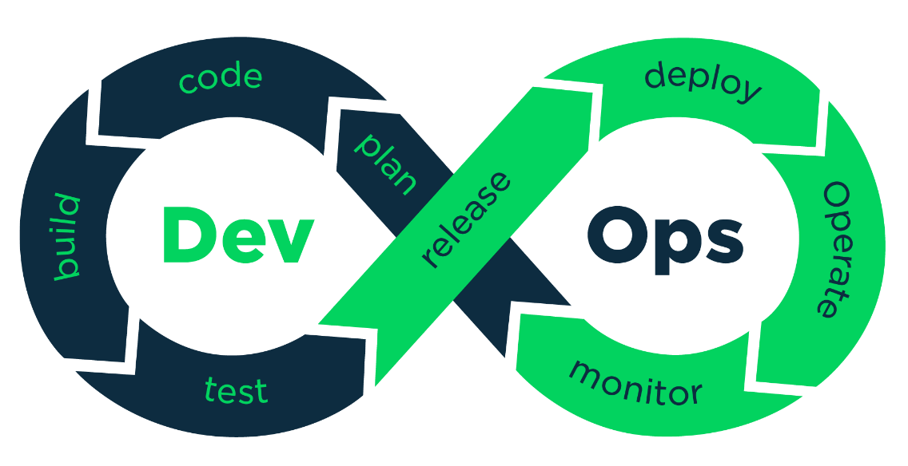

DevOps Material

**(JENKINS / DOCKER / ANSIBLE / CHEF)**

**Continuous Integration with Jenkins**

**Contents**

1. **Concepts of Continuous Integration**
   1. **The agile software development process**
      1. Software development life cycle
   2. **Continuous Integration**
      1. Note
      2. Agile runs on Continuous Integration
   3. **How to achieve Continuous Integration**
      1. Development operations
      2. Use a version control system
      3. Use repository tools
      4. Use a Continuous Integration tool
      5. Creating a self-triggered build
      6. Automate the packaging
      7. Using build tools
      8. Automating the deployments
      9. Note
      10. Automating the testing
      11. Use static code analysis
   4. **Continuous Integration benefits**
      1. Freedom from long integrations
      2. Production-ready features
      3. Analyzing and reporting
      4. Catch issues faster
      5. Spend more time adding features
      6. Rapid development
2. **Setting up Jenkins**
   1. **Introduction to Jenkins**
      1. What is Jenkins made of?
      2. Note
      3. Why use Jenkins as a Continuous Integration server?
      4. Jenkins as a centralized Continuous Integration server
      5. Hardware requirements
   2. **Running Jenkins inside a container**
      1. Installing Jenkins as a service on the Apache Tomcat server
      2. Note
      3. Setting up the Jenkins home path
      4. Why run Jenkins inside a container?
   3. **Running Jenkins as a standalone application** 
      1. Setting up Jenkins on Ubuntu
      2. Note
      3. Setting up Jenkins on Fedora/Centos
      4. Note
      5. Note
      6. Tip
   4. **Sample use cases**
      1. Netflix
      2. Yahoo!
      3. Note
3. **Configuring Jenkins**
   1. **Creating your first Jenkins job**
      1. Note
      2. Note
      3. Adding a build step
      4. Note
      5. Adding post-build actions
      6. Configuring the Jenkins SMTP server
      7. Running a Jenkins job
      8. Note
      9. Jenkins build log
      10. Note
      11. Jenkins home directory
   2. **Jenkins backup and restore**
      1. Creating a Jenkins job to take periodic backup
      2. Restoring a Jenkins backup
   3. **Upgrading Jenkins**
      1. Note
      2. Upgrading Jenkins running on the Tomcat server
      3. Upgrading standalone Jenkins master running on Ubuntu
      4. Script to upgrade Jenkins on Ubuntu
   4. **Managing Jenkins plugins**
      1. The Jenkins Plugins Manager
      2. Installing a Jenkins plugin to take periodic backup
      3. Configuring the periodic backup plugin
      4. Note
   5. **User administration**
      1. Enabling global security on Jenkins
      2. Note
      3. Using the Project-based Matrix Authorization Strategy
4. **Continuous Integration Using Jenkins – Part I**
   1. **Jenkins Continuous Integration Design**
      1. The branching strategy
      2. The Continuous Integration pipeline
      3. Note
      4. Toolset for Continuous Integration
   2. **Setting up a version control system**
      1. Installing Git
      2. Installing SourceTree (a Git client)
      3. Creating a repository inside Git
      4. Uploading code to Git repository
      5. Configuring branches in Git
      6. Note
      7. Git cheat sheet
   3. **Configuring Jenkins**
      1. Installing the Git plugin
      2. Note
      3. Installing and configuring JDK
      4. Note
      5. Installing and configuring Maven
      6. Installing the e-mail extension plugin
   4. **The Jenkins pipeline to poll the feature branch**
      1. Creating a Jenkins job to poll, build, and unit test code on the feature1 branch
      2. Note
      3. Creating a Jenkins job to merge code to the integration branch
      4. Creating a Jenkins job to poll, build, and unit test code on the feature2 branch
      5. Creating a Jenkins job to merge code to the integration branch
5. **Continuous Integration Using Jenkins – Part II**
   1. **Installing SonarQube to check code quality**
      1. Setting the Sonar environment variables
      2. Running the SonarQube application
      3. Note
      4. Creating a project inside SonarQube
      5. Installing the build breaker plugin for Sonar
      6. Creating quality gates
      7. Installing SonarQube Scanner
      8. Setting the Sonar Runner environment variables
   2. **Installing Artifactory**
      1. Setting the Artifactory environment variables
      2. Running the Artifactory application
      3. Creating a repository inside Artifactory
   3. **Jenkins configuration**
      1. Installing the delivery pipeline plugin
      2. Installing the SonarQube plugin
      3. Note
      4. Installing the Artifactory plugin
   4. **The Jenkins pipeline to poll the integration branch**
      1. Creating a Jenkins job to poll, build, perform static code analysis, and integration tests
      2. Creating a Jenkins job to upload code to Artifactory
      3. Note
      4. Note
6. **Continuous Delivery Using Jenkins**
   1. **What is Continuous Delivery?**
   2. **Continuous Delivery Design**
   3. **Jenkins configuration** 
      1. Configuring Jenkins slaves on the testing server
      2. Note
      3. Slave agents via SSH tunneling
      4. Creating a Jenkins job to deploy code on the testing server

**DOCKER**

**Table of Contents**

**The Basic Idea**

1. **Containerization versus virtualization**
   1. Traditional virtualization
   2. Containerization
2. **Understanding Docker**
   1. Difference between Docker and typical VMs
   2. Dockerfile
   3. Docker Networking/Linking
3. **Docker installers/installation**
   1. Types of Installers
   2. Installing Docker on Ubuntu
   3. Installing Docker on RedHat
4. **Understanding the Docker setup**
   1. Client-server communication
5. **Downloading the first Docker image**
6. **Running the first Docker container**
   1. Troubleshooting Docker containers
7. **Handling Docker Containers**
8. **Clarifying Docker terms**
   1. Docker images
   2. Docker containers
   3. Docker Registry
9. **Working with Docker images**
   1. The Docker Hub
   2. Searching Docker images
10. **Working with an interactive container**
    1. Tracking changes inside containers
    2. Controlling Docker containers
    3. Housekeeping containers
    4. Building images from containers
    5. Launching a container as a daemon
11. **Building Images**
12. **Docker's integrated image building system**
13. **A quick overview of the Dockerfile's syntax**
    1. The comment line
    2. The parser directives
14. **The Dockerfile build instructions**
    1. The FROM instruction
    2. The MAINTAINER instruction
    3. The COPY instruction
    4. The ADD instruction
    5. The ENV instruction
    6. The ARG instruction
    7. The environment variables
    8. The USER instruction
    9. The WORKDIR instruction
    10. The VOLUME instruction
    11. The EXPOSE instruction
    12. The LABEL instruction
    13. The RUN instruction
    14. The CMD instruction
    15. The ENTRYPOINT instruction
    16. The HEALTHCHECK instruction
    17. The ONBUILD instruction
    18. The STOPSIGNAL instruction
    19. The SHELL instruction
    20. The .dockerignore file
15. **A brief on the Docker image management**
16. **Publishing Imag0es**
17. **Understanding Docker Hub**
18. **Pushing images to Docker Hub**
19. **Automating the build process for images**
20. **Private repositories on Docker Hub**
21. **Organizations and teams on Docker Hub**
22. **How Docker Works ?**
    1. Namespaces
    2. Cgroups
    3. The Union filesystem
23. **Adding a nonroot user to administer Docker**
    1. Getting ready
    2. How to do it…
24. **Docker Networking Primer**
25. **A brief overview of container networking**
    1. Note
26. **Networking and Docker**
    1. Linux bridges
    2. Open vSwitch
    3. NAT
    4. IPtables
    5. AppArmor/SELinux
27. **The docker0 bridge**
    1. The --net default mode
    2. The --net=none mode
    3. The --net=container:$container2 mode
    4. The --net=host mode
28. **Docker OVS**
29. **Linking Docker containers**
    1. Links
30. **What's new in Docker networking?**
    1. Sandbox
    2. Endpoint
    3. Network
31. **The Docker CNM model**
32. **Envisaging container as a service**
    1. Building an HTTP server image
    2. Running the HTTP server image as a service
33. **Exposing container services**
    1. Publishing a container's port – the -p option
    2. NAT for containers
    3. Note
    4. Retrieving the container port
    5. Binding a container to a specific IP address
    6. Autogenerating the Docker host port
    7. Connecting to the HTTP service
34. **Sharing Data with Containers**
35. **Data volume**
36. **The volume management command**
37. **Sharing host data**
    1. The practicality of host data sharing
38. **Sharing data between containers**
    1. Data-only containers
    2. Mounting data volume from other containers
    3. The practicality of data sharing between containers
39. **Docker inbuilt service discovery**
40. **Linking containers**
41. **Orchestration of containers**
    1. Orchestrating containers using docker-compose
    2. Installing docker-compose
    3. The docker-compose file
    4. The docker-compose command
    5. Common usage
42. **Debugging Containers**
    1. Debugging a containerized application
    2. The docker exec command
    3. The docker ps command
    4. The docker top command
    5. The docker stats command
    6. The Docker events command
    7. The docker logs command
    8. The docker attach command
    9. Debugging a Dockerfile
43. **The Docker use cases**
    1. Integrating containers into workflows
    2. Docker for HPC and TC applications

**ANSIBLE**

**Table of Contents:**

**Getting Started with Ansible**

1. **IT automation**
   1. The history of IT automation
   2. Advantages of IT automation
   3. Disadvantages of IT automation
   4. Types of IT automation
2. **What is Ansible?**
3. **Secure Shell (SSH)**
4. **Installing Ansible**
   1. Installing Ansible using the system's package manager
5. **Ansible version and configuration**
6. **Inventory parsing and data sources**
   1. Static inventory
   2. Inventory variable data
7. **Automating Simple Tasks**
8. **YAML**
9. **Hello Ansible**
10. **Working with playbooks**
    1. Studying the anatomy of a playbook
    2. Running a playbook
11. **Ansible verbosity**
12. **Variables in playbooks**
13. **Creating the Ansible user**
14. **Configuring a basic server** 
    1. Enabling EPEL
    2. Installing Python bindings for SELinux
    3. Upgrading all installed packages
    4. Ensuring that NTP is installed, configured, and running
    5. Ensuring that FirewallD is present and enabled
    6. Adding a customized MOTD
    7. Changing the hostname
    8. Reviewing and running the playbook
15. **Installing and configuring a web server**
16. **Publishing a website**
17. **Jinja2 templates** 
    1. Filters
    2. Conditionals
    3. Cycles
18. **Working with inventory files** 
    1. The basic inventory file
    2. Groups in an inventory file
    3. Regular expressions in the inventory file
19. **Working with variables** 
    1. Host variables
    2. Group variables
    3. Variable files
    4. Overriding configuration parameters with an inventory file
20. **Working with dynamic inventory** 
    1. Amazon Web Services
21. **Working with iterates in Ansible** 
    1. Standard iteration - with_items
    2. Nested loops - with_nested
22. **Delegating a task**
23. **Working with conditionals** 
    1. Boolean conditionals
    2. Checking if a variable is set
24. **Working with include**
25. **Working with handlers**
26. **Working with roles** 
    1. Project organization
    2. Anatomy of a role
    3. Transforming your playbooks in a full Ansible project
27. **Execution strategies**
28. **Tasks blocks**
29. **Security management** 
    1. Using Ansible vault
    2. Vaults and playbooks
    3. Encrypting user passwords
    4. Hiding passwords
    5. Using no_log

**CHEF COOKBOOK DEVELOPMENT**

**Contents**

1. **Chef Infrastructure**
   1. **Introduction**
      1. **Using Version Control System**
         1. Note
         2. Getting Ready
      2. **Installing the Chef Development kit on your workstation**
         1. How to do it
      3. **Using the Hosted Chef**
         1. Getting Ready
         2. How to do it
         3. How it works
         4. There’s more
         5. Note
      4. **Managing Virtual Machines with vagrant**
         1. Tip
         2. Getting Ready
         3. How to do it
         4. How it works
         5. There’s more…
      5. **Creating and Using Cookbooks**
         1. Getting Ready
         2. How to do it
         3. How it works
         4. There’s more
      6. **Inspecting files on your Chefserver with knife**
         1. Getting Ready
         2. How to do it
         3. How it works
         4. There’s more..
      7. **Defining Cookbook dependencies.**
         1. Getting Ready
         2. How to do it
         3. How it works
         4. There’s more
         5. Tip
      8. **Managing CookBook dependencies with berkshelf**
         1. Getting Ready
         2. How to do it
         3. How it works
         4. Note
         5. There’s more
         6. See Also
      9. **Using Custom Knife Plugins**
         1. Getting Ready
         2. How to do it
         3. How it works
         4. There’s more
      10. **Deleting Node from the Chef Server**
          1. Getting Ready
          2. How to do it
          3. How it works
          4. There’s more
      11. **Developing recipes with local mode**
          1. Getting Ready
          2. How to do it
          3. How it works
          4. There’s more
      12. **Using Roles**
          1. Getting Ready
          2. How to do it
          3. How it works
      13. **Using Environments**
          1. Getting Ready
          2. How to do it
          3. How it works
          4. There’s more
      14. **Freezing Cookbooks**
          1. Note
          2. Getting Ready
          3. Make sure you have at least one cookbook (I’ll use the ntp cookbook) registered with your chef server.
          4. How to do it
          5. How it works
          6. There’s more
      15. **Running the chef client as a Daemon**
          1. Getting ready
          2. How to do it
          3. How it works
          4. Tip
          5. There’s more
          6. Note
2. **Evaluating and Troubleshooting Cookbooks and chef Runs**
   1. **Introduction**
   2. **Testing your chef cookbooks with cookstyle and Rubocop** 
      1. How to do it
      2. Carryout the following steps to test your cookbook; run cookstyle on the ntp cookbook.
      3. How it works
      4. There’s more
      5. See also
   3. **Flagging Problems in your chef cookbooks with Foodcritic**
      1. Getting Ready
      2. How to do it
      3. How it works
      4. There’s more
      5. See also