Hadoop下第一个程序运行过程帮助文档

1、启动Hadoop：
wang@kubuntu:~$ start-all.sh
This script is Deprecated. Instead use start-dfs.sh and start-yarn.sh
Starting namenodes on [localhost]
localhost: starting namenode, logging to /usr/local/development/hadoop-2.6.0/logs/hadoop-wang-namenode-kubuntu.out
localhost: starting datanode, logging to /usr/local/development/hadoop-2.6.0/logs/hadoop-wang-datanode-kubuntu.out
Starting secondary namenodes [localhost]
localhost: starting secondarynamenode, logging to /usr/local/development/hadoop-2.6.0/logs/hadoop-wang-secondarynamenode-kubuntu.out
starting yarn daemons
starting resourcemanager, logging to /usr/local/development/hadoop-2.6.0/logs/yarn-wang-resourcemanager-kubuntu.out
localhost: starting nodemanager, logging to /usr/local/development/hadoop-2.6.0/logs/yarn-wang-nodemanager-kubuntu.out

wang@kubuntu:~$ jps
20302 org.eclipse.equinox.launcher_1.2.0.v20110502.jar
30114 ResourceManager
30241 NodeManager
29568 NameNode
29930 SecondaryNameNode
29700 DataNode
30760 Jps

2、创建file 文件夹：
这个是建在本地硬盘上的：
root@kubuntu: cd /usr/local/development/hadoop-2.6.0/;mkdir in
root@kubuntu:/usr/local/development/hadoop-2.6.0/in# echo "hello java hello world hello hadoop hello wang yuan long" > file1.txt
root@kubuntu:/usr/local/development/hadoop-2.6.0/in# echo "hello PHP hello China" > file2.txt
查看创建的 file1.txt ,file2.txt文件：
root@kubuntu:/usr/local/development/hadoop-2.6.0/in# cat file1.txt
hello java hello world hello hadoop hello wang yuan long
root@kubuntu:/usr/local/development/hadoop-2.6.0/in# cat file2.txt
hello PHP hello China

3、在HDFS上创建输入文件夹目录 in ：
wang@kubuntu:/usr/local/development/hadoop-2.6.0/in$ hadoop dfs -mkdir /user/wang/in
把本地硬盘上创建的文件传进in 里面：
wang@kubuntu:/usr/local/development/hadoop-2.6.0/in$ hadoop dfs -put in/* /user/wang/in/

查看结果：
wang@kubuntu:/usr/local/development/hadoop-2.6.0/in$ hadoop dfs -ls /user/wang/in
DEPRECATED: Use of this script to execute hdfs command is deprecated.
Instead use the hdfs command for it.

Found 2 items
-rw-r--r-- 3 wang supergroup 41 2016-03-31 16:37 /user/wang/in/file1.txt
-rw-r--r-- 1 wang supergroup 22 2016-04-08 01:38 /user/wang/in/file2.txt

上述的操作也可在eclipse里面进行：
eclipse3.7.2 + hadoop-2.2.0 hadoopa插件配置
和普通插件配置一样，需要注意的是那个插件的版本，装插件时一定要检查一下权限是否可读，若不可读则插件一定会安装失败。
插件装好后，做一下简单的配置：
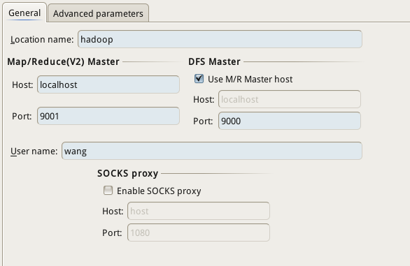

5、开始运行 wordcount：
命令行：
wang@kubuntu:/usr/local/development/hadoop-2.6.0$ hdfs jar WordCount.jar WordCount in/ out/

eclipse运行：
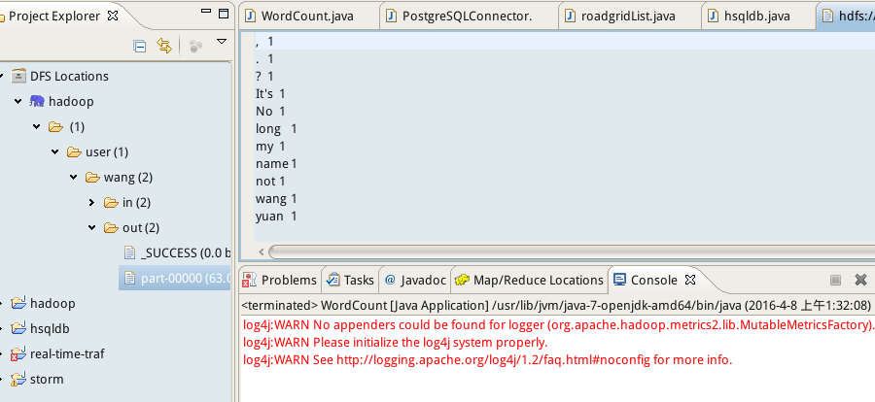

查看运行结果：
wang@kubuntu:/usr/local/development/hadoop-2.6.0$ hdfs dfs -cat out/part-00000
, 1
. 1
? 1
It's 1
No 1
long 1
my 1
name 1
not 1
wang 1
yuan 1

整个过程到此结束！整个程序结构比较简单，两个类部类就都继承了MapReduceBase类并分别实现了Maper和Reducer接口。相关的注解已经在程序中进行了详细的标明。

更多信息请登录下面参考链接： 参考网址：（1）：https://github.com/juditacs/wordcount
（2）：http://www.cnblogs.com/xuxm2007/archive/2012/09/25/2702164.html

附代码：

import java.io.IOException;
import java.util.Iterator;
import java.util.StringTokenizer;
import org.apache.hadoop.fs.Path;
import org.apache.hadoop.io.IntWritable;
import org.apache.hadoop.io.LongWritable;
import org.apache.hadoop.io.Text;
import org.apache.hadoop.mapred.FileInputFormat;
import org.apache.hadoop.mapred.FileOutputFormat;
import org.apache.hadoop.mapred.JobClient;
import org.apache.hadoop.mapred.JobConf;
import org.apache.hadoop.mapred.MapReduceBase;
import org.apache.hadoop.mapred.Mapper;
import org.apache.hadoop.mapred.OutputCollector;
import org.apache.hadoop.mapred.Reducer;
import org.apache.hadoop.mapred.Reporter;
import org.apache.hadoop.mapred.TextInputFormat;
import org.apache.hadoop.mapred.TextOutputFormat;

public class WordCount
{
/**
* MapReduceBase类:实现了Mapper和Reducer接口的基类（其中的方法只是实现接口，而未作任何事情）
* Mapper接口：
* WritableComparable接口：实现WritableComparable的类可以相互比较。所有被用作key的类应该实现此接口。
* Reporter 则可用于报告整个应用的运行进度，本例中未使用。
*
*/
public static class Map extends MapReduceBase implements
Mapper<LongWritable, Text, Text, IntWritable>
{
/**
* LongWritable, IntWritable, Text 均是 Hadoop 中实现的用于封装 Java 数据类型的类，这些类实现了WritableComparable接口，
* 都能够被串行化从而便于在分布式环境中进行数据交换，你可以将它们分别视为long,int,String 的替代品。
*/
private final static IntWritable one = new IntWritable(1);
private Text word = new Text();

/**
* Mapper接口中的map方法：
* void map(K1 key, V1 value, OutputCollector<K2,V2> output, Reporter reporter)
* 映射一个单个的输入k/v对到一个中间的k/v对
* 输出对不需要和输入对是相同的类型，输入对可以映射到0个或多个输出对。
* OutputCollector接口：收集Mapper和Reducer输出的<k,v>对。
* OutputCollector接口的collect(k, v)方法:增加一个(k,v)对到output
*/
public void map(LongWritable key, Text value,
OutputCollector<Text, IntWritable> output, Reporter reporter)
throws IOException
{
String line = value.toString();
StringTokenizer tokenizer = new StringTokenizer(line);
while (tokenizer.hasMoreTokens())
{
word.set(tokenizer.nextToken());
output.collect(word, one);
}
}
}
public static class Reduce extends MapReduceBase implements
Reducer<Text, IntWritable, Text, IntWritable>
{
public void reduce(Text key, Iterator<IntWritable> values,
OutputCollector<Text, IntWritable> output, Reporter reporter)
throws IOException
{
int sum = 0;
while (values.hasNext())
{
sum += values.next().get();
}
output.collect(key, new IntWritable(sum));
}
}
public static void main(String[] args) throws Exception
{
/**
* JobConf：map/reduce的job配置类，向hadoop框架描述map-reduce执行的工作
* 构造方法：JobConf()、JobConf(Class exampleClass)、JobConf(Configuration conf)等
*/
JobConf conf = new JobConf(WordCount.class);
conf.setJobName("wordcount"); //设置一个用户定义的job名称
conf.setOutputKeyClass(Text.class); //为job的输出数据设置Key类
conf.setOutputValueClass(IntWritable.class); //为job输出设置value类
conf.setMapperClass(Map.class); //为job设置Mapper类
conf.setCombinerClass(Reduce.class); //为job设置Combiner类
conf.setReducerClass(Reduce.class); //为job设置Reduce类
conf.setInputFormat(TextInputFormat.class); //为map-reduce任务设置InputFormat实现类
conf.setOutputFormat(TextOutputFormat.class); //为map-reduce任务设置OutputFormat实现类
/**
* InputFormat描述map-reduce中对job的输入定义
* setInputPaths():为map-reduce job设置路径数组作为输入列表
* setInputPath()：为map-reduce job设置路径数组作为输出列表
*/
FileInputFormat.setInputPaths(conf, new Path(args[0]));
FileOutputFormat.setOutputPath(conf, new Path(args[1]));
JobClient.runJob(conf); //运行一个job
}
}

