PreLab: Extraction of Carvone

(Total 10 Points)
On my honor, in preparing this report, I know that I am free to use references and consult with others. However, I cannot copy from other students’ work or misrepresent my own data.

…………………………………………………………….. (signature)

Print Name: _________________________________________

1. Assign the configurations of the two stereocenters in the compound below. (2 points)
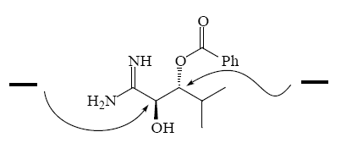

2. Assign R or S configuration to the following molecules. (3 points) (Hint: see examples in Appendix G.)
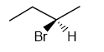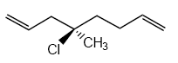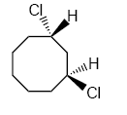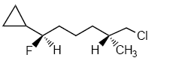

3. Between the stress of university and your diet consisting entirely of pizza, potato chips, and chocolate bars, you have developed an ulcer. In order to numb the burning in your stomach, you take Pepcid. The active ingredient in Pepcid, famotidine, has the structure shown below. For the atoms indicated, identify the hybridization (5 points)

