PreLab: E2 Elimination (Total 10 Points)
On my honor, in preparing this report, I know that I am free to use references and consult with others. However, I cannot copy from other students’ work or misrepresent my own data.

…………………………………………………………….. (signature)

Print Name: _________________________________________

1. Predict the products when the following compounds are treated with sodium hydroxide (base). (3 points)
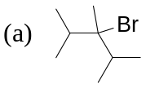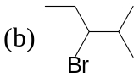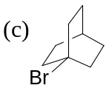

2. Which is the more stable structure and why? (2 points)
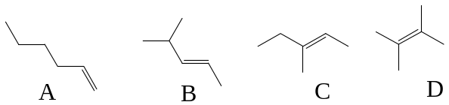

3. Write the major product from the following reactions. (1+ 4= 5 points)

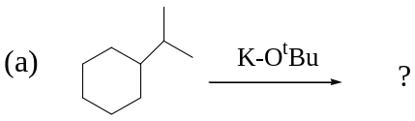

(b) 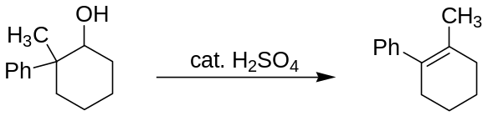
Write the mechanism for this reaction. (Hint: carbocationic rearrangement takes place)

