Lab Revision Questions: NM(Total 20 Points)
On my honor, in preparing this report, I know that I am free to use references and consult with others. However, I cannot copy from other students’ work or misrepresent my own data.

…………………………………………………………….. (signature)

Print Name: _________________________________________

1. The atomic weight of Br is listed as 79.909 on the periodic table, but we use 79, not 80, when calculating the molecular weights of Br-containing compounds for mass spectrometry – why? (2 points)

2.
(a) Draw trans-3-bromo-1-butylcyclohexane in planar form (no chair). Be sure to indicate the stereochemistry in your drawing. (2 points)

(b) Now draw both chair conformations of trans-3-bromo-1-butylcyclohexane. (2 points)

(c) Circle the conformer above that is lower in energy. (1 point)

3.
(a) How many degrees of unsaturation does 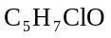 have? (2 points)

(b) Draw an isomer of that contains a ketone (There are many correct answers.). (2 points)

(c) Draw an isomer of that does not contain a ketone. (Again, there are many correct answers.). (2 points)

4. Explain why 3-Chloropentane shows four different absorbencies in the 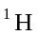 NMR spectrum. (3 points)
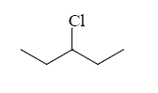
5. Write the structure from the data given. (4 points)

Molecular formula 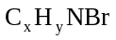

IR:

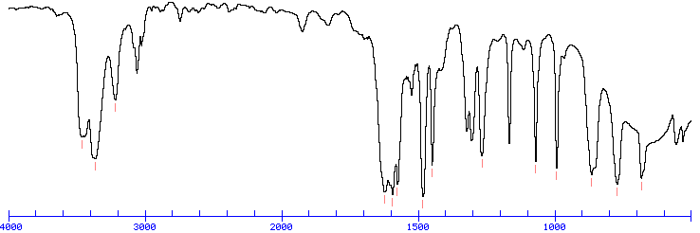

NMR:

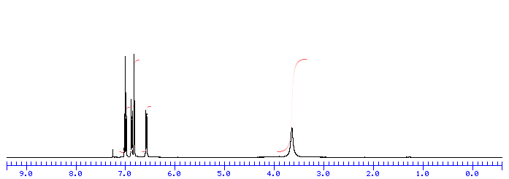

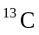 NMR:

