Extraction of Carvone(Total 30 Points)
On my honor, in preparing this report, I know that I am free to use references and consult with others. However, I cannot copy from other students’ work or misrepresent my own data.

…………………………………………………………….. (signature)

Print Name: _________________________________________

1. Which methods that you used in this lab (IR, TLC, and smell) proved to be effective in distinguishing enantiomers? (2 points)

2. Separating enantiomers from a mixture is difficult but possible. Since these compounds have the same melting point, boiling point, and density, as well as other properties, there are few methods that allow a chemist to separate enantiomers. Think of or find a method that will allow a chemist to separate enantiomers. (3 points)

3. What functional groups do you observe in the IR spectrum? (2 points)

4. Circle and name the functional groups in the following molecules. (1 points each for a total of 10 points).

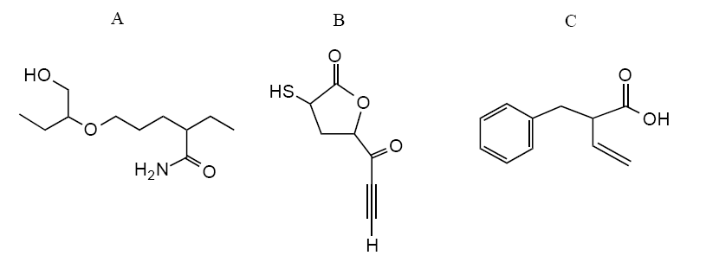
5. Answer the following true or false questions by placing a legible T (for true) or F (for false) in the line provided at left and explain. (2X3= 6 points)
a. ______ The 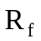 value of the solvent front is always 1.
b. ______ If you are working-up a given reaction and have 100 ml of ether and 100 ml of water in your 500 mL separating funnel, water will be the top layer.
c. ______ The silica gel TLC for compound 3 (shown below) was run in 20% diethyl ether/hexanes. The value will increase if the solvent system is changed to 60% diethyl ether/hexanes.
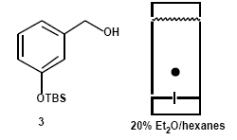
6. Questions a-d refer to the following TLC diagram: (4 points)
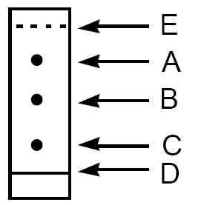
a. In the above TLC, the most non-polar spot is _______.
b. The base line is _______.
c. The solvent front is _______.
d. The value of spot B is _______.

7. The following TLC (run in 40% 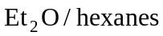) is of an organic reaction.
The starting material is on the right, the mixed spot is in the middle, and reaction is on the left. (3 points)
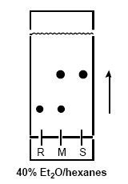

(A) What is the of the starting material?
a. 0.30 b. 0.60 c. 1.75 d. 3.5 e. none of these

(B) What is the of the product?
a. 0.30 b. 0.60 c. 1.75 d. 3.5 e. none of these

(C) Is the reaction complete? a. yes b. no

