Reduction of Carvone
Report Questions
(Total 30 Points)
On my honor, in preparing this report, I know that I am free to use references and consult with others. However, I cannot copy from other students’ work or misrepresent my own data.

…………………………………………………………….. (signature)

Print Name: _________________________________________

1) What are the two products of the sodium borohydride reduction of 2-tertbutylcyclohexanone? Will one be favored and if so, why? (2+2 = 4 points)

2) Explain why the two diastereomers of carveol would have different 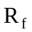 values. (2 points)

3) If instead of HCl, the reaction was quenched with DCl, where would the D be located? Draw the product. (2 points)

4) Give the structure of all the products of the following reactions. Indicate proper stereochemistry where appropriate. (18 points)
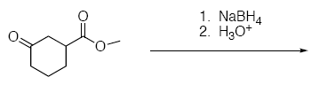
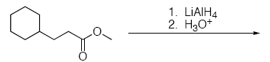
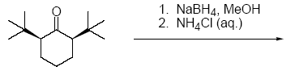
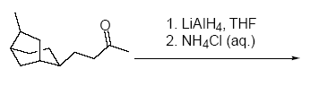
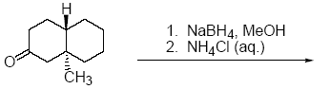
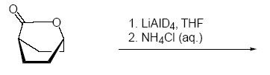
5) Explain the stereochemistry of the following product distributions observed. (4 points)
