NMR Laboratory
Report Questions
(Total 70 Points)
On my honor, in preparing this report, I know that I am free to use references and consult with others. However, I cannot copy from other students’ work or misrepresent my own data.

…………………………………………………………….. (signature)

Print Name: _________________________________________

1. Explain each of the following observations. (3 X 2= 6 points)
(a) The compound 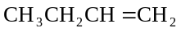 shows an IR absorbance around 1550 cm^{–1}, but its structural isomer 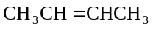 does not-why?

(b) The 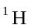-decoupled 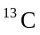 NMR spectrum of 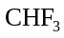 shows a single peak that is split into a quartet.

2.
(a) Draw trans-4-(1-ethylpropyl)cyclohexanol in planar form (no chair). Be sure to indicate the stereochemistry. (2 points)

(b) Now draw trans-4-(1-ethylpropyl)cyclohexanol in its lowest energy conformation. (2 points)

(c) Now draw cis-4-(1-ethylpropyl)cyclohexanol in its lowest energy conformation. (2 points)

(d) Considering your answers to (b) and (c), which is lower in energy, cis or trans-4-(1-ethylpropyl)cyclohexanol? Explain your answer briefly (one sentence). (2 points)

3. In the following compound, label symmetry-equivalent H atoms with the same letter and nonequivalent H atoms with different letters, as we did in class. Then predict the NMR spectrum of the compound, indicating the approximate chemical shift, integration, and multiplicity for each resonance that you expect to see. (20 points)
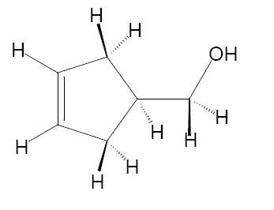
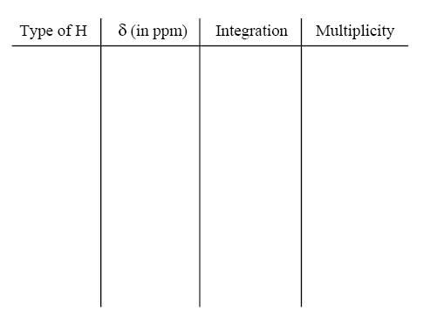
4. Below are the IR spectra of two isomers having the formula 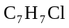. (Total 8 points)

1) What is the unsaturation number of these isomers? _____ (2 points)

2) Why is there such a difference in the intensity of the C-H stretching and C-H bending region between these two isomeric compounds? (2 points)

3) What structure would you assign to Compound A? Indicate on the spectrum which IR bands support your structure assignment. (4 points)

4. What structure would you assign to Compound B? Indicate which IR bands support your structure assignment. Note: NUJOL is a paraffin oil used to prepared the IR sample. (8 points)
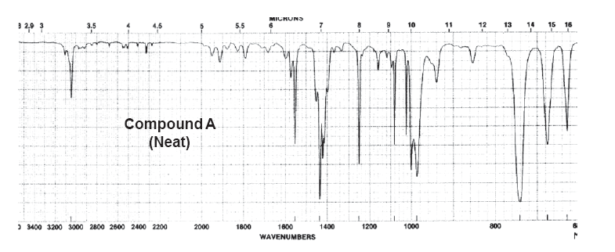
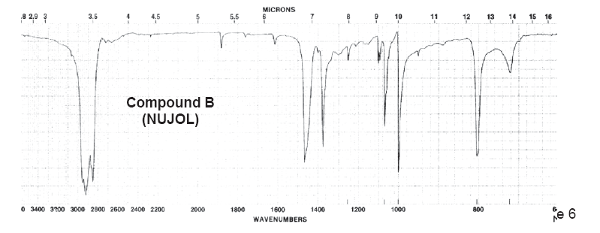
5. Find the structure of the compound and explain each spectrum to support your answer.

(a) Compound contains C, H, and O. (10 points)

MS:
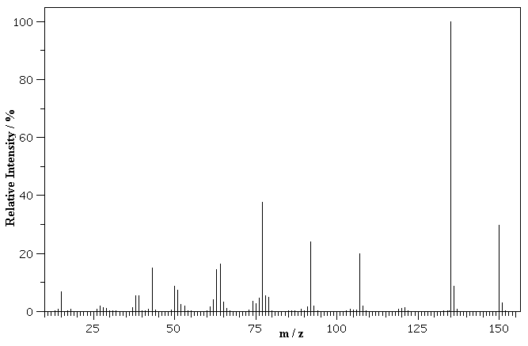

IR:
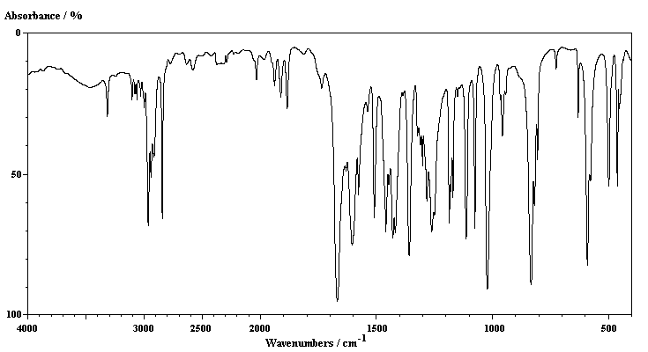
NMR:
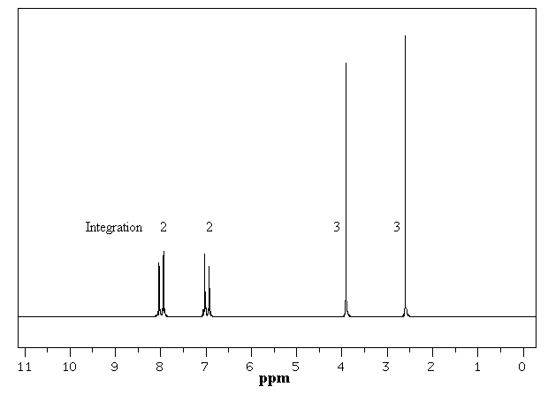
NMR:
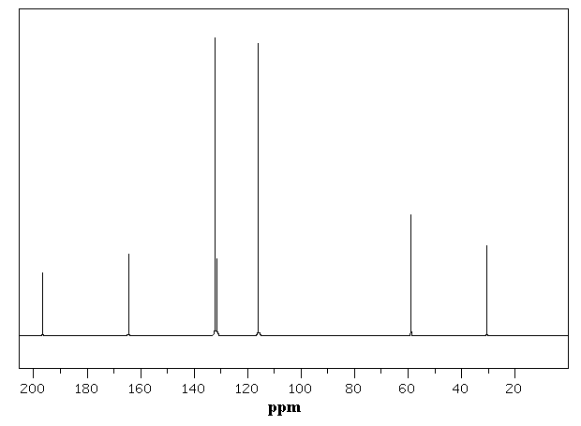

(b) Compound contains C, H, and O. (10 points)

MS:
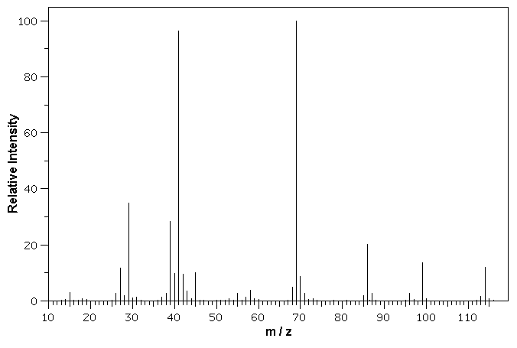
IR:

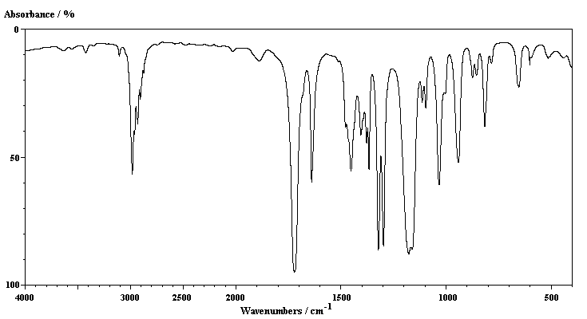
NMR:

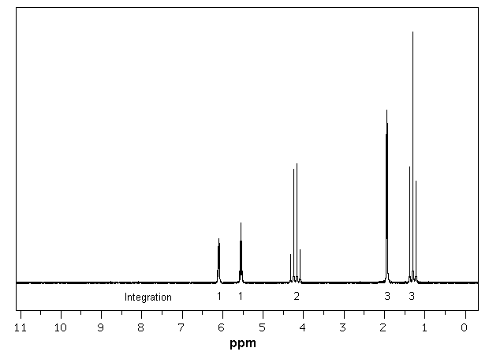

NMR:
