Pre-Lab 4: Friedel-Crafts Reaction
(Total 10 points)
Click here for the Pre-Lab
Name(Print then sign): ___________________________________________________
Lab Day: ___________________Section: ________TA__________________________
This assignment must be completed individually and turned in to your TA at the beginning of lab. You will not be allowed to begin the lab until you have completed this assignment.
1. Classify each of the following species as anti-aromatic, aromatic, or nonaromatic.
Support your answer. (3 points)
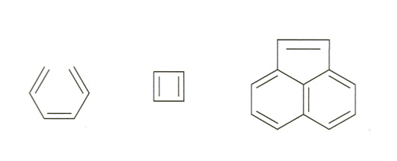

2. Show the mechanism for the following reaction. Be sure to include all intermediates. (5 points)

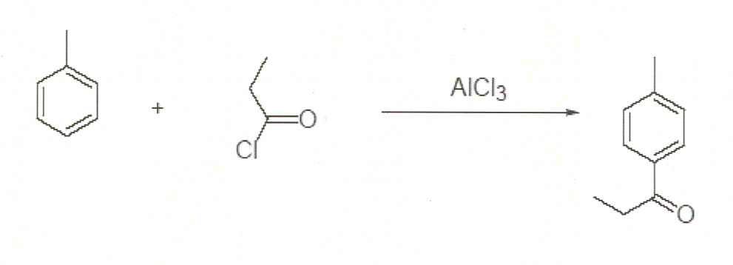

3. Predict the products from the following reactions. (2 points)
