PreLab Questions (Total 10 points)
Click here for the Pre-Lab
Name(Print then sign): ___________________________________________________
Lab Day: ___________________Section: ________TA__________________________
This assignment must be completed individually and turned in to your TA at the beginning of lab. You will not be allowed to begin the lab until you have completed this assignment.
1. A small crystal of iodine is used during the preparation of ‘Grignard reagent’-Why? (1 point)

2. Which solvent can we use in the preparation of GR except ether? (1 point)

3. Why is the addition of the GR to propanal solution done over the period of 30 minutes? (2 points)

4. Write the major product of the following reactions: (4 points)
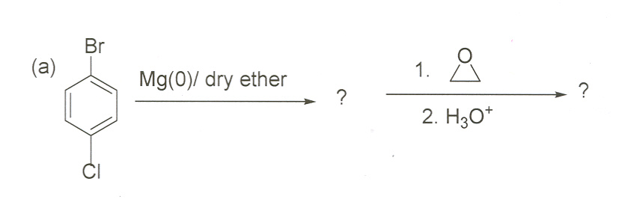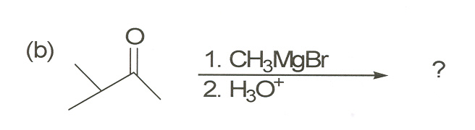

5. How will you synthesize the following molecule? (2 points)

from tertBu-Br, dry ether, 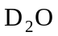 and Mg(0).

