Report 4: Friedel- Crafts
(Total 30 points)
(Click here for the Report Form
Note: In preparing this report you are free to use references and consult with others. However, you may not copy from other students’ work or misrepresent your own data (see honor code).
Name(Print then sign): ___________________________________________________
Lab Day: ___________________Section: ________TA__________________________
1. Draw the mechanism for the reaction of ferrocene, acetic anhydride, and phosphoric acid. (6 points)

2. Show your theoretical and percent yield calculations for the reaction. (3 points)

3. The melting point of your re-crystallized acetylferrocene is: ---- (2 points)
4. Draw the TLC plates and show your 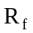 calculations (4 points)

5. Classify each of the following species as anti-aromatic, aromatic, or nonaromatic.
Support your answer. (4 points)
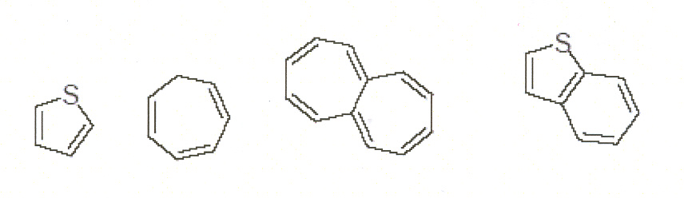

6. Ordinarily the barrier to rotation about a carbon-carbon double bond is quite high (40
kcal/mol), but the compound below was observed to have a rotational barrier of only about 20 kcal/mol. Explain this result. (3 points)
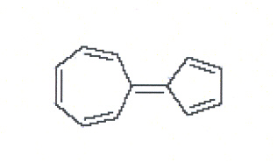

7. Propose a mechanism for the following reaction. (8 points)
