Report Questions (Total 30 points)
(Click here for the Report Form
Note: In preparing this report you are free to use references and consult with others. However, you may not copy from other students’ work or misrepresent your own data (see honor code).
Name(Print then sign): ___________________________________________________
Lab Day: ___________________Section: ________TA__________________________
1. Explain why Grignard reagents cannot be prepared from an organic halide that also contains a hydroxyl (-OH), a carboxyl (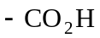), a thiol (-SH), or an amino (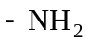) group. (2 points)

2. Why does the 2-bromopentane not appear under UV light for TLC? (2 points)

3. Draw and show your 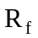 calculations for each TLC run. Which solvent was better? (3 points)

4. Show your theoretical and percent yield calculations. (4 points)

5. Draw the structure of your product and assign a proton to each peak in your NMR spectrum. Try and determine, if any, the impurities are in the sample. (4 points)

6. An NMR and GC-MS of the product are provided. What information can you obtain from the GC-MS? (5 points)

7. Write the major product of the following reactions: (10 points)
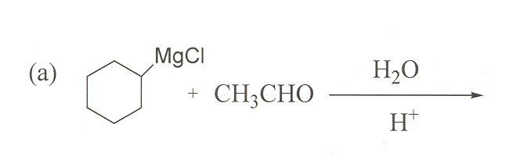

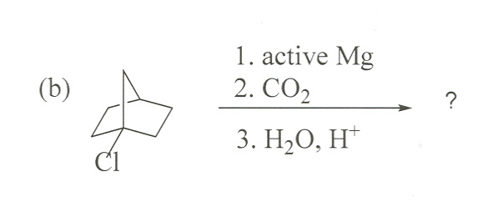
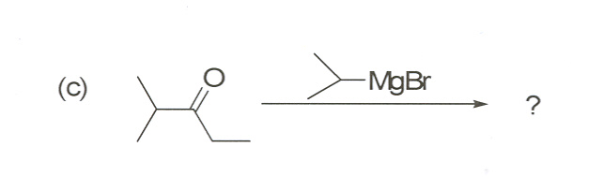
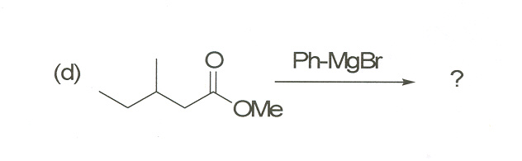

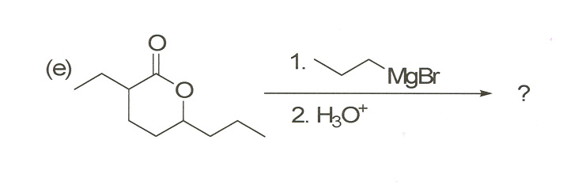

8. Identify the compounds (A-F). (Extra credit 6 points)
