The Central Limit Theorem: Practice (modified R. Bloom)
The Central Limit Theorem

Student Learning Outcomes:

- The student will explore the properties of data through the Central Limit Theorem.

Given:

Yoonie is a personnel manager in a large corporation. Each month she must review 16 of the employees. From past experience, she has found that the reviews take her approximately 4 hours each to do with a population standard deviation of 1.2 hours. Let X be the random variable representing the time it takes her to complete one review. Assume X is normally distributed. Let be the random variable representing the average time to complete the 16 reviews

Distribution

Complete the distributions.

1. X ∼ _________________________

2. ∼ _________________________

Graphing Probability

For each problem below:

a. Sketch the graph. Label and scale the horizontal axis. Shade the region corresponding to the probability.

b. Find the probability or value requested

1. Find the probability that one review will take Yoonie from 3.5 to 4.25 hours.
a. 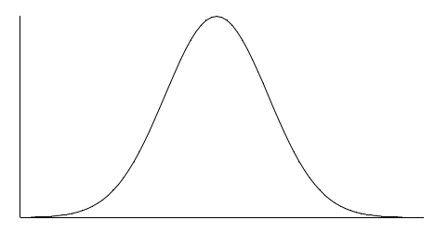
X
b. P( ________ < X < ________ ) = _______

2. Find the probability that the average of a month’s reviews will take Yoonie from 3.5 to 4.25 hrs.
a.
b. P( ) = _______

3. Find the 95th percentile for the average time to complete one month’s reviews.

a. b.

Discussion Question

4. What causes the probabilities in (1) and (2) to differ?

