Concepts of the Experiment
Matter exists in three states. The fact that a gas can be condensed to a liquid and a liquid frozen to a solid indicates that there are attractive forces between all molecules. We can schematically represent these forces at the surface of a liquid by the arrows in Figure 1. In the interior of the liquid, forces exerted on a given molecule are uniform in all directions. At the surface, however, it is clear that there is a net force attracting each surface molecule inward. These molecules have higher energies than interior molecules, thus giving rise to the force known as surface tension. It is because of this force that liquid droplets are spherical. A spherical shape presents the smallest surface area for a given volume.
If the liquid is water, the surface tension is especially strong because particularly strong intermolecular forces, called hydrogen bonds, exist between the water molecules. (While strong for intermolecular bonds, these bonds are still considerably weaker than the intramolecular covalent bonds that bind atoms together in a molecule.) Hydrogen bonding arises whenever a hydrogen atom that is attached to a highly electronegative atom, such as oxygen, has access to an unbonded pair of electrons, such as those of another oxygen atom.
Another property displayed by water is polarity. Polar molecules possess a separation of charge. In ionic compounds, such as NaCl, there is a separation of a full unit charge, Na⁺…..Cl⁻. Polar covalent molecules display a partial separation of charge, denoted by a delta, d. An arrow is used to denote this charge separation. This polarity, referred to as a dipole moment, is equal to the partial charge times the distance separating the charges, and it is represented by an arrow pointing toward the negative end of the molecule. Figure 2 displays the polar nature of the water molecule.
Polar molecules attract each other. The negative end of the dipole of one molecule is attracted to the positive end of the dipole of another molecule. For this reason, water dissolves formic acid, H-COOH, which has a dipole moment, but it does not dissolve butane, CH₃CH₂CH₂CH₃, which
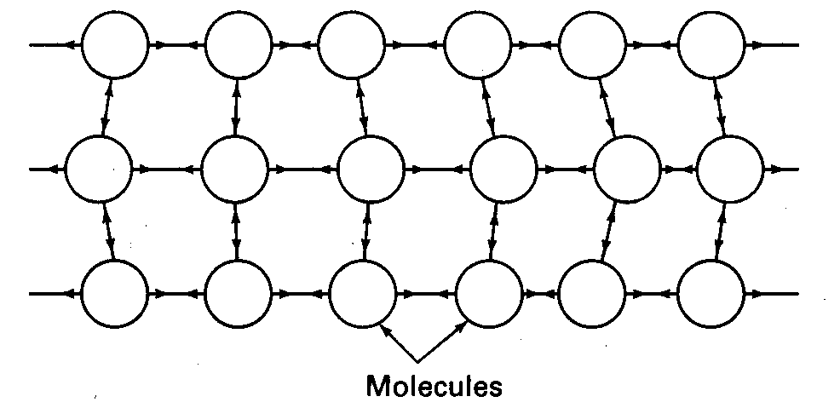
Figure 1. The action of molecular forces at a liquid surface creates a surface tension that tends to minimize the surface area of the liquid.
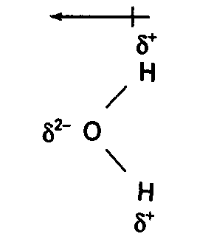
Figure 2. The bond polarity and angular structure of a water molecule create a dipole moment.
has a nearly uniform charge distribution. If a molecule possessing the properties of both of these molecules is brought up to the surface of water, the polar part of the molecule will be attracted to the surface and the nonpolar portion will be repelled. If the nonpolar part is much larger than the polar portion, the molecule will not dissolve in water but will simply stick to its surface. Consequently, it will lower the energy of the surface water molecules and of the adhering molecules.
The molecule we will use in this experiment, stearic acid, behaves in just this way. Stearic acid has a polar end consisting of a carboxyl group, -COOH, and a large nonpolar "tail" consisting of 16 methylene groups, -CH₂-, terminating in a methyl group, -CH₃. Figure 3 is a reasonably accurate representation of this molecule.
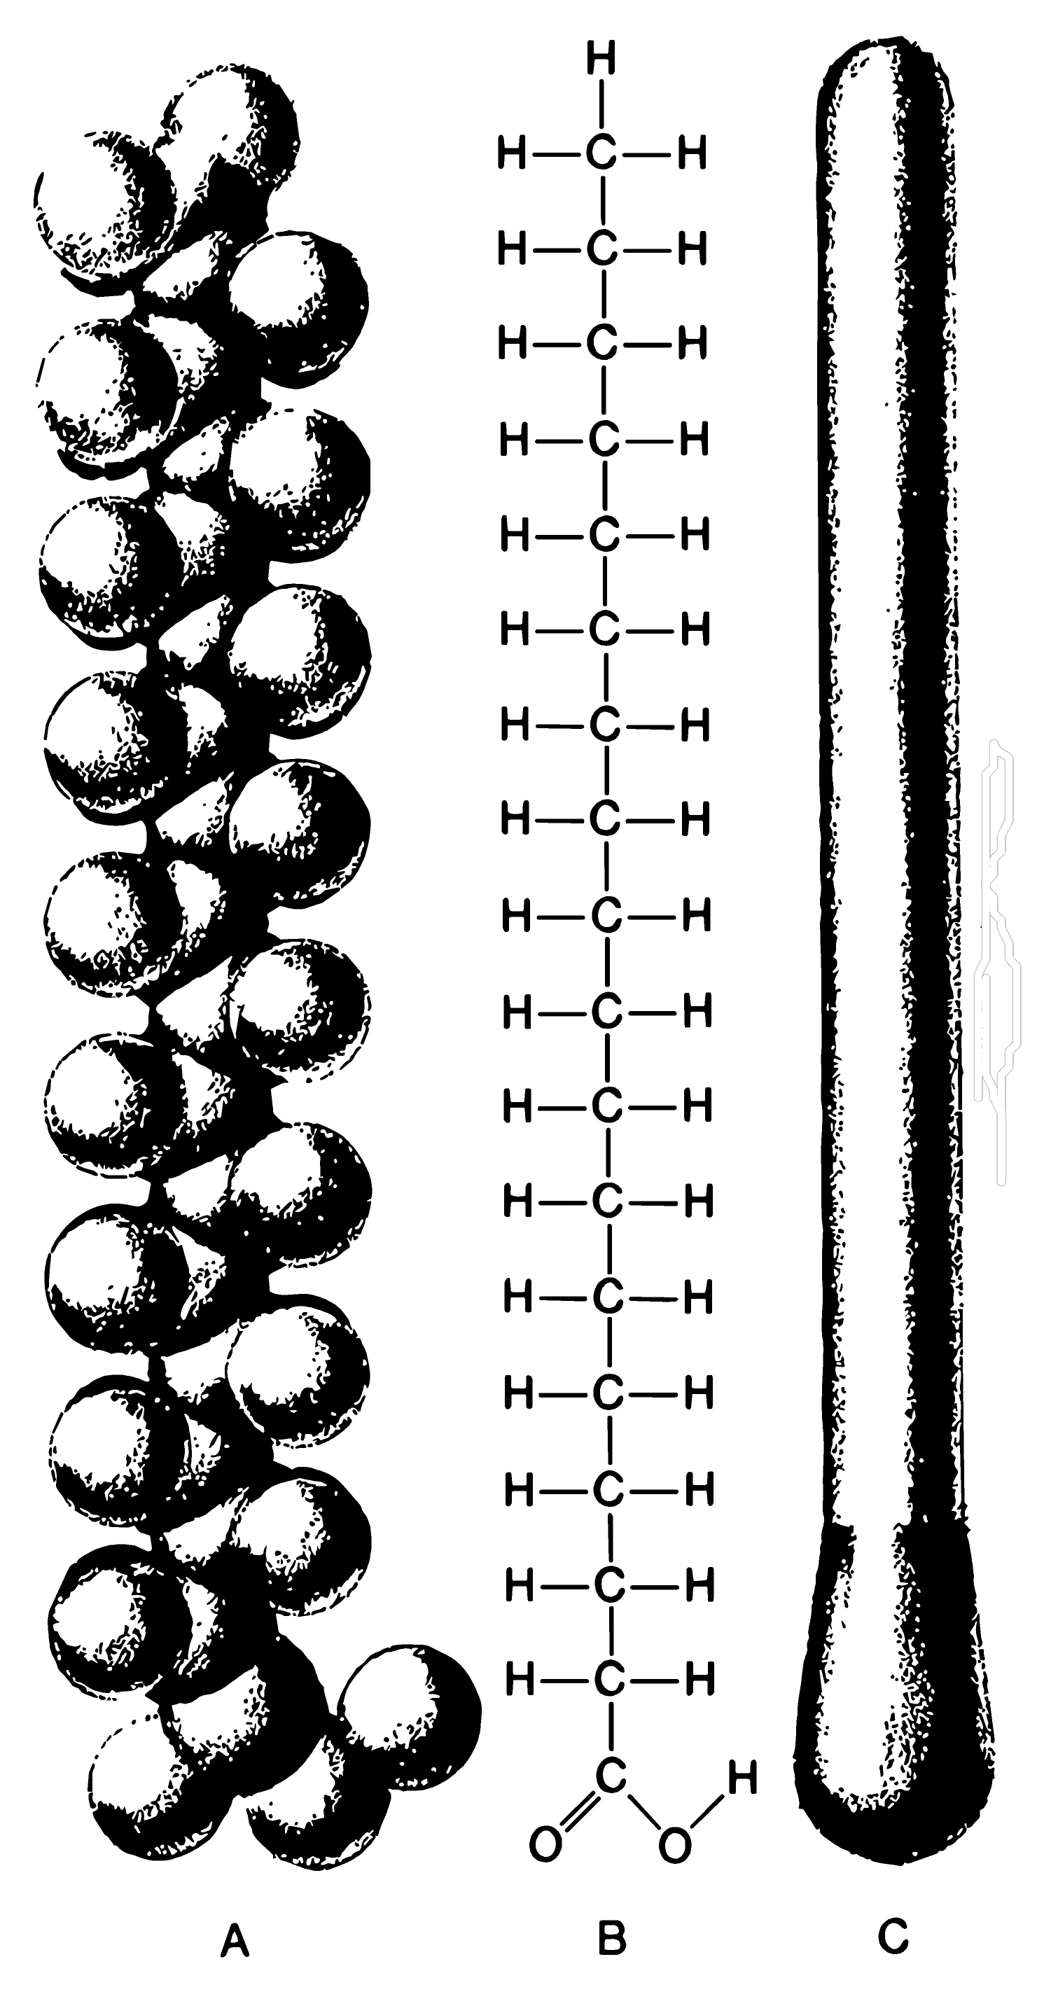
Figure 3. The stearic acid molecule:(A) space-Filling model; (B) structural formula;(C) schematic "matchstick" representation.
Adding a limited number of stearic acid molecules to a water surface results in the formation of a monolayer, as illustrated in Figure 4.
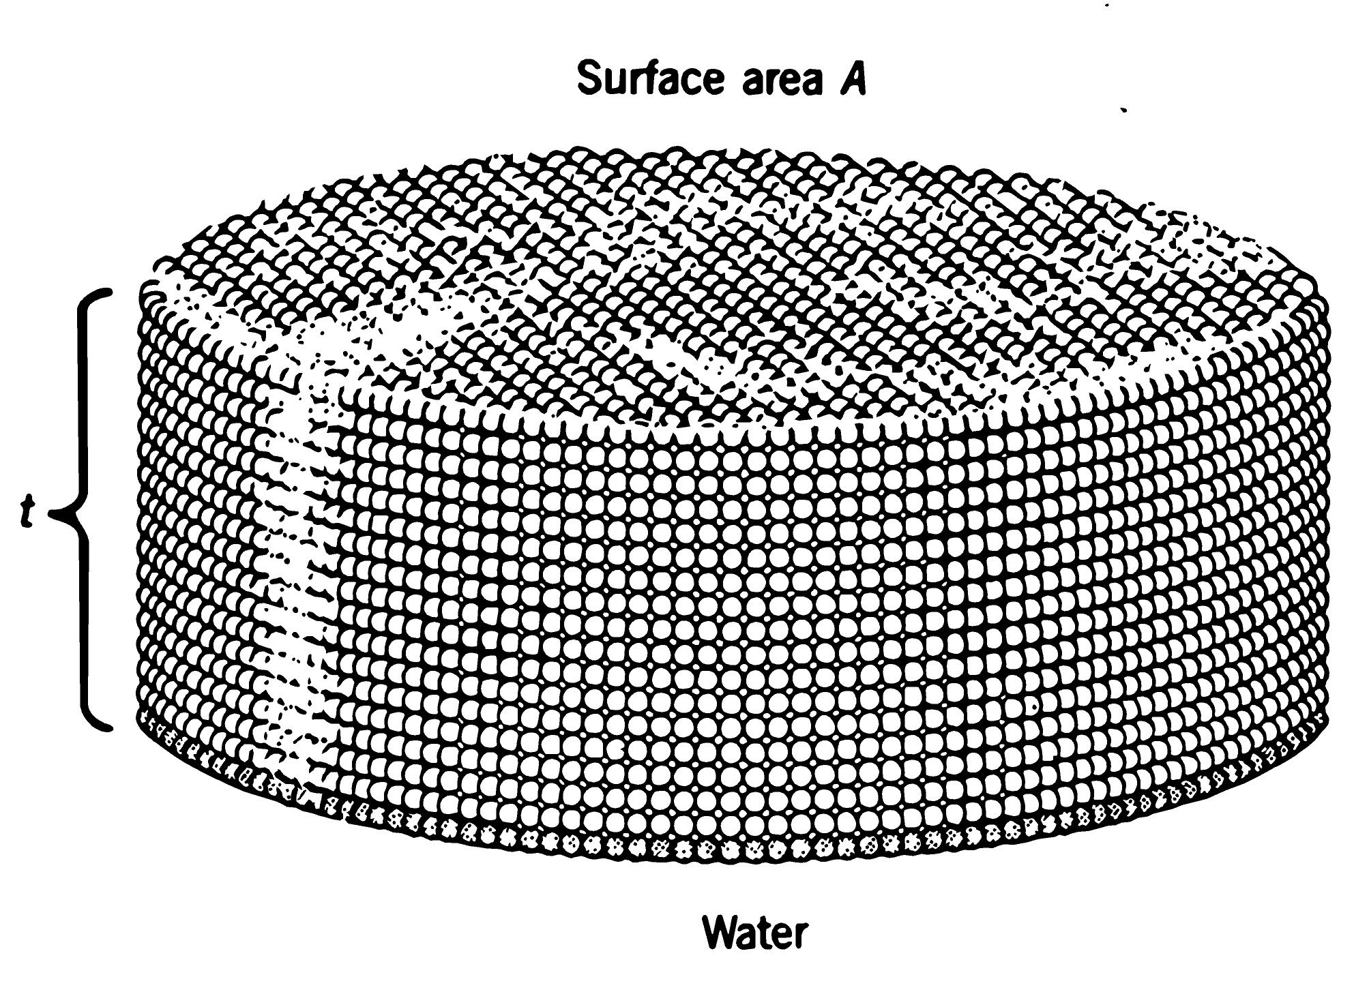
Figure 4. Magnified view of a stearic acid film (not to scale). The stearic acid molecules orient themselves vertically because of the attraction of their polar ends (the -COOH groups) for the water molecules at the water surface and the weak attractive forces between their hydrocarbon tails. The volume of the stearic acid monolayer is the product of surface Area times thickness (A x t).
results in the formation of a monolayer, as illustrated in Figure 4. However, after the surface is covered with a monolayer of stearic acid molecules to cluster in globular aggregates. The polar heads are attracted to the polar water, with the hydrocarbon tails pointing inward to form an "oily" interior.
The properties of the water surface and the stearic acid molecule permits us to perform what amounts to a titration of the water surface. We can add stearic acid molecules to the water surface until a layer of cord wood turned on end. If we know the area of the surface of water and have a way of measuring the volume of substance added to form the monolayer, we can calculate the thickness, t, of the layer. This thickness equals approximately the length of the stearic acid molecule.
As we saw in Figure 3, this molecule consists of 18 carbon atoms linked together. If we make the simple assumption that the atoms are like little cubes linked together (Figure 5), the edge length, we have estimated the volume of a carbon atom. Now we have half the data needed to calculate Avogadro's number.
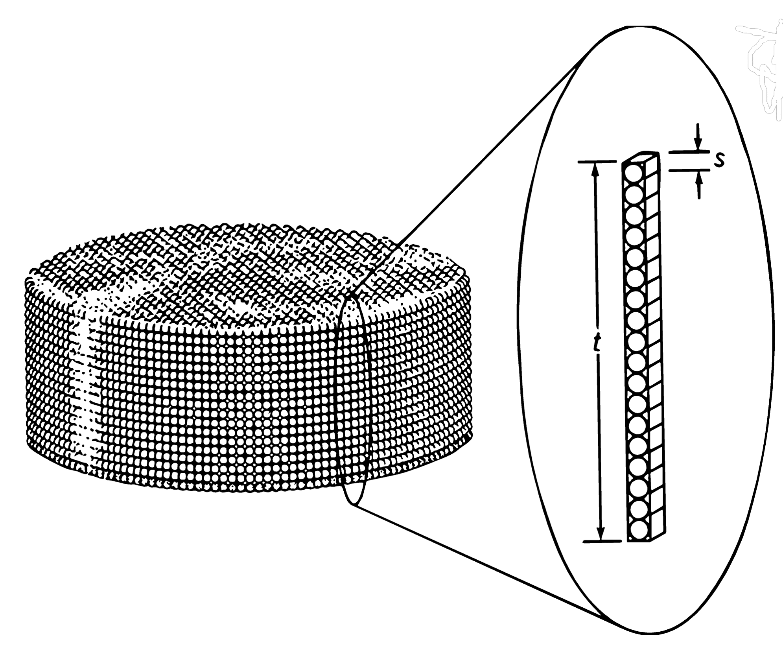

Figure 5. For purposes of our estimate, each stearic acid molecule can be approximated as a vertical stack of 18 carbon atoms with a total height equal to the thickness, t, of the monolayer film. Each carbon atom then has a diameter, s, equal to 1/18 of the film thickness. When empty space beteween the atoms is included, the gross volume of each atom , V_{atom} = s³.
The other necessary data requires no experimental work on your part. What we need is the volume of a mole of carbon. Diamond is pure carbon, and the density of diamond is known to be 3.51 g/cm³. You may recall that you can calculate the molar volume of an element by dividing the molar mass (g/mol) by its density (g/cm³). Verify this idea by looking at the dimensions of this quotient.
If we assume that diamond consists of little cubes of carbon atoms stacked together, an Avogadro's number of them would equal the volume of one mole. Avogadro's number results from one step:
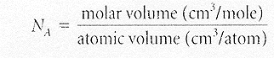
= number of atoms/mol

