Pre-Lab 4: Metathesis – To Exchange or Not
Hopefully here for the Pre-Lab
Name(Print then sign): ___________________________________________________
Lab Day: ___________________Section: ________TA__________________________
This assignment must be completed individually and turned in to your TA at the beginning of lab. You will not be allowed to begin the lab until you have completed this assignment.
1. Write molecular, complete ionic, and net ionic equations for the reactions that occur, if any, when solutions of the following substances are mixed:
(a) nitric acid and barium carbonate

(b) zinc chloride and lead nitrate

(c) acetic acid and sodium hydroxide

(d) calcium nitrate and sodium carbonate

(e) ammonium chloride and potassium hydroxide

2. Which of the following are not water soluble:
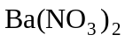, 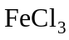, 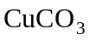, 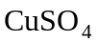, ZnS, 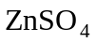?

3. Write equations for the decomposition of 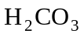 and 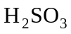.

4. At what temperature (from your graph) do 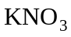 and NaCl have the same molar solubility?
5. Which of the following are strong electrolytes: 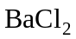, 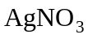, HCl, 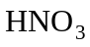, 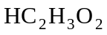?

6. Which of the following are weak electrolytes: , HF, HCl, 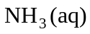, NaOH?

7. For each of the following water-soluble compounds, indicate the ions present in an aqueous solution: NaI, 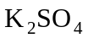, NaCN, 

