Pre-Lab: Nanotechnology

(Total 10 Points)
Note: In preparing this report you are free to use references and consult with others. However, you may not copy from other students’ work (including your laboratory partner) or misrepresent your own data (see honor code).
Name(Print then sign): ___________________________________________________
Lab Day: ___________________Section: ________TA__________________________

Part I. Demo of Gold Nanoparticles
- In a 3 nm gold particle, what percentage of the atoms are on the surface? Hint: You need to find the radius of a single gold atom and the equation for the volume of a sphere is also helpful. Remember that the volume of a shell is 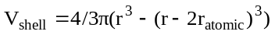.

Part II. Synthesis of an Aqueous Ferrofluid
- How would you make a 100 mL solution of 1.0 M 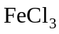 in 2.0 M HCl from 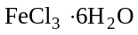 and concentrated HCl solution? Show all calculations. Hint: First find volume of water needed to make concentrated HCl ~12.1 M.

Part III. Liquid Crystal Synthesis
- In your own words, explain what a liquid crystal is.

